

Decision Making in Local Government

Local Governments in Western Australia make decisions through a structured framework established by the Local Government Act 1995 and other relevant legislation.

The two primary decision-making bodies within local government are the Council, which serves as the principal decision-making entity, and the Chief Executive Officer (CEO), who holds specific functions as defined by the Local Government Act. Additional powers and functions may be delegated to these bodies by other legislation.

Legislation designates decision-making powers using specific terms that refer to the relevant entity, office, or individual. Interpreting the Local Government Act 1995 is relatively straight forward, with "Local Government," typically referring to the governing body itself. Other legislation may use different terms but will often include a Local Government through definitions, such as "Permit Authority" in the Building Act 2011 or "Enforcement Agency" in the Food Act 2008.

When legislation specifies "Local Government" for broad discretionary powers, the decision-making authority lies with the Council as the governing body. Conversely, when limited discretion is involved, this may be suitable for acting through administrative processes.

When the term "Council" is used, it indicates that the decision must be made by the Council, by resolution. Terms like "Prescribed Office" refer to specific roles assigned by legislation, such as the Mayor or CEO, where only the person in that role can perform the duties associated with it. For example, the mayor presides over Council meetings as required by section 5.6 of the Local Government Act 1995. These duties cannot be performed by the Council or the CEO unless the CEO holds the prescribed office.

Legislation sometimes requires a person to be "authorised" to perform certain functions, with some provisions limiting this authorisation to local government employees, while others may allow contractors or non-employees to be authorised, depending on the legislation.

It is unreasonable and impossible for every decision to be fulfilled by the Council of a local government. This is why a number of Acts administered by local governments allow the peak decision-making body (Council) to delegate power to certain committees, its CEO, and in some cases employees or other persons.

Delegated Authority

Section 59 of the Interpretation Act 1984 prescribes the overall framework for how delegated authority must be structured in Western Australian law.

In summary:

1. The written law (head of power) must include an express power to delegate, which specifically enables a person (the delegator) to make a delegation.
2. In that same written law, there must be an express power or duty conferred or imposed on the delegator, and it must be capable of being delegated. This means that:
a. The power or duty proposed for delegation must be written in the same law as the express power to delegate; and
b. That written law must not prohibit the power or duty from being delegated or contain limitations or conditions, which the proposed delegation exceeds.
3. The power to delegate cannot be delegated.
4. Delegations must be in writing (the instrument of delegation); and
5. Delegations must be advised to the delegate in writing.

Note that nothing prevents the delegating body or person from taking back a delegation or sub delegation or making the relevant decision on a particular issue. Similarly, a delegator does not have to exercise the delegation and may refer the decision back to the delegator.

Similarly, section 59(2) provides that:

The delegation of a power shall be deemed to include the delegation of any duty incidental thereto or connected therewith and the delegation of a duty shall be deemed to include the delegation of any power incidental thereto or connected therewith.

The purpose of delegating a power is generally aimed at dealing with matters that are routine, may have a time constraint, can change rapidly, or is simply more efficient.

The delegations of authority contained within are made to Committees pursuant to Section 5.16 and to the Chief Executive Officer pursuant to Section 5.42 of the Local Government Act 1995 (the Act) and, where listed, some of these functions are delegated by the Chief Executive Officer to City of Cockburn employees pursuant to Section 5.44 of the Act. All delegations made by the Council must be by an absolute majority decision.

Section 5.43 of the Act provides that the following are decisions that cannot be delegated to the Chief Executive Officer:

- Any power or duty that requires a decision of an absolute majority of the Council.
- Accepting a tender which exceeds an amount determined by the local government for the purpose of this paragraph.
- Appointing an auditor.
- Acquiring or disposing of any property valued at an amount exceeding an amount determined by the local government for the purpose of this paragraph.
- Any of the local government’s powers under sections 5.98, 5.98A, 5.99 and 5.100 of the Act.
- Borrowing money on behalf of the local government.
- Hearing or determining an objection of a kind referred to in Section 9.5.
- The power under Section 9.49A (4) to authorise a person to sign documents on behalf of the local government.
- Any power or duty that requires the approval of the Minister or Governor.
- Such other duties or powers that may be prescribed by the Act.

The Act allows for the Chief Executive Officer to delegate any of their powers to another employee, this must be done in writing. The Act allows for the Chief Executive Officer to place conditions on any delegations if required.

A person to whom a duty or power is delegated under the Act is a ‘designated employee’ under s5.74(b) of the Act and is required to:

- disclose relevant interests
- complete a Primary Return
- complete Annual Returns

Although these requirements relate only to delegations under the Act, compliance requirements are applied uniformly to employees exercising delegated authority.
Any sub delegations by the Chief Executive Officer will be updated in this register as and when required, without presentation to Council, as delegations of power by the Chief Executive Officer to employees are to be determined by the Chief Executive Officer.

Acting Through

Employees do not always need a delegation or authorisation to carry out their tasks and functions on behalf of the local government. A function may be undertaken through the “acting through” concept. This means the person fulfills or carries out a function and has no discretion/decision making, in carrying out that function – the outcome will not be substantially different regardless of the circumstances or who exercised the power.

Section 5.16(4) of the Act provides that: …

(4) Nothing in this section is to be read as preventing a local government from performing any of its functions by acting through another person.

Similarly, s5.45(2) Act provides that:

Nothing in this Division (Division 4 - Local Government Employees) is to be read as preventing – a) a local government from performing any of its functions by acting through a person other than the Chief Executive Officer; or b) a Chief Executive Officer from performing any of his or her functions by acting through another person.

The key difference between a delegation and acting through is that a delegate exercises a decision-making function in his or her own right. For example, an employee may pay an account or issue an approval if directed to do so by another employee who has the power to make such a decision and chooses to “act through” another employee. The employee who has paid the account or issued the approval carried out the function but did so at the direction of the employee who had the decision making or delegated authority to do so.

Authorisations

Authorised persons (and who under some Acts do not necessarily have to be employees of the local government but often are) are given powers to do certain things under an Act, Regulation, or local law; usually to issue an infringement, make inquiries, enter on to property, issue a notice or to enforce a provision.

An authorised person, once appointed, is responsible for fulfilling the powers and duties assigned under law to an authorised person, which may be specified or limited in an Act or Regulation, or the certificate of authorisation.

An authorisation appoints a person to an office prescribed in law (to perform functions of that office) or appoints a person to perform a specific function prescribed in law.

An authorised person cannot delegate their powers and duties to another person.

Register of Delegated Authority

A register of delegations, being this manual, relevant to the Chief Executive Officer and other employees is to be kept and reviewed at least once every financial year. The Register is required to be publicly available and is published on the City’s website.

If a person is exercising a power or duty that they have been delegated, the Act requires them to keep necessary records to the exercise of the power or discharge of the duty. All officers are required to maintain relevant records when exercising the power or discharge of duty delegated to them.

The written record is to contain:

- how the person exercised the power or discharged the duty;
- when the person exercised the power or discharged the duty; and
- the persons or classes of persons, other than council or committee members or employees of the local government, directly affected by the exercise of the power or the discharge of the duty.

In addition to delegations made in accordance with the Act, a number of delegations are also made to the Chief Executive Officer, or directly to other officers in some instances, in accordance with the provisions of other legislation.

The aim of the delegated authority register is to assist with improving the time taken to make decisions within the constraints allowed by the relevant legislation. This is consistent with the City’s commitment to a strong customer service focus.

Each instrument of delegation describes the function being delegated and the relevant statutory reference which is the source of power for the exercise of the function. Also included is a reference to related documents such as policies of the Council which may provide guidance in the exercise of the delegation. This delegated authority register will be reviewed in accordance with the Act on an annual basis.

D E L E G A T I O N R E G I S T E R
Table of Contents
1 Local Government Act 1995 Delegations 1
1.1 Council to Committees of Council 1
1.1.1 Audit Risk and Compliance Committee 1
1.1.2 Code of Conduct Complaints (CCC) Committee 2
1.2 Council to CEO 3
1.2.1 Authorise a Person to Perform Specified Functions 3
1.2.2 Performing Functions Outside the District 5
1.2.3 Compensation - Damage Incurred when Performing Executive Functions 6
1.2.4 Powers of Entry 7
1.2.5 Declare Vehicle is Abandoned Vehicle Wreck 9
1.2.6 Confiscated or Uncollected Goods 11
1.2.7 Disposal of Sick or Injured Animals 13
1.2.8 Temporary Road Closures 14
1.2.9 Control Reserves and Certain Unvested Facilities 16
1.2.10 Obstruction of Footpaths and Thoroughfares 17
1.2.11 Public Thoroughfare – Dangerous Excavations 20
1.2.12 Crossing – Construction, Repair and Removal 22
1.2.13 Private Works on, over or under Public Places 24
1.2.14 Give Notice to Prevent Damage to Local Government Property from Wind Erosion and Sand Drift 26
1.2.15 Expressions of Interest for Goods and Services 27
1.2.16 Tenders for Goods and Services – Call Tenders 29
1.2.17 Exercising Contract Extension Options 31
1.2.18 Accepting and Rejecting Tenders 32
1.2.19 Minor Variation in Goods or Services 35
1.2.20 Selecting the Next Most Advantageous Tender 37
1.2.21 Variation to Contract 39
1.2.22 Tenders for Goods and Services - Exempt Procurement 41
1.2.23 Panels of Pre-Qualified Suppliers for Goods and Services 43
1.2.24 Disposing of Property 46
1.2.25 Payments from the Municipal or Trust Funds 49
1.2.26 Defer, Grant Discounts, Waive or Write Off Debts 51
1.2.27 Power to Invest and Manage Investments 53
1.2.28 Rate Record Amendment 55
1.2.29 Agreement as to Payment of Rates and Service Charges 56
1.2.30 Recovery of Rates or Service Charges 57
1.2.31 Recovery of Rates Debts – Require Lessee to Pay Rent 58
1.2.32 Rate Record – Objections 59
1.2.33 City of Cockburn (Local Government Act) Local Laws 2000 60
1.2.34 Fencing Local Law 2012 62
1.2.35 Jetties, Waterways and Marina Local Law 2012 63
1.2.36 Waste Local Law 2020 65
1.2.37 Parking and Parking Facilities Local Law 2007 66
1.2.38 Authority to accept and award specified tenders during period prescribed by Council 67
1.3 CEO to Employees 68
1.3.1 Determine and Manage Conditions on Approvals to Obstruct a Public Thoroughfare 68
1.3.2 Determine and Manage Conditions on Permission for Dangerous Excavations on or on land adjoining Public Thoroughfares 70
1.3.3 Determine and Manage Conditions on Permission for Private Works on, over, or under Public Places 72
1.3.4 Appoint Persons (Other than Employees) to Open Tenders 73
1.3.5 Electoral Enrolment Eligibility Claims and Electoral Roll 74
1.3.6 Destruction of Electoral Papers 76
1.3.7 Appoint Authorised Persons 77
1.3.8 Information to be Available to the Public 79
1.3.9 Infringement Notices 80
1.3.10 Conduct election of Deputy Mayor 82
2 Building Act 2011 Delegations 83
2.1 Council to CEO 83
2.1.1 Approve or Refuse a Building Permit 83
2.1.2 Demolition Permits 85
2.1.3 Occupancy Permits or Building Approval Certificates 87
2.1.4 Designate Employees as Authorised Persons 89
2.1.5 Building Orders 90
2.1.6 Inspection and Copies of Building Records 92
2.1.7 Legal Proceedings 93
2.1.8 Referrals and Issuing Certificates 94
2.1.9 Appoint Approved Officers and Authorised Officers 96
3 Bush Fires Act 1954 Delegations 97
3.1 Council to CEO, Mayor and Bush Fire Control Officer 97
3.1.1 Prohibited Burning Times - Vary 97
3.1.2 Prohibited Burning Times – Control Activities 98
3.1.3 Restricted Burning Times – Vary and Control Activities 100
3.1.4 Burning Garden Refuse / Open Air Fires 102
3.1.5 Firebreaks 104
3.1.6 Appoint Bush Fire Control Officers 105
3.1.7 Recovery of Expenses Incurred through Contraventions of this Act 106
3.1.8 Prosecution of Offences 107
3.1.9 Bush Fire Brigade Local Law 2000 109
4 Cat Act 2011 Delegations 110
4.1 Council to CEO 110
4.1.1 Cat Registrations 110
4.1.2 Cat Control Notices 112
4.1.3 Approval to Breed Cats 113
4.1.4 Recovery of Costs – Destruction of Cats 115
4.1.5 Authorise a Person to Perform Specified Functions under the Cat Act 2011 116
4.1.6 Applications to Keep Additional Cats 117
4.1.7 Reduce or Waive Registration Fee 118
4.2 CEO to Employees 119
4.2.1 Infringement Notices – Extensions and Withdrawals 119
5 Dog Act 1974 Delegations 120
5.1 Dog Act Delegations Council to CEO 120
5.1.1 Appoint Registration Officer 120
5.1.2 Part Payment of Sterilisation Costs / Directions to Veterinary Surgeons 121
5.1.3 Refuse or Cancel Registration 122
5.1.4 Grant Exemption as to Number of Dogs Kept at Premises 124
5.1.5 Kennel Establishments 126
5.1.6 Recovery of Moneys Due Under this Act 127
5.1.7 Dispose of or Sell Dogs Liable to be Destroyed 128
5.1.8 Declare Dangerous Dog 129
5.1.9 Dangerous Dog Declared – Determine when to Revoke 130
5.1.10 Deal with Objection to Notice to Revoke Dangerous Dog Declaration or Destruction Notice 131
5.1.11 Determine Recoverable Expenses for Dangerous Dog Declaration 132
6 Food Act 2008 Delegations 133
6.1 Council to Officers 133
6.1.1 Determine Compensation 133
6.1.2 Prohibition Orders and Certificates of Clearance 134
6.1.3 Food Business Registrations 136
6.1.4 Appoint Authorised Officers and Designated Officers 138
6.1.5 Debt Recovery and Prosecutions 140
7 Graffiti Vandalism Act 2016 Delegations 141
7.1 Council to CEO 141
7.1.1 Give Notice Requiring Obliteration of Graffiti 141
7.1.2 Notices – Deal with Objections and Give Effect to Notices 143
7.1.3 Obliterate Graffiti on Private Property 144
7.1.4 Powers of Entry 145
8 Health (Miscellaneous Provisions) Act 1911 146
8.1 Council to Deputies 146
8.1.1 Appointment and Authorisation of Deputies 146
8.1.2 Appoint Authorised Officer or Approved Officer (Asbestos Regs) 146
9 Public Health Act 2016 Delegations 148
9.1 Council to CEO 148
9.1.1 Designate Authorised Officers 148
9.1.2 Dealing with Seized Items 150
9.1.3 Enforcement Orders 151
9.1.4 Appoint Designated Officer – Information Sharing 153
10 Planning and Development Act 2005 Delegations 154
10.1 Council to CEO 154
10.1.1 Illegal Development 154
10.1.2 Structure Plans 156
10.1.3 Town Planning Scheme – Development Contributions 159
10.1.4 Town Planning Scheme – Development Control 161
11 External Agency Delegations 165
11.1 Environmental Protection Act 165
11.1.1 Noise Control – Environmental Protection Notices [Reg.65(1)] 165
11.1.2 Noise Management Plans – Keeping Log Books, Noise Control Notices, Calibration and Approval of Non-Complying Events 166
11.1.3 Noise Management Plans - Construction Sites 167
11.2 Planning and Development Act 2005 168
11.2.1 Instrument of Authorisation – Sign Development Applications for Crown Land as Owner 168
11.2.2 Delegation of Certain Powers and Functions of the WAPC relating to the MRS 171
11.2.3 Delegation of Certain Powers under Section 25 of the Strata Titles Act 1985 176
11.2.4 – Delegation of Certain Powers and Functions of the WAPC relating to the Hope Valley-Wattleup Redevelopment Act 2000 and the Hope Valley-Wattleup Mater Plan 178
11.3 Main Roads Act 1930 180
11.3.1 Regulation of Parking on Verges of Main Roads, Highways and Footpaths 180
11.4 Road Traffic Code 2000 183
11.4.1 Authority to Use Traffic Signs and Devices at Roadworks 184
11.4.2 Authority to Use Traffic Signs and Devices at Events 186
11.4.3 Authority to Use Traffic Signs and Devices to Assist Emergency Vehicles at the Intersection of Karel Avenue and Berrigan Drive, Jandakot 188
11.4.4 Approval to Display Yellow Flashing Warning Lights on Ranger Vehicles 189
11.5 Road Traffic (Vehicles) Act 2012 192
11.5.1 Approval for Certain Local Government Vehicles as Special Use Vehicles 192
12 Policy Delegations 194
12.1 Council to CEO 194
12.1.1 Community Funding to Support Local Economic Development 194
12.1.2 Funding Assistance – Community Associations 195
12.1.3 Funding Assistance for Community Organisations and Individuals 196
12.1.4 Funding for Community Organisations and Individuals (Grants, Donations & Sponsorships) 197
12.1.5 Funding Assistance for Sporting Clubs and Individuals 197
12.2 CEO to Employees 197
12.2.1 Elected Member Reimbursement Requests 197
12.2.2 Elected Member Professional Development Applications 199
12.2.3 Elected Member Approvals at Events 200
12.2 CEO to Employee Error! Bookmark not defined.
12.2.1 Elected Member Reimbursement Requests Error! Bookmark not defined.5
12.1.2 Elected Member Professional Development Applications 196
12.1.3 Elected Member Approval at Events Error! Bookmark not defined.7

Local Government Act 1995 Delegations

Council to Committees of Council

Audit Risk and Compliance Committee

Revoked OCM 12 May 2026, 2026/MINUTE NO 0086

Code of Conduct Complaints (CCC) Committee

Revoked OCM 14 April 2026, 2026/MINUTE NO 0086

Council to CEO

Authorise a Person to Perform Specified Functions

Delegator:  Power / Duty assigned in legislation to: | Local Government
Express Power to Delegate:  Power that enables a delegation to be made | Local Government Act 1995:  s.5.42 Delegation of some powers or duties to the CEO  s.5.43 Limitations on delegations to the CEO
Express Power Delegated: | Local Government Act 1995:  s.3.24 Authorising persons under this Subdivision  s.3.31(2) General Procedure for entering property  s.3.39(1) Power to remove and impound  s.3.40A(1) Abandoned vehicle wreck may be taken  s.9.24(1)(c) and (2)(b) Prosecutions, commencing  Local Government (Miscellaneous Provisions) Act 1960  s.449 Pounds, establishing; pound keepers and Rangers, appointing
Delegate: | Chief Executive Officer
Function:  This is a precis only. Delegates must act with full understanding of the legislation and conditions relevant to this delegation. | 1. Authority to authorise persons for the purposes of Part 3, Division 3, Subdivision 2 – Certain provisions about land - to exercise the Local Government’s powers under s.3.25 to 3.27 inclusive, to issue and administer notices requiring certain things to be done by owner or occupier of land [s.3.24].  2. Authority to authorise persons to enter onto land, premises or thing, without consent of the owner / occupier, unless the owner / occupier objects [s.3.31(2)].  3. Authority to authorise an employee to remove and impound any goods that are involved in a contravention that can lead to impounding [s.3.39(1)].  4. Authority to authorise persons to commence prosecutions for offences under the Local Government Act 1995 and any Local Laws made under the Local Government Act 1995 [s.9.24(1)(c) and (2)(b)].  5. Authority to authorise an employee to remove and impound a vehicle that has been determined as an abandoned vehicle wreck [s.3.40A(1)].  6. Authority to appoint fit and proper persons as pound keepers or Rangers [Misc.Prov.s.449].
Council Conditions on this Delegation: | Nil.
Express Power to Sub-Delegate: | Local Government Act 1995:  s.5.44 CEO may delegate some powers and duties to other employees.
Sub-Delegate/s:  Appointed by CEO |  | Director Infrastructure Services  Director Corporate and System Services  Director Sustainable Development and Safety  Director Community and Place
CEO Conditions on this Sub-Delegation:  Conditions on the delegation also apply to sub-delegation. |  | Nil
Compliance Links: |  | Delegates are designated employees under s.5.74 and are required to provide Primary and Annual Returns.
Record Keeping: |  | Details of decisions are to be recorded in the City’s record keeping system.
1 | Adopted 9 July 2024
2 | Modified 11 March 2025

Performing Functions Outside the District

Delegator:  Power / Duty assigned in legislation to: | Local Government
Express Power to Delegate:  Power that enables a delegation to be made | Local Government Act 1995:  s.5.42 Delegation of some powers or duties to the CEO  s.5.43 Limitations on delegations to the CEO
Express Power Delegated: | Local Government Act 1995:  s.3.20(1) Performing functions outside district
Delegate: | Chief Executive Officer
Function:  This is a precis only. Delegates must act with full understanding of the legislation and conditions relevant to this delegation. | Determine the circumstances where it is appropriate for the Local Government’s functions to be performed outside the District and prior to implementing such a decision, obtain the consent of the landowner/s and occupier/s and any other person that has control or management of the land impacted by the performance of the function [s.3.20(1)].
Council Conditions on this Delegation: | - A decision to undertake a function outside the district, can only be made under this delegation where there is a relevant Budget allocation, and the performance of the functions does not negatively impact service levels within the district. Where these conditions are not met, the matter must be referred for Council decision.  - This function is not to be sub-delegated.
Express Power to Sub-Delegate: | Local Government Act 1995:  s.5.44 CEO may delegate some powers and duties to other employees
Sub-Delegate/s:  Appointed by CEO |  | N/A
CEO Conditions on this Sub-Delegation:
Conditions on the delegation also apply to sub-delegation.
Compliance Links: |  | Delegates are designated employees under s.5.74 and are required to provide Primary and Annual Returns.
Record Keeping: |  | Details of decisions are to be recorded in the City’s record keeping system.
1 | Adopted 9 July 2024

Compensation - Damage Incurred when Performing Executive Functions

Delegator:  Power / Duty assigned in legislation to: |  | Local Government
Express Power to Delegate:  Power that enables a delegation to be made |  | Local Government Act 1995:  s.5.42 Delegation of some powers or duties to the CEO  s.5.43 Limitations on delegations to the CEO
Express Power Delegated: |  | Local Government Act 1995:  s.3.22(1) Compensation  s.3.23 Arbitration
Delegate: |  | Chief Executive Officer
Function:  This is a precis only. Delegates must act with full understanding of the legislation and conditions relevant to this delegation. |  | 1. In accordance with the s.3.22 procedures, assess and determine the extent of damage to private property arising directly from performance of executive functions and make payment of compensation [s.3.22(1)].  2. Where compensation is unable to be determined and agreed between parties, give effect to arbitration in accordance with s.3.23.
Council Conditions on this Delegation: |  | Delegation is limited to settlements which do not exceed a material value of $20,000.
Express Power to Sub-Delegate: |  | Local Government Act 1995:  s.5.44 CEO may delegate some powers and duties to other employees
Sub-Delegate/s:  Appointed by CEO |  | Director Infrastructure Services
CEO Conditions on this Sub-Delegation:  Conditions on the delegation also apply to sub-delegation. |  | - Conditions on the delegation also apply to sub-delegation.  - Sub-delegation may only be exercised after receiving advice from General Counsel.
Compliance Links: |  | Delegates are designated employees under s.5.74 and are required to provide Primary and Annual Returns.
Record Keeping: |  | Details of decisions are to be recorded in the City’s record keeping system
1 | Adopted 9 July 2024

Powers of Entry

Delegator:  Power / Duty assigned in legislation to: |  | Local Government
Express Power to Delegate:  Power that enables a delegation to be made |  | Local Government Act 1995:  s.5.42 Delegation of some powers or duties to the CEO  s.5.43 Limitations on delegations to the CEO
Express Power Delegated: |  | Local Government Act 1995:  s.3.32 Notice of entry  s.3.33 Entry under warrant  s.3.34 Entry in an emergency  s.3.36 Opening fences
Delegate: |  | Chief Executive Officer
Function:  This is a precis only. Delegates must act with full understanding of the legislation and conditions relevant to this delegation. |  | 1. Authority to give notice of entry [s.3.32].  2. Authority to seek entry under warrant [s.3.33].  3. Authority to determine if an emergency exists, and then execute entry, using such force as is reasonable [s.3.34(1)-(3)].  4. Authority to give notice and effect entry by opening a fence [s.3.36].
Council Conditions on this Delegation: |  | Nil
Express Power to Sub-Delegate: |  | Local Government Act 1995:  s.5.44 CEO may delegate some powers and duties to other employees
Sub-Delegate/s:  Appointed by CEO |  | Director Infrastructure Services  Director Sustainable Development and Safety  Group Manager Development and Safety  Service Manager Rangers and Community Safety  Service Lead Ranger and Parking  Ranger Team Leader  Service Manager Development Services  Service Lead CoSafe and Community Safety  Service Lead Development Compliance  Functions 1 and 2 only  Service Lead Public Health  Service Lead Building Services
CEO Conditions on this Sub-Delegation:  Conditions on the delegation also apply to sub-delegation. |  | Nil
Compliance Links: |  | Delegates are designated employees under s.5.74 and are required to provide Primary and Annual Returns.  Local Government Act 1995:  s.3.28 When this Subdivision applies  s.3.32 Notice of entry  s.3.33 Entry under warrant  s.3.34 Entry in an emergency  s.3.36 Opening fences
Record Keeping: |  | Details of decisions are to be recorded in the City’s record keeping system
1 | Adopted 9 July 2024
2 | Modified 11 March 2025
3 | Modified 10 April 2025
4 | Modified 8 July 2025
5 | Modified 1 April 2026

Declare Vehicle is Abandoned Vehicle Wreck

Delegator:  Power / Duty assigned in legislation to: |  | Local Government
Express Power to Delegate:  Power that enables a delegation to be made |  | Local Government Act 1995:  s.5.42 Delegation of some powers or duties to the CEO  s.5.43 Limitations on delegations to the CEO
Express Power or Duty Delegated: |  | Local Government Act 1995:  s.3.40A(1), (2), (4) Abandoned vehicle wreck may be taken
Delegate: |  | Chief Executive Officer
Function:  This is a precis only. Delegates must act with full understanding of the legislation and conditions relevant to this delegation. |  | - Provisionally and finally declare that an impounded vehicle is an abandoned vehicle wreck [s.3.40A(1), (4)].  - Give notice to a person advising that an impounded vehicle may be collected from a place specified in the notice [s.3.40(2)] .
Council Conditions on this Delegation: |  | Disposal of a declared abandoned vehicle wreck to be undertaken in accordance with Delegated Authority 1.2.6 Confiscated or Uncollected Goods or alternatively, referred for Council decision.
Express Power to Sub-Delegate: |  | Local Government Act 1995:  s.5.44 CEO may delegate some powers and duties to other employees
Sub-Delegate/s:  Appointed by CEO |  | Director Sustainable Development and Safety  Group Manager Development and Safety  Service Manager Rangers and Community Safety  Service Lead Ranger and Parking  Senior Parking Services
CEO Conditions on this Sub-Delegation:  Conditions on the delegation also apply to sub-delegation. |  | Conditions on the delegation also apply to sub-delegation.
Compliance Links: |  | Delegates are designated employees under s.5.74 and are required to provide Primary and Annual Returns.  Local Government Act 1995:  s.3.40A(3), (5) Abandoned vehicle wreck may be taken
Record Keeping: |  | Details of decisions are to be recorded in the City’s record keeping system
1 | Adopted 9 July 2024
2 | Modified 11 March 2025
3 | Modified 10 April 2025
4 | Modified 8 July 2025

Confiscated or Uncollected Goods

Delegator:  Power / Duty assigned in legislation to: |  |  |  | Local Government
Express Power to Delegate:  Power that enables a delegation to be made |  |  |  | Local Government Act 1995:  s.5.42 Delegation of some powers or duties to the CEO  s.5.43 Limitations on delegations to the CEO
Express Power or Duty Delegated: |  |  |  | Local Government Act 1995:  s.3.42 Impounded non-perishable goods  s.3.44 Notice to collect goods if not confiscated  s.3.46 Goods may be withheld until costs paid  s.3.47 Confiscated or uncollected goods, disposal of  s.3.48 Impounding expenses, recovery of
Delegate: |  |  |  | Chief Executive Officer
Function:  This is a precis only. Delegates must act with full understanding of the legislation and conditions relevant to this delegation. |  |  |  | - Authority to give notice that goods may be collected from a place specified during such hours as specified [ss 3.42, 3.44].  - Authority to refuse to allow goods impounded under s.3.39 or 3.40A to be collected until the costs of removing, impounding and keeping them have been paid to the local government. [s.3.46]  - Authority to sell or otherwise dispose of confiscated or uncollected goods or vehicles that have been ordered to be confiscated under s.3.43 [s.3.47].  - Authority to recover expenses incurred for removing, impounding, and disposing of confiscated or uncollected goods [s.3.48].
Council Conditions on this Delegation: |  |  |  | Nil
Express Power to Sub-Delegate: |  |  |  | Local Government Act 1995:  s.5.44 CEO may delegate some powers and duties to other employees
Sub-Delegate/s:  Appointed by CEO |  | Director Sustainable Development and Safety  Group Manager Development and Safety  Service Manager Rangers and Community Safety  Service Lead Rangers and Parking  Service Lead CoSafe and Community Safety
CEO Conditions on this Sub-Delegation:  Conditions on the delegation also apply to sub-delegation. |  | Nil
Compliance Links: |  |  | Delegates are designated employees under s.5.74 and are required to provide Primary and Annual Returns.
Record Keeping: |  |  | Details of decisions are to be recorded in the City’s record keeping system
1 | Adopted 9 July 2024
2 | Modified 11 March 2025
3 | Modified 10 April 2025
4 | Modified 8 July 2025
5 | Modified 1 April 2026

Disposal of Sick or Injured Animals

Delegator:  Power / Duty assigned in legislation to: |  | Local Government
Express Power to Delegate:  Power that enables a delegation to be made |  | Local Government Act 1995:  s.5.42 Delegation of some powers or duties to the CEO  s.5.43 Limitations on delegations to the CEO
Express Power or Duty Delegated: |  | Local Government Act 1995:  s.3.47A Sick or injured animals, disposal of
Delegate: |  | Chief Executive Officer
Function:  This is a precis only. Delegates must act with full understanding of the legislation and conditions relevant to this delegation. |  | 1. Authority to determine when an impounded animal is ill or injured, that treating it is not practicable, and to humanely destroy the animal and dispose of the carcass [s.3.47A(1)].  2.
Council Conditions on this Delegation: |  | Nil
Express Power to Sub-Delegate: |  | Local Government Act 1995:  s.5.44 CEO may delegate some powers and duties to other employees
Sub-Delegate/s:  Appointed by CEO |  | Director Sustainable Development and Safety  Group Manager Development and Safety  Service Manager Rangers and Community Safety  Service Lead Ranger and Parking
CEO Conditions on this Sub-Delegation:  Conditions on the delegation also apply to sub-delegation. |  | Only where the Delegate’s reasonable efforts to identify and contact an owner have failed.
Compliance Links: |  | Delegates are designated employees under s.5.74 and are required to provide Primary and Annual Returns.  Local Government Act 1995  s.3.47A(3) Sick or injured animals, disposal of
Record Keeping |  | Details of decisions are to be recorded in the City’s record keeping system
1 | Adopted 9 July 2024
2 | Modified 11 March 2025
3 | Modified 10 April 2025
4 | Modified 8 July 2025

Temporary Road Closures

Delegator:  Power / Duty assigned in legislation to: |  | Local Government
Express Power to Delegate:  Power that enables a delegation to be made |  | Local Government Act 1995:  s.5.42 Delegation of some powers or duties to the CEO  s.5.43 Limitations on delegations to the CEO
Express Power or Duty Delegated: |  | Local Government Act 1995:  s.3.50 Closing certain thoroughfares to vehicles  s.3.50A Partial closure of thoroughfare for repairs or maintenance  s.3.51 Affected owners to be notified of certain proposals
Delegate: |  | Chief Executive Officer
Function:  This is a precis only. Delegates must act with full understanding of the legislation and conditions relevant to this delegation. |  | 1. Authority to close a thoroughfare (wholly or partially) to vehicles or particular classes of vehicles for a period not exceeding 4-weeks [s.3.50(1)].  2. Authority to determine to close a thoroughfare for a period exceeding 4-weeks and before doing so, to:  - give; public notice, written notice to the Commissioner of Main Roads and written notice to prescribed persons and persons that own prescribed land; and  - consider submissions relevant to the road closure/s proposed [s.3.50(1a), (2) and (4)].  3. Authority to revoke an order to close a thoroughfare [s.3.50(6)].  4. Authority to partially and temporarily close a thoroughfare without public notice for repairs or maintenance, where it is unlikely to have significant adverse effect on users of the thoroughfare [s.3.50A]  5. Before doing anything to which section 3.51 applies, take action to notify affected owners and give public notice that allows reasonable time for submissions to be made and consider any submissions made before determining to fix or alter the level or alignment of a thoroughfare or draining water from a thoroughfare to private land [s3.51].
Council Conditions on this Delegation: |  | Nil.
Express Power to Sub-Delegate: |  | Local Government Act 1995:  s.5.44 CEO may delegate some powers and duties to other employees
Sub-Delegate/s:  Appointed by CEO |  | Director Infrastructure Services  Group Manager Assets and Projects  Service Manager Traffic and Major Projects  Principal Engineer Traffic and Transport  Director Sustainable Development and Safety  Function 4 only  Service Manager Infrastructure Assets  Service Lead Civil Infrastructure  Group Manager Development and Safety  Service Manager Rangers and Community Safety  Service Lead Emergency Management and Resilience
CEO Conditions on this Sub-Delegation:  Conditions on the delegation also apply to sub-delegation. |  | Nil
Compliance Links: |  | Delegates are designated employees under s.5.74 and are required to provide Primary and Annual Returns.
Record Keeping: |  | Details of decisions are to be recorded in the City’s record keeping system
1 | Adopted 9 July 2024
2 | Modified 11 March 2025
3 | Modified 1 April 2026

Control Reserves and Certain Unvested Facilities

Delegator:  Power / Duty assigned in legislation to: |  | Local Government
Express Power to Delegate:  Power that enables a delegation to be made |  | Local Government Act 1995:  s.5.42 Delegation of some powers or duties to the CEO  s.5.43 Limitations on delegations to the CEO
Express Power or Duty Delegated: |  | Local Government Act 1995:  s.3.53(3) Control of certain unvested facilities  s.3.54(1) Reserves under control of local government
Delegate: |  | Chief Executive Officer
Function:  This is a precis only. Delegates must act with full understanding of the legislation and conditions relevant to this delegation. |  | 1. Authority to agree the method for control and management of an unvested facility which is partially within 2 or more local government districts. [s.3.53(3)].  2. Authority to do anything for the purpose of controlling and managing land under the control and management of the City of Cockburn that the City of Cockburn could do under s.5 of the Parks and Reserves Act 1895. [s.3.54(1)].
Council Conditions on this Delegation: |  | Nil
Express Power to Sub-Delegate: |  | Local Government Act 1995:  s.5.44 CEO may delegate some powers and duties to other employees
Sub-Delegate/s:  Appointed by CEO |  | Director Infrastructure Services  Group Manager Parks, Fleet and Waste  Group Manager Assets and Projects
CEO Conditions on this Sub-Delegation:  Conditions on the delegation also apply to sub-delegation. |  | Nil
Compliance Links: |  | Delegates are designated employees under s.5.74 and are required to provide Primary and Annual Returns.
Record Keeping: |  | Details of decisions are to be recorded in the City’s record keeping system
1 | Adopted 9 July 2024
2 | Modified 11 March 2025

Obstruction of Footpaths and Thoroughfares

Delegator:  Power / Duty assigned in legislation to: |  |  |  | Local Government
Express Power to Delegate:  Power that enables a delegation to be made |  |  |  | Local Government Act 1995:  s.5.42 Delegation of some powers or duties to the CEO  s.5.43 Limitations on delegations to the CEO
Express Power or Duty Delegated: |  |  |  | Local Government (Uniform Local Provisions) Regulations 1996:  r.5(2) Interfering with, or taking from, local government land  r.6 Obstruction of public thoroughfare by things placed and left - Sch. 9.1 cl. 3(1)(a)  r.7A Obstruction of public thoroughfare by fallen things – Sch.9.1 cl.3(1)(b)  r.7 Encroaching on public thoroughfare – Sch.9.1. cl.3(2)
Delegate: |  |  |  | Chief Executive Officer
Function:  This is a precis only. Delegates must act with full understanding of the legislation and conditions relevant to this delegation. |  |  |  | 1. Authority to determine, by written notice served on a person who is carrying out plastering, painting or decorating operations (the work) over or near a footpath on land that is local government property, to require the person to cover the footpath during the period specified in the notice so as to:  a. prevent damage to the footpath; or  b. prevent inconvenience to the public or danger from falling materials [ULP r.5(2)].  2. Authority to provide permission including imposing appropriate conditions or to refuse to provide permission, for a person to place on a specified part of a public thoroughfare one or more specified things that may obstruct the public thoroughfare. [ULP r.6(2) and (4)].  3. Authority to renew permission to obstruct a thoroughfare and to vary any condition imposed on the permission effective at the time written notice is given to the person to whom permission is granted [ULP r.6(6)].  4. Authority to require an owner or occupier of land to remove any thing that has fallen from the land or from anything on the land, which is obstructing a public thoroughfare [ULP r.7A].  5. Authority to require an owner occupier of land to remove any part of a structure, tree or plant that is encroaching, without lawful authority on a public thoroughfare [ULP r.7].
Council Conditions on this Delegation: |  |  |  | a. Actions under this Delegation must comply with procedural requirements detailed in the Local Government (Uniform Local Provisions) Regulations 1996.  b. Permission may only be granted where, the proponent has:  I. Where appropriate, obtained written permission from each owner of adjoining or adjacent property which may be impacted by the proposed obstruction.  ii. Provided a bond, sufficient to the value of works that may be required if the proponent does not satisfactorily make good public assets damaged by the obstruction at the completion of works.  iii. Provided evidence of sufficient Public Liability Insurance.  iv. Provided pedestrian and traffic management plans which are sufficient for the protection of public safety and amenity.
Express Power to Sub-Delegate: |  |  |  | Local Government Act 1995:  s.5.44 CEO may delegate some powers and duties to other employees
Sub-Delegate/s:  Appointed by CEO |  |  | Director Infrastructure Services  Group Manager Parks, Fleet and Waste  Group Manager Assets and Projects  Service Manager Traffic and Major Projects  Service Manager Infrastructure Assets  Service Lead Infrastructure Project Planning  Service Lead Civil Infrastructure  Principal Engineer Traffic and Transport
CEO Conditions on this Sub-Delegation:  Conditions on the delegation also apply to sub-delegation. |  |  | Conditions on the delegation also apply to sub-delegation.
Compliance Links: |  | Delegates are designated employees under s.5.74 and are required to provide Primary and Annual Returns.  Local Government (Uniform Local Provisions) Regulations 1996
Record Keeping |  | Details of decisions are to be recorded in the City’s record keeping system
1 | Adopted 11 May 2023
2 | Modified 9 July 2024
3 | Modified 11 March 2025
4 | Modified 1 April 2026

Public Thoroughfare – Dangerous Excavations

Delegator:  Power / Duty assigned in legislation to: |  | Local Government
Express Power to Delegate:  Power that enables a delegation to be made |  | Local Government Act 1995:  s.5.42 Delegation of some powers or duties to the CEO  s.5.43 Limitations on delegations to the CEO
Express Power or Duty Delegated: |  | Local Government (Uniform Local Provisions) Regulations 1996:  r.11(1), (4), (6) & (8) Dangerous excavation in or near public thoroughfare – Sch.9.1 cl.6
Delegate: |  | Chief Executive Officer
Function:  This is a precis only. Delegates must act with full understanding of the legislation and conditions relevant to this delegation. |  | 1. Authority to determine if an excavation in or on land adjoining a public thoroughfare is dangerous and take action to fill it in or fence it or request the owner / occupier in writing to fill in or securely fence the excavation [ULP r.11(1)].  2. Authority to determine to give permission or refuse to give permission to make or make and leave an excavation in a public thoroughfare or land adjoining a public thoroughfare [ULP r.11(4)].  3. Authority to impose conditions on granting permission [ULP r.11(6)].  4. Authority to renew a permission granted or vary at any time, any condition imposed on a permission granted [ULP r.11(8)].
Council Conditions on this Delegation: |  | a. Permission may only be granted where, the proponent has:  i. Where appropriate, obtained written permission from or entered into a legal agreement with, each owner of adjoining or adjacent property which may be impacted by the proposed works.  ii. Provided a bond, sufficient to the value of works that may be required if the proponent does not satisfactorily make good the public assets at the completion of works.  iii. Provided evidence of sufficient Public Liability Insurance.  iv. Provided pedestrian and traffic management plans which are sufficient for the protection of public safety and amenity.
Express Power to Sub-Delegate: |  | Local Government Act 1995:  s.5.44 CEO may delegate some powers and duties to other employees
Sub-Delegate/s:  Appointed by CEO |  | Director Infrastructure Services  Group Manager Parks, Fleet and Waste  Group Manager Assets and Projects
CEO Conditions on this Sub-Delegation:  Conditions on the delegation also apply to sub-delegation. |  | Conditions on the delegation also apply to sub-delegation.
Compliance Links: |  | Delegates are designated employees under s.5.74 and are required to provide Primary and Annual Returns.  Determination of Bond Value and Conditions - refer to CEO Delegation 1.3.3 – Determine and Manage Conditions on Permission for Dangerous Excavations on or on land adjoining Public Thoroughfares  Local Government (Uniform Local Provisions) Regulations 1996 – prescribe applicable statutory procedures  Penalties under the Uniform Local Provisions Regulations are administered in accordance with Part 9, Division 2 of the Local Government Act 1995
Record Keeping: |  | Details of decisions are to be recorded in the City’s record keeping system
1 | Adopted 9 July 2024
2 | Modified 11 March 2025

Crossing – Construction, Repair and Removal

Delegator:  Power / Duty assigned in legislation to: |  | Local Government
Express Power to Delegate:  Power that enables a delegation to be made |  | Local Government Act 1995:  s.5.42 Delegation of some powers or duties to the CEO  s.5.43 Limitations on delegations to the CEO
Express Power or Duty Delegated: |  | Local Government (Uniform Local Provisions) Regulations 1996:  r.12(1) Crossing from public thoroughfare to private land or private thoroughfare – Sch.9.1 cl.7(2)  r.13(1) Requirement to construct or repair crossing – Sch.9.1 cl.7(3)
Delegate: |  | Chief Executive Officer
Function:  This is a precis only. Delegates must act with full understanding of the legislation and conditions relevant to this delegation. |  | 1. Authority to approve or refuse to approve, applications for the construction of a crossing giving access from a public thoroughfare to land or private thoroughfare serving land [ULP r,12(1)].  2. Authority to determine the specifications for construction of crossings to the satisfaction of the Local Government [ULP r.12(1)(a)].  3. Authority to give notice to an owner or occupier of land requiring the person to construct or repair a crossing [ULP r.13(1)].  4. Authority to initiate works to construct a crossing where the person fails to comply with a notice requiring them to construct or repair the crossing and recover 50% of the cost of doing so as a debt due from the person [ULP r.13(2)].
Council Conditions on this Delegation: |  | Actions under this Delegation must comply with procedural requirements detailed in the Local Government (Uniform Local Provisions) Regulations 1996.
Express Power to Sub-Delegate: |  | Local Government Act 1995:  s.5.44 CEO may delegate some powers and duties to other employees
Sub-Delegate/s:  Appointed by CEO |  | Director Infrastructure Services  Group Manager Assets and Projects  Service Manager Infrastructure Assets  Service Lead Civil Infrastructure  Function 1 and 2 only  Director Sustainable Development and Safety  Group Manager Development and Safety  Service Manager Development Services  Service Manager Health and Building Services  Senior Development Engineer
CEO Conditions on this Sub-Delegation:  Conditions on the delegation also apply to sub-delegation. |  | Conditions on the delegation also apply to sub-delegation.
Compliance Links: |  | Delegates are designated employees under s.5.74 and are required to provide Primary and Annual Returns.  Local Government (Uniform Local Provisions) Regulations 1996 – prescribe applicable statutory procedures  Penalties under the Uniform Local Provisions Regulations are administered in accordance with Part 9, Division 2 of the Local Government Act 1995
Record Keeping: |  | Details of decisions are to be recorded in the City’s record keeping system
1 | Adopted 11 May 2023
2 | Modified 9 July 2024
3 | Modified 11 March 2025
4 | Modified 10 April 2025
5 | Modified 20 January 2026
6 | Modified 1 April 2026

Private Works on, over or under Public Places

Delegator:  Power / Duty assigned in legislation to: |  | Local Government
Express Power to Delegate:  Power that enables a delegation to be made |  | Local Government Act 1995:  s.5.42 Delegation of some powers or duties to the CEO  s.5.43 Limitations on delegations to the CEO
Express Power or Duty Delegated: |  | Local Government (Uniform Local Provisions) Regulations 1996:  r.17 Private works on, over, or under public places – Sch.9.1 cl.8
Delegate: |  | Chief Executive Officer
Function:  This is a precis only. Delegates must act with full understanding of the legislation and conditions relevant to this delegation. |  | 1. Authority to grant permission or refuse permission to construct a specified thing on, over, or under a specified public thoroughfare or public place that is local government property [ULP r.17(3)].  2. Authority to impose conditions on permission including those prescribed in r.17(5) and (6) [ULP r.17(5)].  3. Authority to approve the insurance company providing the mandatory insurance policy prescribed in r.17(8)(b).
Council Conditions on this Delegation: |  | a. Actions under this Delegation must comply with procedural requirements detailed in the Local Government (Uniform Local Provisions) Regulations 1996.  b. Permission may only be granted where, the proponent has:  i. Where appropriate, obtained written permission from or entered into a legal agreement with, each owner of adjoining or adjacent property which may be impacted by the proposed private works.  ii. Provided a bond, sufficient to the value of works that may be required if the proponent does not satisfactorily make good the public place at the completion of works.  iii. Provided evidence of sufficient Public Liability Insurance.  iv. Provided pedestrian and traffic management plans which are sufficient for the protection of public safety and amenity.
Express Power to Sub-Delegate: |  | Local Government Act 1995:  s.5.44 CEO may delegate some powers and duties to other employees
Sub-Delegate/s:  Appointed by CEO |  | Director Infrastructure Services  Director Sustainable Development and Safety  Group Manager Development and Safety  Service Manager Development Services  Senior Development Engineer
CEO Conditions on this Sub-Delegation:  Conditions on the delegation also apply to sub-delegation. |  | Conditions on the delegation also apply to sub-delegation.
Compliance Links: |  | Delegates are designated employees under s.5.74 and are required to provide Primary and Annual Returns.  Local Government (Uniform Local Provisions) Regulations 1996 – prescribe applicable statutory procedures  Determination of Bond Value and Conditions - refer to CEO Delegation 1.3.4 Determine and Manage Conditions on Permission for Private Works on, over, or under Public Places  Penalties under the Uniform Local Provisions Regulations are administered in accordance with Part 9, Division 2 of the Local Government Act 1995
Record Keeping: |  | Details of decisions are to be recorded in the City’s record keeping system
1 | Adopted 9 July 2024
2 | Modified 1 April 2026

Give Notice to Prevent Damage to Local Government Property from Wind Erosion and Sand Drift

Delegator:  Power / Duty assigned in legislation to: |  | Local Government
Express Power to Delegate:  Power that enables a delegation to be made |  | Local Government Act 1995:  s.5.42 Delegation of some powers or duties to the CEO  s.5.43 Limitations on delegations to the CEO
Express Power or Duty Delegated: |  | Local Government (Uniform Local Provisions) 1996:  r.21(1) Wind erosion and sand drifts – Sch.9.1 cl.12
Delegate: |  | Chief Executive Officer
Function:  This is a precis only. Delegates must act with full understanding of the legislation and conditions relevant to this delegation. |  | Authority to give notice to a landowner / occupier if it is considered that clearing the owner / occupier’s land may cause local government land with a common boundary, to be adversely affected by wind erosion or sand drift [ULP r.21(1)].
Council Conditions on this Delegation: |  | Nil
Express Power to Sub-Delegate: |  | Local Government Act 1995:  s.5.44 CEO may delegate some powers and duties to other employees
Sub-Delegate/s:  Appointed by CEO |  | Director Infrastructure Services  Group Manager Assets and Projects  Service Manager Infrastructure Assets  Service Lead Civil Infrastructure  Director Sustainable Development and Safety  Group Manager Development and Safety  Service Manager Development Services  Senior Development Engineer
CEO Conditions on this Sub-Delegation:  Conditions on the delegation also apply to sub-delegation. |  | Conditions on the delegation also apply to sub-delegation.
Compliance Links: |  | Delegates are designated employees under s.5.74 and are required to provide Primary and Annual Returns.  Local Government (Uniform Local Provisions) Regulations 1996 – prescribe applicable statutory procedures  Penalties under the Uniform Local Provisions Regulations are administered in accordance with Part 9, Division 2 of the Local Government Act 1995
Record Keeping: |  | Details of decisions are to be recorded in the City’s record keeping system
1 | Adopted 11 May 2023
2 | Modified 9 July 2024
3 | Modified 11 March 2025
4 | Modified 10 April 2025
5 | Modified 20 January 2026

Expressions of Interest for Goods and Services

Delegator:  Power / Duty assigned in legislation to: |  | Local Government
Express Power to Delegate:  Power that enables a delegation to be made |  | Local Government Act 1995:  s.5.42 Delegation of some powers or duties to the CEO  s.5.43 Limitations on delegations to the CEO
Express Power or Duty Delegated: |  | Local Government Act 1995:  s.3.57 Tenders for providing goods or services  Local Government (Functions and General) Regulations 1996:  r.21 Limiting who can tender, procedure for  r.23 Rejecting and accepting expressions of interest to be acceptable tenderer
Delegate: |  | Chief Executive Officer
Function:  This is a precis only. Delegates must act with full understanding of the legislation and conditions relevant to this delegation. |  | 1. Authority to determine when to seek Expressions of Interest and to invite Expressions of Interest for the supply of goods or services [F&G r.21].  2. Authority to consider Expressions of Interest which have not been rejected and determine those which are capable of satisfactorily providing the goods or services, for listing as acceptable tenderers [F&G r.23].
Council Conditions on this Delegation: |  | Notification that Expressions of Interest have been called to be included in Elected Members Portal (Hub).
Express Power to Sub-Delegate: |  | Local Government Act 1995:  s.5.44 CEO may delegate some powers and duties to other employees
Sub-Delegate/s:  Appointed by CEO |  | Director Infrastructure Services  Director Corporate and System Services  Director Sustainable Development and Safety  Director Community and Place
CEO Conditions on this Sub-Delegation:  Conditions on the delegation also apply to sub-delegation. |  | Conditions on the delegation also apply to sub-delegation.
Compliance Links: |  | Delegates are designated employees under s.5.74 and are required to provide Primary and Annual Returns.  Local Government (Functions and General) Regulations 1996 – prescribe applicable statutory procedures  Procurement Policy
Record Keeping: |  | Copies of all documents and advertisement to be retained on the relevant System.  Details of decisions are to be recorded in the City’s record keeping system.
1 | Adopted 11 May 2023
2 | Modified 9 July 2024
3 | Modified 11 March 2025

Tenders for Goods and Services – Call Tenders

Delegator:  Power / Duty assigned in legislation to: |  | Local Government
Express Power to Delegate:  Power that enables a delegation to be made |  | Local Government Act 1995:  s.5.42 Delegation of some powers or duties to the CEO  s.5.43 Limitations on delegations to the CEO
Express Power or Duty Delegated: |  | Local Government Act 1995:  s.3.57 Tenders for providing goods or services  Local Government (Functions and General) Regulations 1996:  r.11(1), (2) When tenders have to be publicly invited  r.13 Requirements when local government invites tenders though not required to do so  r.14 Publicly inviting tenders, requirements for
Delegate: |  | Chief Executive Officer
Function:  This is a precis only. Delegates must act with full understanding of the legislation and conditions relevant to this delegation. |  | 1. Authority to call tenders [F&G r.11(1)].  2. Authority to invite tenders although not required to do so [F&G r.13].  3. Authority to determine in writing, before tenders are called, the criteria for acceptance of tenders [F&G r.14(2a)].  4. Authority to determine the information that is to be disclosed to those interested in submitting a tender [F&G r.14(4)(a)].  5. Authority to vary tender information after public notice of invitation to tender and before the close of tenders, taking reasonable steps to ensure each person who has sought copies of the tender information is provided notice of the variation [F&G r.14(5)].
Council Conditions on this Delegation: |  | - Tenders can only be invited for those goods and services identified in the Long-Term Financial Plan, the Annual Budget, Corporate Business Plan, or separately approved by Council.  - Notification that Tenders have been called to be included in Elected Members Portal (Hub).
Express Power to Sub-Delegate: |  | Local Government Act 1995:  s.5.44 CEO may delegate some powers and duties to other employees
Sub-Delegate/s:  Appointed by CEO |  | Director Infrastructure Services  Director Corporate and System Services  Director Sustainable Development and Safety  Director Community and Place  Function 4 and 5 only  Service Manager Procurement and Contracts
CEO Conditions on this Sub-Delegation:  Conditions on the delegation also apply to sub-delegation. |  | Conditions on the delegation also apply to sub-delegation.
Compliance Links: |  | Delegates are designated employees under s.5.74 and are required to provide Primary and Annual Returns.  Local Government (Functions and General) Regulations 1996 – prescribe applicable statutory procedures  Procurement Policy
Record Keeping: |  | Copies of all documents and advertisement to be retained on the relevant System.  Details of decisions are to be recorded in the City’s record keeping system
1 | Adopted 11 May 2023
2 | Modified 9 July 2024
3 | Modified 11 March 2025

Exercising Contract Extension Options

Delegator:  Power / Duty assigned in legislation to: |  | Local Government
Express Power to Delegate:  Power that enables a delegation to be made |  | Local Government Act 1995:  s.5.42 Delegation of some powers or duties to the CEO  s.5.43 Limitations on delegations to the CEO
Express Power or Duty Delegated: |  | Local Government Act 1995:  s.3.57 Tenders for providing goods or services  Local Government (Functions & General) Regulations 1996  r.11(2)(j) When tenders have to be publicly invited
Delegate: |  | Chief Executive Officer
Function:  This is a precis only. Delegates must act with full understanding of the legislation and conditions relevant to this delegation. |  | Authority to exercise a contract extension option that was included in the original tender specification and contract in accordance with r.11(2)(j).
Council Conditions on this Delegation: |  | - Extensions must be on the same terms and conditions as the final year of the original term.  - Price variations are only permitted if provided for in the original contract terms.  - Expenditure for the current financial year is included in the adopted Annual Budget and future expenditure in the Corporate Business Plan or Long-Term Financial Plan.  - Contract extensions/renewals using this delegation must be reported to Council through the relevant Committee.
Express Power to Sub-Delegate: |  | Local Government Act 1995:  s.5.44 CEO may delegate some powers and duties to other employees
Sub-Delegate/s:  Appointed by CEO |  | Director Infrastructure Services  Director Corporate and System Services  Director Sustainable Development and Safety  Director Community and Place
CEO Conditions on this Sub-Delegation:  Conditions on the delegation also apply to sub-delegation. |  | - Conditions on the delegation also apply to sub-delegation.  - Must be within the purchasing authority limit of the sub-delegate.  - For renewals where total expenditure exceeds $500,000, the approval of Director Corporate and System Services and one other Director is required.  d. For renewals where total expenditure exceeds $1,000,000, the approval of the CEO and one Director is required.
Compliance Links: |  | Delegates are designated employees under s.5.74 and are required to provide Primary and Annual Returns.  Local Government (Functions and General) Regulations 1996 – prescribe applicable statutory procedures.  Procurement Policy
Record Keeping: |  | Details of decisions are to be recorded in the City’s record keeping system
1 | Adopted 11 May 2023
2 | Modified 9 July 2024
3 | Modified 11 March 2025
4 | Modified 8 July 2025

Accepting and Rejecting Tenders

Delegator:  Power / Duty assigned in legislation to: |  | Local Government
Express Power to Delegate:  Power that enables a delegation to be made |  | Local Government Act 1995:  s.5.42 Delegation of some powers or duties to the CEO  s.5.43 Limitations on delegations to the CEO
Express Power or Duty Delegated: |  | Local Government Act 1995:  s.3.57 Tenders for providing goods or services  Local Government (Functions and General) Regulations 1996:  r.11(2)(j) Exercising contract extension options  r.18(2), (4), (4a), (5), Rejecting and accepting tenders
Delegate: |  | Chief Executive Officer
Function:  This is a precis only. Delegates must act with full understanding of the legislation and conditions relevant to this delegation. |  | 1. Authority to determine whether or not to reject tenders that do not comply with requirements as specified in the invitation to tender [F&G.r.18(2)].  2. Authority to seek clarification from tenderers in relation to information contained in their tender submission [F&G r.18(4a)].  3. Authority to assess, by written evaluation, tenders that have not been rejected, to determine:  i. The extent to which each tender satisfies the criteria for deciding which tender to accept; and  ii. To accept the tender that is most advantageous within the $1,000,000 (Ex GST) detailed as a condition on this Delegation [F&G r.18(4)].  4. Authority to decline to accept any tender [F&G r.18(5)].
Council Conditions on this Delegation: |  | a. Exercise of authority under F&G.r.18(2) requires consideration of whether or not the requirements as specified in the invitation to tender have been expressed as mandatory and if so, discretion may not be capable of being exercised – consider process contract implications.  b. In accordance with s.5.43(b), tenders may only be accepted under this delegation, where:  i. The total consideration under the resulting contract is $1,000,000 (Ex GST) or less;  ii. Expenditure for the current financial year is included in the adopted Annual Budget and future expenditure in the Corporate Business Plan or Long-Term Financial Plan.  iii. The tenderer has complied with requirements under F&G r.18(2) and (4).
Express Power to Sub-Delegate: |  | Local Government Act 1995:  s.5.44 CEO may delegate some powers and duties to other employees
Sub-Delegate/s:  Appointed by CEO |  | Director Infrastructure Services  Director Corporate and System Services  Director Sustainable Development and Safety  Director Community and Place  Function 2 only  Service Manager Procurement and Contracts
CEO Conditions on this Sub-Delegation:  Conditions on the delegation also apply to sub-delegation. |  | - Conditions on the delegation also apply to sub-delegation.  - Must be within the purchasing authority limit of the sub-delegate.  - For tenders where total expenditure exceeds $500,000, the approval of Director Corporate and System Services and one other Director is required.  - Approving Director must not to be the same Director making the recommendation.
Compliance Links: |  | Delegates are designated employees under s.5.74 and are required to provide Primary and Annual Returns.  Local Government (Functions and General) Regulations 1996 – prescribe applicable statutory procedures  Procurement Policy
Record Keeping: |  | Details of decisions are to be recorded in the City’s record keeping system
1 | Adopted 11 May 2023
2 | Modified 9 July 2024
3 | Modified 11 March 2025
4 | Modified 8 July 2025

Minor Variation in Goods or Services

Delegator:  Power / Duty assigned in legislation to: |  | Local Government
Express Power to Delegate:  Power that enables a delegation to be made |  | Local Government Act 1995:  s.5.42 Delegation of some powers or duties to the CEO  s.5.43 Limitations on delegations to the CEO
Express Power or Duty Delegated: |  | Local Government Act 1995:  s.3.57 Tenders for providing goods or services  Local Government (Functions and General) Regulations 1996  r.20(1), (3) Variation of requirements before entry into contract
Delegate: |  | Chief Executive Officer
Function:  This is a precis only. Delegates must act with full understanding of the legislation and conditions relevant to this delegation. |  | Authority to determine whether variations in goods and services required are minor variations, and to negotiate with the successful tenderer to make minor variations before entering into a contract [F&G r.20(1) and (3)].
Council Conditions on this Delegation: |  | - The variation is minor having regard to the total goods or services that tenderers were invited to supply.  - Expenditure for the current financial year is included in the adopted Annual Budget and future expenditure in the Corporate Business Plan or Long-Term Financial Plan.  - Variations using this delegation must be reported to Council through the relevant Committee.
Express Power to Sub-Delegate: |  | Local Government Act 1995:  s.5.44 CEO may delegate some powers and duties to other employees
Sub-Delegate/s:  Appointed by CEO |  | Director Infrastructure Services  Director Corporate and System Services  Director Sustainable Development and Safety  Director Community and Place
CEO Conditions on this Sub-Delegation:  Conditions on the delegation also apply to sub-delegation. |  | - Conditions on the delegation also apply to sub-delegation.  - Must be within the purchasing authority limit of the sub-delegate.  - For variations where total expenditure exceeds $500,000, the approval of Director Corporate and System Services and one other Director is required  - For variations where total expenditure exceeds $1,000,000, the approval of the CEO and one Director is required.
Compliance Links: |  | Delegates are designated employees under s.5.74 and are required to provide Primary and Annual Returns.  Local Government (Functions and General) Regulations 1996 – prescribe applicable statutory procedures.  Procurement Policy
Record Keeping: |  | Details of decisions are to be recorded in the City’s record keeping system
1 | Adopted 9 July 2024
2 | Modified 11 March 2025
3 | Modified 8 July 2025

Selecting the Next Most Advantageous Tender

Delegator:  Power / Duty assigned in legislation to: |  | Local Government
Express Power to Delegate:  Power that enables a delegation to be made |  | Local Government Act 1995:  s.5.42 Delegation of some powers or duties to the CEO  s.5.43 Limitations on delegations to the CEO
Express Power or Duty Delegated: |  | Local Government Act 1995:  s.3.57 Tenders for providing goods or services  Local Government (Functions and General) Regulations 1996  r.20(2) Variation of requirements before entry into contract
Delegate: |  | Chief Executive Officer
Function:  This is a precis only. Delegates must act with full understanding of the legislation and conditions relevant to this delegation. |  | Authority to choose the next most advantageous tender to accept, if the chosen tenderer is unable or unwilling to form a contract to supply the varied requirement OR the minor variation cannot be agreed with the successful tenderer, so that the tenderer ceases to be the chosen tenderer [F&G r.20(2)].
Council Conditions on this Delegation: |  | Tenders may only be accepted under this delegation, where:  - The total consideration under the resulting contract is $1,000,000 (Ex GST) or less;  - Expenditure for the current financial year is included in the adopted Annual Budget and future expenditure in the Corporate Business Plan or Long-Term Financial Plan; and  - The tenderer has complied with requirements under F&G r.18(2) and (4).
Express Power to Sub-Delegate: |  | Local Government Act 1995:  s.5.44 CEO may delegate some powers and duties to other employees
Sub-Delegate/s:  Appointed by CEO |  | Director Infrastructure Services  Director Corporate and System Services  Director Sustainable Development and Safety  Director Community and Place
CEO Conditions on this Sub-Delegation:  Conditions on the delegation also apply to sub-delegation. |  | - Conditions on the delegation also apply to sub-delegation.  - Must be within the purchasing authority limit of the sub-delegate.  - For tenders where total expenditure exceeds $500,000, the approval of Director Corporate and System Services and one other Director is required.  - The approving Director must not to be the same Director making the recommendation.
Compliance Links: |  | Delegates are designated employees under s.5.74 and are required to provide Primary and Annual Returns.  Local Government (Functions and General) Regulations 1996 – prescribe applicable statutory procedures  Procurement Policy
Record Keeping: |  | Details of decisions are to be recorded in the City’s record keeping system
1 | Adopted 11 May 2023
2 | Modified 9 July 2024
3 | Modified 11 March 2025
4 | Modified 8 July 2025

Variation to Contract

Delegator:  Power / Duty assigned in legislation to: |  | Local Government
Express Power to Delegate:  Power that enables a delegation to be made |  | Local Government Act 1995:  s.5.42 Delegation of some powers or duties to the CEO  s.5.43 Limitations on delegations to the CEO
Express Power or Duty Delegated: |  | Local Government Act 1995:  s.3.57 Tenders for providing goods or services  Local Government (Functions and General) Regulations 1996  r.21A Varying a contract for the supply of goods and services
Delegate: |  | Chief Executive Officer
Function:  This is a precis only. Delegates must act with full understanding of the legislation and conditions relevant to this delegation. |  | Authority to vary a tendered contract, after it has been entered into, provided the variation/s are necessary for the goods and services to be supplied, and do not change the scope of the original contract.
Council Conditions on this Delegation: |  | - The variations are necessary for the goods and services to be supplied.  - The variations do not change the scope of the original contract.  - The variations do not exceed the project allocation for the current financial year in the adopted Annual Budget, and/or future expenditure in the Corporate Business Plan or Long-Term Financial Plan.  - Variations using this delegation are to be reported to Council through the relevant Committee.
Express Power to Sub-Delegate: |  | Local Government Act 1995:  s.5.44 CEO may delegate some powers and duties to other employees
Sub-Delegate/s:  Appointed by CEO |  | Director Infrastructure Services  Director Corporate and System Services  Director Sustainable Development and Safety  Director Community and Place
CEO Conditions on this Sub-Delegation:  Conditions on the delegation also apply to sub-delegation. |  | - Conditions on the delegation also apply to sub-delegation.  - Must be within the purchasing authority limit of the sub-delegate.  - For variations that exceed $500,000, the approval of the Director Corporate and System Services and one other Director is required.  - For variations that exceed $1,000,000, the approval of the CEO and one Director is required.
Compliance Links: |  | Delegates are designated employees under s.5.74 and are required to provide Primary and Annual Returns.  Local Government (Functions and General) Regulations 1996 – prescribe applicable statutory procedures.  Procurement Policy
Record Keeping: |  | Details of decisions are to be recorded in the City’s record keeping system
1 | Adopted 11 May 2023
2 | Modified 9 July 2024
3 | Modified 11 March 2025
4 | Modified 8 July 2025

Tenders for Goods and Services - Exempt Procurement

Delegator:  Power / Duty assigned in legislation to: |  | Local Government
Express Power to Delegate:  Power that enables a delegation to be made |  | Local Government Act 1995:  s.5.42 Delegation of some powers or duties to the CEO  s.5.43 Limitations on delegations to the CEO
Express Power or Duty Delegated: |  | Local Government Act 1995:  s.3.57 Tenders for providing goods or services  Local Government (Functions and General) Regulations 1996:  r.11(2) When tenders have to be publicly invited (exemptions)
Delegate: |  | Chief Executive Officer
Function:  This is a precis only. Delegates must act with full understanding of the legislation and conditions relevant to this delegation. |  | 1. Authority to undertake tender exempt procurement, in accordance with the Purchasing Policy requirements, where the total consideration under the resulting contract is expected to be included in the adopted Annual Budget [F&G.r.11(2)].  2. Authority to, because of the unique nature of the goods or services or for any other reason it is unlikely that there is more than one supplier, determine to contract directly with a suitable supplier [F&G r.11(2)(f)].
Council Conditions on this Delegation: |  | - The total consideration under the resulting contract is $1,000,000 (Ex GST) or less;  - There has been compliance with the Council’s Procurement Policy.  - Expenditure for the current financial year is included in the adopted Annual Budget and future expenditure in the Corporate Business Plan or Long-Term Financial Plan.  - For function 2 - the determination is supported by a detailed report.
Express Power to Sub-Delegate: |  | Local Government Act 1995:  s.5.44 CEO may delegate some powers and duties to other employees
Sub-Delegate/s:  Appointed by CEO |  | Director Infrastructure Services  Director Corporate and System Services  Director Sustainable Development and Safety  Director Community and Place
CEO Conditions on this Sub-Delegation:  Conditions on the delegation also apply to sub-delegation. |  | - Conditions on the delegation also apply to sub-delegation.  - Must be within the purchasing authority limit of the sub-delegate.  - For procurement that exceeds $500,000, the approval of the Director Corporate and System Services and one other Director is required.
Compliance Links: |  | Delegates are designated employees under s.5.74 and are required to provide Primary and Annual Returns.  Local Government (Functions and General) Regulations 1996 – prescribe applicable statutory procedures  Procurement Policy
Record Keeping: |  | Details of decisions are to be recorded in the City’s record keeping system
1 | Adopted 11 May 2023
2 | Modified 9 July 2024
3 | Modified 8 July 2025

Panels of Pre-Qualified Suppliers for Goods and Services

Delegator:  Power / Duty assigned in legislation to: |  | Local Government
Express Power to Delegate:  Power that enables a delegation to be made |  | Local Government Act 1995:  s.5.42 Delegation of some powers or duties to the CEO  s.5.43 Limitations on delegations to the CEO
Express Power or Duty Delegated: |  | Local Government (Functions and General) Regulation 1996:  r.24AB Local government may establish panels of pre-qualified suppliers  r.24AC(1)(b) Requirements before establishing panels of pre-qualified suppliers  r.24AD (3) & (6) Requirements when inviting persons to apply to join panel of pre-qualified suppliers  r.24AH (2), (3), (4) and (5) Rejecting and accepting applications to join panel of pre-qualified suppliers
Delegate: |  | Chief Executive Officer
Function:  This is a precis only. Delegates must act with full understanding of the legislation and conditions relevant to this delegation. |  | 1. Authority to determine that a there is a continuing need for the goods or services proposed to be provided by a panel of pre-qualified suppliers [F&G r.24AC(1)(b)].  2. Authority to, before inviting submissions, determine the written criteria for deciding which application should be for inclusion in a panel of pre-qualified suppliers should be accepted [F&G r.24AD (3)].  3. Authority to vary panel of pre-qualified supplier information after public notice inviting submissions has been given, taking reasonable steps to each person who has enquired or submitted an application is provided notice of the variation [F&G r.24AD (6)].  4. Authority to reject an application without considering its merits, where it was submitted at a place and within the time specified, but fails to comply with any other requirement specified in the invitation [F&G r.24AH (2)].  5. Authority to assess applications, by written evaluation of the extent to which the submission satisfies the criteria for deciding which applicants to accept and decide which applications to accept as most advantageous [F&G r.24AH (3)].  6. Authority to request clarification of information provided in a submission by an applicant [F&G r.24AH (4)].  7. Authority to decline to accept any application [F&G r.24AH (5).  8. Authority to enter into contract, or contracts, for the supply of goods or services with a pre-qualified supplier, as part of a panel of pre-qualified suppliers for those particular goods or services [F&G r.24AJ (1)].
Council Conditions on this Delegation: |  | - Notification that a panel of pre-qualified suppliers has been called to be included in Elected Members Portal (Hub).  - In accordance with s.5.43, panels of pre-qualified suppliers may only be established, where the total consideration under the resulting individual contract is $1,000,000 or less.  - The expense for the current financial year is included in the adopted Annual Budget and future expenditure in the Corporate Business Plan or Long-Term Financial Plan.
Express Power to Sub-Delegate: |  | Local Government Act 1995:  s.5.44 CEO may delegate some powers and duties to other employees
Sub-Delegate/s:  Appointed by CEO |  | Director Infrastructure Services  Director Corporate and System Services  Director Sustainable Development and Safety  Director Community and Place  Function 2, 3 and 6 only  Service Manager Procurement and Contracts
CEO Conditions on this Sub-Delegation:  Conditions on the delegation also apply to sub-delegation. |  | - Conditions on the delegation also apply to sub-delegation.  - Must be within the purchasing authorisation limit of the sub-delegate.  - Functions 3 and 6 only after taking reasonable steps to provide each person informed on the application notice of a variation.
Compliance Links: |  | Delegates are designated employees under s.5.74 and are required to provide Primary and Annual Returns.  Local Government (Functions and General) Regulations 1996 – prescribe applicable statutory procedures  Procurement Policy
Record Keeping: |  | Details of decisions are to be recorded in the City’s record keeping system
1 | Adopted 11 May 2023
2 | Modified 9 July 2024
3 | Modified 11 March 2025

Disposing of Property

Delegator:  Power / Duty assigned in legislation to: |  | Local Government
Express Power to Delegate:  Power that enables a delegation to be made |  | Local Government Act 1995:  s.5.42 Delegation of some powers or duties to the CEO  s.5.43 Limitations on delegations to the CEO
Express Power or Duty Delegated: |  | Local Government Act 1995:  s.3.58(2) & (3) Disposing of Property  Local Government (Functions and General) Regulations 1996:  R.30 Dispositions of property excluded from Act s.3.58
Delegate: |  | Chief Executive Officer
Function:  This is a precis only. Delegates must act with full understanding of the legislation and conditions relevant to this delegation. |  | 1. Authority to dispose of property to:  (a) the highest bidder at public auction [s.3.58(2)(a)].  (b) the person who at public tender called by the local government makes what is considered by the delegate to be, the most acceptable tender, whether or not it is the highest tender [s.3.58(2)(b)]  2. Authority to dispose of property by private treaty only in accordance with section 3.58(3) and prior to the disposal, to consider any submissions received following the giving of public notice [s.3.58(3)].  3. Authority to dispose of property, that is prescribed as exempt from the provisions of s.3.58:  (a) disposal of land to an adjoining owner, where the market value is less than $5000 and the delegate has determined that the land would not be of benefit to anyone other than the adjoining owner. [F&G.r.30(2)(a)]  (b) disposal of land to a body with charitable, benevolent, religious, cultural, educational, recreational or sporting objects, whose members are not entitled to pecuniary benefit. [F&G.r.30(2)(b)]  (c) disposal of land to the Crown; a State or Commonwealth department, agency, or instrumentality; or another local government. [F&G.r.30(2)(c)]  (d) disposal of land, by lease, to an employee of the local government for use as the employee’s residence [F&G.r.30(2)(d)].  (e) disposal of land, by lease, for a period of less than 2 years during all or any of which time the lease does not give the lessee the exclusive use of the land. [F&G.r.30(20(e)]  (f) disposal of land, by lease, of a residential property to a person for residential purposes [F&G.r.30(2)(f)].  (g) disposal of property (other than land / buildings), where the property is disposed within 6 months after it has been unsuccessfully put out to auction, public tender or private treaty via Statewide public notice [F&G.r.(2A)  (h) disposal of property, other than land / buildings, where the market value is determined as less than $20,000. [F&G r.30(3)(a)]  (i) disposal of property, other than land / buildings, where the entire consideration received for the disposal is used to purchase other property AND the total value of the other property is not more, or worth more, than $75,000. [F&G.r.30(3)(b)]
Council Conditions on this Delegation: |  | a. Disposal of land or building assets is limited to matters specified in the Annual Budget and in any other case, a Council resolution is required.  b. In accordance with s.5.43, disposal of property, for any single project or where not part of a project but part of a single transaction, is limited to a value of less than $750,000.  c. When determining the method of disposal:  - Where a public auction is determined as the method of disposal:  - Reserve price has been set by independent valuation.  - Where the reserve price is not achieved at auction, negotiation may be undertaken to achieve the sale at up to a -10% variation on the set reserve price.  - Where a public tender is determined as the method of disposal and the tender does not achieve a reasonable price for the disposal of the property, then the CEO is to determine if better value could be achieved through another disposal method and if so, must determine not to accept any tender and use an alternative disposal method.  - Where a private treaty is determined [s.3.58(3)] as the method of disposal, authority to:  - Negotiate the sale of the property up to a -10% variance on the valuation; and  - Consider any public submissions received and determine if to proceed with the disposal, ensuring reasons for the decision are recorded.  - A disposal under Functions and General Regulations 30(2)(a), (f), (2A) or (3)(a), (b), the disposal method selected must obtain a best value outcome for the Local Government.  - A disposal under Functions and General Regulations 30(2)(d), must be assessed as equitable in context of disposals to other employees of the Local Government.  - Disposal methodology must consider and where practicable demonstrate environmentally responsible outcomes.
Express Power to Sub-Delegate: |  | Local Government Act 1995:  s.5.44 CEO may delegate some powers and duties to other employees
Sub-Delegate/s:  Appointed by CEO |  | Director Infrastructure Services  Director Corporate and System Services  Chief Financial Officer  Director Sustainable Development and Safety  Director Community and Place
CEO Conditions on this Sub-Delegation:  Conditions on the delegation also apply to sub-delegation. |  | - Conditions on the delegation also apply to sub-delegation  - Must be within the purchasing authorisation limit of the sub-delegate and not exceed $150,000 for any Director or $50,000 for the Chief Financial Officer
Compliance Links: |  | Delegates are designated employees under s.5.74 and are required to provide Primary and Annual Returns.  Local Government Act 1995 – s.3.58 Disposal of Property  Local Government (Functions and General) Regulations 1995 – r.30 Dispositions of property excluded from Act s. 3.58
Record Keeping: |  | Details of decisions are to be recorded in the City’s record keeping system
1 | Adopted 11 May 2023
2 | Modified 9 July 2024
3 | Modified 11 March 2025
4 | Modified 8 July 2025

Payments from the Municipal or Trust Funds

Delegator:  Power / Duty assigned in legislation to: |  |  | Local Government
Express Power to Delegate:  Power that enables a delegation to be made |  |  | Local Government Act 1995:  s.5.42 Delegation of some powers or duties to the CEO  s.5.43 Limitations on delegations to the CEO
Express Power or Duty Delegated: |  |  | Local Government (Financial Management) Regulations1996:  r.12(1)(a) Payments from municipal fund or trust fund, restrictions on making
Delegate: |  |  | Chief Executive Officer
Function:  This is a precis only. Delegates must act with full understanding of the legislation and conditions relevant to this delegation. |  |  | Authority to make payments from the municipal or trust funds [FM.r.12(1)(a)].
Council Conditions on this Delegation: |  |  | Authority to make payments is subject to annual budget limitations.
Express Power to Sub-Delegate: |  |  | Local Government Act 1995:  s.5.44 CEO may delegate some powers and duties to other employees
Sub-Delegate/s:  Appointed by CEO |  | Director Corporate and System Services  Chief Financial Officer  Service Manager Strategic Finance
CEO Conditions on this Sub-Delegation:  Conditions on the delegation also apply to sub-delegation. |  | - Conditions on the delegation also apply to sub-delegation  - All electronic bank file payments over $500,000 require authorisation by two sub-delegates
Compliance Links: |  |  | Delegates are designated employees under s.5.74 and are required to provide Primary and Annual Returns.  Local Government Act 1995  Local Government (Financial Management) Regulations 1996 - refer specifically r.13 Payments from municipal fund or trust fund by CEO, CEO’s duties as to etc.  Local Government (Audit) Regulations 1996  Department of Local Government, Sport and Cultural Industries Operational Guideline No.11 – Use of Corporate Credit Cards
Record Keeping: |  |  | Details of decisions are to be recorded in the City’s record keeping system
1 | Adopted 11 May 2023
2 | Modified 9 July 2024
3 | Modified 11 March 2025

Defer, Grant Discounts, Waive or Write Off Debts

Delegator:  Power / Duty assigned in legislation to: |  | Local Government
Express Power to Delegate:  Power that enables a delegation to be made |  | Local Government Act  1995:  s.5.42 Delegation of some powers or duties to the CEO  s.5.43 Limitations on delegations to the CEO
Express Power or Duty Delegated: |  | Local Government Act 1995:  s.6.12 Power to defer, grant discounts, waive or write off debts
Delegate: |  | Chief Executive Officer
Function:  This is a precis only. Delegates must act with full understanding of the legislation and conditions relevant to this delegation. |  | 1. Waive a debt which is owed to the City of Cockburn [s.6.12(1)(b)].  2. Grant a concession in relation to money which is owed to the City of Cockburn [s.6.12(1)(b)].  3. Write off an amount of money which is owed to the City of Cockburn [s.6.12(1)(c)]
Council Conditions on this Delegation: |  | - “Waive or grant concessions” does not apply to an amount of money owing in respect of rates and service charges;  - The waiver, concession or write off of money owing not exceeding $5,000  - All waivers, concessions or write offs of money owing greater than $5,001 to be reported to Council via the relevant Committee.
Express Power to Sub-Delegate: |  | Local Government Act 1995:  s.5.44 CEO may delegate some powers and duties to other employees
Sub-Delegate/s:  Appointed by CEO |  | Director Infrastructure Services  Director Corporate and System Services  Director Sustainable Development and Safety  Director Community and Place
CEO Conditions on this Sub-Delegation:  Conditions on the delegation also apply to sub-delegation. |  | Conditions on the delegation also apply to sub-delegation
Compliance Links: |  | Delegates are designated employees under s.5.74 and are required to provide Primary and Annual Returns.
Record Keeping: |  | Details of decisions are to be recorded in the City’s record keeping system
1 | Adopted 11 May 2023
2 | Modified 9 July 2024
3 | Modified 11 March 2025
4 | Modified 8 July 2025

Power to Invest and Manage Investments

Delegator:  Power / Duty assigned in legislation to: |  | Local Government
Express Power to Delegate:  Power that enables a delegation to be made |  | Local Government Act 1995:  s.5.42 Delegation of some powers or duties to the CEO  s.5.43 Limitations on delegations to the CEO
Express Power or Duty Delegated: |  | Local Government Act 1995:  s.6.14 Power to invest  Local Government (Financial Management) Regulations 1996:  r.19 Investments, control procedures for
Delegate: |  | Chief Executive Officer
Function:  This is a precis only. Delegates must act with full understanding of the legislation and conditions relevant to this delegation. |  | 1. Authority to invest money held in the municipal fund or trust fund that is not, for the time being, required for any other purpose [s.6.14(1)].  2. Authority to establish and document internal control procedures to be followed in the investment and management of investments [FM r.19].
Council Conditions on this Delegation: |  | a. All investment activity must comply with the Financial Management Regulation 19C and Investment of Funds Policy.  b. A report detailing the investment portfolio’s performance, exposures and changes since last reporting, is to be provided as part of the Monthly Financial Reports.  c. Procedures are to be systematically documented and retained in accordance with the Record Keeping Plan and must include references that enable recognition of statutory requirements and assign responsibility for actions to position titles.  d. Procedures are to be administratively reviewed for continuing compliance and confirmed as ‘fit for purpose’ and subsequently considered by the Audit, Risk and Improvement Committee at least once within every 3 financial years. [Audit r.17]
Express Power to Sub-Delegate: |  | Local Government Act 1995:  s.5.44 CEO may delegate some powers and duties to other employees
Sub-Delegate/s:  Appointed by CEO |  | Director Corporate and System Services  Chief Financial Officer  Service Manager Strategic Finance
CEO Conditions on this Sub-Delegation:  Conditions on the delegation also apply to sub-delegation. |  | Nil
Compliance Links: |  | Delegates are designated employees under s.5.74 and are required to provide Primary and Annual Returns.  Local Government (Financial Management) Regulations 1996 – refer r.19C Investment of money, restrictions on (Act s.6.14(2)(a))  Investment of Funds Policy
Record Keeping: |  | Details of decisions are to be recorded in the City’s record keeping system
1 | Adopted 9 July 2024
2 | Modified 11 March 2025

Rate Record Amendment

Delegator:  Power / Duty assigned in legislation to: |  | Local Government
Express Power to Delegate:  Power that enables a delegation to be made |  | Local Government Act 1995:  s.5.42 Delegation of some powers or duties to the CEO  s.5.43 Limitations on delegations to the CEO
Express Power or Duty Delegated: |  | Local Government Act 1995:  s.6.39(2)(b) Rate record
Delegate: |  | Chief Executive Officer
Function:  This is a precis only. Delegates must act with full understanding of the legislation and conditions relevant to this delegation. |  | Authority to determine any requirement to amend the rate record for the 5-years preceding the current financial year [s.6.39(2)(b)].
Council Conditions on this Delegation: |  | Nil
Express Power to Sub-Delegate: |  | Local Government Act 1995:  s.5.44 CEO may delegate some powers and duties to other employees
Sub-Delegate/s:  Appointed by CEO |  | Director Corporate and System Services  Chief Financial Officer
CEO Conditions on this Sub-Delegation:  Conditions on the delegation also apply to sub-delegation. |  | Nil
Compliance Links: |  | Delegates are designated employees under s.5.74 and are required to provide Primary and Annual Returns.  Local Government Act 1995 – s.6.40 prescribes consequential actions that may be required following a decision to amend the rate record.  Note – Decisions under this delegation may be referred for review by the State Administration Tribunal
Record Keeping: |  | Details of decisions are to be recorded in the City’s record keeping system
1 | Adopted 9 July 2024
2 | Modified 11 March 2025

Agreement as to Payment of Rates and Service Charges

Delegator:  Power / Duty assigned in legislation to: |  | Local Government
Express Power to Delegate:  Power that enables a delegation to be made |  | Local Government Act 1995:  s.5.42 Delegation of some powers or duties to the CEO  s.5.43 Limitations on delegations to the CEO
Express Power or Duty Delegated: |  | Local Government Act 1995:  s.6.49 Agreement as to payment of rates and service charges
Delegate: |  | Chief Executive Officer
Function:  This is a precis only. Delegates must act with full understanding of the legislation and conditions relevant to this delegation. |  | Authority to make an agreement with a person for the payment of rates or service charges [s.6.49].
Council Conditions on this Delegation: |  | a. Decisions under this delegation must comply with the Financial Hardship Policy.  b. Agreements must be in writing and, subject to the Financial Hardship Policy, must ensure acquittal of the rates or service charge debt before the next annual rates or service charges are levied.
Express Power to Sub-Delegate: |  | Local Government Act 1995:  s.5.44 CEO may delegate some powers and duties to other employees
Sub-Delegate/s:  Appointed by CEO |  | Director Corporate and System Services  Chief Financial Officer  Service Lead Rates and Revenue  Ratepayer Experience Coordinator  Service Manager Strategic Finance
CEO Conditions on this Sub-Delegation:  Conditions on the delegation also apply to sub-delegation. |  | Conditions on the delegation also apply to sub-delegation
Compliance Links: |  | Delegates are designated employees under s.5.74 and are required to provide Primary and Annual Returns.  Financial Hardship Policy
Record Keeping: |  | Details of decisions are to be recorded in the City’s record keeping system
1 | Adopted 9 July 2024
2 | Modified 11 March 2025

Recovery of Rates or Service Charges

Delegator:  Power / Duty assigned in legislation to: |  | Local Government
Express Power to Delegate:  Power that enables a delegation to be made |  | Local Government Act 1995:  s.5.42 Delegation of some powers or duties to the CEO  s.5.43 Limitations on delegations to the CEO
Express Power or Duty Delegated: |  | Local Government Act 1995:  s.6.56 Rates or service charges recoverable in court  s.6.64(3) Actions to be taken
Delegate: |  | Chief Executive Officer
Function:  This is a precis only. Delegates must act with full understanding of the legislation and conditions relevant to this delegation. |  | 1. Authority to recover rates or service charges, as well as costs of proceedings for the recovery, in a court of competent jurisdiction [s.6.56(1)].  2. Authority to lodge (and withdraw) a caveat to preclude dealings in respect of land where payment of rates or service charges imposed on that land is in arrears [s.6.64(3)].
Council Conditions on this Delegation: |  | Nil
Express Power to Sub-Delegate: |  | Local Government Act 1995:  s.5.44 CEO may delegate some powers and duties to other employees
Sub-Delegate/s:  Appointed by CEO |  | Director Corporate and System Services  Chief Financial Officer
CEO Conditions on this Sub-Delegation:  Conditions on the delegation also apply to sub-delegation. |  | Conditions on the delegation also apply to sub-delegation
Compliance Links: |  | Delegates are designated employees under s.5.74 and are required to provide Primary and Annual Returns.
Record Keeping: |  | Details of decisions are to be recorded in the City’s record keeping system
1 | Adopted 9 July 2024
2 | Modified 11 March 2025

Recovery of Rates Debts – Require Lessee to Pay Rent

Delegator:  Power / Duty assigned in legislation to: |  | Local Government
Express Power to Delegate:  Power that enables a delegation to be made |  | Local Government Act 1995:  s.5.42 Delegation of some powers or duties to the CEO  s.5.43 Limitations on delegations to the CEO
Express Power or Duty Delegated: |  | Local Government Act 1995:  s.6.60 Local Government may require lessee to pay rent
Delegate: |  | Chief Executive Officer
Function:  This is a precis only. Delegates must act with full understanding of the legislation and conditions relevant to this delegation. |  | 1. Authority to give notice to a lessee of land in respect of which there is an unpaid rate or service charge, requiring the lessee to pay its rent to the City of Cockburn [s.6.60(2)].  2. Authority to recover the amount of the rate or service charge as a debt from the lessee if rent is not paid in accordance with a notice [s.6.60(4)].
Council Conditions on this Delegation: |  | Nil
Express Power to Sub-Delegate: |  | Local Government Act 1995:  s.5.44 CEO may delegate some powers and duties to other employees
Sub-Delegate/s:  Appointed by CEO |  | Director Corporate and System Services  Chief Financial Officer  Service Manager Strategic Finance
CEO Conditions on this Sub-Delegation:  Conditions on the delegation also apply to sub-delegation. |  | Nil
Compliance Links: |  | Delegates are designated employees under s.5.74 and are required to provide Primary and Annual Returns.  Local Government Act 1995 – refer sections 6.61 and 6.62 and Schedule 6.2 prescribe procedures relevant to exercise of authority under s.6.60.
Record Keeping: |  | Details of decisions are to be recorded in the City’s record keeping system
1 | Adopted 11 May 2023
2 | Modified 9 July 2024
3 | Modified 11 March 2025

Rate Record – Objections

Delegator:  Power / Duty assigned in legislation to: |  | Local Government
Express Power to Delegate:  Power that enables a delegation to be made |  | Local Government Act 1995:  s.5.42 Delegation of some powers or duties to the CEO  s.5.43 Limitations on delegations to the CEO
Express Power or Duty Delegated: |  | Local Government Act 1995:  s.6.76 Grounds of objection
Delegate: |  | Chief Executive Officer
Function:  This is a precis only. Delegates must act with full understanding of the legislation and conditions relevant to this delegation. |  | 1. Authority to extend the time for a person to make an objection to a rate record [s.6.76(4)].  2. Authority to consider an objection to a rate record and either allow it or disallow it, wholly or in part, providing the decision and reasons for the decision in a notice promptly served upon the person who made the objection [s.6.76(5)].
Council Conditions on this Delegation: |  | - Objections allowed on the grounds of non-rateability of Land are limited to where general rates to be charged do not, or would not, exceed $5,000 per annum  - Written notice is to be served upon the person by whom the objection was made, of the decision on the objection and a statement of their reason for that decision.
Express Power to Sub-Delegate: |  | Local Government Act 1995:  s.5.44 CEO may delegate some powers and duties to other employees
Sub-Delegate/s:  Appointed by CEO |  | Director Corporate and System Services  Chief Financial Officer
CEO Conditions on this Sub-Delegation:  Conditions on the delegation also apply to sub-delegation. |  | Conditions on the delegation also apply to sub-delegation
Compliance Links: |  | Delegates are designated employees under s.5.74 and are required to provide Primary and Annual Returns.  Note – Decisions under this delegation may be referred for review by the State Administration Tribunal
Record Keeping: |  | Details of decisions are to be recorded in the City’s record keeping system
1 | Adopted 11 May 2023
2 | Modified 9 July 2024
3 | Modified 11 March 2025

City of Cockburn (Local Government Act) Local Laws 2000

Delegator:  Power / Duty assigned in legislation to: |  | Local Government
Express Power to Delegate:  Power that enables a delegation to be made |  | Local Government Act 1995:  s.5.42 Delegation of some powers or duties to the CEO  s.5.43 Limitations on delegations to the CEO
Express Power or Duty Delegated: |  | City of Cockburn (Local Government Act) Local Laws 2000
Delegate: |  | Chief Executive Officer
Function:  This is a precis only. Delegates must act with full understanding of the legislation and conditions relevant to this delegation. |  | Authority to administer the City of Cockburn (Local Government Act) Local Laws 2000, to exercise all powers and duties of the local government under the local laws, and to do all other things that are necessary or convenient to be done for, or in connection with, performing the functions of the local government under the local laws.
Council Conditions on this Delegation: |  | This delegation excludes:  - Any functions that must be exercised by resolution of Council.  - Applications to keep more than two dogs are dealt with under delegated authority ‘5.1.4 Grant Exemption as to Number of Dogs Kept at Premises.’
Express Power to Sub-Delegate: |  | Local Government Act 1995:  s.5.44 CEO may delegate some powers and duties to other employees
Sub-Delegate/s:  Appointed by CEO |  | Director Infrastructure Services  Director Sustainable Development and Safety  Director Community and Place  Service Manager Health and Building Services  Service Lead Public Health
CEO Conditions on this Sub-Delegation:  Conditions on the original delegation also apply to the sub-delegations. |  | Conditions on the delegation also apply to sub-delegation
Compliance Links: |  | Delegates are designated employees under s.5.74 and are required to provide Primary and Annual Returns.
Record Keeping: |  | Details of decisions are to be recorded in the City’s record keeping system
1 | Adopted 9 July 2024
2 | Modified 11 March 2025
3 | Modified 8 July 2025

Fencing Local Law 2012

Delegator:  Power / Duty assigned in legislation to: |  | Local Government
Express Power to Delegate:  Power that enables a delegation to be made |  | Local Government Act 1995:  s.5.42 Delegation of some powers or duties to the CEO  s.5.43 Limitations on delegations to the CEO
Express Power or Duty Delegated: |  | City of Cockburn Fencing Local Law 2012
Delegate: |  | Chief Executive Officer
Function:  This is a precis only. Delegates must act with full understanding of the legislation and conditions relevant to this delegation. |  | Authority to administer the City’s Fencing Local Law 2012, to exercise all powers and duties of the local government under the local law, and to do all other things that are necessary or convenient to be done for, or in connection with, performing the functions of the local government under the local law.
Council Conditions on this Delegation: |  | This excludes any functions that must be exercised by resolution of Council.
Express Power to Sub-Delegate: |  | Local Government Act 1995:  s.5.44 CEO may delegate some powers and duties to other employees
Sub-Delegate/s:  Appointed by CEO |  | Director Sustainable Development and Safety  Group Manager Development and Safety  Service Manager Health and Building Services  Service Manager Development Services  Service Lead Building Services  Service Lead Development Compliance
CEO Conditions on this Sub-Delegation:  Conditions on the original delegation also apply to the sub-delegations. |  | Conditions on the delegation also apply to sub-delegation
Compliance Links: |  | Delegates are designated employees under s.5.74 and are required to provide Primary and Annual Returns.
Record Keeping: |  | Details of decisions are to be recorded in the City’s record keeping system
1 | Adopted 9 July 2024
2 | Modified 11 March 2025
3 | Modified 8 July 2025

Jetties, Waterways and Marina Local Law 2012

Delegator:  Power / Duty assigned in legislation to: |  | Local Government
Express Power to Delegate:  Power that enables a delegation to be made |  | Local Government Act 1995:  s.5.42 Delegation of some powers or duties to the CEO  s.5.43 Limitations on delegations to the CEO
Express Power or Duty Delegated: |  | City of Cockburn Jetties, Waterways and Marina Local Law 2012
Delegate: |  | Chief Executive Officer
Function:  This is a precis only. Delegates must act with full understanding of the legislation and conditions relevant to this delegation. |  | Authority to administer the City’s Jetties, Waterways and Marina Local Law 2012, to exercise all powers and duties of the local government under the local law, and to do all other things that are necessary or convenient to be done for, or in connection with, performing the functions of the local government under the local law.
Council Conditions on this Delegation: |  | This excludes any functions that must be exercised by resolution of Council.
Express Power to Sub-Delegate: |  | Local Government Act 1995:  s.5.44 CEO may delegate some powers and duties to other employees
Sub-Delegate/s:  Appointed by CEO |  | Director Sustainable Development and Safety  Group Manager Development and Safety  Service Manager Rangers and Community Safety  Service Lead Ranger and Parking  Service Lead CoSafe and Community Safety  Director Community and Place  Group Manager Recreation and Place  Service Manager Recreation Services  Service Lead Port Coogee Marina
CEO Conditions on this Sub-Delegation:  Conditions on the original delegation also apply to the sub-delegations. |  | Conditions on the delegation also apply to sub-delegation
Compliance Links: |  | Delegates are designated employees under s.5.74 and are required to provide Primary and Annual Returns.
Record Keeping: |  | Details of decisions are to be recorded in the City’s record keeping system
1 | Adopted 9 July 2024
2 | Modified 11 March 2025
3 | Modified 10 April 2025
4 | Modified 8 July 2025
5 | Modified 1 April 2026

Waste Local Law 2020

Delegator:  Power / Duty assigned in legislation to: |  | Local Government
Express Power to Delegate:  Power that enables a delegation to be made |  | Local Government Act 1995:  s.5.42 Delegation of some powers or duties to the CEO  s.5.43 Limitations on delegations to the CEO
Express Power or Duty Delegated: |  | City of Cockburn Waste Local Law 2020
Delegate: |  | Chief Executive Officer
Function:  This is a precis only. Delegates must act with full understanding of the legislation and conditions relevant to this delegation. |  | Authority to administer the City’s Waste Local Law 2020, to exercise all powers and duties of the local government under the local law, and to do all other things that are necessary or convenient to be done for, or in connection with, performing the functions of the local government under the local law.
Council Conditions on this Delegation: |  | This excludes any functions that must be exercised by resolution of Council.
Express Power to Sub-Delegate: |  | Local Government Act 1995:  s.5.44 CEO may delegate some powers and duties to other employees
Sub-Delegate/s:  Appointed by CEO |  | Director Infrastructure Services  Group Manager Parks, Fleet and Waste  Service Manager Waste and Fleet Services  Service Lead HWRP  Service Lead Waste Management  Service Lead Sustainability and Climate Change  Waste Collection Supervisor
CEO Conditions on this Sub-Delegation:  Conditions on the original delegation also apply to the sub-delegations. |  | Conditions on the delegation also apply to sub-delegation
Compliance Links: |  | Delegates are designated employees under s.5.74 and are required to provide Primary and Annual Returns.
Record Keeping: |  | Details of decisions are to be recorded in the City’s record keeping system
1 | Adopted 9 July 2024
2 | Modified 11 March 2025
3 | Modified 10 April 2025
4 | Modified 20 January 2026

Parking and Parking Facilities Local Law 2007

Delegator:  Power / Duty assigned in legislation to: |  | Local Government
Express Power to Delegate:  Power that enables a delegation to be made |  | Local Government Act 1995:  s.5.42 Delegation of some powers or duties to the CEO  s.5.43 Limitations on delegations to the CEO
Express Power or Duty Delegated: |  | City of Cockburn Parking and Parking Facilities Local Law 2007
Delegate: |  | Chief Executive Officer
Function:  This is a precis only. Delegates must act with full understanding of the legislation and conditions relevant to this delegation. |  | Authority to administer the City’s Parking and Parking Facilities Local Law 2007, to exercise all powers and duties of the local government under the local law, and to do all other things that are necessary or convenient to be done for, or in connection with, performing the functions of the local government under the local law.
Council Conditions on this Delegation: |  | This excludes any functions that must be exercised by resolution of Council.
Express Power to Sub-Delegate: |  | Local Government Act 1995:  s.5.44 CEO may delegate some powers and duties to other employees
Sub-Delegate/s:  Appointed by CEO |  | Director Sustainable Development and Safety  Group Manager Development and Safety  Service Manager Rangers and Community Safety  Service Lead Ranger and Parking  Senior Parking Services
CEO Conditions on this Sub-Delegation:  Conditions on the original delegation also apply to the sub-delegations. |  | Conditions on the delegation also apply to sub-delegation
Compliance Links: |  | Delegates are designated employees under s.5.74 and are required to provide Primary and Annual Returns.
Record Keeping: |  | Details of decisions are to be recorded in the City’s record keeping system
1 | Adopted 9 July 2024
2 | Modified 11 March 2025
3 | Modified 10 April 2025

Authority to accept and award specified tenders during period prescribed by Council

Delegator:  Power / Duty assigned in legislation to: |  | Local Government
Express Power to Delegate:  Power that enables a delegation to be made |  | Local Government Act 1995:  s.5.42 Delegation of some powers or duties to the CEO  s.5.43 Limitations on delegations to the CEO
Express Power or Duty Delegated: |  | Local Government Act 1995  s.3.57 Tenders for providing goods or services  Local Government (Functions and General) Regulations 1996:  r.18 Rejecting and Accepting Tenders
Delegate: |  | Chief Executive Officer
Function:  This is a precis only. Delegates must act with full understanding of the legislation and conditions relevant to this delegation. |  | - Authority to accept and award specified tenders during a period prescribed by Council.
Council Conditions on this Delegation: |  | - This delegation is in addition to the CEO’s other delegations regarding tenders.  - This delegation can only be exercised in relation to the tenders specified in a Council resolution.  - The CEO must be provided a report similar to that which would ordinarily be provided to Council.  - The decision made by the CEO is to be published on the City’s website within 14 days.  - In accordance with s.5.43(b), tenders may only be accepted under this delegation where:  - Expenditure for the current financial year is included in the adopted Annual Budget and future expenditure in the Corporate Business Plan or Long-Term Financial Plan.  - The tenderer has complied with requirements under F&G r.18(2) and (4).  - This power cannot be sub-delegated.
Express Power to Sub-Delegate: |  | Nil due to conditions on the delegation.
Compliance Links: |  | Delegates are designated employees under s.5.74 and are required to provide Primary and Annual Returns.  Local Government (Functions and General) Regulations 1996 – prescribe applicable statutory procedures  Procurement Policy
Record Keeping: |  | Details of decisions are to be recorded in the City’s record keeping system
1 | Adopted 9 December 2025

CEO to Employees

Determine and Manage Conditions on Approvals to Obstruct a Public Thoroughfare

Delegator:  Power / Duty assigned in legislation to: | Chief Executive Officer
Express Power to Delegate:  Power that enables a delegation to be made | Local Government Act 1995:  s.5.44 CEO may delegate some powers and duties to other employees
Express Power or Duty Delegated: | Local Government (Uniform Local Provisions) Regulations 1996:  r.6(4)(d) Obstruction of public thoroughfare by things placed and left - Sch. 9.1 cl. 3(1)(a)
Delegate/s: | Director Infrastructure Services  Group Manager Assets and Projects  Service Manager Traffic and Major Projects  Service Manager Infrastructure Assets  Service Lead Civil Infrastructure  Service Lead Infrastructure Project Planning  Principal Engineer Traffic and Transport
Function:  This is a precis only. Delegates must act with full understanding of the legislation and conditions relevant to this delegation. | When determining to grant permission to obstruct a public footpath or thoroughfare under Delegated Authority 1.2.10:  1. Authority to determine the sum sufficient to cover the cost of repairing damage to the public thoroughfare resulting from the placement of a thing or a protective structure, on the basis that the local government may retain from that sum the amount required for the cost of repairs by the local government if the damage is not made good by the applicant [ULP r.6(4)(d)]].  2. Authority to determine the requirements for protective structures, during such time as it is considered necessary for public safety and convenience [ULP r.6(5)(b).  3. Authority to determine and require in writing, that the person granted permission to obstruct a public thoroughfare repair damage caused by things placed on the thoroughfare and authority to determine if such repairs are to the satisfaction of the local government [ULP r.6(5)(d)].
CEO Conditions on this Delegation: | a. Decisions under this Delegation must be exercised in alignment with Council’s Delegated Authority 1.2.10 Obstruction of Footpaths and Thoroughfares.  b. Actions under this Delegation must comply with the procedural requirements detailed in the Local Government (Uniform Local Provisions) Regulations 1996.
Express Power to Sub-Delegate: | Nil.
Compliance Links: | This delegated authority is effective only in alignment with Delegated Authority 1.2.10 Obstructions of Footpaths and Thoroughfares.  Delegates are designated employees under s.5.74 and are required to provide Primary and Annual Returns.  Local Government (Uniform Local Provisions) Regulations 1996  Penalties under the Uniform Local Provisions Regulations are administered in accordance with Part 9, Division 2 of the Local Government Act 1995
Record Keeping: | Details of decisions are to be recorded in the City’s record keeping system

1 | Adopted 9 July 2024
2 | Modified 11 March 2025
3 | Modified 1 April 2026

Determine and Manage Conditions on Permission for Dangerous Excavations on or on land adjoining Public Thoroughfares

Delegator:  Power / Duty assigned in legislation to: | Chief Executive Officer
Express Power to Delegate:  Power that enables a delegation to be made | Local Government Act 1995:  s.5.44 CEO may delegate some powers and duties to other employees
Express Power or Duty Delegated: | Local Government (Uniform Local Provisions) Regulations 1996:  r.11(6)(c) and (7)(c) Dangerous excavation in or near public thoroughfare – Sch. 9.1 cl.6
Delegate/s: | Director Infrastructure Services  Group Manager Assets and Projects  Service Manager Traffic and Major Projects  Director Sustainable Development and Safety
Function:  This is a precis only. Delegates must act with full understanding of the legislation and conditions relevant to this delegation. | When determining to grant permission to for a dangerous excavation under Delegated Authority 1.2.11:  1. Authority to determine, as a condition of granting permission, the sum sufficient to deposit to cover the cost of repairing damage to the public thoroughfare or adjoining land resulting from the excavation or a protective structure, on the basis that the local government may retain from that sum the amount required for the cost of repairs by the local government if the damage is not made good by the applicant [r.11(6)(c)].  2. Authority to determine, as a condition of granting permission, requirements for protective structures and for the protective structures to be maintained and kept in satisfactory condition necessary for public safety and convenience [r.11(7)(c)].  3. Authority to determine if repairs to damage resulting from excavation or protective structures have been repaired satisfactorily.
CEO Conditions on this Delegation: | a. Decisions under this Delegation must be exercised in alignment with Council’s Delegated Authority 1.2.11 Public Thoroughfares – Dangerous Excavations.  b. Actions under this Delegation must comply with the procedural requirements detailed in the Local Government (Uniform Local Provisions) Regulations 1996.
Express Power to Sub-Delegate: | Nil.
Compliance Links: | Delegates are designated employees under s.5.74 and are required to provide Primary and Annual Returns.  This delegated authority is effective only in alignment with Delegated Authority 1.2.11 Public Thoroughfares – Dangerous Excavations.  Local Government (Uniform Local Provisions) Regulations 1996  Penalties under the Uniform Local Provisions Regulations are administered in accordance with Part 9, Division 2 of the Local Government Act 1995
Record Keeping: | Details of decisions are to be recorded in the City’s record keeping system

1 | Adopted 9 July 2024
2 | Modified 11 March 2025

Determine and Manage Conditions on Permission for Private Works on, over, or under Public Places

Delegator:  Power / Duty assigned in legislation to: | Chief Executive Officer
Express Power to Delegate:  Power that enables a delegation to be made | Local Government Act 1995:  s.5.44 CEO may delegate some powers and duties to other employees
Express Power or Duty Delegated: | Local Government (Uniform Local Provisions) Regulations 1996:  r.17(5)(b) and r.17(6)(c) Private works on, over, or under public places — Sch. 9.1 cl. 8
Delegate/s: | Director Infrastructure Services  Group Manager Development and Safety  Service Manager Development Services  Senior Development Engineer
Function:  This is a precis only. Delegates must act with full understanding of the legislation and conditions relevant to this delegation. | 1. Authority to determine, as a condition of granting permission for Private Works in Public Places, the sum sufficient to deposit with the Local Government to cover the cost of repairing damage to the public thoroughfare or public place resulting from the crossing construction, on the basis that the Local Government may retain from that sum the amount required for the cost of repairs by the local government if the damage is not made good by the applicant [r.17(5)(b)].  2. Authority to determine if repairs to damage resulting from excavation or protective structures have been repaired satisfactorily. [r.17(6)(c)].
CEO Conditions on this Delegation: | Nil
Express Power to Sub-Delegate: | Nil.
Compliance Links: | Delegates are designated employees under s.5.74 and are required to provide Primary and Annual Returns.  This delegated authority is effective only in alignment with Delegated Authority 1.2.13 Private Works on, over or under Public Places
Record Keeping: | Details of decisions are to be recorded in the City’s record keeping system

1 | Adopted 9 July 2024
2 | Modified 1 April 2026

Appoint Persons (Other than Employees) to Open Tenders

Delegator:  Power / Duty assigned in legislation to: | Chief Executive Officer
Express Power to Delegate:  Power that enables a delegation to be made | Local Government Act 1995:  s.5.44 CEO may delegate some powers and duties to other employees
Express Power or Duty Delegated: | Local Government (Functions and Genera) Regulations 1996:  r.16(3) Receiving and opening tenders, procedure for
Delegate/s: | Director Corporate and System Services
Function:  This is a precis only. Delegates must act with full understanding of the legislation and conditions relevant to this delegation. | Authority to appoint one person (other than employees) to be present with an employee of the Local Government to open tenders, when two employees are unable to attend then tender opening [F&G r.16(3)].
CEO Conditions on this Delegation: | When exercising authority to authorise persons under F&G.r.16(3):  - A register of Authorisations is to be maintained as a Local Government Record.  - Only persons who are appropriately qualified and trained may be authorised for this purpose.  - Authorisations are to be provided in writing by issuing a Certificate of Authorisation.
Express Power to Sub-Delegate: | Nil.
Compliance Links: | Delegates are designated employees under s.5.74 and are required to provide Primary and Annual Returns.
Record Keeping: | Details of decisions are to be recorded in the City’s record keeping system

1 | Adopted 9 July 2024

Electoral Enrolment Eligibility Claims and Electoral Roll

Delegator:  Power / Duty assigned in legislation to: | Chief Executive Officer
Express Power to Delegate:  Power that enables a delegation to be made | Local Government Act 1995:  s.5.44 CEO may delegate some powers and duties to other employees
Express Power or Duty Delegated: | Local Government Act 1995:  s.4.32(4), (5A) & (5) Eligibility to enrol under s.4.30, how to claim  s.4.34 Accuracy of enrolment details to be maintained  s.4.35 Decision that eligibility to enrol under s.4.30 has ended  s.4.37 New roll for each election  Local Government (Elections) Regulations 1997:  r.11(1a) – Nomination under s 4.31(1E) or (1F)  r 11A – Nomination under s 4.31(1G)  r 11B – Currency of nomination under s. 4.31(1E), (1F) or (1G)  r.13(2) & (4) Register - s.4.32(6)  r 13A – Change of name or enrolment address  r 13B – Postal addresses
Delegate/s: | Director Corporate and System Services  Chief Financial Officer  Service Lead Rates and Revenue
Function:  This is a precis only. Delegates must act with full understanding of the legislation and conditions relevant to this delegation. | - Authority to require the written notice for co-owners or co-occupiers to be incorporated into Form 2 [r.11(1a)].  - Authority to decide whether or not the claimant is eligible under s.4.30(1)(a) and (b) and accept or reject the claim accordingly [s.4.32(4)].  - Authority to decide to accept or reject a claim made before the close of enrolments, but less than 14-days before the close of nominations [s.4.32(5A)].  - Authority to make any enquiries necessary in order to make a decision on an eligibility claim [s.4.32(5)].  - Authority to approve the omission of an elector’s address from the Owners and Occupiers Register on the basis of a declaration from the elector that the publication of this information would place the elector’s or their family's safety at risk [Elections r.13(2)].  - Authority to amend the Owners and Occupiers Register from time to time to make sure that the information recorded in it is accurate [Elections r.13(4)].  - Authority to ensure that the information about electors that is recorded from enrolment eligibility claims is maintained in an up to date and accurate form [s.4.34].  - Authority to decide that a person is no longer eligible under s.4.30 to be enrolled on the Owners and Occupiers Electoral Roll [s.4.35(1)] and to give notice [s.4.35(2)] and consider submissions [s.4.35(6)], before making such determination.  - Authority to determine to take any action necessary to give effect to advice received from the Electoral Commissioner [s.4.35(5)].  - Decide, with the approval of the Electoral Commissioner, that a new electoral roll is not required for an election day which is less than 100 days since the last election day [s.4.37(3)].
CEO Conditions on this Delegation: | Decisions on enrolment eligibility are to be recorded in the Enrolment Eligibility Register in accordance with s.4.32(6) and s.4.35(7).
Express Power to Sub-Delegate: | Nil.
Compliance Links: | Delegates are designated employees under s.5.74 and are required to provide Primary and Annual Returns.  Department of Local Government, Sport and Cultural Industries: Returning Officer Manual
Record Keeping: | Details of decisions are to be recorded in the City’s record keeping system

1 | Adopted 9 July 2024
2 | Modified 11 March 2025

Destruction of Electoral Papers

Delegator:  Power / Duty assigned in legislation to: | Chief Executive Officer
Express Power to Delegate:  Power that enables a delegation to be made | Local Government Act 1995:  s.5.44 CEO may delegate some powers and duties to other employees
Express Power or Duty Delegated: | Local Government (Elections) Regulations 1996:  r.82(4) Keeping election papers – s4.84(a)
Delegate/s: | Director Corporate and System Services  Service Lead Information Management
Function:  This is a precis only. Delegates must act with full understanding of the legislation and conditions relevant to this delegation. | Authority to, after a period of 4-years, destroy the parcels of election papers in the presence of at least 2 other employees [Elect. r.82(4)].
CEO Conditions on this Delegation:
Express Power to Sub-Delegate: | Nil.

Compliance Links: | Delegates are designated employees under s.5.74 and are required to provide Primary and Annual Returns.  Department of Local Government, Sport and Cultural Industries: Returning Officer Manual
Record Keeping: | Details of decisions are to be recorded in the City’s record keeping system

1 | Adopted 9 July 2024

Appoint Authorised Persons

Delegator:  Power / Duty assigned in legislation to: | Chief Executive Officer
Express Power to Delegate:  Power that enables a delegation to be made | Local Government Act 1995:  s.5.44 CEO may delegate some powers and duties to other employees
Express Power or Duty Delegated: | Local Government Act 1995:  s.9.10 Appointment of authorised persons [s.9.10(2)]
Delegate: | Director Infrastructure Services  Director Sustainable Development and Safety  Director Corporate and System Services  Director Community and Place
Function:  This is a precis only. Delegates must act with full understanding of the legislation and conditions relevant to this delegation. | 1. Authority to appoint persons or classes of persons as authorised persons [s.9.10(2)] for the purpose of fulfilling functions of an authorised person prescribed in the following legislation inclusive of subsidiary legislation made under each Act i.e. Regulations:  (a) Local Government Act 1995 and its subsidiary legislation, including Local Government Act Regulations, the Local Government (Miscellaneous Provisions) Act 1960 and Local Laws made under the Local Government Act.  (b) Caravan Parks and Camping Grounds Act 1995;  (c) Cat Act 2011;  (d) Cemeteries Act 1986;  (e) Control of Vehicles (Off-road Areas) Act 1978;  (f) Dog Act 1976:  (g) Graffiti Vandalism Act 2016 – refer s.15; and  (e) any other legislation prescribed for the purposes of s.9.10 of the Local Government Act 1995.
CEO Conditions on this Delegation: | a. A register of Authorisations is to be maintained as a Local Government Record.  b. Only persons who are appropriately qualified and trained may be appointed as authorised persons.  c. A person to be appointed as authorised officer in accordance with Regulation 70(2) of the Building Regulations 2012 and section 6(b) of the Criminal Procedure Act 2004 MUST first be appointed as an authorised person for the purposes of section 9.16 of the Local Government Act 1995.
Express Power to Sub-Delegate: | Nil
Compliance Links: | Delegates are designated employees under s.5.74 and are required to provide Primary and Annual Returns.
Record Keeping: | Instruments or Certificates of Authorisation – Copies are to be retained on the Authorised Person’s personnel file.  A record of each Authorisation is to be retained in the Authorised Persons Register, retained as a Local Government Record.

1 | Adopted 9 July 2024
2 | Modified 11 March 2025
3 | Modified 8 July 2025

Information to be Available to the Public

Delegator:  Power / Duty assigned in legislation to: | Chief Executive Officer
Express Power to Delegate:  Power that enables a delegation to be made | Local Government Act 1995:  s.5.44 CEO may delegate some powers and duties to other employees
Express Power or Duty Delegated: | Local Government (Administration) Regulations 1996:  r.29B Copies of certain information not to be provided (Act s.5.96)  Local Government Act 1995:  s.5.95(1)(b) & (3)(b) Limits on right to inspect local government information
Delegate/s: | Director Corporate and System Services  Function 1 only  Service Lead Rates and Revenue
Function:  This is a precis only. Delegates must act with full understanding of the legislation and conditions relevant to this delegation. | 1. Authority to determine the manner and form by which a person may request copies of rates record information [s.5.94(m)] or owners and occupiers register and electoral rolls [s5.94(s)] and to make the information available, if satisfied, by statutory declaration or otherwise, that the information will not be used for commercial purposes [Admin r.29B].  2. Authority to determine not to provide a right to inspect information, where it is considered that in doing so would divert a substantial and unreasonable portion of the local government’s resources away from its other functions [s5.95(1)(b)].
CEO Conditions on this Delegation: | Copies of rates record information, owners and occupiers register or electoral roll only to be provided upon submission of a validly completed statutory declaration that the information will not be used for commercial purposes.
Express Power to Sub-Delegate: | Nil.
Compliance Links: | Delegates are designated employees under s.5.74 and are required to provide Primary and Annual Returns.  Request for Information about Owner Occupiers, Electors and Ratepayers Procedure
Record Keeping: | Details of decisions are to be recorded in the City’s record keeping system

1 | Adopted 9 July 2024

Infringement Notices

Delegator:  Power / Duty assigned in legislation to: | Chief Executive Officer
Express Power to Delegate:  Power that enables a delegation to be made | Local Government Act 1995:  s.5.44 CEO may delegate some powers and duties to other employees
Express Power or Duty Delegated: | Local Government Act 1995:  s.9.13(6)(b) Onus of proof in vehicle offences may be shifted  s.9.19 Extension of Time  s.9.20 Withdrawal of Notice
Delegate/s: | Director Sustainable Development and Safety  Service Manager Rangers and Community Safety  Service Lead Rangers and Parking  Group Manager Development and Safety  Service Manager Health and Building Services
Function:  This is a precis only. Delegates must act with full understanding of the legislation and conditions relevant to this delegation. | 1. Authority to consider an owner of a vehicle’s submission that the vehicle that is subject of an infringement notice, had been stolen or unlawfully taken at the time of the alleged offence [s.9.13(6)(b)].  2. Authority to extend the 28-day period within which payment of a modified penalty may be paid, whether or not the period of 28-days has elapsed [s.9.19].  3. Authority to withdraw an infringement notice within one year after the notice was given, whether or not the modified penalty has been paid by sending a withdrawal notice (in the prescribed form) to the alleged offender and if the modified penalty has been paid, providing a refund [s.9.20].
CEO Conditions on this Delegation: | - A delegate who participated in a decision to issue an infringement notice, must NOT determine any matter related to that infringement notice under this delegation.  - Consideration of withdrawal or extension will be by Manager in the first instance, escalated to Directors for matters of complexity, high risk, or where the Manager has been involved in earlier stage of decision-making.
Express Power to Sub-Delegate: | Nil.
Compliance Links: | Delegates are designated employees under s.5.74 and are required to provide Primary and Annual Returns.
Record Keeping: | Details of decisions are to be recorded in the City’s record keeping system

1 | Adopted 9 July 2024
2 | Modified 11 March 2025
3 | Modified 1 April 2026

Conduct election of Deputy Mayor

Delegator:  Power / Duty assigned in legislation to: |  | Chief Executive Officer
Express Power to Delegate:  Power that enables a delegation to be made |  | Local Government Act 1995:  s. 5.44 CEO may delegate some powers and duties to other employees.
Express Power Delegated: |  | Local Government Act 1995:  Schedule 2.3 Division 2 - Deputy Mayors and Deputy Presidents  Schedule 4.1 – How to count votes and ascertain the result of an election
Delegate: |  | Director Corporate and System Services
Function:  This is a precis only. Delegates must act with full understanding of the legislation and conditions relevant to this delegation. |  | - Appointment as returning officer.  - Authority to conduct the election of the Deputy Mayor in accordance with Division 2 of Schedule 2.3.  - Counting votes and ascertaining the results of the Deputy Mayor election in accordance with schedule 4.1.
CEO Conditions on this Delegation: |  | The General Counsel is only appointed as returning officer for the purposes of the election of the Deputy Mayor.
Express Power to Sub-Delegate: |  | Nil
Compliance Links: |  | Delegates are designated employees under s.5.74 and are required to provide Primary and Annual Return.
Record Keeping: |  | Details of outcome are to be recorded in the City’s record keeping system.
1 | Adopted 27 October 2025
2

Building Act 2011 Delegations

Council to CEO

Approve or Refuse a Building Permit

Delegator:  Power / Duty assigned in legislation to: |  | Permit Authority (Local Government)
Express Power to Delegate:  Power that enables a delegation to be made |  | Building Act 2011:  s.127(1) & (3) Delegation: special permit authorities and local government
Express Power or Duty Delegated: |  | Building Act 2011:  s.18 Further Information  s.20 Grant of building permit  s.22 Further grounds for not granting an application  s.27(1) and (3) Impose Conditions on Permit  Building Regulations 2012:  r.23 Application to extend time during which permit has effect (s.32)  r.24 Extension of time during which permit has effect (s.32(3))  r.26 Approval of new responsible person (s.35(c))
Delegate: |  | Chief Executive Officer
Function:  This is a precis only. Delegates must act with full understanding of the legislation and conditions relevant to this delegation. |  | 1. Authority to require an applicant to provide any documentation or information required to determine a building permit application [s.18(1)].  2. Authority to grant or refuse to grant a building permit [s.20(1) & (2) and s.22].  3. Authority to impose, vary or revoke conditions on a building permit [s.27(1) and (3)].  4. Authority to determine an application to extend time during which a building permit has effect [r.23].  i. Subject to being satisfied that work for which the building permit was granted has not been completed OR the extension is necessary to allow rectification of defects of works for which the permit was granted [r.24(1)]  ii. Authority to impose any condition on the building permit extension that could have been imposed under s.27 [r.24(2)].  5. Authority to approve, or refuse to approve, an application for a new responsible person for a building permit [r.26].
Council Conditions on this Delegation: |  | - Delegates must have the appropriate skills and qualifications to exercise these functions.  - The authority to extend time during which a building permit is limited to a maximum extension of 24 months beyond the standard 2-year validity period.
Express Power to Sub-Delegate: |  | Building Act 2011:  s.127(6A) Delegation: special permit authorities and local governments (powers of sub-delegation limited to CEO)
Sub-Delegate/s:  Appointed by CEO |  | Service Manager Health and Building Services  Service Lead Building Services  Senior Building Surveyor  Building Surveyor
CEO Conditions on this Sub-Delegation:  Conditions on the delegation also apply to sub-delegation. |  | - Sub-delegates must be registered with the Building Services Board in accordance with the Building Services (Registration) Act 2011 as a registered building surveying contractor or registered building surveying practitioner.  - Sub-delegates must be employed by the City of Cockburn.
Compliance Links: |  | Building Act 2011  s.119 Building and demolition permits – application for review by SAT  s.23 Time for deciding application for building or demolition permit  s.17 Uncertified application to be considered by Building Surveyor  Building Regulations 2012 – r.25 Review of decision to refuse to extend time during which permit has effect (s.32(3)) – reviewable by SAT  Building Services (Registration Act) 2011 – Section 7  Home Building Contracts Act 1991 – Part 3A, Division 2 – Part 7, Division 2  Building and Construction Industry Training Levy Act 1990  Heritage Act 2018
Record Keeping: |  | Details of decisions are to be recorded in the City’s record keeping system.
1 | Adopted 11 May 2023
2 | Modified 9 July 2024
3 | Modified 10 April 2025
4 | Modified 8 July 2025

Demolition Permits

Delegator:  Power / Duty assigned in legislation to: |  | Permit Authority (Local Government)
Express Power to Delegate:  Power that enables a delegation to be made |  | Building Act 2011:  s.127(1) & (3) Delegation: special permit authorities and local government
Express Power or Duty Delegated: |  | Building Act 2011:  s.18 Further Information  s.21 Grant of demolition permit  s.22 Further grounds for not granting an application  s.27(1) and (3) Impose Conditions on Permit  Building Regulations 2012  r.23 Application to extend time during which permit has effect (s.32)  r.24 Extension of time during which permit has effect (s.32(3))  r.26 Approval of new responsible person (s.35(c))
Delegate: |  | Chief Executive Officer
Function:  This is a precis only. Delegates must act with full understanding of the legislation and conditions relevant to this delegation. |  | 1. Authority to require an applicant to provide any documentation or information required to determine a demolition permit application [s.18(1)].  2. Authority to grant or refuse to grant a demolition permit on the basis that all s.21(1) requirements have been satisfied [s.20(1) & (2) and s.22].  3. Authority to impose, vary or revoke conditions on a demolition permit [s.27(1) and (3)].  4. Authority to determine an application to extend time during which a demolition permit has effect [r.23].  i. Subject to being satisfied that work for which the demolition permit was granted has not been completed OR the extension is necessary to allow rectification of defects of works for which the permit was granted [r.24(1)]  ii. Authority to impose any condition on the demolition permit extension that could have been imposed under s.27 [r.24(2)].  5. Authority to approve, or refuse to approve, an application for a new responsible person for a demolition permit [r.26].
Council Conditions on this Delegation: |  | - Delegates must have the appropriate skills and qualifications to exercise these functions.  - The authority to extend time during which a demolition permit is limited to a maximum extension of 24 months beyond the standard 2-year validity period.
Express Power to Sub-Delegate: |  | Building Act 2011:  s.127(6A) Delegation: special permit authorities and local governments (powers of sub-delegation limited to CEO)
Sub-Delegate/s:  Appointed by CEO |  | Service Manager Health and Building Services  Service Lead Building Services  Senior Building Surveyor  Building Surveyor
CEO Conditions on this Sub-Delegation:  Conditions on the delegation also apply to sub-delegation. |  | - Sub-delegates must be registered with the Building Services Board in accordance with the Building Services (Registration) Act 2011 as a registered building surveying contractor or registered building surveying practitioner.  - Sub-delegates must be employed by the City of Cockburn.
Compliance Links: |  | Building Act 2011  s.119 Building and demolition permits – application for review by SAT  s.23 Time for deciding application for building or demolition permit  Building Services (Complaint Resolution and Administration) Act 2011 -– Part 7, Division 2  Building and Construction Industry Training Levy Act 1990  Heritage Act 2018  City of Cockburn Town Planning Scheme No 3
Record Keeping: |  | Details of decisions are to be recorded in the City’s record keeping system.
1 | Adopted 11 May 2023
2 | Modified 9 July 2024
3 | Modified 10 April 2025
4 | Modified 8 July 2025

Occupancy Permits or Building Approval Certificates

Delegator:  Power / Duty assigned in legislation to: |  | Permit Authority (Local Government)
Express Power to Delegate:  Power that enables a delegation to be made |  | Building Act 2011:  s.127(1) & (3) Delegation: special permit authorities and local government
Express Power or Duty Delegated: |  | Building Act 2011:  s.55 Further information  s.58 Grant of occupancy permit, building approval certificate  s.62(1) and (3) Conditions imposed by permit authority  s.65(4) Extension of period of duration  Building Regulations 2012  r.40 Extension of period of duration of time limited occupancy permit or building approval certificate (s.65)
Delegate: |  | Chief Executive Officer
Function:  This is a precis only. Delegates must act with full understanding of the legislation and conditions relevant to this delegation. |  | 1. Authority to require an applicant to provide any documentation or information required in order to determine an application [s.55].  2. Authority to grant, refuse to grant or to modify an occupancy permit or building approval certificate [s.58].  3. Authority to impose, add, vary or revoke conditions on an occupancy permit [s.62(1) and (3)].  4. Authority to extend, or refuse to extend, the period in which an occupancy permits or modification or building approval certificate has effect [s.65(4) and r.40].
Council Conditions on this Delegation: |  | Delegates must have the appropriate skills and qualifications to exercise these functions.
Express Power to Sub-Delegate: |  | Building Act 2011:  s.127(6A) Delegation: special permit authorities and local governments (powers of sub-delegation limited to CEO)
Sub-Delegate/s:  Appointed by CEO |  | Service Manager Health and Building Services  Service Lead Building Services  Senior Building Surveyor  Building Surveyor
CEO Conditions on this Sub-Delegation:  Conditions on the delegation also apply to sub-delegation. |  | - Sub-delegates must be registered with the Building Services Board in accordance with the Building Services (Registration) Act 2011 as a registered building surveying contractor or registered building surveying practitioner.  - Sub-delegates must be employed by the City of Cockburn.
Compliance Links: |  | Building Act 2011  s.59 time for granting occupancy permit or building approval certificate  s.60 Notice of decision not to grant occupancy permit or grant building approval certificate  s.121 Occupancy permits and building approval certificates – application for review by SAT  Building Services (Complaint Resolution and Administration) Act 2011 – Part 7, Division 2  Building and Construction Industry Training Levy Act 1990  Heritage Act 2018
Record Keeping: |  | Details of decisions are to be recorded in the City’s record keeping system.
1 | Adopted 11 May 2023
2 | Modified 9 July 2024
3 | Modified 10 April 2025
4 | Modified 8 July 2025

Designate Employees as Authorised Persons

Delegator:  Power / Duty assigned in legislation to: |  | Permit Authority (Local Government)
Express Power to Delegate:  Power that enables a delegation to be made |  | Building Act 2011:  s.127(1) & (3) Delegation: special permit authorities and local government
Express Power or Duty Delegated: |  | Building Act 2011:  s.96(3) authorised persons  s.99(3) Limitation on powers of authorised person
Delegate: |  | Chief Executive Officer
Function:  This is a precis only. Delegates must act with full understanding of the legislation and conditions relevant to this delegation. |  | 1. Authority to designate an employee as an authorised person [s.96(3)].  2. Authority to revoke or vary a condition of designation as an authorised person or give written notice to an authorised person limiting powers that may be exercised by that person [s.99(3)].
Council Conditions on this Delegation: |  | a. Decisions under this delegated authority must be consistent with r.5 of the Building Regulations 2012.  b. NOTE: An authorised person for the purposes of sections 96(3) and 99(3) is not an approved officer or authorised officer for the purposes of Building Reg. 70.
Express Power to Sub-Delegate: |  | Building Act 2011:  s.127(6A) Delegation: special permit authorities and local governments (powers of sub-delegation limited to CEO)
Sub-Delegate/s:  Appointed by CEO |  | Director Sustainable Development and Safety
CEO Conditions on this Sub-Delegation:  Conditions on the delegation also apply to sub-delegation. |  | Conditions on the delegation also apply to sub-delegation
Compliance Links: |  | Building Act 2011:  s.97 each designated authorised person must have an identity card.  r.5A Authorised persons (s.3) – definition
Record Keeping: |  | Details of decisions are to be recorded in the City’s record keeping system.
1 | Adopted 11 May 2023
2 | Adopted 9 July 2024
3 | Modified 11 March 2025

Building Orders

Delegator:  Power / Duty assigned in legislation to: |  | Permit Authority (Local Government)
Express Power to Delegate:  Power that enables a delegation to be made |  | Building Act 2011:  s.127(1) & (3) Delegation: special permit authorities and local government
Express Power or Duty Delegated: |  | Building Act 2011:  s.110(1) A permit authority may make a building order  s.111(1) Notice of proposed building order other than building order (emergency)  s.117(1) and (2) A permit authority may revoke a building order or notify that it remains in effect  s.118(2) and (3) Permit authority may give effect to building order if non-compliance
Delegate: |  | Chief Executive Officer
Function:  This is a precis only. Delegates must act with full understanding of the legislation and conditions relevant to this delegation. |  | 1. Authority to make Building Orders in relation to:  a. Building work  b. Demolition work  c. An existing building or incidental structure [s.110(1)].  2. Authority to give notice of a proposed building order and consider submissions received in response and determine actions [s.111(1)(c)].  3. Authority to revoke a building order [s.117].  4. If there is non-compliance with a building order, authority to cause an authorised person to:  a. take any action specified in the order; or  b. commence or complete any work specified in the order; or  c. if any specified action was required by the order to cease, to take such steps as are reasonable to cause the action to cease [s.118(2)].  5. Authority to take court action to recover as a debt, reasonable costs and expense incurred in doing anything in regard to non-compliance with a building order [s.118(3)].
Council Conditions on this Delegation: |  | Delegates must have the appropriate skills and qualifications to exercise these functions.
Express Power to Sub-Delegate: |  | Building Act 2011:  s.127(6A) Delegation: special permit authorities and local governments (powers of sub-delegation limited to CEO)
Sub-Delegate/s:  Appointed by CEO |  | Director Sustainable Development and Safety  Group Manager Development and Safety  Service Manager Development Services  Service Lead Development Compliance  Senior Development Compliance Officer  Service Manager Health and Building Services  Service Lead Building Services
CEO Conditions on this Sub-Delegation:
Conditions on the delegation also apply to sub-delegation.
Compliance Links: |  | Building Act 2011:  Section 111 Notice of proposed building order other than building order (emergency)  Section 112 Content of building order  Section 113 Limitation on effect of building order  Section 114 Service of building order  Part 9 Review - s.122 Building orders – application for review by SAT
Record Keeping: |  | Details of decisions are to be recorded in the City’s record keeping system.
1 | Adopted 11 May 2023
2 | Modified 9 July 2024
3 | Modified 11 March 2025
4 | Modified 10 April 2025
5 | Modified 8 July 2025

Inspection and Copies of Building Records

Delegator:  Power / Duty assigned in legislation to: |  | Permit Authority (Local Government)
Express Power to Delegate:  Power that enables a delegation to be made |  | Building Act 2011:  s.127(1) & (3) Delegation: special permit authorities and local government
Express Power or Duty Delegated: |  | Building Act 2011:  s.131(2) Inspection, copies of building records
Delegate: |  | Chief Executive Officer
Function:  This is a precis only. Delegates must act with full understanding of the legislation and conditions relevant to this delegation. |  | Authority to determine an application from an interested person to inspect and copy a building record [s.131(2)].
Council Conditions on this Delegation: |  | Nil.
Express Power to Sub-Delegate: |  | Building Act 2011:  s.127(6A) Delegation: special permit authorities and local governments (powers of sub-delegation limited to CEO)
Sub-Delegate/s:  Appointed by CEO |  | Service Manager Health and Building Services  Service Lead Building Services  Senior Building Surveyor  Building Surveyor  Senior Building Administration Officer  Building Administration Officer  Building Administration Assistant
CEO Conditions on this Sub-Delegation:  Conditions on the delegation also apply to sub-delegation. |  | Subdelegates must verify that the person seeking access meets the criteria as an interested person under s.131(1) as:  - An owner of the building or incidental structure  - A person with the written consent of an owner  - A member of a prescribed class of persons (police officer or DFES employee in the course of duty, in connection with a situation in which the safety of a person is at risk [r.13])
Compliance Links: |  | Building Act 2011 - s.146 Confidentiality
Record Keeping: |  | Details of decisions are to be recorded in the City’s record keeping system.
1 | Adopted 9 July 2024
2 | Modified 11 March 2025

Legal Proceedings

Delegator:  Power / Duty assigned in legislation to: |  | Permit Authority (Local Government)
Express Power to Delegate:  Power that enables a delegation to be made |  | Building Act 2011:  s.127(1) & (3) Delegation: special permit authorities and local government
Express Power or Duty Delegated: |  | Building Act 2011:  s.133(1) A permit authority may commence a prosecution for an offence against this Act
Delegate: |  | Chief Executive Officer
Function:  This is a precis only. Delegates must act with full understanding of the legislation and conditions relevant to this delegation. |  | Authority to commence a prosecution for an offence against the Building Act 2011 [s.133(1)(b)].
Council Conditions on this Delegation: |  | Nil.
Express Power to Sub-Delegate: |  | Building Act 2011:  s.127(6A) Delegation: special permit authorities and local governments (powers of sub-delegation limited to CEO)
Sub-Delegate/s:  Appointed by CEO |  | Director Sustainable Development and Safety  Group Manager Development and Safety
CEO Conditions on this Sub-Delegation:  Conditions on the delegation also apply to sub-delegation. |  | Delegates must seek advice from General Counsel before exercising their authority to commence a prosecution.
Compliance Links: |  | Building Act 2011 - s.146 Confidentiality
Record Keeping: |  | Details of decisions are to be recorded in the City’s record keeping system.
1 | Adopted 11 May 2023
2 | Modified 9 July 2024
3 | Modified 11 March 2025

Referrals and Issuing Certificates

Delegator:  Power / Duty assigned in legislation to: |  | Permit Authority (Local Government)
Express Power to Delegate:  Power that enables a delegation to be made |  | Building Act 2011:  s.127(1) & (3) Delegation: special permit authorities and local government
Express Power or Duty Delegated: |  | Building Act 2011:  s.145A Local Government functions
Delegate: |  | Chief Executive Officer
Function:  This is a precis only. Delegates must act with full understanding of the legislation and conditions relevant to this delegation. |  | 1. Authority to refer uncertified applications under s.17(1) to a Building Surveyor who is not employed by the local government [s.145A(1)].  2. Authority to issue a certificate for Design Compliance, Construction Compliance or Building Compliance whether or not the land subject of the application is located in the City of Cockburn’s District [s.145A(2)].
Council Conditions on this Delegation: |  | Nil.
Express Power to Sub-Delegate: |  | Building Act 2011:  s.127(6A) Delegation: special permit authorities and local governments (powers of sub-delegation limited to CEO)
Sub-Delegate/s:  Appointed by CEO |  | Functions 1 and 2  Service Manager Health and Building Services  Function 1 only  Group Manager Development and Safety  Function 2 only  Service Lead Building Services  Senior Building Surveyor  Building Surveyor
CEO Conditions on this Sub-Delegation:  Conditions on the delegation also apply to sub-delegation. |  | - Before exercising Function 2, sub-delegates must receive approval from the Service Manager Health and Building Services  - Certificate of Design Compliance, Construction Compliance or Building Compliance must be signed by a Building Surveyor employed by the City of Cockburn.
Compliance Links: |  | Nil
Record Keeping: |  | Details of decisions are to be recorded in the City’s record keeping system.
1 | Adopted 9 July 2024
2 | Modified 11 March 2025
3 | Modified 10 April 2025

Appoint Approved Officers and Authorised Officers

Delegator:  Power / Duty assigned in legislation to: |  | Local Government
Express Power to Delegate:  Power that enables a delegation to be made |  | Building Act 2011:  s.127(1) & (3) Delegation: special permit authorities and local government
Express Power or Duty Delegated: |  | Building Regulations 2012:  r.70 Approved officers and authorised officers
Delegate: |  | Chief Executive Officer
Function:  This is a precis only. Delegates must act with full understanding of the legislation and conditions relevant to this delegation. |  | 1. Authority to appoint an approved officer for the purposes of s.6(a) of the Criminal Procedure Act 2004, in accordance with Building Regulation 70(1) and (1A).  NOTE: Only employees delegated under s 5.44(1) of the Local Government Act 1995 with power under s 9.19 or 9.20 may be appointed as “approved officers”.  2. Authority to appoint an authorised officer for the purposes of s.6(b) of the Criminal Procedure Act 2004, in accordance with Building Regulation 70(2).  NOTE: Only employees appointed under s 9.10 of the Local Government Act 1995 and authorised for the purpose of performing functions under s 9.16 of that Act may be appointed as “authorised officers” for the purposes of Building Regulation 70(2).
Council Conditions on this Delegation: |  | Nil
Express Power to Sub-Delegate: |  | Building Act 2011:  s.127(6A) Delegation: special permit authorities and local governments (powers of sub-delegation limited to CEO)
Sub-Delegate/s:  Appointed by CEO |  | Director Sustainable Development and Safety
CEO Conditions on this Sub-Delegation:  Conditions on the delegation also apply to sub-delegation. |  | Nil
Compliance Links: |  | Building Regulations 2012:  r 70(3) each authorised officer must be issued a certificate of appointment.
Record Keeping: |  | Details of decisions are to be recorded in the City’s record keeping system.
1 | Adopted 9 July 2024

Bush Fires Act 1954 Delegations

Council to CEO, Mayor and Bush Fire Control Officer

Prohibited Burning Times - Vary

Delegator:  Power / Duty assigned in legislation to: |  | Local Government
Express Power to Delegate:  Power that enables a delegation to be made |  | Bush Fires Act 1954:  s.48 Delegation by local government  s.17(10) Prohibited burning times may be declared by Minister (power of delegation to mayor or president and Chief Bush Fire Control Officer for ONLY powers under s.17(7) and (8))
Express Power or Duty Delegated: |  | Bush Fires Act 1954:  s.17(7) Prohibited burning times may be declared by Minister  Bush Fire Regulations 1954:  r.15 Permit to burn (Act s.18), form of and apply for after refusal etc.  r.38C Harvesters, power to prohibit use of on certain days in restricted or prohibited burning times  r.39B Crop dusters etc., use of in restricted or prohibited burning times
Delegate: |  | Mayor Chief Bush Fire Control Officer (jointly)
Function:  This is a precis only. Delegates must act with full understanding of the legislation and conditions relevant to this delegation. |  | Authority, where seasonal conditions warrant it, to determine a variation of the prohibited burning times, after consultation with an authorised CALM Act officer [s.17(7)].
Council Conditions on this Delegation: |  | Decisions under s,17(7) must be undertaken jointly by both the Mayor and the Chief Bush Fire Control Officer and must comply with the procedural and publication requirements of s.17(7B) and (8).
Express Power to Sub-Delegate: |  | Nil – Sub-delegation is prohibited by s.48(3)
Compliance Links:

Record Keeping: |  | Details of decisions are to be recorded in the City’s record keeping system.
1 | Adopted 11 May 2023
2 | Modified 9 July 2024

Prohibited Burning Times – Control Activities

Delegator:  Power / Duty assigned in legislation to: |  | Local Government
Express Power to Delegate:  Power that enables a delegation to be made |  | Bush Fires Act 1954:  s.48 Delegation by local government
Express Power or Duty Delegated: |  | Bush Fires Act 1954:  s.27(2) and (3) Prohibition on use of tractors or engines except under certain conditions  s.28(4) and (5) Occupier of land to extinguish bush fire occurring on own land  Bush Fire Regulations 1954:  r.15 Permit to burn (Act s.18), form of and apply for after refusal etc.  r.38C Harvesters, power to prohibit use of on certain days in restricted or prohibited burning times  r.39B Crop dusters etc., use of in restricted or prohibited burning times
Delegate: |  | Chief Executive Officer
Function:  This is a precis only. Delegates must act with full understanding of the legislation and conditions relevant to this delegation. |  | 1. Authority to determine permits to burn during prohibited burning times that have previously been refused by a Bush Fire Control Officer [r.15].  2. Authority to declare that the use of any harvesting machinery on any land under crop during the whole or any part of any Sunday or public holiday in the whole or a specified part of the District during Restricted Burning Times is prohibited, unless written consent of a Bush Fire Control Officer is obtained [r.38C].  3. Authority to determine, during a Prohibited Burning Time, if a firebreak around a landing ground for an aeroplane has been satisfactorily prepared [r.39B(2)].  4. Authority to issue directions, during a Prohibited Burning Time, to a Bush Fire Control Officer, regarding matters necessary for the prevention of fire on land used as a landing ground for an aeroplane [r.39B(3)].  5. Authority to prohibit the use of tractors, engines or self-propelled harvester, during a Prohibited Burning Times, and to give permission for use of same during the Restricted Burning Time subject to compliance with requirements specified in a notice [s.27(2) and (3)].  6. Authority to recover the cost of measures taken by the City of Cockburn or Bush Fire Control Officer, to extinguish a fire burning during Prohibited Burning Times, where the occupier of the land has failed to comply with requirements under s.28(1) to take all possible measures to extinguish a fire the land they occupy [s.28(4)], including authority to recover expenses in any court of competent jurisdiction [s.28(5)].
Council Conditions on this Delegation: |  | Nil.
Express Power to Sub-Delegate: |  | NIL – Sub-delegation is prohibited by s.48(3)
Compliance Links:

Record Keeping: |  | Details of decisions are to be recorded in the City’s record keeping system.
1 | Adopted 11 May 2023
2 | Modified 9 July 2024

Restricted Burning Times – Vary and Control Activities

Delegator:  Power / Duty assigned in legislation to: |  | Local Government
Express Power to Delegate:  Power that enables a delegation to be made |  | Bush Fires Act 1954:  s.48 Delegation by local government
Express Power or Duty Delegated: |  | Bush Fires Act 1954:  s.18(5), (11) Restricted burning times may be declared by FES Commissioner  s.22(6) and (7) Burning on exempt land and land adjoining exempt land  s.27(2) and (3) Prohibition on use of tractors or engines except under certain conditions  s.28(4) and (5) Occupier of land to extinguish bush fire occurring on own land  Bush Fire Regulations 1954:  r.15 Permit to burn (Act s.18), form of and apply for after refusal etc.  r.15C Local Government may prohibit burning on certain days  r.38C Harvesters, power to prohibit use of on certain days in restricted or prohibited burning times  r.39B Crop dusters etc., use of in restricted or prohibited burning times
Delegate: |  | Chief Executive Officer
Function:  This is a precis only. Delegates must act with full understanding of the legislation and conditions relevant to this delegation. |  | 1. Authority, where seasonal conditions warrant it and after consultation with an authorised CALM Act officer, to determine to vary the restricted burning times in respect of that year [s.18(5)].  a. Authority to determine to prohibit burning on Sundays or specified days that are public holidays in the district [r.15C].  2. Authority, where a permitted burn fire escapes or is out of control in the opinion of the Bush Fire Control Officer or an officer of the Bush Fire Brigade, to determine to recoup bush fire brigade expenses arising from preventing extension of or extinguishing an out of control permitted burn [s.18(11)].  3. Authority to determine permits to burn during restricted times that have previously been refused by a Bush Fire Control Officer [r.15].  4. Authority to arrange with the occupier of exempt land, the occupier of land adjoining it and the Bush Fire Brigade to cooperate in burning fire-breaks and require the occupier of adjoining land to provide by the date of the burning, ploughed or cleared fire-breaks parallel to the common boundary [s.22(6) and (7)].  5. Authority to declare that the use of any harvesting machinery on any land under crop during the whole or any part of any Sunday or public holiday in the whole or a specified part of the District during Restricted Burning Times is prohibited, unless written consent of a Bush Fire Control Officer is obtained [r.38C].  6. Authority to determine, during a Restricted Burning Time, if a firebreak around a landing ground for an aeroplane has been satisfactorily prepared [r.39B].  7. Authority to issue directions, during a Restricted Burning Time, to a Bush Fire Control Officer, regarding matters necessary for the prevention of fire on land used as a landing ground for an aeroplane [r.39B(3)].  8. Authority to prohibit the use of tractors, engines or self-propelled harvester, during a Restricted Burning Times, and to give permission for use of same during the Restricted Burning Time subject to compliance with requirements specified in a notice [s.27(2) and (3)].  9. Authority to recover the cost of measures taken by the City of Cockburn or Bush Fire Control Officer, to extinguish a fire burning during Restricted Burning Times, where the occupier of the land has failed to comply with requirements under s.28(1) to take all possible measures to extinguish a fire the land they occupy [s.28(4)], including authority to recover expenses in any court of competent jurisdiction [s.28(5)].
Council Conditions on this Delegation: |  | Nil
Express Power to Sub-Delegate: |  | NIL – Sub-delegation is prohibited by s.48(3)
Compliance Links: |  | Bush Fires Act 1954 s.18  Bush Fire Regulations 1954 r.15
Record Keeping: |  | Details of decisions are to be recorded in the City’s record keeping system
1 | Adopted 11 May 2023
2 | Modified 9 July 2024

Burning Garden Refuse / Open Air Fires

Delegator:  Power / Duty assigned in legislation to: |  | Local Government
Express Power to Delegate:  Power that enables a delegation to be made |  | Bush Fires Act 1954:  s.48 Delegation by local government
Express Power or Duty Delegated: |  | Bush Fires Act 1954:  s.24F Burning Garden refuse during limited burning times  s.24G Minister or local government may further restrict burning of garden refuse  s.25 No fire to be lit in open air unless certain precautions taken  s.25A Power of Minister to exempt from provisions of section 25  Bush Fires Regulations 1954:  r.27(3) Permit, issue of
Delegate: |  | Chief Executive Officer
Function:  This is a precis only. Delegates must act with full understanding of the legislation and conditions relevant to this delegation. |  | 1. Authority to give written permission, during prohibited times and restricted times, for an incinerator located within 2m of a building or fence, only where satisfied it is not likely to create a fire hazard [s.24F(2)(b)(ii) and (4)].  2. Authority to prohibit or impose restrictions on the burning of garden refuse that is otherwise permitted under s.24F [s.24G(2)].  a. Authority to issue directions to an authorised officer as to the manner in which or the conditions under which permits to burn plants or plant refuse shall be issued in the district [r.27(3) and r.33(5)].  b. Authority to prohibit (object to) the issuing of a permit for the burning of a proclaimed plan growing upon any land within the district [r.34].  3. Authority to provide written approval, during prohibited times and restricted times, for fires to be lit for the purposes of:  a. camping or cooking [s.25(1)(a)].  b. conversion of bush into charcoal or for the production of lime, in consultation with an authorised CALM Act officer [s.25(1)(b)].  4. Authority to prohibit the lighting of fires in the open are for the purposes of camping or cooking for such period during the prohibited burning times as specified in a note published in the Gazette and newspaper circulating in the district and authority to vary such notice [s.25(1a) and (1b)].  5. Authority to serve written notice on a person to whom an exemption has been given under s.25 for lighting a fire in open air, prohibiting that person from lighting a fire and to determine conditions on the notice [s.25A(5)].
Council Conditions on this Delegation: |  | Nil.
Express Power to Sub-Delegate: |  | NIL – Sub-delegation is prohibited by s.48(3)
Compliance Links:

Record Keeping: |  | Details of decisions are to be recorded in the City’s record keeping system
1 | Adopted 11 May 2023
2 | Modified 9 July 2024

Firebreaks

Delegator:  Power / Duty assigned in legislation to: |  | Local Government
Express Power to Delegate:  Power that enables a delegation to be made |  | Bush Fires Act 1954:  s.48 Delegation by local government
Express Power or Duty Delegated: |  | Bush Fires Act 1954:  s.33 Local government may require occupier of land to plough or clear firebreaks
Delegate: |  | Chief Executive Officer
Function:  This is a precis only. Delegates must act with full understanding of the legislation and conditions relevant to this delegation. |  | 1. Authority to give written notice to an owner or occupier of land or all owners or occupiers of land within the district, requiring:  a. clearing of firebreaks as determined necessary and specified in the notice; and  b. act in respect to anything which is on the land and is or is likely to be conducive to the outbreak of a bush fire or the spread or extension of a bush fire; and  c. as a separate or coordinated action with any other person carry out similar actions [s.33(1)].  d. determine that these matters have been acted upon to the satisfaction of the City of Cockburn.  2. Authority to direct a Bush Fire Control Officer or any other employee to enter onto the land of an owner or occupier to carry out the requisitions of the notice which have not been complied with [s.33(4)].  3. Authority to recover any costs and expenses incurred in doing the acts, matters or things required to carry out the requisitions of the notice [s.33(5)].
Council Conditions on this Delegation: |  | The owner or occupier of land within the district must provide a duly completed "Request-Removal/Abatement of Fire Danger" form accompanied by the prescribed payment assessed by the Volunteer Bush Fire Brigade concerned and duly signed by the Captain of the Brigade.
Express Power to Sub-Delegate: |  | NIL – Sub-delegation is prohibited by s.48(3)
Compliance Links:

Record Keeping: |  | Details of decisions are to be recorded in the City’s record keeping system
1 | Adopted 11 May 2023
2 | Modified 9 July 2024

Appoint Bush Fire Control Officers

Delegator:  Power / Duty assigned in legislation to: |  | Local Government
Express Power to Delegate:  Power that enables a delegation to be made |  | Bush Fires Act 1954:  s.48 Delegation by local government
Express Power or Duty Delegated: |  | Bush Fires Act 1954:  s.38 Local Government may appoint bush fire control officer
Delegate: |  | Chief Executive Officer
Function:  This is a precis only. Delegates must act with full understanding of the legislation and conditions relevant to this delegation. |  | 1. Authority to appoint persons to be Bush Fire Control Officers for the purposes of the Bush Fires Act 1954; and  a. Of those Officers, appoint one as the Chief Bush Fire Control Officer and one as the Deputy Chief Bush Fire Control Officer; and  b. Determine the respective seniority of the other Bush Fire Officers so appointed [s.38(1)].  2. Authority to issue directions to a Bush Fire Control Officer to burn on or at the margins of a road reserve under the care, control and management of the City of Cockburn [s.38(5A)]
Council Conditions on this Delegation: |  | Nil.
Express Power to Sub-Delegate: |  | NIL – Sub-delegation is prohibited by s.48(3)
Compliance Links: |  | Publication and certificate requirements - Bush Fires Act 1954 s.38(2A) (2E)
Record Keeping: |  | Details of decisions are to be recorded in the City’s record keeping system
1 | Adopted 11 May 2023
2 | Modified 9 July 2024

Recovery of Expenses Incurred through Contraventions of this Act

Delegator:  Power / Duty assigned in legislation to: |  | Local Government
Express Power to Delegate:  Power that enables a delegation to be made |  | Bush Fires Act 1954:  s.48 Delegation by local government
Express Power or Duty Delegated: |  | Bush Fires Act 1954:  s.58 General penalty and recovery of expenses incurred
Delegate: |  | Chief Executive Officer
Function:  This is a precis only. Delegates must act with full understanding of the legislation and conditions relevant to this delegation. |  | Authority to recover expenses incurred as a result of an offence against the Bush Fires Act, through the fulfilment of a duty imposed, empowered or required under the Act [s.58].
Council Conditions on this Delegation: |  | Nil.
Express Power to Sub-Delegate: |  | NIL – Sub-delegation is prohibited by s.48(3)
Compliance Links:

Record Keeping: |  | Details of decisions are to be recorded in the City’s record keeping system
1 | Adopted 11 May 2023
2 | Modified 9 July 2024

Prosecution of Offences

Delegator:  Power / Duty assigned in legislation to: |  | Local Government
Express Power to Delegate:  Power that enables a delegation to be made |  | Bush Fires Act 1954:  s.59(3) Prosecution of offences
Express Power or Duty Delegated: |  | Bush Fires Act 1954:  s.59 Prosecution of offences  s.59A(2) Alternative procedure – infringement notices
Delegate: |  | Chief Executive Officer  Chief Bush Fire Control Officer  Group Manager Development and Safety  Service Manager Rangers and Community Safety  Service Lead Ranger and Parking  Ranger Team Leader  Ranger  CoSafe Team Leader  CoSafe Community Patrol Officer  Service Lead Emergency Management and Resilience  Fire and Emergency Management Officer  Fire Inspection Officer  Courts and Legal Process Coordinator
Function:  This is a precis only. Delegates must act with full understanding of the legislation and conditions relevant to this delegation. |  | 1. Authority to institute and carry on proceedings against a person for an offence alleged to be committed against this Act [s.59].  2. Authority to serve an infringement notice for an offence against this Act [s.59A(2)].
Council Conditions on this Delegation: |  | Nil.
Express Power to Sub-Delegate: |  | NIL – Sub-delegation is prohibited by s.48(3)
Compliance Links: |  | Bush Fires Act 1954:  s.65 Proof of certain matters  s.66 Proof of ownership or occupancy
Record Keeping: |  | Details of decisions are to be recorded in the City’s record keeping system
1 | Adopted 11 May 2023
2 | Modified 9 July 2024
3 | Modified 11 March 2025
4 | Modified 8 July 2025
5 | Modified 1 April 2026
6 | 12 May 2026

Bush Fire Brigade Local Law 2000

Delegator:  Power / Duty assigned in legislation to: |  | Local Government
Express Power to Delegate:  Power that enables a delegation to be made |  | Bush Fires Act 1954:  s.48 Delegation by local government
Express Power or Duty Delegated: |  | City of Cockburn Bush Fire Brigade Local Law 2000
Delegate: |  | Chief Executive Officer
Function:  This is a precis only. Delegates must act with full understanding of the legislation and conditions relevant to this delegation. |  | Authority to administer the City’s Bush Fire Brigade Local Law 2000 to exercise all powers and duties of the local government under the local law, and to do all other things that are necessary or convenient to be done for, or in connection with, performing the functions of the local government under the Local Law.
Council Conditions on this Delegation: |  | This excludes any functions that must be exercised by resolution of Council.
Express Power to Sub-Delegate: |  | Nil
Compliance Links: |  | Bush Fires Act 1954 s.18  Bush Fire Regulations 1954 r.15
Record Keeping: |  | Details of decisions are to be recorded in the City’s record keeping system
1 | Adopted 9 July 2024

Cat Act 2011 Delegations

Council to CEO

Cat Registrations

Delegator:  Power / Duty assigned in legislation to: |  | Local Government
Express Power to Delegate:  Power that enables a delegation to be made |  | Cat Act 2011:  s.44 Delegation by local government
Express Power or Duty Delegated: |  | Cat Act 2011:  s.9 Registration  s.10 Cancellation of registration  s.11 Registration numbers, certificates and tags  Cat Regulations 2012  Schedule 3, cl.1(4) Fees Payable
Delegate: |  | Chief Executive Officer
Function:  This is a precis only. Delegates must act with full understanding of the legislation and conditions relevant to this delegation. |  | 1. Authority to grant, or refuse to grant, a cat registration or renewal of a cat registration [s.9(1)].  2. Authority to refuse to consider an application for registration or renewal where an applicant does not comply with a requirement to give any document or information required to determine the application [s.9(6)].  3. Authority to cancel a cat registration [s.10].  4. Authority to give the cat owner a new registration certificate or tag, if satisfied that the original has been stolen, lost, damaged or destroyed [s.11(2)].  5. Authority to reduce or waive a registration or approval to breed fee, in respect of any individual cat or any class of cats within the City’s District [Regs. Sch. 3 cl.1(4)].
Council Conditions on this Delegation: |  | a. Notices of decisions must include advice as to Objection and Review rights in accordance with Part 4, Division 5 of the Cat Act 2011.
Express Power to Sub-Delegate: |  | Cat Act 2011:  s.45 Delegation by CEO of local government
Sub-Delegate/s:  Appointed by CEO |  | Director Sustainable Development and Safety  Group Manager Development and Safety  Service Manager Rangers and Community Safety  Service Lead Rangers and Parking  Function 1, 2 and 4 only  Service Lead Customer Experience  Senior Community Safety Administration Officer  Function 1 and 4 only  Animal Compliance Investigator  Community Safety Appeals and Support Officer  Community Safety Administration Officer  Customer Experience Team Leader  Customer Experience Officer  Ranger Team Leader  Ranger
CEO Conditions on this Sub-Delegation:  Conditions on the delegation also apply to sub-delegation. |  | Nil
Compliance Links: |  | Cat Regulations 2012  r.11 Application for registration (s.8(2)), prescribes the Form of applications for registration.  r.12 Period of registration (s.9(7))  r.11 Changes in registration  r.14 Registration certificate (s.11(1)(b))  r.15 Registration tags (s.76(2))  Decisions are subject to Objection and Review by the State Administration Tribunal rights – refer Part 4, Division 5 of the Cat Act 2011.
Record Keeping: |  | Details of decisions are to be recorded in the City’s record keeping system
1 | Adopted 12 September 2013
2 | Modified 9 July 2024
3 | Modified 11 March 2025
4 | Modified 10 April 2025
5 | Modified 6 November 2025

Cat Control Notices

Delegator:  Power / Duty assigned in legislation to: |  | Local Government
Express Power to Delegate:  Power that enables a delegation to be made |  | Cat Act 2011:  s.44 Delegation by local government
Express Power or Duty Delegated: |  | Cat Act 2011:  s.26 Cat control notice may be given to cat owner
Delegate: |  | Chief Executive Officer
Function:  This is a precis only. Delegates must act with full understanding of the legislation and conditions relevant to this delegation. |  | Authority to give a cat control notice to a person who is the owner of a cat ordinarily kept within the City of Cockburn’s District [s.26].
Council Conditions on this Delegation: |  | Nil.
Express Power to Sub-Delegate: |  | Cat Act 2011:  s.45 Delegation by CEO of local government
Sub-Delegate/s:  Appointed by CEO |  | Director Sustainable Development and Safety  Group Manager Development and Safety  Service Manager Rangers and Community Safety  Service Lead Ranger and Parking  Ranger Team Leader
CEO Conditions on this Sub-Delegation:  Conditions on the delegation also apply to sub-delegation. |  | Nil
Compliance Links: |  | Cat Regulations 2012 – r.20 Cat control notice [s.23(3)], prescribes the Form of the notice.
Record Keeping: |  | Details of decisions are to be recorded in the City’s record keeping system
1 | Adopted 12 September 2013
2 | Modified 9 July 2024
3 | Modified 11 March 2025
4 | Modified 10 April 2025
5 | Modified 1 April 2026

Approval to Breed Cats

Delegator:  Power / Duty assigned in legislation to: |  | Local Government
Express Power to Delegate:  Power that enables a delegation to be made |  | Cat Act 2011:  s.44 Delegation by local government
Express Power or Duty Delegated: |  | Cat Act 2011:  s.37 Approval to Breed Cats  s.38 Cancellation of approval to breed cats  s.39 Certificate to be given to approved cat breeder
Delegate: |  | Chief Executive Officer
Function:  This is a precis only. Delegates must act with full understanding of the legislation and conditions relevant to this delegation. |  | 1. Authority to grant or refuse to grant approval or renew an approval to breed cats [s.37(1) and (2)].  2. Authority to refuse to consider an application for registration or renewal where an applicant does not comply with a requirement to give any document or information required to determine the application [s.37(4)].  3. Authority to cancel an approval to breed cats [s.38].  4. Authority to give an approved breeder a new certificate or tag, if satisfied that the original has been stolen, lost, damaged or destroyed [s.39(2)].
Council Conditions on this Delegation: |  | Nil.
Express Power to Sub-Delegate: |  | Cat Act 2011:  s.45 Delegation by CEO of local government
Sub-Delegate/s:  Appointed by CEO |  | Director Sustainable Development and Safety  Group Manager Development and Safety  Service Manager Rangers and Community Safety  Service Lead Ranger and Parking  Function 4 only  Senior Community Safety Administration Officer
CEO Conditions on this Sub-Delegation:  Conditions on the delegation also apply to sub-delegation. |  | Nil
Compliance Links: |  | Cat Regulations 2012:  r.21 Application for approval to breed cats (s.36(2))  r.22 Other circumstances leading to refusal of approval to breed cats (s.37(2)(f))  r.23 Person who is not refused approval to breed cats (s.37(5))  r.24 Duration of approval to breed cats (s.37(6))  r.25 Certificate given to approved cat breeder (s.39(1))
Record Keeping: |  | Details of decisions are to be recorded in the City’s record keeping system
1 | Adopted 12 September 2013
2 | Modified 9 July 2024
3 | Modified 11 March 2025
4 | Modified 10 April 2025
5 | Modified 20 January 2026

Recovery of Costs – Destruction of Cats

Delegator:  Power / Duty assigned in legislation to: |  | Local Government
Express Power to Delegate:  Power that enables a delegation to be made |  | Cat Act 2011:  s.44 Delegation by local government
Express Power or Duty Delegated: |  | Cat Act 2011:  s.49(3) Authorised person may cause cat to be destroyed
Delegate: |  | Chief Executive Officer
Function:  This is a precis only. Delegates must act with full understanding of the legislation and conditions relevant to this delegation. |  | 1. Authority to recover the amount of the costs associated with the destruction and the disposal of a cat [s.49(3)].
Council Conditions on this Delegation: |  | Nil.
Express Power to Sub-Delegate: |  | Cat Act 2011:  s.45 Delegation by CEO of local government
Sub-Delegate/s:  Appointed by CEO |  | Director Sustainable Development and Safety  Group Manager Development and Safety  Service Manager Rangers and Community Safety  Service Lead Ranger and Parking
CEO Conditions on this Sub-Delegation:  Conditions on the delegation also apply to sub-delegation. |  | Nil
Compliance Links:

Record Keeping: |  | Details of decisions are to be recorded in the City’s record keeping system
1 | Adopted 12 September 2013
2 | Modified 9 July 2024
3 | Modified 11 March 2025
4 | Modified 10 April 2025

Authorise a Person to Perform Specified Functions under the Cat Act 2011

Delegator:  Power / Duty assigned in legislation to: |  | Local Government
Express Power to Delegate:  Power that enables a delegation to be made |  | Cat Act 2011:  s.44 Delegation by local government
Express Power or Duty Delegated: |  | Cat Act 2011:  s.73 Prosecutions
Delegate: |  | Chief Executive Officer
Function:  This is a precis only. Delegates must act with full understanding of the legislation and conditions relevant to this delegation. |  | Authority to authorise a person to commence a prosecution for an offence against the Cat Act 2011 [s.73(1)(b) & (2)(b)
Council Conditions on this Delegation: |  | Nil
Express Power to Sub-Delegate: |  | Cat Act 2011:  s.45 Delegation by CEO of local government
Sub-Delegate/s:  Appointed by CEO |  | Director Sustainable Development and Safety
CEO Conditions on this Sub-Delegation:  Conditions on the delegation also apply to sub-delegation. |  | All authorisations must include a condition that General Counsel advice is received before a prosecution is commenced.
Compliance Links: |  | Nil
Record Keeping: |  | Details of decisions are to be recorded in the City’s record keeping system
1 | Adopted 9 July 2024
2 | Modified 10 April 2025

Applications to Keep Additional Cats

Delegator:  Power / Duty assigned in legislation to: |  | Local Government
Express Power to Delegate:  Power that enables a delegation to be made |  | Cat Act 2011:  s.44 Delegation by local government
Express Power or Duty Delegated: |  | Cat (Uniform Local Provisions) Regulations 2013:  r.8 Application to keep additional number of cats  r.9 Grant of approval to keep additional number of cats
Delegate: |  | Chief Executive Officer
Function:  This is a precis only. Delegates must act with full understanding of the legislation and conditions relevant to this delegation. |  | 1. Authority to require any document or additional information required to determine an application [r.8(3)]  2. Authority to refuse to consider an application if the applicant does not comply with a requirement to provide any document or information required to determine an application [r.8(4)].  2. Authority to grant or refuse approval for additional number of cats specified in an application to be kept at the prescribed premises and to determine any condition reasonably necessary to ensure premises are suitable for the additional number of cats [r.9].
Council Conditions on this Delegation: |  | Notices of decisions must include advice as to Review rights in accordance with r.11 of the Cat (Uniform Local Provisions) Regulations 2013.
Express Power to Sub-Delegate: |  | Cat Act 2011:  s.45 Delegation by CEO of local government
Sub-Delegate/s:  Appointed by CEO |  | Director Sustainable Development and Safety  Group Manager Development and Safety  Service Manager Rangers and Community Safety  Service Lead Ranger and Parking
CEO Conditions on this Sub-Delegation:  Conditions on the delegation also apply to sub-delegation. |  | Conditions on the delegation also apply to sub-delegation
Compliance Links:

Record Keeping: |  | Details of decisions are to be recorded in the City’s record keeping system
1 | Adopted 12 September 2013
2 | Modified 9 July 2024
3 | Modified 11 March 2025
4 | Modified 10 April 2025

Reduce or Waive Registration Fee

Delegator:  Power / Duty assigned in legislation to: |  | Local Government
Express Power to Delegate:  Power that enables a delegation to be made |  | Cat Act 2011:  s.44 Delegation by local government
Express Power or Duty Delegated: |  | Cat Regulations 2012:  Schedule 3 Fees clause 1(4)
Delegate: |  | Chief Executive Officer
Function:  This is a precis only. Delegates must act with full understanding of the legislation and conditions relevant to this delegation. |  | Authority to reduce or waive a fee payable under Schedule 3 clauses (2) or (3) in respect to any individual cat.
Council Conditions on this Delegation: |  | This delegation does NOT provide authority to determine to reduce or waive the fees payable in regard to any class of cat within the district. This matter requires a Council decision in accordance with s.6.16, 6.17 and 6.18 of the Local Government Act 1995.
Express Power to Sub-Delegate: |  | Cat Act 2011:  s.45 Delegation by CEO of local government
Sub-Delegate/s:  Appointed by CEO |  | Director Sustainable Development and Safety  Group Manager Development and Safety  Service Manager Rangers and Community Safety  Service Lead Ranger and Parking
CEO Conditions on this Sub-Delegation:  Conditions on the delegation also apply to sub-delegation. |  | Conditions on the delegation also apply to sub-delegation.
Compliance Links:

Record Keeping: |  | Details of decisions are to be recorded in the City’s record keeping system
1 | Adopted 12 September 2013
2 | Modified 9 July 2024
3 | Modified 11 March 2025
4 | Modified 10 April 2025

CEO to Employees

Infringement Notices – Extensions and Withdrawals

Delegator:  Power / Duty assigned in legislation to: | Chief Executive Officer
Express Power to Delegate:  Power that enables a delegation to be made | Cat Act 2011:  s.45 Delegation by CEO of local government
Express Power or Duty Delegated: | Cat Act 2011:  s.64 Extension of time  s.65 Withdrawal of notice
Delegate/s: | Director Sustainable Development and Safety  Service Manager Rangers and Community Safety  Service Lead Rangers and Parking
Function:  This is a precis only. Delegates must act with full understanding of the legislation and conditions relevant to this delegation. | 1. Authority to extend the period of 28 days within which the modified penalty may be paid, and the extension may be allowed whether or not the period of 28 days has elapsed [s.64].  2. Authority, within one year of the infringement notice being given and whether or not the modified penalty has been paid, to withdraw an infringement notice [s.65].
CEO Conditions on this Delegation: | Nil
Express Power to Sub-Delegate: | Nil.
Compliance Links: | Cat Regulations 2012:  r.28 Withdrawal of infringement notice (s.65(1))
Record Keeping: | Details of decisions are to be recorded in the City’s record keeping system

1 | Adopted 9 July 2024
2 | Modified 11 March 2025
3 | Modified 10 April 2025
4 | Modified 1 April 2026

Dog Act 1974 Delegations

Dog Act Delegations Council to CEO

Appoint Registration Officer

Delegator:  Power / Duty assigned in legislation to: |  | Local Government
Express Power to Delegate:  Power that enables a delegation to be made |  | Dog Act 1976:  s.10AA Delegation of local government powers and duties
Express Power or Duty Delegated: |  | Dog Act 1976:  s.3 Terms Used (Registration officer means a person authorised by the local government to affect the registration of dogs pursuant to this Act)
Delegate: |  | Chief Executive Officer
Function:  This is a precis only. Delegates must act with full understanding of the legislation and conditions relevant to this delegation. |  | Authority to authorise a person for the purposes of performing the prescribed office of Registration Officer under the Dog Act 1976 [s.3].
Council Conditions on this Delegation: |  | The Chief Executive Officer permitted to sub-delegate to employees [s.10AA (3)].
Express Power to Sub-Delegate: |  | Dog Act 1976:  s.10AA (3) Delegation of local government powers and duties (NOTE – sub-delegation only permitted where delegation to the CEO expressly authorises sub-delegation)
Sub-Delegate/s:  Appointed by CEO |  | Director Sustainable Development and Safety
CEO Conditions on this Sub-Delegation:  Conditions on the delegation also apply to sub-delegation. |  | Authorisation must be in the prescribed form [Form 1, Schedule 1, Dog Regulations 2013]
Compliance Links:

Record Keeping: |  | Details of decisions are to be recorded in the City’s record keeping system
1 | Adopted 11 May 2023
2 | Modified 9 July 2024
3 | Modified 11 March 2025
4 | Modified 10 April 2025

Part Payment of Sterilisation Costs / Directions to Veterinary Surgeons

Delegator:  Power / Duty assigned in legislation to: |  | Local Government
Express Power to Delegate:  Power that enables a delegation to be made |  | Dog Act 1976:  s.10AA Delegation of local government powers and duties
Express Power or Duty Delegated: |  | Dog Act 1976:  s.10A Payments to veterinary surgeons towards costs of sterilisation
Delegate: |  | Chief Executive Officer
Function:  This is a precis only. Delegates must act with full understanding of the legislation and conditions relevant to this delegation. |  | 1. Authority to determine where a resident who is the owner of a registered dog, would suffer hardship in paying the whole of the cost of sterilisation and determine to pay part of such costs [s.10A(1)(a) and (3)].  2. Authority to give written directions to a veterinary surgeon to be complied with as a condition of part payment of the cost of sterilisation [s.10A(1)(b) and (2)].
Council Conditions on this Delegation: |  | The Chief Executive Officer is permitted to sub-delegate to employees [s.10AA (3)].
Express Power to Sub-Delegate: |  | Dog Act 1976:  s.10AA (3) Delegation of local government powers and duties (NOTE – sub-delegation only permitted where delegation to the CEO expressly authorises sub-delegation)
Sub-Delegate/s:  Appointed by CEO |  | Director Sustainable Development and Safety
CEO Conditions on this Sub-Delegation:  Conditions on the delegation also apply to sub-delegation. |  | Nil
Compliance Links:

Record Keeping: |  | Details of decisions are to be recorded in the City’s record keeping system
1 | Adopted 11 May 2023
2 | Modified 9 July 2024
3 | Modified 10 April 2025
4 | Modified 8 July 2025

Refuse or Cancel Registration

Delegator:  Power / Duty assigned in legislation to: |  | Local Government
Express Power to Delegate:  Power that enables a delegation to be made |  | Dog Act 1976:  s.10AA Delegation of local government powers and duties
Express Power or Duty Delegated: |  | Dog Act 1976:  s.15(2) and (4A) Registration periods and fees  s.16(3) Registration procedure  s.17A(2) If no application for registration made  s.17(4) and (6) Refusal or cancellation of registration
Delegate: |  | Chief Executive Officer
Function:  This is a precis only. Delegates must act with full understanding of the legislation and conditions relevant to this delegation. |  | 1. Authority to determine to refuse a dog registration and refund the fee, if any [s.16(2)].  2. Authority to direct the registration officer to refuse to effect or renew or to cancel the registration of a dog, and to give notice of such decisions, where:  i. the applicant, owner or registered owner has been convicted of an offence or paid a modified penalty within the past 3-years in respect of 2 or more offences against this Act, the Cat Act 2011 or the Animal Welfare Act 2002; or  ii. the dog is determined to be destructive, unduly mischievous or to be suffering from a contagious or infectious disease or  iii. the delegate is not satisfied that the dog is or will be effectively confined in or at premises where the dog is ordinarily kept  iv. the dog is required to be microchipped but is not microchipped; or  v. the dog is a dangerous dog [s.16(3) and s.17A(2)].  3. Authority to discount or waive a registration fee, including a concessional fee, for any individual dog or any class of dogs within the City of Cockburn’s District [s15(4A)].  4. Authority to apply to a Justice of the Peace for an order to seize a dog where, following a decision to refuse or cancel a registration and the applicant / owner has not applied to the State Administration Tribunal for the decision to be reviewed. [s.17(4)].  i. Authority, following seizure, to determine to cause the dog to be detained or destroyed or otherwise disposed of as though it had been found in contravention of section 31, 32 or 33A and had not been claimed [s.17(6)]
Council Conditions on this Delegation: |  | The Chief Executive Officer is permitted to sub-delegate to employees [s.10AA (3)].
Express Power to Sub-Delegate: |  | Dog Act 1976:  s.10AA (3) Delegation of local government powers and duties (NOTE – sub-delegation only permitted where delegation to the CEO expressly authorises sub-delegation)
Sub-Delegate/s:  Appointed by CEO |  | Director Sustainable Development and Safety  Group Manager Development and Safety  Service Manager Rangers and Community Safety  Service Lead Ranger and Parking
CEO Conditions on this Sub-Delegation:  Conditions on the delegation also apply to sub-delegation. |  | Nil
Compliance Links: |  | Dog Act 1976  s.17A If no application for registration made – procedure for giving notice of decision under s.16(3)  Note – Decisions under this delegation may be referred for review by the State Administration Tribunal – s.16A, s.17(4) and (6)
Record Keeping: |  | Details of decisions are to be recorded in the City’s record keeping system
1 | Adopted 11 May 2023
2 | Modified 9 July 2024
3 | Modified 11 March 2025
4 | Modified 10 April 2025
5 | Modified 8 July 2025

Grant Exemption as to Number of Dogs Kept at Premises

Delegator:  Power / Duty assigned in legislation to: |  | Local Government
Express Power to Delegate:  Power that enables a delegation to be made |  | Dog Act 1976:  s.10AA Delegation of local government powers and duties
Express Power or Duty Delegated: |  | Dog Act 1976:  s.26(3) Limitation as to numbers  City of Cockburn (Local Government Act) Local Laws:  cl 2.9 Number of Dogs
Delegate: |  | Chief Executive Officer
Function:  This is a precis only. Delegates must act with full understanding of the legislation and conditions relevant to this delegation. |  | Authority to approve, and determine conditions that apply to, an exemption as to the limit to the number of dogs that can be kept at a premises [s.26(3)].
Council Conditions on this Delegation: |  | a. The premises complying in all respects with the provisions of the Act and Local Law.  b. The applicant provides approval for the City’s Officers to request community feedback:  1. In residential area – within 50 metres of the applicant’s premises; and  2. in rural areas – within 100 metres of the applicant’s premises.  - Any approval issued is subject to the relevant dog or dogs being registered.  - The number of dogs is limited to six over the age of three months and the young of those dogs under that age.
Express Power to Sub-Delegate: |  | Dog Act 1976:  s.10AA (3) Delegation of local government powers and duties (NOTE – sub-delegation only permitted where delegation to the CEO expressly authorises sub-delegation)
Sub-Delegate/s:  Appointed by CEO |  | Director Sustainable Development and Safety  Group Manager Development and Safety  Service Manager Rangers and Community Safety  Service Lead Ranger and Parking
CEO Conditions on this Sub-Delegation:  Conditions on the delegation also apply to sub-delegation. |  | If any objection is received, this sub-delegation may not be exercised and must be referred to Council for decision.  The Chief Executive Officer is permitted to sub-delegate to employees [s.10AA (3)].
Compliance Links: |  | Note – Decisions under this delegation may be referred for review by the State Administration Tribunal
Record Keeping: |  | Details of decisions are to be recorded in the City’s record keeping system
1 | Adopted 11 May 2023
2 | Modified 9 July 2024
3 | Modified 11 March 2025
4 | Modified 10 April 2025
5 | Modified 8 July 2025

Kennel Establishments

Delegator:  Power / Duty assigned in legislation to: |  | Local Government
Express Power to Delegate:  Power that enables a delegation to be made |  | Dog Act 1976:  s.10AA Delegation of local government powers and duties
Express Power or Duty Delegated: |  | Dog Act 1976:  s.27 Licensing of approved kennel establishments
Delegate: |  | Chief Executive Officer
Function:  This is a precis only. Delegates must act with full understanding of the legislation and conditions relevant to this delegation. |  | Authority to grant, refuse to grant or cancel a kennel licence [s.27(4) and (6)].
Council Conditions on this Delegation: |  | The Chief Executive Officer is permitted to sub-delegate to employees [s.10AA (3)].
Express Power to Sub-Delegate: |  | Dog Act 1976:  s.10AA (3) Delegation of local government powers and duties (NOTE – sub-delegation only permitted where delegation to the CEO expressly authorises sub-delegation)
Sub-Delegate/s:  Appointed by CEO |  | Director Sustainable Development and Safety  Group Manager Development and Safety  Service Manager Rangers and Community Safety  Service Lead Ranger and Parking  Service Manager Health and Building Services
CEO Conditions on this Sub-Delegation:  Conditions on the delegation also apply to sub-delegation. |  | Nil
Compliance Links: |  | Note – Decisions under this delegation may be referred for review by the State Administration Tribunal
Record Keeping: |  | Details of decisions are to be recorded in the City’s record keeping system
1 | Adopted 11 May 2023
2 | Modified 9 July 2024
3 | Modified 11 March 2025
4 | Modified 10 April 2025
5 | Modified 8 July 2025

Recovery of Moneys Due Under this Act

Delegator:  Power / Duty assigned in legislation to: |  | Local Government
Express Power to Delegate:  Power that enables a delegation to be made |  | Dog Act 1976:  s.10AA Delegation of local government powers and duties
Express Power or Duty Delegated: |  | Dog Act 1976:  s.29(5) Power to seize dogs
Delegate: |  | Chief Executive Officer
Function:  This is a precis only. Delegates must act with full understanding of the legislation and conditions relevant to this delegation. |  | Authority to recover moneys, in a court of competent jurisdiction, due in relation to a dog for which the owner is liable [s.29(5)].
Council Conditions on this Delegation: |  | The Chief Executive Officer is permitted to sub-delegate to employees [s.10AA (3)].
Express Power to Sub-Delegate: |  | Dog Act 1976:  s.10AA (3) Delegation of local government powers and duties (NOTE – sub-delegation only permitted where delegation to the CEO expressly authorises sub-delegation)
Sub-Delegate/s:  Appointed by CEO |  | Director Sustainable Development and Safety  Group Manager Development and Safety  Service Manager Rangers and Community Safety  Service Lead Ranger and Parking  Courts and Legal Process Coordinator
CEO Conditions on this Sub-Delegation:  Conditions on the delegation also apply to sub-delegation. |  | This sub-delegation may only be exercised after receiving advice from the General Counsel.
Compliance Links: |  | Includes recovery of expenses relevant to:  s.30A(3) Operator of dog management facility may have dog microchipped at owner’s expense  s.33M Local government expenses to be recoverable.  s.47 Veterinary service expenses recoverable from local government  r.31 Local government expenses as to dangerous dogs (declared)
Record Keeping: |  | Details of decisions are to be recorded in the City’s record keeping system
1 | Adopted 11 May 2023
2 | Modified 9 July 2024
3 | Modified 11 March 2025
4 | Modified 10 April 2025
5 | Modified 8 July 2025
6 | Modified 29 May 2026

Dispose of or Sell Dogs Liable to be Destroyed

Delegator:  Power / Duty assigned in legislation to: |  | Local Government
Express Power to Delegate:  Power that enables a delegation to be made |  | Dog Act 1976:  s.10AA Delegation of local government powers and duties
Express Power or Duty Delegated: |  | Dog Act 1976:  s.29(11) Power to seize dogs
Delegate: |  | Chief Executive Officer
Function:  This is a precis only. Delegates must act with full understanding of the legislation and conditions relevant to this delegation. |  | Authority to dispose of or sell a dog which is liable to be destroyed [s.29(11)].
Council Conditions on this Delegation: |  | The Chief Executive Officer is permitted to sub-delegate to employees [s.10AA (3)].
Express Power to Sub-Delegate: |  | Dog Act 1976:  s.10AA (3) Delegation of local government powers and duties (NOTE – sub-delegation only permitted where delegation to the CEO expressly authorises sub-delegation)
Sub-Delegate/s:  Appointed by CEO |  | Director Sustainable Development and Safety  Group Manager Development and Safety  Service Manager Rangers and Community Safety  Service Lead Ranger and Parking
CEO Conditions on this Sub-Delegation:  Conditions on the delegation also apply to sub-delegation. |  | Nil
Compliance Links:

Record Keeping: |  | Details of decisions are to be recorded in the City’s record keeping system
1 | Adopted 11 May 2023
2 | Modified 9 July 2024
3 | Modified 11 March 2025
4 | Modified 8 July 2025

Declare Dangerous Dog

Delegator:  Power / Duty assigned in legislation to: |  | Local Government
Express Power to Delegate:  Power that enables a delegation to be made |  | Dog Act 1976:  s.10AA Delegation of local government powers and duties
Express Power or Duty Delegated: |  | Dog Act 1976:  s.33E(1) Individual dog may be declared to be dangerous dog (declared)
Delegate: |  | Chief Executive Officer
Function:  This is a precis only. Delegates must act with full understanding of the legislation and conditions relevant to this delegation. |  | Authority to declare an individual dog to be a dangerous dog [s.33E(1)].
Council Conditions on this Delegation: |  | The Chief Executive Officer is permitted to sub-delegate to employees [s.10AA (3)].
Express Power to Sub-Delegate: |  | Dog Act 1976:  s.10AA (3) Delegation of local government powers and duties (NOTE – sub-delegation only permitted where delegation to the CEO expressly authorises sub-delegation)
Sub-Delegate/s:  Appointed by CEO |  | Service Manager Rangers and Community Safety  Service Lead Ranger and Parking
CEO Conditions on this Sub-Delegation:  Conditions on the delegation also apply to sub-delegation. |  | Conditions on the delegation also apply to sub-delegation
Compliance Links: |  | Note – Decisions under this delegation may be referred for review by the State Administration Tribunal
Record Keeping: |  | Details of decisions are to be recorded in the City’s record keeping system
1 | Adopted 11 May 2023
2 | Modified 9 July 2024
3 | Modified 11 March 2025
4 | Modified 10 April 2025
5 | Modified 8 July 2025

Dangerous Dog Declared – Determine when to Revoke

Delegator:  Power / Duty assigned in legislation to: |  | Local Government
Express Power to Delegate:  Power that enables a delegation to be made |  | Dog Act 1976:  s.10AA Delegation of local government powers and duties
Express Power or Duty Delegated: |  | Dog Act 1976:  s.33H(1) and (2) Local government may revoke declaration or proposal to destroy
Delegate: |  | Chief Executive Officer
Function:  This is a precis only. Delegates must act with full understanding of the legislation and conditions relevant to this delegation. |  | 1. Authority to revoke a declaration of a dangerous dog or revoke notice proposing to cause a dog to be destroyed, only where satisfied that the dog can be kept without likelihood of any contravention of this Act [s.33H(1)]  i. Authority to, before dealing with an application to revoke a declaration or notice, require the owner of the dog to attend with the dog a course in behaviour and training or otherwise demonstrate a change in the behaviour of the dog [s.33H(2)].
Council Conditions on this Delegation: |  | The Chief Executive Officer is permitted to sub-delegate to employees [s.10AA (3)].
Express Power to Sub-Delegate: |  | Dog Act 1976:  s.10AA (3) Delegation of local government powers and duties (NOTE – sub-delegation only permitted where delegation to the CEO expressly authorises sub-delegation)
Sub-Delegate/s:  Appointed by CEO |  | Director Sustainable Development and Safety  Group Manager Development and Safety
CEO Conditions on this Sub-Delegation:
Conditions on the delegation also apply to sub-delegation.
Compliance Links: |  | Note – Decisions under this delegation may be referred for review by the State Administration Tribunal – See s.33H(5) of the Dog Act 1976
Record Keeping: |  | Details of decisions are to be recorded in the City’s record keeping system
1 | Adopted 11 May 2023
2 | Modified 9 July 2024
3 | Modified 10 April 2025
4 | Modified 8 July 2025

Deal with Objection to Notice to Revoke Dangerous Dog Declaration or Destruction Notice

Delegator:  Power / Duty assigned in legislation to: |  | Local Government
Express Power to Delegate:  Power that enables a delegation to be made |  | Dog Act 1976:  s.10AA Delegation of local government powers and duties
Express Power or Duty Delegated: |  | Dog Act 1976:  s.33H(5) Local government may revoke declaration or proposal to destroy
Delegate: |  | Chief Executive Officer
Function:  This is a precis only. Delegates must act with full understanding of the legislation and conditions relevant to this delegation. |  | 1. Authority to consider and determine to either dismiss or uphold an objection to a decision to revoke [s.33H(5)]:  a. a notice declaring a dog to be dangerous; or  b. a notice proposing to cause a dog to be destroyed.
Council Conditions on this Delegation: |  | The Chief Executive Officer permitted to sub-delegate to employees [s.10AA (3)].
Express Power to Sub-Delegate: |  | Dog Act 1976:  s.10AA (3) Delegation of local government powers and duties (NOTE – sub-delegation only permitted where delegation to the CEO expressly authorises sub-delegation)
Sub-Delegate/s:  Appointed by CEO |  | Director Sustainable Development and Safety  Group Manager Development and Safety
CEO Conditions on this Sub-Delegation:  Conditions on the delegation also apply to sub-delegation. |  | Conditions on the delegation also apply to sub-delegation
Compliance Links: |  | Note – Decisions under this delegation may be referred for review by the State Administration Tribunal
Record Keeping: |  | Details of decisions are to be recorded in the City’s record keeping system
1 | Adopted 11 May 2023
2 | Modified 9 July 2024
3 | Modified 10 April 2025

Determine Recoverable Expenses for Dangerous Dog Declaration

Delegator:  Power / Duty assigned in legislation to: |  | Local Government
Express Power to Delegate:  Power that enables a delegation to be made |  | Dog Act 1976:  s.10AA Delegation of local government powers and duties
Express Power or Duty Delegated: |  | Dog Act 1976:  s.33M(1)(a) Local Government expenses to be recoverable
Delegate: |  | Chief Executive Officer
Function:  This is a precis only. Delegates must act with full understanding of the legislation and conditions relevant to this delegation. |  | Authority to determine the reasonable charge to be paid by an owner at the time of payment of the registration fee under s.15, up to the maximum amount prescribed, having regard to expenses incurred by the Local Government in making inquiries, investigations and inspections concerning the behaviour of a dog declared to be dangerous [s.33H(5)].
Council Conditions on this Delegation: |  | The Chief Executive Officer is permitted to sub-delegate to employees [s.10AA (3)].
Express Power to Sub-Delegate: |  | Dog Act 1976:  s.10AA (3) Delegation of local government powers and duties (NOTE – sub-delegation only permitted where delegation to the CEO expressly authorises sub-delegation)
Sub-Delegate/s:  Appointed by CEO |  | Director Sustainable Development and Safety  Group Manager Development and Safety  Service Manager Rangers and Community Safety  Service Lead Ranger and Parking
CEO Conditions on this Sub-Delegation:  Conditions on the delegation also apply to sub-delegation. |  | Nil
Compliance Links: |  | Note – Decisions under this delegation may be referred for review by the State Administration Tribunal
Record Keeping: |  | Details of decisions are to be recorded in the City’s record keeping system
1 | Adopted 11 May 2023
2 | Modified 9 July 2024
3 | Modified 11 March 2025
4 | Modified 10 April 2025
5 | Modified 8 July 2025

Food Act 2008 Delegations

Council to Officers

Determine Compensation

Delegator:  Power / Duty assigned in legislation to: |  | Local Government
Express Power to Delegate:  Power that enables a delegation to be made |  | Food Act 2008:  s.118Functions of enforcement agencies and delegation  (2)(b) Enforcement agency may delegate a function conferred on it  (3) Delegation subject to conditions [s.119] and guidelines adopted [s.120]  (4) Sub-delegation permissible only if expressly provided in regulations
Express Power or Duty Delegated: |  | Food Act 2008:  s.56(2) Compensation to be paid in certain circumstances  s.70(2) and (3) Compensation
Delegate: |  | Chief Executive Officer
Function:  This is a precis only. Delegates must act with full understanding of the legislation and conditions relevant to this delegation. |  | 1. Authority to determine applications for compensation in relation to any item seized, if no contravention has been committed and the item cannot be returned [s.56(2)].  2. Authority to determine an application for compensation from a person on whom a prohibition notice has been served and who has suffered loss as the result of the making of the order and who considers that there were insufficient grounds for making the order [s.70(2) and (3)].
Council Conditions on this Delegation: |  | Compensation under this delegation may only be determined upon documented losses up to a maximum of $5,000. Compensation requests above this value are to be reported to Council.
Express Power to Sub-Delegate: |  | NIL – Food Regulations 2009 do not provide for sub-delegation.
Compliance Links: |  | Note – Decisions under this delegation may be referred for review by the State Administration Tribunal
Record Keeping: |  | Details of decisions are to be recorded in the City’s record keeping system
1 | Adopted 9 July 2024

Prohibition Orders and Certificates of Clearance

Delegator:  Power / Duty assigned in legislation to: |  | Local Government
Express Power to Delegate:  Power that enables a delegation to be made |  | Food Act 2008:  s.118Functions of enforcement agencies and delegation  (2)(b) Enforcement agency may delegate a function conferred on it  (3) Delegation subject to conditions [s.119] and guidelines adopted [s.120]  (4) Sub-delegation permissible only if expressly provided in regulations
Express Power or Duty Delegated: |  | Food Act 2008:  s.65(1) Prohibition orders  s.66 Certificate of clearance to be given in certain circumstances  s.67(4) Request for re-inspection
Delegate: |  | Chief Executive Officer  Director Sustainable Development and Safety  Group Manager Development and Safety  Service Manager Health and Building Services  Service Lead Public Health
Function:  This is a precis only. Delegates must act with full understanding of the legislation and conditions relevant to this delegation. |  | 1. Authority to serve a prohibition order on the proprietor of a food business in accordance with s.65 of the Food Act 2008 [s.65(1)].  2. Authority to give a certificate of clearance, where inspection demonstrates compliance with a prohibition order and any relevant improvement notices [s.66].  3. Authority to give written notice to proprietor of a food business on whom a prohibition order has been served of the decision not to give a certificate of clearance after an inspection [s.67(4)].
Council Conditions on this Delegation: |  | In accordance with s.118(3)(b), this delegation is subject to relevant Department of Health CEO Guidelines, as amended from time to time.
Express Power to Sub-Delegate: |  | NIL – Food Regulations 2009 do not provide for sub-delegation.
Compliance Links: |  | Note – Decisions under this delegation may be referred for review by the State Administration Tribunal
Record Keeping: |  | Details of decisions are to be recorded in the City’s record keeping system
1 | Adopted 11 May 2023
2 | Adopted 9 July 2024
3 | Modified 11 March 2025

Food Business Registrations

Delegator:  Power / Duty assigned in legislation to: |  | Local Government
Express Power to Delegate:  Power that enables a delegation to be made |  | Food Act 2008:  s.118Functions of enforcement agencies and delegation  (2)(b) Enforcement agency may delegate a function conferred on it  (3) Delegation subject to conditions [s.119] and guidelines adopted [s.120]  (4) Sub-delegation permissible only if expressly provided in regulations
Express Power or Duty Delegated: |  | Food Act 2008:  s.110(1) and (5) Registration of food business  s.112 Variation of conditions or cancellation of registration of food businesses
Delegate: |  | Chief Executive Officer  Director Sustainable Development and Safety  Group Manager Development and Safety  Service Manager Health and Building Services  Service Lead Public Health
Function:  This is a precis only. Delegates must act with full understanding of the legislation and conditions relevant to this delegation. |  | 1. Authority to consider applications and determine registration of a food business and grant the application with or without conditions or refuse the registration [s.110(1) and (5)].  2. Authority to vary the conditions or cancel the registration of a food business [s.112].
Council Conditions on this Delegation: |  | In accordance with s.118(3)(b), this delegation is subject to relevant Department of Health CEO Guidelines, as amended from time to time, including but not limited to:  - Food Act 2008 Regulatory Guideline No.1 Introduction of Regulatory Food Safety Auditing in WA  - Food Unit Fact Sheet 8 – Guide to Regulatory Guideline No.1  - WA Priority Classification System  - Verification of Food Safety Program Guideline
Express Power to Sub-Delegate: |  | NIL – Food Regulations 2009 do not provide for sub-delegation.
Compliance Links: |  | Note – Decisions under this delegation may be referred for review by the State Administration Tribunal
Record Keeping: |  | Details of decisions are to be recorded in the City’s record keeping system
1 | Adopted 11 May 2023
2 | Adopted 9 July 2024
3 | Modified 11 March 2025

Appoint Authorised Officers and Designated Officers

Delegator:  Power / Duty assigned in legislation to: |  | Local Government
Express Power to Delegate:  Power that enables a delegation to be made |  | Food Act 2008:  s.118Functions of enforcement agencies and delegation  (2)(b) Enforcement agency may delegate a function conferred on it  (3) Delegation subject to conditions [s.119] and guidelines adopted [s.120]  (4) Sub-delegation permissible only if expressly provided in regulations
Express Power or Duty Delegated: |  | Food Act 2008:  s.122(1) Appointment of authorised officers  s.126(6), (7) and (13) Infringement Officers
Delegate: |  | Chief Executive Officer
Function:  This is a precis only. Delegates must act with full understanding of the legislation and conditions relevant to this delegation. |  | 1. Authority to appoint a person to be an authorised officer for the purposes of the Food Act 2008 [s.122(2)].  2. Authority to appoint an authorised officer appointed under s.122(2) of this Act or the s.24(1) of the Public Health Act 2016, to be a designated officer for the purposes of issuing Infringement Notices under the Food Act 2008 [s.126(13)].  3. Authority to appoint an authorised officer to be a designated officer (who is prohibited by s.126(13) from also being a designated officer for the purpose of issuing infringements), for the purpose of extending the time for payment of modified penalties [s.126(6)] and determining withdrawal of an infringement notice [s.126(7)].
Council Conditions on this Delegation: |  | In accordance with s.118(3)(b), this delegation is subject to relevant Department of Health CEO Guidelines, as amended from time to time, including but not limited to:  - Appointment of Authorised Officers as Meat Inspectors  - Appointment of Authorised Officers  - Appointment of Authorised Officers – Designated Officers only  - Appointment of Authorised Officers – Appointment of persons to assist with the discharge of duties of an Authorised Officer
Express Power to Sub-Delegate: |  | NIL – Food Regulations 2009 do not provide for sub-delegation.
Compliance Links: |  | s.122(3) requires an Enforcement Agency to maintain a list of appointed authorised officers  s.123(1) requires an Enforcement Agency to provide each Authorised Officer with a Certificate of Authority as prescribed
Record Keeping: |  | Details of decisions are to be recorded in the City’s record keeping system
1 | Adopted 11 May 2023
2 | Adopted 9 July 2024

Debt Recovery and Prosecutions

Delegator:  Power / Duty assigned in legislation to: |  | Local Government
Express Power to Delegate:  Power that enables a delegation to be made |  | Food Act 2008:  s.118Functions of enforcement agencies and delegation  (2)(b) Enforcement agency may delegate a function conferred on it  (3) Delegation subject to conditions [s.119] and guidelines adopted [s.120]  (4) Sub-delegation permissible only if expressly provided in regulations
Express Power or Duty Delegated: |  | Food Act 2008:  s.54 Cost of destruction or disposal of forfeited item  s.125 Institution of proceedings
Delegate: |  | Chief Executive Officer  Director Sustainable Development and Safety  Group Manager Development and Safety  Service Manager Health and Building Services  Service Lead Public Health
Function:  This is a precis only. Delegates must act with full understanding of the legislation and conditions relevant to this delegation. |  | 1. Authority to recover costs incurred in connection with the lawful destruction or disposal of an item (seized) including any storage costs [s.54(1)] and the costs of any subsequent proceedings in a court of competent jurisdiction [s.54(3)].  2. Authority to institute proceedings for an offence under the Food Act 2008 [s.125].
Council Conditions on this Delegation: |  | Nil
Express Power to Sub-Delegate: |  | NIL – Food Regulations 2009 do not provide for sub-delegation.
Compliance Links:

Record Keeping: |  | Details of decisions are to be recorded in the City’s record keeping system
1 | Adopted 11 May 2023
2 | Modified 9 July 2024
3 | Modified 11 March 2025
4 | Modified 10 April 2025
5 | Modified 8 July 2025

Graffiti Vandalism Act 2016 Delegations

Council to CEO

Give Notice Requiring Obliteration of Graffiti

Delegator:  Power / Duty assigned in legislation to: |  | Local Government
Express Power to Delegate:  Power that enables a delegation to be made |  | Graffiti Vandalism Act 2016:  s.16 Delegation by local government
Express Power or Duty Delegated: |  | Graffiti Vandalism Act 2016:  s.18(2) Notice requiring removal of graffiti  s.19(3) & (4) Additional powers when notice is given
Delegate: |  | Chief Executive Officer
Function:  This is a precis only. Delegates must act with full understanding of the legislation and conditions relevant to this delegation. |  | 1. Authority to give written notice to a person who is an owner or occupier of property on which graffiti is applied, requiring the person to ensure that the graffiti is obliterated in an acceptable manner, within the time set out in the notice [s.18(2)].  2. Authority, where a person fails to comply with a notice, to do anything considered necessary to obliterate the graffiti in an acceptable manner [s.19(3)] and to take action to recover costs incurred as a debt due from the person who failed to comply with the notice [s.19(4)].
Council Conditions on this Delegation: |  | Nil.
Express Power to Sub-Delegate: |  | Graffiti Vandalism Act 2016:  s.17 Delegation by CEO of local government
Sub-Delegate/s:  Appointed by CEO |  | Director Sustainable Development and Safety  Group Manager Development and Safety  Service Manager Rangers and Community Safety  Service Lead Rangers and Parking  Service Lead CoSafe and Community Safety
CEO Conditions on this Sub-Delegation:  Conditions on the delegation also apply to sub-delegation. |  | The affected person must be given reasons for the notice and advice of their objection and review rights in accordance with sections 21 and 22 of the Graffiti Vandalism Act 2016 and Part 9 of the Local Government Act 1995.
Compliance Links: |  | Note – Decisions under this delegation may be referred for review by the State Administration Tribunal
Record Keeping: |  | Details of decisions are to be recorded in the City’s record keeping system
1 | Adopted 11 May 2023
2 | Modified 9 July 2024
3 | Modified 11 March 2025
4 | Modified 1 April 2026

Notices – Deal with Objections and Give Effect to Notices

Delegator:  Power / Duty assigned in legislation to: |  | Local Government
Express Power to Delegate:  Power that enables a delegation to be made |  | Graffiti Vandalism Act 2016:  s.16 Delegation by local government
Express Power or Duty Delegated: |  | Graffiti Vandalism Act 2016:  s.24(1)(b) & (3) Suspension of effect of notice
Delegate: |  | Chief Executive Officer
Function:  This is a precis only. Delegates must act with full understanding of the legislation and conditions relevant to this delegation. |  | 1. Authority, where an objection has been lodged, to:  i. determine and take action to give effect to the notice, where it is determined that there are urgent reasons or an endangerment to public safety or likely damage to property or serious nuisance, if action is not taken [s.24(1)(b)] and  ii. to give notice to the affected person, before taking the necessary actions [s.24(3)].
Council Conditions on this Delegation: |  | Nil
Express Power to Sub-Delegate: |  | Graffiti Vandalism Act 2016:  s.17 Delegation by CEO of local government
Sub-Delegate/s:  Appointed by CEO |  | Director Sustainable Development and Safety  Group Manager Development and Safety
CEO Conditions on this Sub-Delegation:  Conditions on the delegation also apply to sub-delegation. |  | This sub-delegation may only be exercised if the sub-delegate played no role in the decision to issue the notice.
Compliance Links: |  | Note – Decisions under this delegation may be referred for review by the State Administration Tribunal
Record Keeping: |  | Details of decisions are to be recorded in the City’s record keeping system
1 | Adopted 9 July 2024
2 | Modified 10 April 2025

Obliterate Graffiti on Private Property

Delegator:  Power / Duty assigned in legislation to: |  | Local Government
Express Power to Delegate:  Power that enables a delegation to be made |  | Graffiti Vandalism Act 2016:  s.16 Delegation by local government
Express Power or Duty Delegated: |  | Graffiti Vandalism Act 2016:  s.25(1) Local government graffiti powers on land not local government property
Delegate: |  | Chief Executive Officer
Function:  This is a precis only. Delegates must act with full understanding of the legislation and conditions relevant to this delegation. |  | Authority to determine to obliterate graffiti applied without consent of the owner or occupier, even though the land on which it is done is not local government property and the local government does not have consent [s.25(1)].
Council Conditions on this Delegation: |  | Nil
Express Power to Sub-Delegate: |  | Graffiti Vandalism Act 2016:  s.17 Delegation by CEO of local government
Sub-Delegate/s:  Appointed by CEO |  | Director Sustainable Development and Safety  Group Manager Development and Safety
CEO Conditions on this Sub-Delegation:  Conditions on the delegation also apply to sub-delegation. |  | Nil
Compliance Links:

Record Keeping: |  | Details of decisions are to be recorded in the City’s record keeping system
1 | Adopted 9 July 2024
2 | Modified 11 March 2025
3 | Modified 10 April 2025

Powers of Entry

Delegator:  Power / Duty assigned in legislation to: |  | Local Government
Express Power to Delegate:  Power that enables a delegation to be made |  | Graffiti Vandalism Act 2016:  s.16 Delegation by local government
Express Power or Duty Delegated: |  | Graffiti Vandalism Act 2016:  s.28 Notice of entry  s.29 Entry under warrant
Delegate: |  | Chief Executive Officer
Function:  This is a precis only. Delegates must act with full understanding of the legislation and conditions relevant to this delegation. |  | 1. Authority to give notice of an intended entry to the owner or occupier of land, premises or thing, specifying the purpose for which entry is required [s.28].  2. Authority to obtain a warrant to enable entry onto any land, premises or thing for the purposes of this Act [s.29].
Council Conditions on this Delegation: |  | Nil
Express Power to Sub-Delegate: |  | Graffiti Vandalism Act 2016:  s.17 Delegation by CEO of local government
Sub-Delegate/s:  Appointed by CEO |  | Director Sustainable Development and Safety  Group Manager Development and Safety  Service Manager Rangers and Community Safety  Service Lead Ranger and Parking
CEO Conditions on this Sub-Delegation:  Conditions on the delegation also apply to sub-delegation. |  | Nil
Compliance Links:

Record Keeping: |  | Details of decisions are to be recorded in the City’s record keeping system
1 | Adopted 9 July 2024
2 | Modified 11 March 2025
3 | Modified 10 April 2025

Health (Miscellaneous Provisions) Act 1911

Council to Deputies

Appointment and Authorisation of Deputies
Note: The health (Miscellaneous Provisions) Act 1911 does not provide a power of delegation. Instead, local governments may appoint and authorise a person to be its deputy. A deputy may exercise all or any of the powers and functions of the local government, according to the conditions and limitations of the appointment.

Power / Duty assigned in legislation to: |  | Local Government
Express Power to Appoint: |  | Health (Miscellaneous Provisions) Act 1911:  s.26 Powers of local government
Express Powers and Duties to be exercised: |  | Health (Miscellaneous Provisions) Act 1911:  Part IV Sanitary provisions  Part V Dwellings  Part VI Public Buildings  Part VII Nuisances and Offensive trades  Part IX Infectious diseases  Part XII Hospitals  Part XIIA Community health centres etc  Part XV Miscellaneous provisions  City of Cockburn Health Local Laws 2000
Deputy: |  | Chief Executive Officer  Service Manager Health and Building Services  Service Lead Public Health
Functions:  This is a precis only. |  | Authority to exercise and discharge all the powers and functions of the local government under:  - Parts IV, V, VI, VII, IX, XII, XIIA and XV of the Health (Miscellaneous Provisions) Act 1911; and  - The City of Cockburn Health Local Laws 2000.
Council Conditions on this Appointment: |  | Nil.
Express Power to Sub-Delegate: |  | Nil.
Compliance Links:
Record Keeping: |  | Details of decisions are to be recorded in the City’s record keeping system
1 | Previously adopted as SPD6 14 December 2017
2 | Modified 11 March 2025

Appoint Authorised Officer or Approved Officer (Asbestos Regs)

Delegator:  Power / Duty assigned in legislation to: |  | Local Government
Express Power to Delegate:  Power that enables a delegation to be made |  | Health (Asbestos) Regulations 1992:  r.15D(7) Infringement Notices
Express Power or Duty Delegated: |  | Health (Asbestos) Regulations 1992:  r.15D(5) Infringement Notices
Delegate: |  | Chief Executive Officer
Function:  This is a precis only. Delegates must act with full understanding of the legislation and conditions relevant to this delegation. |  | Authority to appoint a person or classes of persons as an authorised officer or approved officer for the purposes of the Criminal Procedure Act 2004 Part 2 [r.15D(5)].
Council Conditions on this Delegation: |  | Nil.
Express Power to Sub-Delegate: |  | Nil – the Health (Asbestos) Regulations 1992 do not provide a power to sub-delegate.
Compliance Links: |  | Criminal Procedure Act 2004 – Part 2
Record Keeping: |  | Details of decisions are to be recorded in the City’s record keeping system
1 | Adopted 9 July 2024

Public Health Act 2016 Delegations

Council to CEO

Designate Authorised Officers

Delegator:  Power / Duty assigned in legislation to: |  | Enforcement Agency (Local Government)
Express Power to Delegate:  Power that enables a delegation to be made |  | Public Health Act 2016:  s.21 Enforcement agency may delegate
Express Power or Duty Delegated: |  | Public Health Act 2016  s.24(1) and (3) Designation of authorised officers
Delegate: |  | Chief Executive Officer
Function:  This is a precis only. Delegates must act with full understanding of the legislation and conditions relevant to this delegation. |  | 1. Authority to designate a person or class of persons as authorised officers for the purposes of:  i. The Public Health Act 2016 or other specified Act  ii. Specified provisions of the Public Health Act 2016 or other specified Act  iii. Provisions of the Public Health Act 2016 or another specified Act, other than the specified provisions of that Act.  Including:  a. an Environmental Health Officer or Environmental Health Officers as a class; OR  b. a person who is not an Environmental Health Officer or a class of persons who are not Environmental Health Officers, OR  c. a mixture of the two. [s.24(1) and (3)].
Council Conditions on this Delegation: |  | Nil.
Express Power to Sub-Delegate: |  | NIL – Public Health Regulations 2017 do not provide for sub-delegation.
Compliance Links: |  | Public Health Act 2016  s.20 Conditions on performance of functions by enforcement agencies.  s.25 Certain authorised officers required to have qualifications and experience.  s.26 Further provisions relating to designations  s.27 Lists of authorised officers to be maintained  s.28 When designation as authorised officer ceases  s.29 Chief Health Officer may issue guidelines about qualifications and experience of authorised officers  s.30 Certificates of authority  s.31 Issuing and production of certificate of authority for purposes of other written laws  s.32 Certificate of authority to be returned.  s.136 Authorised officer to produce evidence of authority  Criminal Investigation Act 2006, Parts 6 and 13 – refer s.245 of the Public Health Act 2016  The Criminal Code, Chapter XXVI – refer s.252 of the Public Health Act 2016
Record Keeping: |  | Details of decisions are to be recorded in the City’s record keeping system
1 | Adopted 11 May 2023
2 | Modified 9 July 2024

Dealing with Seized Items

Delegator:  Power / Duty assigned in legislation to: |  | Enforcement Agency (Local Government)
Express Power to Delegate:  Power that enables a delegation to be made |  | Public Health Act 2016:  s.21 Enforcement agency may delegate
Express Power or Duty Delegated: |  | Public Health Act 2016  s.260 Return of seized item  s.262 Cost of destruction or disposal of forfeited items  s.263 Return of forfeited items  s.264 Compensation
Delegate: |  | Chief Executive Officer
Function:  This is a precis only. Delegates must act with full understanding of the legislation and conditions relevant to this delegation. |  | 1. Authority to determine if no contravention of the Public Health Act 2016 has occurred and return seized items or forfeited items to the person from whom the items were seized or to any other person who is determined to be entitled to it [s.260 and 263].  2. Authority to recover the cost of destruction or disposal of forfeited items [s.262].  3. Authority, in response to an application for compensation, to determine compensation that is just and reasonable in relation to any item seized under Part 16 if there has been no contravention of the Act and the item cannot be returned or has in consequence of the seizure depreciated in value [s.264].
Council Conditions on this Delegation: |  | Nil
Express Power to Sub-Delegate: |  | NIL – Public Health Regulations 2017 do not provide for sub-delegation.
Compliance Links: |  | Public Health Act 2016  s.20 Conditions on performance of functions by enforcement agencies.  Note – Decisions about compensation may be referred for review by the State Administration Tribunal [s.265]
Record Keeping: |  | Details of decisions are to be recorded in the City’s record keeping system
1 | Adopted 9 July 2024

Enforcement Orders

Delegator:  Power / Duty assigned in legislation to: |  | Enforcement Agency (Local Government)
Express Power to Delegate:  Power that enables a delegation to be made |  | Public Health Act 2016:  s.21 Enforcement agency may delegate
Express Power or Duty Delegated: |  | Public Health Act 2016  s.216 Issue of enforcement orders  s.217 Contents of enforcement order  s.218 Extension of period of compliance with enforcement order  s.219 Enforcement agency may implement enforcement order  s.223 Certificate of clearance to be given in certain circumstances  s.224 Request for assessment
Delegate: |  | Chief Executive Officer  Service Manager Health and Building Services (Authorised Officer)
Function:  This is a precis only. Delegates must act with full understanding of the legislation and conditions relevant to this delegation. |  | - Authority to give an enforcement order to a person based on a reasonable belief that:  - the person has not complied with an improvement notice [s.216(1)(a)]; or  - the issue of the notice is necessary to prevent or mitigate a serious public health risk [s.216(1)(b)].  - Authority to limit the prohibition order, determine whether it is absolute or conditional, or include ancillary or incidental directions [s.217].  - Authority to extend the period of time for compliance with the order [s.218].  - Authority, where the order is not complied with as specified in s.219(1), to take any action the delegate reasonably believes is necessary to ensure the order is complied with [s.219(2)].  - Authority to determine, for the purposes of taking action to effect compliance with an order under s.219(2):  - that the circumstances are sufficiently serious or urgent that immediate entry is required [s.219(3)(a)(ii)], and  - whether any persons are necessary to accompany an authorised officer to enter premises [s.219(3)(a)(ii)].
Council Conditions on this Delegation: |  | Nil.
Express Power to Sub-Delegate: |  | NIL – Public Health Regulations 2017 do not provide for sub-delegation.
Compliance Links: |  | Public Health Act 2016  s.300 Guidelines relating to information sharing.  Note – Decisions under this delegation may be referred for review by the State Administration Tribunal
Record Keeping: |  | Details of decisions are to be recorded in the City’s record keeping system
1 | Adopted 9 July 2024
2 | Modified 11 March 2025

Appoint Designated Officer – Information Sharing

Delegator:  Power / Duty assigned in legislation to: |  | Enforcement Agency (means Local Government vide s.4 definition)
Express Power to Delegate:  Power that enables a delegation to be made |  | Public Health Act 2016:  s.21 Enforcement agency may delegate
Express Power or Duty Delegated: |  | Public Health Act 2016  s.299 Information Sharing
Delegate: |  | Chief Executive Officer
Function:  This is a precis only. Delegates must act with full understanding of the legislation and conditions relevant to this delegation. |  | Authority to appoint Designated Officer/s for the purposes of s.299 [s.299(1)].
Council Conditions on this Delegation: |  | Appointments must be consistent with requirements outlined in the Chief Health Officer’s Information Sharing Guideline, prepared in accordance with s.300.
Express Power to Sub-Delegate: |  | NIL – Public Health Regulations 2017 do not provide for sub-delegation.
Compliance Links: |  | Public Health Act 2016  s.300 Guidelines relating to information sharing.  Note – Decisions under this delegation may be referred for review by the State Administration Tribunal
Record Keeping: |  | Details of decisions are to be recorded in the City’s record keeping system
1 | Adopted 9 July 2024

Planning and Development Act 2005 Delegations

Council to CEO

Illegal Development

Delegator:  Power / Duty assigned in legislation to: |  | Local Government
Express Power to Delegate:  Power that enables a delegation to be made |  | Local Government Act 1995:  s.5.42(b) Delegation of some powers or duties to the CEO  s.5.43 Limitations on delegations to the CEO
Express Power or Duty Delegated: |  | Planning and Development Act 2005:  Section 214(2), (3) and (5)
Delegate: |  | Chief Executive Officer
Function:  This is a precis only. Delegates must act with full understanding of the legislation and conditions relevant to this delegation. |  | 1. Give a written direction to the owner or any other person undertaking an unauthorised development to stop, and not recommence, the development or that part of the development that is undertaken in contravention of the planning scheme, interim development order or planning control area requirements;  2. Give a written direction to the owner or any other person who undertook an unauthorised development:  (a) to remove, pull down, take up, or alter the development; and  (b) to restore the land as nearly as practicable to its condition immediately before the development started, to the satisfaction of the responsible authority.  3. Give a written direction to the person whose duty it is to execute work to execute that work where it appears that delay in the execution of the work to be executed under a planning scheme or interim development order would prejudice the effective operation of the planning scheme or interim development order.
Council Conditions on this Delegation: |  | Nil.
Express Power to Sub-Delegate: |  | Local Government Act 1995:  s.5.44 CEO may delegate some powers and duties to other employees
Sub-Delegate/s:  Appointed by CEO |  | Director Sustainable Development and Safety  Group Manager Development and Safety  Service Manager Development Services  Service Lead Development Compliance  Senior Development Compliance Officer  Service Lead Statutory Planning
CEO Conditions on this Sub-Delegation:  Conditions on the delegation also apply to sub-delegation. |  | Nil
Compliance Links: |  | Part 13 of the Planning and Development Act 2005  Delegates are designated employees under s.5.74 and are required to provide Primary and Annual Returns.
Record Keeping: |  | Details of decisions are to be recorded in the City’s record keeping system
1 | Adopted 9 July 2024
2 | Modified 11 March 2025
3 | Modified 10 April 2025
4 | Modified 8 July 2025

Structure Plans

Delegator:  Power / Duty assigned in legislation to: |  | Local Government
Express Power to Delegate:  Power that enables a delegation to be made |  | Planning and Development (Local Planning Schemes) Regulations 2015:  Schedule 2 Deemed provisions for local planning schemes  cl.82 Delegations by local government
Express Power or Duty Delegated: |  | Planning and Development (Local Planning Schemes) Regulations 2015  Schedule 2 Deemed provisions for local planning schemes:  cl. 17. Action by local government on receipt of application  cl. 18. Advertising structure plan  cl. 19. Consideration of submissions  cl. 20. Local government report to Commission  cl. 28. Duration of Approval  cl. 29. Amendment of structure plan
Delegate: |  | Chief Executive Officer
Function:  This is a precis only. Delegates must act with full understanding of the legislation and conditions relevant to this delegation. |  | - In accordance with Clause 17(1) of the Deemed Provisions, the authority to determine whether:  - A Proposed Structure Plan complies with Clause 16(1) of the Deemed Provisions; or  - Further information from the applicant is required before a Proposed Structure Plan can be accepted for assessment and advertising.  - In accordance with Clause 17(1)(b) of the Deemed Provisions, the authority to estimate and provide to the applicant the fee for dealing with a Proposed Structure Plan in accordance with the Planning and Development Regulations 2009.  - In accordance with Clause 18 of the Deemed Provisions, the authority to advertise the Proposed Structure Plan;  - In accordance with Clause 19(1) of the Deemed Provisions, the authority:  - To request further information from a person who prepared a Proposed Structure Plan and;  - To advertise any modifications proposed to a Proposed Structure Plan to address issues raised in submissions.  - In accordance with Clause 20(1) of the Deemed Provisions, the authority to prepare a report on an amendment to a Structure Plan, where the amendment is considered to be minor in nature, and to submit this directly to the Western Australian Planning Commission.  - In accordance with Clause 28(2) of the Deemed Provisions, the authority to seek Western Australian Planning Commission Approval to extend the period of approval of a Structure Plan.  - In accordance with Clause 28(3) of the Deemed Provisions, the authority to request that the Western Australian Planning Commission revoke its approval of a Structure Plan.  - In accordance with Clause 28(3)(d)(ii) of the Deemed Provisions, the authority to agree to the revocation of the Western Australian Planning Commission’s approval for a Structure Plan that was the subject of an application under Clause 16(3).  - In accordance with Clause 29(3) of the Deemed Provisions, the authority to decide not to advertise an amendment to a Structure Plan if, in the opinion of the officer, the amendment is of a minor nature.
Council Conditions on this Delegation: |  | Where an amendment to a Structure Plan may be considered minor in nature:  - As per Clause 7.1.1 of the WA Planning Manual – Guidance for Structure Plans, an amendment can be considered minor if the proposed changes do not impact on the purpose, objectives, or the overall design response of the plan, and in addition the changes:  - are required to give effect to a state planning policy; or  - do not have a consequential impact on the land, landowners or occupiers in and around the structure plan area; or  - are administrative in nature, for example, where required to remove redundant provisions or requirements; and  - the proposed changes do not impact on the infrastructure provision or the environment.
Express Power to Sub-Delegate: |  | Planning and Development (Local Planning Schemes) Regulations 2015:  Schedule 2 Deemed provisions for local planning schemes  cl.83 Local government CEO may delegate powers
Sub-Delegate/s:  Appointed by CEO |  | Director Sustainable Development and Safety  Group Manager Growth and Sustainability  Service Manager Strategic Planning  Service Lead Strategic Planning  Senior Strategic Planner
CEO Conditions on this Sub-Delegation:  Conditions on the delegation also apply to sub-delegation. |  | Conditions on the delegation also apply to sub-delegation.
Compliance Links:

Record Keeping: |  | Details of decisions are to be recorded in the City’s record keeping system
1 | Adopted 11 May 2023
2 | Modified 9 July 2024
3 | Modified OCM 12 November 2024, CEO 21 November 2024
4 | Modified 11 March 2025
5 | Modified 8 July 2025
6 | Modified 1 April 2026

Town Planning Scheme – Development Contributions

Delegator:  Power / Duty assigned in legislation to: |  | Local Government
Express Power to Delegate:  Power that enables a delegation to be made |  | Planning and Development (Local Planning Schemes) Regulations 2015:  Schedule 2 Deemed provisions for local planning schemes  cl.82 Delegations by local government
Express Power or Duty Delegated: |  | City of Cockburn Town Planning Scheme No. 3 (TPS 3)
Delegate: |  | Chief Executive Officer
Function:  This is a precis only. Delegates must act with full understanding of the legislation and conditions relevant to this delegation. |  | - The authority to adopt a Development Contribution Plan Report and Cost Apportionment Schedules for Development Contribution Areas within 90 days of the development contribution plan coming into effect (clause 5.3.10).  - Authority to review the cost apportionment schedules at least annually (clause 5.3.11.2) and make necessary adjustments (clause 5.3.11.4(i)).  - Authority to accept a cost contribution based on an estimated costs as a final contribution and enter into an agreement with the owner accordingly (clause 5.3.11.4(ii))  - Authority to deal with objections to the amount of a cost contribution by:  - Agreeing with the owner on an independent expert (clause 5.3.11.7); and  - Agreeing with the owner to a valuation method if required (clause 5.3.11.8 (i)).  - Authority to agree with the owner the appointment of a licensed valuer for the purpose of undertaking a valuation (clause 5.3.12) and determine the method by which the value is to be determined where the valuer’s determination is not accepted by the owner.  - Authority to agree with the owner as to the method and manner of payment of cost contribution acceptable to the City, in accordance with clause 5.3.14, including provision of physical infrastructure (clause 5.3.14.1(iii)).  - Authority to lodge and withdraw caveats as a charge on land (clause 5.3.15).
Council Conditions on this Delegation: |  | This authority must be exercised consistently with all applicable State planning policies, guidelines and the City’s Town Planning Scheme No. 3
Express Power to Sub-Delegate: |  | Planning and Development (Local Planning Schemes) Regulations 2015:  Schedule 2 Deemed provisions for local planning schemes  cl.83 Local government CEO may delegate powers
Sub-Delegate/s:  Appointed by CEO |  | Director Sustainable Development and Safety  Group Manager Growth and Sustainability  Service Manager Strategic Planning  Service Lead Strategic Planning  Development Contributions Officer
CEO Conditions on this Sub-Delegation:  Conditions on the delegation also apply to sub-delegation. |  | Conditions on the delegation also apply to sub-delegation.
Compliance Links:

Record Keeping: |  | Details of decisions are to be recorded in the City’s record keeping system
1 | Adopted 11 May 2023
2 | Modified 9 July 2024
3 | Modified OCM 12 November 2024, CEO 21 November 2024
4 | Modified 11 March 2025
5 | Modified 1 April 2026

Town Planning Scheme – Development Control

Delegator:  Power / Duty assigned in legislation to: |  | Local Government
Express Power to Delegate:  Power that enables a delegation to be made |  | Planning and Development (Local Planning Schemes) Regulations 2015:  Schedule 2 Deemed provisions for local planning schemes  cl.82 Delegations by local government
Express Power or Duty Delegated: |  | City of Cockburn Town Planning Scheme No. 3 (TPS 3)
Delegate: |  | Chief Executive Officer
Function:  This is a precis only. Delegates must act with full understanding of the legislation and conditions relevant to this delegation. |  | - Local Development Plans:  - The authority to approve local development plans.  - The authority to refuse to approve local development plans and, to provide reasons for this to the owner.  - Amending or cancelling development approval:  - The authority to amend a development approval so as to extend the period within which any development approved must be substantially commenced.  - The authority to determine when a development has been ‘substantially commenced’, subject to sufficient evidence on planning grounds.  - The authority to amend or delete any condition to which the approval is subject.  - The authority to amend an aspect of the development approved which, if amended, would not substantially change the development approved.  - The authority to cancel the approval, subject to sufficient planning grounds.  - Unauthorised Existing Subsequent approval of development.  - The authority to determine applications excludes the determination of Category ‘A: Heritage places, the removal of ‘Significant Trees’ or ‘Protected Tree’ subject to a Tree Preservation order and those applications proposing demolition of any category of heritage building or structure as contained in the Local Government Heritage List and Inventory except where those applications are for minor amendments or minor works as defined in Local Planning Policy LPP4.4 and the amendments or minor works are supported by the State Heritage Office.  - Determination of Applications (other than ‘Industry General – Licensed’)  - The authority to grant approval with or without conditions.  - The authority to refuse to grant planning approval.  - Form and Date of Determination  - The authority to convey its determination to the applicant in the form of the “Notice of determination on application for development approval” prescribed in TPS 3.  - Temporary Development Approval  - The authority to impose conditions limiting period of time for which an approval is granted.  - Approval Subject to Later Approval of Details  - The authority to grant development approval subject to a condition that further detail any works or use specified in the condition must be submitted to, and approved by, the City before the developer commences the development.
Council Conditions on this Delegation: |  | - The authority to determine applications subject to those applications being in accordance with the relevant legislative, scheme and policy requirements, or where discretion is permitted.  - The authority to determine applications where advertising of an application is required in accordance with TPS 3 subject to:  - No objections are received during the consultation period.  - The objection can be resolved through a condition imposed on an approval or negotiation of a design change with the applicant.  - The objection does not relate to valid planning considerations associated with the proposal (as confirmed by the Service Manager Development Services).  - The authority to determine applications excludes the determination of category “A” Heritage places and those applications proposing demolition of any category of heritage building or structure as contained in the Local Government Heritage List and Inventory except where those applications are for minor amendments or minor works as defined in Local Planning Policy 4.4 and the amendments or minor works are supported by the State Heritage Office.  - The authority to determine applications for ‘Industry – General (Licenced)’ subject to:  (a) compliance with the minimum recommended separation distance required by the Environmental Protection Authority’s ‘Guidance for the Assessment of Environmental Factors – Separation Distances between Industrial and Sensitive Land Uses’;  (b) non-objection to the proposal by the Service Manager Health and Building Services  - The authority to issue a renewal of a development approval or extension of the approval period prior to expiry subject to:  - The development being substantially the same as that previously approved by Council or the City under delegation.  - Unless sufficient planning grounds are provided, any conditions of development approval shall be the same as those previously imposed.  - In relation to a decision that is subject to a review in the State Administrative Tribunal, sub-delegated officers may:  - Attend directions hearings, mediations and hearings.  - Appear as an expert witness in a hearing.  - Provide evidence in a hearing.  - Prepare any written documents required as part of matter the subject of a review.
Express Power to Sub-Delegate: |  | Planning and Development (Local Planning Schemes) Regulations 2015:  Schedule 2 Deemed provisions for local planning schemes  cl.83 Local government CEO may delegate powers
Sub-Delegate/s:  Appointed by CEO |  | Director Sustainable Development and Safety  Group Manager Development and Safety  Service Manager Development Services  Service Lead Statutory Planning  Senior Development Engineer  Senior Planning Officer  Planning Officer  Service Manager Health and Building Services  Service Lead Public Health  Director Infrastructure Services  Group Manager Assets and Projects  Service Lead Infrastructure Project Planning  Condition (6) Only:  Senior Development Engineer  Development Engineer  Service Manager Traffic and Major Projects  Principal Engineer Traffic and Transport  Landscape Officer  Senior Environmental Health Officer  Environmental Health Officer
CEO Conditions on this Sub-Delegation:  Conditions on the delegation also apply to sub-delegation. |  | As per Council’s conditions on delegation to the CEO
Compliance Links:

Record Keeping: |  | Details of decisions are to be recorded in the City’s record keeping system
1 | Adopted 11 May 2023
2 | Modified 9 July 2024
3 | Modified 11 March 2025
4 | Modified 8 July 2025
5 | Modified 1 April 2026

External Agency Delegations

Environmental Protection Act

11.1.1 Noise Control – Environmental Protection Notices [Reg.65(1)]

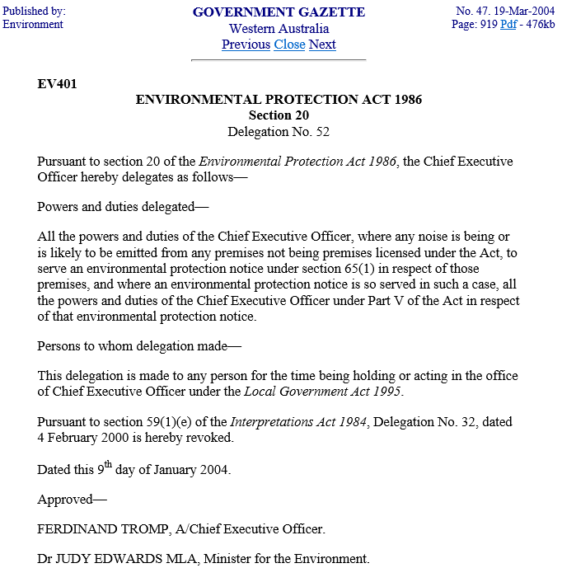

11.1.2 Noise Management Plans – Keeping Log Books, Noise Control Notices, Calibration and Approval of Non-Complying Events

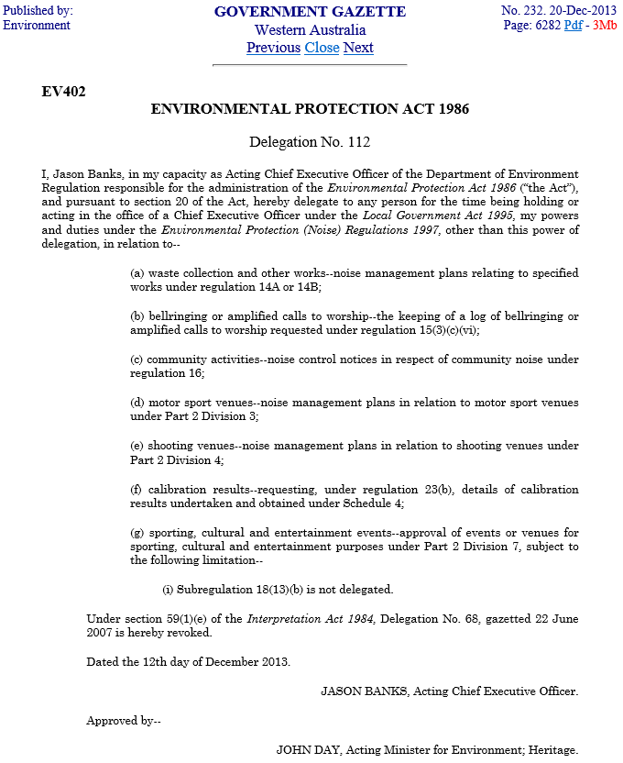

11.1.3 Noise Management Plans - Construction Sites

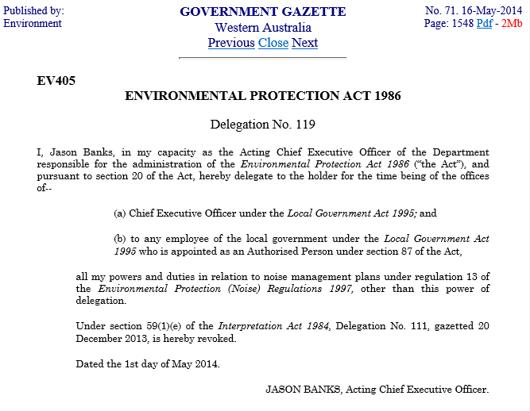

Planning and Development Act 2005

11.2.1 Instrument of Authorisation – Sign Development Applications for Crown Land as Owner

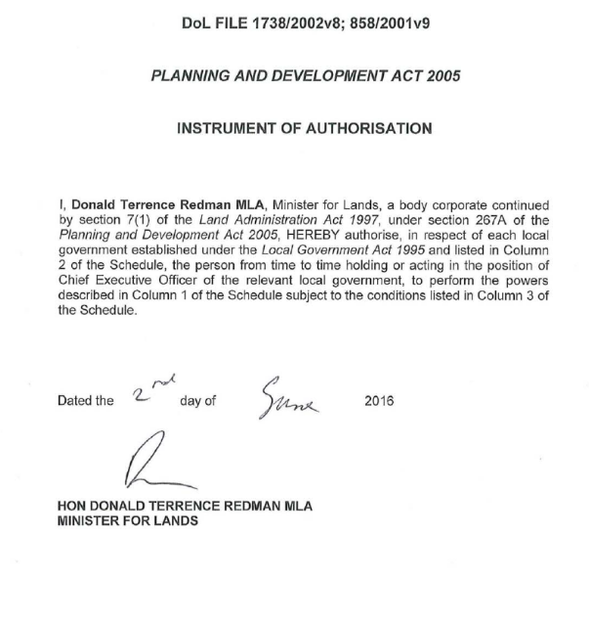

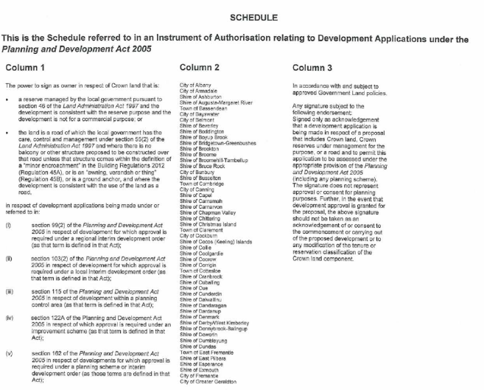



11.2.2 Delegation of Certain Powers and Functions of the WAPC relating to the MRS

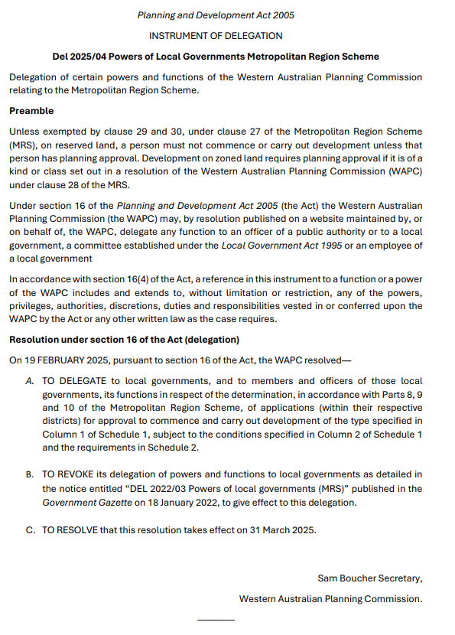
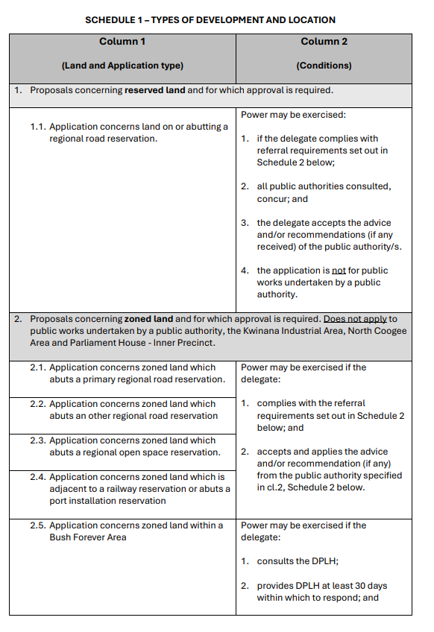
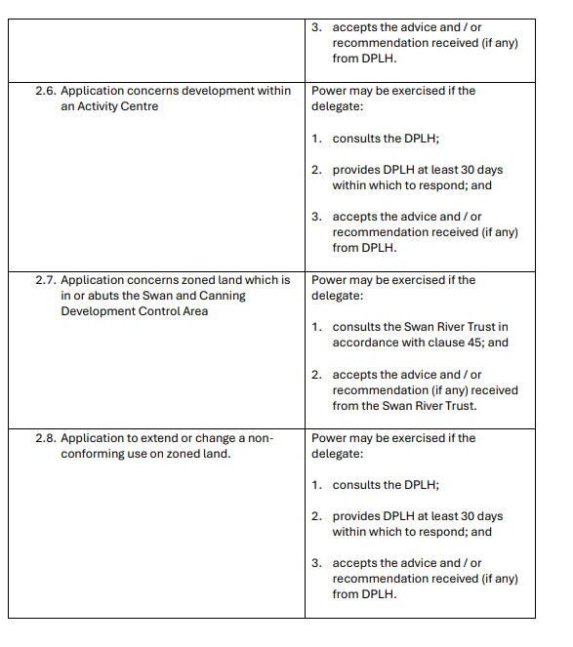
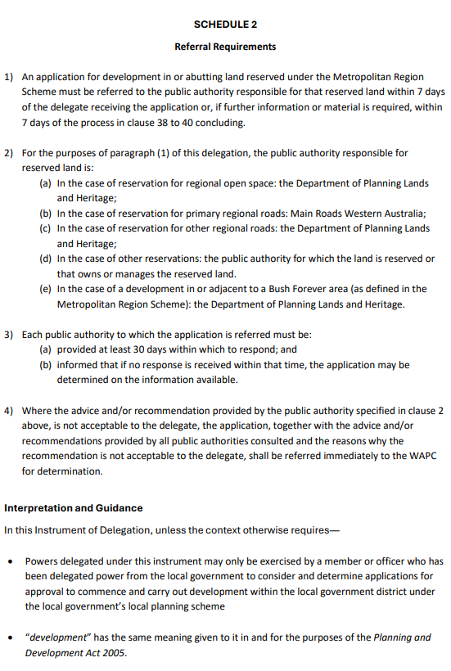

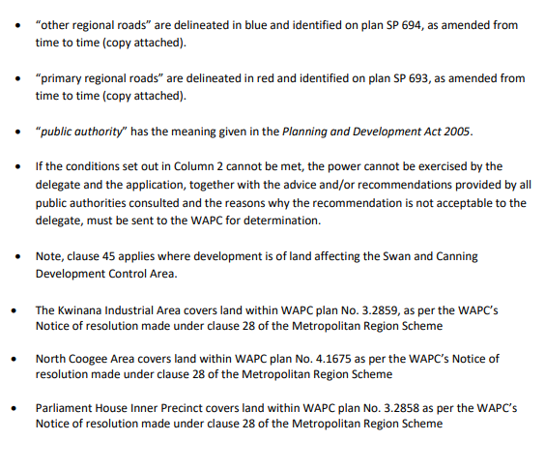

11.2.3 Delegation of Certain Powers under Section 25 of the Strata Titles Act 1985

This delegation needs to be read in conjunction with the amendment to the delegation reproduced on the following page (PL402)

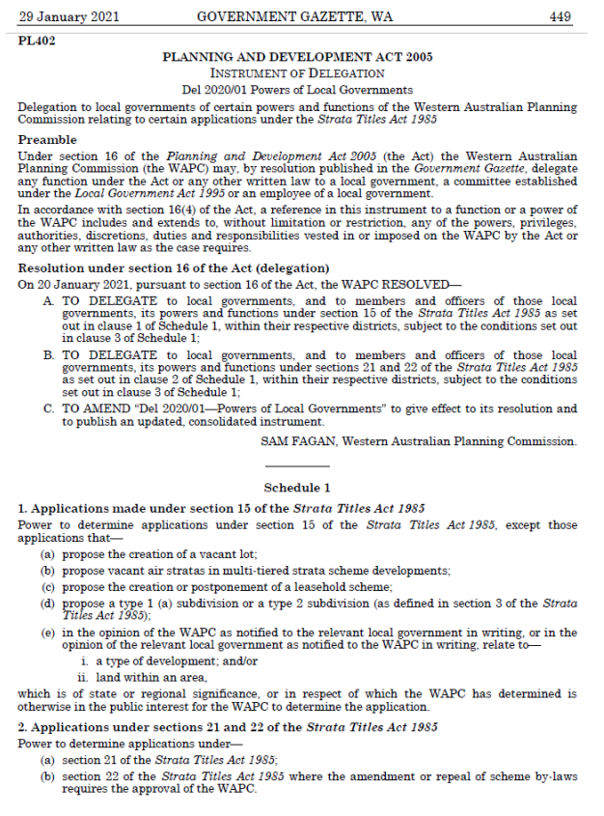
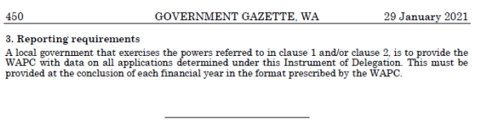

AMENDMENT TO DEL 2020/21

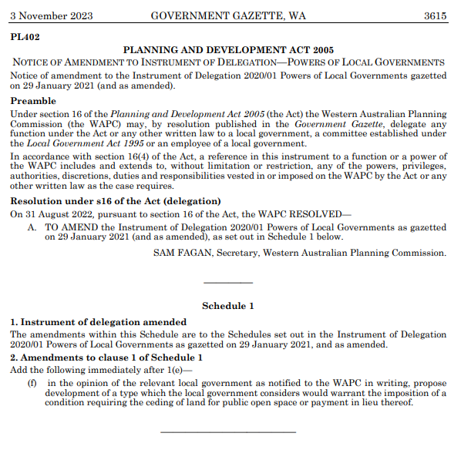

11.2.4 – Delegation of Certain Powers and Functions of the WAPC relating to the Hope Valley-Wattleup Redevelopment Act 2000 and the Hope Valley-Wattleup Mater Plan

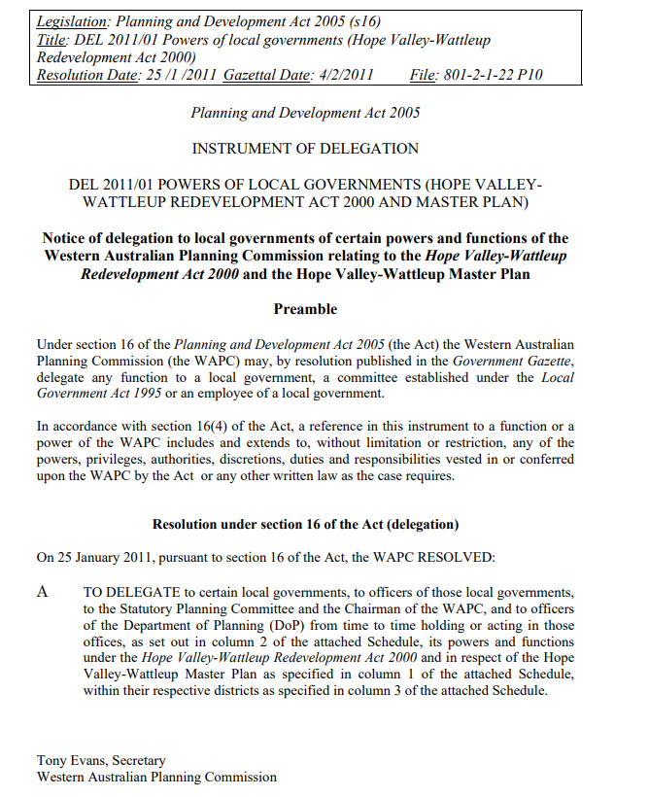
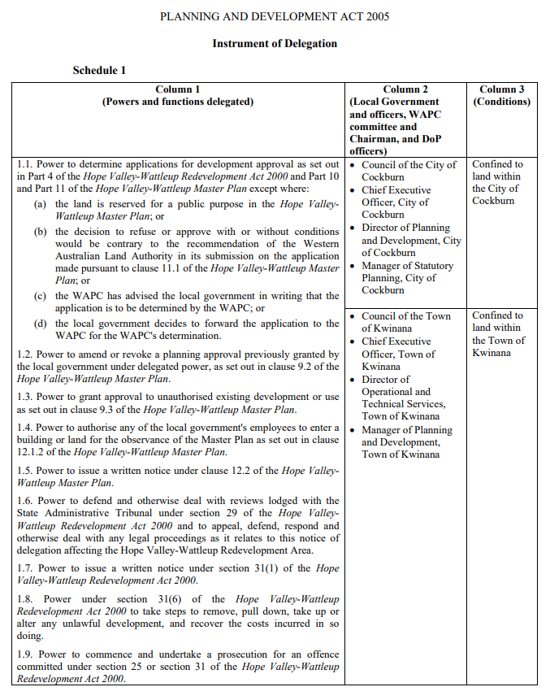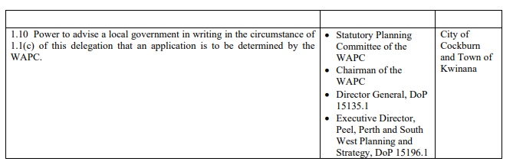

Main Roads Act 1930

11.3.1 Regulation of Parking on Verges of Main Roads, Highways and Footpaths

This direction needs to be read in conjunction with the clarification from WALGA reproduced on page 192.

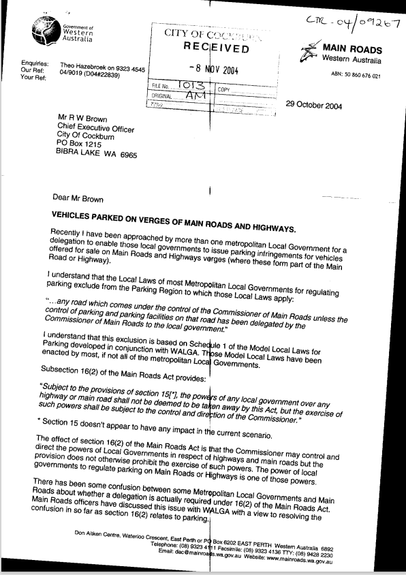

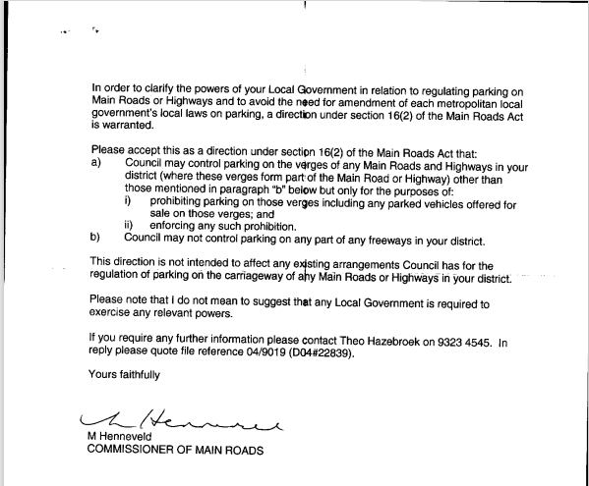

CLARIFICATION OF DIRECTION

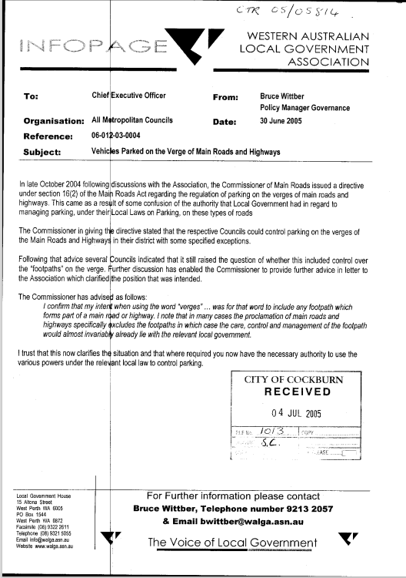

Road Traffic Code 2000

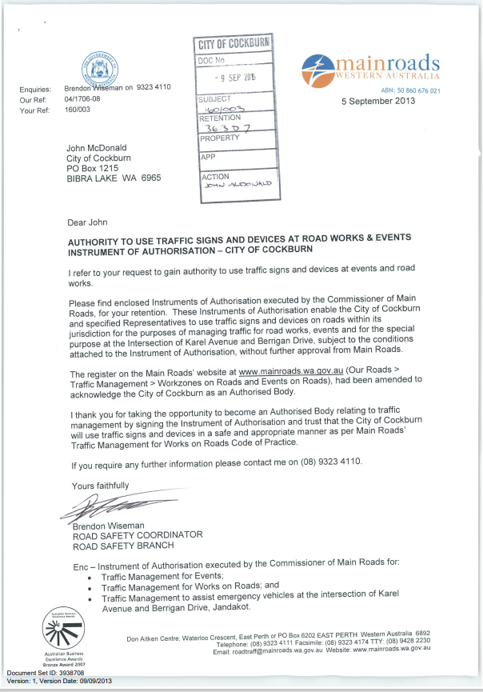

11.4.1 Authority to Use Traffic Signs and Devices at Roadworks

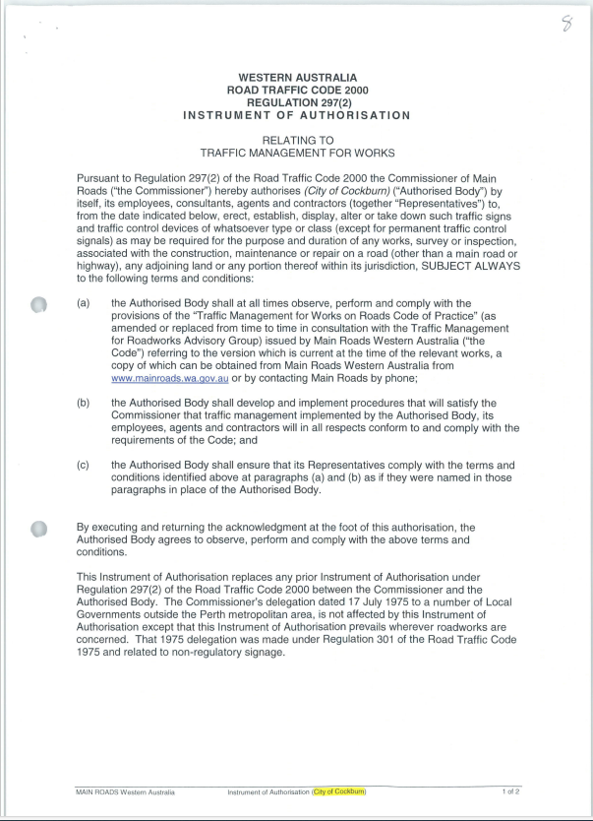
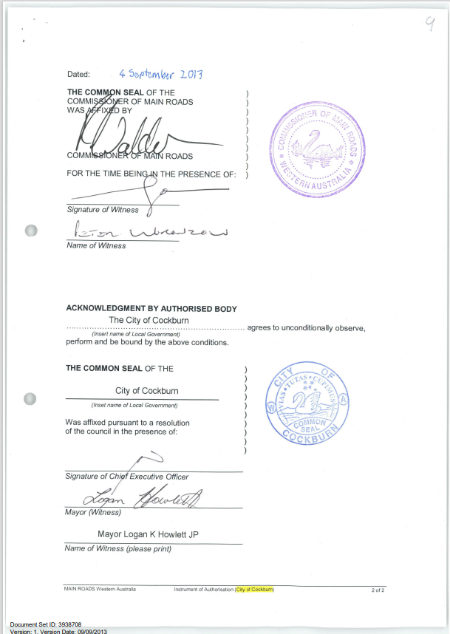

11.4.2 Authority to Use Traffic Signs and Devices at Events

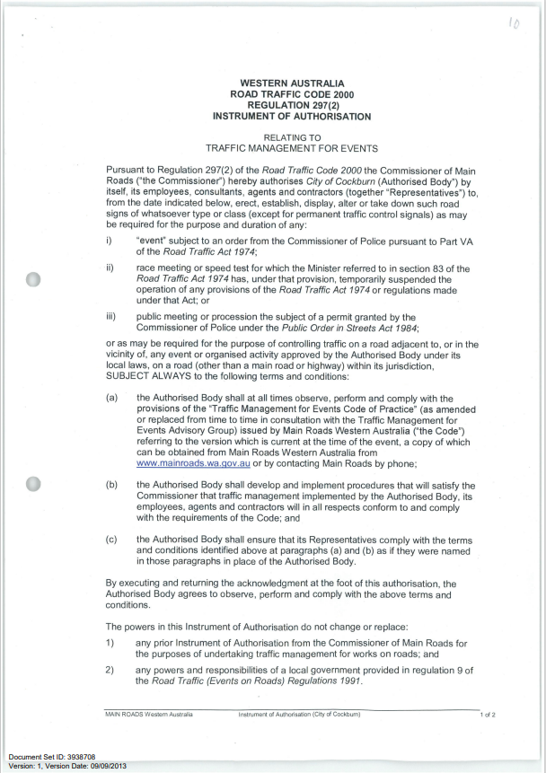
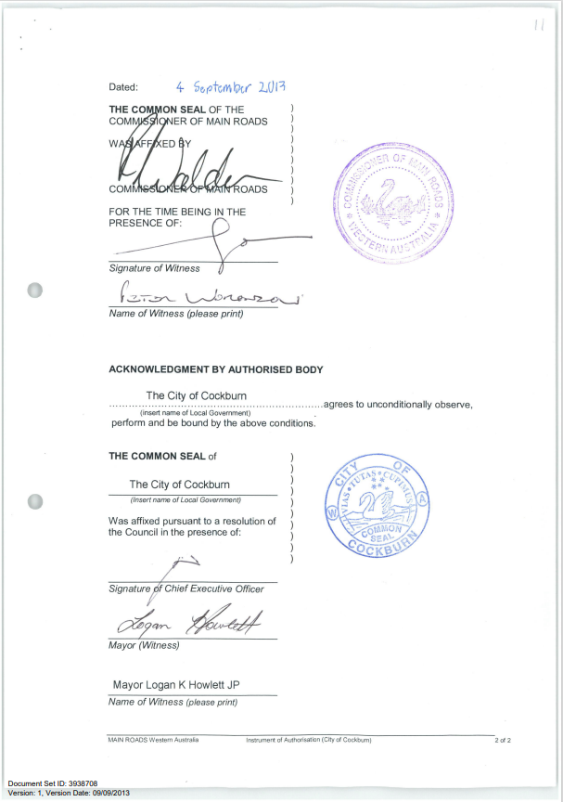

11.4.3 Authority to Use Traffic Signs and Devices to Assist Emergency Vehicles at the Intersection of Karel Avenue and Berrigan Drive, Jandakot

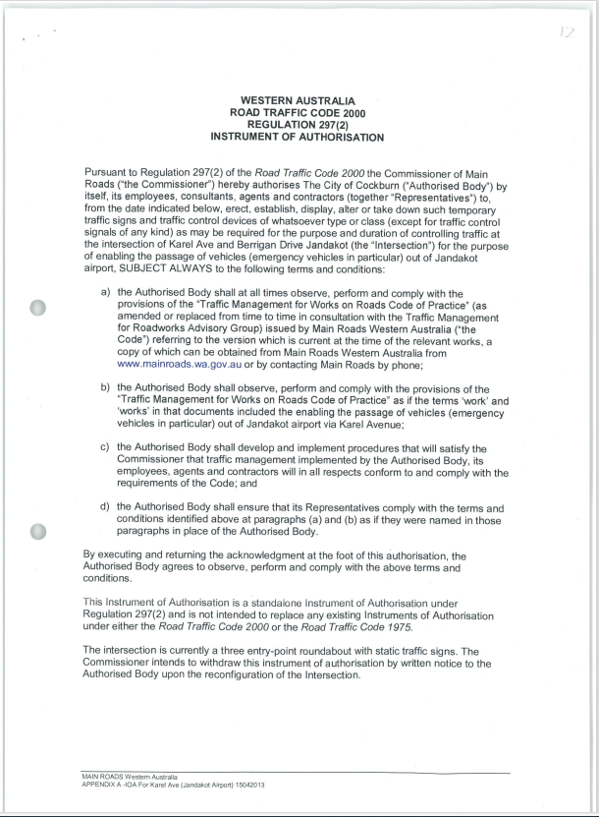
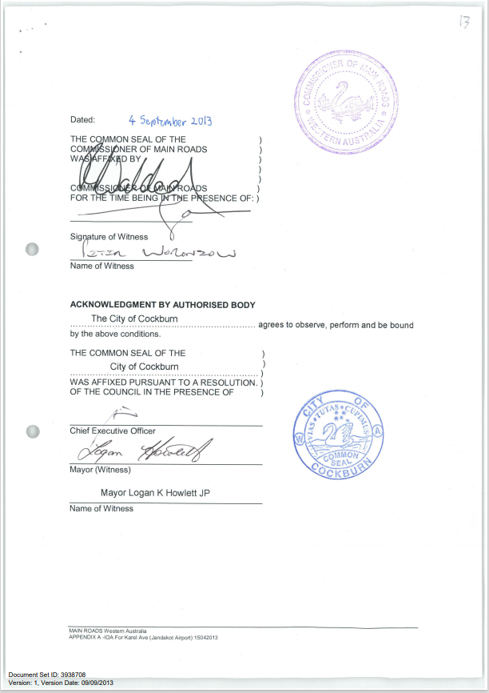

11.4.4 Approval to Display Yellow Flashing Warning Lights on Ranger Vehicles

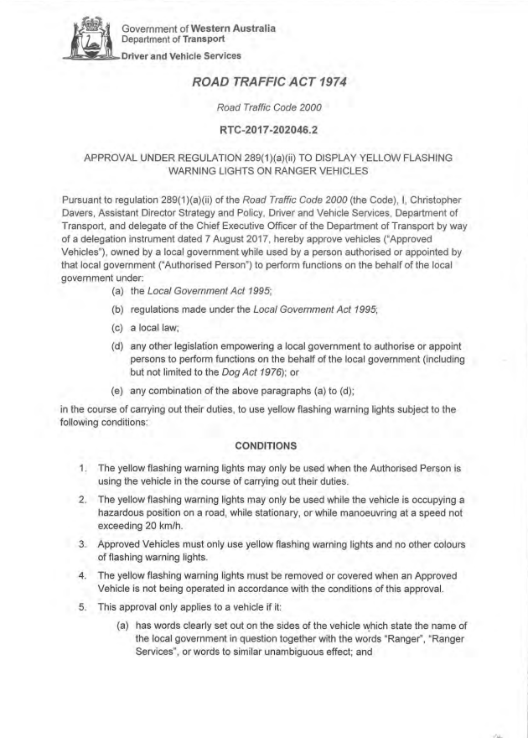
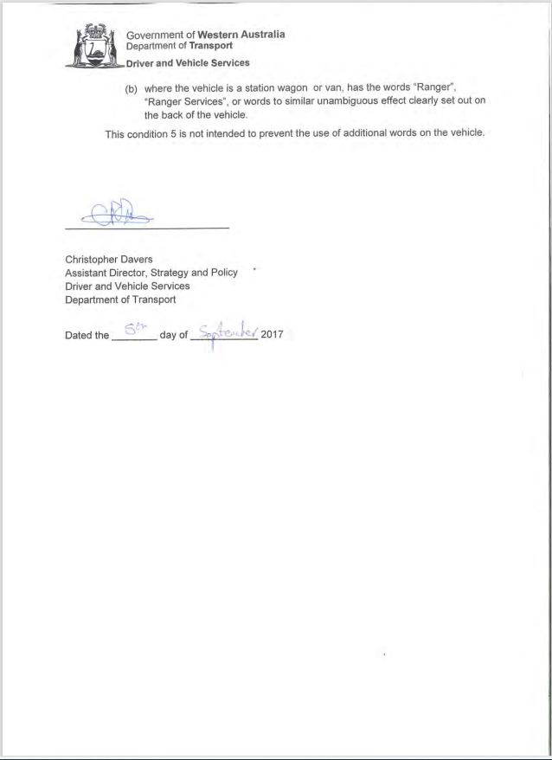

Road Traffic (Vehicles) Act 2012

11.5.1 Approval for Certain Local Government Vehicles as Special Use Vehicles

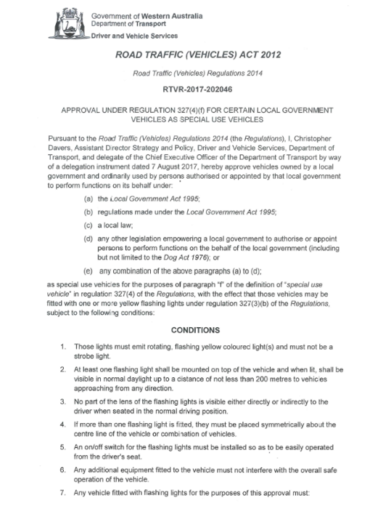
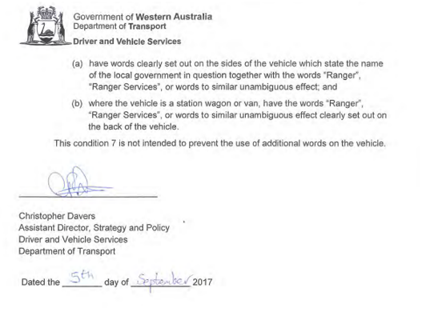

12 Policy Delegations

12.1 Council to CEO
These are non-statutory delegations but are included to address City of Cockburn Policies that make reference to delegated authority for decision-making under the Policy.

12.1.1 Community Funding to Support Local Economic Development

Delegator: |  | Council
Policy: |  | Community Funding to Support Local Economic Development
Delegate: |  | Chief Executive Officer
Function:  This is a precis only. Delegates must act with full understanding of the legislation and conditions relevant to this delegation. |  | The authority to evaluate funding submissions in accordance with grant programs listed under policy ‘Community Funding to Support Local Economic Development’ and to manage and allocate funds to submissions compliant with this policy and respective guidelines.
Council Conditions on this Delegation: |  | To approve applications for the following grant programs:  1. Category A – Economic Development Grants
Sub-Delegate/s:  Appointed by CEO |  | Director Sustainable Development and Safety
CEO Conditions on this Sub-Delegation:
Conditions on the delegation also apply to sub-delegation.
Compliance Links:

Record Keeping:
1 | Modified 11 March 2025

12.1.2 Funding Assistance – Community Associations

Delegator: | Council
Policy: | Community Funding for Community Organisations and Individuals (Grants, Donations & Sponsorships)
Delegate: | Chief Executive Officer
Function:  This is a precis only. Delegates must act with full understanding of the legislation and conditions relevant to this delegation. | The authority to approve payment of funding and donations available in Council's Adopted Budget for Community Associations.
Council Conditions on this Delegation: | Funding for Community Associations will be considered under the following sub-categories as provided for in Council Policy ‘Community Funding for Community Organisations and Individuals (Grants, Donations & Sponsorships), Category G – Major and Minor Funding  - Publication and Distribution of Newsletters  - Cockburn Community Insurance Program  - Hire of Council Community Centres and Halls  - Resident Association Support
Sub-Delegate/s:  Appointed by CEO | Director Community and Place
CEO Conditions on this Sub-Delegation:
Conditions on the delegation also apply to sub-delegation.
Compliance Links:

Record Keeping:

12.1.3 Funding Assistance for Community Organisations and Individuals

Delegator: | Council
Policy: | Community Funding for Community Organisations and Individuals (Grants, Donations & Sponsorships)
Delegate: | Chief Executive Officer
Function:  This is a precis only. Delegates must act with full understanding of the legislation and conditions relevant to this delegation. | The authority to allocate funds to projects, events or activities that best meet the Community Innovation and Participatory Budgeting, Grants, Small Events or Individual Sponsorships Program Criteria.
Council Conditions on this Delegation: | The following categories are to be used to prioritise the projects to be funded or considered for funding under the below Council funded programs: -  - As provided for in Council Policy ‘Community Funding for Community Organisations and Individuals (Grants, Donations & Sponsorships)’ for:  - Community Grants (Category A)  - Cultural Grants (Category B)  - Sustainability Grants (Category C)  - Small Events Sponsorship (Category D)  - Sponsorship Program (Individuals – Category F)  - Community Innovation and Participatory Budgeting (Category G)  - Elected Members are to be informed of the outcome of applications.
Sub-Delegate/s:  Appointed by CEO | Director Community and Place
CEO Conditions on this Sub-Delegation:
Conditions on the delegation also apply to sub-delegation
Compliance Links:

Record Keeping:

12.1.4 Funding for Community Organisations and Individuals (Grants, Donations & Sponsorships)

Revoked OCM 12 November 2024, 2024/MINUTE NO 0268

12.1.5 Funding Assistance for Sporting Clubs and Individuals

Delegator: |  | Council
Policy: |  | Community Funding for Sporting Clubs and Individuals
Delegate: |  | Chief Executive Officer
Function:  This is a precis only. Delegates must act with full understanding of the legislation and conditions relevant to this delegation. |  | The authority to determine applications for funding under and in accordance with the Community Funding for Sporting Clubs and Individuals Policy..
Council Conditions on this Delegation: |  | Funding for Sporting Clubs and Individuals must be considered under the following selection criteria as provided for in the Policy:  - Major Capital Works Grant  - Minor Capital Works Grant  - Sports Equipment Grant  - Junior Sports Travel Assistance  Applicants must be able to demonstrate compliance with any relevant eligibility or additional criteria.  The CEO may only award grants up to the maximum amount provided for in the Policy, and if the application is made by the relevant closing date (if any).
Sub-Delegate/s:  Appointed by CEO |  | Director Community and Place
CEO Conditions on this Sub-Delegation:
Conditions on the delegation also apply to sub-delegation.
Compliance Links:

Record Keeping:
1 | Adopted 12 May 2026.

12.2 CEO to Employees
These are non-statutory delegations but are included to address City of Cockburn Policies that make reference to delegated authority for decision-making under the Policy.

12.2.1 Elected Member Reimbursement Requests

Delegator: |  | CEO
Policy: |  | Elected Member Entitlements
Delegate: |  | General Counsel  Service Lead Governance and Council Support
Function:  This is a precis only. Delegates must act with full understanding of the legislation and conditions relevant to this delegation. |  | Authority to approve reimbursement for Elected Member expenses, in line with the Elected Member Entitlements Policy [cl.10.1]
CEO Conditions on this Delegation: |  | Expenditure does not exceed the budget allocation for the current financial year in the adopted Annual Budget.
Compliance Links: |  | Local Government Act 1995 – Division 8 and 10, Part 5  Local Government (Functions and General) Regulations 1996 – Part 8
Record Keeping: |  | Details of decisions are to be recorded in the City’s record keeping system.
1 | Adopted 18 December 2025.

12.2.2 Elected Member Professional Development Applications

Delegator: |  | CEO
Policy: |  | Elected Member Professional Development
Delegate: |  | General Counsel  Service Lead Governance and Council Support
Function:  This is a precis only. Delegates must act with full understanding of the legislation and conditions relevant to this delegation. |  | Authority to approve applications for Elected Member professional development or professional membership, in line with the Elected Member Professional Development Policy [cl.4.1]
CEO Conditions on this Delegation: |  | Expenditure does not exceed the budget allocation for the current financial year in the adopted Annual Budget.  Expenditure over $5,000 per single application/event (including travel costs etc.) is to be approved by the General Counsel.
Compliance Links: |  | Local Government Act 1995 – Division 10, Part 5  Local Government (Functions and General) Regulations 1996 – Part 10
Record Keeping: |  | Details of decisions are to be recorded in the City’s record keeping system.
1 | Adopted 18 December 2025.

12.2.3 Elected Member Approvals at Events

Delegator: |  | CEO
Policy: |  | Elected Member Attendance at Events
Delegate: |  | General Counsel  Service Lead Governance and Council Support
Function:  This is a precis only. Delegates must act with full understanding of the legislation and conditions relevant to this delegation. |  | Authority to approve Elected Member attendance at events which are not pre-approved under the Elected Member Attendance at Events Policy [cl.5.2.1]
CEO Conditions on this Delegation: |  | Nil.
Compliance Links: |  | Local Government Act 1995 – Division 6A, Part 5
Record Keeping: |  | Details of decisions are to be recorded in the City’s record keeping system.
1 | Adopted 18 December 2025.



