Policy Type

Local Planning Policy

Policy Purpose

This policy should be read in conjunction with the City of Cockburn’s Town Planning Scheme No. 3 (TPS 3), any of the City’s specific Design Guidelines and Signage Local Laws.
The purpose of this policy is to ensure that the display of signs and advertisements on properties does not adversely impact upon the amenity of the area while providing appropriate exposure of activities or services. The objectives of the policy are:
- To ensure that signage and advertising does not detract from the streetscape or amenity of the area.
- To avoid the proliferation of signage in commercial areas.
- To avoid an abundance of signs on individual sites and buildings.
- To ensure that signs only relate to the services and products on the site.
- To encourage the rationalisation of advertising signs on individual premises.
- To encourage the incorporation of advertising signs into the design consideration of buildings.

Policy Statement

(1) Application

- This policy applies to all advertisements as defined within Planning and Development (Local Planning Schemes) Regulations 2015. All references here within to the words ‘sign’ or ‘signage’ shall also be read as advertisement.

- In accordance with Clause 61 of the Planning and Development (Local Planning Schemes) Regulations 2015, development approval is not required where signage meets all of the following:
  - Meets the criteria of the ‘General Development Provisions’ in Part (2) below;
  - Meets the definition and provisions of the ‘Permissible Signs and Standards’ table in Part (3) below;
  - Is not erected or installed within 1.5m of any part of a crossover or street truncation;
  - Is erected within the boundaries of a freehold lot;
  - Is not proposed on land reserved (partially or wholly) under the MRS;
  - The works are not located within a heritage-protected place.
- Where signage does not meet the criteria set out in Part 1b above, development approval is required. Development applications shall be determined in accordance with clause 67 of Planning and Development (Local Planning Schemes) Regulations 2015.

- Development approval is required for all signage which meets the expectations of the table ‘Signage that Requires Development Approval’ in Part (4) below. The ‘expectations’ column of the table provides guidance on what the City would generally accept in relation to each type of sign, however an assessment against clause 67 of the Planning and Development (Local Planning Schemes) Regulations 2015 is still required.

- Where assessing an application for development approval the City may, at its discretion, request the provision of a Signage Strategy detailing how signage is to be integrated into the overall development on the site.

- Where a property is subject to specific Design Guidelines which contain provisions inconsistent with this policy, the Design Guidelines shall prevail.

- Signs proposed on land reserved (partially or wholly) under the MRS shall be referred to the relevant Public Authority in accordance with the relevant WAPC Instrument of Delegation.

- The maximum signage area contained in the policy refers to an aggregate of signage.

- General Development Provisions

- All Signs shall:
- Not pose a threat to public safety or health.
- Only relate to services and products on the subject site.
- Not consist of inappropriate or offensive language or material.
- Not protrude over Council property, including footpaths (unless allowed under a verandah or attached to a fascia) or neighbour’s property.
- Be in accordance with the requirements of Australian Standard AS 4282 - 2019 "Control of the Obtrusive Effects of Outdoor Lighting";
- Not comprise flashing, intermittent or running lights;
- Have any boxing or casing in which it is enclosed, constructed of incombustible material;
- Have its electrical installation constructed and maintained to the satisfaction of Western Power Corporation or the appropriate electricity supply authority and in accordance with the S.A.A. Code 3000-1991;
- Be maintained to operate as an illuminated sign where proposed as such.

- Standards

 | Sign Type | Definition | Provisions
1. | Awning Sign (Below) | A sign fixed to or suspended from the underside of a verandah, balcony or awning. | - Maximum size of 6m².  - Minimum headway/clearance of 2.75m.
2. | Construction Sign | A sign which is displayed for the duration of the construction period which displays the project or contractors details relating to the site. | - Maximum size of 6m² for single/grouped dwellings.  - Maximum size of 12m² for multiple dwellings, commercial development not within centre zoned land and industrial development.  - Maximum size of 20m² for centre zoned development.  - In place for the duration of construction/development works only.
3. | Fence Sign | Any sign attached to a fence. | - Maximum size of 6m² per street frontage.  - Maximum of one sign per street frontage on any one lot.
 | 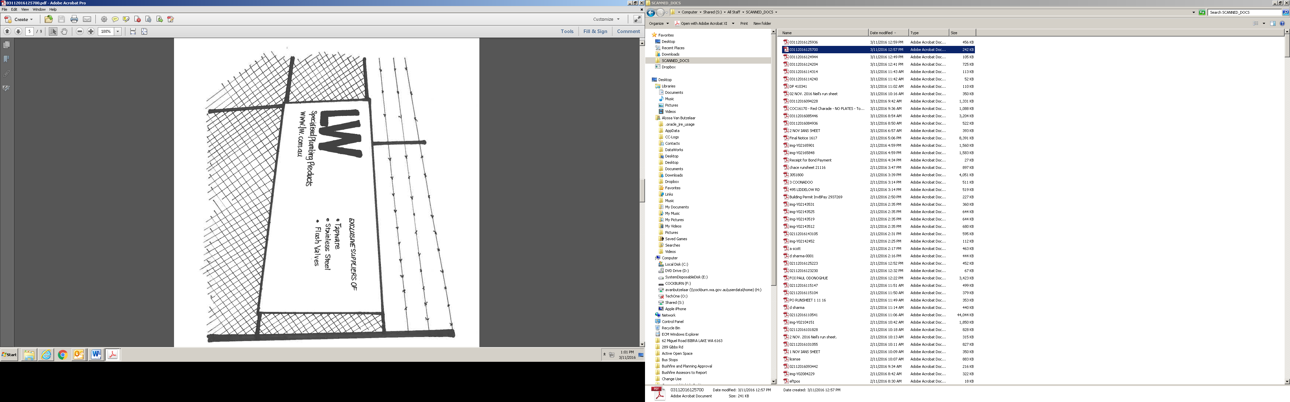 | Any sign attached to a fence.
4. | Ground Based Sign | A sign which is not attached or otherwise affixed to a building and no portion of which is higher than 1.2m above natural ground level. | - Maximum size of 6m².  - Maximum of one sign per tenancy on a lot.  - Where incorporated in a barrier that distinguishes an outdoor dining area, clause b above is varied to allow up to three signs per tenancy on a lot.
 | 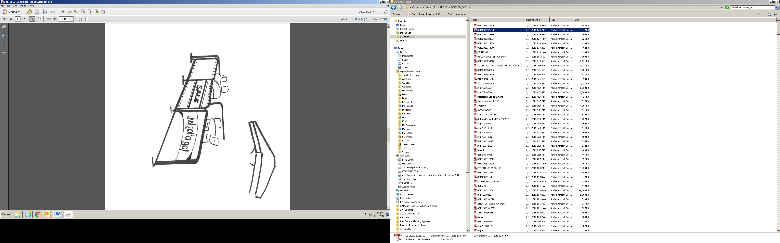
5. | Projecting Sign | A sign which projects from a wall of the building below the eaves or ceiling height. | - Maximum size of 6m².  - Minimum headway/clearance of 2.75m.  - Shall not project more than 1m from the wall.
6. | Pylon Sign | A sign supported by one or more piers and not attached to a building. | - Maximum size of 6m² per street frontage.  - Maximum height of 3m.  - On any one lot, maximum of one sign per frontage, or one sign per 100 metres of frontage; whichever is the greater.  - Setback a minimum distance of half its own overall height to the front property boundary.  - Setback 6m from any other sign erected on the same lot.
7. | Real Estate Sign | A sign advertising the display, sale or lease of the property. | - Maximum size of 6m².  - Limited to one sign per lot.
8. | Residential Property Sign | A sign affixed to, or located on, a Residential property, and includes signs relating to Home Occupations and approved Home Businesses. | - Maximum size of 0.2m².  - Maximum height of 0.5m where the sign is a single line of letters fixed to the facade of a building.  - Only used for the purpose of identifying the name of the dwelling and/or nature of a Home Occupation or approved Home Business operating from the dwelling.
 | 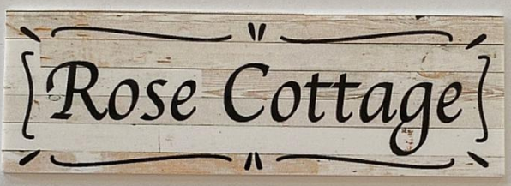
9. | Roof Sign | A sign which is affixed to the facia or parapet, or forms part of a projection above the eaves of the building. | - Maximum size of 6m².  - Not located within 0.5m of either end of the external walls of the building.
 | 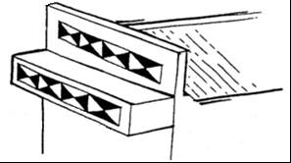
10. | Safety/Warning Signs | A sign which displays safety or warning messages relating to a potential hazard on or around a site. | - Necessary to comply with occupational, health and safety requirements.
 | 
11. | Temporary Signs (for events) | A sign which advertises an upcoming event. | - Maximum size of 6m².  - Exhibited up to a maximum of four (4) weeks prior to the event advertised and removed by the end of the day following the event.
 | 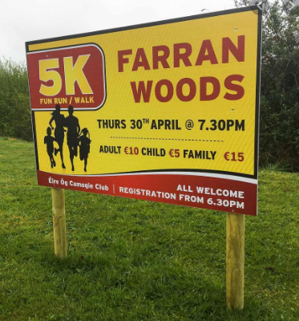 | A sign which advertises an upcoming event.
12. | Variable Message Sign | A sign which is permanent or portable and displays electronically generated variable messages. | - Used by public authorities for public purposes only.
 | 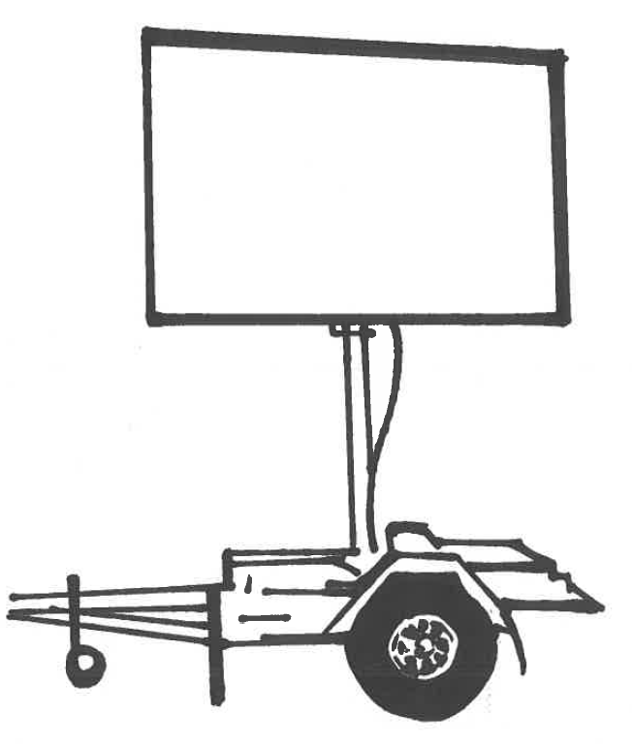 |  | - Used by public authorities for public purposes only.
13. | Wall Sign | A sign which is affixed to the external part of a wall of the building but does not project above the lowest point of the eaves or ceiling of the building. | - Maximum size of 6m².  - Not exceeding 10% in area on any one wall.  Note: If the background colour of the sign matches the balance of the colour of the wall on which it is located, then the area of the sign shall be determined by measuring around the words of the sign.
 | 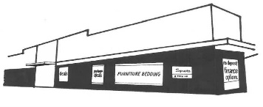
14. | Window Sign | Sign which is affixed to either the interior or exterior of the glazed area of a window. | - Maximum size of 6m².  - Not exceeding more than 25% of the overall area of glazing of the individual façade.  - Lettering shall not exceed 1m in height.
 | 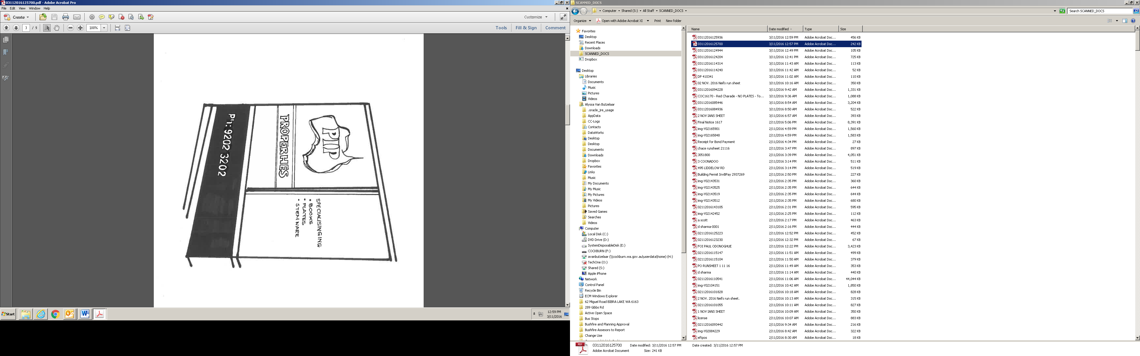

(4) Signage that Requires Development Approval

 | Sign Type | Definition | Expectations
1. | 3D Replica Model or Shape/Object | A three dimensional replica object or shape used as an advertising device and designated to replicate or copy a real world reject or shape. The replica may be freestanding or attached to a building or other sign. | - Maximum volume of 4m³.  - Maximum height of 5m.  - Must not be erected for more than 4 weeks in any 12 month period.
 | 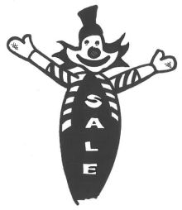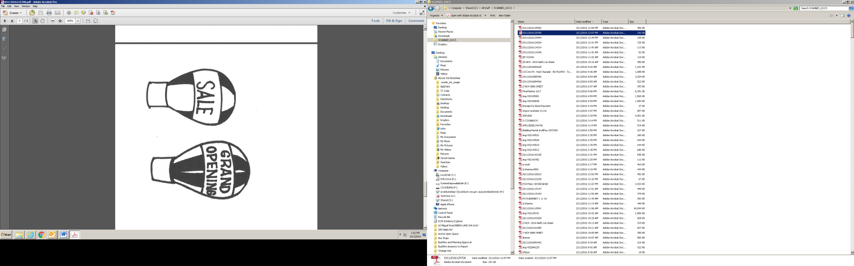
2. | Advisory Sign | A sign erected on land which has been approved for subdivision, advertising the lots for sale. | - Does not exceed 20m².  - One sign per subdivision.  - Shall be removed from the site within two years or when 80% of the lots in the subdivision have been sold, whichever comes first.  - A bond received by the City to cover any costs associated to the removal of Advisory signage (particularly where signage includes lighting and any water features).
 | 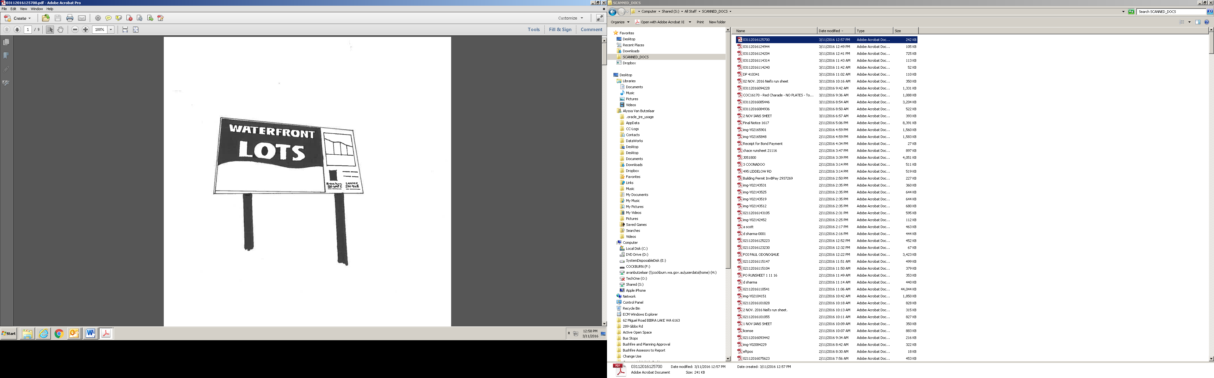
3. | Any sign on a Heritage Place | Any sign located in a heritage-protected place. | - Shall contribute to the significance of a Heritage Place and existing signs should be retained and maintained.  - Shall not dominate a Heritage Place. Instead, new signs should be placed where they would have traditionally been placed, and should be limited to a level consistent with traditional coverage.  - Shall not be located where they would obscure or detract from a feature of the building.  - Shall be located so as to ensure views to individually significant signs are maintained.  - Shall not result in physical damage to any significant fabric. Signage should be readily removable, with careful consideration given in regards to the method of installation, in order to ensure that the original material can be reinstated.  - If included on the State Heritage Register, shall be referred to the Heritage Council of Western Australia for comment.  - Shall not require reproduction of historic advertising styles. Rather, respectful but clearly modern design is preferred for new signs.  - Colours should be appropriate to the Heritage Place and in some instances which may require departure from standard company advertising colours.
4. | Awning Sign (Above) | A sign located above the outer fascia of a verandah, balcony or awning. | - Maximum area of 6m².  - Lettering shall not exceed 1m in height.
5. | Billboard Sign | A sign fixed to a free-standing structure that is not a building and has one or more supports. | - Billboard signs are generally not supported unless the City deems that the sign has a public/community purpose
 | 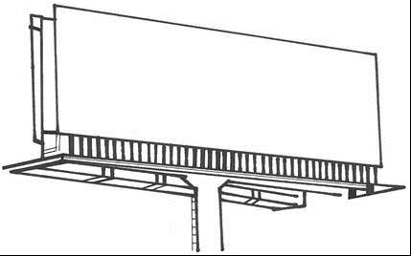
6. | Bunting/Flag/Tethered | A single or group of flags or material that may be freestanding or attached to a rope or line stretched between two or more points. | - Bunting, flags and tethered signs are generally not supported unless the City deems the sign has a public/community purpose
 | 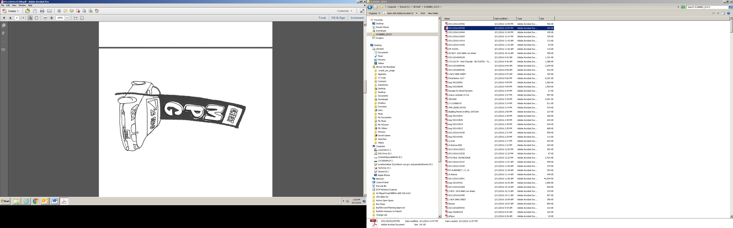
7. | Estate Entry Signage | A sign which serves to announce the entry to an estate or new residential development. | - Temporary only.  - A bond being received, where the estate entry signage is located on land vested to the Crown and/or the City, to cover any costs associated to the removal of the signage (particularly where signage includes lighting and any water features).
 | 
8. | Product Display Sign | An object which is displayed for the purposes of advertisement; or an advertisement sign which is attached to or placed on a vehicle (car, truck, boat, trailer, caravan, machinery, whether moveable or not). | - Product display signs are generally not supported within the City unless the sign has a public/community purpose.
 | 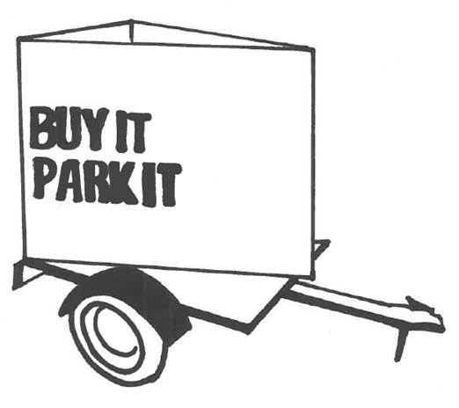
9. | Roof Sign (Above) | A sign erected on or attached to the roof of a building. | - Not permitted if there is a roof sign on the same lot.  - Shall not project higher than 2m above the roof or 50% of the height of the building to which it is attached (whichever is higher).
10. | Tower Sign | A sign affixed to, or placed on an open structural mast or tower. | - Maximum area of 6m².  - Where applicable a minimum headway/clearance of 2.75m.

Strategic Link: | Town Planning Scheme No. 3
Category | Planning - Town Planning & Development
Lead Business Unit: | Statutory Planning
Public Consultation:  (Yes or No) | Yes
Adoption Date:  (Governance Purpose Only) | 12 November 2024
Next Review Due:  (Governance Purpose Only) | November 2026
ECM Doc Set ID:  (Governance Purpose Only) | 4518397

