Street Walls and Fences (Including Dividing Fences)

Planning Information Sheet

WHAT IS A STREET WALL OR FENCE

A street wall or fence is considered to be a wall, screen or barrier that abuts a street boundary or is located in the primary street setback area (normally anywhere in front of a dwelling). This includes fencing on the side boundaries in the street setback area.

DO FRONT FENCES REQUIRE PLANNING APPROVAL?

Development approval for your street wall or fence is not required if it complies with the following (unless the site is a heritage protected area):
• Solid portions of street walls or fences are permitted to a maximum 1.2 m high;
• Portions of street walls or fences above 1.2 m must be visually permeable;
• The overall height of the street walls or fence must be a maximum of 1.8m high;
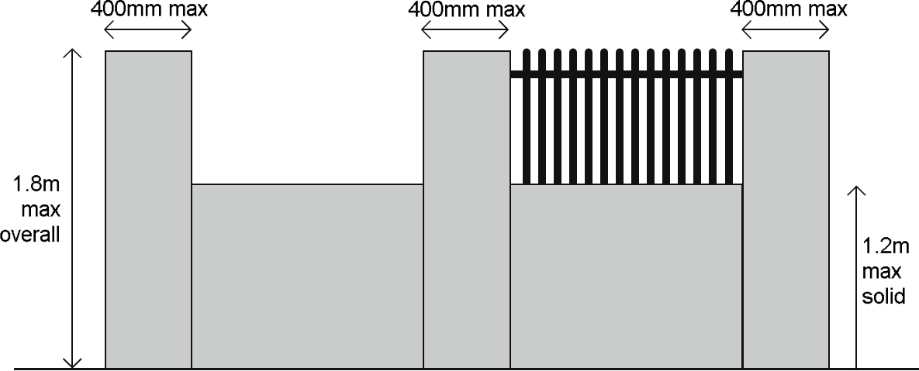
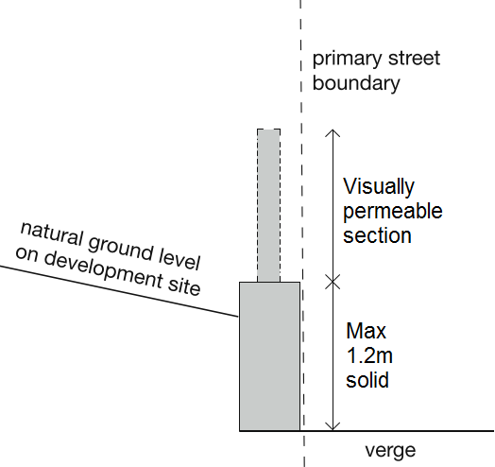
• The horizontal dimension of the pillars or piers may not exceed 400mm by 400mm.

Street walls and fences are assessed against the Residential Design Codes – Volume 1 (R-Codes) as shown above.

Street walls and fences should ensure that they do not intrude into vehicle sight line areas.

WHAT DOES VISUALLY PERMEABLE MEAN?

Visually permeable’ is defined by the Residential Design Codes – Volume 1 as:
In reference to a wall, gate, door, screen or fence that the vertical surface when viewed directly from the street or other public space has:
- continuous vertical or horizontal gaps of 50mm or greater width occupying not less than one third of the total surface area;
- continuous vertical or horizontal gaps less than 50mm in width, occupying at least one half of the total surface area in aggregate; or
- a surface offering equal or lesser obstruction to view.

Gap Sizes Based on Slat Sizes |  | Slat Sizes Based on Gap Sizes
Slats up to 50mm in size | Gap size equal to slat size or greater | Gap size less than 50mm | Slats would need to equal the gap size or be smaller
Slats between 51mm to up to 100mm in size | Gap size to 50mm or greater | Gap size of 50mm or greater  4m | Slats may be up to double the gap size or smaller
Slats above 100mm in size | Gap size equal to half the slat size or greater | Gap size of 50mm or greater  4m | Slats may be up to double the gap size or smaller

CAN I BUILD MY FENCE UP TO A DRIVEWAY?

Yes you can. However, vehicle sightline areas must be maintained where your driveway intersects with the property boundary.

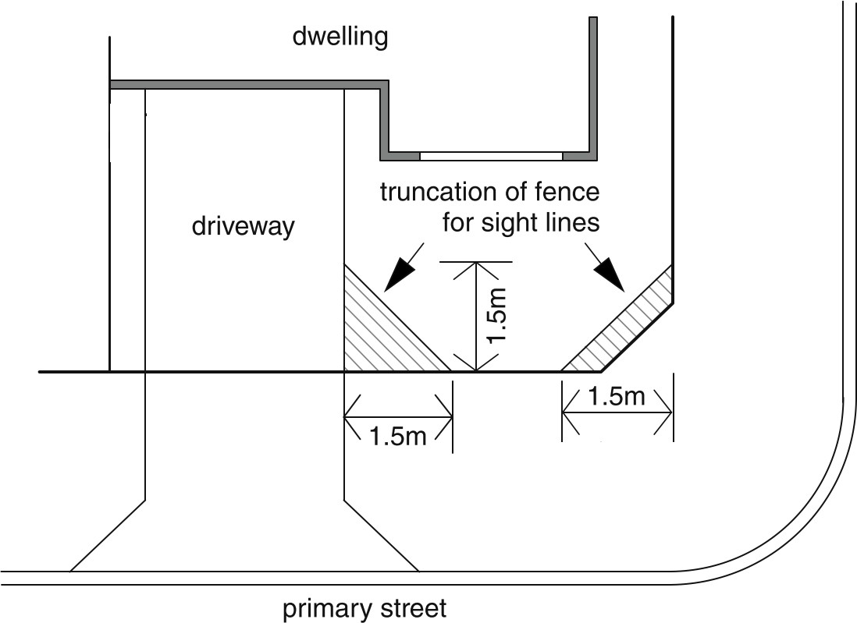
Street walls and fences can either be truncated so they do not protrude into the sightline area (shown hatched in the figure below). If the fence is proposed to be within the sightline areas, no part of the fence (including pillars or posts) may exceed 750mm in height.
CAN I HAVE A POOL FENCE IN THE STREET SETBACK AREA?

If a street wall or fence forms part of a Swimming Pool or Spa Safety Barrier (barrier), it must also comply with Australian Standard 1962.1-2012, the Building Act 2011, the Building Regulations 2012 as well as the planning requirements contained in this information sheet.

A Building Permit may be required for the barrier. More information can be found on the City’s website.

DO FENCES REQUIRE A BUILDING PERMIT

A building permit is required for any masonry street wall or fence. The City’s Building Team are happy to provide guidance if you require any assistance to lodge a Building Permit with the City.

DO THESE PLANNING CONTROLS APPLY TO WALLS AND FENCES ON THE SIDE BOUNDARY?

Walls and fences behind the street setback area and those on side and rear lot boundaries are not subject to these requirements. The Dividing Fences Act 1961 allows for matters related to dividing fences to be resolved as a civil matter between neighbouring owners. The Department of Building and Energy’s website explains the process to negotiate with your neighbour, agree on costs and settle disputes.

The City’s Fencing Local Law provides a definition of a “sufficient fence” for the purposes of the
Dividing Fences Act 1961.

WHAT IS THE DIFFERENCE BETWEEN A STREET WALL AND A DIVIDING FENCE

A dividing fence is usually a fence that separates two privately owned properties. It does not include a fence running along the boundary of a road and it does not include a retaining wall. A street wall or fence is a wall, screen or barrier that fronts a street boundary and is in the primary street area (normally anywhere in front of a dwelling). This includes fencing on the side boundaries in the street setback area.

WHAT IS A SUFFICIENT FENCE?

The Dividing Fences Act 1961 (the Act) defines a dividing fence as a fence that separates the lands of different owners. The Act enables local laws to be created which outline the minimum standards of a sufficient fence. The City’s Fencing Local Law is available on the City’s website and its requirements are designed to define a sufficient fence under the Act. Although the City has a Local Law which outlines the standards for a sufficient fence, disputes relating to dividing fences are a civil matter between two neighbours.

The Act provides a mechanism for courts to deal with disputes over dividing fences. In a civil court action, the Magistrate will also refer to the City’s Local Law to determine what is considered a sufficient fence.

FENCES ADJOINING CITY OWNED LAND

The Act does not apply to the government or to land used for public purposes, such as roads, rights-of- way, paths and reserves under the care and control of the Local Government. Therefore, if your property adjoins land used for public purposes, you are responsible to pay the full cost of the fence.

Some properties may be subject to a Local Development Plan (LDP) which may stipulate the specific style of fencing that must be maintained against government controlled land, particularly when the lots abut Public Open Space

I WANT TO BUILD A DIVIDING FENCE. WHAT ARE MY OBLIGATIONS?

The City encourages owners looking to construct a dividing fence to find out about their obligations and responsibilities, as defined in the Act, prior to construction. The Department of Mines, Industry, Regulation and Safety (DMIRS) provides information on their website relating to dividing fence matters. More information can be found on the DMIRS by clicking here.

The next step is to discuss your proposal with your neighbour.

Maintaining verbal communication with your neighbour during dividing fence discussions is advised as the most effective method of communication, with any agreements followed up in writing.

Dividing fences generally do not require planning approval.

I WANT TO BUILD A DIVIDING FENCE THAT IS HIGHER THAN A SUFFICINET FENCE

Any dividing fence more than 1.8 metres in height requires agreement with the adjoining neighbour and may require a building permit.

If you would like a dividing fence replaced completely by a different type of fence, you should give the adjoining owner a notice describing the kind and extent of the fence to be built.

You may be liable for the full cost of the new fence if the existing fence is in good condition. You may also require approval from the City under the Fencing Local Law to construct any non-sufficient fence.

WHAT CAN I DO REPAIR OR REPLACE AN EXISTING FENCE?

The Act provides for owners of land on either side of the fence to join in or contribute in equal proportions to the repair of the fence. This applies to both developed and vacant land.

The Act defines the word repair as including realign and re-erect, accordingly, the provisions which deal with repairing a dividing fence also apply in the same way to fences which need realignment or re- erection.

The replacement of an existing fence with an entirely different type of fence, for example replacing a damaged old asbestos fence with a new sheet metal one, is not a repair.

DISPUTES AND MEDIATION

The City does not administer the Dividing Fences Act 1961 and is therefore unable to direct property owners to construct or repair a dividing fence, or to determine how costs should be shared. These matters are considered private and are typically resolved between neighbours. If reaching agreement with your neighbour is proving difficult, you may wish to consider mediation. The City funds a mediation service available to all residents and ratepayers, delivered by the Citizens Advice Bureau.

This service can assist with resolving community disputes, including those related to dividing fences, in a constructive and neutral environment.

The Magistrates Court deals with applications by the owners of adjoining lands for the construction and repair of a dividing fence. Court may be an alternative if you have exhausted other alternatives, like speaking with your neighbour and formalised mediation, to resolve the dividing fence dispute.

