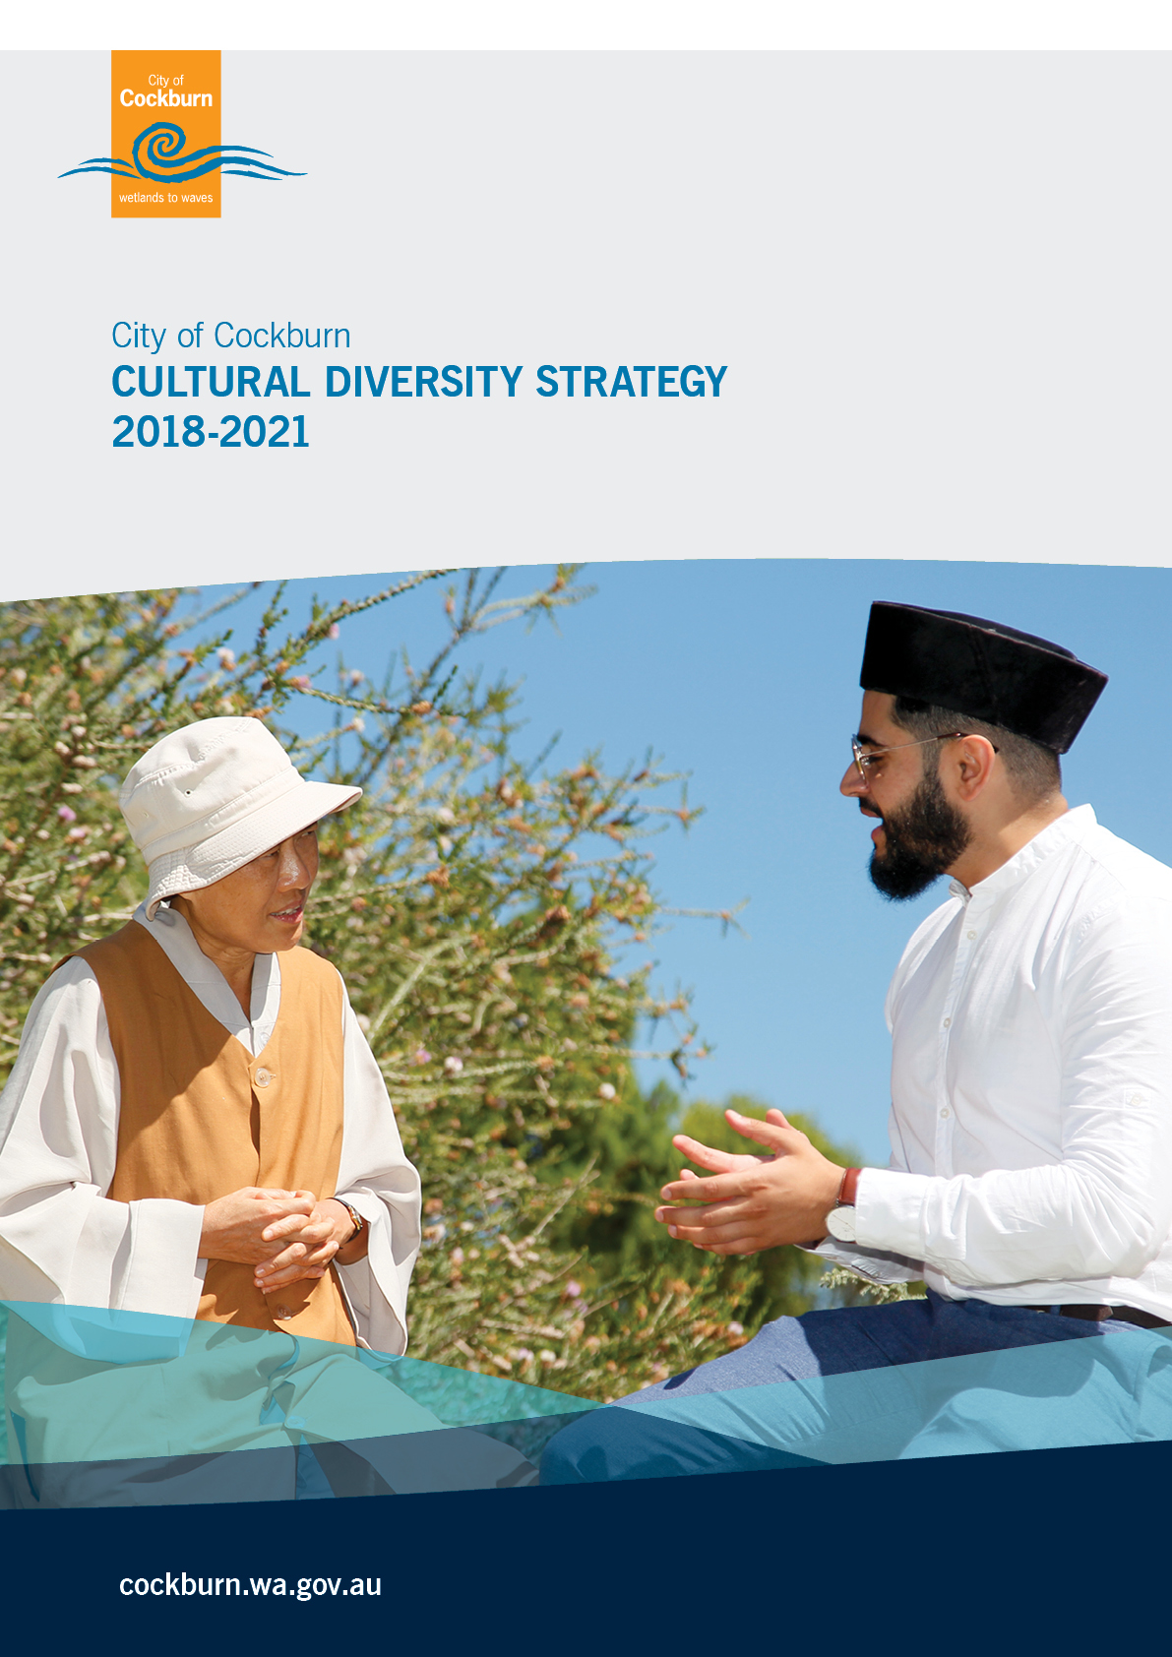

Table of Contents

1.0 Executive Summary 3

2.0 Key achievements 4

3.0 Methodology 4

4.0 Demographic information 5

4.1 Ancestry 6

4.2 Birthplace 6

4.3 Year of arrival 8

4.4 Language spoken at home 8

4.5 Non-English speaking background ancestry by suburb 9

4.6 Demographic Analysis 10

5.0 Links to the Strategic Community Plan 2016 – 2026 11

6.0 Current services and activities 12

7.0 Research and trends 16

7.1 Welcoming Cities 16

7.2 Office of Multicultural Interests 16

7.3 City of Hume – Local jobs for local people 17

7.4 Mapping Social Cohesion 18

7.5 Research and trend summary analysis 18

8.0 Consultation outcomes 19

8.1 Community survey 19

8.2 Consultations with culturally diverse groups 23

8.3 Consultations with City of Cockburn staff 24

8.4 Consultations with service providers 25

8.5 Consultation analysis 27

9.0 Vision, Outcomes, Strategies and Actions 28

10.0 Review process 45

11.0 References 45

APPENDIX A – Summary of consultations 46

APPENDIX B – General comments from the survey 48

# Executive Summary

This is the City Of Cockburn’s first Cultural Diversity strategy and reflects the aspirations of a growing and increasingly diverse community.

In 2016 the City of Cockburn has a diverse community with 34% of its residents born overseas. Historically, the City had significant populations of Italian, Croatian, German and Portuguese people while immigrants over the past five years have largely come from China, India and the Philippines. Currently in the City of Cockburn, 20% of residents come from countries where English is not their first language and 21% of people speak a language other than English at home. While many reported being fluent in English, 2.8% i.e. 3132 people reported some difficulty.

To inform the development of this strategy 618 people were consulted via a survey, focus groups and workshops. The resulting vision, six outcomes and 24 strategies have been developed to align with the Welcoming Cities framework. A total of 56 actions have been identified and ten of those have been highlighted for priority consideration.

The survey results indicated that connection to a cultural community, engagement with neighbours, and utilisation of local services and facilities enhanced a sense of inclusion. The lack of local employment, no access to information on services and facilities, and no immediate family in the area were barriers to inclusion. These themes were borne out in every consultation and emphasise the need for ***connection and information***.

Other more specific identified issues included the need for more English language classes and cultural language schools; greater access to venues and consideration of a multi-cultural hub; concern regarding the quality of education being delivered at local schools; and the need to address isolation of the elderly including those caring for grandchildren.

The Cultural Diversity Strategy aims to achieve the following outcomes:

* The City of Cockburn actively leads, advocates and promotes cultural diversity and inclusion.
* Ensure social and cultural inclusion by addressing and removing barriers which prevent equitable access to all City of Cockburn services, and promote social cohesion.
* Culturally diverse communities actively participate in the economic development of the City of Cockburn with equitable access to employment, business development and entrepreneurship opportunities.
* Ensure culturally diverse communities, City of Cockburn staff, and other relevant parties have access to learning and capacity building opportunities.
* Culturally diverse communities engage in all levels of civic activity within the City of Cockburn.
* The needs of culturally diverse communities are considered in the planning and delivery of recreational, social, learning and sports facilities as well as regional open spaces within the City of Cockburn.

# Key achievements

This is the first Cultural Diversity Strategy for the City of Cockburn. However the needs and contributions of culturally diverse communities have been recognised for some time and are demonstrated by the following City’s activities and achievements:

* Establishment of a fulltime Cultural Diversity Officer position
* Dedicated City of Cockburn website page focused on Cultural Diversity matters
* Translation of relevant information on the City of Cockburn website into four languages reflecting the four largest cultural groups i.e. Mandarin, Croatian, Italian and Portuguese
* Development of intercultural and interfaith relationships and understanding through the planning and delivery of shared events
* Community consultations and relationship-building with 10 cultural groups within Cockburn
* Establishment of a working relationship with the Office of Multicultural Interests
* Supporting opportunities for culturally-specific small businesses e.g. cultural food catering

# Methodology

A three-stage process was used to develop the Cultural Diversity Strategy 2018-22 as outlined below:

1. **Stage One:**

Desktop research and analysis of demographics; mapping of existing programs and services; and analysis of existing research and identification of trends

1. **Stage Two:**

Consultations undertaken with culturally diverse communities, the broader City of Cockburn community, relevant Government bodies, City of Cockburn staff and a broad range of service providers

**3. Stage Three:**

Development of a forward plan complete with strategies and actions to progress the vision of a City that provides awelcoming and inclusive environment where people of all backgrounds have a sense of belonging, feel valued and fully participate in social, cultural, civic, and economic life.

# Demographic information

The City of Cockburn is located approximately 20 kilometres south of the Perth CBD.

Australian Census 2016data1 reports that 104,473 people lived in the City and it was estimated that the resident population in 2017 had increased to 110,710.

The City of Cockburn is becomingly increasingly culturally diverse and this diversity has intensified over the past five years. Some of the key features of these demographic trends are summarized in Table 1.

***Table 1 – Key features of City of Cockburn demographics***

|  |
| --- |
| Key features of City of Cockburn 2016 Census data1 |
| * The ten largest ancestries in the City of Cockburn in 2016 were English (34.1%), Australian (28.7%), Italian (8.8%), Irish (8.4%), Scottish (8.3%), Chinese (5.3%), Croatian (2.8%), Indian (2.7%), German (2.7%) and Portuguese (2.6%) |
| * 34% of people living in the City of Cockburn were born overseas and 22% arrived in Australia within the 5 year period 2011 to 2016 |
| * 20% of residents in the City of Cockburn came from countries where English was not their first language |
| * 2.8% of the population reported difficulty speaking English |
| * 21% of residents spoke a language other than English in the home |

## 4.1 Ancestry

Ancestry defines the cultural association and ethnic background of an individual going back three generations. Ancestry is a good measure of the total size of cultural groups in the City of Cockburn regardless of where they were born or what language they speak.

It is interesting to note that six of the top ten ancestries in the City of Cockburn do not have English as their first language. The major difference between ancestries in the City of Cockburn and Greater Perth was a slightly larger percentage of people with Italian, Portuguese and Croatian in Cockburn and a slightly lower percentage of people with English ancestry.

Ancestry in the City of Cockburn in 2016 is summarized in Table 2 below.

***Table 2 – Ancestry in the City of Cockburn, 2016***

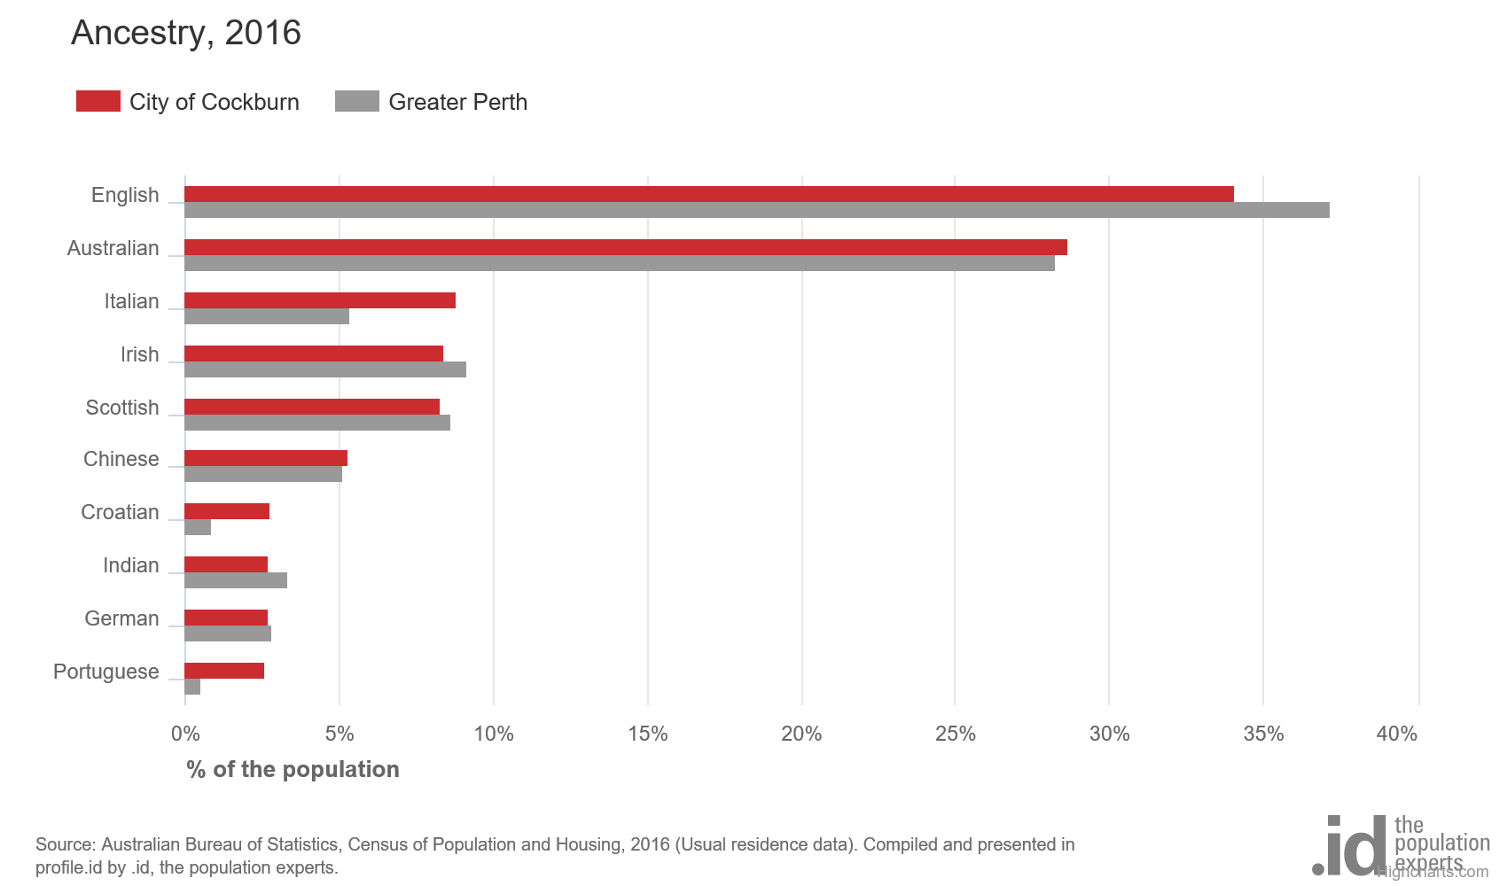

## 4.2 Birthplace

Country of birth data identifies where people were born and is indicative of the level of cultural diversity in the City of Cockburn. The mix of country of birth is also indicative of historical settlement patterns as source countries for Australia's immigration program have varied significantly over time. Historically many immigrants came from the UK, Italy, Croatia and Portugal while more recent source countries have included China, India and the Philippines.

Country of birth data in the City of Cockburn compared to greater Perth shows a smaller proportion of people born overseas and a slightly higher proportion of people from a non-English speaking background.

Overall, 34.1% of the population was born overseas and 20% were from a non-English speaking background compared with 36.1% and 19.3% respectively for greater Perth.

The largest non-English speaking country of birth in the City of Cockburn was the Philippines, where 2.3% of the population i.e. 2,408 people were born.

Between 2011 and 2016, the number of people born overseas increased by 6634 (22.8%), and the number of people from a non-English speaking background increased by 4,809 (30.2%).

The largest changes in birthplace countries of the population in this area between 2011 and 2016 were for those born in:

* The Philippines (+1,073 persons)
* India (+834 persons)
* United Kingdom (+773 persons)
* China (+732 persons)

Birthplace in the City of Cockburn in 2016 is summarized in table 3 below

***Table 3 – Birthplace in the City of Cockburn, 2016***

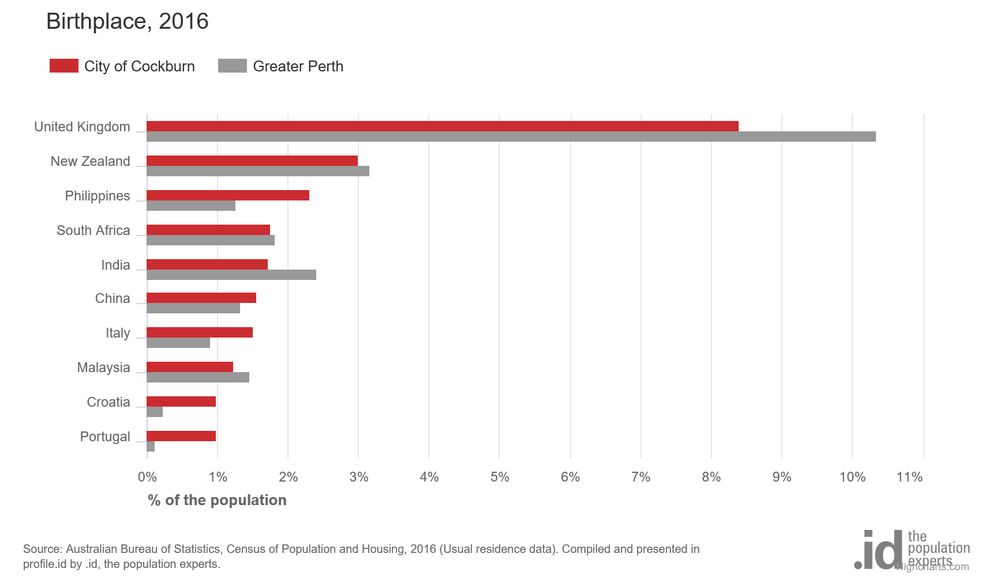

## 4.3 Year of arrival

The Year of Arrival data records when the overseas born population arrived in Australia. The number of recent overseas arrivals is often determined by a combination of housing affordability, employment opportunities and pre-existing communities located in the area.

It is interesting to note that the percentage of people born overseas has been somewhat constant since 1960 but with a significant upward spike in numbers since 2006.

***Table 4 –Year of arrival in the City of Cockburn, 2016***

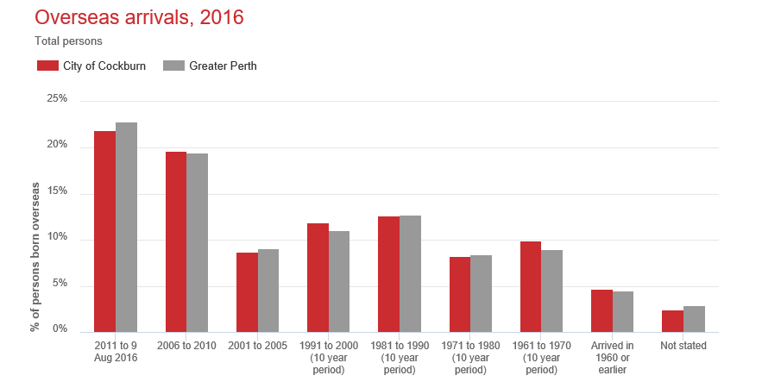

## 4.4 Language spoken at home

The City of Cockburn's language statistics show the proportion of the population who speak a language at home other than English. This indicates how culturally diverse a population is and the degree to which different ethnic groups and nationalities are retaining their language. In the City of Cockburn, 21% of people spoke a language other than English at home in 2016 with Mandarin, Italian and Filipino/Tagalog the largest language groups. According to Diversity Statistics report from the Office of Multicultural Interests, this statistics ranks the City of Cockburn the 6th most diverse City in Western Australia.

***Table 5 – Language spoken at home, 2016***

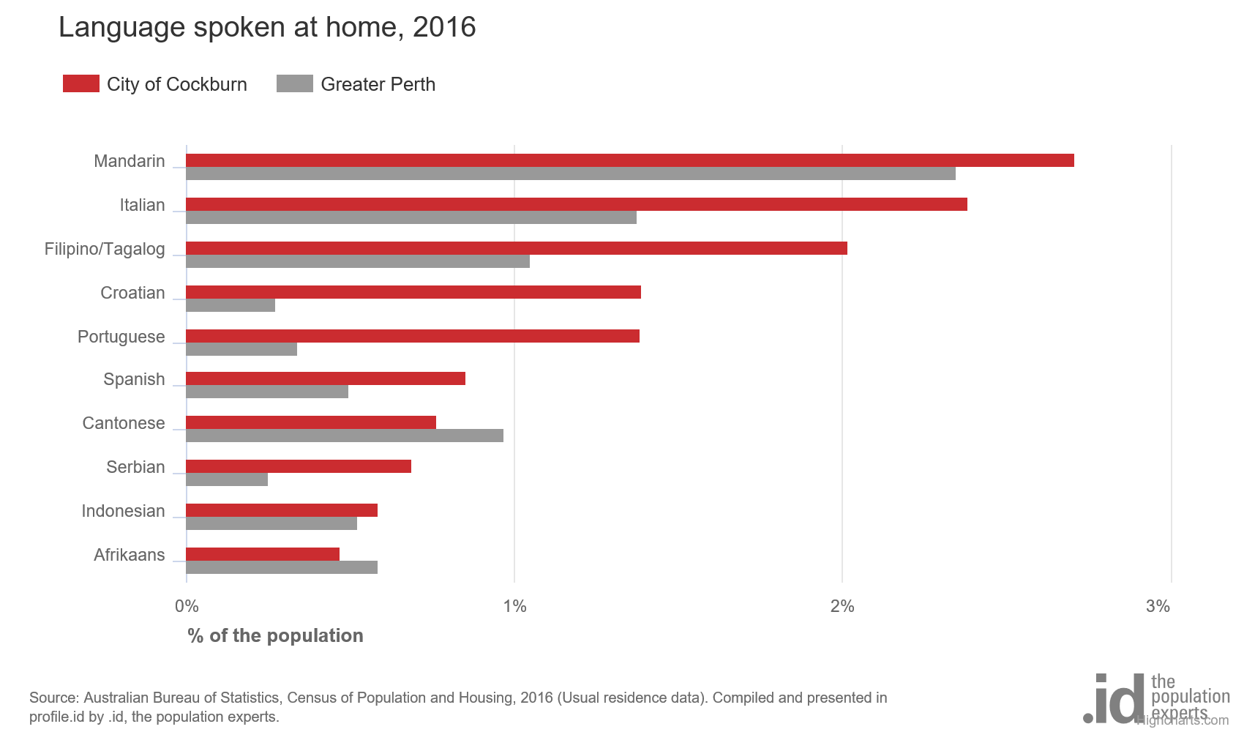

Data is collected on the self-assessed proficiency of spoken English for people who speak a language other than English at home. In 2016, 2.8% (3132) of City of Cockburn residents reported difficulty speaking English.

## 4.5 Non-English speaking background ancestry by suburb

Culturally diverse communities have settled in all suburbs across the City of Cockburn.

The more established cultural groupings e.g. Portuguese, Italian and Croatian communities have favoured suburbs including Munster, Spearwood and Yangebup.

The German community is evenly spread across the City with slightly higher numbers of people in North Lake and Hamilton Hill.

The Chinese community has higher concentrations in North Lake and Leeming while the Indian community has favoured Hammond Park, Wattleup-Henderson and Aubin Grove.

A summary of the six largest non-English speaking background ancestries by suburb within the City of Cockburn is outlined below. For ease of reporting, only the four most populated suburbs for each ancestry group have been included.

***Table 6 – Non-English speaking background ancestry by suburb***

|  |  |  |  |  |  |  |
| --- | --- | --- | --- | --- | --- | --- |
|  | ***Italian*** | ***Chinese*** | ***Croatian*** | ***Indian*** | ***German*** | ***Portuguese*** |
| ***Munster*** | 11% |  | 14% |  |  | 11% |
| ***Spearwood*** | 10% |  | 16% |  |  | 10% |
| ***Coogee/North Coogee*** | 10% |  | 12% |  |  |  |
| ***Bibra Lake*** | 9% |  |  |  | 6% |  |
| ***North Lake*** |  | 14% |  |  | 8% |  |
| ***Leeming*** |  | 14% |  |  |  |  |
| ***Success*** |  | 9% |  | 9% |  |  |
| ***Jandakot*** |  | 9% |  |  |  |  |
| ***Yangebup*** |  |  | 7% |  |  | 9% |
| ***Beeliar*** |  |  | 7% |  |  | 9% |
| ***Hammond Park/Wattleup-Henderson*** |  |  |  | 13% |  |  |
| ***Aubin Grove*** |  |  |  | 12% |  |  |
| ***Banjup*** |  |  |  | 10% |  |  |
| ***Hamilton Hill*** |  |  |  |  | 8% |  |
| ***Coolbellup*** |  |  |  |  | 7% |  |

## 4.6 Demographic Analysis

The City of Cockburn is becomingly increasingly culturally diverse with 34% of its residents born overseas. Historically the City of Cockburn had significant populations of Italian, Croatian, German and Portuguese people while immigrants over the past five years have largely come from China, India and the Philippines.

In the City of Cockburn, 20% of residents in the City of Cockburn came from countries where English was not their first language and 21% of people speak a language other than English at home. While many reported being fluent in English, 2.8% i.e. 3132 people reported some difficulty.

Munster and Spearwood are the most popular suburbs to live in for Italian, Croatian and Portuguese communities. North Lake and Leeming are the most popular for Chinese families and Hammond Park, Wattleup-Henderson and Aubin Grove are the most popular suburbs for the Indian community.

These demographics present some challenges for the City of Cockburn in terms of balancing the needs of older and more established culturally diverse communities with those of the emerging groups. While English language proficiency is important for both employment and social activity, it is anticipated that most cultural groups will wish to maintain their language skills. This will present a challenge to the City in terms of supporting the breadth of culturally diverse communities to achieve this. It is also noted that culturally diverse communities reside in all suburbs across the city which is positive in terms of the level of integration but will place pressure on the allocation of culturally-specific facilities and services.

# Links to the Strategic Community Plan 2016 – 2026

The Cultural Diversity Strategy aligns with the following Strategic Community Plan objectives:

* Objective 3: Provide safe, attractive, healthy programs and infrastructure for a diverse range of activity and people.
  + 3.1. Provide residents with a range of high quality, accessible programs and services.
  + 3.3. Provide safe places and activities for residents and visitors to relax and socialise
* Objective 4: Economic, Social and Environmental Responsibility
  + 4.1. Create opportunities for community, business and industry to establish and thrive through planning, policy and community development
  + 4.7. Continue to recognise and celebrate the significance of cultural, social and built heritage including local indigenous and multicultural groups.

# Current services and activities

Below is a list of current services and activities specifically delivered to culturally diverse communities within the City of Cockburn.

***Table 7 – Services and activities specifically for culturally diverse communities***

|  |  |  |  |
| --- | --- | --- | --- |
| **CURRENT CULTURALLY DIVERSE PROGRAMS, SERVICES & ACTIVITIES** | | | |
| ***Agency name*** | ***Address*** | ***Contact details*** | ***Brief description of services and programs*** |
| **City of Cockburn** | 9 Coleville Crescent, Spearwood 6163 | P.O. Box 1215, Bibra Lake, WA 6965  08 9411 3444  [customer@cockburn.wa.gov.au](mailto:customer@cockburn.wa.gov.au) | 1. ***Cultural Diversity Officer***   The position was established in 2017 to engage, facilitate and undertake community development activities with culturally diverse communities.   1. ***Library Programs:***  * Success Library runs a 10 week LETS program – Learning English Through Storytime, aimed at 3 to 4 year old children and their parents. Inspire Me classes run during school terms. Computer and job ready skills for the CaLD community in conjunction with Fremantle Multicultural Centre. * All Cockburn Libraries have books in languages other than English, including Italian, Portuguese, Croatian and a range of Asian languages. * There are also collections to help English Language learners, including IELTS resources and Easy Readers for both children and adults. * Weekly English language and conversation classes are held at all three Cockburn Libraries - Spearwood, Coolbellup and Success. Crèche facilities are currently only available at Coolbellup.  1. ***Citizenship ceremonies.***   The City delivers regular and highly valued ceremonies throughout the year for residents to receive Australian Citizenship from the Commonwealth Department of Home Affairs.   1. ***Cultural Fair***   A free cultural fair with over 20 performances is held in April attracting over 4,000 residents   1. ***Harmony Week***   The City co-ordinated a variety of highly engaging events across the week that were well supported by residents.   1. ***English language classes***   The City's Coolbellup and Success libraries host weekly conversational English classes with a crèche available at Coolbellup but not at Success.   1. ***Women of the World*** (in partnership with the Yangebup Centre)   *Women of the World* is a free group for women who are new to Perth and looking to make new connections and friendships. Provided by the Cockburn Support Service, the group meets weekly with a free onsite crèche.   1. ***Translation and interpreter services***   Interpreting and translating services are available for non-English speaking residents. This service is free for residents and ratepayers who do not speak English when accessing the City's services.   1. ***Sister City agreements***   The City of Cockburn has three sister cities, Yueyang in China, Mobile in Alabama USA and Split in Croatia The sister city relationships are marked by decorative artworks along Friendship Way which runs along Spearwood Avenue from Hamilton Road to Beeliar Drive. |
| ***Agency name*** | ***Address*** | ***Contact details*** | ***Brief description of services and programs*** |
| **Fremantle Multicultural Centre** | 241-243 High Street, Fremantle WA 6160 | 08 9336 8282  [www.fmcwa.com.au](http://www.fmcwa.com.au)  [administration@fmcwa.com.au](mailto:administration@fmcwa.com.au) | Services provided for Culturally Diverse people include:   * Accommodation: crisis accommodation and case management support; * Mental Health Access service: Counselling and support services * Settlement grants: employment pathways; educational and skills training * Emergency relief to assist with financial issues and constraints * Family and Domestic Violence counselling. * Early intervention for children and young people * Conversational English classes * Computer classes |
| ***Agency name*** | ***Address*** | ***Contact details*** | ***Brief description of services and programs*** |
| **South Lake Ottey Family and Neighbourhood Centre** | 2A South Lake Drive, South Lake WA 6164 | 08 9417 2372  [www.otteycentre.org](http://www.otteycentre.org)  [otteyfam@bigpond.net.au](mailto:otteyfam@bigpond.net.au) | ***Conversational English classes***  Weekly sessions for up to 8 weeks free-of-charge and delivered in a friendly environment and in collaboration with Glow Community Services Inc. |
| **Yangebup Family Centre Inc.** | 11 Dunraven Drive, Yangebup WA 6164 | 08 9417 9995  [www.yangebupfamilycentre.org](http://www.yangebupfamilycentre.org)  [info@yangebupfamilycentre.org](mailto:info@yangebupfamilycentre.org)  PO Box 3039, Success WA 6964 | ***Events and activities***  The centre has recently facilitated a wide range of events and activities to include local culturally diverse community members including:   * Suq Al’usra Family Market * Harmony Day celebrations * Chinese New Year * Totem Pole project – community art reflecting cultural diversity |
| **Palmerston** | L3 / 22 Queen Street, Fremantle WA 6160 | 08 9430 5966    [www.palmerston.org.au/contact/smcds-fremantle](http://www.palmerston.org.au/contact/smcds-fremantle)    [fremantle@palmerston.org.au](mailto:fremantle@palmerston.org.au)  PO Box 1460, Fremantle 6959 | The integrated Community Alcohol and Drug Services in South Metro were developed through a partnership between Palmerston and Next Step (Drug and Alcohol Office). Palmerston provides counselling and support for individuals and their families while Next Step provides medical and psychological services.  The community drug service has a culturally diverse outreach service offered from the following locations:   * **S**outh Lake Ottey Family and Neighbourhood Centre * Coolbellup Community Hub * Cockburn Integrated Health in Success and * The Alcohol and Drug Service office in Fremantle |
| ***Agency name*** | ***Address*** | ***Contact details*** | ***Brief description of services and programs*** |
| **Silver Chain**  **Fremantle Social Centre** | 12 Laidlaw St, Hilton WA 6163 | 08 9242 242  [***https://www.agedcareguide.com.au/silver-chain-fremantle-social-centre***](https://www.agedcareguide.com.au/silver-chain-fremantle-social-centre) | This service provides meals, transport, medication supervision, social and recreational support for those with dementia and personal care needs, and to provide respite. This service specifically caters for Croatian, Italian and Portuguese clients. |
| **Connecting Communities for Kids** |  | 0429 904 324  [***http://www.connecting4kids.com***](http://www.connecting4kids.com)  [***info@connecting4kids.com.au***](mailto:info@connecting4kids.com.au) | Connecting Community for Kids is a collective impact initiative developed to empower parents, children and professionals in the communities of Cockburn and Kwinana to improve childhood outcomes.  One of the four community priorities focuses on creating pride in culture. The strategies to achieve this include embracing all cultures and celebrating them through events and gatherings; and developing cultural mentors and advisory groups to work alongside the City of Cockburn.  The anticipated outcome is increased knowledge and engagement in cross-cultural activities. |
| **Fremantle Women’s Health Centre** | 114 South St  Fremantle WA 6160 | 08 9431 0500  [**www.fwhc.org.au**](http://www.fwhc.org.au)  [**enquiries@fwhc.org.au**](mailto:enquiries@fwhc.org.au) | Fremantle Women’s Health Centre is a not for profit, community health organisation dedicated to women-centred care for women who live or work in the Fremantle, East Fremantle, Cockburn, and Melville regions.  Originally known as the Multicultural Women’s Health Centre, the service has been providing health and wellbeing services to women since 1985. Outreach services, inclusive of culturally diverse women, are provided at the Coolbellup Hub. |

# Research and trends

Below are four key resources in the multi-cultural and inclusion sector that were used to inform the development of the Cultural Diversity Strategy 2018-22.

## Welcoming Cities

Launched in early 2016, Welcoming Cities2 is a network of cities, shires, towns and municipalities committed to welcoming and inclusion. The network encourages a culture and policy environment that makes it possible for people of all backgrounds to feel valued and to fully participate in social, civic, and economic life.

Welcoming Cities is part of a growing international movement. Members form part of a network of 135 cities and municipalities across Australia, New Zealand, North America, Germany, and the UK.

Australian Local Government members include:

* City of Monash
* Lake Macquarie
* City of Whittlesea
* Warrnambool City Council
* Ararat Rural City
* City of Darebin
* City of Melton
* City of Port Adelaide -Enflield
* City of Greater Bendigo
* Moreland City Council
* Hume City Council
* City of Canning, and
* City of Stirling
* Glenorchy City

*The Australian Standard for Welcoming Cities* is a central element of the Welcoming Cities network. The Standard establishes the framework for local councils to:

* benchmark their Cultural Diversity policies and practices across the organisation;
* identify where and how further efforts could be directed; and,
* assess progress over time.

On March 23, 2018, version 2.0 of The Australian Standard for Welcoming Cities3 was launched. and this framework has informed the development of the outcomes, strategies and actions developed within this plan.

## 7.2 Office of Multicultural Interests

The Office of Multicultural Interests**4**(OMI) is a division of the Department of Local Government, Sport and Cultural Industries. OMI's key role is to advise the Minister for Citizenship and Multicultural Interests on the development of state government policies and programs to achieve the full potential of multiculturalism.

Supports and resources available via OMI include:

* Development of a strategy to ensure people with disability from culturally and linguistically diverse backgrounds can access the National Disability Insurance Scheme (NDIS).
* Grant funding through its Community Grants Program (CGP) for community-led activities with a total annual budget of $500,000
* Community languages program that supports not-for-profit organisations to teach languages other than English and cultural maintenance programs in the community
* Civics and citizenship workshops designed to improve community understanding of the Australian political system and citizenship rights and responsibilities
* On-line cultural competency training, and
* Harmony Week resources

## 7.3 City of Hume – Local jobs for local people

The City of Hume is one of Australia’s fastest growing and most culturally diverse municipalities located in an urban growth corridor on the north-west edge of metropolitan Melbourne. Hume welcomed over 8,800 new residents in the 2016-17 financial year, including Australia’s second-highest intake of humanitarian entrants. Over 35% of its residents were born overseas and almost half speak a language other than English at home. Hume is also one of Melbourne’s most socio-economically disadvantaged areas with an unemployment rate of 10% which is almost double the national level.

In 2012, The City of Hume’s social justice commitment led the council to look for practical solutions to the local unemployment situation and the Economic Development Strategy 2030 and four year Council Plan prioritised the need to stimulate economic participation by generating *Local jobs for local people5.*

In the five years since the program implementation, more than 5,000 job vacancies have been identified and promoted to Hume residents and over 1,200 residents have secured employment as a result. In addition to securing jobs for local residents the program has increased the wellbeing, social inclusion and economic participation of their residents, increased engagement with local employers and developers, and enhanced the overall economic prosperity of the community.

The City of Hume has developed a handbook to provide other Local Governments with practical information to implement the highly successful Hume model in their own communities.

## 7.4 Mapping Social Cohesion

Produced by Monash University researchers, with a collective sample of 42,000 respondents, the Scanlon Foundation Survey 2007 - 20176 is the largest survey of its kind and tracks Australian attitudes on issues including immigration, multiculturalism, discrimination and political trust.

Despite significant demographic change over the decade including population rise and increased diversity, Australian attitudes have remained stably positive. The survey reports that 63% of respondents agree or strongly agree in the statement “accepting immigrants from many different countries makes Australia stronger” and agreement that “multiculturalism has been good for Australia” remain high at 83-86%.

However, it is important to acknowledge that a significant 37% of the population believe Australia’s immigration intake is “too high” and much work still needs to be done to engage with this section of the community to better understand their concerns.

The report identifies that 28% of Australians are born overseas and this represents the highest percentage in Organisation for Economic Corporation and Development (OECD) countries compared to Canada at 20%, the US at 13% and UK at 12%. In Australia immigrants are increasingly drawn from Asia, most notably from China and India, but our culturally diverse population is drawn from at least 29 different countries.

## 7.5 Research and trend summary analysis

The Welcoming Cities network is increasingly recognised as an important framework for guiding Local Government on cultural diversity issues. With an international profile, the network is gathering increasing momentum in Australia with at least 14 Local Governments signed up as of May, 2018. The recently released second version of the Australian Standard for Welcoming Cities substantially informed the development of this strategy document.

The Office of Multicultural Interests participated in a number of the consultative processes for the development of this strategy and is recognised as a highly useful resource with regards to both strategy and implementation.

Employment issues were high on the agenda for many culturally diverse communities and the highly successful ***Local jobs for local people*** initiative developed by the City of Hume provided inspiration for a number of actions contained within this strategy.

The Scanlon Foundation survey has mapped social cohesion for 10 years and their findings were cross-referenced with the City of Cockburn consultation outcomes. Both processes clearly indicated that the cultural diversity was embraced and multiculturalism highly valued.

# Consultation outcomes

A total of 618 residents were consulted via surveys, focus groups, workshops and informal meetings. ***A summary of the consultations undertaken is attached at Appendix A and a list of survey comments is listed at Appendix B.***

## 8.1 Community survey

The community survey opened in February 2018, closed on 20 April 2018 and included an online survey, a hardcopy version handed out at the City’s Citizenship ceremonies and cultural events along with copies provided at face-to-face consultation sessions. Residents could also send an email to [comment@cockburn.wa.gov.au](mailto:comment@cockburn.wa.gov.au).

A total of 187 residents completed the survey.

A summary of the key responses to the survey is outlined in table 7.

***Table 8 – Key features of survey responses***

|  |  |
| --- | --- |
| Key features of survey responses | |
| We asked if you felt included in the community | You said:  “Already doing great”  “Promote places such as the Yangebup Family Centre who do such a good job of making everyone feel welcome and included in the community.”  “This is a really good initiative by the City of Cockburn and it must be advertised” |
| Factors assisting inclusion:   * 29% said there were no barriers and they felt included in their community * Activities within their cultural group, church, friendly neighbours and meeting people at parents groups helped people feel included * 67% spoke English very well |
| Barriers to belonging included:   * Not having a job * Having a disability or being a carer * A lack of information on local services | “I didn't go to school in my country and learning English is very hard. We need more support for people who don't speak English well and free English classes.”  “More support to get a job” |

Of those residents who completed the survey 44% were aged 35 to 49 years and a further 25% were aged 25 to 34 years. 58% of the surveys were completed by women with men completing the balance at 42%.

Respondents reflected the cultural diversity of the City of Cockburn and reported their place of birth from 44 different countries as follows:

***Table 9 – Birth place of survey respondents***

|  |  |  |  |
| --- | --- | --- | --- |
| Reported Birth Place of Survey Respondents | | | |
| Portugal | Burundi | Italy | Germany |
| Serbia | China | New Zealand | Wales |
| South Africa | Congo | Sudan | Scotland |
| Spain | Croatia | Ethiopia | Zimbabwe |
| UK | Philippines | Nigeria | Japan |
| Australia | India | Czech Republic | Venezuela |
| El Salvador | Pakistan | France | Brazil |
| Mauritius | Iraq | Iran | Lebanon |
| Persia | South Korea | Tanzania | Peru |
| Sri Lanka | Nigeria | Russia | Indonesia |
| Bangladesh | Thailand | Poland | Finland |

Somewhat surprisingly 54% of respondents reported that they only occasionally or annually attended cultural activities although 40% reported that they engaged in cultural activities on a weekly or monthly basis.

***Table 10 – Involvement in cultural activities***

**Reported Level of Involvement in Cultural Activities**

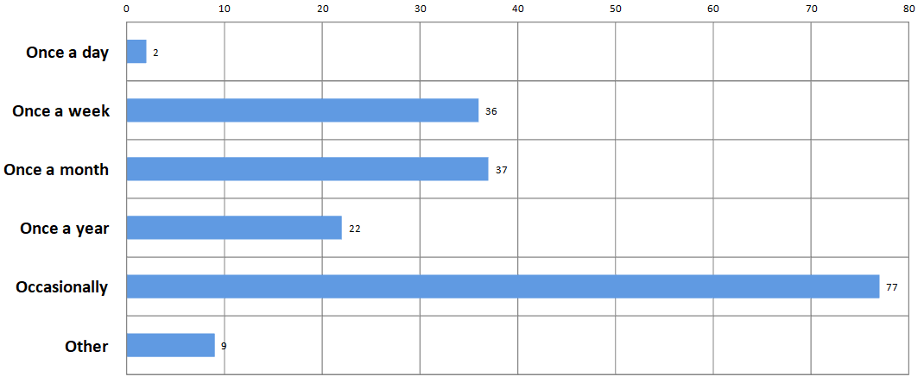

Two of the most significant questions asked in the survey attempted to explore what were the factors that helped culturally diverse people feel included in their local community and what were the barriers.

Three factors that were identified as most helpful and included:

1. **Activities within my cultural group (41%)**
2. **Friendly neighbours and (40%)**
3. **Using local facilities including gym, community centre, library, pool, park and playground (40%)**

***Table 11 – Factors helping inclusion***

**Reported Factors Helping Inclusion**

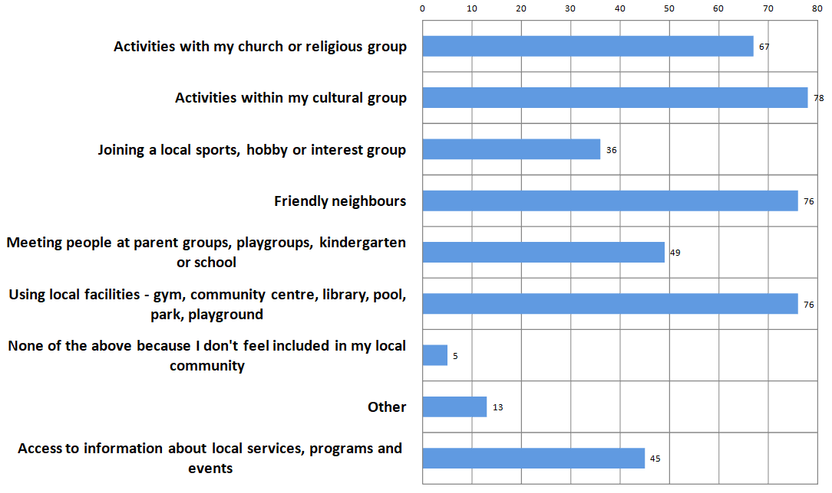

Three factors that were identified as barriers to inclusion and included:

1. ***Don’t have a job (21%)***
2. ***No information on programs, services and events (19%)***
3. ***No family here (17%)***

It is important to note that 30% of respondents indicated that none of these barriers applied to them as they felt included in their local community.

***Table 12 – Barriers to inclusion***

**Reported Barriers to Inclusion**

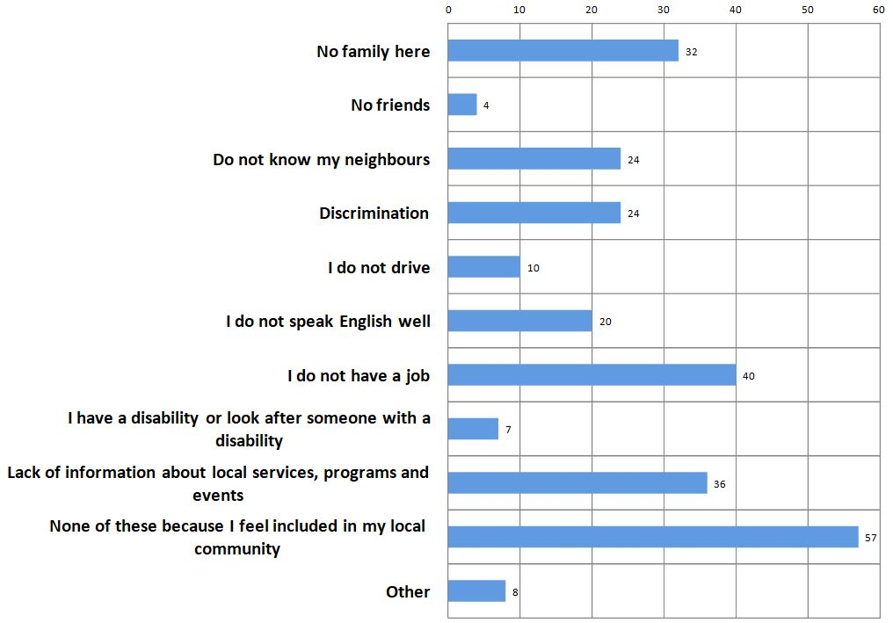

## 8.2 Consultations with culturally diverse groups

Focus group consultations were undertaken with ten community groups with participant numbers included in brackets:

* Croatian (10)
* Democratic Republic of Congo (18)
* Burundian (14)
* Indian (30)
* Fijian (5)
* Serbian (11)
* Filipino (80)
* Chinese (127)
* Samoan (7)
* Tongan (67)

These culturally diverse groups were asked to identify what they saw as the strengths in their communities, from whatever perspective they chose, followed by a discussion on what they perceived to be the challenges and opportunities.

The focus groups varied considerably in size with the smallest involving five participants and the largest involving one hundred and twenty seven. Generally only one facilitator was present with two or more involved in the larger consultations. Notes were taken by the facilitator in the smaller consultations with the whiteboard used to record feedback in the larger groups.

Despite the diversity of cultural groups consulted there was a surprising consistency in the responses. A summary of the community feedback is outlined below.

***Table 13 – Summary of culturally diverse community feedback***

|  |  |
| --- | --- |
| Strengths | Challenges and Opportunities |
| Establishment of the Cultural Diversity position and very positive contact and communication with the incumbent officer | There are limited local employment opportunities for culturally diverse job seekers who often feel disadvantaged without locally recognised skills and experience |
| All communities appreciated being involved in the consultation process for the development of this strategy | Many participants had no understanding of what services and supports were available via the City Of Cockburn |
| Highly rated facilities/services included the Cockburn Aquatic Recreation Centre, libraries and child health services | The need for more English language classes, cultural language schools and life-skill classes all with crèche facilities |
| Libraries were viewed positively but there was a need for more books in languages other than English | Greater access to shared and/or subsidized venues to support a range of cultural and social activity and establishment of a multi-cultural hub |
|  | Concern regarding the quality of education available via local schools and recognition that many families leave the area due to this issue |
|  | Concern regarding the social isolation of seniors including those who were caring for grandchildren with limited English skills |

## 8.3 Consultations with City of Cockburn staff

Two two-hour workshops were held with a total of 40 City of Cockburn staff utilising a very similar approach to that of the focus groups as outlined in 7.2. Staff were asked to identify what they saw as the strengths of culturally diverse communities and the City of Cockburn’s interaction with them. This was followed by a discussion on what were the perceived challenges and opportunities of working with culturally diverse communities.

Both groups involved between 20 to 25 staff members who were highly engaged and very responsive in both sessions. Two facilitators guided the discussion and recorded feedback on a whiteboard.

Again there was consistency of feedback across the two sessions and a summary of the strengths, challenges and opportunities is outlined below.

***Table 14 – Summary of City of Cockburn staff feedback***

|  |  |
| --- | --- |
| Strengths | Challenges and Opportunities |
| The City of Cockburn was recognised as a leader in cultural diversity evidenced by the appointment of a Cultural Diversity Officer and the development of this strategy | While there is growing momentum regarding Cultural Diversity there is not yet a whole of organization commitment to the area |
| The on-line Directory of Services was highly regarded and well-used as was other information translated into 4 languages | Similarly, while some staff have participated in cultural awareness training there are still many who have not |
| City of Cockburn funding opportunities for community groups with quarantined amounts for culturally diverse applicants was identified as a strength | The development of a Cultural Diversity strategy will encourage all staff to put a diversity lens over everything they do |
| Well organized and attended citizenship ceremonies were acknowledged as a strength which demonstrates that cultural diversity was valued with participants feeling welcomed and highly valued | Recognising that many culturally diverse communities do not understand the role and responsibilities of the City, there is an opportunity to inform and educate |
| A dedicated budget for the delivery of translation and interpreter services was viewed as a strength | New and emerging culturally diverse communities e.g. Indian, Chinese and Filipino would benefit from proactive assistance with reference to accessing venues, funding support, governance information and the exploration of mentoring and partnership opportunities |

## 8.4 Consultations with service providers

One consultation was undertaken with a diverse group of service providers operating within the City of Cockburn.

A total of twelve agencies were represented and included:

* Silver Chain
* Office of Multicultural Interests
* WA Primary Health Alliance
* Yangebup Family Centre
* Palmerston
* Fremantle Family Support Network
* South Lake Ottey Family and Neighbourhood Centre
* Interlife
* Commonwealth Respite and Carelink Centres
* Mercycare
* Helping Minds

Participants were asked to identify what they saw as the strengths within culturally diverse communities and their agency’s interaction with them. This was followed by a discussion on what they perceived to be the challenges and opportunities of working with culturally diverse communities.

A summary of the strengths, challenges and opportunities is outlined below.

***Table 15 – Summary of service provider feedback***

|  |  |
| --- | --- |
| Strengths | Challenges and Opportunities |
| Agencies reported an increasing need to engage dedicated culturally diverse staff and/or offer cultural awareness training to other staff | Migration and re-settlement can be traumatic and the subsequent loss of identity, perceived stigma regarding accessing support and possible mental health issues can limit engagement. |
| Agencies identified the need to offer outreach services into culturally diverse communities, specific programs e.g. Women of the World group or events to celebrate cultural diversity | The current funding model provides support for the first five years but issues often continue after this period with fewer supports in place |
| The City of Cockburn was congratulated for its leadership in cultural diversity as evidenced by the appointment of a Cultural Diversity Office | Lack of employment opportunities for people in culturally diverse communities continues to be an ongoing issue long after settlement and this issue needs to be prioritised |
| Service providers reported valuing the opportunity to share strategies and identified the need to meet regularly on Cultural Diversity issues | Some people have limited English proficiency; access to interpreter and translation services is critical and all communication should be delivered in straightforward English |

## 8.5 Consultation analysis

There was overwhelmingly positive engagement with the consultation processes to inform the development of the City of Cockburn’s first Cultural Diversity strategy. All participants including cultural groups, City of Cockburn staff and service providers were enthusiastic regarding the recent appointment of a Cultural Diversity Officer and reported very positive interaction with the incumbent.

The survey results indicated that connection to a cultural community, engagement with neighbours and utilisation of local services and facilities enhanced a sense of inclusion. The lack of local employment, no access to information on services and facilities, and no immediate family in the area were barriers to inclusion. These themes were borne out in every consultation and emphasize the need for ***connection and information***.

Other more specific issues included the need for more English language classes and cultural language schools; greater access to venues and consideration of a multi-cultural hub; concern regarding the quality of education being delivered at local schools; and the need to address isolation of the elderly including those caring for grandchildren.

# 9.0 Vision, Outcomes, Strategies and Actions

The consultation findings, research, and demographic analysis have been utilised to develop the three year Cultural Diversity Strategy 2018-21. The six outcome areas and 24 strategies have also been aligned with the Welcoming Cities standard. The 56 actions detailed below have been developed to achieve the vision, outcomes and strategies for the City of Cockburn with regard to cultural diversity and inclusion. A total of ten actions have been identified for priority consideration and these are asterisked and shaded in red.

|  |
| --- |
| **VISION – The City of Cockburnprovides awelcoming and inclusive environment where people of all backgrounds have a sense of belonging, feel valued and fully participate in social, cultural, civic, and economic life.** |
| **Outcome 1 – Leadership**  The City of Cockburn actively leads, advocates and promotes cultural diversity and inclusion. |

|  |  |  |  |  |
| --- | --- | --- | --- | --- |
| **Strategy 1.1**  Facilitate communication between Aboriginal and Torres Strait Islander and culturally diverse communities to promote and strengthen the City’s Reconciliation Action Plan. | | | | |
| **Actions** | **Leaders** | **Budget** | **Time frame** | **Measures of success** |
| * + 1. Formally and informally link culturally diverse and Aboriginal and Torres Strait Islander groups. | * Cultural Diversity Officer * Aboriginal Community Development Officer | Existing | Ongoing | Linkages developed between culturally diverse and Aboriginal and Torres Strait Islander groups. |
| * + 1. Enhance the awareness of culturally diverse communities in regard to Aboriginal cultural heritage. | * Cultural Diversity Officer * Aboriginal Community Development Officer | Existing | Ongoing | Culturally diverse communities have increased awareness of Aboriginal cultural heritage. |
| * + 1. Encourage culturally diverse groups to acknowledge Aboriginal culture by integrating ‘Acknowledgement of Country’ messages into their events and gatherings as appropriate. | * Cultural Diversity Officer * Aboriginal Community Development Officer | Existing | Ongoing | Culturally diverse groups integrate an ‘Acknowledgement of Country’ messages into their events and gatherings as appropriate. |

|  |  |  |  |  |  |
| --- | --- | --- | --- | --- | --- |
| **Strategy 1.2**  Seek membership to the ***Welcoming Cities Network*** of Australia, and commit to be welcoming and inclusive. | | | | | |
| **Actions** | **Leaders** | | **Budget** | **Time frame** | **Measures of success** |
| *1.2.1 Seek membership to the ***Welcoming Cities Network.*** | • Cultural Diversity Officer | | Existing | 2018/19 | Membership achieved |
| 1.2.2 Establish relationships and explore best practice sharing opportunities with other West Australian Local Governments (either individually and/or as a group of Councils) who are members of the ***Welcoming Cities Network***. | **•** Cultural Diversity Officer | | Existing | 2018/19 | * Linkage established with other WA Local Government members * City of Cockburn best practice experiences shared and opportunities identified |
| **Strategy 1.3**  Identify and pursue opportunities to promote the leadership and best practice achievements of the City of Cockburn in Cultural Diversity on the local, state, national and international stage. | | | | | |
| **Actions** | **Leaders** | | **Budget** | **Time frame** | **Measures of success** |
| 1.3.1 Launch the City’s ‘Cultural Diversity Strategy 2018 – 21’ and widely distribute and promote using various platforms. | * Manager Community Development * Family and Community Development Manager * Cultural Diversity Officer | | Existing | 2018/19 | * Strategy distributed widely internally and externally * Increased requests for further information * Increased request to collaborate from other organisations |
| 1.3.2 Seek opportunities to present at conferences or forums, or apply for awards to showcase successful. projects, positive outcomes and best practice within the Strategy. | * Cultural Diversity Officer * Manager Community Development * Family and Community Development Manager | | Existing | Ongoing | * Presentations delivered at conferences or forums * Projects recognised as best practice |
| **Strategy 1.4**  Ensure a whole of organisation approach by incorporating Cultural Diversity in all strategic, business and community planning processes. | | | | | |
| **Actions** | **Leaders** | | **Budget** | **Time frame** | **Measures of success** |
| 1.4.1 Encourage senior management to consider integrating Cultural Diversity aspects in their planning. | * Manager Community Development * Family and Community Development Manager | | Existing | Ongoing | Cultural diversity and inclusion issues are considered regularly at senior levels of the organisation |
| **Strategy 1.5**  Advocate the benefits of Cultural Diversity to the community and inform public debate about this as required. | | | | | |
| **Actions** | **Leaders** | | **Budget** | **Time frame** | **Measures of success** |
| 1.5.1 Promote cultural diversity using various platforms (e.g. cultural events). | * Cultural Diversity Officer | | Existing | Ongoing | Regular presentations, events or activities delivered to community groups. |
| 1.5.2 Proactively respond to media coverage on the benefits of cultural diversity. | * Manager Corporate Communications * Cultural Diversity Officer | | Existing | Ongoing | Opportunities are maximized to positively advocate the benefits of cultural diversity |
| 1.5.3 Develop audio-visual and print messaging that communicates the community-wide benefit of Cultural Diversity. | * Manager Corporate Communications * Cultural Diversity Officer | | Existing | ongoing | * Key messages developed * Key messages are used in City audio-visual materials and publications |
| **Outcome 2 – Social and cultural inclusion**  Ensure social and cultural inclusion by addressing and removing barriers which prevent equitable access to all City of Cockburn services, and promote social cohesion. | | | | | |
| **Strategy 2.1**  Recognise the value of engaging, consulting and involving culturally diverse communities and the importance of an on-going feedback process to inform continual improvement. | | | | | |
| **Actions** | | **Leaders** | **Budget** | **Time frame** | **Measures of success** |
| *2.1.1 The Cultural Diversity Officer continues to engage, consult and seek continuous feedback for improvement purposes (both formal and informal). | | * Cultural Diversity Officer * Community Engagement Officer | Existing | Ongoing | * Continuous engagement, consultation and the joint identification of capacity building opportunities with culturally diverse communities * Relationships are developed to embrace the sharing of both formal and informal feedback |
| **Strategy 2.2**  Develop an innovative and sustainable ***Welcome to the City of Cockburn*** information initiative and other communication approaches to enhance community awareness and improve engagement. | | | | | |
| **Actions** | | **Leaders** | **Budget** | **Time frame** | **Measures of success** |
| * + 1. Research, develop, and distribute an innovative and on-going tailored ***Welcome to the City of Cockburn*** information pack. | | * Manager Community Development, * Corporate Communications * Cultural Diversity Officer | New $5000 | 2019/20 | * A successful business case developed for a ***Welcome to the City of Cockburn*** information pack * A pack is developed and distributed |
| * + 1. Explore opportunities to promote and encourage the use of the online Cockburn Community Directory. | | * Manager Community Development * Manager Corporate Communications * Cultural Diversity Officer | Existing | Ongoing | * Current levels of use determined * Use of the online Cockburn Community Directory increases * Informal feedback gathered on the value of the directory and what could be improved |
| * + 1. Improve the accessibility and promote the use of City of Cockburn’s website, print media and other communication tools. | | * Manager Corporate Communications * Cultural Diversity Officer | Existing | Ongoing | * Current levels of use determined * Use of the website, print media and other communication tools increases * Informal feedback gathered on the value of these tools and improvements made |
| **Strategy 2.3**  Recognise the importance of utilising interpreting and translation services when engaging with culturally diverse individuals and communities over the phone and face-to-face. | | | | | |
| **Actions** | | **Leaders** | **Budget** | **Time frame** | **Measures of success** |
| *2.3.1 Develop a City of Cockburn languages policy to ensure that limited competence in the English language is not a barrier to accessing services. | | * Manager Community Development * Family and Community Development Manager * Cultural Diversity Officer | Existing | 2018/19 | Languages policy developed and promoted to senior staff once adopted |
| * + 1. Monitor interpreting and translating needs and ensure sufficient funding is available. | | * Manager Corporate Communications * Cultural Diversity Officer | Existing | 2018/19 | * Dedicated budgets maintained and increased as required * Monitor and identify any essential information that is not translated and request funding as required. |
| * + 1. Ensure that relevant City of Cockburn staff are appropriately trained in the use of interpreting and translating services. | | * Family and Community Development Manager * Learning and Development team | New $5,000 | 2019/20then  Ongoing | * City of Cockburn staff are appropriately trained in the use of translating and interpreter services * usage increases |
| **Strategy 2.4**  Promote culture through events and celebrations with active involvement and co-design approaches with culturally diverse communities. | | | | | |
| **Actions** | | **Leaders** | **Budget** | **Time frame** | **Measures of success** |
| 2.4.1 Actively involve communities in the City’s existing or newly created culturally diverse events. | | * Cultural Diversity Officer * Events management team * Youth Development Officer | Existing | Ongoing | A range of culturally diverse communities engage in a co-design process for a number of existing or newly created events. |
| *2.4.2 Enhance intercultural understanding and build cultural harmony through events that promote cultural fusion with Aboriginal and Torres Strait Islander, culturally diverse and broader communities. | | * Cultural Diversity Officer * Events management team * Youth development officer | Existing | Ongoing | Intercultural understanding and cultural harmony is increased for Aboriginal and Torres Strait Islander, culturally diverse and broader communities. |
| **Strategy 2.5**  Address issues of social isolation which may create a barrier to accessing information and inclusion in services and activities. | | | | | |
| **Actions** | | **Leaders** | **Budget** | **Time frame** | **Measures of success** |
| *2.5.1 Identify and promote opportunities that will reduce social isolation for seniors, grandparents caring for children, and others, in culturally diverse communities. | | Cultural Diversity Officer | Existing | 2018/19 | Opportunities for social connectedness are identified and promoted for seniors; grandparents caring for children; people with disability; and others who could be socially isolated. |
| **Strategy 2.6**  Identify and respond to specific issues which may impact on the wellbeing of individuals and families in culturally diverse communities e.g. disability, mental health, family and domestic violence (FDV) and alcohol and other drug (AOD) use. | | | | | |
| 2.6.1 Strengthen the capacity of the City’s grant-funded and municipal services to address any barriers for residents of culturally diverse background in accessing services. | | Cultural Diversity Officer | Existing | Ongoing | Provide support to these areas via information, and attendance at activities as required |
| * + 1. Develop effective and culturally appropriate referral pathways to address issues of FDV, AOD and other concerns, and advocate for the increased provision of relevant services and service providers in the City. | | Cultural Diversity Officer | Existing | ongoing | Number of partnerships developed and referral pathways available |
| **Outcome 3 - Economic development**  Culturally diverse communities actively participate in the economic development of the City of Cockburn with equitable access to employment, business development and entrepreneurship opportunities. | | | | | |
| **Strategy 3.1**  Identify and address any barriers that may limit diversity and inclusion in employment practices at the City of Cockburn. | | | | | |
| **Actions** | | **Leaders** | **Budget** | **Time frame** | **Measures of success** |
| * + 1. Identify and adopt innovative approaches to communicate employment opportunities to culturally diverse communities. | | * Manager Human Resources * Cultural Diversity Officer | Existing | 2020/21 | * Increased applicants with a culturally diverse background * Increased staff employed with a culturally diverse background |
| * + 1. Review current recruitment processes to identify and address barriers and unconscious bias that may limit diversity and inclusion in employment practices. | | * Manager Human Resources * Cultural Diversity Officer | Existing | 2020/21 | * Review undertaken * Amendments made to recruitment processes as identified |
| *3.1.3 Explore unpaid work experience opportunities within the City of Cockburn to provide employment opportunities for professional residents with high skills sets who are constrained by lack of Australian work experience. | | * Manager Human Resources * Cultural Diversity Officer | Existing | Ongoing | Skilled migrants lacking Australian work experience are provided with short-term and unpaid opportunities. |
| * + 1. Consider suitable candidates from culturally diverse background to fill casual, contract and fulltime work roles. | | * Manager Human Resources * Family and Community Development Manager | Existing | 2020/21 | Candidates from culturally diverse backgrounds are offered opportunities to fill casual, contract and fulltime work roles in the cultural diversity area. |
| Strategy 3.2 Explore opportunities to improve employment opportunities for culturally diverse communities locally. | | | | | |
| **Actions** | | **Leaders** | **Budget** | **Time frame** | **Measures of success** |
| 3.2.1 Research potential benefits and ways of encouraging “local jobs for local people” approaches to improve diversity and inclusion in employment. | | * Human Resources * Cultural Diversity Officer | Existing | 2020/21 | Research is undertaken to progress a “local jobs for local people” strategy. |
| 3.2.2 Support and facilitate events and activities that grow local employment opportunities, business incubation and the development of commercial acumen within culturally diverse communities. | | * Cultural Diversity Officer * Business Engagement Officer | Existing | 2020/21 | Events and activities are delivered that grow local employment opportunities, business incubation and the development of commercial acumen. |
| 3.2.3 Encourage culturally diverse communities to explore alternative employment options such as self-employment and small business; and organize business development workshops and networking events to promote these opportunities. | | * Cultural Diversity Officer * Business Engagement Officer | Existing | 2019/20 | A range of business focused activities, including workshops and networking events, are offered to culturally diverse communities |
| 3.2.4 Explore opportunities to advocate to local employers the potential benefits of employing staff from local and culturally diverse communities. | | * Cultural Diversity Officer * Business Engagement Officer | Existing | Ongoing | Ongoing advocacy occurs, via various events and activities, of the potential benefits of employing staff from local and culturally diverse communities. |
| **Outcome 4 – Capacity building, learning and skill development**  Ensure culturally diverse communities, City of Cockburn staff, and other relevant parties have access to learning and capacity building opportunities. | | | | | |
| **Strategy 4.1**  Identify and deliver cultural diversity learning opportunities for City of Cockburn staff to increase their capacity and skill to engage with and appropriately respond to the needs of culturally diverse communities. | | | | | |
| **Actions** | | **Leaders** | **Budget** | **Time frame** | **Measures of success** |
| 4.1.1 Develop and deliver cultural diversity training opportunities as required utilising local skills and resources where possible. | | * Manager Human Resources * Cultural Diversity Officer | New  $10,000 | 2019/20  then ongoing | Cultural diversity training delivered as required utilising local skills and resources |
| 4.1.2. Explore best practice approaches (in addition to 4.1.1) to continuously improve staff capacity to respond to Cultural Diversity needs. | | * Cultural Diversity Officer | Existing | 2018/19 | Other strategies are identified and delivered to continuously improve staff capacity to respond to Cultural Diversity needs. |
| 4.1.3. Promote the City’s Cultural Diversity Officer position and encourage staff to seek the opportunity for specialist advice and guidance as required. | | * Cultural Diversity Officer | Existing | Ongoing | City of Cockburn staff utilise the Cultural Diversity Officer position for expert advice and guidance as required. |
| **Strategy 4.2**  Build the capacity of culturally diverse groups to identify and respond to needs within their own communities. | | | | | |
| **Actions** | | **Leaders** | **Budget** | **Time frame** | **Measures of success** |
| *4.2.1 Assess, prioritise and respond to appropriate learning and development needs (including English language classes, culture-specific language classes, creche and playgroups) within culturally diverse communities. | | * Cultural Diversity Officer * Manager Library Services * Manager Community Development | New  $8000 | 2019/20  Then ongoing | Learning and skill development opportunities, including English language classes, are prioritised and delivered as required. |
| *4.2.2 Deliver workshops to raise community awareness of grant opportunities and provide guidance to build community’s capacity in developing successful project proposals. | | * Cultural Diversity Officer * Grants and Research Coordinator | Existing | Ongoing | Workshops are delivered and guidance provided as required to build community capacity to develop successful project proposals. |
| *4.2.3 Encourage and support community groups to become incorporated, build their confidence and ability to become self-sufficient. | | * Community Development team * Cultural Diversity Officer | Existing | Ongoing | Encouragement and support delivered to community groups to build confidence and self-sufficiency. |
| 4.2.4 Actively support communities to initiate and lead projects, events and activities. | | * Cultural Diversity Officer | Existing | Ongoing | Communities are actively supported to initiate and lead projects, events and activities. |
| 4.2.5 Facilitate opportunities for established culturally diverse communities to provide guidance, support and mentoring to build the capacity of new and emerging community groups. | | * Cultural Diversity Officer | Existing | Ongoing | Opportunities are provided for established culturally diverse communities to provide guidance, support and mentoring to build the capacity of new and emerging community groups. |
| 4.2.6 Encourage and facilitate cross-cultural collaboration in delivering events, projects and activities to build on social capital. | | * Cultural Diversity Officer | Existing | Ongoing | Cross-cultural collaboration to deliver events, projects and activities is encouraged and facilitated. |
| **Strategy 4.3**  Support culturally diverse and inclusive communities to work more closely with schools to identify and better meet their needs. | | | | | |
| 4.3.1 Explore opportunities to involve local students and schools in cultural events to celebrate cultural diversity and enhance their understanding of multiculturalism. | | * Youth Development Officer * Childrens Development Officer * Cultural Diversity Officer | Existing | Ongoing | Local students and schools are involved in cultural events. |
| 4.3.2 Support local schools in their efforts to cultivate a culture of respect, caring and inclusion through exploring opportunities to connect with speakers and/or groups of diverse cultural and religious background. | | * Youth Development Officer * Childrens Development Officer * Cultural Diversity Officer | Existing | Ongoing | Local schools connect with speakers and/or groups of diverse cultural and religious background. |
| 4.3.3 Empower culturally diverse communities to connect with local schools and the Education Department and communicate their concerns regarding the quality of education and jointly identify strategies to address this issue. | | * Youth Development Officer * Childrens Development Officer * Cultural Diversity Officer | Existing | Ongoing | Culturally diverse communities connect with local schools and the Education Department to explore quality of education issues. |
| **Outcome 5 - Civic participation**  Culturally diverse communities engage in all levels of civic activity within the City of Cockburn. | | | | | |
| **Strategy 5.1**  Assist culturally diverse communities to understand the roles, functions, services and responsibilities of the City of Cockburn. | | | | | |
| **Actions** | | **Leaders** | **Budget** | **Time frame** | **Measures of success** |
| 5.1.1 Develop innovative approaches to facilitate understanding on the role, functions, services and opportunities across local government, ensuring language and other accessibility needs are addressed. | | * Cultural Diversity Officer * Manager Corporate Communications | Existing | 2019/20 | Accessible and sustainable information on functions, services and opportunities for engagement with the City of Cockburn is available in multiple languages |
| **Strategy 5.2**  Raise awareness about civic opportunities within the City of Cockburn to culturally diverse communities. | | | | | |
| **Actions** | | **Leaders** | **Budget** | **Time frame** | **Measures of success** |
| 5.2.1 Develop and communicate information on the roles and responsibilities of local government and all tiers of government; and actively encourage community members to consider these opportunities. | | * Cultural Diversity Officer * Manager Corporate Communications | Existing | 2019/20 | Increased interest from culturally diverse communities in attending potential candidates information sessions for local government |
| 5.2.2 Enhance understanding of active citizenship, community leadership, participation and the benefits of this both personally and for culturally diverse communities. | | * Cultural Diversity Officer | Existing | Ongoing | Increased understanding of active citizenship, community leadership, participation and the benefits of this both personally and for culturally diverse communities. |

|  |  |  |  |  |
| --- | --- | --- | --- | --- |
| **Strategy 5.3**  Identify interested culturally diverse community representatives and facilitate opportunities to bring them together to discuss opportunities and issues. | | | | |
| **Actions** | **Leaders** | **Budget** | **Time frame** | **Measures of success** |
| 5.3.1 Consult with culturally diverse communities to determine interest and explore best practice models for establishing discussion platforms e.g. reference group or other forums. | * Cultural Diversity Officer * Community Engagement Officer | Existing | 2019/20 | Appropriate discussion platforms are identified and established. |

|  |  |  |  |  |
| --- | --- | --- | --- | --- |
| **Outcome 6 - Places and spaces**  The needs of culturally diverse communities are considered in the planning and delivery of recreational, social, learning and sports facilities as well as regional open spaces within the City of Cockburn. | | | | |
| **Strategy 6.1**  Ensure planning processes for facilities and public spaces reflect cultural diversity interests and needs to allow for full inclusion. | | | | |
| **Actions** | **Leaders** | **Budget** | **Time frame** | **Measures of success** |
| 6.1.1 Review City of Cockburn facility and open space planning processes to ensure the specific needs of culturally diverse communities are identified and considered e.g. prayer rooms, crèche. | * Manager Community Development * Cultural Diversity Officer * Manager Recreation & Community Safety | Existing | 2019/20 | Planning considerations are reviewed and updated, if necessary, to ensure the specific needs of culturally diverse communities are considered. |
| **Strategy 6.2**  Ensure that the operation of recreational, community and sports facilities and regional open spaces recognize cultural diversity needs and universal use. | | | | |
| **Actions** | **Leaders** | **Budget** | **Time frame** | **Measures of success** |
| 6.2.1 Ensure that planned use of facilities and spaces allow for diverse cultural needs and practices in order to encourage inclusion e.g. gender specific programs, timeslots and spaces. | * Manager Recreation & Community Safety * Cultural Diversity Officer | Existing | Ongoing | Planned use of facilities and spaces allow for diverse cultural needs and practices to encourage inclusion e.g. gender specific programs, timeslots and spaces |
| 6.2.2 Encourage the use of available facilities and spaces for specific cultural groups where appropriate, and where possible aim for a gradual transition to more universally inclusive services and programs. | * Manager Recreation & Community Safety * Cultural Diversity Officer | Existing | 2019/20 | Diverse cultural communities participate with their own groups initially and understand the value of integrating with the broad community in the longer term. |
| **Strategy 6.3**  Recognise the need for targeted community engagement and education processes for identified culturally sensitive environmental issues e.g. turtle fishing. | | | | |
| **Actions** | **Leaders** | **Budget** | **Time frame** | **Measures of success** |
| 6.3.1 Build on established relationships to facilitate engagement and consultation with culturally diverse communities regarding sensitive environmental issues e.g. turtle fishing. | * Manager Environmental Services * Cultural Diversity Officer | Existing | Ongoing | Positive engagement and consultation is achieved with culturally diverse communities to protect the environment. |
| **Strategy 6.4**  Ensure that new and emerging culturally diverse communities have equitable access to facilities on both a short and long term basis in balance with established culturally diverse groups. | | | | |
| **Actions** | **Leaders** | **Budget** | **Time frame** | **Measures of success** |
| 6.4.1 Develop monitoring systems to measure utilisation level of leased facilities to ensure equitable access for all groups. | * Manager Recreation & Community Safety * Cultural Diversity Officer | Existing | 2019/20 | Monitoring systems to measure utilisation level of leased facilities are established to ensure equitable access for all groups. |
| 6.4.2 Support culturally diverse groups to advocate for their facility requirements and explore opportunities for additional resources including a subsidy program for cultural activities. | * Manager Recreation & Community Safety * Cultural Diversity Officer * Manager Community Development | New $2,000 subsidy | 2019/20 | Culturally diverse groups are supported to advocate for their facility requirements and additional resources are provided through a grants and donations subsidy |
| **Strategy 6.5**  Explore options and models for multicultural meeting hub/s or space/s for culturally diverse groups. | | | | |
| **Actions** | **Leaders** | **Budget** | **Time frame** | **Measures of success** |
| *6.5.1 Undertake a review of best practice models for multicultural hub/s to provide shared use of meeting spaces and appropriate storage for culturally diverse groups. | * Manager Recreation & Community Safety * Manager Community Development * Cultural Diversity Officer | Existing | 2019/20 | Review undertaken and best practice models identified to provide shared use of meeting spaces and the provision of storage for culturally diverse groups in the City of Cockburn. |
| 6.5.2 Explore partnership opportunities and grant- funding opportunities for the development of multicultural facilities. | * Manager Recreation & Community Safety * Manager Community Development * Family and Community Development Manager * Cultural Diversity Officer | Existing | Ongoing | Partnership opportunities and grant- funding opportunities are explored, as required, for the development of multicultural facilities. |
| 6.5.3 Ensure that the meeting space, storage, and specific requirements of culturally diverse communities are actively considered in planning for the proposed City of Cockburn Lifelong Learning Centre. | * Manager Community Development * Cultural Diversity Officer | Existing | Ongoing | The meeting and storage space need of culturally diverse communities is actively considered in planning for the proposed City of Cockburn Lifelong Learning Centre. |

# 10.0 Review process

Community members are invited to provide feedback on the Cultural Diversity Strategy 2018-2021 at any time via Comment on Cockburn [comment.cockburn.wa.gov.au](https://comment.cockburn.wa.gov.au/), during various engagements, and will be encouraged to contact the Cultural Diversity Officer.

A comprehensive review of all components of the Cultural Diversity Strategy will be undertaken in 2021.This will include consideration of embedding the Cultural Diversity Strategy into a broader Access and Inclusion Strategy.

# 11.0 References

1. City of Cockburn demographics<https://profile.id.com.au/cockburn/ancestry>
2. Welcoming Cities

<https://welcomingcities.org.au>

1. The Australian Standard for Welcoming Cities

<https://welcomingcities.org.au/wp-content/uploads/2018/03/AustralianStandardWC_digital_2_0.pdf>

1. Office of Multicultural Interests

<https://www.omi.wa.gov.au>

1. Scanlon Survey - mapping social cohesion

<http://scanlonfoundation.org.au/socialcohesion2017/>

1. City of Hume – Local jobs for local people

<https://www.hume.vic.gov.au/files/sharedassets/hume_website/business/hcc3689_localjobshandbook_web_enabled_final.pdf>

# APPENDIX A – Summary of consultations

|  |  |  |  |  |  |  |
| --- | --- | --- | --- | --- | --- | --- |
|  | ***Group*** | ***Approach*** | ***Date*** | ***Number of participants*** | ***Length on consultation*** | ***Comments*** |
| 1 | City of Cockburn residents | On-line survey | February to April, 2018 | 187 | N/A |  |
| 2 | Croatian community | Focus group | 25 February, 2018 | 10 | 2 hours |  |
| 3 | Democratic Republic of Congo | Focus group | 27 February, 2018 & 28 March, 2018 | 18 | 1.45 hours | Included 11 members of the community and 7 members of the youth group |
| 4 | Burundi community | Focus group | 1 March, 2018  & 9 March, 2018 | 14 | 1.5 hours |  |
| 5 | Indian community | Focus group | 10 March, 2018 | 5 | 2.5 hours |  |
| 6 | Serbian community | Focus group | 11 March, 2018 | 11 | 2 hours |  |
| 7 | Filipino Christian community | Forum | 18 March, 2018 | 80 | 2 hours |  |
| 8 | Business owners | Short consultations | 19 and 21 March, 2018 | 4 | N/A |  |
| 9 | City of Cockburn staff | Forum | 28 March, 2018 & 18 April, 2018 | 46 | 2 and  1.5 hours |  |
| 10 | Service providers | Focus group | 28 March, 2018 | 12 | 2 hours | Included health, mental health, disability, aged care and family support service providers |
| 11 | Chinese community | Forum | 7 April, 2018 | 127 | 2 hours |  |
| 12 | Fijian community | Short consultation | 3 May,2018 | 5 | 1 hour |  |
| 13 | Samoan community | Short consultation | 4 May,2018 | 7 | 1 hour |  |
| 14 | Tongan community | Focus group | 7 May, 2018 | 67 | 2.5 hours |  |
| 15 | Indian community | Focus group | 25 May, 2018 | 25 | 2.5 hours |  |
| **TOTALS** | | | | 618 | 24.45 hours | 187 via the survey and 431 face to face |

# 

# APPENDIX B – General comments from the survey

|  |  |
| --- | --- |
| 23. General comments about how we can support multicultural people and groups or help people feel more included: | |
| 1 | By organizing more social events |
| 2 | Since my English and computer skills are not good, maybe have information provided by City of Cockburn staff to our community group, face to face. Free venues/rooms to be used by community groups to meet and socialised. |
| 3 | More employment opportunities or at least chance for work placement experience by local businesses |
| 4 | More support to get a job |
| 5 | Information about services to be accessible not only on the website/computer. I have low computer skills and cant navigate internet well |
| 6 | Help to find a job |
| 7 | I didn't go to school in my country and learning English is very hard. More support for people who don't speak English well, more free English classes |
| 8 | Affordable sport activities |
| 9 | Educating residents about cultural diversity |
| 10 | More services for multicultural residents similar that Fremantle Multicultural provides |
| 11 | Reducing stereotyping in mainstream Australian society about different cultural groups by educating them |
| 12 | More services for migrants what Multicultural Centre does |
| 13 | Have many more cultural events and share the location around or at least, find out where the majority of each culture lives and celebrate it there. There are many beautiful parks in Aubin Grove that there should be an event every single weekend. |
| 14 | Multicultural activities |
| 14 | By letting them appreciate Australian culture and joining in rather than promoting other cultures and dividing the community. They came here for something different than their homelands, otherwise they would never have left. |
| 15 | May we know more about the planting plan? Maybe publish on the Cockburn website? |
| 16 | Encourage friends and friends neighbours to join any activities of interest |
| 17 | Make friends with Jesus |
| 18 | A lot are struggling to get jobs to start with and l think there should be a place to train hands on and make them work ready in any area |
| 19 | Information dissemination |
| 20 | A really good initiative by the city of Cockburn and it must be advertised. |
| 21 | I think we should come together as one and share what we go through life and other that troubles us. |
| 22 | Buddy system where people from “different” groups can visit each other |
| 23 | Thanks a lot for giving some time to ask me. |
| 24 | To have more cultural activities |
| 25 | Already doing great, |
| 26 | I think amiable is cool |
| 27 | Great Day!! |
| 28 | Promoting groups throughout the community Grants |
| 29 | More youth inclusion programs for CALD community |
| 30 | More multicultural event |
| 31 | All good |
| 32 | Since Split in Croatia and Cockburn are city sisters, maybe on their biggest day St Duje, city of Cockburn can have something similar on the same day. As example |
| 33 | Very friendly and appreciable at all time |
| 34 | Need more support toward deaf community by providing funds |
| 35 | To celebrate multicultural day |
| 36 | Thrust educating us all the laws /rules/benefits |
| 37 | Thank you for your support of our culture! In 2012 we received grant from the city of Cockburn. We perform and take part in multicultural events) |
| 38 | Great community of tremendous diversity |
| 39 | More kids cultural activities e.g. sports, events, cultural cooking classes & cultural information in schools. |
| 40 | By celebrating multicultural day in community |
| 41 | To hold various events like Chinese New Year, Deepavolki etc to bring various groups of people together and learn about each other’s culture |
| 42 | Playgroup |
| 43 | More well maintained park |
| 44 | I also discuss things with my dogs. Continue the good work. |
| 45 | How about a multicultural food festival? That would bring everyone together. |
| 46 | Promote places such as the Yangebup Family Centre who do such a good job of making everyone feel welcome and included in the community. |
| 47 | I don't know. I noticed that that "birds of a feather tend to flock together". As such you have many enclaves. It’s difficult when one lives outside of such enclaves or choose to live outside such enclaves. Typical prejudices, biases and stereotyping runs deep. |
| 48 | Thank you for providing free computer services! Where can I find out more about this? |
| 49 | Sauna in ARC should have water to throw to heater.... To support Finnish tradition. There is not a proper sauna anywhere. I had this discussion many times inside Arc's sauna with other people in there. |
| 50 | Celebrate all culture events. Just a mention in the newsletter would be a good way to make aware of the cultural events. I'm not Sri Lankan but did you know 14/4 was Sri Lankan new year day? Having these on your calendar that is given to residents would be great and it sure beats blank squares. I didn't get a Welcome pack when I first moved in so it must be a new concept which sounds great. Love to see what's included in that. |

