Policy Type

Local Planning Policy

Policy Purpose

To provide site specific design guidelines for Development Area 19 (DA19) that will assist in the delivery of high quality and functional built environment.

All applications for subdivision and development shall have due regard with the Design Guidelines.

Policy Statement

(1) Introduction

These Design Guidelines shall be read in conjunction with the City of Cockburn Town Planning Scheme No.3 (TPS 3), Residential Design Codes, Cockburn Central North (Muriel Court) Local Structure Plan and other applicable Local Planning Policies and Local Development Plans.

(2) Vision

The Muriel Court Local Structure Plan area will be characterised as a sustainable, contemporary, high quality, vibrant, urban village which is an extension of the Cockburn Central Town Centre.

(3) Objectives

The objectives of the Design Guidelines are:

Physical
- Promote a safe, comfortable and easily accessible environment for residents and visitors;
- Ensure that buildings address and complement public spaces by providing transparent and engaging interfaces between the street and the public realm;

Social
- Promote a strong sense of place and community;
- Promote walking, cycling and public transport use through appropriately designed streets and buildings;
- Provide for a mix of housing opportunities to cater for a diverse community;
- Ensure good access to public open space for residents and visitors;

Economic
- Promote a viable local centre that supplies the daily needs of the local residents;
- Facilitate a development intensity that complements the Cockburn Central Town Centre and Cockburn Central West.

(4) Local Development Plans

Any subdivision application that proposes to create lots suitable for single house (including terrace-style) or grouped dwelling development in the Local Structure Plan (LSP) area will require the preparation of a Local Development Plan (LDP) for approval by the City to guide development outcomes. LDPs may address:
- Boundary setbacks;
- Building Heights;
- Vehicle Access;
- Open Space;
- Fencing;
- Built Form requirements;
- Roof Form and Design;
- Storage; and
- Any other design element as agreed to by the City.

(5) Minimum Residential Densities and Staging

In accordance with TPS 3 (DA19 provisions), as a minimum, the following zones are required to achieve density at the equivalent of 75% of greater of the density code applicable to the zone:

Density Code | Min Land Area (Lot) to Yield 75% | Land Area to Yield 100%
R25 | 466 | 350
R40 | 293 | 220
R60 | 200 | 150
R80 & R160 | 160 | 120

Achieving the 75% minimum residential density provision for multiple dwellings is calculate based on the single house/grouped dwelling yield.

The 75% minimum residential density requirement may be achieved via a staged approach which can be demonstrated as part of any application. Staged development shall demonstrate how future stages address:
- Minimum density requirements;
- Earthworks;
- Levels;
- Drainage;
- Road connections;
- Any other relevant information.

(6) Noise Attenuation

To address potential noise sources in the area, an Acoustic Report shall accompany applications for residential development and subdivision in the following locations:
- All development adjacent to the Kwinana Freeway;
- All development abutting the Mixed Business zone;
- All development incorporating a mix of uses;
- All development incorporating residential uses adjacent to North Lake Road.
- All noise attenuation and noise management shall be in accordance with Council’s Local Planning Policy LPP 1.12 Noise Attenuation.

(7) Vehicle Access – North Lake Road

Reciprocal vehicle access arrangements and shared vehicle access points are specified for lots abutting North Lake Road. Please refer to Council’s Local Planning Policy LPP 5.6 Vehicle Access.

(8) Low Density Zone (R25) Standards

- As per R-Codes and LDP.

(9) Primary Controls for Medium Density Zone (R40 & R60) and High Density Zone (R80 & R160)

- Single House and Grouped Dwellings – As per R-Codes and LDP.
- Multiple Dwellings (Apartments):

 | R40 | R60 | R80 | R160
Building height (storeys) Minimum | Two storeys | Two storeys | Two storeys | Two storeys
Building height (Storeys) Maximum | Three storeys | Four storeys | Four storeys | No maximum (refer to Jandakot Airport Obstacle Limitation Surfaces)
Boundary wall height (storeys) | As per R-Codes (R40) | Two storeys | As per R-Codes (R80) | Two storeys
Minimum primary and secondary street setbacks | Primary - 2m  Secondary – 1m | Primary - 2m  Secondary – 1m | As per R-Codes (R80) | As per R-Codes (R160)
Minimum side setbacks | As per R-Codes (R40) | As per R-Codes (R60) | As per R-Codes (R80) | As per R-Codes (R160)
Minimum rear setback | As per R-Codes (R40) | As per R-Codes (R60) | As per R-Codes (R80) | As per R-Codes (R160)
Plot Ratio | 0.7 | 1.0 | As per R-Codes (R80) | As per R-Codes (R160)

All other provisions as per R-Codes and any variations to the provisions above shall be assessed using the relevant element objectives in the R-Codes as they related to apartment design.

(10) Mixed Business & Local Centre Standards

 | Restricted Use – Office/Residential | Restricted Use – Non-Residential | Local Centre
Building height (storeys) Minimum | Three storeys | Nil | Two storeys
Building height (Storeys) Maximum | No maximum (refer to Jandakot Airport | No maximum (refer to Jandakot Airport | Four Storeys
Boundary wall height (storeys) | As per R-Codes  (R160) | As per BCA | Two storey
Minimum primary and secondary street setbacks | Subject to design in accordance with LPP 5.6 Vehicle Access. | Subject to design in accordance with LPP 5.6 Vehicle Access. | Nil
Minimum side setbacks | 3m | As per BCA. | Nil
Minimum rear setback | 3m | 10m | Nil
Plot Ratio | N/A | N/A | As per R-Codes (R80) – Residential Component

All other provisions as per R-Codes and any variations to the provisions above shall be assessed using the relevant element objectives in the R-Codes as they related to apartment design.

Bookmark 2
Bookmark 3
Strategic Link: | Town Planning Scheme No.3
Category | Planning – Town Planning & Development
Lead Business Unit: | Development Assessment and Compliance
Public Consultation:  (Yes or No) | Yes
Adoption Date:  (Governance Purpose Only) | 10 November 2022
Next Review Due:  (Governance Purpose Only) | November 2024
ECM Doc Set ID:  (Governance Purpose Only) | 4517094

APPENDIX 1 - STREETS

The following sets out the City’s specific streetscape requirements to be adopted by developers when designing and planning civil works. The City will refer to this section when assessing civil drawings. Developers are encouraged to engage with the City’s Engineering and Parks Team early in the civil design process to discuss the below and further site specific design considerations prior to lodging civil drawings for approval.

Objectives for the design of public spaces in Cockburn Central North

Designs that seek to:
- Contribute to a vibrant, pedestrian friendly community that promotes use of public spaces;
- Provide the functional and aesthetic requirements required to support medium and high density development of which is expected to occur across the precinct;
- Promote the design of streets and public open spaces that will allow users and residents to connect to the local environment. This includes accommodating street trees consistent with the scale of development being proposed on adjoining lands.

Design process

Developers and applicants are advised that the City will be seeking evidence that streetscape civil drawings have responded to:
- The Cockburn Central North Structure Plan (Muriel Court Structure Plan) including but not limited to the design requirements set out within the Local Water Management Strategy;
- Site specific conditions including: Site context, topography and geotechnical conditions, environmental constraints and opportunities, and the retention of significant trees, and;
- Sustainable design measures including water quality and management.

STREET PROFILES

The following details set out the City’s requirements for the design of new roads and associated infrastructure within the precinct.

Semple Court (25.2 metres)
- Semple Court will be designed as an Integrator B Road, as defined by Liveable neighbourhoods, with a 25.2m road reserve;
- The design speed will be 50 km/hr and provide for up to 15,000 vehicles per day;
- Road pavement widths will be sufficient to provide for a traffic lane, segregated bicycle lane and on-street parking;
- 1.5m wide footpaths on both sides of the road which are adjacent property boundaries (0.3m offset);
- Within the local centre, the footpaths will be wider and constructed between the property boundary and the kerb; and
- Street lighting and tree planting in central median;
- Median width 4m; and
- See Appendix 2 for material selections.

Muriel Court (25.2m – East of Semple Court Realignment)
- Semple Court will be designed as an Integrator B Road, as defined by Liveable neighbourhoods, with a 25.2m road reserve;
- Muriel Court is designed for 50 km/hr and will provide for up to 15,000 vehicles per day;
- See attachment 2 for required intersection types along Muriel Court;
- Road pavement widths will be sufficient to provide for a traffic lane, segregated bicycle lane and on-street parking;
- 1.5m wide footpaths on both sides of the road which are adjacent property boundaries (0.3m offset);
- Within the local centre, the footpaths will be wider and constructed between the property boundary and the kerb;
- Street lighting and tree planting in central median;
- Median width 4m; and
- See Appendix 2 for material selections.

Muriel Court (24.4m – West of Semple Court Realignment)
- Muriel Court will be designed as a Neighbourhood Connector Road, as defined by Liveable Neighbourhoods, within a 24.4m road reserve;
- Muriel Court is designed for 50 km/hr and will provide for up to 15,000 vehicles per day;
- 1.5m wide footpaths on both sides of the road which are adjacent property boundaries (0.3m offset);
- Segregated bicycle lane for the entirety of the length of Muriel Court;
- Street lighting in a minimum 2m wide central median; and
- See Appendix 2 for material selections.

18 metre wide roads
- These roads are designed as wide access streets suitable for higher density residential areas and provide for on street parking and street tree planting;
- Street pavement 6m with one verge 6.2m and the other 5.8m. The wider verge on one side will accommodate sewer and stormwater drainage;
- 1.5m wide footpaths on both sides of the road which are adjacent to property boundary (0.3m); and
- 2.1m wide on-street car parking bays.
15 metre wide roads
- These roads are for lower density residential areas and some on-street parking (on the carriageway), which provide speed control;
- 4.5m verges and 6m pavement;
- Street trees are to be provided in the road reserve;
- 1.5m wide footpaths on both sides of the road which are adjacent to property boundary (0.3m offset); and
- 2.1m side on-street car parking bays.

16 metre wide road
- As per 15m wide roads, except that verges are 5m wide each;
- 1.5m wide footpaths on both sides of the road which are adjacent property boundaries (0.3m offset);
- For lots that abut public open space the road reserve is 14.5m; and
- The street profile is the same, except on the public open space side the verge which is 3.5m and contains a Dual Use Path (2.1m) and no car parking.

Laneways
- New laneways may be required to provide access to new lots created through subdivision.
- Road Design speed of 10 km/h;
- 6m wide road pavements with no footpaths with 1x0.5m setbacks for lighting at regular spacing as illustrated in Figure below; and
- Require traffic calming where length is deemed to warrant it.

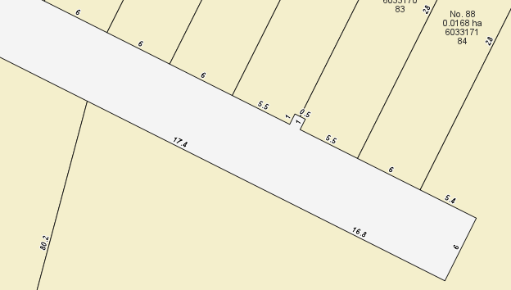

APPENDIX 2 - MATERIAL SELECTIONS

Street lighting – precinct wide

Street name/type | Type | Western Power item
Muriel Court/Semple Court | Double outreach pole | DM25_10.5m Standard Pole, MEADOW SPRINGS 3m DOR, Parkville Luminaire, EBONY
Residential Access streets | 6.5m standard pole | DM2_STANDARD POLE 6.5m, LED Luminaire, EBONY
Laneways | 4.5m standard pole | DM3 Bourdeaux Pole 4.5m, LED Luminaire, EBONY

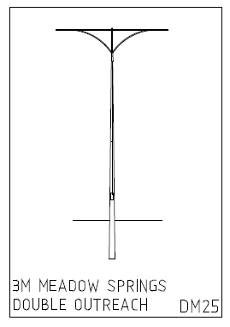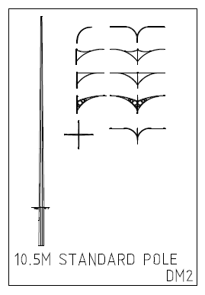 | 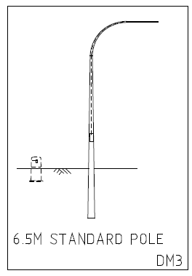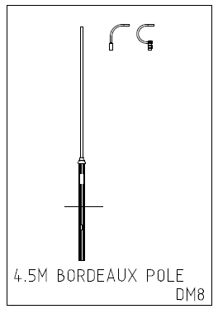

Muriel Court road reserve materials and standard requirements

Component | Material/colour
Travel lane | - Black asphalt
Cycle lane | - Red asphalt and green at intersections. White lines
Footpath | - Exposed light grey aggregate at corners. Grey concrete footpaths. Exposed aggregate colour: Preston Beach form Boral, or similar to be approved by the City of Cockburn.  - Bollards to be included on corners while at same time meeting City requirements for pedestrian ramps.
Round about | - Black asphalt with MRWA intersection mix
3 and 4-way intersections | - Black asphalt with linemarking and signage
Tactile pavers at pram ramps and medians | - Charcoal 60mm tactile pavers
On-street parking bays/Intersection threshold treatment | - Charcoal interlock pavers
Median finishes | - Semi mountable kerbing  - 600mm concrete apron to the outer, inside edge of the median: concrete to be finished with dark red ochre faux paving.  - Remaining garden bed to have trees planted max. of 6 -8m apart.  - Chunky pine bark mulch to remaining unpaved median area.
Tree nibs (between car embayments) | - Tree nibs to have flush beam edging (to allow rain water flow).  - Nibs to be minimum of 1.2m wide at road edge.  - Trees to have root barrier installed to furthest edge of tree nib at 600mm deep.  - Trees between car embayments to have tree surrounds installed as per the City of Cockburn standard detail.  - Wheel stops to be installed either side of a tree on in-car embayments to prevent cars damaging trees.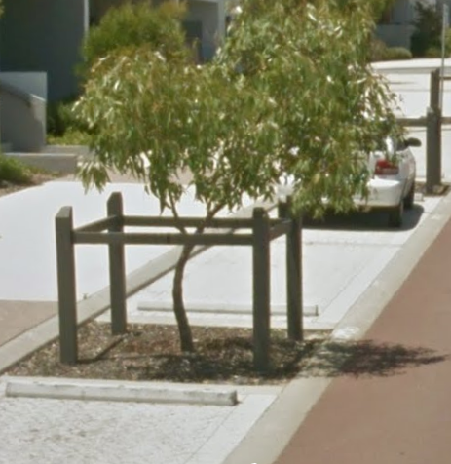

For material selections for streets other than Muriel Court please contact the City’s Engineering and Parks teams.

Street trees

Road | Location | Species selection
Muriel Court | - Centre line planting  - Verge both sides or in nibs | - Claret Ash (Fraxinus Raywoodii)  - Chinese elm (Ulmus Parivolia)
15m access streets | - Select at time of civil approvals by Parks | Applicants choice subject to City approval

APPENDIX 3 – MURIEL COURT AND KNOCK PLACE INTERSECTION TREATMENTS

In 2018 the City engaged GTA Consultants to undertake a review of the Muriel Court Traffic Impact Assessment due to revised traffic generation numbers expected across the Muriel Court precinct. This recognises several structure plan amendments have cumulatively impacted on dwelling yield and therefore also traffic generation numbers.

The addendum is to be read alongside the original Muriel Court traffic impact assessment undertaken in 2008. The full report can be accessed on the Muriel Court webpage https://www.cockburn.wa.gov.au/Building-and-Development/Town-Planning-and-Development/Current-Development-Projects/Cockburn-Central-North-(Muriel-Court)

Within the TIA Addendum at Attachment 6 and provided below is the City’s preferred and now adopted option for the design of intersection treatments along Muriel Court and Knock Place.

