Policy

Planning Around Mosquito and Midge Infested

Wetlands

Policy Number

LPP 1.10

Policy Type
  - Local Planning Policy

Policy Purpose

There is a problem of seasonal midge swarms in the vicinity of lakes and wetlands, which adversely affects the quality of life of nearby residents. The City receives complaints from residents living within 1km from wetlands subject to midge infestation on an annual basis.

There were a large number of cases of Ross River Virus (RRV) in Cockburn during
summer of 2011/12. These were investigated by experts at the WA Department of Health
(DoH). Subsequent advice from DoH to the City has advised that there is a heightened risk
of contracting the disease for people residing near Thomsons Lake.

It is considered prudent and responsible for the City to ensure that prospective purchasers
of residential properties around midge and mosquito infested wetlands are alerted to this emerging risk. While comprehensive public awareness campaigns are used to educate, a further means of communicating the risk recommended by the DoH is through placing memorials on new land titles created at subdivision stage.

The purpose of this policy is to restrict residential subdivision, strata’s and development in areas considered most likely to be subjected to midge nuisance and to advise nearby residents of the potential midge nuisance prior to purchase. Where residential development is proposed in proximity to Thomsons Lake, this policy aims to provide a long term mechanism to inform prospective purchasers of the potential risk of contracting RRV.

Policy Statement

(1) The City does not support the rezoning, subdivision or strata titling of land for residential development within 500m of the edge of any lake or wetland in the district that is subject to potential midge infestation, unless it can be demonstrated to the satisfaction of the City’s Environmental Services that the lake or wetland does not have or can be prevented from midge infestation.

(2) The City will require subdivider(s)/developer(s) of land between 500m and 800m of the lake or wetland edge to impose a Notification, pursuant to Section 165 of the Planning and Development Act 2005 on the title of each new residential lot advising prospective purchaser(s) that the land may be affected by midge infestation. Notice of this Notification is to be included on the Deposited Plan and shall state the following:

This land may be affected by midge from nearby lakes and/or wetlands. Enquiries can be made with the City of Cockburn Environmental Services.

The above notification will also be required to be imposed on any infill residential subdivision, strata and development on land already zoned Residential within 500m of the edge of any lake or wetland subject to potential midge infestation.

(3) Where a subdivision, strata or development is separated from a wetland by a wide vegetation buffer that will be permanently maintained, the City may vary its policy by waiving the Notification requirement for lots between 500m and 800m of the wetland edge it can be adequately proved to the satisfaction of the City’s Environmental Services, that the vegetated buffer to remain is of the appropriate density and vegetation structure to prevent the dispersal of midge nuisance swarms in adjacent residential areas.

(4) The policy applies to the attached list of wetlands subject to potential midge and mosquito infestation together with the accompanying map.

(5) A mosquito management plan shall be required as a condition of subdivision approval for all new subdivisions proposing the creation of new road infrastructure and/or open space located within the area depicted on Appendix B Policy Area

(6) The City shall recommend the Western Australian Planning Commission impose a condition requiring a memorial be placed on all new residential lots created within the area depicted on Appendix B – Policy Area warning of the heightened risk of mosquito born disease in the area.

Strategic Link: | Town Planning Scheme No.3
Category: | Planning – Town Planning & Development
Lead Business Unit: | Development Services
Public Consultation:  (Yes or No) | Yes
Adoption Date:  (Governance Purpose Only) | 12 November 2024
Next Review Due: (Governance Purpose Only) | November 2026
ECM Doc Set ID: (Governance Purpose Only) | 4922955

Appendix A

List of Wetlands and Lakes in the City of Cockburn
Subject to Potential Midge Infestation:

A wetland/lake has the potential to be subject to midge infestation if it holds water during spring and summer and is nutrient enriched or has the potential to become nutrient enriched.

Wetlands/lakes that meet these criteria in the City of Cockburn are:

- Manning Lake
- Market Garden Swamp 1
- Boodjar Mooliny Lake
- Bindjar Lake
- Lake Coogee
- North Lake
- Bibra Lake
- South Lake
- Little Rush Lake
- Yangebup Lake
- Kogolup Lake
- Thomsons Lake
- Copulup Lake
- Jubilee Lake
- Branch Circus Lakes
- Twin Bartram Swamp
- Bartram Road Buffer Lakes
- The Perena Rocchi Reserve Lake

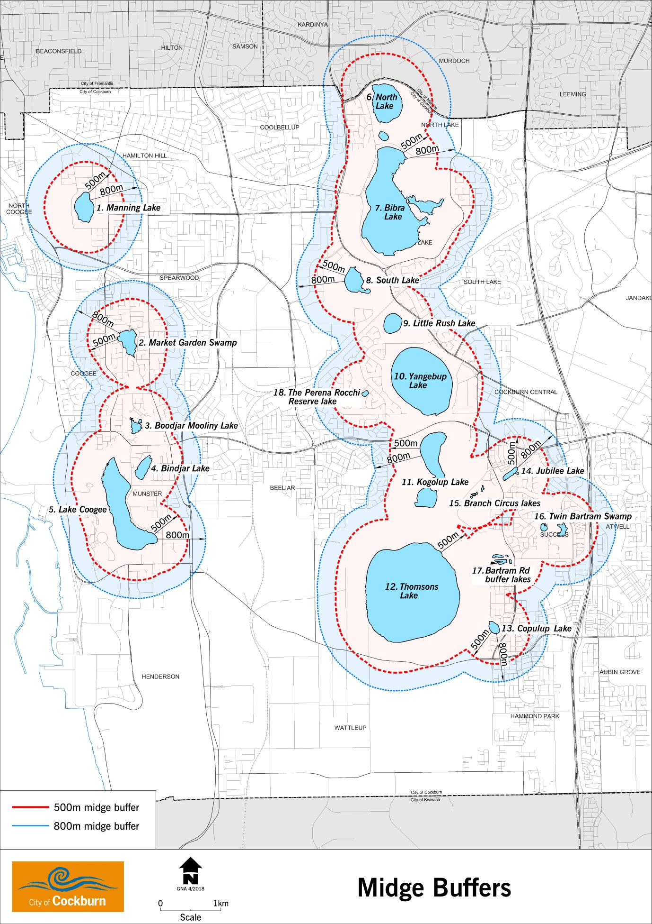

Appendix B – Mosquito Infestation Policy Area
