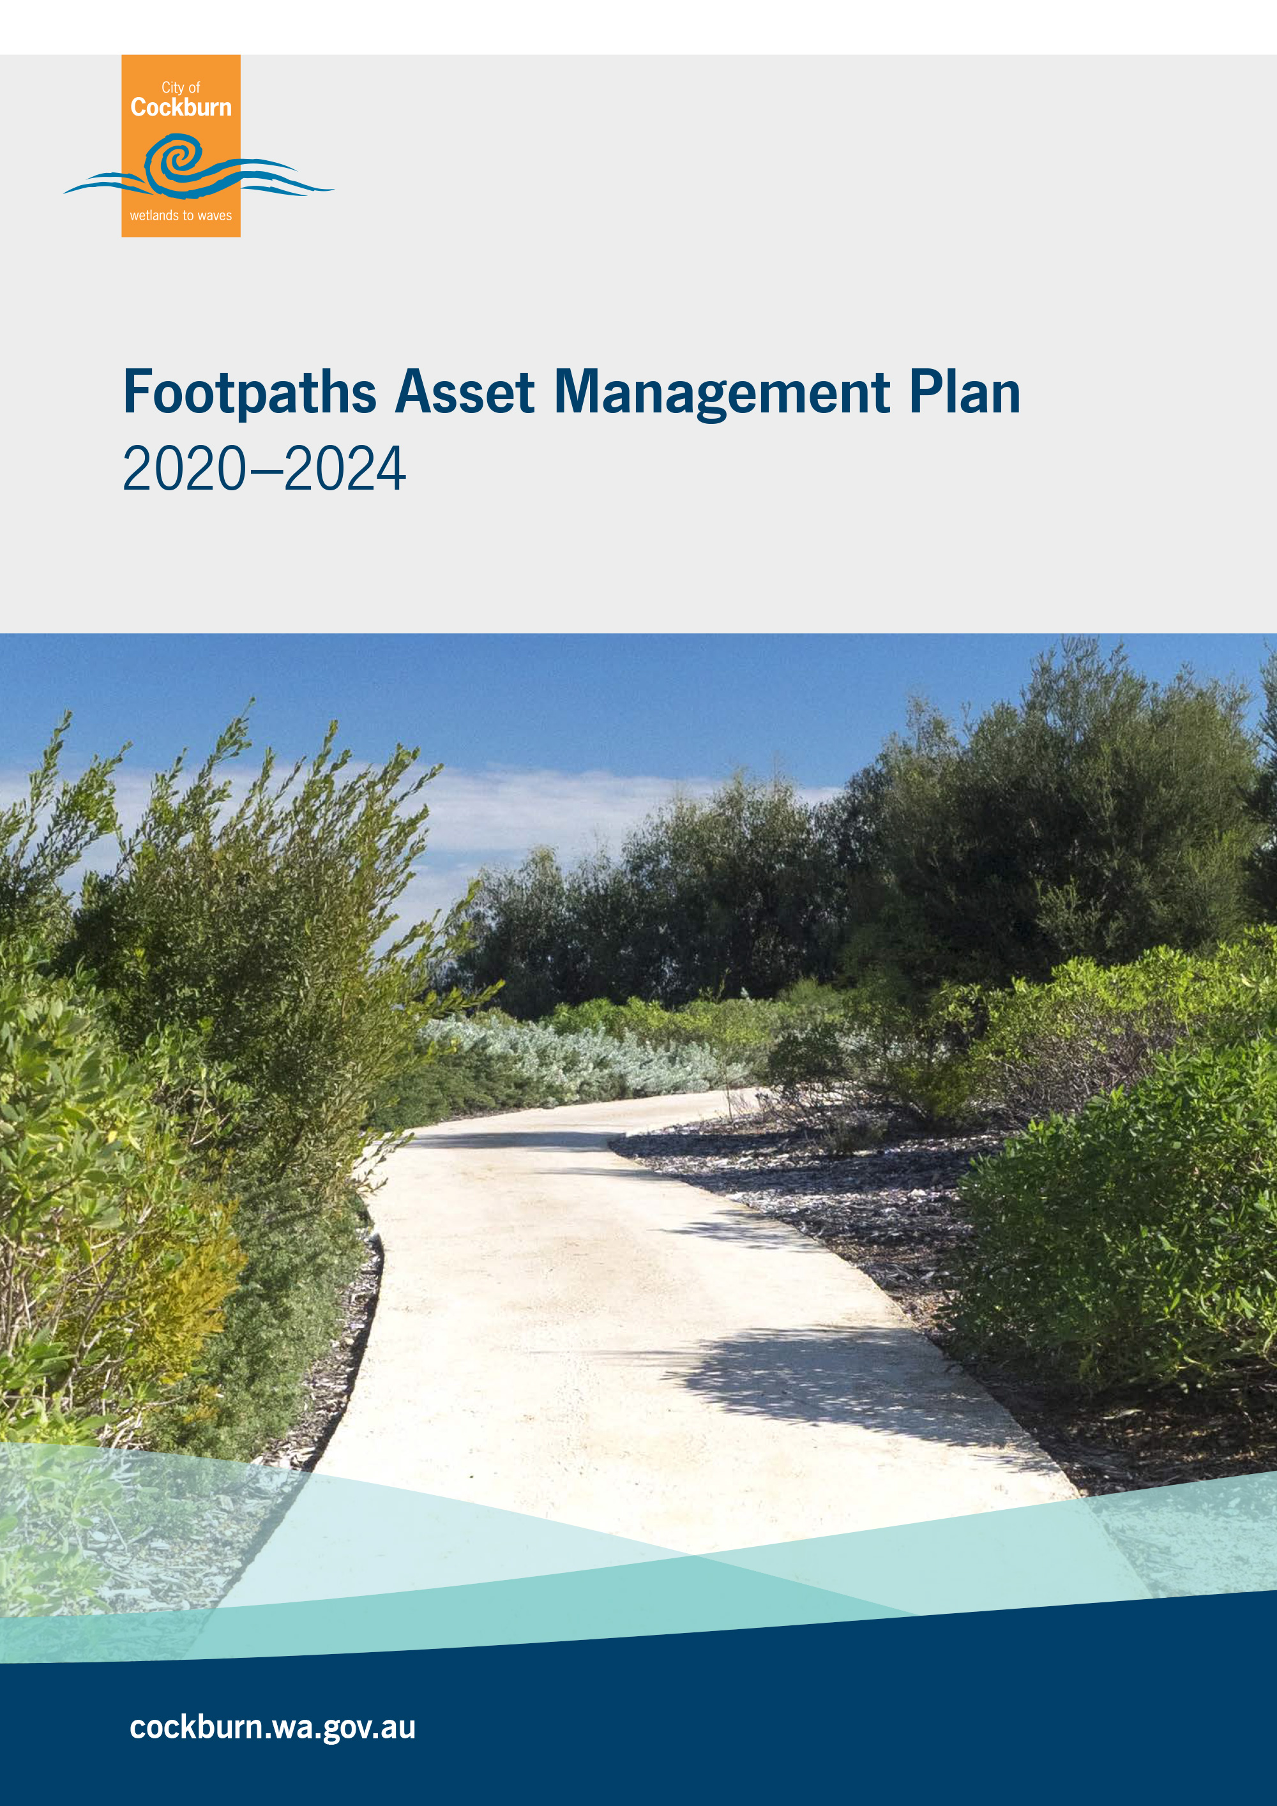
Front cover image is taken at Coogee Beach Reserve, Coogee

Document Control |  | 
Version No | Date | Version Details | Author | Reviewer | Approver
1 | Dec 2012 | Original document | Asset Services | Road services
2 | Feb 2013 | Final version for adoption | Asset Services | Manager Engineering service | Council
3 | August 2015 | Final version 2014 - 2017 | Asset Services | Manager Engineering Services | Executive Group
4 | June 2018 | Final Version 2017-2020 | Asset Services | Manager Engineering Services | Executive Group
5 | Sept 2021 | Final Version 2020 -2024 | Project & Asset Services | Manager Engineering Services | Executive Committee (ExCo)
Acknowledgement of Country
The Mayor, Councillors and staff of the City of Cockburn acknowledge the Whadjuk Nyungar people of Beeliar boodja as the traditional custodians of this land. We pay our respect to the Elders, past, present and emerging.

Table Of Contents
Glossary i
1. Executive Summary 1
2. Introduction 5
2.1 Background 5
2.2 Goals and Objectives of Asset Management 6
2.3 Plan Framework 8
2.4 Asset Management Maturity 8
2.5 Asset Management Plan – Data confidence assessment 10
3. LEVELS OF SERVICE 12
3.1 Customer Research and Expectations 12
3.2 Current Levels of Service 13
3.3 Enterprise Risk Management 15
3. 4 Legislative Requirements 18
3.5 Asset Capacity and Performance 18
4. FUTURE DEMAND 19
4.1 Growth Forecast 19
4.2 Changes in Technology 20
4.3 Demand Management Plan 20
4.4 New Assets from Growth 22
5. LIFECYCLE MANAGEMENT 24
5.1 Asset Data 24
5.1.1 Asset Age 25
5.1.2 Asset condition 26
5.1.3 Useful life 30
5.1.4 Asset Valuations 32
5.2 Maintenance and Operating expenditure 34
5.2.1 Summary of future maintenance expenditures 35
5.2.2 Standards and specifications 35
5.3 Renewal and Replacement Plan 35
5.3.1 Renewal plan - Footpaths 35
5.4 New and Upgrade Plan 36
5.4.1 Summary of future upgrade/new assets expenditure 36
5.5 Disposal Plan 37
6. FINANCIAL ANALYSIS 38
6.1 Financial Statements and Projections 38
6.2 Funding Strategy 41
6.3 Sustainability of service delivery 41
6.3.1 Asset Consumption Ratio (ACR) 42
6.3.2 Asset Sustainability Ratio (ASR) 42
6.3.3 Asset Renewal Funding Ratio (ARFR) 43
6.4 Valuation Forecasts 44
6.5 Key Assumptions made in Financial Forecasts 46

7. ASSET MANAGEMENT PRACTICES 47
7.1 Accounting/Financial Systems 47
7.2 Asset Management Systems (EAM) 47
7.3 Information Flow Requirements and Processes 48
7.4 Standards and Guidelines 48
8. PLAN IMPROVEMENT AND MONITORING 49
8.1 Performance Measures 49
8.2 Improvement Strategy 49
8.3 Monitoring and Review Procedures 52
REFERENCES 54
APPENDICES 55
Appendix A Legislative Requirements 55
Appendix B Footpath Renewals for 2021/22 57
Appendix C New Footpaths for 2021/22 58
Appendix D Preliminary Renewals for 2021/22 59
Appendix E Standards and Specifications 61

Glossary
ASPEC (M, O, R, D) Specification
ASPEC data Specification and the City’s operational register classification i.e. Marina and Coastal Infrastructure, Open Space, Road and Drainage Specification

Asset
A physical component of a facility which has value enables a service to be provided and has an economic life of greater than 12 months.
Asset Class
Groupings of assets of similar nature and use in a local government’s operations (AASB 166.37)
Asset Classification
A division of the asset class regarded as having particular shared characteristics
Asset Type
Defines the range of assets held in the asset classification ie ASpec
Asset Condition
Is a measure of the asset’s physical integrity to enable prediction of maintenance, rehabilitation and renewal requirements.
Asset Management
The combination of management, financial, economic, engineering and other practices applied to physical assets with the objective of providing the required level of service in the most cost effective manner.
Capital Renewal Expenditure
Expenditure/ works on an existing asset which returns the service potential or the life of the asset to that which it had originally.
Capital New Expenditure
Expenditure used to create new assets or to increase the capacity of existing assets beyond their original design capacity or service potential.
Capital Upgrade Expenditure
Expenditure which enhances an existing asset to provide a higher level of service or expenditure that will increase the life of the asset beyond that which it had originally.
Current Replacement Cost (CRC)
The cost of replacing the service potential of an existing asset, by reference to some measure of capacity, with an appropriate equivalent asset.

Depreciation
The wearing out, consumption or other loss of value of an asset whether arising from use, passing of time or obsolescence through technological and market changes.
*The systematic allocation of the depreciable amount (service potential) of an asset over its useful life.
Depreciated Replacement Cost
The replacement cost of an existing asset less an allowance for wear and consumption, having regard for the remaining economic life of the existing asset.
Expenditure
The spending of money on goods and services.
Fair value
Fair value is defined as the price that would be received to sell an asset or paid to transfer a liability in an orderly transaction between market participants at the measurement date.
Funding gap *
Difference between estimated budgets and projected expenditures from the Long Term Financial Plan for maintenance and renewal of assets, totalled over a defined time.
Gap Analysis
A method of assessing the gap between a business’s current asset management practices and the future desirable asset management practices.
Integrated Planning and Reporting
A framework for establishing community priorities and linking this information into different parts of a local government’s functions.

Level of Service *
The defined service quality for a particular activity or service area against which service performance can be measured. Service levels usually relate to quality, quantity, reliability, responsiveness, environmental, acceptability and cost.
Life Cycle Management
The total cost of an asset throughout its life including costs for planning, design, construction, acquisition, operation, maintenance, rehabilitation and disposal.
Long Term Financial Plan (LTFP)
Supported by the Asset Management Planning Process the LTFP is a ten year rolling plan that informs the Corporate Business Plan to activate Strategic Community Plan priorities. From these planning processes, Annual Budgets that are aligned with strategic objectives can be developed.
Maintenance
All actions necessary for retaining as asset as near as practicable to its original condition, but excluding rehabilitation or renewal.
Non-Asset Solution
The process used to identify the alternative methods of addressing, reducing and/ or increasing demand for services other than by adjusting asset capacity.
Operating expenditure *
Recurrent expenditure, which is continuously required excluding maintenance and depreciation, eg power, fuel, staff, plant equipment, on-costs and overheads.
Planned Maintenance *
Repair work that is identified and managed through a maintenance management system, activities include inspection, assessing the condition against failure/breakdown criteria/experience, prioritising scheduling, actioning the work and reporting what was done to develop a maintenance history and improve maintenance and service delivery performance.

Reactive maintenance *
Unplanned repair work that is carried out in response to service requests and management/supervisory directions.
Remaining life *
The time remaining until an asset ceases to provide the required service level or economic usefulness. Age plus remaining life is economic life.
Replacement Cost
The cost of replacing an existing asset with a substantially identical new asset.
Risk Management *
The application of a formal process to determine the range of possible values relating to key factors associated with a risk in order to determine the resultant ranges of outcomes and their probable occurrence.
Strategic Community Plan
The strategy and planning document that reflects the longer term (10+ year) community and local government aspirations and priorities.
Useful life *
Either:
(a) the period over which an asset is expected to be available for used; or
(b) the number of production or similar units (i.e. intervals, cycles) that is expected to be obtained from the asset..
Source: Government of WA Asset management framework and guidelines, Glossary
*Source: DVC 2006, Glossary ‘Asset Investment Guidelines’

1. Executive Summary
With the implementation of the City’s Integrated Corporate planning Framework, the Footpath Asset Management Plan (FAMP) has been developed to establish sustainable financial management, robust governance, continuous improvement and best practice management of the City’s infrastructure assets.
The FAMP covers the 2020-21to 2023-24 financial years and includes all footpaths within the City. The data utilised in the creation of the Footpath Asset Management Plan is based on the City’s operational asset register and is considered to be approximately 95% accurate. The condition ratings were established as a result of a full footpath network assessment conducted by Talis Ltd in 2019.
The FAMP is one of eight AMPs developed by the City and forms part of the City’s Strategic Asset Management Planning Framework. The FAMP will be developed every four years in alignment with the Corporate Planning Framework ensuring that the City’s long term financial planning (LTFP) is supported by timely and accurate asset information and financial projections derived from a structured and strategic asset management planning process.
The 2020 - 2024 version of the FAMP is developed by the City and in accordance with the International Infrastructure Management Manual (IIMM) and has achieved intermediate level status.
The FAMP improvement strategy will guide the Engineering Service Unit to continuously improve services provided, establishing best practice strategic and operational asset management methodologies across people, processes and systems.
Table 1.1 Footpath Infrastructure Assets Summary Table as at October 2020
Asset category | Category | 13/14  Dimension | 13/14  CRC | 16/17  Dimension | 16/17  CRC | 19/20  Dimension | 19/20  CRC
Roads | < 1.5m width | 63.11 km | $44.70m | 63.70 km | $56.51m | 65 km | $74m
Roads | > or = to 1.5m width | 470.27 km | $44.70m | 512.78 km | $56.51m | 566 km | $74m
Parks | < 1.5m width | 5.20 km | $7.48m | 5.21 km | $8.78m | 5.44 km | $12m
Parks | > or = to 1.5m width | 88.50 km | $7.48m | 90.36 km | $8.78m | 105.46 km | $12m
TOTAL |  | 627.08 km | $52.18m | 672.05 km | $68.23m | 736.73 km | $86m
The key messages from the 2020 Footpath Infrastructure Asset Management Plan are summarised below.
Asset Data & Condition Analysis
- The data utilised to develop the FAMP is considered to be approximately 95% accurate and of medium confidence. The recent condition ratings were established by network assessment conducted by Talis in August, 2019.

- The FAMP Infrastructure assets are in an excellent to moderate condition with 32% of the assets in condition 1, 42% in condition 2 and 20% in condition 3. See legend at Graph 5.1.2A Asset Condition Profile.
Level of Service and Risk Management
Level of Service is a measurable target which determines the type and extent of services delivered to the Community. Footpath Infrastructure levels are measured internally and, by the community to determine adequate provision. The following findings have been drawn from the CATALYSE Pty Ltd Survey 2019.
- Overall Satisfaction with the City of Cockburn has increased by 1% from 2017 to 98% in 2019.

- Community satisfaction for the City’s footpath maintenance service is high, with 82% of those surveyed either delighted or satisfied.

- There are 10% of footpaths that do not currently meet the desired service level of a minimum width of 1.5m.
See (Section 3) for further information
Future Growth and Demand Management
Future growth projections are supported by the City’s Strategic Planning Service Population and demographic research, whilst Demand for new services will be administered through upgrading existing and providing new assets.
- A cumulative growth of approximately 18,788 m² to the footpath network every year, over the next 5 years. This represents an increase in replacement cost of $1,215,895 per year.

- Estimated project costs of $13 million invested through the delivery of the ten year new capital works program.

See (Section 4) for further information
Lifecycle Management findings
The lifecycle management section details how the City plans to manage and operate both current and future assets to the agreed levels of service whilst optimising life cycle costs.
- Maintenance expenditure levels are considered to be adequate to meet current service levels.

- Planned maintenance work was 80% of total maintenance expenditure for 2019-20.

- By 2029-30 required expenditure for Operations and Maintenance is expected to be around $1.5million per year.
See (Section 5) for further information
Financial Analysis
Footpath Asset Renewal Forecasts
The City has developed a 10 year footpath renewal plan which will drive the budget planning process and form the basis to the City’s long term financial planning
- The City’s footpath network is in excellent condition with 73% currently rating as either a 1 or a 2.

- Currently only 6.8% of footpaths have reached the renewal intervention level of condition 4. These assets and less than 1.5m width paths currently form the basis of the 10 year renewal program.

- The higher risk rated assets (condition 4 & 5) will be internally reassessed late 2020 and form the basis of the 5 year Renewal Program.
See (Section 6) for further information

Sustainability of Service Delivery
The City will compile and report its Footpath infrastructure assets performance in relation to the Dept. of Local Government’s Asset Management Guidelines and Framework.
Based on actual expenditure in 2019/20, the following table indicates the City’s performance in managing footpath infrastructure assets as at October 2020.
Table 1.2 Footpath Infrastructure Asset Ratio Summary Table
Asset Class | Consumption Ratio  20190-20 | Sustainability Ratio  201920 | Renewal Funding Ratio
Asset Class | Consumption Ratio  20190-20 | Sustainability Ratio  201920 | 10 year | 5 year
Footpaths | 70% | 24% | 98% | 97%
Dept. of LG Framework Standards | Met | Not met | Met | Met

Sustainability ratios for Footpath infrastructure have been forecast for the next 10 years to reflect the improvements the City will make following the completion of the LTFP. The sustainability ratio for the 2029-30 period is predicted to be 49%, the renewal funding ratio for the same period is predicted to be 99%. Since 73% of the City’s footpath network is condition 1 or 2 thus explaining the lower sustainability ratio.
See (Section 6) for further information
Plan Improvement Strategy and Monitoring
Most of the strategic improvements identified in the previous FAMP are now complete.
Further improvements that will continue to develop future revisions of the plan have been identified and provide greater financial alignment with the Long Term Financial Plan 2020/21-2029/30.
- Review asset custodianship across Service Units to better target ongoing maintenance and renewal expenditure i.e. Parks.

- Reassess higher risk rated (Condition 4 & 5) paths internally to create a more informed renewal works program.

- Review and update City’s Cycling and Walking Network Plan 2016-2021.
See (Section 8) for further information

2. Introduction

2.1 Background
This asset management plan has been developed to assist the Infrastructure Services unit to outline the management of assets, compliance with regulatory requirements, and to highlight the funding required to provide the appropriate Levels of Service.
The assets covered by this plan are summarised in Table 2.1.1. Figures as at June 2020 have been extracted from Council’s Technology One Enterprise Asset Management System (EAM)
Table 2.1.1 Footpath Infrastructure Assets covered by this FAMP
Jurisdiction | Width | Length (km) | Area (m2)
Parks | < 1.5m width | 5.44 | 6,570
Parks | 1.5m to 2.0m width | 38.59 | 72,211
Parks | > 2.0m width | 66.98 | 163,753
Roads | < 1.5m width | 64.88 | 81,071
Roads | 1.5m to 2.0m width | 373.64 | 647,469
Roads | > 2.0m width | 187.39 | 461,407
TOTAL |  | 735.92 | 1,432,480

The AMP is to be read in conjunction with the following associated planning documents:
City of Cockburn Strategic Community Plan 2020 – 2030
City of Cockburn Corporate Business Plan 2016/17 – 2019/20
City of Cockburn Annual Business Plan 2019 – 2020
City of Cockburn Long Term Financial Management Plan 2020/21 – 2029/30

Key stakeholders in the preparation and implementation of this asset management plan are shown in Table 2.1.2.
Table 2.1.2 Key Stakeholders in the AM Plan
ENTITY: | NATURE OF INVOLEMENT
INTERNAL STAKEHOLDERS:
The Elected Council | Community representation
Chief Executive Officer (CEO) | Asset management direction and leadership
Executive Committee (ExCo) | Executive management endorsement, sign off and executive ownership
Manager Property and Assets | Review and strategic management sign off
Manager Civil Infrastructure | Review and line management sign off and implementation of the AMP maintenance actions.
Property and Assets | Asset management plan development, review and continuous improvement
EXTERNAL STAKEHOLDERS:
Insurers | Assist to manage financial risk of the City
City of Cockburn community | Footpath and service users
City of Cockburn Businesses | Footpath and service users
Government Agencies | Attend emergencies, provide assistance and security
Department of Transport | Attend emergencies, provide assistance and security
Department of Lands | Attend emergencies, provide assistance and security

2.2 Goals and Objectives of Asset Management
The City of Cockburn exists to deliver services to its community supported by the City’s infrastructure assets. The City acquires infrastructure assets by ‘purchase’, ‘contract’, construction by council and by handover of ‘donated’ assets constructed by developers in order to meet the increased demand for services.
The City of Cockburn’s goal in managing infrastructure assets is to meet the required level of service in the most cost effective manner for present and future consumers.
The key elements of infrastructure asset management are:
- Taking a life cycle approach,
- Developing cost-effective management strategies for the long term,
- Providing a defined level of service and monitoring performance,
- Understanding and meeting the demands of growth through demand management and infrastructure investment,
- Managing risks associated with asset failures,
- Sustainable use of physical and financial resources, and
- Continuous improvement in asset management practices.

This AMP is prepared under the direction of Council’s vision, mission, goals and objectives.

The City of Cockburn’s vision is:
Cockburn, the best place to be
The City of Cockburn’s purpose is:
Support our communities to thrive by providing inclusive and sustainable services which reflect their aspirations
The 5 key outcomes as detailed in the Strategic Community Plan (SCP) 2020-2030 are:
- Local Economy,
- Environmental Responsibility
- Community, Lifestyle & Security
- City Growth and Moving Around
- Listening and Leading
The relevant goals and objectives as outlined in the Strategic Community Plan and how these are addressed in this asset management plan are detailed in Table 2.2.1.
Table 2.2.1 Council Goals and how these are addressed in this Plan
Strategic Outcome | Strategic Objective | How Outcomes and Objectives are addressed in this asset management plan
Community, Lifestyle and Secutity:  A vibrant, healthy, safe, inclusive and connected community | 1. Accessible and inclusive community, recreation and cultural services and facilities that enrich our community | Future Demand:  Section 4  Financial Analysis:  Section 6
Environmental Responsibility:  A leader in environmental management that enhances and sustainably manages our local natural areas and resources | 1. A vibrant, healthy, safe, inclusive and connected community | Levels of Service:  Section 3
City Growth and Moving Around: A growing City that is easy to move around and provides great places to live | 1. An attractive, socially connected and diverse built environment  2. An integrated, accessible and improved transport network | Future Demand:  Section 4
Listening and Leading:  A community focused, sustainable, accountable and progressive organisation | 1. Best practice Governance, partnerships and value for money | Financial Analysis:  Section 6

2.3 Plan Framework
Key elements of the AMP are:
- Levels of Service and Enterprise Risk Management – outlines the levels of service provided by Council and identifies risks to the City.

- Future Growth and Demand – how this will impact on future service delivery and how this is to be met.

- Lifecycle Management – how the City will manage its existing and future assets to provide the required services.

- Financial Analysis – what funds are required to provide the required services.

- Asset management practices.

- Asset management monitoring and improvement plan – how the plan will be monitored and improved to ensure it is meeting Council’s objectives.

2.4 Asset Management Maturity
The 2020-24 FAMP has been developed in accordance with the International Infrastructure Management Manual (IIMM) and complies with the Department of Local Government & Communities Asset Management Framework.
As part of the City’s Strategic Asset Management Framework, the FAMP will formalise the City’s future forecasting for Footpath Infrastructure, enabling the organisation to determine future budgeting requirements, sustain the current and future asset base, whilst ensuring that optimisation of activities and programs facilitate for the capture and reporting of adopted service levels.
The FAMP has reached an ‘intermediate’ level of maturity and provides Executive level monitoring and reporting of key improvement areas from the Improvement Strategy.
With the continued implementation of the Strategic Asset Management Framework, the City will commence measuring service levels for planned and reactive maintenance to determine operational performance and asset utilisation.
The City strives to improve its strategic and operational asset management practices and to continue its journey towards advanced asset management. The Department of Local Government, Sport and Cultural Industries (DLGSC) has developed the Western Australia Local Government Integrated Planning and Reporting Framework. The future direction and need for advanced level practices are continually assessed in accordance with this and the City’s Asset Management Policy. The Integrated Planning and Reporting Framework is shown Figure 2.4.1.
Figure 2.4.1 The City’s Corporate Planning Framework
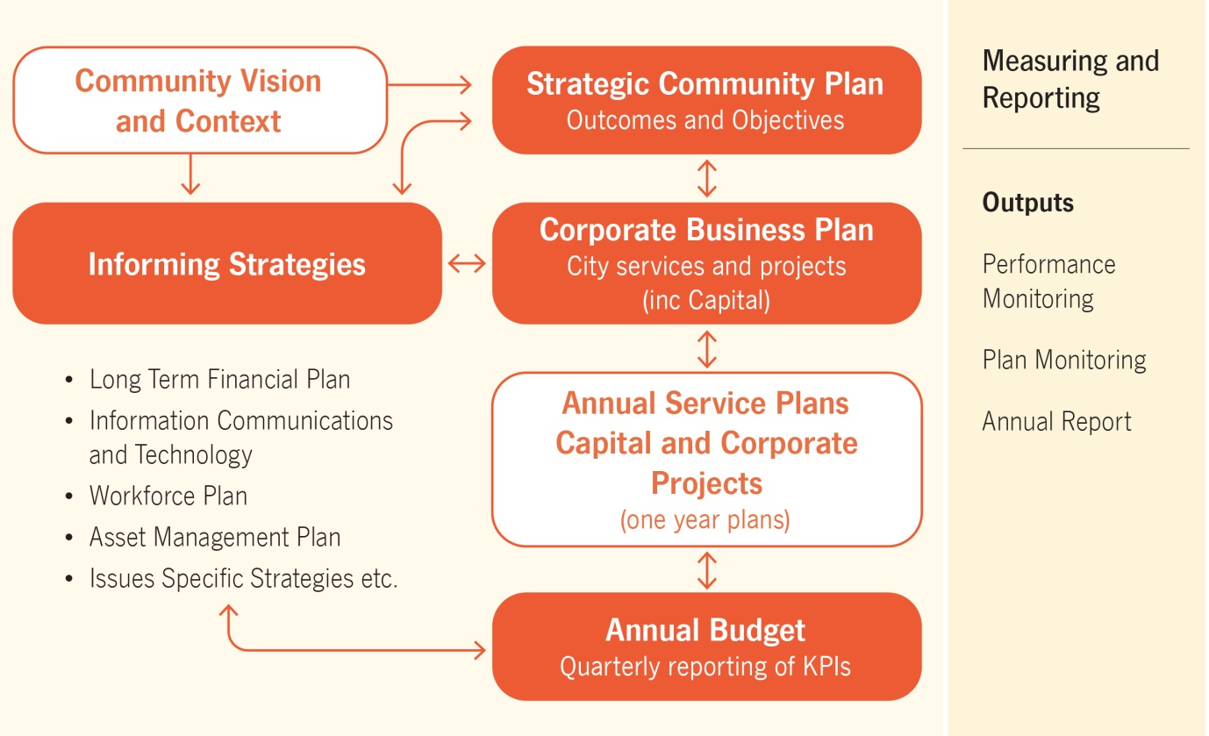
The FAMP forms part of the City’s Assets Informing Strategies, which consists of the following strategy and asset management plans:
Asset Management Strategy – 2017 - 2014
Buildings AMP - 2020 - 2024
Cockburn Aquatics and Recreation Centre (ARC) AMP – 2020 - 2024
Drainage AMP - 2020 - 2024
Fleet and Plant AMP - 2020 - 2024
Marina and Coastal Infrastructure AMP - 2020 - 2024
Parks & Environment AMP - 2020 - 2024
Road AMP - 2020 – 2024

2.5 Asset Management Plan Maturity - Data Confidence Assessment
Each of the five sections within the FAMP were reviewed to determine Stakeholder confidence as to the accuracy and maturity of the City’s asset data and services.
Table 2.5.1 Data Accuracy
AMP | Contents | Data Accuracy
Section 2 | Strategic goals & objectives | A
Section 3 | Levels of Service | A
Section 3 | Risk Management | A
Section 4 | Growth, Demand, New Assets | A
Section 5 | Asset data; Age, Condition | B
Section 5 | Operating & Maintenance Expenditure, Renewal Expenditure | B
Section 6 | Financial statements; Renewals Gap, Ratios | A

Ratings are based on the following criteria / inputs.
Table 2.5.2 Data confidence criteria
Confidence Grade | Description
A Highly reliable | Data based on sound records, procedures, investigations and analysis, documented properly and agreed as the best method of assessment. Dataset is complete and estimated to be accurate ± 2%
B Reliable | Data based on sound records, procedures, investigations and analysis, documented properly but has minor shortcomings, for example some of the data is old, some documentation is missing and/or reliance is placed on unconfirmed reports or some extrapolation. Dataset is complete and estimated to be accurate ± 10%
C Uncertain | Data based on sound records, procedures, investigations and analysis which is incomplete or unsupported, or extrapolated from a limited sample for which grade A or B data are available. Dataset is substantially complete but up to 50% is extrapolated data and accuracy estimated ± 25%
D Very Uncertain | Data is based on unconfirmed verbal reports and/or cursory inspections and analysis. Dataset may not be fully complete and most data is estimated or extrapolated. Accuracy ± 40%
E Unknown | None or very little data held.

3. Levels of Service
To support the management of footpath assets the City has developed industry best practice asset management and customer focussed levels of service (LOS) for infrastructure assets and associated services. These LOS’s provide the City with a mechanism to deliver operational activities that endeavour to meet community expectations in the most cost effective manner possible.

The City administers Community and Technical Services levels to ensure that quality service provision is provided in accordance with the City’s customer Service Charter and Community Engagement Framework, whilst Technical Services are sustainable, and adhere to all relevant compliance and safety industry standards.

The FAMP community and technical levels of service are defined to an asset group level and enable the City to monitor and report operational performance against adopted community and technical targets.

Similar to the City’s existing Asset Management Plans, future FAMP Service level reporting will be derived from the City’s Enterprise Asset Management System (EAM). The Implementation of the EAM will establish improved reporting of operational and maintenance budget expenditure providing increased confidence in projecting future budget needs.

3.1 Customer Research and Expectations
The City of Cockburn administered the CATALYSE Business and Community Perceptions Survey’s to evaluate and monitor performance across a range of services.
699 Residents and 138 local businesses participated in the studies. The surveys were conducted by CATALYSE Pty Ltd and provide Council with valid performance measures that can be benchmarked and consistently monitored over time.
The most recent customer satisfaction surveys were undertaken in May 2019 – Customer Scorecard and October 2019 – Business scorecard the performance comparison of satisfaction levels over the past five years are compared using a traffic light system to measure increasing or decreasing satisfaction.
Key to status
Drop in customer satisfaction of 3% or more
Change in customer satisfaction of 2% or less
Increase in customer satisfaction of 3% or more

3.2 Current Levels of Service
The City of Cockburn has defined service levels in two terms:
- Community Levels of Service relate to how the community receives the service in terms of safety, quality, quantity, reliability, responsiveness, cost efficiency and legislative compliance.

- Supporting the community service levels are operational or technical measures of performance developed to ensure that at least the minimum community levels of service are met. Technical Levels of Service relate to how the City provides the service using technical terms
Historical tracking of customer satisfaction surveys over the last 5 years
Table 3.1.1 Community
Performance Measure | Satisfaction Level (delighted & satisfied)
Performance Measure | 2015-16 | 2016-17 | 2017-18 | 2018-19 | 2019-20 | Status from last year
Overall satisfaction with City of Cockburn (as a place to live) | 93 | 99 | 97 | 97 | 98
Footpaths | 82 | 56 | 59 | 85 | 82
Cycleways
Access to public transport | 80 | 61 | 61 | 85 | 83

Table 3.1.2 Business
Performance Measure | Satisfaction Level (delighted & satisfied)
Performance Measure | 2014-15 | 2015-16 | 2016-17 | 2017-18 | 2019-20 | Status from last year
Overall satisfaction with City of Cockburn (as a business location) | 85 | 89 | 95 | 93 | 91
Access to public transport | 67 | 60 | 84 | 77 | 77

Although overall satisfaction levels with the City of Cockburn as a business location have slightly fallen, the City has achieved the Industry High with an index score of 71.
Community satisfaction is 82% for footpath and cycleways, but this is still a priority area for further improvement with 11% of respondents rating it as a main priority.
The City of Cockburn uses this information to continue developing the Strategic Community Plan and determine the allocation of resources to meet the community’s needs.
- Footpaths have a suitable smooth walking surface and are aesthetically pleasing
Community – Total number of Customer enquiries and/or requests relating to footpath repairs
Community | 2012-13 | 2013-14 | 2016-17 | 2017-18 | 2019-20 | Status
Total | 207 | 204 | 213 | 156 | 222

Technical – Footpaths are to be maintained to a good condition with an intervention level being set at condition 4
Condition rating of footpath as a % of total area
Technical | % of total area | % of total area in condition 4 or 5 |  |  |  |  | Status
Technical | % of total area | 2011-12 | 2012-13 | 2013-14 | 2016-17 | 2019-20 | Status
Total | 100% | 3.77% | 3.35% | 3.42% | 14.2% | 6.8%
Parks | 17.30% | 1.47% | 1.36% | 1.38% | 4.7% | 1.8%
Roads | 82.70% | 2.30% | 1.99% | 2.04% | 9.5% | 5.0%

- Footpaths are free from trip hazards and obstructions and are an adequate width
Community – Total number of Customer enquiries and-or requests relating to footpath sweeping
Community | 2012-13 | 2013-14 | 2016-17 | 2017-18 | 2019-20 | Status
Total | 50 | 58 | 68 | 70 | 100

The footpath sweeping schedule is currently being revised as at present only footpaths 2m or wider are swept on a regular basis.
Technical – Percentage of footpaths (by length) less than 1.5m wide.
Technical | % of total length | % of total length less than 1.5m wide |  |  |  |  | Status
Technical | % of total length | 2011-12 | 2012-13 | 2013-14 | 2017-18 | 2019-20 | Status
Total |  | 11.34% | 10.92% | 10.89% | 10.25% | 10.00%
Parks | 14.98% | 0.86% | 0.80% | 0.83% | 0.77% | 1.00%
Roads | 85.02% | 10.48% | 10.92% | 10.06% | 9.48% | 9.00%

- Ensure that footpaths meet community needs for pedestrian and bike travel and that all new footpaths are DDA compliant.
Community – Total number of Customer enquiries and-or requests relating to new footpaths
Community | 2012-13 | 2013-14 | 2016-17 | 2017-18 | 2019-20 | Status
Total | 77 | 64 | 60 | 70 | 71

Technical – Number of footpath junctions requiring kerb ramps – Not known
- Maintain footpaths by proactive repairs
Technical – Lower percentage of maintenance done by reactive repairs
Technical | 2011-12 | 2012-13 | 2013-14 | 2016-17 | 2019-20 | Status
Reactive maintenance | 38.80% | 27.10% | 26.50% | 60.78% | 20.20%
Planned maintenance | 61.20% | 72.90% | 73.50% | 39.22% | 79.80%

3.3 Enterprise Risk Management
In 2015 the City implemented a Risk Management & Safety System (RMSS) in which all operational and strategic risks are captured, rated and receives ongoing monitoring based on their level of risk.
Additionally, in 2017 the Risk Management Framework was adopted with the aim of supporting an integrated and effective organisational wide approach to risk management.
The implementation of the Framework sought to:
- Ensure a consistent approach to the risk management process across Council;
- Establish a structured process for undertaking the risk management process to identify, assess and control/treat risks;
- Encourage the integration of risk management into the strategic and operational process across all Business Units of the Council
There are currently no Extreme and High Risks associated with the Footpath Infrastructure only substantial risks as determined by the City’s risk register.

Table 3.3.1 Substantial Risk and Existing Controls
Risk Description | Risk Rating | Proposed Treatment | Due Date
Failure to adequately review and deliver the City's walking, cycling and trail network due to inadequate data, incorrect analysis of walking and cycling uses, inaccuracy in prioritising the network upgrade, lack of resources, human error and inadequate funding. | Substantial | 1. Use of external funding | Ongoing
 | Substantial | 2. City's walking, cycling and trail plan | Ongoing
 | Substantial | 3. Stakeholders consultation | Ongoing
 | Substantial | 4. Engage an external consultant and contractors | Ongoing
 | Substantial | 5. Peer review | Ongoing
Footpath not compliant to disability access guidelines leading to complains and reconstruction | Substantial | 1. Consultation and design as per disability access standards. | Ongoing
Footpath trip hazard causing injury, legal action, financial impact and reputation damage. | Substantial | 1. Sign Off process | Ongoing
 | Substantial | 2. Membership of peak bodies | Ongoing
 | Substantial | 3. Relationship with Main Roads and other stakeholders | Ongoing
 | Substantial | 4. Road Safety Audit | Ongoing
Failure to plan for the future maintenance and the path assets resulting in asset failure and service delivery delay | Substantial | 1. Supporting the City's Asset Management team | Ongoing
 | Substantial | 2. Reviewing process, engage an external consultant | Ongoing

The City uses a matrix based approach when addressing risk level, treatment and responsibility as detailed in Table 3.3.2.

Table 3.3.2 Risk Treatment Matrix
Risk Level | Code | Criteria | Treatment | Responsibility
LOW | L | Risk acceptable with adequate controls, managed by routine procedures. Subject to annual monitoring or continuous review throughout project lifecycle. | Management through routine operations/project, Risk Registers to be updated. | Service Unit Manager/Project Manager
MODERATE | M | Risk acceptable with adequate controls, managed by specific procedures. Subject to semi- annual monitoring or continuous review throughout project lifecycle. | Communication and awareness of increasing risk provided to SM, Risk Registers to be updated. | Senior Manager/Project Manager
SUBSTANTIAL | S | Accepted with detailed review and assessment. Action Plan prepared and continuous review. | Assess impact of competing Service Unit/Business Unit Projects. Potential redirect of Service Unit/Business Unit resources. Risk registers to be updated. | Director/Steering Committee
HIGH | H | Risk acceptable with effective controls, managed by senior management/executive. Subject to quarterly monitoring or continuous review throughout project lifecycle. | Escalate to CEO, report prepared for Audit & Strategic Finance Committee. Quarterly monitoring and review required. Risk Registers to be updated. | Executive/ Steering Committee/Project Sponsor
EXTREME | E | Risk only acceptable with effective controls and all treatment plans to be explored and implemented where possible, managed by highest level of authority and subject to continuous monitoring. | Escalate to CEO, report prepared for Audit & Strategic Finance Committee. Monthly monitoring and review required. Risk Registers to be updated. | CEO/Council/Project Sponsor
Each of the risks are reviewed with current and proposed control measures being assessed yearly to ensure industry standards and potential advancements are considered and are incorporated as required.

3. 4 Legislative Requirements
The City of Cockburn has to meet many legislative requirements including Australian and State legislation and State regulations.
See (Appendix A) for the Legislative Requirements

3.5 Asset Capacity and Performance
The City of Cockburn services are generally provided to meet design and performance standards where these are available.
Locations where deficiencies in service performance are known have been identified by Road Services and are detailed in the following table.
Table 3.5.1 Known Service Performance Deficiencies
Location | Service Deficiency
New development inconsistencies | Not built to standards as no strict guidelines; except liveable neighbourhoods standards.

4. Future Growth & Demand

4.1 Growth Forecast
Cockburn is one of the major Coastal Cities found in the state of Western Australia, totalling 170 square kilometres. This coastal City is renowned for its historical and tourism features along with agriculture and ship building industries.
The City of Cockburn’s 2020 forecasted population and dwelling is 120,417 and 46,800 dwellings respectively. The population is forecast to reach 169,700 by 2041, an increase of 40.92%.
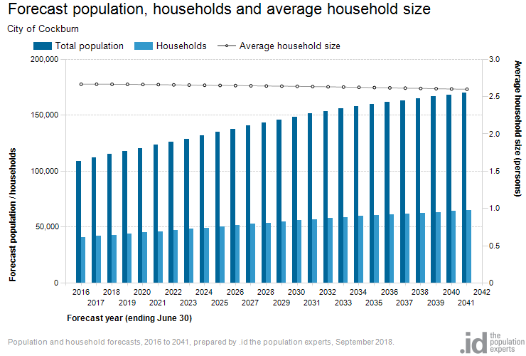
Growth factor trends and the impacts these have on service delivery across the City are summarised in Table 4.1.

Table 4.1 Growth, Projections and Impact on Services

Demand factor | Present position | Projection | Impact on services
Population | 120,417 as at year 2020 | Change between 2019 and 2041 is projected to be 49,283 a 41% increase at an average 2% per annum | Increased path asset requirement.  Increased annual maintenance costs.
Demographics | Aging population | Between 2016 and 2031 the age structure forecasts indicate 43% increase in the population of retirement age. | Increased bus services resulting in damage to road pavement & requirement to upgrade local roads for turning movements.
Industry | Existing industrial areas are expanding and reaching full potential | Extensive new industrial and commercial areas focused around Jandakot Airport and Latitude 32 Industrial area. | Requirement for freight routes and upgrading of existing roads.

4.2 Changes in Technology
Technology changes within the footpath construction industry are forecast to have little effect on the delivery of services covered within this plan.

4.3 Demand Management Plan
Demand management strategies provide alternatives to the creation of new assets in order to meet demand, and look at ways to modify customer demands so that the utilisation of existing assets is maximised and the need for new assets deferred or reduced. The objective of demand management is to actively seek to modify customer demands for services in order to;
- Optimise the utilisation and performance of existing assets,
- Reduce or defer the need for new assets,
- Meet organisation’s strategic objectives,
- Deliver a more sustainable service, and
- Respond to changing customer needs.

The opportunities identified to date for demand management, the impact these drivers may have on future service delivery and the utilisation of these assets are shown in the Table 4.3.1.
Demand for new services will be recognised through a combination of managing and upgrading of existing assets and providing new assets. Demand management practices include non-asset solutions, insuring against risks and managing failures.
Table 4.3.1 Demand Management Plan Summary
Demand Driver | Impact on Services | Demand Management Plan
Population Increase | - Strain on existing path assets  - Community dissatisfaction | - A well-considered town planning scheme  - Acquire new/expand existing additional path assets to cope with demand.  - Ensure planning any new assets are fit for purpose and financially sustainable  - Engage with community to ensure expectations are understood and managed.  - Review Service levels to manage community expectation
Changing Demographic | - Potential change in service requirement – a younger more active population will require access to adequate & connected path network | - Monitor demographic trends within the population  - Engage with community to ensure expectations are understood and managed.
Global Age Friendly Cities - The World Health Organisation (WHO) | - Upgrade of existing or new infrastructure required to ensure compliance with the Age Friendly Cities. Principles include community and healthcare, transportation, housing, social participation, outdoor spaces and buildings, respect and social inclusion, civic participation, employment and communication and information. | - City of Cockburn Age Friendly Strategy 2016 - 2021

4.4 New Assets from Growth
The new assets required to meet growth will be constructed by the City of Cockburn and acquired from land developments. The new footpath projects to be funded by the City are based on the Cycling and Walking Network Plan 2016 - 2021. This plan needs to be reviewed as part of the improvement strategy.
The forecast for donated assets likely to be received from developers over the next five years has been calculated by averaging out the previous 5 years total donated assets received through subdivisions. This equates to approx. 18,788 m² per year in hard infrastructure approximating to $1,216,000.
Graph 4.4 New Assets from Growth

These figures have been used throughout this AMP where growth has been considered.

5. Lifecycle Management
The lifecycle management area details how the City of Cockburn plans to manage and operate the footpath infrastructure assets while optimising life cycle costs. The data is based on the City’s financial and operational asset registers.

5.1 Asset Data
Approximately 110 km of footpaths fall within a public open space and are managed by the Parks and Environment service unit, these have been considered separately throughout the AMP. This does not include the trails managed by Environment services.

Table 5.1 Breakdown of Footpath Assets
Jurisdiction | Width | Length (km) | Area (m2)
Parks | < 1.5m width | 5.44 | 6,570
Parks | 1.5m to 2.0m width | 38.59 | 72,211
Parks | > 2.0m width | 66.97 | 163,753
Roads | < 1.5m width | 64.88 | 81,071
Roads | 1.5m to 2.0m width | 373.64 | 647,469
Roads | > 2.0m width | 186.39 | 461,407
TOTAL |  | 735.91 | 1,432,481

5.1.1 Asset Age
The age profile for the footpath infrastructure assets are shown in Graph 5.1.1.
Graph 5.1.1 Age Profile - Footpaths

From graph 5.1.1, 84% of the City’s Footpath assets have been constructed within the last 20 years.

5.1.2 Asset condition
The Condition profile of the City’s footpath infrastructure assets are measured using a 1 to 5 rating system as outlined below.
Rating | Description
1 | Excellent | 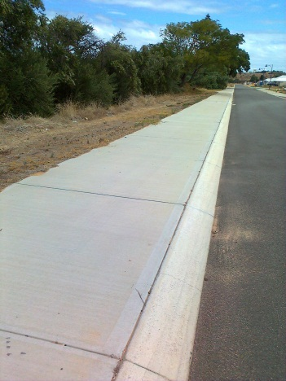 | A new asset or an asset in overall excellent condition with only a slight condition decline.
2 | Good | 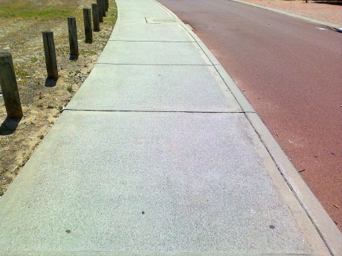 | An asset in an overall good condition but with minor signs of deterioration evident, serviceability may be slightly impaired. Minor maintenance is required
3 | Moderate | 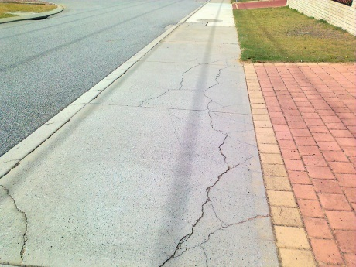 | An asset with obvious signs of deterioration. Significant maintenance is required
4 | Poor | 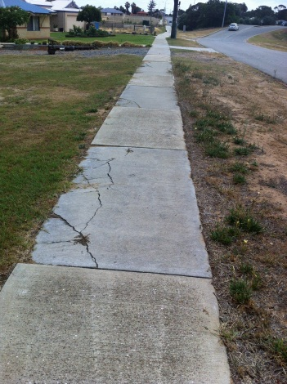 | An asset in a poor condition. Condition deterioration is severe and serviceability is becoming limited. Significant renewal or upgrade is required.
5 | Very poor | 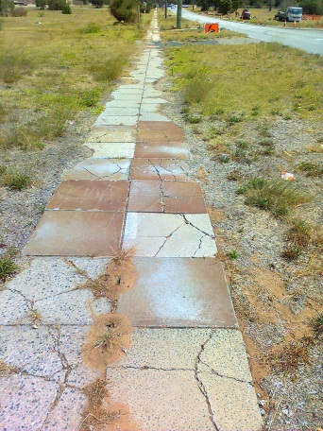 | An asset that has failed and is no longer serviceable. There would be a risk in leaving the asset in service. Replacement is required.

Based on the City’s operational asset register the condition profile for footpaths is shown on Graph 5.1 2A.

Graph 5.1.2A Condition Profile for Footpaths

The following table shows the percentage breakdown across the condition ratings by area, both as a total and by asset category.
Table 5.1.2 Summary of Footpath Condition
CONDITION | Total | Roads | Parks
1 | 31.37% | 31.97% | 28.44%
2 | 41.91% | 42.76% | 37.72%
3 | 19.91% | 19.22% | 23.32%
4 | 5.40% | 4.70% | 8.84%
5 | 1.41% | 1.36% | 1.68%
 | 100.00% | 100.00% | 100.00%

Graph 5.1.2B below shows the breakdown of footpath condition by suburb.
Graph 5.1.2B Condition Profile – Footpaths by Suburb

5.1.3 Useful life
Based on the current depreciation rate a useful life has been applied to each footpath by surface type.
Table 5.1.3A Footpath surface and useful life
Surface material | Jurisdiction | Length (km) | Area (m²) | Useful Life
Asphalt | Parks | 38.95 | 90,471 | 30
Asphalt | Roads | 46.62 | 106,421 | 30
Brick | Parks | 0.77 | 2,152 | 50
Brick | Roads | 10.64 | 23,729 | 50
Concrete | Parks | 71.07 | 149,396 | 50
Concrete | Roads | 574.43 | 1,077,695 | 50
Wood | Parks | 0.23 | 515 | 45
Wood | Roads | 0.00 | 0 | 45
TOTAL |  | 742.71 | 1,450,379

Further analysis of the City’s footpath assets by age and condition are shown on the table 5.1.3B in m2.

KEY
Greater than 50,000 m2
Between 20,000 to 50,000 m2
Between 10,000 to 20,000 m2
Between 1,000 to 10,000 m2
Less than 1,000 m2

Type | Condition | Service unit | Age of Footpath (years) |  |  |  |  |  | Average age
Type | Condition | Service unit | 0 to 5 | 6 to 10 | 11 to 15 | 16 to 20 | 21 to 25 | >25 | Average age
50 year useful life  Concrete  Brick | 1 | Parks | 25,748 | 8,870 | 24,606 | 1,921 | 2,536 | 0 | 7.5
50 year useful life  Concrete  Brick | 1 | Roads | 164,409 | 73,275 | 105,792 | 28,277 | 2,124 | 135 | 7.5
50 year useful life  Concrete  Brick | 2 | parks | 4,034 | 2,712 | 22,025 | 14,674 | 5,078 | 1,283 | 16.2
50 year useful life  Concrete  Brick | 2 | Roads | 8,958 | 54,575 | 138,521 | 171,997 | 61,390 | 28,741 | 16.2
50 year useful life  Concrete  Brick | 3 | Parks | 0 | 1,908 | 2,976 | 16,570 | 4,238 | 448 | 18.8
50 year useful life  Concrete  Brick | 3 | Roads | 268 | 7,156 | 30,179 | 85,955 | 42,413 | 22,160 | 18.8
50 year useful life  Concrete  Brick | 4 | Parks | 0 | 731 | 5,105 | 3,167 | 768 | 0 | 19.2
50 year useful life  Concrete  Brick | 4 | Roads | 263 | 2,338 | 5,609 | 15,466 | 12,072 | 7,763 | 19.2
50 year useful life  Concrete  Brick | 5 | Parks | 0 | 0 | 1,844 | 57 | 209 | 41 | 22.8
50 year useful life  Concrete  Brick | 5 | Roads | 16 | 0 | 1,847 | 4,450 | 2,220 | 5,185 | 22.8
30 year useful life  Asphalt  Wood | 1 | Parks | 5,095 | 115 | 0 | 83 | 0 | 0 | 9.8
30 year useful life  Asphalt  Wood | 1 | Roads | 764 | 994 | 1,867 | 2,197 | 550 | 0 | 9.8
30 year useful life  Asphalt  Wood | 2 | parks | 0 | 5,485 | 22,842 | 5,157 | 7,855 | 0 | 14.7
30 year useful life  Asphalt  Wood | 2 | Roads | 1,169 | 11,380 | 16,453 | 14,835 | 672 | 138 | 14.7
30 year useful life  Asphalt  Wood | 3 | Parks | 0 | 272 | 10,461 | 17,876 | 1,442 | 208 | 17.7
30 year useful life  Asphalt  Wood | 3 | Roads | 132 | 7,699 | 6,121 | 18,534 | 6,437 | 1,601 | 17.7
30 year useful life  Asphalt  Wood | 4 | Parks | 0 | 122 | 3,315 | 3,610 | 3,681 | 934 | 18.4
30 year useful life  Asphalt  Wood | 4 | Roads | 0 | 1,175 | 1,147 | 6,217 | 3,549 | 302 | 18.4
30 year useful life  Asphalt  Wood | 5 | Parks | 0 | 0 | 0 | 1,918 | 0 | 0 | 20
30 year useful life  Asphalt  Wood | 5 | Roads | 0 | 0 | 171 | 1,414 | 874 | 0 | 20
Total m2 |  |  | 210,857 | 178,809 | 400,880 | 414,374 | 158,108 | 68,938 | 1,431,966
% of footpaths |  |  | 14.72% | 12.49% | 28.00% | 28.94% | 11.04% | 4.81% | 100%

Table 5.1.3B Age / Condition of Footpaths (m2)

5.1.4 Asset Valuations
The Replacement Cost of assets as covered by this AMP are summarised in Table 5.1.4. as at 30th June 2020 in line with the current Schedule of Rates as used by Road Construction Services.
Table 5.1.4 Footpath Infrastructure Current Asset Values
Surface material | Jurisdiction | Area (m²) | CRC
Asphalt | Parks | 90,471 | $1,866,041
Asphalt | Roads | 106,421 | $2,270,311
Brick | Parks | 2,152 | $130,785
Brick | Roads | 23,729 | $1,442,246
Concrete | Parks | 149,396 | $9,710,730
Concrete | Roads | 1,077,695 | $70,318,776
Wood | Parks | 515 | $51,457
Wood | Roads | 0 | $0
TOTAL |  | 1,450,379 | $85,790,345

A breakdown of asset valuation by suburb is shown on the following table.
Suburb | Area (m²) | CRC
Atwell | 87,812 | $5,441,770
Aubin Grove | 71,941 | $4,551,221
Banjup | 2,844 | $115,348
Beeliar | 77,112 | $4,461,152
Bibra Lake | 123,757 | $6,751,633
Cockburn Central | 59,562 | $3,652,359
Coogee | 60,474 | $3,165,071
Coolbellup | 72,064 | $4,504,329
Hamilton Hill | 123,930 | $7,853,606
Hammond Park | 83,991 | $5,435,739
Henderson | 36,566 | $1,328,199
Jandakot | 44,133 | $2,586,835
Lake Coogee | 45,772 | $2,742,529
Leeming | 9,002 | $423,254
Munster | 772 | $50,196
North Coogee | 73,830 | $4,488,713
North Lake | 22,854 | $1,404,089
South Lake | 61,705 | $3,767,330
Spearwood | 115,383 | $7,184,374
Success | 130,218 | $7,169,508
Treeby | 53,599 | $3,483,631
Wattleup | 8,709 | $566,080
Yangebup | 86,724 | $4,814,383
TOTAL | 1,452,754 | $85,941,349

5.2 Maintenance and Operating expenditure
Maintenance work includes reactive or planned maintenance work activities.
Reactive maintenance is unplanned repair work, carried out in response to service requests, from Management or Supervisory directions.
Planned maintenance is work that is identified and managed through a maintenance schedule, these activities include inspection, assessing the condition against failure or breakdown experience, prioritising, scheduling and reporting along with capture of rectification works to develop a maintenance history and improve maintenance and service delivery performance.
Operating expenditure is continuously required expenditure e.g. power, fuel, staff, security patrols, plant equipment, on-costs and overheads.
Maintenance and operating expenditure trends are shown in Table 5.2.

Table 5.2 Operating and Maintenance Expenditure Trends
Footpath Maintenance (OP8510) budget reports
Year | Maintenance Expenditure |  |  | Operating Expenditure | Budget | Total expenditure
Year | Planned | Reactive | Reactive % | Operating Expenditure | Budget | Total expenditure
2010/11 | $229,731 | $56,473 | 19.7% | $375,701 | $618,000 | $661,905
2011/12 | $196,538 | $124,565 | 38.8% | $245,208 | $655,440 | $566,311
2012/13 | $307,193 | $114,294 | 27.1% | $300,175 | $642,427 | $721,662
2013/14 | $343,369 | $123,796 | 26.5% | $348,050 | $860,697 | $815,215
2014/15 | $494,834 | $202,790 | 29.1% | $340,131 | $879,134 | $1,037,755
2015/16 | $449,039 | $156,959 | 25.9% | $374,263 | $906,323 | $980,261
2016/17 | $500,682 | $153,382 | 23.5% | $493,066 | $1,041,076 | $1,147,130
2017/18 | $473,857 | $110,183 | 18.80% | $436,562 | $1,216,910 | $1,020,602
2018/19 | $568,421 | $138,306 | 19.6% | $334,685 | $940,696 | $1,041,412
2019/20 | $714,498 | $180,769 | 20.19% | $153,136 | $1,159,354 | $1,048,403

Planned maintenance work for the financial year 2019/20 was 80% of the total maintenance expenditure. Maintenance expenditure levels are considered to be adequate to meet current service levels. Future revision of this asset management plan will include linking required maintenance expenditures with desired service levels and this has been included in the improvement strategy.

5.2.1 Summary of future maintenance expenditures
The future maintenance and operating expenditure is forecast to grow in line with the value of the asset stock and this increase needs to be budgeted to ensure new footpath assets are maintained to the service level identified in section 3. This is further discussed in Section 6.2 of the Financial Analysis.
The forecast expenditure has been calculated as follows:
- Current maintenance expenditure for 19/20 per m2 of footpath = $0.62
- Taking into consideration total m² of growth per year as in Graph 4.4 the average increase in maintenance per year for the next 10 years is forecast to be $11,648 per year.
- Therefore by 29/30 operations and maintenance expenditure is expected to be approximately $1,459,809 per year including a 2% CPI increase per year forward.

5.2.2 Standards and specifications
Maintenance, renewals and upgrade work are carried out in accordance with Standards and Specifications listed in Appendix E.

5.3 Renewal and Replacement Plan
Renewal expenditure is major work which does not increase the asset’s design capacity but restores, rehabilitates, replaces or renews an existing asset to its original service potential.

5.3.1 Renewal plan - Footpaths
The City’s footpath network is in an excellent condition with 73% of the footpaths currently rated as either a condition 1 or 2. Two key parameters were established to enable the creation of the footpath renewal plan:
- There are 6.8% of footpaths that are currently at the intervention level of condition 4.
- There are 10% of footpaths that do not currently meet the desired service level of a minimum width of 1.5m.
These form the basis of the 10 year renewal works program presented in Graph 5.3.1. Renewals are incorporated into the City’s capital works program. Renewals are to be funded from the City of Cockburn’s capital works program and grants where available. This is further explored in Section 6.2.
Graph 5.3.1 Projected renewals - Footpaths

5.4 New and Upgrade Plan
New works are those works that create a new asset that did not previously exist, or works which upgrade or improve an existing asset beyond its existing capacity. They may result from growth, social or environmental needs. Assets may also be acquired at no cost to the Council from land development, these assets are detailed in Section 4.4 and shown on Graph 4.4.

5.4.1 Summary of future upgrade/new assets expenditure
Appendix C provides the new footpaths to be constructed for 2020/21 and future new path requirements will be updated from this years’ review of City’s Cycling and Walking Network Plan. For this review a budget is allocated based on this years budget. For the purpose of this FAMP, capital expenditure for the next 10 year is calculated based on a average of the previous 2 years spending. It is assumed that new footpaths are to be constructed from grants and the City’s own funds and will be in line with this projection.

5.5 Disposal Plan
Disposal includes any activity associated with disposal of a decommissioned asset including sale, demolition or relocation. There are no disposals planned for any Footpath assets at this time.

6. Financial Analysis
The Financial Analysis section of this report provides the recommended financial forecasts for the next 10 years. This section brings together the various types of expenditure described throughout the previous sections of the AMP and provides recommended budgets for Council to achieve the appropriate level of service through Municipal funding.

6.1 Financial Statements and Projections
From the financial asset register, the value of assets as covered by this asset management plan are summarised in Table 6.1.1. The current replacement cost, fair value (also known as written down value or depreciated replacement cost), depreciation and the annual depreciation values are shown. Footpath infrastructure was last revalued in June 2020 in line with the City’s revaluation process, these figures have been used throughout the AMP.
Table 6.1.1 Current Replacement Cost and Depreciation
Jurisdiction | Current Replacement Cost | Depreciated Replacement Cost | Annual Depreciation Expense | Annual Asset Consumption
Jurisdiction | Current Replacement Cost | (Fair Value) | Annual Depreciation Expense | Annual Asset Consumption
Parks | $11,759,012 | $8,043,989 | $260,175 | 2.20%
Roads | $74,031,333 | $51,828,699 | $1,510,897 | 2.00%
Footpath Items | $2,939,300 | $1,913,784 | $146,965 | 2.00%
Total | $88,729,645 | $61,786,471 | $1,918,038

The financial projections are shown below in Graph 6.1.1, for the forecasted operating (operations and maintenance) and capital expenditure (renewal and upgrade/ new assets). The operating and maintenance costs are projected to increase with the addition of new assets from both council funded projects and donated assets as mentioned previously.

Graph 6.1.1 Forecast Operating and Capital Expenditure

The costs shown are in 2020 dollar replacement values and also include the 2% CPI increase.
The projected renewals are taken from Section 5.3.1 and have been converted from m2 to 2020 dollar value with a 2% CPI increase per year added.

The proposed budget allocation displayed in Fig 6 has been based on the Long Term Financial Plan (LTFP) allocated funding for renewals per year. The total figure as shown in the LTFP has been apportioned across the 5 AMP’s accordingly. These figures are only available up to year 29/30.

Graph 6.1.2 Projected Renewals and Annual Depreciation

In Graph 6.1.2, data for the projected renewals are taken from Section 5.3.1 and have been converted from m2 to dollar value. The projected depreciation expense takes into account all new asset values and the budget allocation has been based on the funding for the renewals per year.
These costs are shown in 2020 dollar values and also include the 2% CPI increase per year forward.
Table 6.1.2 shows the gap between projected renewals and the expected budget allocation for all footpaths (roads and parks). New assets from growth have not been included in the projected renewals as they will not reach the end of their predicted useful life before 2030.

Table 6.1.2 Projected Renewals and Budget Allocation Gap
Year | Projected Renewals inc. 2% |  |  |  | Proposed Budget Allocation from LTFP | Funding gap | Cumulative Gap
Year | Roads | Parks | Under 1.5m wide | Total | Proposed Budget Allocation from LTFP | Funding gap | Cumulative Gap
20/21 | $343,765 | $0 | $258,535 | $602,300 | $527,115 | $75,185 | $75,185
21/22 | $177,854 | $17,997 | $927,813 | $1,123,664 | $1,011,851 | $111,813 | $186,998
22/23 | $251,862 | $38,098 | $1,801,453 | $2,091,413 | $1,986,843 | $104,571 | $291,568
23/24 | $111,955 | $122,880 | $2,428,246 | $2,663,082 | $2,663,082 | $0 | $291,568
24/25 | $0 | $0 | $547,677 | $547,677 | $547,677 | $0 | $291,568
25/26 | $1,176 | $0 | $0 | $1,176 | $1,176 | $0 | $291,568
26/27 | $678,808 | $0 | $0 | $678,808 | $678,808 | $0 | $291,568
27/28 | $1,112,500 | $355,093 | $0 | $1,467,593 | $1,467,593 | $0 | $291,568
28/29 | $904,666 | $143,483 | $0 | $1,048,150 | $1,048,150 | $0 | $291,568
29/30 | $588,243 | $512,840 | $0 | $1,101,083 | $1,101,083 | $0 | $291,568
Total | $4,170,829 | $1,190,393 | $5,963,724 | $11,324,945 | $11,033,377 | $291,568

The 10 year funding gap for footpath infrastructure is a deficit of $175,891.

6.2 Funding Strategy
Projected expenditure identified in Section 6.1 is to be funded from the City’s capital budgets. The funding strategy is detailed in the City’s Long Term Financial Plan 2019-2020 to 2029-2030.
In order to provide effective management of the footpath asset base it is imperative that LTFP funding strategies are adequate and timely to support asset renewal projections and new projects outlined within the FAMP.
The City relies heavily on the provision of road funding from other sources including the Federal and State Governments. Additionally, under the Local Government Act (1995) the City can levy developers to provide a contribution to road funding, where this is directly linked to their development activities. The City has been receiving funds from this source for many years.

6.3 Sustainability of service delivery
There are three key performance indicators for financial sustainability as recommended in the Department of Local Government (LG) Asset Management National Framework and Guidelines that have been considered in the analysis of the Footpath infrastructure financial data.
The aim of the Framework is to enhance the sustainable management of Local Government assets by encouraging ‘whole of life’ and ‘whole of organisation’ approaches and the effective identification and management of risks associated with the use of the assets.

6.3.1 Asset Consumption Ratio (ACR)
- This ratio shows the written down current value of the City’s depreciable assets relative to their ‘as new’ value in up to date prices.
- These values are calculated by dividing the fair value by the current replacement cost. These figures are shown below.

Asset | Consumption Ratio |  |  |  |  | Standard Achieved
Asset | 11/12 | 12/13 | 13/14 | 16/17 | 19/20 | Standard Achieved
Footpaths | 70% | 71% | 73% | 63% | 70% | Improving

The target ratio should be between 50% and 75%. A ratio of less than 50% indicates a rapid deterioration of the asset base, whilst a ratio greater than 75% may indicate an over investment in the asset base.
Integrated Planning and Reporting Advisory Standard KPI targets are outlined below
Standard is not met if ratio data cannot be identified or ratio is less than 50%.
Standard is met if ratio data can be identified and ratio is 50% or greater.
Standard is improving if this ratio is between 60% and 75%.

6.3.2 Asset Sustainability Ratio (ASR)
- This ratio indicates whether assets are being replaced or renewed at the same rate that the overall asset stock is wearing out.
- It is calculated by dividing the annual capital expenditure spent on replacements (reserve funding required) by the annual depreciation expense. If capital expenditure on renewing or replacing assets is at least equal to depreciation on average over time, then the value of the existing stock will be maintained. If capital expenditure on existing assets is less than depreciation then underspending on replacement of assets will occur and this is likely to result in additional maintenance costs for assets that have exceeded their useful life that may exceed the cost of renewal or replacement.
The target ratio should be between 90% - 110%. The forecast asset sustainability ratios shown below have been calculated on an accumulative basis.
Asset | Actual Sustainability Ratio
Asset | 12/13 | 13/14 | 17/18 | 19/20
Footpaths | 45% | 32% | 32% | 24%

Asset | Forecast Asset Sustainability Ratio (accumulative)
Asset | 20/21 | 21/22 | 22/23 | 23/24 | 24/25 | 25/26 | 26/27 | 27/28 | 28/29 | 29/30
Footpaths | 24% | 38% | 45% | 48% | 56% | 54% | 52% | 51% | 50% | 49%

The ratios for the footpath infrastructure indicate that the annual expenditure is low and that overall the ASR standard is not met this is due to the infant nature of assets and the lack of requirement for renewals.
Integrated Planning and Reporting Advisory Standard KPI targets are outlined below
Standard is not met if ratio data cannot be identified or ratio is less than 90%.
Standard is met if ratio data can be calculated and ratio is 90% or greater.
Standard is improving if this ratio is between 90% and 110%

6.3.3 Asset Renewal Funding Ratio (ARFR)
- This is an indicator as to the ability of the City to fund the projected asset renewals and replacements in the future and therefore continue to provide existing levels of service, without additional operating income or reductions in operating expenses, or an increase in net financial liabilities above that currently projected.
- The ratio is calculated by dividing the planned capital expenditure (from the long term financial plan) on renewals over the next 10 years by the required (projected) capital expenditure on renewals over the same period.
- The standard is met if the ratio is between 75% and 95%.
The forecast asset renewal funding ratios shown below have been calculated on an accumulative basis.
Asset | Forecast Asset Renewal Funding Ratio
Asset | 20/21 | 21/22 | 22/23 | 23/24 | 24/25 | 25/26 | 26/27 | 27/28 | 28/29 | 29/30
Footpaths | 100% | 93% | 94% | 96% | 97% | 97% | 98% | 98% | 98% | 98%

The target ratio should be between 95% and 105% which indicates that adequate provision / expenditure is being made for the future renewal and replacement of assets. Overall the standard is met.
Integrated Planning and Reporting Advisory Standard KPI targets are outlined below
Standard is not met if ratio data cannot be identified or ratio is less than 75%
Standard is met if the ratio is between 75% and 95%.
Standard is improving if this ratio is between 95% and 105% and the ASR falls within the range 90% to 110% and ACR falls within the range of 50% to 75%.

6.4 Valuation Forecasts
Asset values are forecast to increase as additional assets are added to the asset stock from construction and acquisition by Council, and from assets constructed by land developers and others and donated to Council.
Graph 6.4.1 shows the projected depreciated replacement cost / asset values over the next 10 years, and the fair value also known as the depreciated replacement cost (WDV) is the current replacement cost less accumulated depreciation. These figures include the projected growth and capital upgrade / new as mentioned in section 6.1.
Graph 6.4.1 Projected Asset Values (CRC) and Fair Value (WDV)

The fair value will vary over the forecast period depending on the rates of addition of new assets, disposal of old assets and consumption and renewal of existing assets.
Depreciation expense values are forecast to trend in line with asset values as shown in the Graph 6.4.2. The yellow highlighted line provides the current depreciation expense note that all costs are shown in current 2020 dollar values and a 2% CPI increase per year forward.

Graph 6.4.2 Projected Depreciation Expense

6.5 Key Assumptions made in Financial Forecasts
This section details the key assumptions made in presenting the information contained in this asset management plan and in preparing forecasts of required operating and capital expenditure and asset values, depreciation expense and carrying amount estimates. It is presented to enable readers to gain an understanding of the levels of confidence in the data behind the financial forecasts.
Key assumptions made in this asset management plan are:
- The data supplied was as accurate as possible at the time of compilation of this asset management plan.
- The breakdown of the actual reactive, planned and operational expenditure is considered accurate.

7. Asset Management Practices

7.1 Accounting/Financial Systems

7.1.1 Summary of Accounting & Financial Systems
Technology One Financials version 11.09.19.011

7.1.2 Accountabilities and Responsibilities for Financial System
Financial Services - for the accounts and costing methodologies

7.1.3 Accounting Standards / Regulations / Guidelines
- Australian Accounting Standards including:
- AASB116 - Property, Plant and Equipment
- AASB13 Fair Value Measurement
- AASB136 - Impairment of Assets
- AASB 140 Investment Property
- AASB 5 Non-current Assets Held for Sale and Discontinued Operations
- Local Government Act 1995
- Local Government (Financial Management) Regulations 1996
- Local Government (Functions & General) Regulations 1996

7.2 Asset Management Systems (EAM)

7.2.1 Summary of Asset Management System
Technology One Enterprise Asset Management version 11.09.19.011
Technology One Intramaps 8.1

7.2.2 Summary of how the Enterprise Asset Management System aligns to the Accounting / Financial system
The operational asset register within the Enterprise Asset Management system acts as the master asset dataset for determining renewal projections, future refurbishment.
The financial registers values are updated yearly from the operational asset register as part of Assets Services revaluation procedures.

7.2.3 Accountabilities and Responsibilities for AM System (s)
Project & Asset Services is accountable and responsible for the EAM system, with other service areas assisting with the currency and maintenance of the data sets within the system databases.

7.2.4 Changes to the Asset Management Systems resulting from the AMP
All proposed/agreed system changes will be documented in Section 8 Plan Improvement and Monitoring.

7.3 Information Flow Requirements and Processes
The key information flows into this asset management plan are:
- The asset register data on size, age, condition, value and remaining life of the network;
- The unit rates for categories of work/material;
- The adopted service levels;
- Projections of various factors affecting future demand for services;
- Correlations between maintenance and renewal, including decay models;
- Data on new assets acquired by council.
The key information flows from this asset management plan are:
- The assumed Works Program and trends;
- The resulting budget, valuation and depreciation projections;
- The useful life analysis.
These will impact the Long Term Financial Plan, Strategic Community Plan, annual budget and departmental business plans and budgets.

7.4 Standards and Guidelines
Asset Management Policy Statement (SC 39) 2017

8. Plan Improvement And Monitoring

8.1 Performance Measures
The effectiveness of the asset management plan can be measured in the following ways:
- The degree to which the required cash flows identified in this asset management plan are incorporated into council’s Long Term Financial Plan and Strategic Management Plan,
- The degree to which 1-5 year detailed works programs, budgets, business plans and organisational structures take into account the ‘global’ works program trends provided by the asset management plan, and
- The degree to which existing and projected service levels and consequences, risks and residual risks are incorporated into Council’s plans.

8.2 Improvement Strategy
The improvements completed since previous FAMP are detailed in table 8.2.1
Table 8.2.1 Improvements completed
Section | Project | Responsibility | Task | Status
3.3 | Monitoring performance measures against levels of service targets | Project & Asset Services, Business Systems | - Include more detailed questions, specific to levels of service, in the customer satisfaction survey  - Investigate customer request configuration | Completed
4.4 | Investigate improvements of recording donated assets and Council funded assets | Project & Asset Services | - To be reviewed as part of the ‘as constructed’ drawing process (external and internal) | Completed
5.1.2 | Condition assessment of footpath assets | Project & Asset Services | - Data pickup on a 5 year basis  - Review data audit requirements | Completed 2016 & 2019
5.1.3 | Deterioration modelling | Project & Asset Services | - Develop deterioration model to determine useful life and asset trends  - Develop deterioration strategy | Reassessed /strategy completed
5.2  5.4 | Investigate recording of Operational and Capital Works expenditure | Finance Services, Project & Asset Services | - Improve reporting from Technology One to reflect reactive versus planned expenditure  - Alter CW program templates to identify upgrade, renewals and new | Completed
6.2 | Review Funding Strategy | Finance Services, Project & Asset Services | - Report increase from 20% to 80% depreciation for renewal of assets | Addressed in LTFP
6.3 | Dept. of LG sustainability ratios | Finance Services, Project & Asset Services | - Improve financial reporting on renewal and upgrade expenditure | Completed
6.3 | Sustainability Ratios Performance | Project & Asset Services, Road Services | - Recommend improvements to achieve advanced status | Completed
6.4 | Improve asset revaluation process | Project & Asset Services, Road Services, Finance Services | - Continue to develop plan to better reflect acquisitions, renewals, upgrades and disposals  - Ensure the financial and operational asset registers replicate the same data | Completed

The asset management improvement plan generated from this asset management plan is shown in table 8.2.2.

Table 8.2.2 Improvement Strategy 2020 to 2024
Section | Project | Responsibility | Task | Timeline
3.3 | Monitoring performance measures against levels of service targets | Project & Asset Services, Business Systems | - Link budget allocation to desired levels of service  - Service Level Analysis workshops to review service delivery | 22/23
5.1 | Footpath Categorisation | Project & Asset Services, Road Services | - Hierarchy to be applied from a risk perspective to prioritise renewals | 21/22
5.1 | Clarification of asset ownership (eg. car parks, footpaths, lighting) | Project & Asset Services, Road Services | - As part of the integration between Tech One and Intramaps clearly define a single point of responsibility for each asset classification | 21/22
5.3 | Internally reassess the higher risk rated footpath assets | Project & Asset Services, Road Services | - Reassess the condition 4 & 5 rated footpath to form the list of projects for next 2 – 3 years | 22/23
5.4 | Review 2016 Bike Plan | Road Planning & Development Services, Project & Asset Services | - Update project status and priorities, estimate project cost  - DoT has developed a working group identifying frequently used footpaths and cycle paths outcomes to be used in future versions of FAMP | 22/23
6.1 | Financial Statements | Operations & Maintenance, Asset Services | - Establish true unit rates based on footpath construction to increase accuracy of the CRC and improve renewal modelling | 22/23

8.3 Monitoring and Review Procedures
The FAMP forms part of the City’s Strategic Asset Management Planning Framework (SAMPF), covers four financial years (20/21 – 23/24) and acts as an informing strategy to the City’s Corporate Planning Framework.

Future iterations of the FAMP will be developed every 4 year and be subject to a 2 year desktop review. The FAMP review will focus on core elements required by the LTFP, for example asset valuations, growth projections, financial analysis including operating, sustainability ratios and 10 year renewals. This will ensure that future revisions of the LTFP will be derived from a structured AMP development cycle which has received Executive and or Council approval, increasing confidence and integration of asset management data and methodologies into the City’s long term financial planning.
The following diagram provides a visual representation and timeline of the Strategic Asset Planning Frameworks plans and strategies.
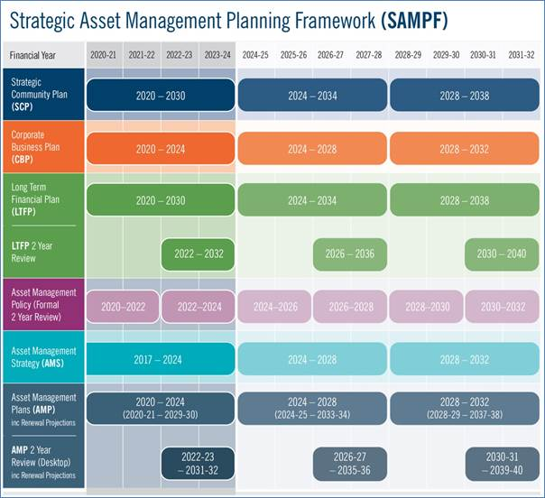

The formalisation and alignment of the City’s SAMPF (Asset Management Policy, Strategy and AMP’s) within the Integrated Corporate Planning Framework reflects the City’s increasing maturity and recognises the importance of Asset Management in supporting the City in delivering long term financial sustainability of services and capital asset renewal.
Supported by the relevant business area and the Asset Management Sections of the Property & Asset Service Unit, the Project & Asset Manager has overall responsibility and management for each of the Improvement Strategies identified within section 8 of the FAMP.

References
City of Cockburn – Asset Management Strategy 2017 – 2024
City of Cockburn – Strategic Community Plan 2020 – 2030
City of Cockburn – Long Term Financial Plan 2020-2021 to 2029-2030
City of Cockburn – Management Budget 2020 - 2021
City of Cockburn – Enterprise Risk Management
City of Cockburn - A Plan for the District 2010 – 2020
City of Cockburn - MARKYT – Community Scorecard 2017, 2018, 2019
City of Cockburn - MARKYT – Business Scorecard 2017, 2019
City of Cockburn - Population forecast - https://forecast.id.com.au/cockburn/population-age-structure
City of Cockburn Cycling and Walking Network Plan 2016 - 2021 https://www.cockburn.wa.gov.au/getattachment/9d6378f1-3168-496a-bc91-f8b36be76cd4/ECM_7899154_v2_City-of-Cockburn-Cycling-and-Walking-Network-Plan-2016-2021-docx.aspx
City of Cockburn - Intramaps (Bike Plan Module)
IPWEA, 2011, ‘International Infrastructure Management Manual’, Institute of Public Works Engineering Australia, Sydney, www.ipwea.org.au
Government of Western Australia, Department of The Premier and Cabinet - Western Australian Legislation - Acts in force
The Local Government and Municipal Knowledge Base - LGAM Knowledge Base
Main Roads Western Australia - Welcome - Main Roads Western Australia
DVC, 2006, ‘Asset Investment Guidelines’, ‘Glossary’, Department for Victorian Communities, Local Government Victoria, Melbourne, http://www.dvc.vic.gov.au/web20/dvclgv.nsf/allDocs/RWP1C79EC4A7225CD2FCA257170003259F6?OpenDocument
Local Government of Western Australia – Asset Management Framework and Guidelines

Appendices

Appendix A Legislative Requirements
Legislation | Requirement
Local Government Act 1995 | Provides for a system of Local Government by describing the functions of and providing a framework for the administration and financial management of Local Governments.
Main Roads Act 1930 | Consolidates and amends the law relating to and making provision for the construction, maintenance and supervision of highways, main and secondary roads, and other roads and the control of access to roads..
Main Roads WA – Code of Practice for traffic management for works on roads (April 2011) | To promote safe and consistent traffic management practice at work sites on roads in accordance with state legislation and national standards. Requires general compliance with the Australian Standard 1742.3-2009 and associated field guides, provides details of additional requirements necessary to meet WA requirements. Also outlines the competency requirements for personnel responsible for managing traffic on work sites.
Transport Co-ordination Act 1966 | Provides for the co-ordination, planning and advancement of all forms of transport in WA, to provide for the review, control and licensing of transport services and for incidental and other purposes.
Planning and Development Act 2005 | Provides for a system land use planning and development in the State and for related purposes.
Environmental Protection Act 1986 | Provides for an Environmental Protection Authority, for the protection, control and abatement of pollution and environmental harm, for the conservation, preservation, protection, enhancement and management of the environment and for matters incidental to or connected to the foregoing.
Contaminated Sites Act 2003 | Provides for the identification, recording, management and remediation of contaminated sites, to consequentially amend certain other Acts and for related purposes.
Conservation and Land Management Act 1984 | Makes better provision for the use, protection and management of certain public lands and waters and the flora and fauna thereof, establishes authorities to be responsible therefore, and for incidental or connected purposes.
Soil and Land Conservation Act 1945 | Relates to the conservation of soil and land resources, and to the mitigation of the effects of erosion, salinity and flooding.
Rail Safety Act 2010 | Requires Local Governments to develop an Interface Agreement with the rail manager/operator for every rail/road crossing in their area of responsibility by 1 February 2014
Fire and Emergency Services Authority of WA Act 1998 | Establishes an Authority with functions relating to the provision and management of emergency services, and for related purposes.
Aboriginal Heritage Act 1972 | Provision for the preservation on behalf of the community of places and objects customarily used by or traditional to the original inhabitants of Australia or their descendants
Native Title (state provisions) Act 1999 | Provides for the recognition and protection of native title and to establish ways in which future dealings affecting native title may proceed.
Occupational Safety and Health Act 1984 (WA) | Provides for the promotion, coordination, administration and enforcement of Safety and Health in WA. Places emphasis on the prevention of accidents and injury
Disability Services Act 1993 | An Act for the establishment of the Disability Services Commission and the Ministerial Advisory Council on Disability, for the furtherance of principles applicable to people with disabilities, for the funding and provision of services to such people that meet certain objectives, for the resolution of complaints by such people, and for related purposes.
Code of Practice Working Hours 2006 | Provides guidance for employers and workers on the management of Safety and Health hazards and risks commonly associated with working hour arrangements.
Australian Standards | Standards are published documents setting out specifications and procedures designed to ensure products, services and systems are safe, reliable and consistently perform the way they were intended to. They establish a common language which defines quality and safety criteria.

Appendix B Planned Footpath Renewals for 2020/21
Footpath Renewal Project Description | Adopted Budget $
AMITY BOULEVARD (BAUDIN PL - TOULON PL) | 15,864
ARLINGTON LOOP (AIRLE PL- HOWICK COURT) | 10,204
ATWELL CL - CEPA | 47,837
AW (JERVOISE BAY - O'KANE COURT) | 50,044
AW (NYYERBUP CT - O'KANE COURT) | 116,802
COCKBURN RD - WOODMAN POINT | 57,693
COCKBURN RD (JESSE LEE- ZEDORA TURN) | 53,294
PRINSEP RD IMLAH TO BERRIGAN | 84,900
STUART DRIVE - COCKBURN RD INTERSECTION | 28,656
Total Renewal 2020/21 | $465,294

Appendix C New Footpaths for 2020/21
New Footpath Project Description | Adopted Budget $
BEEDLEUP LOOP#16 TO PARKWAY | 45,278
BIRKETT AVE ROACH TO SENICO | 21,550
BP OIL PATH STAGE 2 PHONIX TO ANGUS | 120,000
DATER CLOSE BIRKETT TO SENICO | 18,673
DORRIGO WAY BRIGGS TO BERRIGAN | 24,963
DOT/ BIKE BOULEVARD DEMONSTRATION PROJECTS | 40,000
GAUNT ROAD BOLINBROKE TO SUSSEX | 50,215
HAMILTON RD LINK TO LAKE COOGEE FOOTBRIDGE | 108,000
HOPE ROAD SHARED PATH WABN GRANT APPLICATION | 580,000
LINK PATH THOMAS TO BRIGGS | 121,850
LYON ROAD FOOTPATH | 30,000
MANBERRY WAY #42 TO WILLIAMBURY DR | 5,875
MERVALE IVANKOVICH TO EASTERN SIDE PRIMARY SCHOOL | 12,533
MINOR FOOTPATHS (CW3891) | 85,000
PARKES ROAD OSPREY TO OMEO | 95,925
PERI END PERLINTE TO CAR PARK | 35,417
PRINSEP IMLAH TO FREMANTLE STEEL | 86,658
PRINSEP ROAD #34 TO BERRIGAN | 69,045
PROSPERO CRESCENT CORDELIA TO STEPHANO | 18,788
THE GARAGE SCHOOL KISS & RIDE TO BUS SHELTER | 49,350
TREVALLYN GARDENS GLENBAWN TO RESERVE | 22,394
YANGEBUP ROAD #340 SCHOOL FRONTAGE | 21,345
Total New Footpaths 2020/21 | $1,662,859

Appendix D Preliminary Renewals for 2021/22
ASSET_ID | Road Name | Area m2 | Condition | CRC($) | Renewal Year
FP_002617 | AW | 203.87 | 5 | 4,077 | 2021/22
FP_000897 | TOMISLAV PLACE | 26.68 | 5 | 1,734 | 2021/22
FP_001028 | ROCKINGHAM ROAD | 556 | 5 | 36,171 | 2021/22
FP_000721 | ROCKINGHAM ROAD | 88 | 5 | 5,751 | 2021/22
FP_000722 | AW | 58 | 5 | 3,770 | 2021/22
FP_000724 | ROCKINGHAM ROAD | 271.5 | 5 | 17,648 | 2021/22
FP_003347 | HAMILTON ROAD | 102.97 | 5 | 6,693 | 2021/22
FP_002758 | PEREGRINE CIRCLE | 63.86 | 5 | 4,151 | 2021/22
FP_004997 | MARBAN WAY | 41.03 | 5 | 2,667 | 2021/22
FP_000839 | ANNOIS ROAD | 170.05 | 4 | 11,053 | 2021/22
FP_003410 | ANNOIS ROAD | 284.04 | 4 | 18,463 | 2021/22
FP_000725 | MELLER ROAD | 116.44 | 4 | 7,569 | 2021/22
FP_000727 | MELLER ROAD | 100.44 | 4 | 6,529 | 2021/22
FP_002020 | CAMILLO STREET | 295.06 | 4 | 19,179 | 2021/22
FP_003297 | WINTERFOLD ROAD | 277.75 | 4 | 18,054 | 2021/22
FP_000746 | PHOENIX ROAD | 122.86 | 4 | 7985.9 | 2021/22
FP_000699 | HOSKINS STREET | 189.6 | 4 | 12,324 | 2021/22
FP_002146 | BRIGGS STREET | 251.48 | 4 | 16,346 | 2021/22
FP_000895 | MARBAN WAY | 137.94 | 4 | 8,966 | 2021/22
FP_003061 | WILLIAMBURY DRIVE | 132.12 | 4 | 8,588 | 2021/22
FP_001027 | WILLIAMBURY DRIVE | 84.4 | 4 | 5,486 | 2021/22
FP_000432 | WILLIAMBURY DRIVE | 58.79 | 4 | 3,821 | 2021/22
FP_000720 | ROCKINGHAM ROAD | 65.44 | 4 | 4,254 | 2021/22
FP_001950 | WINFIELD STREET | 171.57 | 4 | 11,152 | 2021/22
FP_001951 | WINFIELD STREET | 159.72 | 4 | 10,382 | 2021/22
FP_000705 | AW | 32.69 | 4 | 654 | 2021/22
FP_000396 | SOUTH LAKE DRIVE | 356.86 | 5 | 23,196 | 2021/22
FP_003819 | SOUTH LAKE DRIVE | 515.61 | 5 | 33,515 | 2021/22
FP_000397 | SOUTH LAKE DRIVE | 185.24 | 5 | 12,041 | 2021/22
FP_003826 | ELDERBERRY DRIVE | 629.17 | 5 | 40,896 | 2021/22
FP_003812 | ELDERBERRY DRIVE | 455.2 | 5 | 29,588 | 2021/22
FP_004218 | WATTLEUP ROAD | 168.9 | 5 | 10,979 | 2021/22
FP_004217 | WATTLEUP ROAD | 215.58 | 5 | 14,013 | 2021/22
FP_002172 | WATTLEUP ROAD | 131.77 | 5 | 8,565 | 2021/22
FP_004216 | WATTLEUP ROAD | 69.8 | 5 | 4,537 | 2021/22
FP_000723 | WATTLEUP ROAD | 237.26 | 5 | 15,422 | 2021/22
FP_003413 | COLLOVA WAY | 253.27 | 5 | 16,463 | 2021/22
FP_003414 | COLLOVA WAY | 131.32 | 5 | 8,536 | 2021/22
FP_003416 | COLLOVA WAY | 266.82 | 5 | 17,343 | 2021/22
FP_003417 | WENLOCK ROAD | 146.6 | 5 | 9,529 | 2021/22
FP_003418 | WENLOCK ROAD | 139 | 5 | 9,031 | 2021/22
FP_003419 | WENLOCK ROAD | 152.39 | 5 | 9,905 | 2021/22
FP_003420 | WENLOCK ROAD | 149.63 | 5 | 9725.95 | 2021/22
FP_003421 | MARBAN WAY | 439.8 | 5 | 28,587 | 2021/22
FP_004212 | MARBAN WAY | 116.43 | 5 | 7,568 | 2021/22
FP_003422 | CORIN WAY | 424.4 | 5 | 27,586 | 2021/22
FP_000877 | AW | 97.47 | 5 | 1,949 | 2021/22
FP_002162 | AW | 235.95 | 5 | 4,719 | 2021/22
FP_000876 | AW | 268.19 | 5 | 5,364 | 2021/22
Total |  | 10122.52 |  | $ 602,522

Appendix E Standards and Specifications
- City of Cockburn road construction and maintenance service specification
- City of Cockburn road construction and maintenance service standards
- City of Cockburn road construction and maintenance service unit action plan
- Road Services: Standards, procedures and checklists manual
- Road Services: Best practice manual for road asset management
- Road Services Unit: Code of Practice - Local road asset and risk management system
- Code of Practice: Footpath risk management policy
- Pavement condition definitions manual
- Public Utilities Code of Practice 2000
- Restoration and Reinstatement Specification for Local Government 2002
- City of Cockburn - Excavation Reinstatement Standards 2003”
- AS 1742 – Australian Standard Manual of uniform traffic control devices
- AS 1428 – Parts 1 & 2 Access and Mobility and Part 4 – Tactile ground surface indicators
- AS/NZS 1158 – Lighting for roads and public spaces
- Austroads Guide to Traffic Engineering Practice Parts 1 & 15
- Austroads design vehicles and turning path templates
- Austroads guide to Road Design
- Main Roads WA – Standard Drawings and Documentation



