Tender Title: |  | Landscape Works – Various Arterial Roads
Request ID: |  | 78984
Tender Description: |  | The City of Cockburn (The Principal) is seeking a suitably qualified and experienced Contractor for the provision of landscape works with a primary focus on mulch supply and installation and tree planting in road verges, median islands, and roundabouts along arterial roads within Cockburn, including the implementation of suitable Traffic Management to ensure a safe delivery of works.
Advert Approval: |  | Decision to Advertise: Director Infrastructure Services  Decision Date: Wednesday, 21 January 2026
Closing Date and Time: |  | 2:00PM (AWST) Tuesday, 17 February 2026
Opening Date and Time: |  | 2:00PM (AWST) Tuesday, 17 February 2026
 | Tenderer’s Name:
1 | GAS ASSETS PTY LTD t/as Gecko Contracting Turf & Landscape Maintenance
2 | EIGHTH ST PTY LTD t/as Ligna Construction
3 | PERTH MATERIALS BLOWING PTY LTD t/as Perth Materials Blowing
4 | UGC HOLDINGS PTY LTD

Advertisement
Method 1: City of Cockburn website | Method 2: City of Cockburn Libraries Public Noticeboards
Method 3:  The Western Australian, Saturday, 24 January, 2026 | Tender Awarded by:
Copy of Statewide Notice:  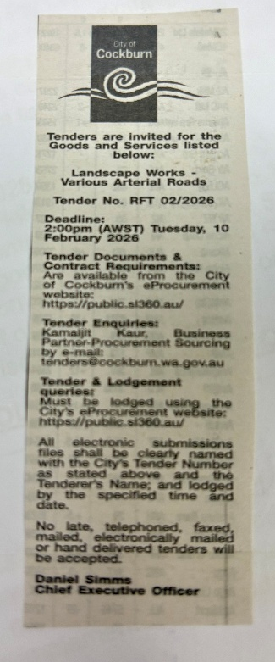 | OCM  Director Infrastructure Services  Tuesday, 14 April 2026
 | Date of Council Meeting:
Tuesday, 14 April 2026
2026/MINUTE NO 0049
Item 14.3.1
Name of Successful Tenderer(s): | Projects 1-3: GAS ASSETS PTY LTD t/as Gecko Contracting Turf & Landscape Maintenance  Projects 4-11: UGC HOLDINGS PTY LTD
Amount of Successful Tender(s): (ex GST) | Projects 1-3: GAS ASSETS PTY LTD t/as Gecko Contracting Turf & Landscape Maintenance - $579,175.00  Projects 4-11: UGC HOLDINGS PTY LTD - $683,506.00

