Tender Title: |  | RFT 05/2026 – Carpark Sweeping & Coastal Pathway Services
Request ID: |  | 79194
Tender Description: |  | The City of Cockburn (the Principal) is seeking a suitably qualified and experienced Contractor to deliver programmed and reactive sweeping services across carparks and hardstand areas using vehicle mounted sweepers.  These services will be undertaken at parks, reserves, community facilities, the coastal pathway and other locations owned or managed by the Principal.
Advert Approval: |  | Decision to Advertise: Director Infrastructure Services  Decision Date: Tuesday, 17 March 2026
Closing Date and Time: |  | 2:00PM (AWST) Thursday, 2 April 2026
Opening Date and Time: |  | 2:00PM (AWST) Thursday, 2 April 2026
 | Tenderer’s Name:
1 | The Trustee for E W C S UNIT TRUST t/a ENVIRO SWEEP
2 | Enviropath Pty Ltd t/a Spot’s All Surface Cleaning
3
4
5
6
7
8
9
10

Advertisement
Method 1: City of Cockburn website | Method 2: City of Cockburn Libraries Public Noticeboards
Method 3: The Western Australian Newspaper  Wednesday, 18 March 2026  Page # 43 | Tender Awarded by:  Anton Lees | Director Infrastructure Services
Copy of Statewide Notice:  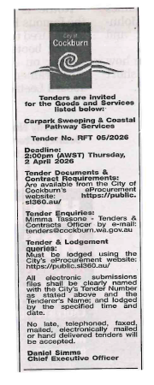 | Director Infrastructure Services  Director Corporate & System Services  Thursday, 21 May 2026
 | Date of Council Meeting:
Not applicable
Item No:
Name of Successful Tender(s): | The Trustee for E W C S Unit Trust t/a Enviro Sweep
Amount of Successful Tender(s): | $293,952 (Ex GST)

