Tender Title: |  | LEN PACKHAM SPORTING RESERVE UPGRADE
Request ID: |  | 63440
Tender Description: |  | The intent of this Tender is to select a suitably qualified and experienced Contractor to complete the upgrade of the Len Packham Sporting Reserve in Cordelia Avenue  Coolbellup that includes two tennis courts. The City has allocated funding in its capital works budget for resurfacing of the tennis courts and upgrades to the sports lighting to meet the current Australian Standards.
Advert Approval: |  | Decision to Advertise: Director Infrastructure Services  Decision Date: Friday, 21 March 2025
Closing Date and Time: |  | 2:00PM (AWST) Thursday, 15 May 2025
Opening Date and Time: |  | 2:00PM (AWST) Thursday, 15 May 2025
 | Tenderer’s Name:
1 | LKS Constructions (WA) Pty Ltd
2 | CIVCON Civil & Project Management t/a CIVCON Civil and Project Management
3 | Doolee Construction Pty Ltd (Doolee)
4 | BOS Civil (BOS Civil Pty Ltd)
5 | BIDI Facility Services Pty Ltd (N/A)
6 | PCH Civil Pty Ltd t/a PCH Civil
7
8
9
10

Advertisement
Method 1: City of Cockburn website | Method 2: City of Cockburn Libraries Public Noticeboards
Method 3:  The Western Australian, Wednesday, 26 March 2025 | Tender Awarded by:
Copy of Statewide Notice:  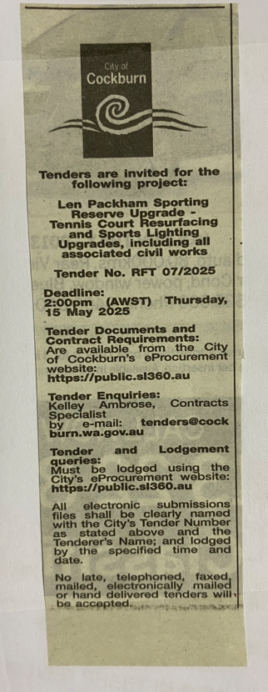 | Director Infrastructure Services  Director Corporate & System Services  Wednesday, 18 June 2025
 | Date of Council Meeting:
Date:
Minutes:
Item No.
Name of Successful Tenderer(s): | PCH Civil Pty Ltd
Amount of Successful Tender(s): (ex GST) | $609,742.35 (Ex GST)

