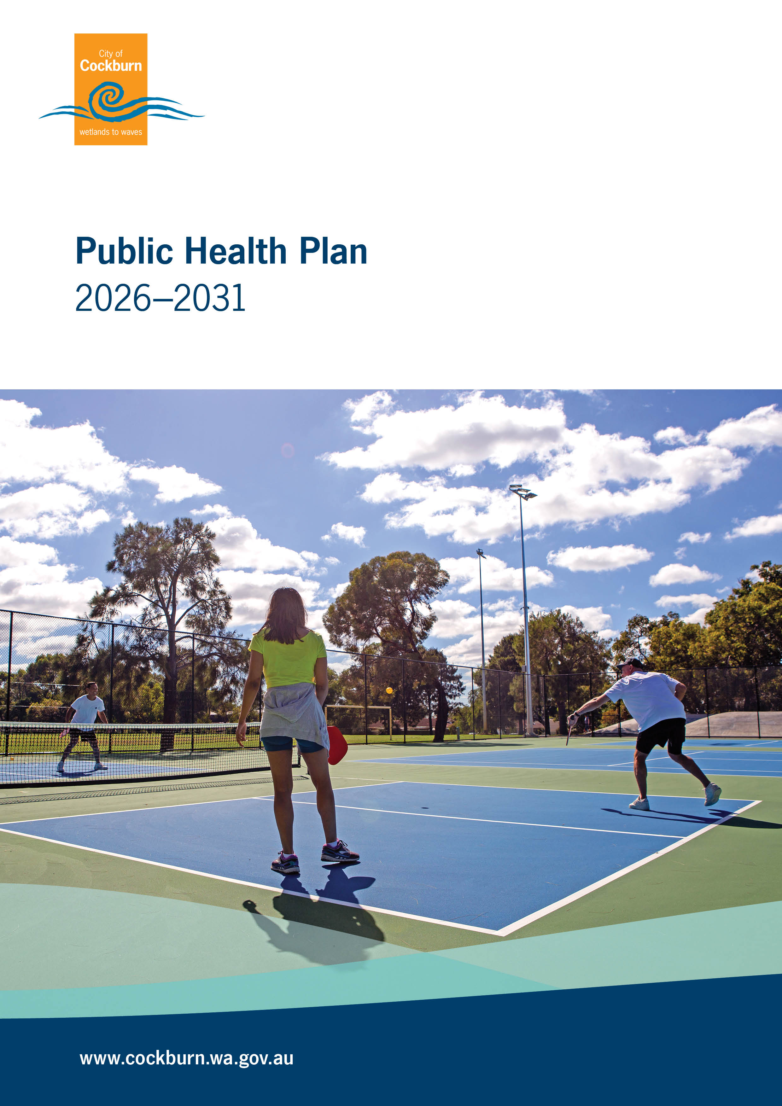

Contents
Executive Summary 3
Introduction 4
Vision 4
Our public health journey 5
How this plan fits (Integrated Planning and Reporting) 5
Social and commercial determinants of health 6
Our community 7
Our health 8
Aboriginal health in our community 9
Equity, inclusion and our CaLD community 9
Public Health Plan 2026-2031 10
City of Cockburn Public Health Plan Actions Tables 11
State Public Health Plan Objective One - Promote 12
State Public Health Plan Objective Two - Prevent 16
State Public Health Plan Objective Three – Protect 19
State Public Health Plan Objective Four - Enable 22
APPENDIX 1 25
The City’s Inaugural Public Health Plan 2013- 2018 25
APPENDIX 2 26
The State Public Health Plan for Western Australia 2025-2030 26
APPENDIX 3 27
The City’s Strategic Community Plan 2025-2035 27
Our Community Strategy on a Page 29
APPENDIX 4 30
Alignment of Local and State Public Health Plans 30
Contact Us 31

Executive Summary
The City of Cockburn Public Health Plan 2026–2031 sets out how we will support the health and wellbeing of our community over the next five years.
The City has a strong history of leadership in public health, having developed one of Western Australia’s first local government Public Health Plans in 2013. This plan builds on that foundation and reflects our ongoing commitment to creating a healthy, safe and connected community.
Health and wellbeing are shaped by more than healthcare services. They are influenced by the environments people live in, the opportunities available to them, and their ability to connect with others and access support. As a local government, the City plays an important role in shaping these conditions through planning, services, programs and partnerships.
This plan has been developed in accordance with the Public Health Act 2016 and aligns with the Strategic Community Plan 2025–2035 and the State Public Health Plan for Western Australia 2025–2030. It draws on local data and community insights to identify key health challenges and priorities.
In Cockburn, these include:
- low levels of physical activity and healthy eating
- overweight and obesity
- alcohol use
- smoking and vaping
- Injury
- mental health and wellbeing
- social connection and inclusion.
The plan recognises that some groups in our community may face additional barriers to good health, including Aboriginal and Torres Strait Islander people and culturally and linguistically diverse communities. Supporting equity and inclusion is a key focus across all areas of the plan.
Actions are grouped under four focus areas, aligned with the State Public Health Plan:
- Promote – supporting healthy environments and connected communities
- Prevent – reducing chronic disease, injury and illness
- Protect – managing environmental and public health risks
- Enable – strengthening partnerships, systems and services.
Together, these actions reflect a whole-of-organisation approach, recognising that health and wellbeing are influenced by many areas of the City’s work.
Progress will be reported annually, and the plan will be reviewed regularly to ensure it remains responsive to community needs.

Introduction
The City of Cockburn Public Health Plan 2026–2031 outlines how we will support the health and wellbeing of our community over the next five years.

Local governments play an important role in public health. Beyond delivering environmental health services, we help shape the places where people live, work and connect. This includes planning neighbourhoods, providing community facilities and programs, and supporting social connection and inclusion.

This plan has been developed in line with the requirements of the Public Health Act 2016 and aligns with both the City of Cockburn Strategic Community Plan 2025–2035 and the State Public Health Plan for Western Australia 2025–2030.

It brings together local data, community priorities and existing City services to identify where we can make the greatest impact. It also ensures that health and wellbeing are considered in decision-making across the organisation.

Vision
Guided by our vision Cockburn: the best place to be, this Public Health Plan focuses on creating the conditions for a healthy, connected and inclusive community.

Our vision for all people in Cockburn is for them to have:

- access to safe and welcoming places
- opportunities to be active
- access to healthy food and appropriate housing
- strong social connections
- services that meet their needs.

By embedding health and wellbeing into everything we do, we aim to support people to live well at every stage of life.

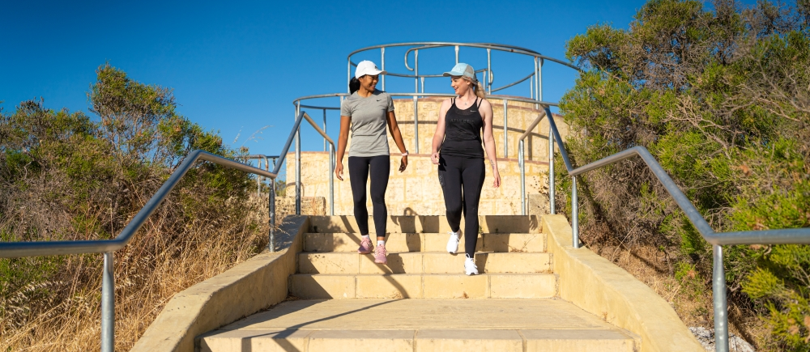

Our public health journey
The City of Cockburn has a strong history of leadership in public health, developing one of Western Australia’s first local government Public Health Plans in 2013.

This initial plan marked a shift beyond traditional environmental health services, recognising the broader role local government plays in supporting healthy lifestyles and community wellbeing. It strengthened partnerships with local organisations, health providers and community groups, and supported the delivery of a range of prevention-focused programs.

Since then, the City has continued to build on this work, expanding its focus on health promotion, social connection and access to services. Partnerships such as Cockburn Integrated Health have helped increase the availability of locally delivered programs that support nutrition, physical activity and mental wellbeing.

This Public Health Plan 2026–2031 builds on these foundations, continuing the City’s commitment to improving health and wellbeing outcomes for the community.

How this plan fits (Integrated Planning and Reporting)
This Public Health Plan is part of the City’s Integrated Planning and Reporting Framework. It aligns with the Strategic Community Plan, Corporate Business Plan and other key strategies and policies.

This ensures that health and wellbeing are considered in:

- long-term planning
- service delivery
- resource allocation
- day-to-day decision making.

The plan also aligns with the State Public Health Plan for Western Australia, supporting a coordinated approach to improving health outcomes across the state.

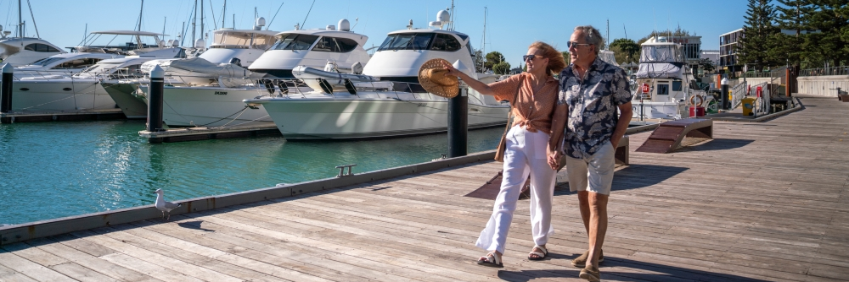

Social and commercial determinants of health
Health is influenced by more than individual choices. It is shaped by the environments people live in and the opportunities available to them.

In Cockburn, key factors influencing health and wellbeing include:

- housing affordability and quality
- employment and income
- education
- transport and access to services
- social connection
- the availability and promotion of products such as alcohol and fast food.

Population growth and urban development continue to shape how people access services, infrastructure and open space.

The City responds to these factors through planning, policy and partnerships. This includes designing walkable neighbourhoods, supporting access to green space, delivering community programs, and working with local organisations and health services.

These approaches help create environments that support healthy choices and reduce health inequalities across the community.

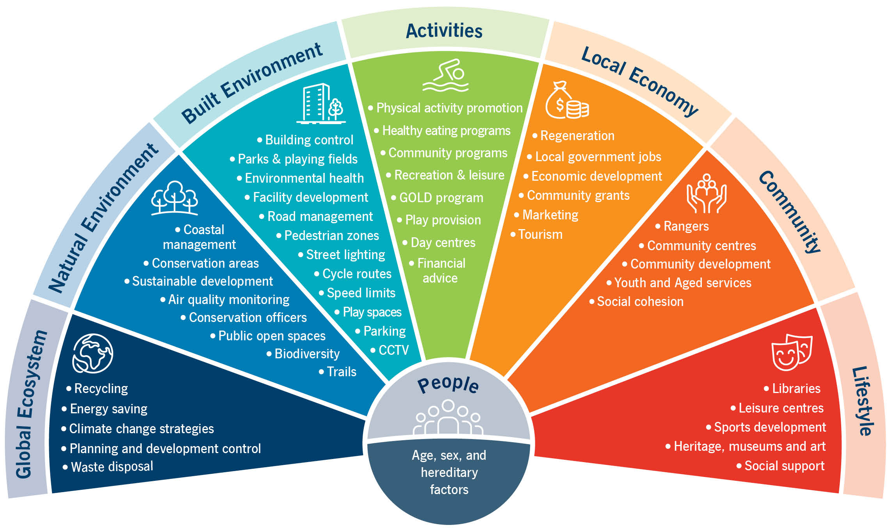

Our community
The City of Cockburn is a diverse and growing community of more than 135,000 people, living across 24 suburbs.
Our community is characterised by:
- strong cultural diversity
- a growing population
- a mix of families, young people and older residents.
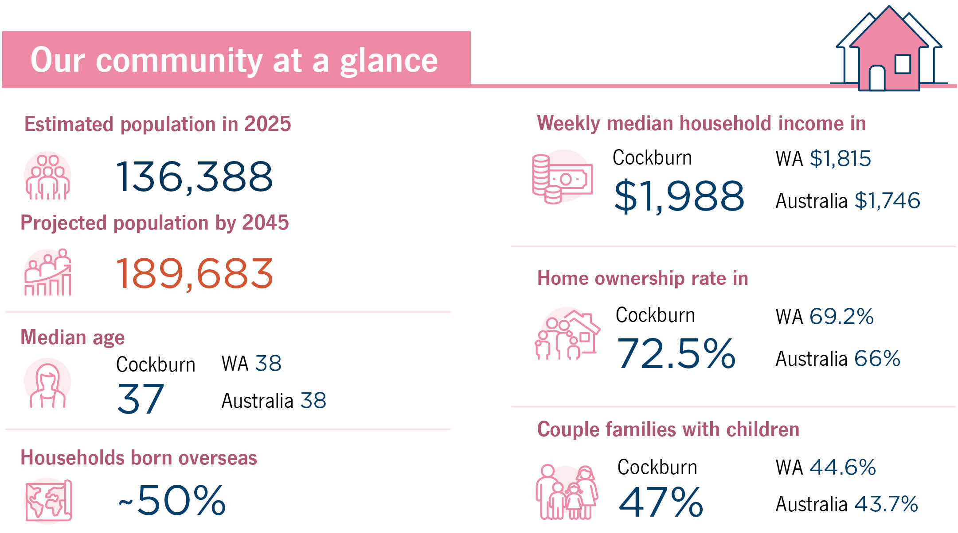
Around half of residents were born overseas, contributing to a rich mix of cultures, languages and perspectives that strengthen community life. The City provides a wide range of infrastructure and spaces that support health and wellbeing, including parks, sporting facilities, libraries, community centres and a growing network of footpaths and shared paths.

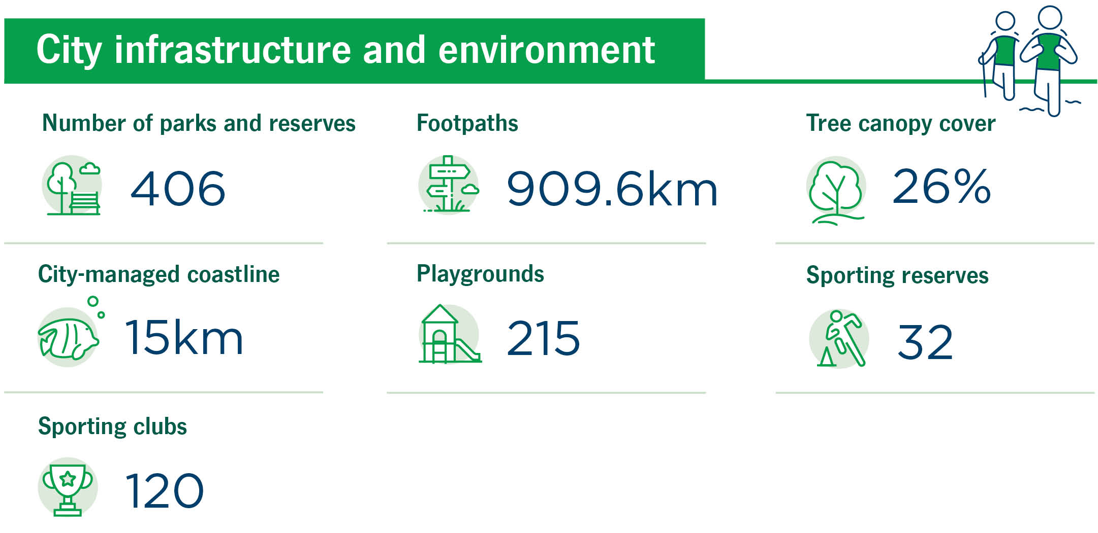

Our health
Local data shows that many residents face challenges in maintaining healthy lifestyles. Key health concerns include:
- low intake of fruit and vegetables
- low levels of physical activity
- overweight and obesity
- alcohol use at high-risk levels
- smoking and vaping
- increasing mental health concerns.
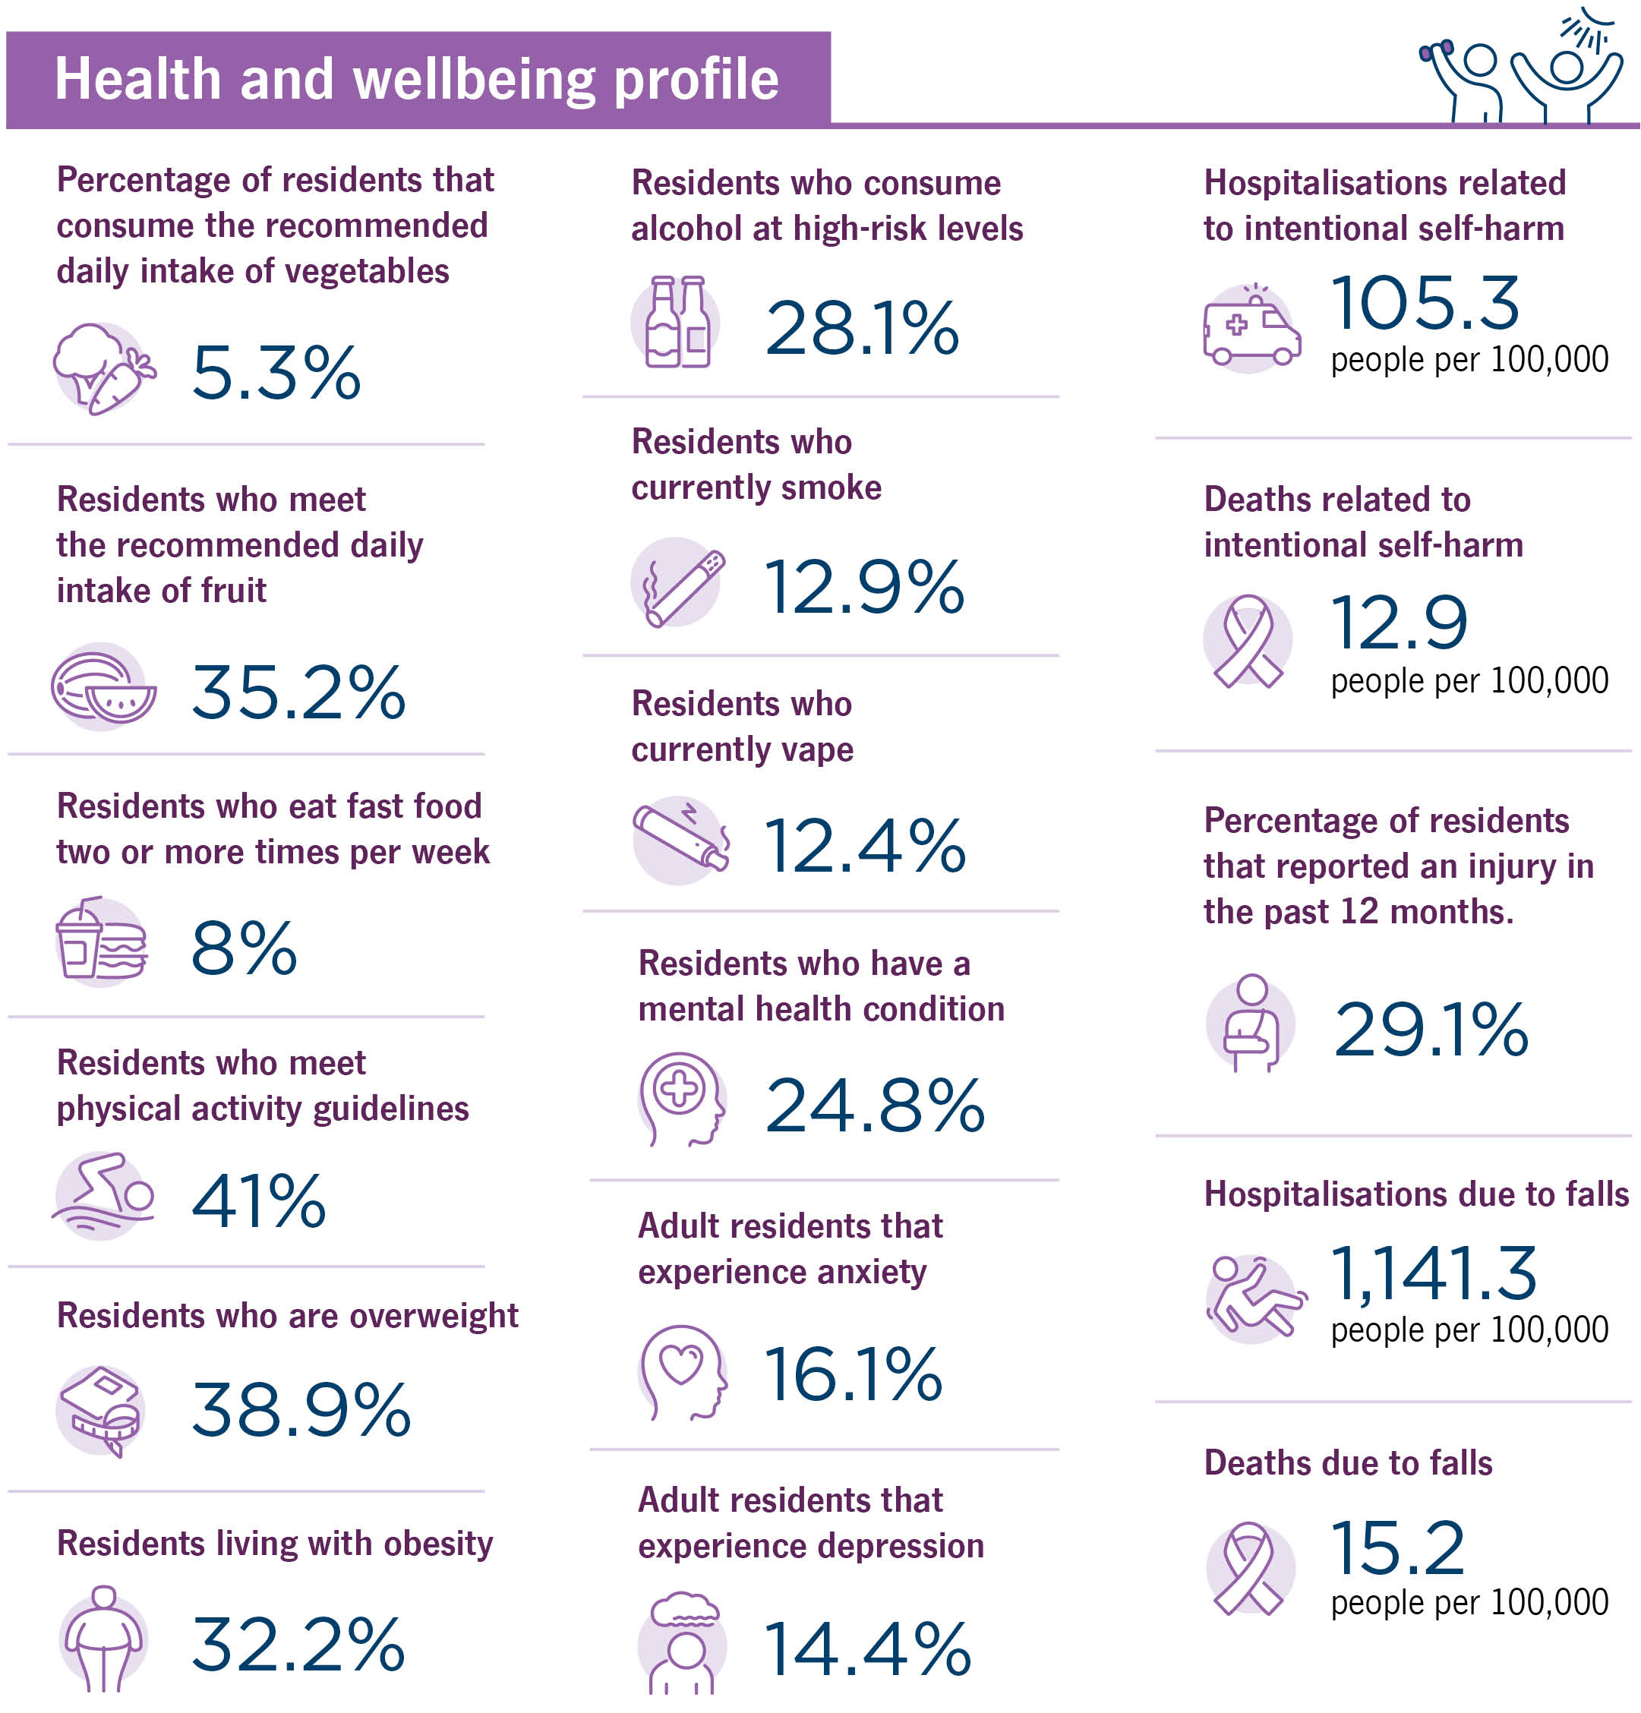
Many adults experience anxiety or depression, and rates of hospitalisation related to self-harm highlight the importance of early intervention and community support. These trends reinforce the need for continued focus on prevention, mental wellbeing and creating environments that support healthier choices.

.
Source: City of Cockburn Health and Wellbeing profile published by South Metropolitan Health Service, 2026.

Aboriginal health in our community
Aboriginal and Torres Strait Islander people make up approximately 2.4 per cent of the Cockburn community.
The City is committed to supporting Aboriginal health and wellbeing through culturally appropriate, community-led approaches that recognise the importance of culture, connection and self-determination. Improving Aboriginal health and wellbeing should be embedded across all objectives and actions, rather than addressed as a standalone priority, in line with the WA State Plan. Applying an Aboriginal cultural lens across all areas of public health helps ensure strategies are appropriate, informed, responsive, and support stronger cultural determinants of health for Aboriginal people in Western Australia.
Key initiatives include:
- implementation of the Reconciliation Action Plan
- employment of Aboriginal Community Development Officers
- support for community-led programs and groups
- cultural awareness training for staff and elected members
- events and initiatives that celebrate and strengthen culture including National Reconciliation Week and NAIDOC Week
- Consultation of City’s Aboriginal Reference Group.
These actions support stronger connections, reduce barriers to services, and contribute to improved health and wellbeing outcomes.

Equity, inclusion and our CaLD community
Cockburn is one of the most culturally diverse communities in Western Australia, with a large proportion of residents from culturally and linguistically diverse (CaLD) backgrounds.
While this diversity is a strength, some residents may face barriers in accessing services, information and opportunities.
The City works to reduce these barriers by:
- providing inclusive and culturally responsive services
- delivering community events and programs that support connection and belonging
- improving access to information and local services
- building staff capability through training.
Initiatives such as Harmony Week events, Welcoming Week, and multicultural programs help create opportunities for people to connect, participate and feel included in community life.
The City remains committed to ensuring all residents can access the support they need to achieve good health and wellbeing.

Public Health Plan 2026-2031
Delivering the Plan
This Public Health Plan outlines how the City of Cockburn will support improved health and wellbeing across the community over the next five years.
Our approach recognises that health is influenced by many factors, and that meaningful change requires coordinated action across the organisation and with our partners.
To support this, actions are grouped under four focus areas aligned with the State Public Health Plan:
Promote – supporting healthy environments and connected communities
Prevent – reducing chronic disease, injury and illness
Protect – managing environmental and public health risks
Enable – strengthening partnerships, systems and services
These focus areas reflect the many ways the City contributes to public health through planning, service delivery, community programs and partnerships.
Each action identifies how different service areas contribute to improved health outcomes, reinforcing a whole-of-organisation approach.
Progress will be monitored through the City’s Integrated Planning and Reporting Framework and reported annually. The plan will also be reviewed regularly to ensure it remains relevant and responsive to emerging community needs.

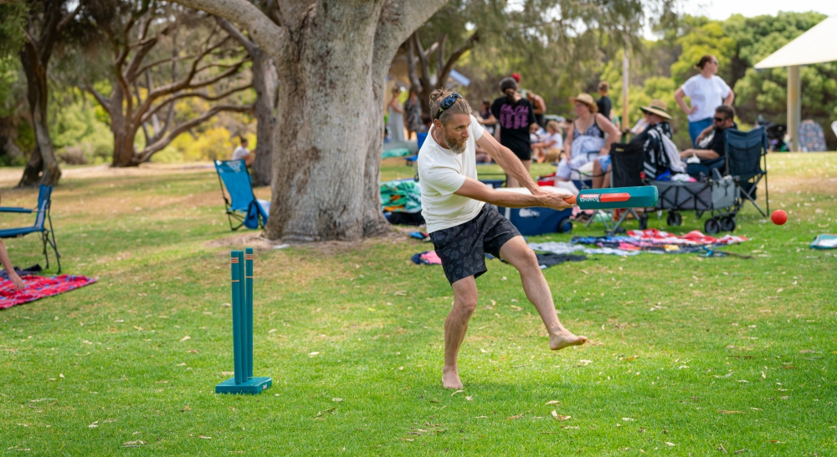

City of Cockburn Public Health Plan Actions Tables
The Public Health Plan must align with the State Public Health Plan for WA 2025–2030, which sets out a vision for “the best possible health, wellbeing and quality of life for all Western Australians – now and into the future.”
The State Public Health Plan is structured around four key objectives – Promote, Prevent, Protect, and Enable – supported by two overarching priorities: Aboriginal health and wellbeing and equity and inclusion (see table inset). Each objective is linked to specific public health priorities, such as reducing chronic disease, improving mental health, addressing climate change impacts, and strengthening public health systems and partnerships.
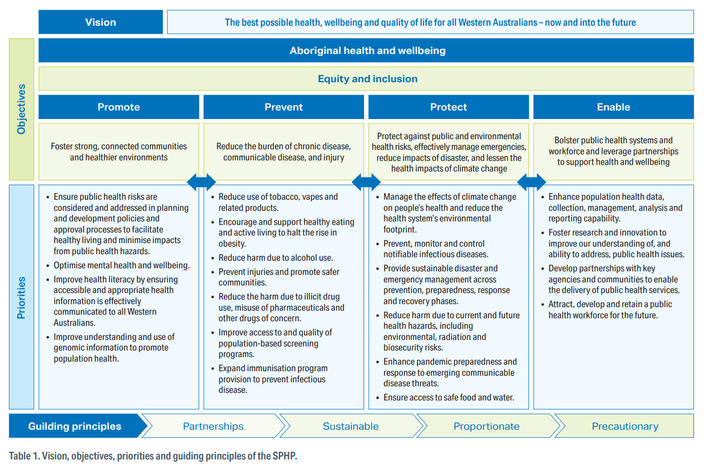
Vision, objectives, priorities and guiding principles of the State Public Health Plan for Western Australia 2025-2030
This Public Health Plan aligns with the City’s Strategic Community Plan 2025–2035 and draws on its reference to the United Nations Sustainable Development Goals (SDGs), a global framework of 17 interconnected goals that support health, equity, sustainability and community wellbeing. The actions described in the following table are aligned with the Strategic Objectives identified in the Strategic Community Plan, with relevant SDGs shown in the final column.
These priorities guide statewide action and provide a strategic framework for local governments to tailor their plans to community needs while contributing to broader public health outcomes.

State Public Health Plan Objective One - Promote
Foster strong, connected communities and healthier environments
Action plan:
Strategic Objective | Action | Service Unit or Team | Public Health Outcome | SDG
3B | Deliver inclusive recreation programs for all ages and abilities | Recreation Services | Increased participation and reduced barriers to wellbeing | 3, 10
3B | Continue to support Heart Foundation Walking Groups | Public Health | Improved physical activity and social engagement | 3
3B | Deliver Parks and Environment Asset Management Plan, for playground renewal including for exercise equipment and shade- sails | Parks and Environment | Safer, inclusive play spaces supporting mental wellbeing and physical activity | 3, 10, 11
3C | Deliver cultural recognition and inclusion programs as part of community events such as Coogee Live, Mosaic Festival and NAIDOC week events | Events and Culture | Strengthened cultural identity and mental wellbeing | 3, 10, 11
3D | Continue to plan, provide and upgrade facilities to be welcoming and inclusive environments, guided by the Community Infrastructure Plan 2024 -2041. | Recreation Services | Increased physical activity, increase inclusivity and safety | 3,11
3D | Continue to implement the Success Regional Reserve Masterplan to enhance community use and environmental value. | Recreation Services | Increased physical activity, Increased use of greenspace, Increased mental wellbeing | 3,11,  13
3C | Provide inclusive cultural events that celebrate diversity and foster belonging | Events and Culture, Community Development | Enhanced social cohesion and mental wellbeing | 3, 10, 11
3D | Strengthen partnership with Act Belong Commit, distributing resources and collaborating on initiatives | Public Health | Increased mental wellbeing and resilience | 3, 11
3D | Provide mental health support and referral services through Cockburn Support Service | Family and Community Services | Improved mental wellbeing and early intervention | 3
3D | Provide financial counselling services to reduce stress and improve wellbeing | Family and Community Services | Reduced financial stress and improved mental health | 1, 3, 10
3D | Support community gardens on City owned properties | Community Development | Improved nutrition, food security, environmental awareness, social and community connection | 2, 3, 11, 12
3D | Support and deliver community sustainability education programs | Sustainability | Improved environmental awareness, community and social connection | 3, 11, 12
3D | Deliver youth engagement programs that promote resilience and mental wellbeing | Youth Services | Reduced risk behaviours and improved mental health outcomes | 3, 4, 10
3D | Provide seniors programs that support social connection and active ageing | Seniors Centre | Improved mental and physical health for older adults | 3, 11
3A | Deliver inclusive community development programs and events | Community Development | Increased social connection and mental wellbeing | 3, 10, 11
3A | Provide grants to support community-led health and wellbeing initiatives | Community Grants | Empowered communities promoting health | 3, 11, 17
3A | Provide grants to support community-led health and wellbeing initiatives | Community Grants | Empowered communities promoting health and wellbeing | 3, 11, 17
3B | Deliver health and fitness programs and services to the community Continue to promote and provide a wide variety of health and fitness programs and services at Cockburn ARC to support active lifestyles. | Cockburn ARC / Recreation Services | Increased physical activity and reduced chronic disease risk | 3
3B | Promote, facilitate and provide inclusive recreation programs for all ages and abilities. | Cockburn ARC/Recreation services | Increased physical activity and reduced chronic disease risk | 3
3A | Partner with Food Core and South Metropolitan Health Service to Promote uptake of Healthy Venue Grant at Local facilities | Public Health | Increased access to healthy food options, decrease in obesity rates, increase in nutritional adequacy | 3
3A | Deliver youth engagement programs including health and wellbeing education | Youth Services | Improved health literacy and youth engagement | 3, 4, 10
3A | Deliver cultural and recreational events that promote inclusion and wellbeing | Events and Culture Events and Cultural Services | Enhanced community participation and mental wellbeing | 3, 11
3A | Deliver library-based programs that support health literacy and wellbeing | Library Place and Events and Culture Services | Increased access to trusted health information and education; increased social connectedness | 3, 4
3A | Deliver parenting programs and family support services | Family and Community Services | Strengthened family health and early childhood development | 3, 4, 10
2C | Deliver sustainability education and engagement programs | Sustainability | Increased environmental health awareness and community resilience | 3, 11, 13
1A | Deliver capacity-building workshops and networking for micro-businesses | Business and Economic Development | Economic empowerment and mental wellbeing through employment | 3, 8
3B | Integrate health-focused design into planning decisions to create walkable, shaded, and well-connected neighbourhoods with equitable access to community facilities | Development Service | Healthier living environments, increased community engagement and increased physical activity | 3, 11

State Public Health Plan Objective Two - Prevent
Reduce the burden of chronic disease, communicable disease, and injury
Action plan:
Strategic Objective | Action | Service Unit or Team | Public Health Outcome | SDG
3D | Explore partnership with Luma: For her health and wellbeing to deliver free female focused health and wellbeing education | Public Health | Increased mental wellbeing and health literacy of women | 3, 11
3D | Progress partnership with Better Health Company, to deliver physical activity, nutrition and mental wellbeing education sessions to parents and children | Public Health | Increased physical activity, improve nutrition outcomes and increase mental wellbeing | 3, 11
3B | Continue engagement with South Western Sydney Primary Health Network to deliver the HEAL™ program | Public Health / Cockburn Healthy Lifestyle Service | Increased physical activity, improve nutrition outcomes and increase mental wellbeing | 3, 11
3B | Continue partnership with FoodBank delivering the nom!™ program to parents and explore delivery of the nom!™ youth program | Public Health | Increased physical activity and improved nutrition outcomes | 3, 11
3B | Investigate avenues to reduce exposure to unhealthy food and drink advertising | Public Health | Decreased consumption of unhealthy food and drink | 3
3B | Maintain Smoke and Vape Free signage at key locations in the City to encourage people not to smoke or vape in the area | Public Health | Discourage smoking and reduce the impact of second-hand smoke | 3,11
3A | Deliver CoSafe patrols and community safety initiatives | CoSafe and Community Safety | Reduced risk of injury and increased perception of safety | 3, 11
3A | Ensure buildings are constructed in accordance with the Building Act and Regulations and National Construction Code | Building Services | Reduced injury risk and improved safety | 3, 11
3A | Provide public building safety inspections and compliance monitoring | Public Health | Reduced injury risk and improved safety | 3, 11
3A | Provide public aquatic facility inspections and compliance monitoring | Public Health | Reduced injury risk and improved safety | 3, 11
3A | Deliver CCTV Home Rebate Program | Community Safety | Increased safety and reduced injury risk | 3, 11
3B | Provide free culturally appropriate, accessible health checks at major City events, to assist community members to identify chronic disease risk factors | Public Health | Increased awareness of risk factors, opportunity for education on program availability and benefits | 2, 3
3B | Continue the delivery and renewal of City physical activity and healthy eating programs | Public Health | Reduced obesity and chronic disease risk, reduced incidence of Type 2 diabetes | 2, 3
2A | Conduct water quality testing for recreational and potable water sources | Public Health | Reduced risk of waterborne illness | 3, 6
2A | Regulate food safety through inspections, training, and complaint response | Public Health | Reduced foodborne illness | 3, 12
3B | Explore advertising options at local bus stops to promote smoke/vape free messaging and other positive behaviour change | Public Health | Promote positive behaviour change and reduce harmful advertising | 3, 11
2A | Manage compliance with legislative requirements for environmental health risks | Public Health | Reduced exposure to environmental health risks | 3, 11, 13
3A | Ensure private swimming pool safety barriers are maintained in accordance with minimum safety requirements | Development Compliance | Reduced injury risk and improved safety | 3, 11
2C | Finalise and advance the actions and recommendations of the Public Open Space Strategy | Strategic Planning | Improved community wellbeing, supporting active lifestyles | 3, 11, 13
2C | Deliver Urban Forest Program | Parks and Environment | Reduced heat stress and heat island effect, improved wellbeing | 3, 11, 13
3B | Deliver community safety patrols and respond to incidents | CoSafe and Community Safety | Reduced crime and increased perception of safety | 3, 11, 16
3B | Deliver fire prevention education and bushfire risk reduction programs | Fire and Emergency Management | Reduced injury and property loss from fire | 3, 11, 13
2C | Deliver mosquito monitoring and control programs | Public Health | Reduced vector-borne disease risk | 3, 15
2B | Deliver hazardous waste collection and disposal programs | Waste Management | Reduced environmental health risks | 3, 12
3B | Deliver youth outreach and early intervention programs | Youth Services | Reduced risk behaviours and improved mental health | 3, 4, 10
3B | Deliver community safety education and injury prevention programs, such as Injury Matters -Stay on Your Feet and Neighbourhood Watch | Community Safety | Reduced injury rates and increased safety awareness | 3, 11, 16
3B | Deliver Age-Friendly information sessions | Seniors Centre | Reduced injury rates and increased safety awareness | 3, 11, 16
3B | Support active transport (cycling, walking) alongside diverse, affordable housing near services and transit | Development Services | Increased physical activity, community engagement | 3, 11
3A | Ensure unauthorised or unapproved buildings and developments are altered, modified or removed to comply with the relevant legislation | Development Compliance | Reduced injury risk, improved safety and safety outcomes | 3, 11
3A | Explore partnership with Injury Matters to increase older residents awareness of falls prevention strategies | Public Health | Increased knowledge of falls prevention, reduced injury rates from falls | 3,11
3B | Support additional community-based exercise programs for older residents | Public Health | Increased strength and balance, reduced rate and injury from falls | 3,11

State Public Health Plan Objective Three – Protect
Protect against public and environmental health risks, effectively manage emergencies, reduce impacts of disaster, and lessen the health impacts of climate change
Action plan:
Strategic Objective | Action | Service Unit or Team | Public Health Outcome | SDG
2A | Deliver natural area management and biodiversity protection | Public Health / Parks and Environment / Sustainability | Reduced exposure to vector-borne disease and improved ecosystem health | 3, 15
3B | Manage compliance with legislative requirements for environmental public health risks | Public Health | Reduced adverse preventable environmental public health impacts | 3, 11, 13
3B | Conduct water quality testing for recreational and potable sources | Public Health | Reduced risk of waterborne illness | 3, 6
2B | Expand waste recovery and resource conservation programs | Waste Management | Reduced environmental contamination and improved public health | 3, 12
2C | Amplify public health communication related to declared heat waves, continue ongoing planning for emergency management of heat wave events and facilitate public education on heat wave response strategies to improve community resilience | Public Health / Emergency Management / Sustainability | Reduced disease burden from heat and improved emergency response and communication | 3, 11, 13
4A | Assess the environmental public health implications of development proposals | Development Services / Public Health | Reduced risk of land use conflict, improved amenity, public health and wellbeing outcomes | 3, 6, 11, 15
3A | Implement Bushfire Risk Management Plan 2023–2028 | Fire and Emergency Management | Reduced injury and respiratory illness from bushfire events | 3, 13
3A | Provide public building safety inspections, venue operator education and compliance monitoring | Public Health | Reduced injury risk and improved safety in public spaces | 3, 11
3B | Deliver community safety patrols and respond to incidents | CoSafe and Community Safety | Reduced crime and increased perception of safety | 3, 11, 16
3B | Deliver fire prevention education and bushfire risk reduction programs | Fire and Emergency Management | Reduced injury and property loss from fire | 3, 11, 13
3B | Deliver dog and animal control services | Ranger Services | Reduced injury and zoonotic disease risk | 3, 11, 15
2C | Conduct food safety inspections and enforcement | Public Health | Reduced foodborne illness | 3, 12
2C | Deliver mosquito monitoring and control programs | Public Health | Reduced vector-borne disease risk | 3, 15
2C | Deliver industrial premises assessments for small to medium businesses, to prevent pollution and contamination incidents | Public Health | Improved management of pollutants by small to medium enterprise | 3, 6, 12
2B | Deliver hazardous waste collection and disposal programs | Waste Management | Reduced environmental health risks | 3, 12
3B | Deliver youth outreach and early intervention programs | Youth Services | Reduced risk behaviours and improved mental health | 3, 4, 10
3A | Deliver swimming lessons to the community to reduce the risk of drowning | Cockburn ARC / Recreation Services | Reduced risk of drowning and injury | 3, 4
3B | Engage young people in driver safety initiatives and programs. | Youth Services | Reduced injury rates and increased safety awareness | 3, 11, 16
3B | Deliver Age-Friendly information sessions | Seniors Centre | Reduced injury rates and increased safety awareness | 3, 11, 16
2A | Manage compliance with legislative requirements for environmental public health risks | Public Health | Reduced adverse preventable environmental public health impacts | 3, 11
3B | Manage building and development compliance with legislative requirements to address potential public safety risks | Development Compliance | Reduced injury rates and increased safety awareness | 3, 11
3B | Reduce environmental health risks through planning controls that enforce buffers, noise mitigation, and climate-resilient features like shade trees and water sensitive urban design | Development Services / Strategic Planning | Reduced environmental health risks, improved amenity, improved public health and wellbeing outcomes | 3, 11

State Public Health Plan Objective Four - Enable
Bolster public health systems and workforce and leverage partnerships to support health and wellbeing
Action plan:
Strategic Objective | Action | Service Unit or Team | Public Health Outcome | SDG
5A | Deliver Integrated Planning and Reporting framework to align services with community health priorities | Integrated Planning and Reporting | Improved coordination of health-related services and accountability | 3, 16, 17
5C | Facilitate Sustainability and Environment Reference Group meetings to guide strategic advice on any public health impacts associated with the City’s approach to environmental management or sustainability. | Sustainability | Strengthened partnerships for environmental health | 3, 11, 13, 17
5C | Collaborate with Cockburn Integrated Health and the Cockburn Healthy Lifestyle Service to deliver preventive health education programs | Public Health | Improved chronic disease prevention through partnerships | 3, 17
5C | Partner with Diabetes WA and other local health stakeholders to deliver community education and chronic disease prevention programs | Public Health | Improved chronic disease prevention through partnerships | 3, 17
5C | Investigate other opportunities to collaborate and partner with local public health service providers to deliver education and prevention programs | Public Health | Improved chronic disease prevention through partnerships | 3, 17
5C | Strengthen partnership other opportunities with South Metropolitan Health Service to deliver data informed preventive health education and prevention programs | Public Health | Improved chronic disease prevention through partnerships | 3, 17
5C | Investigate other opportunities to collaborate and partner with local public health service providers to deliver education and prevention programs | Public Health | Improved chronic disease prevention through partnerships | 3, 17
5C | Deliver City events in partnership with community organisations | Events and Culture | Increased community engagement and mental wellbeing | 3, 11, 17
5D | Deliver Safety Leadership Program to embed health and safety culture across the organisation | People Experience | Improved workplace health and safety outcomes | 3, 8
5D | Deliver Financial Counselling Services to support vulnerable residents | Family and Community Services | Reduced financial stress and improved mental health | 1, 3, 10
4A | Advance Key Planning Directions and Actions of the City's Local Planning Strategy to guide sustainable growth and land use that supports housing, public open space, and community wellbeing | Strategic Planning | Sustainable community development, reduced land use conflict, improved amenity, health and wellbeing outcomes | 3, 11,
3B | Explore avenues to reduce stigma and discrimination for people wanting to change their alcohol use and promote help-seeking behaviours | Public Health | Reduce chronic disease risk and alcohol related harm | 3, 11,
5D | Address workforce shortages in Environmental Health, Building Surveying and Planning, through targeted attraction, retention and workforce transformation strategies | Public Health and Building Services / Development Services / People Experience | Strengthened public health workforce and improved service delivery capacity | 3, 4, 8, 17
5D | Ongoing employment of Technicians, Assistants and Undergraduate Officers into the Environmental Health, Building Surveying and Planning professions to support workforce development and training pathways | Public Health and Building Services / Development Services / People Experience | Strengthened public health workforce pipeline and improved service continuity | 3, 4, 8, 17
3A | Provide grants to support community-led health and wellbeing initiatives | Community Grants | Strengthened community capacity and partnerships | 3, 11, 17
3A | Deliver inclusive community development programs and events | Community Development | Enhanced collaboration and community leadership in health | 3, 10, 11
3A | Deliver Cockburn Care services including home support and personal care | Cockburn Care | Strengthened local health workforce and service delivery | 3, 10
3A | Deliver seniors programs including pick up and drop off service | Seniors Centre | Strengthened senior support, social engagement, aged care and support services | 3, 10
3A | Deliver family support services including parenting programs and referrals | Family and Community Services | Improved service integration and early intervention systems | 3, 4, 10
2C | Deliver sustainability education and engagement programs | Sustainability | Strengthened partnerships for environmental protection | 3, 11, 13
3B | Deliver community safety programs including support for vulnerable groups | Community Safety | Improved inter-agency coordination for safety and wellbeing | 3, 11, 16
4C | Deliver safe walking and cycling networks and integrate sustainable transport infrastructure to boost active travel and connectivity | Traffic and Major Projects | Improved opportunity for active transport, increased physical activity, social and community engagement | 3, 11, 13
3B | Embed environmental public health assessments into planning processes through development assessment protocols, staff training, and monitoring | Development Services | Reduced environmental health risks, improved amenity, improved public health and wellbeing outcomes | 3, 11

APPENDIX 1

The City’s Inaugural Public Health Plan 2013- 2018
The City of Cockburn’s inaugural Public Health Plan (2013–2018) marked an important milestone in recognising the wider role of local government in supporting community wellbeing. Developed ahead of the implementation of the Public Health Act 2016, the plan went beyond traditional environmental health protection services to include broader preventive health initiatives. It described ambitious plans to better support healthy lifestyles and work in partnership with schools, workplaces, and health providers.
This early Public Health Plan was developed before the construction of the GP Super-clinic now known as Cockburn Integrated Health (CIH) in Success. Since its establishment, the strong partnership has formed between the City and CIH which has expanded the preventive health opportunities available to our community. The Cockburn Healthy Lifestyle Service was a direct result of the partnership between Cockburn Integrated Health and the City of Cockburn, with funding provided by the Western Australian Primary Health Alliance.
The City’s Health Promotion team works with the Cockburn Healthy Lifestyle Service to provide accessible, evidence based programs that support improved nutrition, physical activity, and mental wellbeing for residents, including programs such as:
- HEAL™ Program – A Nationally recognised 8-week Healthy Eating and Active Lifestyle program for adults, run by allied health professionals from Cockburn Integrated Health
- Healthy Eating Programs (nom! and Food Sensations) – Free cooking and nutrition workshops for families and carers
- Kicking Goals for Life – A social soccer program for men aged 18+ focused on weight loss and wellbeing
- Heart Foundation Walking Groups – Community walking groups supported by the City
- Cockburn Support Service – Free counselling, workshops, and referrals for mental health and wellbeing
- Financial Counselling – Confidential support to help residents manage financial stress.
These programs reflect the City’s ongoing commitment to accessible, community-based preventive health and wellbeing initiatives.

APPENDIX 2

State Public Health Plan for Western Australia 2025-2030
Published in June 2025, the State Public Health Plan for Western Australia 2025-2030 (SPHP), outlines a strategic framework to improve the health and wellbeing of all Western Australians. The first State Public Health Plan published in accordance with Part 5 of the Public Health Act 2016; it mandates the role of both state and local government action to achieve a vision of:

The best possible health, wellbeing and quality of life for all Western Australians – now and into the future
The (SPHP) is built around four primary objectives, as shown in the image below:
- Promote – Build healthier environments and connected communities
- Prevent – Reduce chronic disease, communicable disease, and injury
- Protect – Safeguard against environmental and public health risks, including climate change
- Enable – Strengthen public health systems and workforces.
With additional overarching objectives on across all of these to deliver Aboriginal health and wellbeing and equity and inclusion.
These objectives provide a foundation for local governments to align their Public Health Plans with statewide priorities, ensuring a coordinated and evidence-based approach to improving community health.
Vision, objectives, priorities and guiding principles of the State Public Health Plan for Western Australia 2025-2030

APPENDIX 3

The City’s Strategic Community Plan 2025-2035
Under the Public Health Act 2016, all local governments in Western Australia must both protect public health and actively work to improve community health and wellbeing. The Act recognises that local governments are best placed to understand the needs, strengths, and priorities of their populations, and provides a framework to guide their planning and actions.

This commitment is reflected in the Strategic Community Plan, which was written to achieve a purpose to:
Support our communities to thrive by providing inclusive and sustainable services which reflect their aspirations
and identifies a key strategic objective to create:
A diverse, active, and connected community that feels safe and has access to local services
The Strategic Community Plan is the City of Cockburn’s long-term guide to shaping the Cockburn community’s future. It captures the community’s shared vision and aspirations, based on what residents have said matters most for our economy, environment, community, infrastructure and governance. The plan helps Council make informed decisions about services, projects, budgets and resources, sets the key priorities the City will focus on, and ensures all day-to-day work and operational plans align with the community’s long-term goals.
A key strategic objective for the City is recognising the diversity of our community and ensuring our local services provide an inclusive, welcoming, and safe environment for all. This commitment to inclusion is embedded across the City’s operational programs and is reflected throughout a range of corporate strategies, policies, and service plans.
These frameworks guide our support for Aboriginal and Torres Strait Islander people, people living with disability, and culturally and linguistically diverse communities. They also address the needs of socio-economically disadvantaged or at-risk cohorts, including:
- older people
- young people
- people experiencing, or at risk of, homelessness
- individuals facing financial hardship
- residents impacted by community safety concerns
- required access to affordable, fit-for-purpose community infrastructure.
Some of these strategies and planning documents include:
- Disability Access & Inclusion Plan (DAIP) 2023–2028 - Ensures equitable access to City services, information, facilities, employment, consultation, complaints and events. Other information on services, facilities and services offered for people with disability is available at: People with Disability - City of Cockburn

- Reconciliation Action Plan (RAP) 2023–2025 – The City has commenced development of a new RAP to replace this expiring RAP. As we reflect on our reconciliation journey, we will identify the further actions needed to continue our progress towards reconciliation. Other information on services, facilities and services offered for Aboriginal and Torres Strait Islander (First Nations People) is available at: Aboriginal and Torres Strait Islander (First Nations People) - City of Cockburn

- Cultural Diversity Strategy 2018–2021 – The City’s first CaLD strategy, promoting welcoming, inclusive environments and intercultural relationships. Other information on services, facilities and services offered for our multicultural community such as interpreting, translation, English programs and settlement support is available at: Multicultural Support and Services - City of Cockburn

- Age‑Friendly Strategy 2016–2021 - WHO-aligned framework ensuring accessible, safe, inclusive communities for older adults. Ongoing services include access to social programs, care, safety rebates and connection hubs as described at Seniors (50+) - City of Cockburn

- Housing Affordability & Diversity Strategy – looking to respond to the needs of existing and future residents of Cockburn, the strategy seeks to expand affordable and diverse housing options; addresses needs of low-income households, youth, ageing and disability groups. Further information on this is available on the City website at Housing Affordability and Diversity - City of Cockburn
Drawing from the Strategic Community Plan and the City’s other strategic plans and programs, the City’s Public Health Plan applies a public health lens to the programs, services and day today actions the City delivers, recognising how these activities influence the health and wellbeing of our community. It expands the City’s traditional focus on environmental health and preventing infectious disease by including a renewed focus on preventive health promotion – and providing appropriate support to facilitate healthier lifestyles to reduce the risk of chronic disease. The day-to-day actions the City delivers, recognising how these activities influence the health and wellbeing of our community.
Progress on the City’s services, programs and projects is reported on in the Annual Report. The PHP will be reviewed each year to ensure that the action items described are kept up to date and comprehensively updated every five years following the review of the Strategic Community Plan and in accordance with Public Health Act requirements.
Embedding public health priorities into our broader planning and reporting processes, ensures health and wellbeing remain at the core of service delivery, community engagement, and organisational improvement. This integrated, health‑focused approach strengthens transparency and accountability while aligning our work with legislative requirements and the expectations of our community to protect their health.

Our Community Strategy on a Page
Our SCP encompasses the City of Cockburn’s vision and purpose. Our five key outcomes are supported by specific objectives that drive sustainable growth, enhance livability, strengthen community wellbeing, and ensure transparent, accountable leadership.
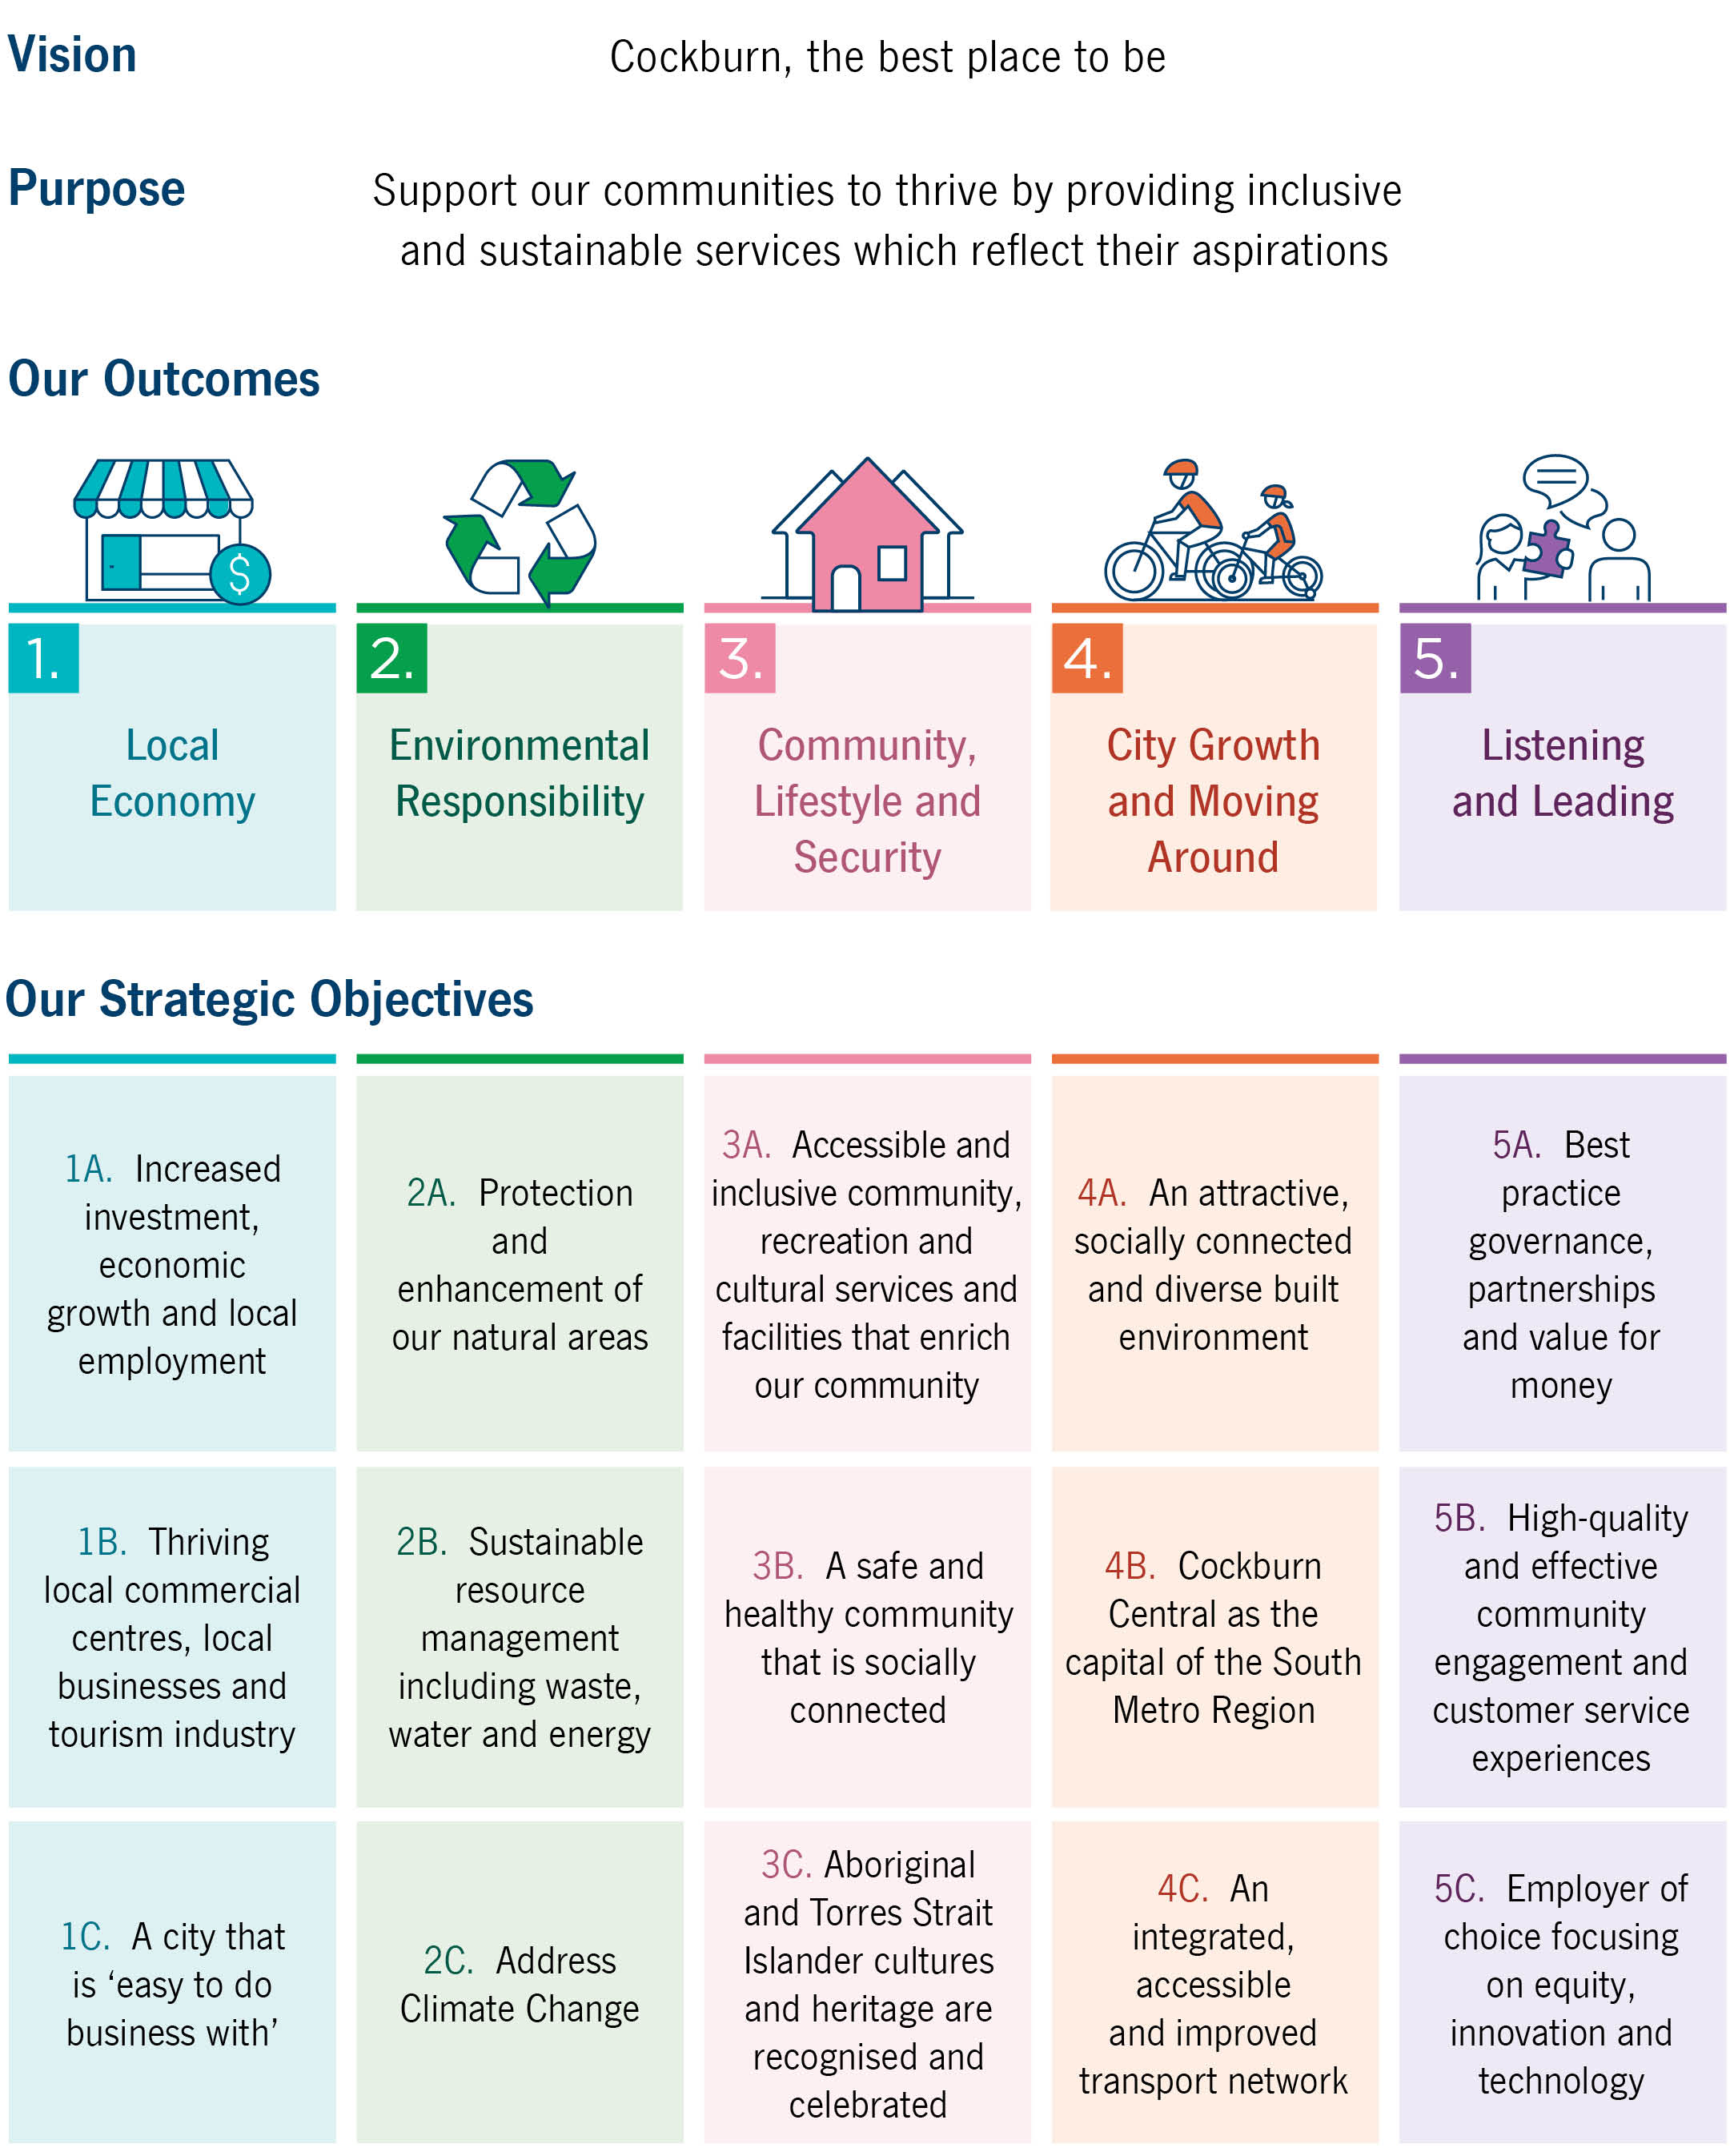
Together, these strategic pillars form an integrated framework that directs decision‑making and service delivery for the years ahead.

APPENDIX 4

Alignment of Local and State Public Health Plans
The City of Cockburn’s Public Health Plan 2026–2031 outlines how the City’s services and programs contribute to improved health and wellbeing outcomes for our community. The actions in this plan are drawn from the City’s strategic and operational documents and align with the Public Health Act 2016 as well as the State Public Health Plan for WA 2025–2030.
The Strategic Community Plan outcomes align closely with the State Public Health Plan’s four key objectives—Promote, Prevent, Protect and Enable—together with its cross‑cutting themes of Aboriginal health and wellbeing, and equity and inclusion.
Promote – Build healthier environments and connected communities
Aligned SCP outcomes:
- 3B Active, healthy lifestyles
- 3C Celebrating Aboriginal and Torres Strait Islander and diverse cultures
- 3D Connected, accessible communities and services.
Prevent – Reduce chronic disease, communicable disease and injury
Aligned SCP outcomes:
- 3A Safe and secure community
- 3B Active, healthy lifestyles
- 2A Protect natural areas and streetscapes
- 2C Climate resilience and environmental initiatives.
Protect – Safeguard against environmental and public health risks
Aligned SCP outcomes:
- 2A Protect natural areas and streetscapes
- 2B Sustainable waste management
- 2C Climate resilience
- 3A Safe and secure community.
Enable – Strengthen public health systems and workforces
Whilst the State Public Health Plan focuses on planning and delivery of the state public health system, for the City of Cockburn this objective also describes how the City ensures that the community is supported to make healthier choices, facilitating preventive health and positive wellbeing outcomes. Aligned SCP outcomes:
- 5A Transparent, accountable governance
- 5B Engagement and customer experience
- 5C Strategic partnerships
- 5D Financial sustainability and operational excellence
- 4A–4C Planning, liveability and connectivity.
As with all City programs, the public health actions identified in these tables are monitored through the City’s Integrated Planning and Reporting Framework and reported annually.
