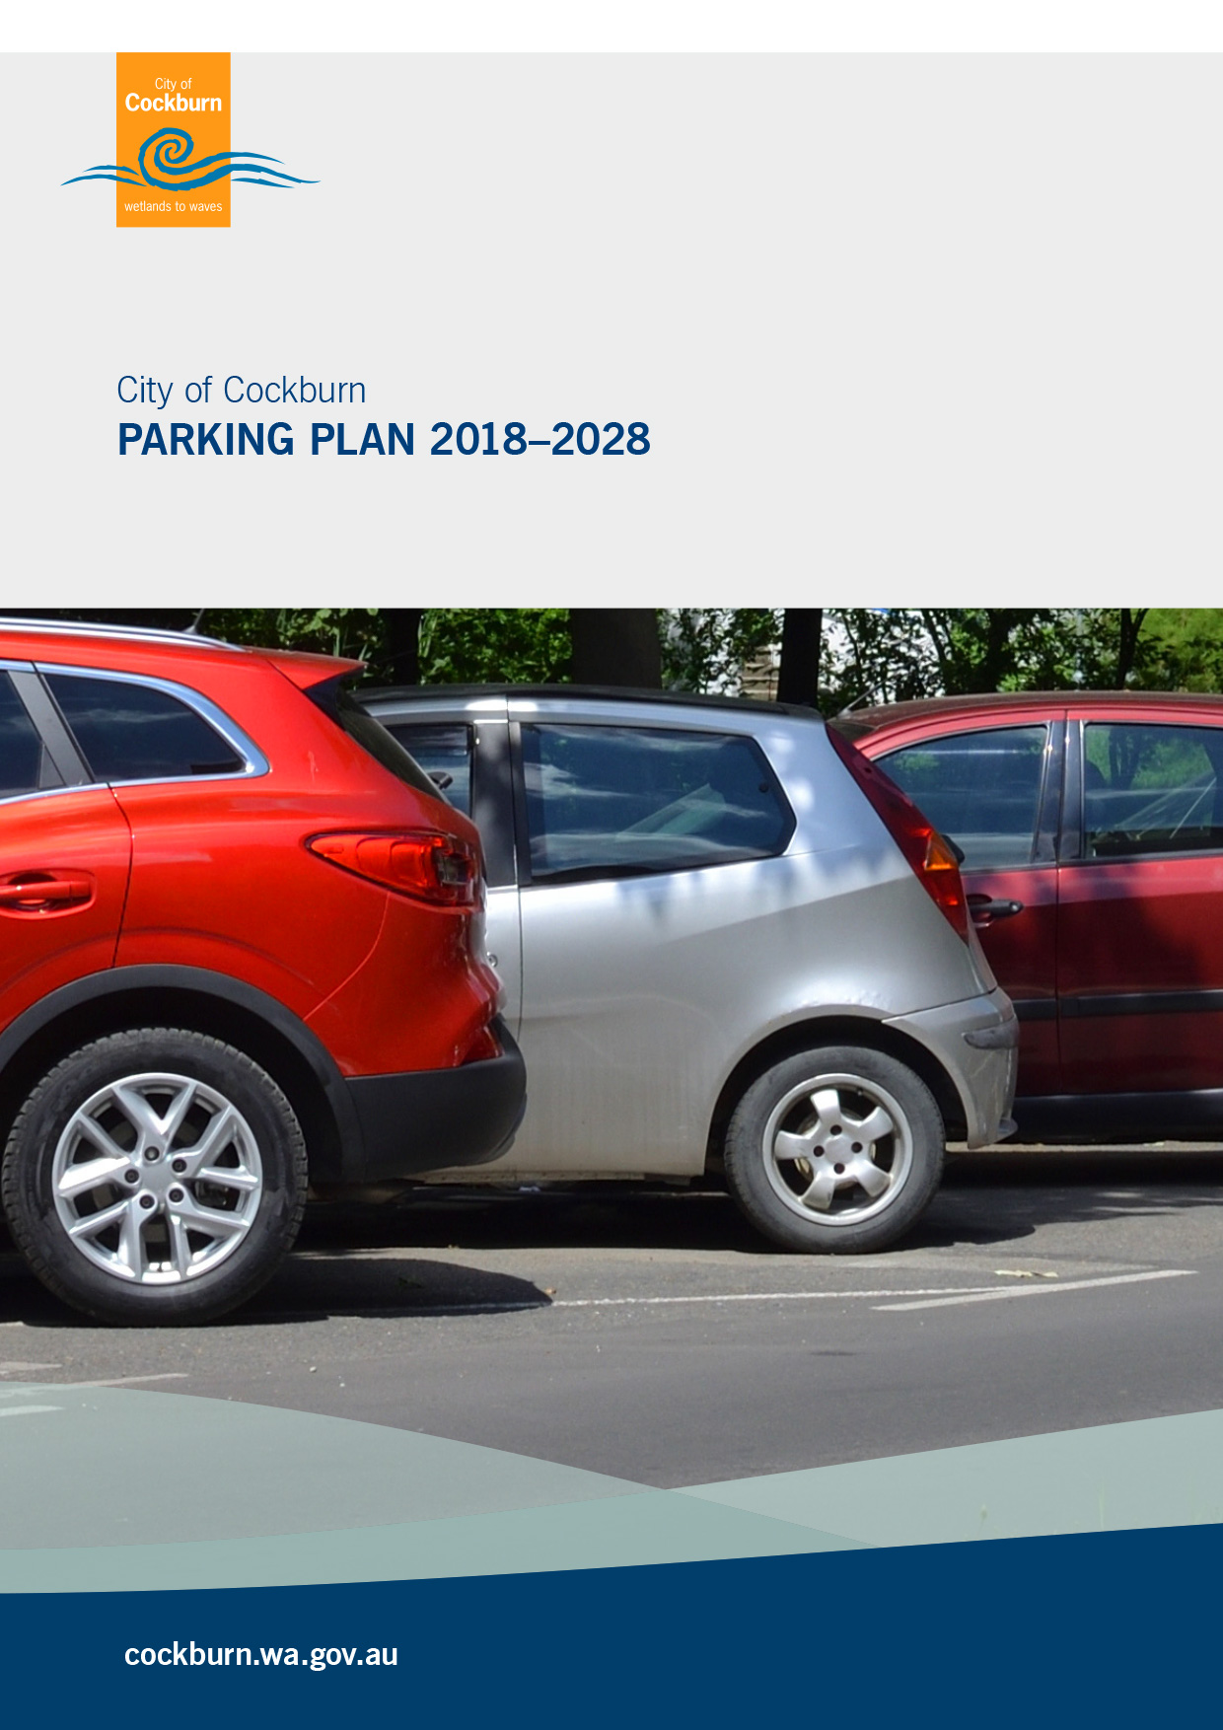

Contact Information | Document Information
Cardno (WA) Pty Ltd  ABN 77 009 119 000  11 Harvest Terrace  West Perth WA 6005  Australia  www.cardno.com  Phone +61 8 9273 3888  Fax +61 8 9486 8664 | Prepared for | Insert client name
 | Project Name | Parking Plan
 | File Reference | Document2
 | Job Reference | CW978300_TR_RP_001_B_January2019
 | Date | 4 February 2019
 | Version Number | B
Author(s):

Alix Oakes  Sustainable Transport Planner | Effective Date | 4/02/2019
Approved By:

Ray Cook  Senior Principal/Manager, Traffic & Transport WA | Date Approved | 4/02/2019

Document History
Version | Effective Date | Description of Revision | Prepared by | Reviewed by
A | 16 Nov 2017 | For Issue | Alix Oakes | Jacob Martin
B | January 2019 | For Adaption | Alix Oakes | Jacob Martin

Table of Contents
1 Introduction 1
1.1 Background 1
1.2 Scope of Work 2
2 Literature Review 3
2.1 Travel Demand Management Plan – Transport at 3.5 Million (2015) 3
2.2 Perth and Peel Transport Plan for 3.5 Million People and Beyond (2016) 3
2.3 Department of Transport WA - Parking Guidelines for Activity Centres (2016) 3
2.4 City of Cockburn Town Planning Scheme No. 3 (Updated 2016) 4
2.5 City of Cockburn Strategic Community Plan 2016-2026 5
2.6 City of Cockburn Parking Guide (2015) 6
2.7 Local Commercial and Activity Centres Strategy (2012) 6
2.8 Integrated Transport Plan (ITP) (Feb 2012) 6
2.9 Cockburn Central Town Centre Parking Strategy (2007) 7
2.10 Parking and Parking Facilities Local Law 2007 7
2.11 Summary 8
3 Existing Supply 9
3.1 Parking Supply 9
3.2 Parking Distribution 10
3.3 Future Parking Requirements 13
3.4 Parking Demand 14
4 Stakeholder Consultation 15
4.1 Consultation Method 15
4.2 Internal Consultation 15
4.3 Community Surveys 17
5 Findings, Recommendations and Implementation 23
5.1 Findings 23
5.2 Recommendations 25
5.3 Implementation 38
6 Action Plan 40
7 References 43

Appendices
- INTERNAL CONSULTATION RECORD
- PUBLIC CONSULTATION REPORT
- PARKING MANAGEMENT STRATEGY –PRINCIPLES AND CONCEPTS

Tables
Table 2-1 Parking requirements by land use 4
Table 2-2 Parking strategy statements within the LCACS 6
Table 3-1 Parking supply by land use 9
Table 4-1 Summary of discussions with internal stakeholders 15
Table 4-2 Summary of comments from the online survey 20
Table 4-3 Face-to-Face/ Intercept Survey Summary 22
Table 5-1 Parking Requirements at High Schools (TPS vs Department of Education) 29
Table 5-2 Summary of recommendations 38
Table 6-1 Action Plan 41

Figures
Figure 3-1 Formalised (marked) Parking Bays in the West Ward 10
Figure 3-2 Formalised (marked) Parking Bays in the Central Ward 11
Figure 3-3 Formalised (marked) Parking Bays in the Eastern Ward 12
Figure 3-4 Future Land Use Areas within City of Cockburn 13
Figure 4-1 Parking issue - location 17
Figure 4-2 Parking survey – reasons for parking at location 18
Figure 4-3 Parking issue 18
Figure 4-4 Time of day the issue occurs 19
Figure 4-5 Respondents’ home suburbs 20
Figure 4-6 Comments by land use 21
Figure 5-1 Parking Intervention Framework 25
Figure 5-2 Conflicts between land uses 35

Introduction

Background
The City of Cockburn (the City) is an outer suburban Local Government Area in the context of its proximity to the Perth CBD, with a wide variety of land uses and development scales, as well as a high potential for continuing population and employment growth.
The City of Cockburn is one of the fastest developing sectors in the South-Western Urban Corridor with significant residential development planned to occur in the suburbs of Cockburn Central, Hammond Park, North Coogee and Treeby. Additional brownfields development is occurring across the City, particularly because of changes to permitted densities in revitalisation areas.
Cardno has been commissioned by the City of Cockburn (“the City”) to undertake a Citywide Parking Strategy to identify parking issues throughout the LGA, and to present appropriate strategies to prevent, mitigate or offset these issues.
The supply and management of parking is a multi-faceted task and the number of the City’s service units that influence or have responsibility for the supply and management of parking in some way demonstrates this:
Corporate Communications | - Consideration of the availability of parking supply for City organised community events
Engineering Services | - Provision of technical advice about parking requirements for developments  - Investigation of on-street parking issues  - Design of parking control signs and pavement markings  - Manufacture and installation of parking control signs  - Construction/maintenance of on and off-street public parking facilities  - Management of off-street parking at the City’s public facilities
Planning Services | - Application of the parking requirements of the City’s Town Planning Scheme to all new developments
Ranger and Community Safety Services | - Investigation of on-street parking issues  - Monitoring of road users compliance with parking controls  - Enforcement of the City’s Parking & Parking Facilities Local Laws
Recreation Services | - Consideration of the availability of parking when approving the use of the City’s reserves for short-term events or long-term sport use

Scope of Work
The key objectives of this Plan are to support the City’s goals to:
- Reduce development costs and increase affordability;
- Facilitate more compact, multi-modal community planning (smart growth);
- Encourage the use of alternative modes and reduce motor vehicle use (thereby reducing traffic congestion, accidents and pollution);
- Improve user options and quality of service, particularly for non-drivers;
- Improve infrastructure design flexibility, creating more functional and attractive communities;
- Identify appropriate principles for paid parking to help fund the maintenance and management of existing parking facilities and the provision of new parking facilities;
- Develop a five-year operational parking plan. The scope of work has altered slightly since the inception of the project and this document seeks to identify solutions to specific operational parking issues identified through consultation with the City and the City’s residents. Strategic recommendations have been made where appropriate, alongside more practical actions that will assist the City in achieving the above strategic goals.
The investigations include a review of background documents and the existing situation, stakeholder engagement (workshops and surveys), analysis of different parking strategies, and an assessment of future demand.
Parking issues have been considered across 8 functional categories, as follows:
- Distributor and Local Roads
- Residential Areas
- Education
- Commercial Centre
- Industrial Areas
- Recreation/Leisure/Culture Facilities
- Public Open Space
- Public Transport Nodes
Note that these groups should not be seen in isolation from one another and are not in priority order.

Literature Review
Issues and Strategy recommendations have been considered in the context of Local and State Government policies and plans, with consideration for internationally recognised best-practice.

Travel Demand Management Plan – Transport at 3.5 Million (2015)
This plan, produced by Main Roads WA is part of the Transport @ 3.5 million suite of documents, and it identifies a number of mechanisms which should be implemented to result in more efficient use of parking facilities. These include:
- Supply constraints
- Sharing of parking
- Efficient pricing of parking
- Improved user information
- Incentives to use alternative modes.
All the above are valuable tools and, by incorporating them into this Strategy will ensure that parking in the City is used efficiently and provided where it is needed most.

Perth and Peel Transport Plan for 3.5 Million People and Beyond (2016)
The aim of this document is to increase public transport use, increase cycling and walking and reduce the mode share of car driver in Perth. It outlines the following parking strategies:
- Combine the use of long and short term parking charges or levies
- Limit the number of parking spaces in a particular area
- Reduce car travel to activity centres by up to 30 percent when good transport alternatives are made available
- Travel plans to minimise traffic congestion will be required for activity centres and industrial areas
- Local governments will be encouraged to implement strategies that support the use of active and public transport.
This document seeks to provide the conditions for a reduced level of car travel. This will have a positive impact on congestion and traffic safety.

Department of Transport WA - Parking Guidelines for Activity Centres (2016)
The purpose of this document, produced by the Department of Transport, is to ‘set out an approach to planning parking provision and management for major activity centres and provide direction on appropriate principles and management techniques to be considered when developing access and parking plans for these activity centres.’ It demonstrates:
- Evolution of parking policy from ‘predict and provide’
- Application to small activity centres
- Principles of planning, pricing and managing parking
- Approach to assessing centre accessibility and road network capacity
- Preparation of a Parking Management and Travel Plan
- Parking as one way of protecting the capacity of the road network
The outcome of these guidelines will realise accessible and well-connected activity centres that ease or assist in alleviating transport demand on the entire network and can be applied in the City particularly in activity centres such as Cockburn Gateway.

City of Cockburn Town Planning Scheme No. 3 (Updated 2016)
The aims of the Town Planning Scheme No. 3 (TPS3) are to:
- ensure that development and the use of land within the district complies with accepted standards and practices for public amenity and convenience;
- ensure that the future development and use of land within the district occurs in an orderly and proper way so that the quality of life enjoyed by its inhabitants is not jeopardised by poor planning, unacceptable development and the incompatible use of land.
These aims are compatible with this Strategy document which seeks to ensure that planning of parking occurs in such a way to contribute positively to the quality of life of the City’s inhabitants.
The parts of the document, which relate to parking, are:
- 4.8 Residential Uses
  - 4.8.4 Parking of Commercial Vehicles
  - 4.8.6 Vehicle Parking Residential Use Classes (see Table 2-1 for parking requirements)
- 4.9 Commercial and Industrial Uses
  - 4.9.5 Vehicle Parking
  - 4.9.6 Cash Payment in Lieu of Providing Car Parking Spaces
  - 4.9.7 Joint Use of Car Parking Facilities
  - 4.9.8 Vehicle Parking - Commercial Use Classes (see Table 2-1 for parking requirements)
- 4.10 Rural Uses
  - 4.10.8 Parking of Commercial Vehicles
  - 4.10.10 Vehicle Parking - Rural Use Classes.
The City uses the road industry standards AS1742.11 for a parking control and AS2890 for parking facilities. Issues about the application of these standards and use of minimum standards by developers vs the City’s desire to implement best practice by using more than minimum standards have been considered in the context of the City’s planning policies and plans.
The supply of car and bicycle parking for new developments for residents, staff, visitors etc. is prescribed by the City’s Town Planning Scheme No. 3. Examples of parking supply rates for different classes of land use are provided in Table 2-1 .
            - Parking requirements by land use
Land Use | Parking requirement
Residential | As per the WAPC’s Residential Design Codes | 1-bedroom dwelling 1  2 + bedroom dwelling 1 (or 2 if not within 800m of a train station or 250m of a high frequency bus route)  Aged persons’ dwelling 1  Ancillary dwelling nil (or 1if not within 800m of a train station or 250m of a high frequency bus route)
Education | Primary Schools | 1/classroom
Education | Secondary Schools | 1/classroom Plus 1/25 Year 12 students
Commercial Centres | Office | 1:50m² gla
Commercial Centres | Fast Food Outlet | 1:15m² gla
Commercial Centres | Hotel/Tavern | 1:2m² nla of Drinking Area Plus 1:1 bedroom
Commercial Centres | Restaurant | 1:4 seats OR*  1:4 people accommodated
Commercial Centres | Medical Centre | 5:1 Practitioner OR*  5:1 Consulting Room
Commercial Centres | Convenience Store | 1:15m² nla  1:1 employee Plus  2:1 Service Bays
Commercial Centres | Shop | 1:12m² nla for 0-5,000m² nla  1:14m² nla for 5,000-10,000m² gla  1:16m²nla for 10,000m² and over gla
Industrial Areas | Commercial Vehicle Parking | 1:per vehicle Plus  1:employee
Industrial Areas | Marine Engineering AMD 6 GG 13/6/06 | 1:1 employee  Visitor Car Parking Bays: additional 1:200 parking bays required per employee
Recreation, Leisure and Cultural Facilities | Place of Worship | 1:4 seats OR*  1:4 people accommodated
Recreation, Leisure and Cultural Facilities | Club Premises | 1:50m² gla
Recreation, Leisure and Cultural Facilities | Private Recreation | 1:4 seats OR*  1:4 people accommodated
Public Open Spaces | No requirement stated
Parking is discussed within the above in terms of its accessibility and the amount of parking to be provided. Additional guidance is provided for commercial and industrial land on the use of cash in lieu payments and joint use of parking.

City of Cockburn Strategic Community Plan 2016-2026
The City’s Strategic Community Plan 2016-2026 sets out five key strategic directions. Strategic Objectives Moving Around and Community, Lifestyle and Security, focuses on facilitation of safe, efficient, connected and sustainable movement around the City.
This strategy aims to:
- Reduce traffic congestion, particularly around Cockburn Central and other activity centres;
- Identify gaps and take action to extend the coverage of the cycle way, footpath and trail networks;
- Improve connectivity of transport infrastructure;
- Continue advocacy for a better solution to regional freight movement;
- Provide for community facilities and infrastructure in a planned and sustainable manner;
- Provide safe places, safe movement and safe programs to ensure a focus on maintaining a safe community;
- Improve parking facilities, especially close to public transport links and the City centre; and
- Advocate for improvements to public transport, especially bus transport
All of the above aims supported for an efficient and sustainable approach to parking management in the City. This parking plan has been is developed in this context.

City of Cockburn Parking Guide (2015)
The purpose of this document (Parking Guide), prepared by the Rangers and Community Safety Services unit, is to educate road users about their responsibilities when parking a vehicle and encourage them to comply with the City’s Parking and Parking Facilities Local Laws when parking within the road reserve and in Parking Station facilities.’ It includes guidance for, amongst other things:
- Footpath parking
- no parking areas
- no stopping areas
- verge parking
- obstructions
- parking on a public reserve
- parking stations
- timed parking.
This document demonstrates the importance of parking controls, and particularly ensures that parking does not impede on the experiences of others using the road reserve. It is an important complementary document, which assists in the implementation of the strategy at an operational level.

Local Commercial and Activity Centres Strategy (2012)
This Planning strategy is an important document for ‘implementing the new direction for the planning of activity centres in Perth and Peel set by the Directions 2031 and beyond: Metropolitan planning beyond the horizon, and State Planning Policy No. 4.2 – Activity Centres for Perth and Peel.’ The table below outlines its references to parking.
            - Parking strategy statements within the LCACS
Section | Strategy
Amenity and public realm attributes | Buildings other than residential-only developments must be sited and orientated to provide an active interface with the pedestrian realm rather than set back or wrapped in car parking or other inactive uses.
Parking within activity centres | The responsible authority should set upper limits in view of opportunities for shared and reciprocal parking, on-street or other parking, and the need for land efficiency.  Minimums may also be required, in addition to flexibility for developers providing less or no on-site parking and cash-in-lieu contributions.
Employment density | The larger the area provided for parking, the greater the detrimental effect will be on scoring within the Sustainable Activity Centres assessment method.
Economic activation | Strategic distribution of car parks will allow for greater pedestrian movement.  Street parking is important for business.
These help to shape the programme for parking management at local commercial and activity centres in long term.

Integrated Transport Plan (ITP) (Feb 2012)
This document summarizes recommendations for the Cockburn Coast development project and states that the ‘fundamental strategy for the ITP is to minimise the amount of car parks provided to promote public and active transport’. It focuses on:
- The nexus between the supply, location and price of parking and the amount of driving will be used to manage travel.
- Parking management program which contribute to greenhouse gas reductions.
- Land area used for road and parking, and number of parking bays per capita.
- Car free or parking restricted areas.
All these are important reinforcing reasons for the development of a parking strategy to shape the programme for parking management in the Cockburn area.

Cockburn Central Town Centre Parking Strategy (2007)
The purpose of this document when published, was to provide a strategy for providing car parking “in a manner reflecting the characteristics of the town centre and nature of the uses intended”. The principles guiding the development of the document were:
Recognising that Cockburn Central is a Transit Oriented Development (TOD)
The Strategy should be easy to administer, flexible and responsive to changing land uses and community needs
- Recognising differing TOD/Non-TOD parking requirements
- Balancing parking supply and demand while not unduly encouraging private vehicle use
- Consideration of alternative methods of parking management.
- Ultimately the adopted approach was to:
- Standardise parking requirements for non-TOD parking
- Allow consistent discounting for TOD related parking provision
- Adopt a cash-in-lieu approach by concentrating parking in public parking precincts, not onsite.
The guiding principles are still relevant to the provision of parking in the City today, however this Strategy will seek to provide greater differentiation in its approach to managing parking by land use rather than just a TOD/Non TOD scenario.

Parking and Parking Facilities Local Law 2007
This law aims to regulate the parking of vehicles in specified thoroughfares and reserves under the care, control and management of the local government and to provide for the management and operation of parking facilities. It sets out a number of arrangements with relation to parking, including:
- Parking Stations, tickets and ticket issuing machines
- Parking on thoroughfares
- Stopping and Parking generally
- Residential parking permits
- Metered zones.
All of the above contribute to the parking management in the local area, in particular, maximising the use of verge areas for construction of new parking stations and maintenance of existing parking facilities, as well as the application of paid parking.

Summary
The key points from this literature review are:
- Efficient use of parking will ensure a quality experience for all road users;
- Management and parking strategies for special cases are required to protect individuals’ and business interests;
- Rules around parking are required to ensure that traffic flow, road safety and amenity are not compromised
- Proper and considered planning and development of parking will ensure that the provision of these facilities do not impede the quality of life of the City’s residents and visitors;
- Parking facilities should interact with the pedestrian realm and other transport modes;
- An appropriate Parking Plan will help reduce congestion and avoid excessive growth of private vehicle use.

Existing Supply

Parking Supply
The City currently manages approximately 5,000 marked bays and 75,000m² of unmarked bays, spread over 1,400+ off-street car parks and road segments. This does not include the majority of parking that is provided in unmarked on-street parking bays, within residential streets.
Table 3-1 summarises data provided by the City in relation to public parking supply within the LGA, disaggregated by associated land use and frontage road category.
            - Parking supply by land use
Land Use | Road Types |  |  |  |  |  |  |  |  |  |  |  |  |  |  |  | Parking Permits | TOTAL Parking Bays | TOTAL ACROD Bays
Land Use | Regional Distributor |  | Primary Distributor |  | District Distributor A |  | District Distributor B |  | Distributor A |  | Distributor B |  | Local Distributor |  | Access Road |  | Parking Permits | TOTAL Parking Bays | TOTAL ACROD Bays
Land Use | TOTAL | ACROD | TOTAL | ACROD | TOTAL | ACROD | TOTAL | ACROD | TOTAL | ACROD | TOTAL | ACROD | TOTAL | ACROD | TOTAL | ACROD | Parking Permits | TOTAL Parking Bays | TOTAL ACROD Bays
Commercial |  |  |  |  |  |  |  |  |  |  |  |  | 27 | 5 | 905 | 11 |  | 932 | 16
Educational |  |  |  |  | 10 |  | 31 |  | 22 | 2 |  |  | 428 | 3 | 435 |  |  | 926 | 5
Industrial |  |  |  |  |  |  |  |  |  |  |  |  |  |  | 165 |  |  | 165 | 0
Public Open Space | 8 |  |  |  | 26 |  | 2 |  | 13 | 1 |  |  | 62 | 1 | 2,644 | 56 | 22 | 2,755 | 58
Recreational/ Leisure/ Cultural |  |  | 47 | 1 |  |  | 33 |  | 42 | 4 | 29 | 2 | 200 | 5 | 1,087 | 31 |  | 1,438 | 43
Residential |  |  |  |  | 6 |  | 69 |  | 18 |  |  |  | 272 |  | 1,549 |  | 114 | 1,914 | 0
TOTAL | 8 | 0 | 47 | 1 | 42 | 0 | 135 | 0 | 95 | 7 | 29 | 2 | 989 | 14 | 6,785 | 98 | 136 | 8,130 | 122
Note: Data is a snapshot of time circa September 2017 and is subject to change.

Parking Distribution
The existing parking locations for each land use are illustrated in the following three maps, separated by Ward (Figure 3-1 to Figure 3-3).
From these figures it can be seen that formalised parking area, where signage and line marking to formalise parking bays, bollards and wheel stops and pedestrian access have been included, is provided in new and dense development areas such as North Coogee and Spearwood.
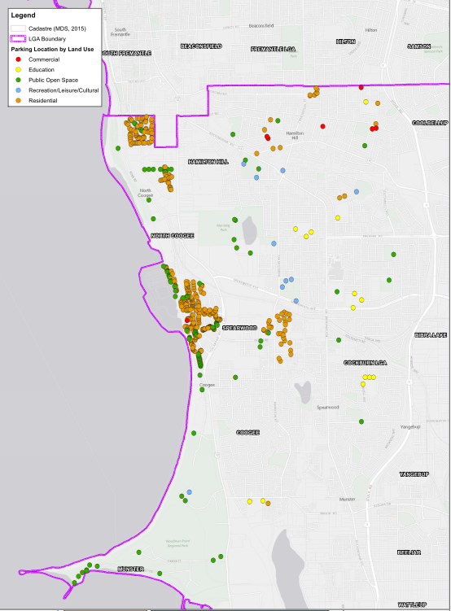
Source: City of Cockburn (September 2017)
          - Formalised (marked) Parking Bays in the West Ward

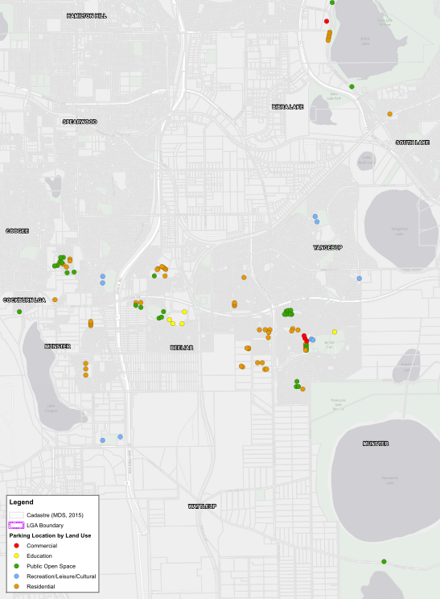
Source: City of Cockburn (September 2017)
          - Formalised (marked) Parking Bays in the Central Ward

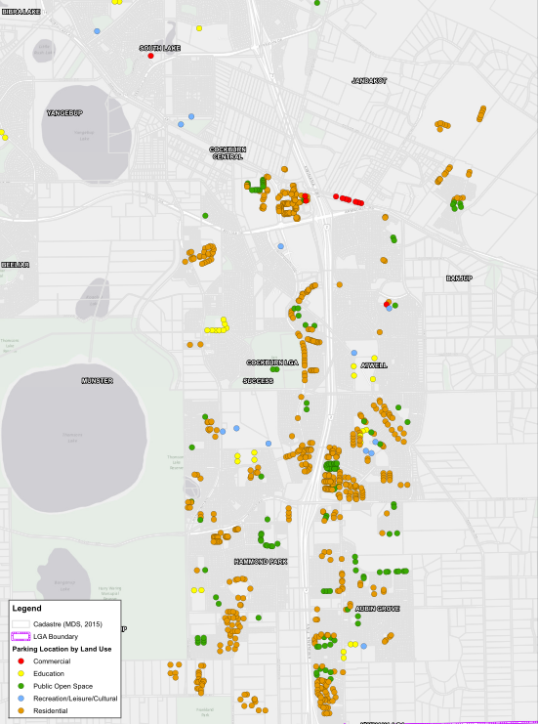
Source: City of Cockburn (September 2017)
          - Formalised (marked) Parking Bays in the Eastern Ward

Future Parking Requirements
The location of existing formalised parking can be seen in the context of the City’s future development projections, as shown in Figure 3-4 below. These development areas are likely to create a significant increase in demand of on-street and off-street parking resources as they grow, necessitating City intervention in the provision, maintenance and enforcement of public parking.
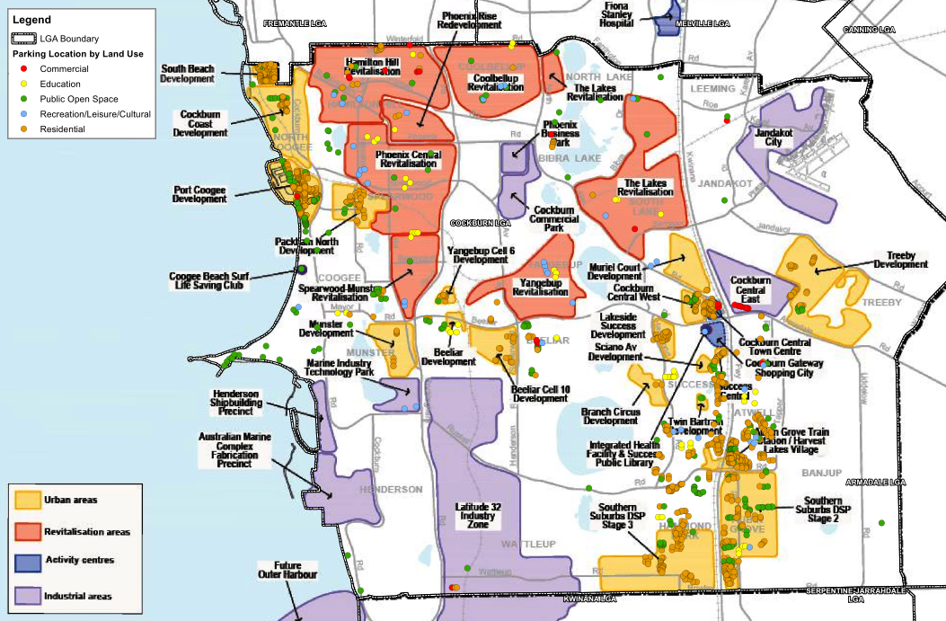
Source: City of Cockburn (September 2017)
          - Future Land Use Areas within City of Cockburn

Parking Demand
Whilst no detailed parking surveys have been undertaken in the City, anecdotal reports from community stakeholders suggests that, there are areas of high parking demand, which create localised issues. These issues are outlined in the consultation findings (see Chapter 5).
The findings from the consultation exercises highlighted some areas such as:
- At Knock Place (in line for Armadale Road deviation project), Jandakot and the Cockburn Central Town Centre due to the demand for unpaid commuter parking;
- The typical concentrated demand for on-street parking around all schools at the end of the school day;
- The demand for all day on-street parking in the vicinity of educational facilities with driving age students such as on Farrington Road (Kennedy Baptist College and Murdoch University); east of Hammond Road (Emmanuel Catholic College)
- The demand for short-term all-day on-street parking around construction sites such as at the Cockburn Central Town Centre and Port Coogee.

Stakeholder Consultation

Consultation Method
Following discussion with the City, stakeholder consultation was undertaken to engage City staff and Cockburn’s community on parking issues. Comments were sought through the following forums:
- Internal stakeholder consultation with relevant departments
- An online community survey conducted by the City
- Face-to-face intercept surveys

Internal Consultation
Cardno consulted with the following departments at the City:
- Rangers
- Statutory Planning
- Strategic Planning
- Transport Engineering
- Disability Access Officer
- Community Engagement.
Table 4-1 provides a summary of these discussions.
            - Summary of discussions with internal stakeholders
Item | Discussion Topics
Distributor and local roads | - Large vehicle movements are adversely impacted by verge and on-street parking  - Footpath parking creates hazards and disadvantages pedestrians and cyclists  - There is likely to be an impact on parking supply as a result of the Cockburn Coastal Highway and the North Lake Road Bridge infrastructure changes
Residential areas | - Parking over-spill in high density residential developments creates amenity and equity issues  - There may be a need to consider an on-street parking strategy to address both verge and on-street use  - There may be a need to consider a more consistent residential parking permit system  - Provision of visitor bays in high density areas where on-street bays are provided  - Small-lot development restricts on-site residential parking storage, with parking impacts on laneways and verge frontages  - Aged Care facilities often provide insufficient parking on-site to accommodate demand, on-street parking restrictions may disadvantage carers  - Car ownership/parking expectations of residents exceeds on-site supply in dense and mixed use areas
Education | - Schools parking - drop off/pick up at peak times results in poor parking behavior and impacts road function  - Schools spread the demand by staggering start/finish times  - Parking Management Plans/Travel Plans are being sought under planning conditions  - Government schools provide significantly more parking than the TPS requirements, this may require a review of appropriate education rates  - Demand for parking at schools is proportional to catchment growth
Commercial centres | - Increased number of ACROD parking bays provided at Integrated Health Facility (IHF)  - Wayfinding issues at IHF  - Commuter and all day parking in Cockburn Centre (on perimeter of site in City managed bays)  - Some buildings are developed up to the extent of their footprint (no parking provision)  - Require adequate provision of loading bays including flexible/shared bays
Industrial areas | - Some bays are occupied for other purposes  - On-site parking areas are difficult to control  - Lots of verge and footpath parking, impeding pedestrian/cycling access and safety  - Require adequate locations and provision for loading, motorcycle, disabled bays and short term freight parking  - Many employees are restricted by mode, requiring a vehicle for their work. This is exacerbated by the lack of public transport and path networks for cyclists and pedestrians to most industrial areas  - Large vehicles have difficulty negotiating the on-street network where parking reduces road width or impedes swept paths
Recreation/leisure/culture facilities | - Parking shortages at the man-made beach; could be addressed by a coastal parking strategy.  - Verge/footpath parking observed near Adventure World/Bibra Lake Playground  - ARC – distance from car park and shortage of bays. This is particularly a problem for  - Elderly and mobility impaired visitors, due to the small number of ACROD bays: many visitors are from areas outside of Cockburn  - Cockburn ARC will eventually be surrounded by residential developments – this may impact adversely on ARC parking (and vice versa)  - Minimal public transport to coastal areas  - Event parking should consider drop off zones and ACROD parking in prime locations
Public Open Spaces | - There is currently no parking requirement for POS; demand varies greatly by location, amenity and time of day/week/year  - Verge parking e.g. weekend football matches  - Lack of visitor parking at the beach  - Wayfinding at Bibra Lake playground is poor, resulting in inefficient use of parking supply  - ACROD Parking - strategy to consider:  - the distance from accessible parking to exercise equipment/toilet facilities;  - path access from the car park to areas that likely to be used by disabled patrons; Consider existing, proposed reserves and the differences between areas such as dog exercise areas, local parks and regional play spaces in terms of parking.
Other matters | - Public parking is controlled via restrictions by time and type. There is no paid parking  - When a “parking area” should become a “parking station”?  - Development sites – managing builder and tradesman parking.  - Park ‘n’ ride use of public parking to avoid the PTA $2 fee  - Feedback on parking from the mobility impaired relates to:  - Distance of parking from the facility  - Connectivity of parking to facility  - Directness of route to facility  - Bay width  - Placement of bollards  - Shelter  - Obstructions on footpaths which cause issues for mobility impaired  - Opportunities to work with private operators to provide match funding for upgrades/retro-fitting of ACROD bays  - There is a need for better clarity on who is enforcing particular car parks

Community Surveys
The City commissioned Research Solutions to conduct face-to-face interviews in key locations across Cockburn to ensure that specific groups of people were able to provide their views. The City also coordinated online surveys to capture the experiences of residents, employees and visitors.
The online survey was published via Facebook and email newsletters by the City.

Online Survey

Quantitative data
The online surveys had a reach of 333 people visiting the site and 60 participants. Figure 4-1 shows that the majority of comments related to parking in residential areas (35%) or near schools (26%). The least comments were received about parking in Industrial areas which is likely to be a reflection of the numbers of people requiring parking in those locations.
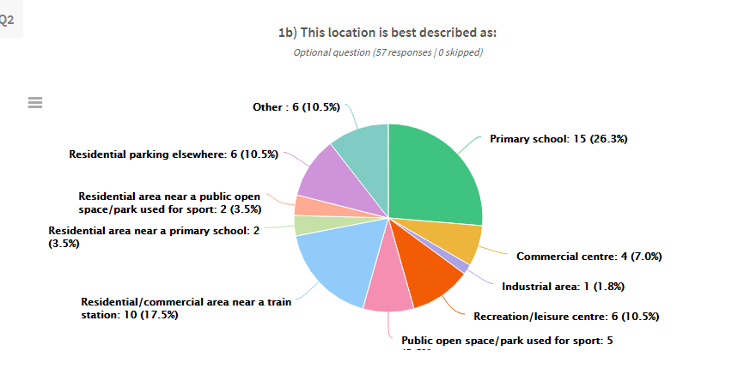
Source: City of Cockburn
          - Parking issue - location
The reasons for parking at the location are varied and presented in Figure 4-2. The highest number of responses (28%) related to parents dropping off children and the next most common response related to employee parking (23%).
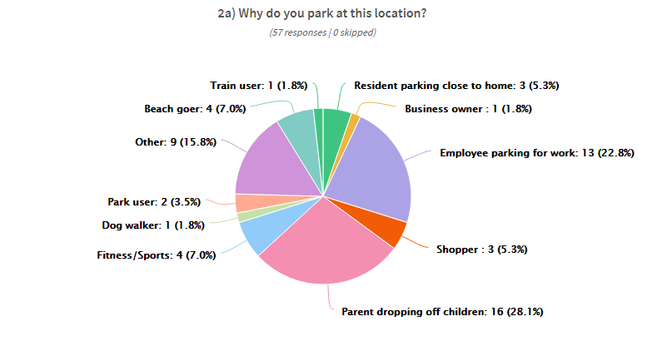
Source: City of Cockburn
          - Parking survey – reasons for parking at location
In terms of the issues with parking at the location, respondents identified a lack of free parking leading to overspill into nearby streets as the main concern (47%) as illustrated in Figure 4-3
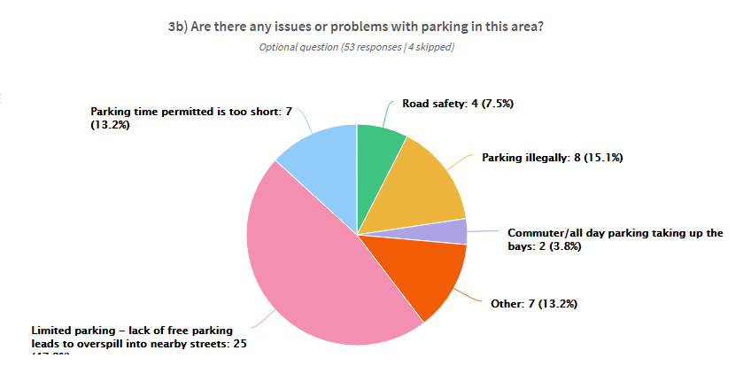
Source: City of Cockburn
          - Parking issue

There were no particular times of day that stood out as particularly problematic. Instead, the time of day was related specifically to the issue. For example, issues with parking at schools during weekday mornings, issues with parking in recreational locations or public open spaces on Sunday mornings, and employee parking as an issue throughout the weekday (see Figure 4-4).
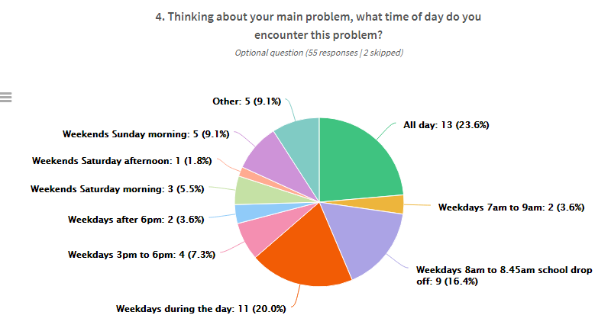
Source: City of Cockburn
          - Time of day the issue occurs

The majority of respondents reside in the suburbs of Success, Beeliar and Spearwood (see Figure 4-5).
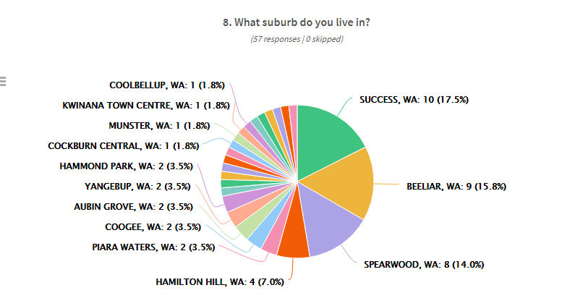
Source: City of Cockburn
          - Respondents’ home suburbs

Qualitative Data
A summary of the general issues and concerns collected from the online survey are presented in Table 4-2 below.
            - Summary of comments from the online survey
Land Use or topic | Comment
General comments | - Parking shortages have resulted in overspill to other land uses  - There is a perceived lack of free parking  - Parking duration restrictions are too short and there is a perceived lack of all-day parking  - Bay sizes are inadequate for some users
Residential Areas | - Verge, footpath, and crossover parking increase safety risks by obstructing vision
Education | - Primary schools are perceived to have an insufficient supply of parking
Commercial Centres | - Employees are consuming visitor parking spaces in some commercial centres, at least partially as a result of displaced park ‘n’ ride commuters using the limited available all-day parking.  - Parking for employees is limited  - There are parking shortages within the Commercial Centre in Cockburn Central, and conflicts between demand from employees, residential and commercial visitors and park ‘n ‘ride commuters.
Public Open Space/Recreation | - Sports field/ ovals are perceived as having a lack of parking supply for larger events such as AFL and AusKick.
Figure 4-6 provides a summary of which land use the parking issue originates from. Comments relating to parking issues around educational and commercial land uses dominate, followed by issues at Public Open Spaces.
Industrial areas have the fewest parking issues according to respondents of this particular survey, although the respondents themselves are unlikely to be representative of the community that uses industrial parking facilities.

          - Comments by land use
Excluding the option to simply “build more parking” a number of suggestions were made by survey respondents as to how to improve parking in the City:
- More free parking;
- Allow more all-day parking even if it’s paid parking, particularly in the vicinity of train station;
- More enforcement of illegal verge, crossover and footpaths parking;
- Traffic management for school areas;
- Redesign parking bay dimensions.
Participants were also asked what they would do if the issues persisted. Responses included:
- Stop visiting the area or look for other areas that offer similar interest/ needs;
- Park in nearby streets or other areas even it is far away;
- Relocate businesses to other areas;
- Look for alternative workplaces;
- Shift to public transport, including having the car parked at other places prior taking public transport;
- Park illegally;
- Parents to arrive at school earlier or later during peak periods;
- Vote for new councillors.
A comprehensive summary of issues is provided in Appendix A.

Face to Face/Intercept Surveys
Face-to-face surveys were conducted at 12 locations over a period of two weeks across the City using the same questions as the online survey. The consultation report is provided in Appendix B. A summary of the issues and suggested solutions from interviewees for each category are illustrated in Table 4-3 below.
            - Face-to-Face/ Intercept Survey Summary
Land Uses/ Users | Issues | Suggested Solutions
Education | - Lack of parking close to school  - Verge and footpath parking  - Traffic delays due to on-street illegal parking/stopping  - Illegal parking reduces visibility of on-coming traffic  - Kiss and drive is not effective | - School attendant supervision of traffic and children  - Construct crossings  - More parking  - Ride bike to school  - Come later after siren
Commercial centre | - Apartment parking spills over into commercial car parking  - Lack of visitor parking for apartments  - One bay per shop is not sufficient  - No all-day parking is available for staff  - Unaware of time limited parking | - Dedicated parking bays for business  - Utilise nearby vacant land for parking  - Remove verge trees and convert to parking  - Construct multi-storey car park  - Remove service bay signs to free up space for parking
Industrial | - Contractor and employees verge parking causing visual obstructions  - Congestion due to informal on-street parking  - Signs have been removed illegally  - Parking aggression  - Lack of public transport to industrial areas | - Provide on-site parking for contractors  - Provide on-street parking  - Provide footpaths for pedestrians  - Provide public transport services  - Provide on-site drop off bays
Public open space and parking for sport | - Car bays too small  - Insufficient parking during events  - No drop off points | - Provide drop off zones  - Ensure disabled parking is available  - Provide shuttle service between the location and car parking  - Allow parking on the grass  - Rangers more lenient at events
Parking adjacent to station | - Insufficient parking  - Not enough space for pick up and drop off  - Verge parking  - Limited motorcycle bays  - Parking areas are not clearly signed | - Utilise nearby vacant land for parking  - Allow parking on the opposite side of the road  - Separate drop off from the circuit at the station
Heavy Vehicle Drivers | - No truck parking bays available in Bibra Lake area  - Loading bays are too small for larger vehicles  - Overhanging trees prevent the use of bays | - Provide heavy truck parking area  - Increase bay sizes for large truck  - Provide better signage for loading areas
ACROD | - Too few bays at shopping centres  - All day parking in ACROD bays  - Bay dimensions are too small or narrow  - Illegal parking by tradesmen and couriers | - Redesign bay size to accommodate larger vehicles  - Provide drop off and pick up zones outside venue entrances  - Increase the parking provision and locate them closer to entrances.
A comprehensive summary of issues is provided in Appendix B.

Findings, Recommendations and Implementation

Findings
The City uses the Main Roads Western Australia (MRWA) Functional Road Hierarchy method to identify road function. On-road parking is permitted on Local Distributor (LD) and Access (AR) roads where there is sufficient width and sight distance to allow safe passing (although not in non-built up areas, excepting emergency parking on shoulders).
On-Street parking is not allowed on all other roads except in emergencies

Existing Supply
Parking in Cockburn is:
- Plentiful: over 5,000 marked bays and 75,000m² of unmarked bays, spread over 1,400+ car parks across the City, greatly exceeding the demand for bays (in general)
- Mainly located in public open spaces and residential areas
- Situated primarily along or adjacent to Access Roads
- Not readily available in industrial areas
- Highly sought after around activity centres, at beaches and in areas of recreational use.

Consultation Exercises
The findings from the consultation exercises have been distilled into the topics below and these will be addressed within the Strategy.
- Distributor and Local Roads
  - Verge/on-street/ footpath parking
- Residential
  - Visitor parking
  - Parking overspill
  - Too many cars for property ratios
  - Parking permits
  - Verge/ footpath/ crossover parking
- Education
  - Dangerous and illegal parking
  - Review of existing and future school generated traffic parking provided
  - Safety issues
  - Performance of Kiss and Drive facilities
- Commercial Centres (mainly Cockburn Gateway)
  - Lack of loading bays
  - Lack of all-day parking for employees
  - Lack of parking for customers
  - Some businesses are considering relocating due to parking issues
  - Apartment parking is overspilling into bays that would be used by businesses
- Industrial Areas
  - Size of bays for heavy vehicles
  - Difficulty of Heavy Vehicles accessing properties due to incorrect, dangerous or illegal parking
  - Lack of public transport to industrial areas
- Recreation
  - Beach parking
  - Parking at Bibra Lake
  - Parking issues at ARC
  - ACROD parking
    - Planning (location and connectivity)
    - Events
  - Parking for sports events and at ovals
- Public Open Space
  - Similar to recreation
  - No parking requirements for Public Open Spaces – there is a need to consider the different uses of these areas e.g. dog exercise areas, local parks and regional play spaces
  - Verge and haphazard parking
- Strategy and Planning issues
  - Paid Parking
  - Parking Permits
  - Time and duration restrictions
  - Parking areas vs parking stations
  - Parking overspill (residential areas, commercial areas and stations)
  - School parking
  - Carer and ACROD parking provision
  - Enforcement of Parking
  - Public expectations for parking
  - Planning for parking at new developments
  - Tradesmen and Construction parking
  - Special use parking (families, seniors)
  - Bike parking
  - The cost of parking
  - Autonomous vehicles and parking.

Recommendations

Parking Intervention Framework
The recommendations that are put forward in the following sub-sections, should, where possible, follow the order of priority of this Parking Intervention Framework. This framework has been adapted from work undertaken for the South Perth Parking Strategy (2016) and describes at what demand point certain interventions should take place. This information has been supplemented by complementary actions that should take place simultaneously to these interventions being carried out.
The stages of this framework are:
- Existing parking should be used as efficiently as possible through education and user information where alternative parking facilities are available and compliance is an issue.
- Existing restrictions should be adhered to and enforced as appropriate.
- Additional restrictions should be considered where parking compliance remains an issue, and should be accompanied by additional educational campaigns.
- Further enforcement is carried out and infringements issued if necessary to reinforce restrictions and encourage compliance.
- Paid parking should be introduced alongside further educational campaigns if the above interventions have not been successful. This is particularly appropriate if there are no alternative parking locations in the vicinity for people to use.
In order to identify the trigger points as described in Figure 5-1, the City must undertake regular parking occupancy surveys to understand the nature of parking demand in popular locations.
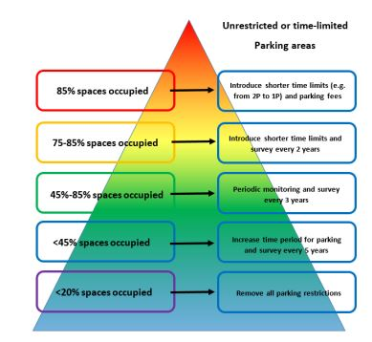
Promote as all day parking to nearby businesses or for P&R
Promote to nearby attractions and land uses as overspill parking
Promote for shared parking when demand is low
Periodic patrols to ensure compliance when demand is high
Enforcement, education (time and duration restrictions, alternatives)
          - Parking Intervention Framework
Adapted from the South Perth Parking Strategy, Luxmoore (2016)

Parking Approach by Land Use
As a result of the high level of development, the population is increasing rapidly and thus the demand for local parking amenities have also increased. The predicted population forecast from the City of Cockburn website from 2016 to 2036 is an increase of 53.65% (111,787 to 171,760 residents).
With the predicted continued growth of the City of Cockburn the consideration of whether to supply more parking is always at the front of developers minds. The City needs to focus on a way to create a society that is predominately using the parking sparingly and in the right way to reduce the demand for more.
The principles behind this parking plan, which support the above, are included in Appendix C along with the concepts of parking management approaches recommended in the following sections.

Distributor and Local Roads
Distributor and Local Roads do not create parking demand, and have not been highlighted by the consultation exercise specifically as creating parking issues except where they abut Public Open Spaces. In these instances, illegitimate parking has been reported on verges, or on streets and footpaths in such a way that causes a hazard. It has been identified that much of the on-street parking takes place on local roads within the various land use settings however, and therefore it is important to ensure that vulnerable road users are protected from hazardous parking practices and that traffic flow in those areas is maintained.
To ensure compliance, enforcement should take place at times when issues are most likely to occur, and infringements issued where necessary. In situations where parking becomes an issue on distributor roads, parking should be embayed, regulated, or banned altogether.
There is a value in the provision of on street parking on local roads; it should be encouraged to an extent and in appropriate locations as a way of ensuring amenity but in parallel with consideration of the impact on other transport modes.
To assist users in locating parking, a wayfinding strategy for areas of high parking demand could be devised to direct people to alternative parking facilities, or educate them about the availability of other transport facilities which serve the area.
The future North Lake Road Bridge may have an impact on the quantum of available parking along Knock Place, and consideration as to how to mitigate this should take place at as early an opportunity as possible. If the current unrestricted parking is lost, it is likely to relocate to other areas of high demand such as Cockburn Central or the industrial area to the east.
Mitigations strategies such as time and duration restrictions and/or paid parking should be used to direct parking to appropriate locations and not undermine nearby PTA paid parking facilities.

Residential Areas
Residents historically have not intended the residential streets of the City for on-street parking, as properties are all single lot dwellings and have parking on-site. However, the on-street environment is available for parking by visitors to residential properties.
The City is now becoming more populated and denser, and with density comes more vehicles. As parking areas become full and/or fees and restrictions are implemented, parking spills over to surrounding residential streets and verges to utilise a cost-free/restriction-free parking environment.
On-street parking is supported in preference to verge parking. On-street parking increases friction, resulting in reduced traffic speeds and safer vulnerable road users.

Issues related to parking in residential areas (particularly in high-density residential and mixed use areas such as North Coogee) commonly falls under one of the following types:
- Residential parking in visitor bays
- Hazardous or illegitimate parking on verges, footpaths and crossovers.
It is recommended to increase a number of enforcement officers to ensure that regular patrols are taking place that encourage compliance with existing restrictions. In addition, regulatory practices such as timed parking or limits on visitor parking can be implemented alongside rigid enforcement.
A small number of residential parking permit schemes have been introduced where the availability of on-street parking has become an issue.
It is not recommended to implement additional parking permit schemes, except in exceptional circumstances. As discussed further in Appendix D, such schemes are not desirable since it shifts the burden of the cost to park the vehicle from the owner to the City.
If a parking permit scheme is unavoidable, these permits should attract a fee commensurate with their value. A representative scheme has been implemented in the City Darebin0F. In this case, the cost of a permit is set against the on-site provision of a private bay (either land value or construction cost).
There may be circumstances where special permits can be issued, such as in the case of carers who need to be present at a property for longer than time and/or duration restrictions allow.
Operators of service vehicles have reported issues accessing properties in laneways due to parked vehicles.
Where there is sufficient width, time restrictions should be implemented to ensure access for service vehicles. In cases where the width or design does not allow it, parking in laneways should be banned.
It is possible that there is a mismatch between the expectations of home owners and the parking provision in high density residential areas. Such locations are designed to produce a vibrant, diverse and sustainable community and concentrate on the needs of people first, not transport.
It is important to engage with the community on a regular basis to educate them on the transport options available to them and to keep lines of communication about transport issues open and positive. As the development in North Coogee progresses, more transport services will become available and ultimately this will become a well-connected area of which residents should be kept informed.
The City may also consider engaging with Real Estate Agents to make them aware of the parking provision in the properties, which they are selling. This will ensure that potential buyers do not have unrealistic expectations of the number of vehicles that may park at the property.
Being situated within walking distance of other community facilities such as shops, restaurants and public open spaces significantly increases travel by foot (while providing a quantum of parking for those with higher priority needs such as those with disabilities or visitors from outside of the area). However, it is also acknowledged that residents need to travel out of the area for work and other purposes.
Opportunities for linking new communities with the Department of Transport’s Your Move program should be exploited to ensure that residents are aware of all the transport options available to them for their journeys.
Welcome Packs could be developed for new residents, which provide information on a number of topics including transport and parking requirements.
A balanced and responsible approach is required in these areas to ensure that the needs of residents and visitors are met, without contravening the intent high density living.
The current review of the Town Planning Scheme creates an opportunity to ensure that parking ratios for such developments are appropriate and provide clear guidance for developers and planners.
Infill in traditional low-density neighbourhoods often results in an increased visitor demand for on-street parking. Where on-street parking availability is low, duration restrictions or even paid parking may be necessary, in line with the guidance in Section 5.2.1.
Parking ratios should be reviewed at a strategic level and parking caps considered for high-density residential developments (as well as for Aged Care Centres where parking issues have been noted by some).
It is recommended that a maximum residential parking rate be imposed for multiple and group dwellings within the high density and mixed use developments which are close to high frequency public transport and would assist in supporting a sustainable transport environment by reducing private vehicle mode shares by residents. Where this occurs, on-street parking must also be controlled, and a restriction enforces, to support the intent of these developments.
In the case of new, high-density residential developments, which are yet to be built and/or occupied, on-street parking for residential uses is not supported except for visitor parking. It is expected that residential developments will provide sufficient parking on site, with the maximum parking rates recommended. This will minimise conflicts over on-street supply and retain it for valuable short stay.

Education
Issues with parking around educational establishments are centred on the parking behaviour of parents at drop off and pick up times and the safety issues that result from inconsiderate and illegitimate parking. Parking around primary schools is generally more problematic than at high schools, although there are peaks and troughs in terms of the number of complaints received and infringements issued.
These issues are problematic for residents living near the schools, with relation to property access, verge and footpath parking, and visual obstructions; for the schoolchildren with regard to road safety, and for the parents in terms of the efficiency of their journeys.
The main issues identified during the face-to-face consultation are summarised as follows:
- The lack of parking close to the school meant that people parked on the verge and on the footpaths illegally.
- There is not always a crosswalk for the children and the parking reduces the visibility of oncoming traffic.
If it is appropriate for parking to occur in locations further away from the school, it is necessary to ensure that it is safe for children and their parents to access the school, ensuring adequate paths and crossing facilities are provided.
- With parking on both sides of the road as well as the illegal parking, the road is narrowed to a single lane for traffic in both directions, which creates significant delays.
Schools could consider appointing wardens to assist parents with considerate and formalised parking/drop off facilities, as well as coordinating safe passage of children from the roadside into schools. If such an approach does not produce compliance, rangers can attend the school and issue warnings or infringements as necessary. Enforcement should be used as a tool to ensure compliance in conjunction with more positive approaches to parking management.
- The kiss and drive is not effective as it only fits a small number of cars causing parents to circle around the block until the area is free, and people have been known to park in the facility.
It is advised that the updated TPS reference kiss and drop facilities and the on-street parking environment with relation to accommodating pick up and drop off traffic.
Kiss and drive parking should be monitored to prevent parking, and expanded as required to support demand.
The fact that school start and finish times are so clearly defined means that hundreds of people are arriving and departing a single location within a very short space of time. Mater Christi Catholic Primary School and Divine Mercy College schools in Yangebup have been trialling staggered start and finish times to help alleviate parking and traffic congestion issues.
It is recommended that the City engage with those schools to identify how trials have progressed and what the outcomes have been. If the trials have found successful it would be useful to provide guidance notes to schools who may wish to consider a similar approach.
There appears to be discrepancies between the amount of parking provided by government schools and private schools in the City since the rates referenced differ. Using High Schools as an example, Table 5-1 compares the parking requirements from the TPS3 and from the Secondary School Planning Guide provided by the Department of Education (2015). The discrepancy between required bays in a scenario of the 500-student high school is presented in the final row of this table.
            - Parking Requirements at High Schools (TPS vs Department of Education)
 | TPS | DoE
Staff | 1:1 classroom | 10:100 students
Students | 1:25 Year 12 students | 7 embayment bays:100 students*
Deliveries | 1 per lot | Not stated
Visitors | Not stated | 5 visitor bays
Total required bays for a 500 student/16 classroom school | 37 | 126
* Student parking is not considered to be within the scope of the Guide, and should be generally discouraged.
For Primary Schools the Primary School Brief (also produced by the Department of Education in 2015) indicates that the minimum number of bays required is 121 which includes an allocation for:
- staff and visitors (46 bays)
- early childhood educators (15 bays)
- embayment (presumably for pickups and drop offs – 60 bays)
- universal access (3 bays, incorporated into the above provision).
The TPS3 states that for a Primary school the provision should be one bay per classroom. Assuming a 2-stream primary school there are likely to be 16 classrooms.
The above scenarios relate primarily to the provision of on-site bays rather than parking bays for parents or guardians of the attending children, and it is generally accepted that it is impossible to provide sufficient parking for pick up and drop off times. Therefore, the function and management of on street parking surrounding the site becomes more important.
The City should require all schools to produced Green Travel Plans and Parking Management Plans. Initially these should be secured through planning applications and development approvals however eventually it should be an aspiration that all schools have these plans in place, and the initiatives and outcomes are measured and monitored. Schools should engage with the Department of Transport’s Your Move team to identify and implement appropriate initiatives.
As part of the above process, a wayfinding strategy should be produced to help manage the function of on street parking for existing schools in the City. The City should provide some guidelines to assist schools in communicating parking availability to parents. Wayfinding to each school will be very site specific however undergoing the process will help schools identify existing parking opportunities and may help them to implement shared parking arrangements with underused parking facilities in the vicinity of the school.
The City should engage with schools to open up communication around transport and parking related topics. The Department of Transport’s Your Move program should be promoted and encouraged to schools as a way of managing the demand for parking and working with parents to achieve better outcomes.
The above scenario highlights the difference in provision however, and by using the TPS3 rates, it is possible that some all day parking needs from private schools using the TPS3 requirements are pushed onto the surrounding street network and potentially adding to the parking issues in the area. A case-by-case analysis of the on-street parking environment is considered essential to determine the likely quantum of available parking when planning a new school.
It is advisable to review the parking ratios for schools within the review of the TPS3 to ensure that they are appropriate, and are not likely to add to parking issues associated with schools. The City could consider doing away with parking ratios for schools and instead requesting that developers propose a quantum of parking in line with their Green Travel Initiatives.

Commercial Centres
Parking issues in commercial centres are causing significant problems for businesses that fear not having adequate parking spaces because of the related predicted loss of revenue. As reported during the consultation exercise, some businesses are considering relocating to locations with more parking for customers and employees.
The City should implement a parking user priority in its commercial centres to help support growth and intensification. The priority for parking should be as follows:
- Loading
- Public Transport
- Drop-off/pick up
- Short to medium stay
- Motorcycle/Scooters/Cyclists
- Disability permit holders
Consideration for other specialty uses (e.g. banks, taxis, emergency vehicles, deliveries etc.) should be given, depending on the requirements of adjacent land uses.
Long stay commuter parking should be confined to off-street facilities, preferably in consolidated areas at the periphery of the Centre.
Business owners and delivery drivers report issues of being unable to receive deliveries or deliver goods to businesses due to a lack of loading bays or zones.
For new developments, the likely requirement for deliveries in new commercial developments should be considered and where appropriate, enabled through an increase in on-street loading zone areas, particularly in ‘main street’ precincts where demand for parking is high, and where smaller office/retail development is located. Loading bays/zones should be flexible/shared where possible between businesses, and have timed restrictions (usually 15 minutes), and designed to accommodate larger and heavier vehicles as appropriate.
Larger office/commercial buildings should be serviced via on-site docks connected to basement or under-croft parking structures. Access to dock areas through a laneway network is recommended to minimise the impact of service/delivery vehicles on pedestrian, cycling and bus modes.
Loading zones should be avoided in angle parking bays to prevent larger vehicles overhanging into the carriageway.
Issues resulting from of the amount of available parking and periods of high demand can be managed through timed restrictions and implementation of paid parking, if appropriate.
The primary use of on-street parking should be for short-stay visitor parking, particularly in and around activated streets. This parking should be time-restricted to avoid illegitimate commuter parking or priced on a demand-sensitive basis to promote vacancies. These could be altered during times of peak demand such as at Christmas to encourage turnover.
Longer restrictions beyond 3P are suitable only for the fringes of a commercial centre and accompanied by regular and consistent enforcement. Non-compliance for free 3P and 4P parking bays is very high by employees, where these bays are located adjacent to the business.
Paid parking could be considered in areas of high demand, and should be used as a tool alongside more parking restrictions. The on-street pricing structure should be one which encourages short stay parking, with all-day parking directed to other locations.
It was also identified that residents of and visitors to apartment buildings in mixed use developments are using bays allocated for other uses, and employees are using 2P bays and relocating their vehicles every 2 hours.
Long stay and residential parking should not be permitted on-street in commercial centres. Enforcement alongside other more positive tools should be used to ensure compliance.
Peripheral parking is often available if people are willing to walk a little further to their destination. However, it may be necessary to increase the public’s awareness of nearby underused alternative car parking facilities.
Travel Plans (and if appropriate, Parking Management Plans) should be required as part of planning conditions for new developments, using the Department of Transport’s guidelines on Travel Planning and Parking for Large Shopping Centres as a basis for good practice. The City should engage with businesses and customers of commercial centres (and residents if applicable) to raise awareness of the transport opportunities within and to the area.
An area-wide travel plan should be considered for large mixed-use developments such as Cockburn Central to ensure that all transport opportunities (including availability of peripheral parking) are exploited and publicised. Travel Plans are also a good way of communicating the rules and expectations for parking in particular areas, and for garnering the engagement of the community. If a community is brought together and consulted on an issue, buy in and compliance is more likely to be achieved due to a sense of ownership and responsibility.
Developers have a responsibility to provide sufficient parking for their needs, either through direct provision of parking or through cash-in-lieu to Local Government.
The City should collaborate with developers at the earliest opportunity with regards to parking at new commercial developments to ensure that provision is adequate for the site. Opportunities for unbundled parking, reciprocal parking and shared parking should be explored for every development.

Industrial Areas
Parking issues in industrial areas often arise when the nature of the business changes from purely industrial to industrial with elements of office or commercial use. Industrial areas in Cockburn include the Australian Marine Complex in Henderson, and the Bibra Lake Industrial Area.
If an application for a Change of Use is received, the City needs to ensure that the proposed parking (and applicable on-site storage) provision is adequate, particularly if the use incorporates an element of office use and the demand for parking from employees is likely to rise.
Where there is insufficient space available on-site, Cash-in-Lieu may be warranted to be put towards the provision of on-street parking facilities. This may be in on-street or embayed verge parking and should include appropriate no stopping areas and line marking, and accompanied by enforcement patrols.
When larger numbers of employee vehicles are accessing the site and requiring parking for the whole day this can result in:
- Storage of large items in parking bays, displacing cars to the street
- Obstruction of heavy vehicles accessing buildings by vehicles parked on-streets and verges, as well as throughout the site
- Issues transporting large or heavy items from vehicles on the street (due to a lack of loading bays or problems negotiating other vehicles on the site).
For existing premises, issues are mainly about the current availability of appropriately sized bays and the control/management of parking in those areas, since legacy issues mean that contributions from business for the improvement of parking are not available.
The improvement of existing parking facilities should be explored and supported to ensure that heavy vehicles can be safely accommodated in appropriately sized bays, and regular enforcement needs to occur to eliminate the incidences of hazardous parking.
Assuming accommodation of heavy vehicles is likely to be a regular requirement, plans for new developments should include bays of appropriate sizes for both short and long stay purposes.
It is recommended that the City coordinate a working group for industrial areas so that parking issues (and any other relevant issues) can be addressed. Opening channels of communication between organisations in the industrial areas will provide opportunities for collaboration such as the sharing of parking facilities and carpooling for employees. Transport information can then be more easily disseminated and cascaded down to employees.
Businesses in commercial and industrial areas can also join the Department of Transport’s Your Move program, which is an active lifestyle program, to encourage staff to travel by other modes than just a single occupant private vehicle.
For planned industrial developments or redevelopment of existing premises (including change of use), there is an opportunity to ensure that parking provision is adequate for all likely vehicle types and provides a mix of loading bays and all day parking areas.
The opportunity for shared parking should be explored at an early opportunity through the planning process, and the site designed in order to locate the business and parking efficiently to facilitate the sharing of parking facilities is appropriate.
When the TPS text is reviewed it is recommended that reference is made to bay sizes in industrial areas to ensure that heavy vehicles can be accommodated, as well as cover the provision of loading bays. ACROD bays and motorcycles.
ACROD parking should be provided in accordance with the details provided in section 5.2.3.3.

Recreation, Leisure and Cultural Facilities
Cockburn Arc, Bibra Lake and Adventure World are examples of recreational land uses in the City, although there are many that are much smaller in size and attract much fewer patrons. Currently issues relate to ACROD bays in these bigger areas, event parking and provision for parking at sports events and ovals.
ACROD parking should be provided in accordance with the details provided in section 5.2.3.3 and upgraded if necessary.
When there are special events taking place that occur sporadically throughout the year, a special event parking management plan should be produced and implemented by the City. A combination of parking wardens, event parking permits for organisers, drop off/pick up points and way finding tools can be used to ensure a satisfactory experience for visitors. A scaled down version of this could be used to manage parking at locations such as Bibra Lake and sports ovals depending on the nature of the parking demand. The City should produce guidelines for managing parking at community events.
The nature of these sites is that peak demand for parking can often be limited to a couple of very specific times during the week. Demand for parking at Ovals or Bibra Lake for example is likely to be at its peak on a Saturday or Sunday morning. Although it is obviously important to provide a quantum of parking for these land uses, it is not efficient to aim to cater for peak demand. At these times of peak demand, verge parking becomes problematic.
The City may wish to consider improving the opportunities for verge parking to improve peak accessibility and increase safety in and around the area.
For proposed facilities, overspill parking areas should be designated, and the design of the verges and the on-street environment should aim to accommodate safe parking; considering angle parking, sight lines and surface treatments.
The lack of parking availability during peak use can mean that heavy sports equipment needs to be transported long distances.
Drop off facilities should be considered for all proposed facilities, and retrofitted at ovals which have high levels of use. Guidelines should be produced for providing drop off and Kiss and Drive facilities.
Facility users may not be aware of alternative parking locations and parking congestion occurs in the immediate vicinity, causing safety issues for both users and residents.
It is common that multiple car parks are situated within close proximity of a given destination. It is recommended that each facility is supported by the City to identify nearby available parking. Depending on the nature of the facility, wardens can be appointed at busy times to direct people to alternative parking locations that are close by. Wayfinding or transport information can also be collated for promotion via facility websites, on-site notice boards or as a leaflet drop during events. Education and better transport information will empower users to identify the most appropriate transport service.
In some locations it may be appropriate to implement parking restrictions such as timed or paid parking and enforcement can be used in combination to ensure that hazardous parking does not occur.
The planned update of the TPS3 provides an opportunity to review the parking rates for these types of facilities and perhaps provide greater layers of differentiation or parking requirements between community facilities.
In the development stage, opportunities for shared and reciprocal parking should be explored, particularly if the development is mixed use in nature.
Depending on the nature of the development, travel plans should be required as part of planning conditions to ensure that all possible transport services to the location are identified and encouraged.

Public Open Space
Public Open Spaces (POS) include the beach and regional play spaces as well as other much smaller and less patronised green spaces. The beaches experience high levels of demand both from Cockburn residents and visitors from other suburbs.
In the case of coastal attractions, the City should refer to the planning documents for Cockburn Coast Transport Plan and Integrated Transport Plan to guide appropriate beach parking provision in light of the vision for the area and available/proposed transport network.
As with recreational facilities such as sports ovals, appropriate wayfinding or transport information can be collated for promotion through the media, on-site notice boards or as a leaflet drop during busy periods. Education and better transport information will empower users to identify the most appropriate transport service.
In the event that sufficient parking to cater for frequent demand periods cannot be provided, paid parking should be introduced. This acknowledges that beachfront areas are sensitive environments and the provision of additional parking comes at a cost to amenity and natural heritage.
Drivers with ACROD stickers identified that parking at some of these locations were under-designed for the intended use, and not enough thought was put into the connection between ACROD bays and the ultimate destination.
ACROD parking should be provided in accordance with the details provided in section 5.2.3.3 and upgraded if necessary.
There are currently no requirements for parking at POS; parking provision is negotiated on a case by case basis and there is no differentiation between areas (e.g. dog exercise areas, regional play spaces etc.).
The planned update of the TPS3 provides an opportunity to review the parking rates for these types of facilities and perhaps provide greater layers of differentiation or parking requirements between community facilities. It is, however, still appropriate to request proposals from the developer on an adequate level of parking on a case by case basis as this encourages more thorough thought and investigation into the likely use of the site and demand for parking.
Depending on the development and adjacent land uses, the concepts of shared and reciprocal parking should be explored.
Verge parking causes obstructions and is seen as dangerous at times of high demand.
Since these spaces are lightly used the majority of the time, it is not appropriate to propose large amounts of parking. It is also better to accept that verge parking is likely during these times and design the verges and the on-street environment to accommodate parking safely, considering angle parking, sight lines and surface treatments.

Conflicts between Land Uses
Figure 5-2 below identified locations (shown in yellow circles) where different land uses abut and have the potential to conflict with each other. It should be possible to identify at the planning stage what the neighbouring land uses will be and therefore it follows that appropriate policy responses can be drawn in order to mitigate any potential conflicts in terms of parking and access.
Examples of land uses where conflicts can arise include:
- Residential/education
- Residential/commercial
- Special use/residential
- Public Open Spaces/Residential.
In locations where this is an issue, alternative nearby parking facilities should be identified and promoted, and wardens should be used to direct users to other car parks. If none exist, time and duration restrictions and paid parking should be considered to encourage turnover. If parking issues continue, enforcement should be used in combination with the restrictions to ensure that problematic parking is discouraged.
In planning new developments, the City should identify other locations which are similar and identify conflicts that exist in those locations to apply learnings. The likely conflicts should be identified early on and potential management strategies formulated. Depending on the size and nature of the development, and the likely number of patrons/time of uses, the use of Travel Plans and/or wayfinding could be considered to ensure that all transport options are documented.
If the time of use of the abutting land uses differ, there may be an opportunity for shared and/or reciprocal parking and this is also possible in the case of mixed use developments.
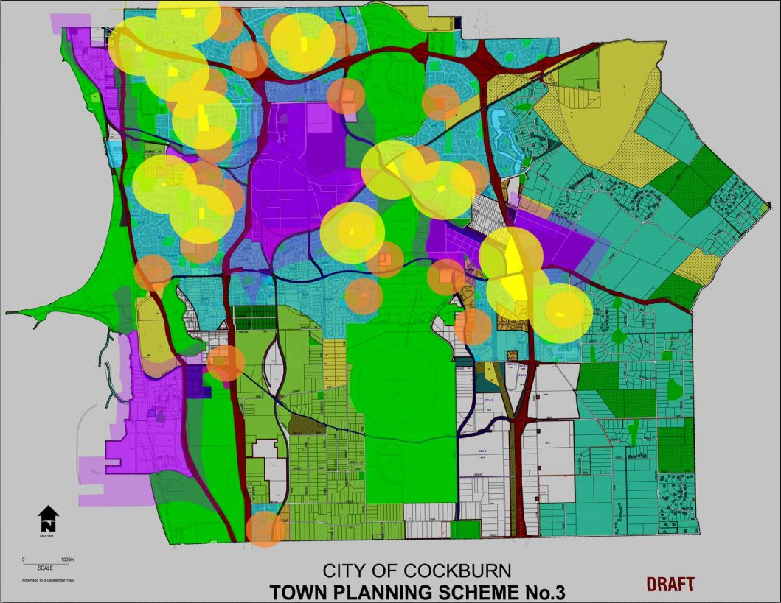
          - Conflicts between land uses

Strategic Matters

Collaboration and Engagement
The City has a role in continually educating all stakeholders on the broader impacts of parking, its environmental and other costs, and the benefits of sustainable transport policies. The education program can be updated with actions being taken within the community to improve and provide information about different options for transport access. This type of intervention has been successfully employed in both South Perth and Melville.
Such an education program would be aimed at all stakeholders (internal and external) including planners, developers, designers, ratepayers, retailers, property owners, tenants, elected officials and council officers, business and community groups, students, residents, visitors, commuters, and the general public. Education and appreciation of the unsustainability of current parking demand should be available and regularly communicated in the City’s publications.
Collaboration with private car park operators is advised to ensure clarity for parking users as to who manages a facility. This is particularly relevant where the City is receiving enquiries from the public about infringements issued by private operators.
When plans for new and redevelopments, the appropriate departments within the city must be consulted to ensure that strategic goals are met and parking provision is both adequate and sustainable given the nature of the land use and possible impacts from future trends (see section 5.2.3.6).
The City should investigate methods of managing parking, including parking apps which will assist users in locating the most appropriate car park for their needs. This is particularly relevant for areas of high density, mixed use developments and parking areas adjacent to stations. However, the viability of this intervention may be predicated on funding through paid parking.

Parking Areas and Parking Stations
A Parking Area should become a Parking Station when average occupancy sits between 45-85% (see Figure 5-1). At this point, regular patrols should take place to ensure compliance, intervening early to issue warnings and/or infringements so that parking issues are less likely to occur.
The City will need to undertake periodic surveys to determine which Parking Areas are nearing this threshold. This data will also assist in the management of the parking system as a whole.

ACROD Parking
It is recommended in the short term to promote ACROD parking rates above the stipulated rate given in the Building Code Australia (BCA). This reflects the growing mobility of people with disabilities and is consistent with the increasing uptake in ACROD permits in the Perth metropolitan region. Notwithstanding any provision in the BCA or AS2890, it is recommended that parking spaces for people with disabilities are to comprise 2-3% of the total number of parking spaces in non-residential development, with a higher provision rate required for car parks serving health facilities or which provide specific services for aged persons and people with disabilities.
ACROD bays must be:
- Of an appropriate size
- Located close to the facility
- Connected directly to the facility by unobstructed paths with dropped kerbs, appropriate widths and shelters where necessary
- Enforced to ensure availability for legitimate users - illegal use of ACROD bays on public roads or the City’s Parking Stations should result in infringements being issued.
- Angled parking as a preference to parallel parking spaces where possible to enhance safety and accessibility
- Restricted by time as per adjacent parking spaces at the location (although vehicles may remain in on-street bays for double the posted time as per the Road Traffic Act)
- Considered only in commercial and mixed use areas. As a general rule ACROD parking will not be provided in residential areas.
The City must ensure that developers are aware of the availability of match funding for ACROD bays to be upgraded or retro-fitted.

Construction Sites
It is recommended that Construction Management Plans (CMP) continue to be requested by the City. CMPs should be a requirement in the following circumstances:
- Basement excavations
- Demolition of more than two (2) storeys
- External works with a value greater than $1 million
- Where traffic or pedestrian management measures are required
- Where there is a likelihood of damage to local government property
- Any other case where it is considered that a CMP should be provided due to the nature of the work or locality or where the amenity of the area is likely to be disrupted or adversely affected.
In areas where construction activity is likely to take place for extended periods of time, the City may identify appropriate external locations for tradesmen parking, using a permit system to control access. This will reduce the safety and congestion issues prevalent in development areas during the construction phase.

Station Parking and Park ‘n Ride
Council parking adjacent to public transport stations should be managed in such a way that it limits the overspill of park ‘n’ ride demand. Unrestricted parking should not be provided on-street, in favour of time-restricted and/or paid parking.
This is equally true of off-street public and private parking, and may require coordination with local businesses to ensure continued viability of the local parking system.
Enforcement should be undertaken to reduce the incidence of hazardous and illegitimate parking on streets surrounding stations so that local employees are not using these bays all day, and that commuters parking and riding into Perth are using the paid PTA bays.

Future Trends
As healthcare continues to improve, people are living much longer, and an aging population will have specific needs in terms of transport. Particularly the number of ACROD bays may need to increase in line with the number of mobility impaired individuals as a proportion of the population. Sites which are for the purpose of healthcare should already be considered in this context, and recreational and commercial sites should consider senior parking bays.
Disrupters such as Ride-Sharing, Electric Vehicles (EVs) and Autonomous Vehicles (AVs) may all have an impact on the need for and nature of parking in the future.
Ride-Sharing is already causing ripples in the transport industry, demonstrating how the sharing of resources can result in more affordable transport (and other items) for all. If Ride and Car-sharing reaches its full potential the possibility is that people may not see the need to own their own car, instead opting to jointly own a vehicle with neighbours, friends and family members, or using the services of a car club such as Go Get in preference to traditional ownership models. This would result in the rate of car ownership declining and therefore less of a need for parking bays. Taxi bays and drop off zones will become more important as uptake increases.
If EVs become more prominent there may be a need to provide charging points at many more developments, particularly those where all day parking is available such as residential developments and workplaces. As battery technology improves and faster charging becomes available and affordable, there may be a need to provide charging points at other locations where parking turnover is more regular. The planners of parking facilities are best advised to allow for the necessary infrastructure in advance so that retro-fitting of charging facilities can take place easily and economically, otherwise these facilities may become underutilised.
It is possible that with the advent of AVs, parking facilities will become more and more redundant and hence new parking facilities may not get a sufficient return on investment; particularly deck parking which costs in excess of $30k per bay.
These are considerations which should be taken into account in the planning of any parking facilities since take up of these technologies may progress faster than expected.

Implementation
The recommendations presented within this chapter can be categorised as follows:
- Engagement
- Infrastructure and Engineering
- Policy and Planning.
Table 5-2 summarises the recommendations by the above categories along with the purpose of implementation.
            - Summary of recommendations
 | Recommendation | Purpose
Engagement | Community Engagement (Transport)  - High density residential developments  - Mixed use commercial and activity centres | - To raise awareness of available transport options and obtain buy in from residents, employees and businesses  - To promote transport events such as Walk over October/Ride to Work day etc.
Engagement | Promote Your Move for Schools | - To prepare schools for a future requirement to produce and implement travel plans
Engagement | Engage with developers | - So that developers fully understand and recognise opportunities for parking concepts such as cash in lieu, unbundled parking, shared parking and reciprocal parking
Engagement | Engage with real estate agents | - So that potential buyers are aware of parking characteristics of new residential developments and expectations regarding parking are realistic
Engagement | Create a Working Group for organisations in industrial areas | - To discuss and rectify parking (and other) issues  - Promote Your Move for Workplaces
Infrastructure/Engineering | Kiss and Drive/Drop off  - Review facilities at Government Schools  - Review of drop off facilities at sports ovals  - Provide guidelines for implementation/ upgrade of Kiss and Drive/drop off facilities | - To identify where Kiss and Drive/drop off facilities require upgrade and to identify examples of best practice  - To provide guidance on the practical issues around Kiss and Drive/drop off  - To identify opportunities for Kiss and Drive/drop off points at other land uses (particularly for use at sports ovals and when autonomous vehicles become more prevalent)
Infrastructure/Engineering | Review existing facilities for parking of Heavy Vehicles in industrial areas (City managed bays) | - To retro-fit/upgrade parking facilities to ensure safe and accessible parking is available for heavy vehicles
Policy and Planning | Produce Wayfinding Strategy Guidelines | - To assist facilities in producing wayfinding materials for their site and promote alternative parking facilities and transport services to enable their customers to access the site more easily
Policy and Planning | Undertake a study of the potential for paid parking in the City and identify car parks which may be appropriate candidates for the introduction of parking fees | - To be set the foundations for paid parking should implementation in certain areas become necessary
Policy and Planning | Undertake a study relating to parking permits in residential areas, commercial areas and for special events | - To identify if and when a parking permit scheme should be introduced
Policy and Planning | Undertake a review of parking rates | - To ensure that planning documents provide consistent and up to date advise on parking provision by land use
Policy and Planning | Undertake a case study review of schools that have trialled staggered start and finish times | - To provide advice to schools that are interested in trialling a similar approach
Policy and Planning | Parking surveys  - Identify car parks with sufficient occupancy to warrant regular parking occupancy surveys  - Plan/resource surveys | - To identify car parks which are operating close to capacity and to identify suitable management strategies  - To identify parking areas which would be better managed as parking stations
Policy and Planning | Produce Construction Management Plans | - To ensure that traffic in and around significant development sites does not cause a negative effect on other road users
Policy and Planning | Review and implement parking restrictions around Stations | - To support PTA parking and to reduce all day parking in spaces which are for other parking needs
Policy and Planning | Request travel plans for large developments and from schools | - To normalise the use of sustainable and active transport modes and reduce the demand for parking.

Action Plan
Table 6-1 outlines a program for implementation of the recommendations made in Chapter 5.

The implementation plan is presented in the table in this section. Note that specific on road parking capacity upgrades have not been included in the implementation plan but are planned for in the City’s Major Capital Works Programme and in the future development proposals.
The actions within the plan have been given a priority according to the following timescales:
- Short: to 2020
- Medium: 2020 to 2025
- Long: 2025 to 2028.

Actions centred on management, advocacy, policy/strategy development or education have generally been categorised as short term actions, under the assumption that the City will provide sufficient resources to drive these actions forward.
Scale of Cost
0 Operational*
$ Low (< $100,000)**
$$ Medium ($100,000 - $500,000)
$$$ High (>$500,000)

* Sourced from existing budget. Assumed work done in-house using existing staff and funding resources.
** May be funded from operational sources if there is capacity for work to be done in-house.

            - Action Plan
Action description | Responsible authority | Potential funding sources | Potential risks | Governance Requirements | Priority | Cost
Community Engagement (Transport) | City (Transport) | DoT | Lack of community buy-in | City to work with DoT | Short | 0
Promote Your Move for Schools | City (Transport) | DoT | Lack of buy in from schools/parents | Schools to govern | Short | 0
Engage with developers | City (Planning) | N/A | Lack of buy-in from developers | City/UDI (WA) | Short | 0
Engage with real estate agents | City (Planning) | N/A | Lack of buy-in from real estate agents | City/REIWA | Short | 0
Create a Working Group for organisations in industrial areas | City (Transport/ Commerce) | N/A | Lack of buy in from affected organisations | City | Short | 0
Undertake a study of the potential for paid parking in the City and identify car parks which may be appropriate candidates for the introduction of parking fees | City (Transport) | City funded | The number of car parks with potential for surveying and associated costs being unachievable | City | Medium | $
Review Kiss and Ride facilities at Government Schools | City (Transport) | DoE | Facilities being under designed and need for upgrades | DoE | Short/Medium | $
Provide guidelines for implementation/ upgrade of Kiss and Drive/drop off facilities | City (Transport) | DoE/DSR | Costs and practicality of application in existing schools. Potential for roll out across Metro area which could delay actual improvements | DoE/DSR | Medium | $
Review existing facilities for parking of Heavy Vehicles in industrial areas (City managed bays) | City (Transport) | City funded | Practicality and cost of making improvements | City | Short/Medium | $
Undertake a study relating to parking permits in residential areas, commercial areas and for special events | City | City funded | Lack of case studies in Cockburn | City | Medium/Long | $/$$
Undertake a review of parking rates | City and WAPC | N/A | Lack of agreement with WAPC due to implications across Metro area | WAPC | Short/Medium | 0
Undertake a case study review of schools that have trialled staggered start and finish times | City and schools | City funded | Possibility of application at government schools/ lack of buy in from private schools/parents | City/Schools | Short | $
Produce Construction Management Plans | City | City funded | Lack of buy in from developers and lack of compliance by sub-contractors | City/UDI (WA) | Short/Medium | $
Request travel plans for large developments and from schools | City | City funded | Management of process and assessment of resulting travel plans | City | Medium/Long | $$
Produce Wayfinding Strategy Guidelines | City | City funded | Guidelines not being used and being superseded by travel plans | City | Medium/Long | $$
Undertake a study (including design and costing) relating to parking station along shoreline | City | City funded | Lack of parking station along shoreline in Cockburn | City | Medium/Long | $

References
City of Cockburn. (2012). Retrieved from Local Commercial & Activities Centres Strategy: http://www.cockburn.wa.gov.au/documents/CouncilServices/CityDevlpmt/PROJECTS/LCACS/LCACS_Final_Dec_2012_v_1.pdf
Commercial Vehicle Parking. (n.d.). Retrieved from City of Cockburn: http://www.cockburn.wa.gov.au/Council_Services/City_Development/Planning_Documents/3921-commercial_vehicle_parking.pdf
Integrated Transport Plan. (n.d.). Retrieved from City of Cockburn: http://www.cockburn.wa.gov.au/documents/CouncilServices/CityDevlpmt/Cockburn_Coast/DistrictSP/sect7.pdf
Parking and Parking Facilities Local Law 2007. (n.d.). Retrieved from Department of the Premier and Cabinet: https://www.slp.wa.gov.au/gazette/gazette.nsf/lookup/2008-6/$file/gg006.pdf
Parking Guide. (n.d.). Retrieved from City of Cockburn : http://www.cockburn.wa.gov.au/documents/CouncilServices/Rangers/Parking_Guide2015.pdf
Parking Guidelines - School & Disabled. (n.d.). Retrieved from City of Cockburn: http://www.cockburn.wa.gov.au/Council_Services/Rangers/Parking_Guidelines_-_School_and_Disabled/
Parking Guidelines for activity centres. (n.d.). Retrieved from Department of Transport: http://www.transport.wa.gov.au/mediaFiles/projects/DOT_P_Parking_Guidelines_ActivityCentres.pdf
Perth and Peel Transport Plan for 3.5 Million People and Beyond. (n.d.). Retrieved from Department of Transport: http://www.transport.wa.gov.au/mediaFiles/projects/PROJ_P_Perth_Transport_Plan__full.pdf
Policy P315 Car parking reductions for non-residential developments. (n.d.). Retrieved from City of South Perth: https://southperth.wa.gov.au/docs/default-source/6-about-us/council/policies-delegations/housing-and-land-uses/p315-car-parking-reductions-for-non-residential-development.pdf?sfvrsn=2
Travel Demand Management Plan – Transport at 3.5 Million . (n.d.). Retrieved from Department of Transport: http://www.transport.wa.gov.au/mediaFiles/projects/PROJ_P_Travel_Demand_Management__Plan.pdf


Parking Plan

APPENDIX

INTERNAL CONSULTATION RECORD

Item | Discussion
Distributor and local roads | - Large vehicles movements  - B-Doubles using roads sometimes find it hard to access sites due to verge parking  - Rubbish trucks are sometimes unable to collect bins due to on-street parking in residential roads  - Difficulty on negotiating other vehicles  - Footpath parking is an issue  - Need to consider the potential impact of the Cockburn Coastal Highway and the North Lake Road Bridge on parking in those areas
Residential areas | - Parking  - high density dwellings are bringing multiple cars to the site in over and above the number allocated to them and are parking in on-street visitor bays of other properties  - Need to look at the practice of reducing visitor parking due to the availability of street bays in high density areas  - There is a small number of residential areas with parking permits (near Aubin Grove Station and in North Coogee). The strategy needs to consider the circumstances for issuing residential parking permits  - Verge parking reduces the occurrence of street parking – which is preferable?  - Need a strategy for on street parking in residential areas  - Cottage blocks  - Consider making laneways/access ways for cottage blocks no parking at certain times?  - What should rate for reloaded lots on cottage blocks be?  - Also need to consider infill areas (e.g. apartment in Hamilton Hill)  - Aged Care Centre  - Parking requirements for Aged Care facilities should be reviewed  - Special circumstances exist for carers visiting clients needing 24 hr care in their homes  - Management of expectations of residents moving to dense and mixed use areas  - Welcome packs for new residents in high density residential areas describing expectations for car ownership/parking (e.g. South Beach estate)
Education | - There are 29 primary schools & 7 Senior High Schools  - Primary School  - Parking of drop off/pick up times is worse than at High Schools  - General  - Parking issues include verge parking, footpath parking and dangerous parking  - Infringements have reduced recently along with the number of complaints  - Demand for parking at schools expands and retracts with the rate of occupation of new residential developments  - There will be a new TPS in the next 12-24 months  - A review of parking rates for educational uses needs to take place to account for current parking requirements  - Government schools  - Provides more parking that the City of Cockburn rates state as these are under the jurisdiction of the State Government.  - Private schools  - Provides parking in line with the City’s rates  - Some schools are experimenting with staggered start times to spread the demand for parking outside the school  - Parking Management Plans/Travel Plans are being sought under planning conditions
Commercial centres | - Integrated Health Facility (IHF)  - Numbers of ACROD bays have been increased in response to customer comments  - Issues relating to wayfinding IHF  - Directness of IHF to shopping centre  - Commuter and all day parking is a problem in Cockburn Centre where it is congested  - Some buildings are being developed up to the extent of their footprint and are therefore pushing parking to other areas  - Need to consider the adequate (and possibly flexible/shared) provision of loading bays
Industrial areas | - Parking  - Some buildings are using shipping containers in parking bays for extra storage which has a knock on effect on parking, pushing staff and visitors onto the road or verge  - Short term freight parking  - Parking areas area difficult to control  - Adequate provision for loading, motorcycle and disabled bays, specify the locations  - Lots of verge and footpath parking  - Mode of travel/ transport  - Many workers are vehicle based  - Large vehicles have difficulty negotiating other vehicles
Recreation/leisure/culture facilities | - Parking  - Parking at the man-made beach in the summer is in high demand. Visitors from out of Cockburn are using the facility and there is not enough parking  - Should there be a coastal parking strategy?  - Adventure World/Bibra Lake Playground – verge/footpath parking  - Consider disabled parking bays in recreational areas to ensure that as well as being compliant that they are actually useable in terms of positioning and safety, including disabled visitors parking  - Public Transport  - There is minimal public transport to coastal areas resulting in higher demand for parking  - Cockburn ARC  - It is used by elderly people with mobility limitations and many people from outside of Cockburn travel to use the facility  - 700 bays (over 10,000 people attend on match days)  - The areas surrounding will eventually be residential (cottage blocks)  - Distance to the ARC from the car park is an issue for some  - Consider more drop off zones at events
Public Open Spaces | - Parking  - There is no requirement at Public open spaces; it is negotiated on a case-by-case basis and there should be a strategy in place  - Current parking provisions state that verge parking is not allowed for public open spaces however in certain circumstances this is overlooked (e.g. weekend football matches)  - Visitors from outside of Cockburn visiting the beach for its accessible features (Fishing Jetty, beach mat etc) and car parking has not been provided with these visitors in mind  - Accessible parking should be placed closer to exercise equipment and toilet facilities  - There needs to be path access from the car parks to the areas likely to be used by disabled patrons  - Need to consider general, existing, proposed reserves and consider the differences between areas such as dog exercise areas, local parks and regional play spaces  - Wayfinding required at Bibra Lake playground to redirect cars to larger car parks rather than park on verges
Other matters | - Majority of feedback on parking from the mobility impaired relates to:  - Distance of parking from the facility  - Connectivity of parking to facility  - Directness of route to facility  - Bay width  - Placement of bollards  - Shelter  - Obstructions on footpaths which cause issues for mobility impaired  - Ageing Population  - Consider the ageing population in planning (e.g. pick up/drop off areas)  - Parking  - There is no paid parking, just timed restrictions  - The strategy should define when a “parking area” should become a “parking station”. Traffic management at some City owned parking facilities (e.g. City’s Admin Building, Coogee Coastal areas, Success Regional Sports centre) could be better enforced/managed if these were Parking Stations.  - A parking area cannot be managed or enforced whereas a parking station can  - Aubin Grove Station – car parking is not being taken up.  - Cockburn Central Station - People are parking illegally to avoid the $2 fee  - Better internal coordination of parking issues at the City  - ACROD Parking  - Can work with private operators to provide match funding for upgrades/retro-fitting of ACROD bays  - Better enforcement of ACROD spaces to ensure they are used appropriately  - Development sites  - Builder and tradesman parking. Construction management plans are requested and bonds are paid in case of damage to infrastructure but a strategy is required  - Collaboration is required between the City and private car park operators to provide clarity (signage) on who is enforcing particular areas so that the public can contact the correct authority
Parking Strategy | Considerations for inclusion in the Strategy:  - Management of public expectations  - Definitions/alignment of parking areas/ parking stations to provide clarity on when one should become another – may need to update the Parking Law/Road Traffic Act to provide clarity  - Residential parking permits  - Unbundled parking  - Wayfinding/ City parking app.  - How to achieve strategic goals for land uses through planning/ policy/ engineering  - Taxi/ Uber ranks  - Autonomous vehicles (consider in light of cost of providing new parking facilities – especially multi deck parking)  - Parking issues around stations (not PTA) – Aecom appointed to undertake a traffic study for PTA at Aubin Grove  - Priority of parking  - Tradie parking and Construction Management Plans  - Family friendly parking  - Bike parking  - Senior parking  - Reiterate what the City is already doing

Parking Plan

APPENDIX

PUBLIC CONSULTATION REPORT

Parking Plan

APPENDIX

PARKING MANAGEMENT STRATEGY –PRINCIPLES AND CONCEPTS

Principles
Parking management offers a broad and open field of discussion. Often cities try to solve the parking problem by increasing parking supply. By now it has been internationally proven that more parking spaces cause more traffic. The following guiding principles have been applied in this Parking Management Action Plan.

“Free” parking
Free parking that is available for all has generally been perceived as an ideal objective for both policy and decision makers, with any proposed measures which have sought to constrain demand or determine priority for access bitterly resisted, often in an emotional and irrational way.
This level of emotional response is related to the availability of parking and its significant role and impact on the ability of private individuals to access employment and the range of services and facilities that the community offers. The attitude of many people has, in the past, been that if parking is not readily available and accessible to services and amenities, they would often make the choice to shop or go elsewhere.
However, all parking has a cost; in space, in opportunity, in construction, maintenance and enforcement. Where parking is provided free of charge to users, the direct financial costs are borne by the City and passed on to residents via increased rates, or by businesses and passed onto retailers and consumers through higher rents and prices. The opportunity costs are realised through reduced connectivity (land uses are further apart), decreased local amenity (pedestrian paths, trees), and a higher economic burden for development (the cost of parking infrastructure results in decreased investment in the area).

Support and encourage the use of a range of transport modes
Access for pedestrians, cyclists, public transport users and people with disabilities should be prioritised, and balanced with the needs of the City road network, in order to minimise congestion. The support of these modes will help lessen the demand for parking in desirable and well-connected locations.
While the City only has limited influence over the bus routes, the provision of convenient public transport is a very important aspect of the transport mix, especially if a reduction of traffic generated by private vehicles is desired.
It is important to acknowledge that a Parking Strategy is only one part of an Integrated Transport Strategy which should also consider transport matters such as:
- road safety
- green travel planning
- local area traffic management plans
- parking management plan
- pedestrian strategies
- bike plans.
It is widely recognised that mode choice is likely to be impacted by the nature of the provision of parking and where supply is not efficiently managed or accessible.

Maintain an appropriate supply of affordable, secure, convenient and appealing shared public parking that is accessible to all segments of the community.
Supply of public parking should be located in proximity to major generators and be managed according to a predetermined hierarchy of use. This hierarchy applies primarily to on-street parking but should be considered with respect to the off-street supply and specific provisions within public and private car parks for high priority users.
The City of Cockburn Parking Strategy for on-street access hierarchy employs the following priorities in the Commercial Centre:
- Loading
- Public transport
- Drop-off/pick-up
- Short-to medium-stay
- Motorcycle/scooter parking
- Disability permit holders
- Long-stay parking & park ‘n’ ride
- Residents.
This hierarchy helps to ensure that the on-street space is utilised efficiently and effectively in locations with high demand for parking.
The usage of public parking should be monitored to determine hotspots and low utilisation areas so that refinements to parking restrictions can be made. This will ensure a robust system that maximises efficient use of available parking and thereby minimise the capital investment required to accommodate demand.
To make parking accessible to all speciality bays, the bays should be reserved around the clock.

Parking management should be used as a tool for traffic demand management
It is understood that a perceived lack of parking availability can create an emotional response in car drivers, particularly when there is no viable alternative to driving. Parking supply management therefore relies upon effective alternatives to driving, through high-quality path infrastructure and public transport, such that the limitations on parking supply do not reduce the economic viability of the area, or create adverse impacts in the surrounding environment. Provision of wayfinding information (see point 6) can also help raise awareness of little-used parking areas a little further from desirable locations which could be used if people are willing to walk.
In cities like London and Munich, core areas have relatively low levels of car ownership in spite of greater wealth. This reflects a decreased availability of residential and public parking, offset by a high degree of public transport accessibility and service. The Transit Oriented Development at Cockburn Central has the potential to achieve this if supporting transport conditions and policy are favourable.

Increases to parking supply
Construction of additional parking spaces should be considered where it facilitates desired activity within an activity centre, and where the associated trips are unlikely to be undertaken by alternative transport modes.
Any increases in public parking supply should be considered in the context of all existing parking, and should be managed in accordance with best-practice design principles.

Interactions with private parking supplies
Parking should be considered as an ecosystem consisting of public and private, on-street and off-street, and considering all of the many needs of those people who use those bays. The optimal parking system would be one where all parking is used efficiently, with the minimum amount of space devoted to parking activities. After all, parking itself only facilitates activity; it does not create any of its own.

Wayfinding and Signage
The effectiveness of parking is greatly improved through supplying better information to users. This information is typically provided in a range of media, including maps, mobile applications, static and dynamic signage and prominent parking information.
A coherent signage strategy is therefore recommended across the City, identifying off-street car parking supplies and significant on-street parking. This may be implemented through static wayfinding signage displaying route/location and supply numbers, using a design of signage consistent for on-street and off-street. Dynamic signage is available but the City is not yet in need of such infrastructure.

Parking prices are a strong tool to manage demand
To improve parking management as a tool for traffic demand management, a parking fee structure can be used to preferentially benefit certain target groups, based on the ideal function for a particular car parking location.
For example:
- A one-hour free period supports short trips including shopping and café visits
- A linear per-hour rate effectively penalises long-stay parking while maintaining maximum flexibility for users
- A maximum fee can be used to support employee parking in selected locations – effectively giving them a discount beyond a given duration of stay.
These demand management tools can be used in combination, with restrictions on duration to narrow down the target market.
Parking pricing levels should ideally be set such that demand peaks at approximately 85-90% occupancy. Best-practice implementation involves ‘demand-responsive’ pricing, which increases or reduces fees based on occupancy. This can involve different fees at different times of day, or different days of the week, and include a mechanism to modify prices on a periodical basis to maximise the utility of the parking. Demand responsive pricing relies on a high degree of good quality occupancy and duration of stay data.

Hypothecation of parking revenue
Paid parking fees are an effective measure of managing parking, by increasing the efficient use of a shared resource. The revenue obtained from this form of parking management is, by definition, used to offset the cost of enforcement and installation. Beyond this maintenance cost, paid parking revenues may be ‘hypothecated’ to improvements in transport and local streetscapes.
This provides direct benefit to the community and additional value over and above the impacts of managed parking alone. International examples show that where revenue is hypothecated to local improvements, patronage of these businesses and land values increase markedly.

Management Concepts
The following sub-sections describe the concepts behind a number of headline strategies, some of which will be recommended for the City for certain land uses.

On Street Parking Management
The following describes the methodology used to determine parking restrictions within the on-street environment. It is suggested that all implementation measures are reviewed annually.
- 2P Free Parking: Time restricted 2-hour parking is best used in residential areas, to support visitation throughout the day. This form of parking may also be used where there is moderate commercial visitor demand, to limit use by employees. However, where there is a scarcity of employee parking, free 2-hour parking may be used illegitimately by employees (reparking their vehicle every 2 hours).
- 4P Free Parking: Time restricted 4-hour parking supports medium-stay uses such as recreational and cultural facilities. However, such parking controls are generally not recommended where these areas are located close to businesses. The incentive for employees and other long-stay users to park in these zones illegitimately (by reparking their vehicle every 4 hours), is strong.
- All day Free Parking: All-day free parking provides the maximum flexibility for users, but is appropriate only when there is ample parking supply to cater for everyone. Where demand begins to approach 85% or more of supply at peak times, alternative controls should be used to differentiate parking areas.
- Time Restrictions: It is recommended that all managed parking be restricted to the 8am-6pm period. For the majority of the network, this can be retained for Monday-Friday only, but in locations where weekend demand is high, parking restrictions should be set for Monday-Sunday.
Limiting duration restrictions and or paid parking to daylight hours limits the potential impact on residents and visitors. This is particularly important in Cockburn Central, as a result of the high level of residential density and mixed-use throughout the area.
- 1P Paid Parking: Used in retail areas to support high turnover business visitors, and to redistribute longer-stay activates to adjacent off-street public and private car parks
- 2P Paid Parking: Used in areas adjacent to retail to support business and medical visitors; specifically excludes use by employees and construction workers and all day parking.
- 4P Paid Parking: Allows a mixture of short-stay uses; specifically excludes all day parking.
- Capped Fee Parking: Allows for hourly paid parking up to a set duration, with no additional cost beyond this duration. This is intended to create spaces for employees and construction workers to park in the public realm, while still retaining viability for short-stay visitors.
- First-Hour Free Parking: Used to promote very short stay uses and encourage rapid turnover of parking. This is particularly valuable as a way to shift parking off-street, and away from the prime on-street locations. Private car parks often utilise this form of parking management to shift cars onto their site, ensuring that customers walk through their establishment and an increase in footfall. Though its effectiveness can be diminished if there is free parking in close proximity.
First-hour free parking is not considered to provide the same level of advantage in on-street environments, particularly where demand is already high. It also has less utility in public car parks, where the trip destination is largely unknown.
- Residential Parking Permits: Residential parking permits are considered to be appropriate where on-site parking supply is low, and where adjacent land uses are likely to consume the bays required for these residents.
New apartment buildings and townhouses are often constructed with a reduced parking supply, in line with the City’s sustainability goals and as a measure to increase housing affordability. The creation of a residential parking permit scheme to allow residents to own and keep additional vehicles on the street shifts the burden of cost from the owner to the City.
Residential parking permit schemes are expensive to maintain, and are generally not priced at a level commensurate with their value. It is therefore recommended that such schemes be avoided unless under exceptional circumstances.

Off-Street Parking Management
The following describes the methodology used to determine parking restrictions within the public off-street environment. It is expected that all implementation measures should be reviewed on an annual basis.
- Free Parking: Off-street parking is an expensive resource, provided by a business or on behalf of the City for the community. There are many important reasons to provide parking, for the benefit of social, cultural or economic development. However, where demand for this free resource exceeds the available supply, alternative methods of control are recommended. This may include duration restrictions to increase turnover and relocate long-stay parkers, or the introduction of paid parking to manage demand.
- 2P Paid Parking: Parking in high-turnover areas to support recreation or retail/restaurant uses; specifically excludes use by all day parkers.
- 4P Paid Parking: Allows a mixture of short-stay uses and specifically excludes use for park ‘n’ ride, with minimal value for all day parkers.
- Unrestricted Paid Parking: Allows use for all purposes but disadvantages long-stay employees.
- Capped Fee Parking: Allows for hourly paid parking up to a set duration cap with no additional cost beyond this duration. This is intended to create spaces for employees and construction workers to park in the public realm, while still retaining viability for short-stay visitors including
- Private/Tenant Parking: This parking is privately owned and outside of the control of the City and this Plan. It is beneficial for the function of the parking system that all bays are efficiently used. Relocation of parking by employees within Cockburn Central to private tenant bays frees up public spaces for visitors, and privately owned public parking represents a valuable supply located close to attractive destinations.
Where the City transitions to a paid parking focus and demand for parking on the whole increases, there will be increased pressure on private parking. This may result in a change in management of these private bays. Currently, many of these private car parks allow a 1-hour or 2-hour free period to make these spaces attractive to retail visitors.

Maximum Parking Rates
Minimum parking ratios are generally set in isolation of broader policy objectives. In their current form they do not explicitly take into account accessibility by alternative modes of travel and other factors that might reduce demand for travel by car. Consequently, they may encourage an oversupply of parking and the use of cars in locations where good alternatives exists.
Maximum standards (without any associated minimum) are a more market-driven approach as they permit developers to determine how much parking they wish to provide in a new development up to the maximum amount. Over time, replacing minimum parking standards with maximum standards would reduce the incentives to the use of the car resulting from the oversupply and under-pricing of parking. It is likely to be most appropriate for those centres where public transport offers a good alternative to the car. For maximum parking rates to be used appropriately, the adjacent supply of public parking must be actively managed, most likely through a paid parking system.
It should also be noted that parking maximums are generally not compatible with cash-in-lieu as developers are no longer required to provide parking for the land uses concerned.

Cash in Lieu
The City’s 2007 Town Centre parking strategy states that “Cash-in-lieu of parking will be required where site constraints prevent the construction of required (or additional) onsite parking. Any cash-in-lieu received will be applied as per Town Planning Scheme No. 3 requirements”.
The current Town Planning Scheme requirements state that approval for cash in lieu may be given if:
- The payment is not less that the estimated cost to the owner of providing and constructing the required bays, plus the value of the land (including the costs incurred in obtaining a valuation) on which the bays would have been located and manoeuvring area
- The local government has provided, or made firm proposals for providing a public car parking station in the vicinity of the land, before an offer of a cash in lieu payment has been accepted
- Cash in lieu payments will be paid into a special fund set aside solely to provide public car parking stations in that locality.
Cash-in-lieu of parking can provide an attractive alternative to developers with regard to parking requirements. This arrangement can also benefit the wider community through the supply of publicly and equitably managed parking for the use of high-value or highest-need parkers. Factors to be addressed by staff and Council in considering entering into a cash-in-lieu arrangement include, but are not limited to the following:
- Consistency with the objectives of the Town Planning Scheme
- Requirements/concerns of commenting agencies
- Consistency with the objectives of the Parking Strategy
- Whether there is an identified local government interest in providing public parking facilities in the immediate area
- The timing for the delivery of the public parking facilities and the adequacy of alternatives to on-site parking until public parking facilities are delivered
- Whether on-site parking deficiencies would result in a hardship for the site or surrounding area
- Ability of the site to accommodate the proposed development, based on the available supply of parking; and
- The number of spaces proposed to be considered for payment-in-lieu.
It is important to note that the success of cash-in-lieu parking arrangements can be substantially compromised if the City approves parking concessions in order to relieve owners from any obligation to provide car parking according to the zoning requirements, which would then relieve them of the need to provide cash-in-lieu. Concessions should only be approved where the applicant can clearly demonstrate that the parking requirement is excessive and not simply as a mechanism to allow applicants to proceed because they are unable to provide what is deemed to be an appropriate amount of parking.
Should the City approve a concession because it is technically justifiable, the applicant should still have the ability to use the cash-in-lieu program to further reduce the amount of parking required on-site.
The cash-in-lieu amount should be set at a discount to the actual cost of providing the parking to:
- Provide a financial incentive for developers to contribute to the creation of strategically located public parking facilities
- Recognise that the City will be able to recover some of the costs through user fees
- Recognise that parking spaces are not allocated to specific users on a reserved basis, although the general supply will be available to meet demand
- Recognise that the contributor will not have an ownership interest in the public parking facilities
- Recognise that the parking may not be as conveniently located to a specific development compared to on site or other nearby parking facilities
- Recognise that all or a portion of the parking may not be constructed at the same time as the development
- Recognise that the developer/owner will not have any control over parking fees and use regulations.
Some Local Governments have attempted to charge developers/builders the full cost of the parking bay which results in little or no take up of the offer, except for very small infill projects which have no alternative and find it financially palatable. This is because the value of a parking bay which the developers do not own or control cannot be worth the same as the cost of building one on their own land over which they then have full control. Given these factors, the cash-in-lieu rate in other LGA’s is often set at 50% of the estimated cost of providing a new parking bay, although this is often not evident because the value set does not come with an explanation in the fee schedule.
It should be noted that the decision to accept cash-in-lieu should remain at the discretion of the City and not become an automatic right. This will allow the City to ensure that if it accepts cash-in-lieu payments, there is a reasonable expectation that municipal parking is already available to serve the development or that the City will be able to provide a supply increase in the short term.
It is also necessary to ensure that planning for the provision of future parking structures is transparent and that contributors to the cash-in-lieu fund are given clear indication as to what their payments are funding. This will ensure that developers continue to see benefits in contributing towards public parking, over the intrinsic advantages visible on-site.
Another mechanism would be the establishment of a dedicated car parking infrastructure fund, into which cash-in-lieu payments would be directed, under a modified arrangement and out of which the planning, upgrading and management of car parking facilities would be funded.
Regardless of the mechanism for funding, either through developer contributions, parking fees and fines or other public monies, it is important that the revenues and costs from parking-related activities be accounted for under one umbrella. This allows for reasonable modifications to the management structure, pricing regimes, infrastructure and maintenance, enforcement and compliance activities to be resolved in a transparent system with full accounting of the costs and benefits provided. This will then form the foundation for assessment of the requirements for cash-in-lieu payments by developers as well as determining and varying parking restrictions and pricing schemes based upon location, time of day and seasonal factors. Accounting for all financial aspects of parking will enable a much greater appreciation for the real costs of providing this service to the community.

Shared Parking
Shared parking is parking that is used by 2 or more land uses instead of restricting parking to the exclusive use of a single land use - the more exclusive the parking is, the less effective it becomes for the development as a whole. Shared parking takes advantage of the fact that most parking bays are only used part-time by a particular group, and many parking facilities have a significant proportion of unused bays, with utilisation patterns that follow predictable daily, weekly and annual cycles. Efficient sharing of bays can allow parking requirements to be reduced significantly. Partial sharing occurs when arrangements are made by one facility to use another’s parking facilities at certain times for example an office block would use parking spaces by day while restaurant users, or residents in the same building is more likely to require bays in the evening.

Reciprocal Parking
Reciprocal parking occurs when a visitor has more than one purpose within an area and hence only one trip is required to serve two or more purposes. For example, Cockburn Central is a substantial mixed-use development with retail, office, residential and leisure venues, there is likely to be a high degree of reciprocity at all times.
The degree of reciprocal parking occurring depends on the type of land use in the vicinity and the time of day. The most important component to determine the rates of reciprocal parking is the proximity of the land use pairs. As most developments within activity centres are generally located within acceptable walking distances, by accommodating reciprocal parking a lower total parking supply is therefore likely to be required to satisfy demand for parking.

Unbundled Parking
The cost of parking for residential and commercial units is usually passed on to the occupants indirectly through the rent or purchase price (bundled) rather than through a separate transaction. This means that tenants or owners are not able to purchase additional parking if required or given the opportunity to save money by reducing their parking demand. Giving the tenants or owners the opportunity to rent or sell the parking spaces separately may also reduce the total amount of parking required for a development. The unbundling of parking can be introduced in several different ways:
- Facility managers can unbundle parking when renting building space;
- Developers can make some or all parking optional when selling buildings;
- Renters can be offered a discount on their rent for not using some or all of their allocated parking spaces; and
- Parking costs can be listed as a separate line item in the lease agreement to show tenants the cost and enable them to negotiate reductions.
Providing tenants or owners with the opportunity of unbundled parking is also likely to create a market for available parking spaces. It should be noted that if an unbundled parking policy is introduced, it is important to consider the cost of alternative parking in the nearby area. If there is a supply of free or low-cost parking nearby, there may be an incentive for tenants or owners to find other places to park their cars to avoid the parking charge, potentially resulting in spillover effects.

Timed Restrictions
The following principles apply to the implementation of timed restrictions for parking:
- There should be some consistency with the timed restrictions used around the City to allow for greater understanding
- 2P is recommended for shopping high streets where paid parking is not suitable
- Longer timed restrictions such as 3P are suitable for the fringes of a commercial centre
- Timed restrictions above three hours should be avoided except for park ‘n’ ride prevention, as they are difficult to enforce and compliance tends to be low.

Paid parking
Paid parking is one of the most effective ways of influencing parking and travel demand. Pay parking can influence parking location, destination, mode, travel time and, in particular, parking duration. The impacts vary depending on the price structure and the relative convenience of alternative parking facilities and modes. If the cost of driving to destinations is increased through the implementation of paid parking and the public transport network becomes serviceable and accessible, then the shift between the use of cars and hence requiring parking to public transport theoretically should increase.
As pay parking generally results in reductions in car use and traffic congestion among other environmental benefits, it is one of the essential transport measures necessary to ensure the long-term viability of commercial centres.
Pay parking increases equity by charging users (user pay) for their parking costs and by reducing the parking costs imposed on non-drivers. Paying directly rather than indirectly benefits consumers because it reduces parking and traffic problems and allows individuals to decide how much parking to purchase giving them an opportunity to save money. Drivers may use a space as long as they want, as long as they are prepared to pay for it.
On-street parking plays an important role in the effective functioning of town centres and access to residential areas. Many businesses rely on on-street parking to provide access for their customers and meet their loading requirements. On-street parking also caters for specific uses such as dedicated space for taxis and mobility parking for people with impaired mobility.
On-street parking management broadly consists of the following:
- Unrestricted: where there are no limitations on parking
- Time restricted: with a range of time limitations and enforcement used to ensure compliance
- Reserved parking: reserved for a certain type of user, such as mobility card holders, or taxis, or for loading zones
- Priced parking: with varying rates applying sometimes alongside a time restriction.

http://www.darebin.vic.gov.au/-/media/cityofdarebin/Files/Darebin-Living/ParkingTransport/Parking/2017-Conditionsandgeneralinfomation.ashx?la=en

