Tender Title: |  | RFT 08/2021  Educting / Cleaning Services  Gully & Access Pits
Request ID: |  | 38348
Tender Description: |  | Educting / Cleaning of the Principal’s estimated 14,013 gully and access pits, gross pollutant traps, and assist with road sweeping at locations throughout the City of Cockburn.
Advert Approval: |  | Decision to Advertise: Chief of Operations  Decision Date: Friday, 14 May 2021
Closing Date and Time: |  | 2:00pm (AWST) Thursday, 3 June 2021
Opening Date and Time: |  | 2:00pm (AWST) Thursday, 3 June 2021
 | Tenderer’s Name:
1 | The Trustee for RICO Family Trust  t/a Solo Resource Recovery
2 | Drainflow Services Pty Ltd  t/a Drainflow Services Pty Ltd
3 | RIVERJET Pty Ltd  t/a Riverjet Pipeline Solutions (Office)
4 | The Trustee for Perth Pressure Jet Services Trust  t/a Cleanflow Environmental Solutions
5
6
7
8
9
10

Advertisement
Method 1: City of Cockburn | Method 2: NA
Method 3:  The Western Australian, Wednesday,  19th May 2021 | Tender Awarded by:
Copy of Statewide Notice: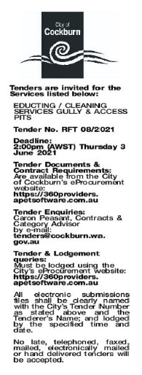 | Chief of Operations  Wednesday, 28 July 2021
 | Date of Council Meeting:
 | Not applicable
Name of Successful Tenderer(s): | RIVERJET PTY LTD
Amount of Successful Tender(s): (ex GST) | $690,885

