24 May 2023

Fauna diversity survey confirms Bibra Lake reserve teeming with locally and conservation-significant wildlife

Main points:
- A diverse range of fauna has been recorded in independent surveys at the City’s Bibra Lake and Yaakan Park reserves
- The results confirm management efforts by the City in partnership with community stakeholders is paying off
- Fauna detected included conservation-significant skink and waterbird, locally significant Greater Western Long-eared Bat, Quacking Frog, Quenda and Brush-tailed Possum, and key species including Carnaby’s and Forest Red-tailed Black Cockatoo.
A diverse range of native fauna, including six species of micro-bat, was detected during zoological surveys at Bibra Lake and Yaakan Park, confirming the conservation reserves’ largely intact habitats are teeming with wildlife.
The survey also confirmed a diverse array of reptiles including four species of conservation-significant skink, plus key species such as Carnaby’s and Forest Red-tailed Black Cockatoo, a range of conservation significant and migratory waterbird, and the locally significant Quacking Frog, Quenda and Brush-tailed Possum.
Six of a possible nine species of insectivorous micro-bat, including the locally significant Greater Western Long-eared Bat rarely detected in the region, were detected in the reserves, a resounding result that could be due in part to the City’s installation of more than 50 bat nesting boxes in recent years.
The survey, conducted independently for the City of Cockburn in November and December 2022 by FaunaTrack, found the reserves contain areas of habitat in good condition.
City of Cockburn Acting Head of Sustainability and Environment Rory Garven said the survey results were good news, confirming management efforts by the City and the community were paying off.
“Community and stakeholder collaboration is fundamental to the City’s success in managing these two reserves. These long-term partnerships help us all make a real difference to our urban biodiversity,” Mr Garven said.
An example of community involvement in caring for these reserves are the 370 people who attended 12 community events held by the Rehabilitate Roe 8 project, managed by the City on behalf of Main Roads WA, in the past 12 months.
In the past five years 250,000 seedlings have been planted in the Roe 8 Corridor to provide a continuous habitat between Bibra Drive and Stock Road, enabling an ecological connection to Bibra Lake and Yaakan Park for native fauna.
Mr Garven said the City was in constant communication with The Wetlands Centre Cockburn and the Friends of Bibra Lake South Bank to achieve its management objectives.
“We have recently partnered with Murdoch University and the local community to install 160 Black Cockatoo habitat trees in Bibra Lake this winter.”
The survey report made several recommendations to help guide the City’s ongoing management of the much-loved reserves which contain numerous habitats including Banksia/Eucalypt low open forest, Eucalypt rudis open forest, Melaleuca pressiana low open forest, and low-lying Banksia woodland/dampland.
“The City has a range of well-established methods to manage Bibra Lake and Yaakan Park. This includes feral animal, fire, dieback and weed management,” Mr Garven said.
“Regular fauna surveys inform best practice to help us sustain and improve our habitats and the fauna that call them home, for future generations.
“The City’s Environment and Sustainability teams will assess the report’s recommendations as we strive to maintain and improve these vital habitats and build on biodiversity in our urban settings.”
The City manages the Bibra Lake and Yaakan Park reserves which form part of Beeliar Regional Park.
Bibra Lake and Yaakan Park projects:
- Off grid bird waterer and seven native bee hotels installed in the Roe 8 Corridor
- Annual dieback mapping, public education and ongoing maintenance of boot cleaning stations at Yaakan Park. Dieback has not been detected at Yaakan Park or Bibra Lake
- Bi-annual feral animal control program for foxes, cats and rabbits. In the most recent program nine foxes were removed. Rehabilitate Roe 8 removed seven foxes, two cats and 12 feral beehives in the past year
- Annual weed mapping and removal, which has created areas where migratory Rainbow Bee-eaters have successfully nested
- More than a hectare of invasive fig trees removed from Bibra Lake dampland habitat, enabling the regeneration of native species
- Public bird nesting box workshops will be held in June and a bat nesting box workshop is planned for later this year.
Caption: The Quacking Frog (Crinea georgiana) was among many species of local and conservation significance detected in independent surveys at the City's Bibra Lake and Yaakan Park reserves. Pic credit - FaunaTrak.
ENDS

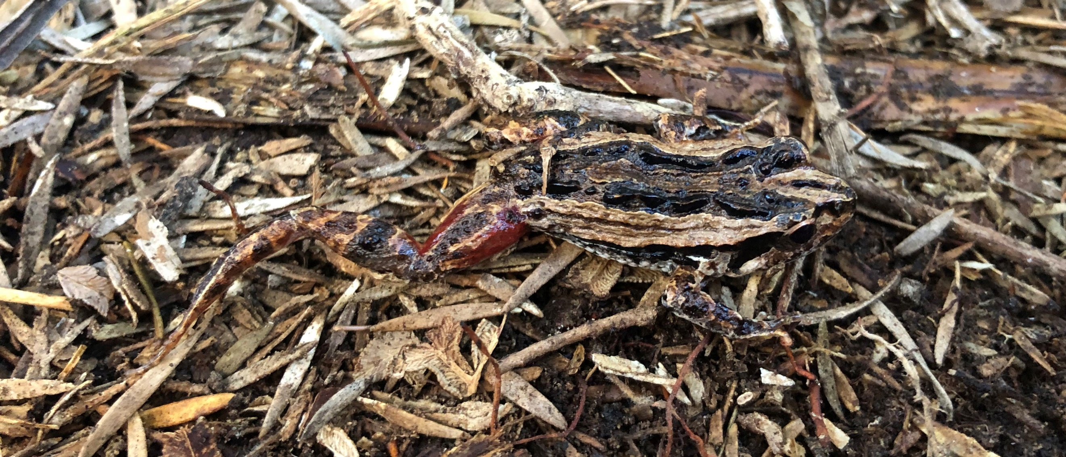

For more information contact:
Media and Communications Officer
City of Cockburn
T: 08 9411 3551
E: media@cockburn.wa.gov.au

