Tender Title: |  | HOT ASPHALT SURFACES  (Supply and Lay and Supply Only)
Request ID: |  | 79170
Tender Description: |  | The City is seeking a Contractor for the supply and laying of hot asphalt road surfacing, and includes new works as well as road resurfacing works, at locations throughout the Principles municipal boundary area.
Advert Approval: |  | Decision to Advertise: Director Infrastructure Services  Decision Date: Monday, 23 March 2026
Closing Date and Time: |  | 2:00PM (AWST) Tuesday, 21 April 2026
Opening Date and Time: |  | 2:00PM (AWST) Tuesday, 21 April 2026
 | Tenderer’s Name:
1 | Downer EDI Works Pty Ltd T/as Downer (Surfacing)
2 | ASPHALTTECH Pty Ltd (WA)
3 | Roads 2000 Pty Ltd
4 | SGA Group (WA) (Estimating WA)
5
6
7
8
9
10

Advertisement
Method 1: City of Cockburn website | Method 2: City of Cockburn Libraries Public Noticeboards
Method 3:  The Western Australian, Saturday, 21 April 2026 | Tender Awarded by:
Copy of Statewide Notice:  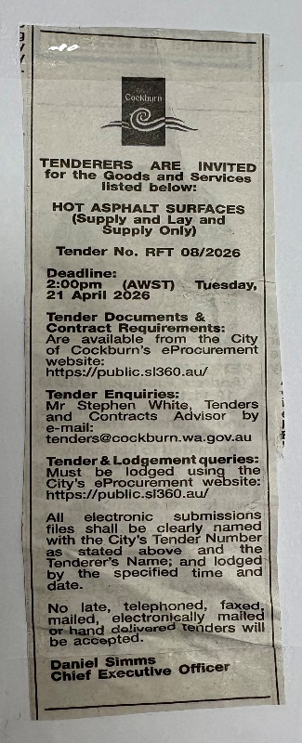 | OCM  Choose an item.  Tuesday, 9 June 2026
 | Date of Council Meeting:
Date: 9 June 2026
Minutes: 2026/MINUTE NO 0096
Item No. 14.3.1
Name of Successful Tenderer(s): | Downer EDI Works Pty Ltd T/as Downer (Surfacing)
Amount of Successful Tender(s): (ex GST) | $16,210,363.00

