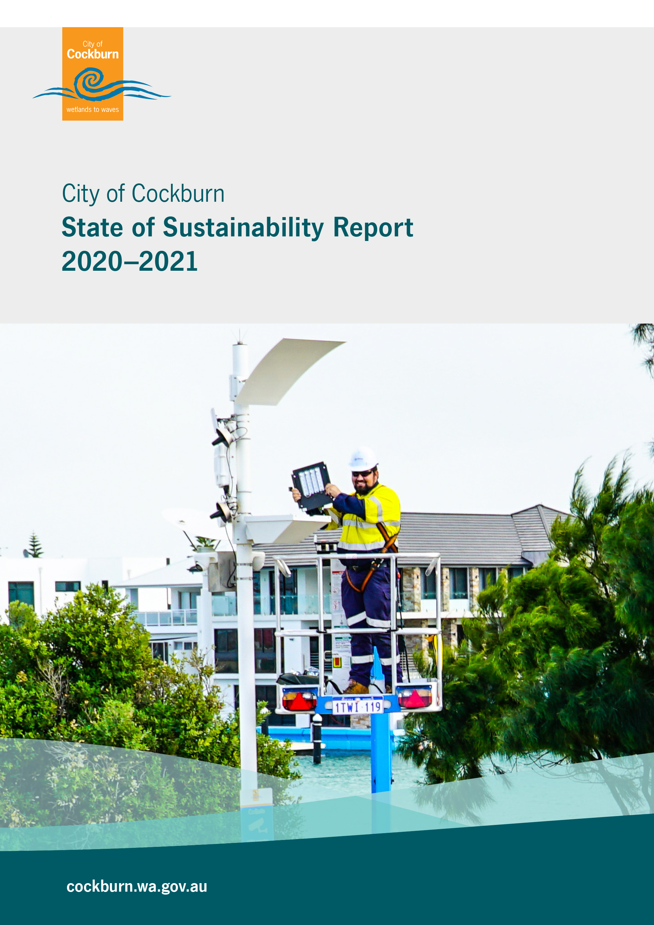

Table of Contents

Table of Contents 1
Acknowledgement of Country 1
1. Our Vision 2
2. Our Sustainability Definition 2
3. Annual Sustainability Reporting 2
4. Sustainability Targets 3
5. Performance Summary 6
6. Highlights 2020-2021 7
7. Planning and Review 11
Appendix A - Integrated Reporting Platform 12
Appendix B – Sustainability Action 2017-2022 13

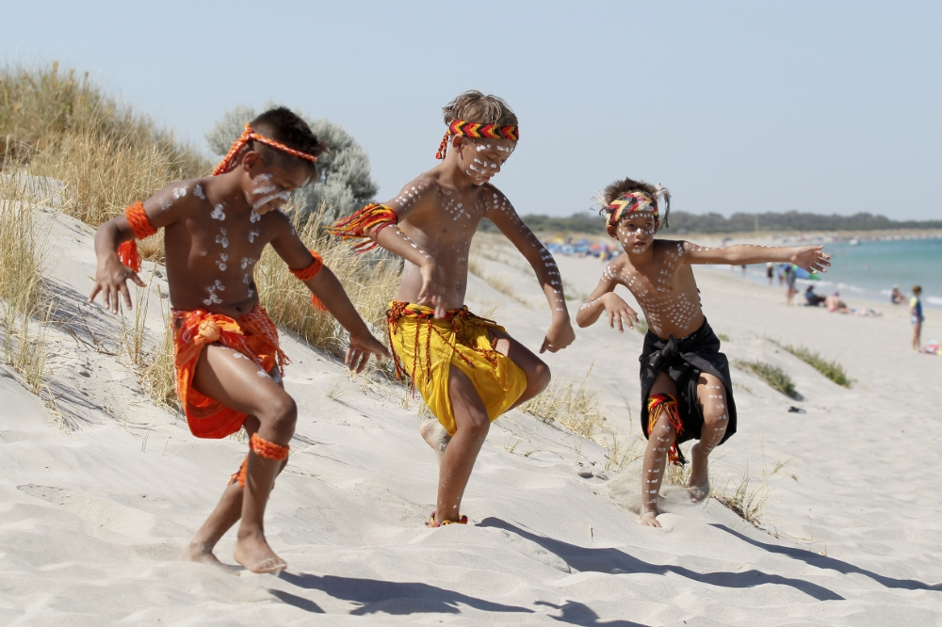

Acknowledgement of Country
The Mayor, Councillors and staff of the City of Cockburn acknowledge the Whadjuk Nyungar people of Beeliar boodja as the traditional custodians of this land. We pay our respect to the Elders, past, present and emerging.

Our Vision
Cockburn, the best place to be
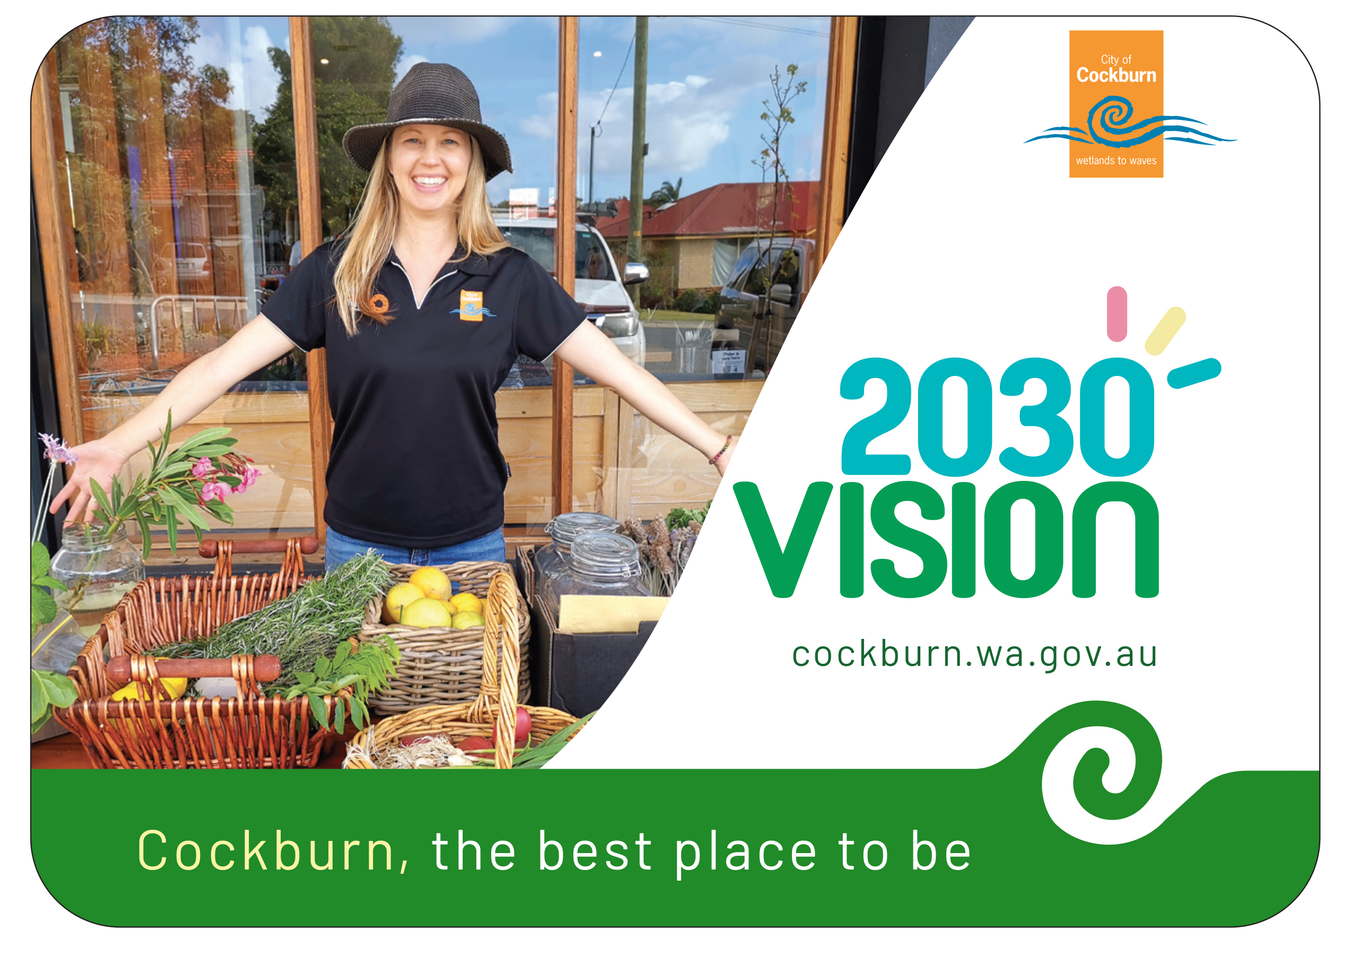

Our Sustainability Definition
Pursuing governance excellence to meet the needs of current and future generations through integration of the environment, society, economy.

Annual Sustainability Reporting
The State of Sustainability (SoS) report is released each year to track progress towards sustainability.
This is a public document whereby our achievements to address sustainability and areas for improvement are transparently communicated to Council and the community. A summary of performance, whether positive or negative, is also included in the City’s Annual Report.
This report is the City’s 11th annual State of Sustainability and outlines the City’s collective efforts in working toward the 14 Targets and 76 Key Performance Indicators (KPI’s) set out in the Sustainability Action Plan 2017-2022. Detailed information on the City’s sustainability reporting framework is outlined in Appendix A.
This report closes out a 4 year reporting cycle against the KPI’s established in 2017. A major review of the City’s Sustainability Strategy is due in 2022. A new action plan will be established to align with the Strategic Community Plan and corporate KPIs to ensure best practice in sustainability.

Sustainability Targets

Fourteen high-level targets have been identified to address key sustainability areas including water conservation, waste minimisation, energy and emissions reduction, biodiversity and liveability.

The City achieved 9 out of the 14 targets in 2020-21. Highlights include the completion of the garden waste bin rollout, platinum Waterwise Council award, production of renewable energy for council facilities and a zero emissions fleet.

The City has identified the need to improve its recovery and diversion rate for waste and has set a new long term target for zero non-hazardous waste to landfill, supported by the Waste Strategy 2020-2030.

Electricity and gas usage has increased and requires significant investment, including upgrades to LED streetlighting to meet new targets for net zero emissions, which are supported by the City’s Climate Change Strategy 2020 -2030.

Obesity continues to be a major public health challenge in Cockburn communities and will be addressed in the upcoming Local Public Health Plan.

Targets |  | Progress 2020 - 2021
Waste Minimisation | 100% rollout of the Garden Waste Bin program across Cockburn by 2020 | Target achieved  100% of the bin rollout is complete
Waste Minimisation | 12% of waste to be recovered and diverted from landfill at Henderson Waste Recovery Park (HWRP), per annum | Target not yet achieved  11.5% of waste was recovered in 2020-2021.  New target set for zero non-hazardous waste to landfill by 2030
Waste Minimisation | Ongoing commitment to 10% waste recovery from the Bulk Junk Verge collection | Target not yet achieved  6.7% recovered from bulk verge collection in 2020-2021.

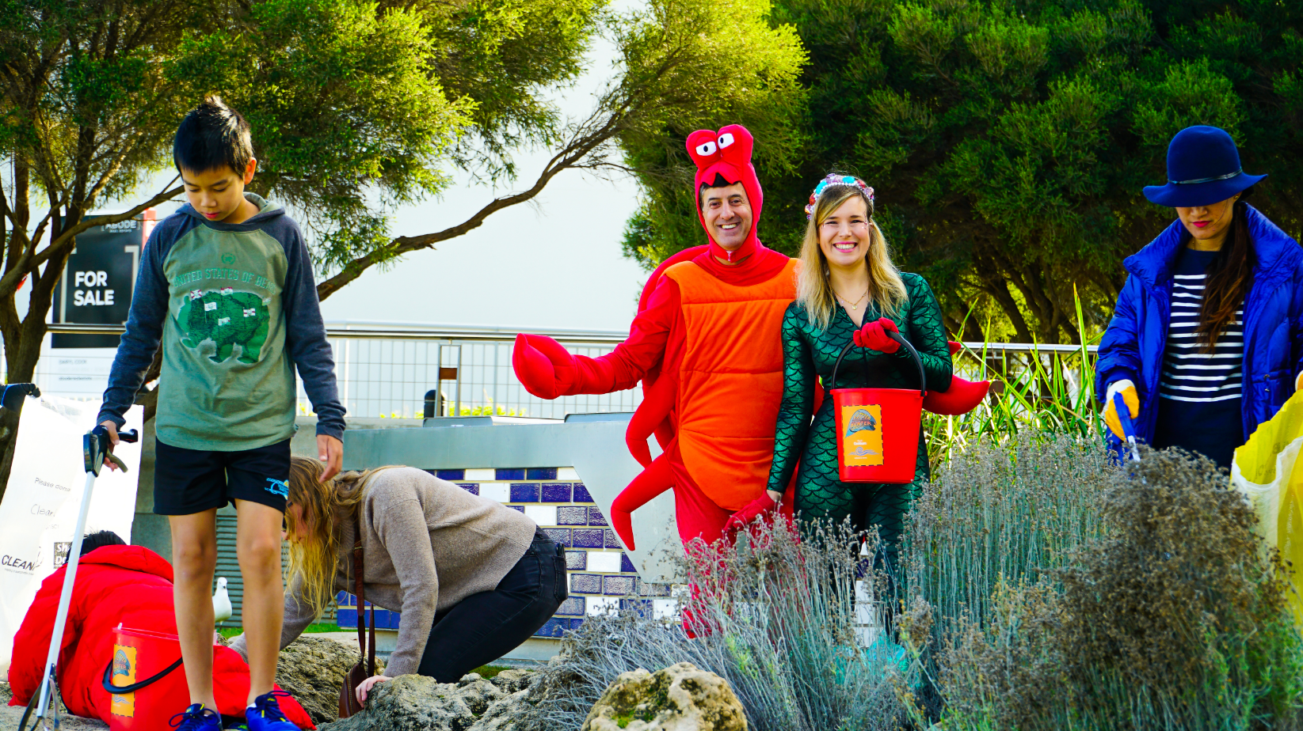
Image 1: World Oceans Day community beach clean up, 2021
Sustainability Targets |  | Progress 2020 - 2021
Water Conservation | Maintain Waterwise Council status by achieving all water conservation targets and actions identified in the Water Efficiency Action Plan 2016. | Target achieved  The City achieved Platinum Waterwise Council status in 2021
Energy and Emissions Reduction | Ongoing commitment to the Zero Emissions Fleet | Target achieved  Zero Emissions Fleet maintained
Energy and Emissions Reduction | 20% renewable energy generation by 2020 | Target Achieved  New target set for 100% renewable energy for Council buildings by 2030
Energy and Emissions Reduction | Electricity and gas emissions to be 20% below 2008-2009 levels, by 2020 | 2020 Target not achieved  New target set for net zero emissions. Action plan endorsed by Council to help achieve target by 2030.
Energy and Emissions Reduction | Western Power Street Lighting emissions to be 10% below 2008-2009 levels, by 2020 | 2020 Target not achieved  New target set for net zero emissions by 2030.  Council approved funding for LED streetlight upgrade for 2021/22.
Energy and Emissions Reduction | Waste Emissions to be no more than 45% above 2008-2009 levels, by 2020 at Henderson Waste Recovery Park. | Target achieved  Waste emissions have remained below the cap since 2011

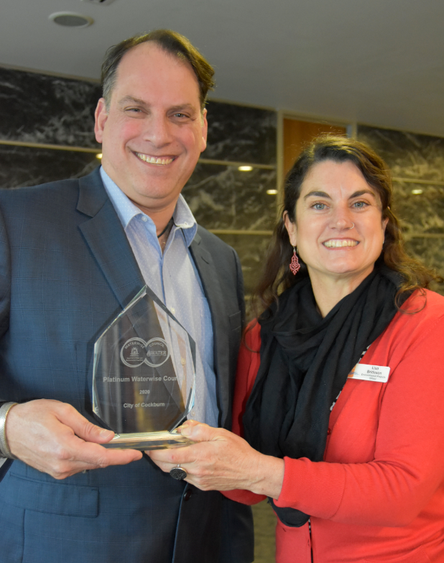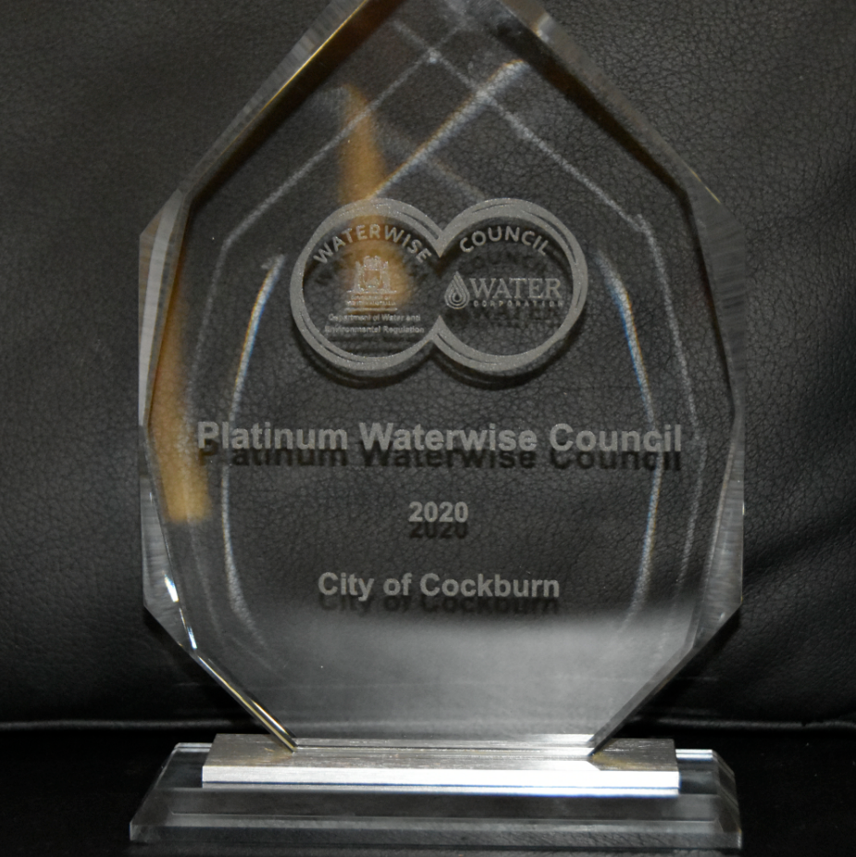
Image 2: The City achieved ‘Platinum’ Waterwise Council Status in 2021
Sustainability Targets |  | Progress 2020 - 2021
Biodiversity | Complete 2.5 hectares of revegetation annually with an emphasis on enhancing ecological corridors linking natural areas | Target achieved  Revegetated 4.8 hectares of bushland in 2020-21 with over 76,000 seedlings
Biodiversity | The percent of vegetation in conversation reserves in good or better condition is increasing against the 2010 base year figure of 62% | Target achieved  78.66% vegetation rated as being in good or better condition
Livability and Social Capital | 100% of structure plans comply with the elements of Livable Neighbourhoods Design Code | Target achieved  100% of structure plans assessed in 2020/21 comply with the elements of Liveable Neighbourhoods.
Livability and Social Capital | To reduce our percentage of overweight and obese adults to be less than or equal to the WA State average | Target not yet achieved The most current obesity statistics (Jan 2015 to Dec 2016) suggest that 79% of Cockburn’s adults are either overweight or obese, this is 12.4% higher than the WA State average (66.6%). Obesity will continue to be a major public health challenge to be addressed in the City’s updated Local Public Health Plan.
Livability and Social Capital | 9500m² of new pathways and cycleways constructed per annum to facilitate sustainable transport. | Target achieved  New pathways and cycleways constructed in 2020-2021 exceeded target.

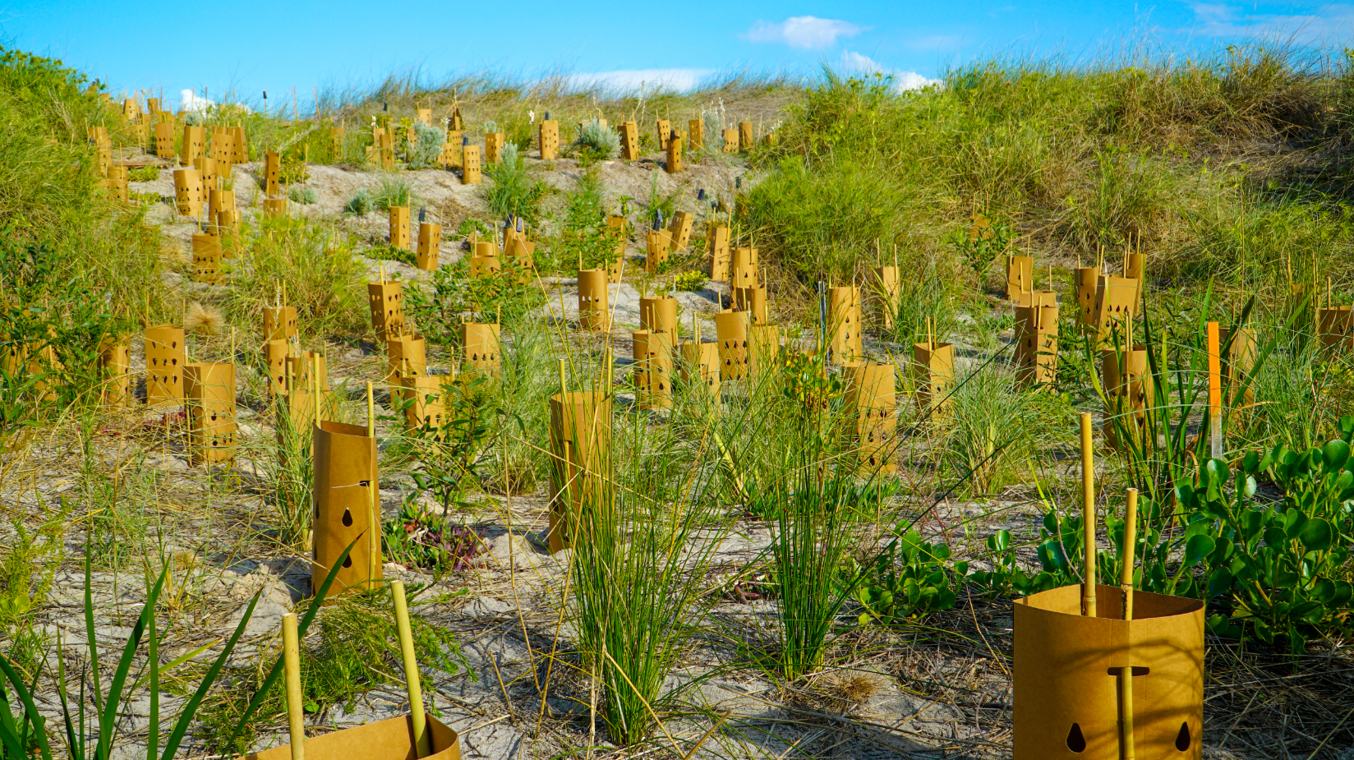Image 3: Biodegradable tree guards are used in Cockburn’s coastal revegetation sites, 2021

KPI Performance Summary
The Sustainability Action Plan 2017 – 2022 includes 76 KPI’s that were selected by senior management in 2017 from the Corporate Business Plan and Strategic Community Plan.

The City has been successful in taking action towards the KPI’s over the 4 year sustainability reporting cycle.

During the first year (2017-18) an average of 9% of KPIs had not started, 67% were in progress and 24% were achieved.

By the final year (2020-2021) all KPIs had commenced, with 30% in progress and 70% of KPIs achieved. The City has advanced action across all of the sustainability focus areas including governance, environment, society and the economy.

Key highlights for 2020-2021 are outlined in the following pages. A full report on progress against the 76 KPIs has been included in Appendix B.

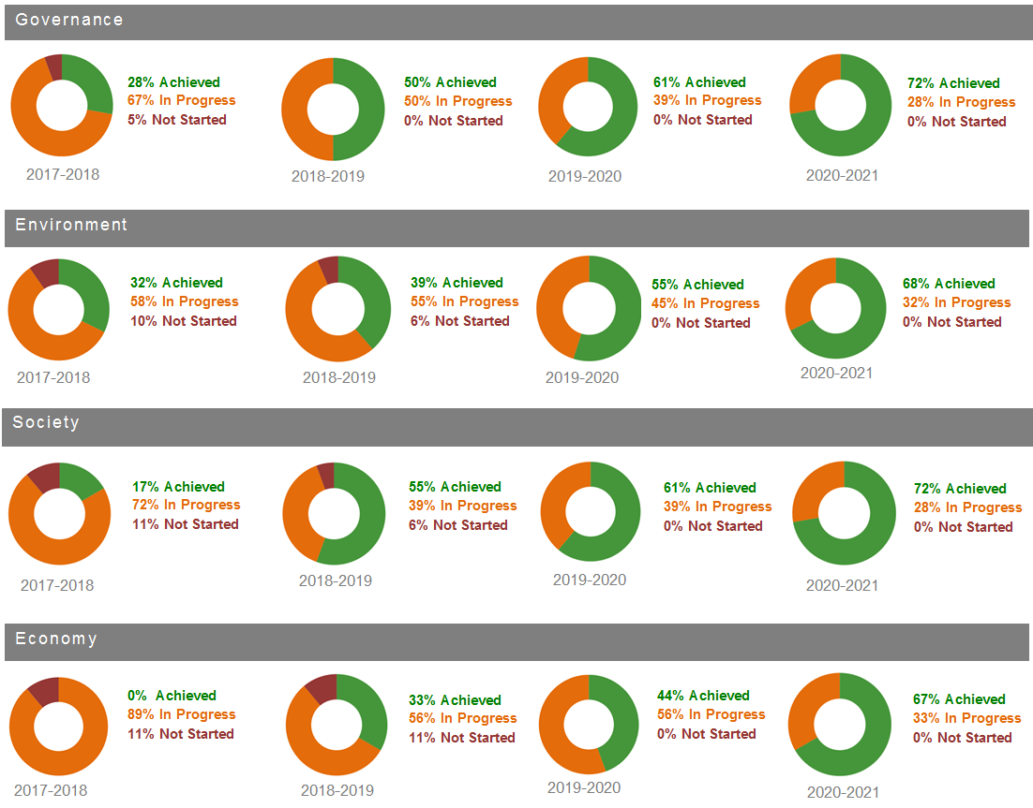

Image 4: Summary of progress against the Sustainability Action Plan (2017 -2021)

Highlights 2020-2021

Governance Highlights 2020-2021
- Installed a 30kW solar photovoltaic system on the Wetlands Precinct
- Upgraded 400 streetlights to energy efficient LEDs
- Council approved funding for a City-wide LED streetlight upgrade program
- Celebrated the Sustainability Committee’s 11th year
- Reviewed the Strategic Community Plan
- Achieved several sustainability-related awards
  - Platinum Waterwise Council
  - National Cities Power Partnership Award – High Commendation -Renewable Energy Achievements
  - 2020 PHAIWA Local Government Policy Awards, -Winner Shade in Public Place and Smoke Free Environment, and Overall Winner
  - Master Builders-Bankwest Excellence in Construction Awards, Winner, Lakelands Multipurpose Hockey and Community Facility
  - 2020 WA Heritage Awards, Commendation, Cockburn History Website

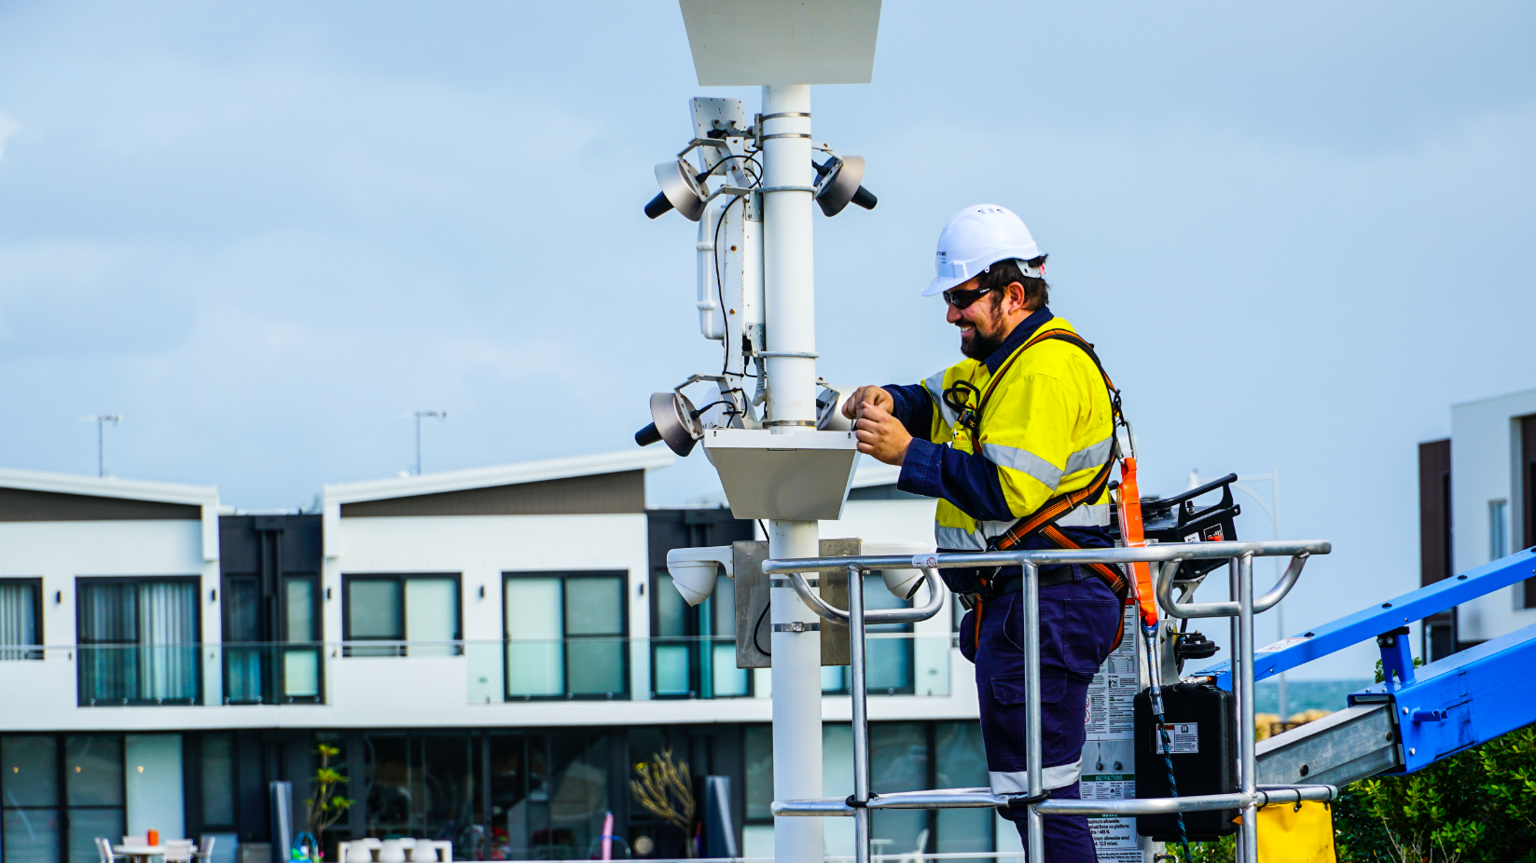

Image 5: LED streetlight upgrade, Port Coogee, June 2020

Environment Highlights 2020-2021

- Achieved platinum Waterwise Council status
- Adopted the following strategies and plans:
  - Climate Change Strategy 2020-2030
  - Waste Strategy 2020-2030
  - Integrated Transport Strategy 2020-2030
  - Coogee Beach Foreshore Management Plan 2020-2070
- Exceeded the renewable energy target with over 26% of Council buildings receiving power from solar photovoltaic systems
- Established new corporate targets for 100% renewable energy and net zero emission by 2030
- Maintained a Zero Emissions Fleet via the carbon offset program
- Rehabilitated 4.8 hectares of bushland with 76,000 seedlings
- Commenced a green hydrogen feasibility study and electric waste truck trial
- Integrated Environmentally Sustainable Design (ESD) into 5 facilities
- Supported 68 residents with a waterwise verge rebate
- Planted 1400 street trees

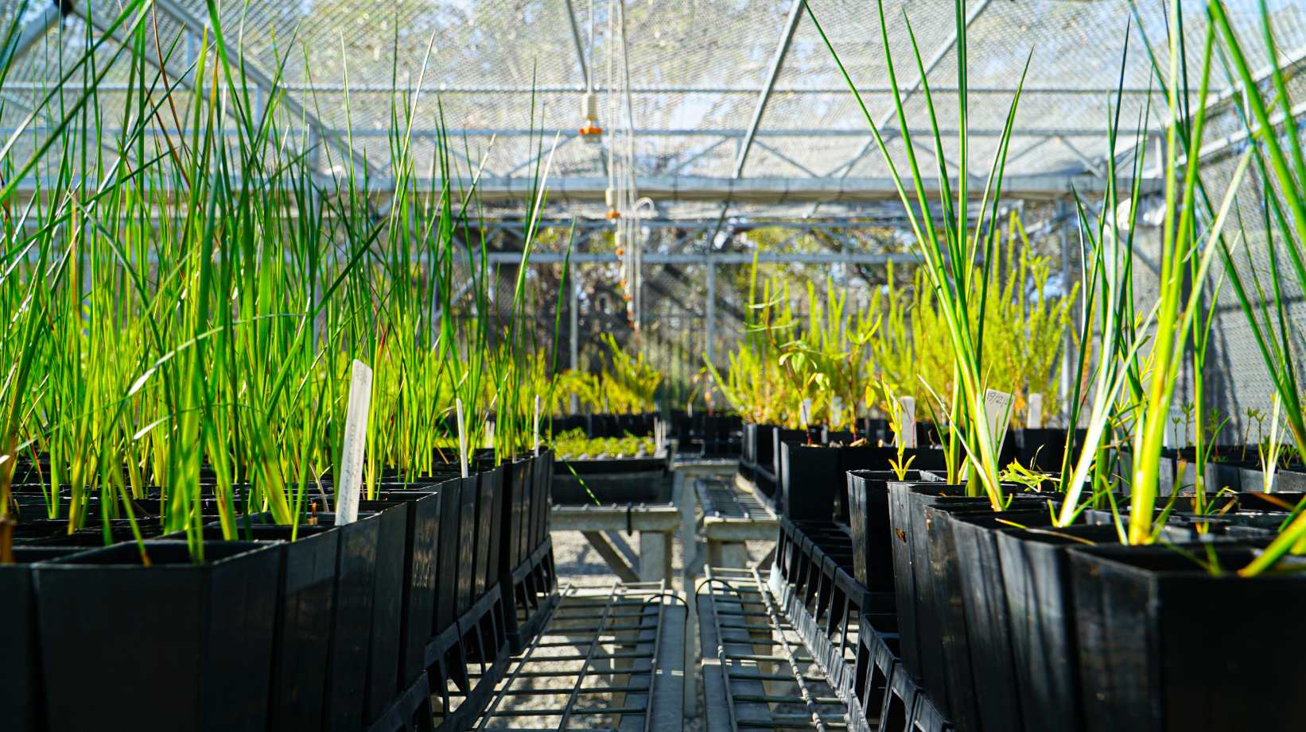
Image 6: Native Plant Nursery, The Wetlands Centre, Cockburn
Society Highlights 2020-2021
- Revised the concept design for the Aboriginal Cultural and Visitors Centre
- Allocated over $950,000 to 132 community groups and organisations
- Received a commendation for the History website, 2020 WA Heritage Awards
- Adopted the Community Development Strategy 2021 – 2025
- Continued to deliver cultural community events
- Established a partnership with Climate Active to empower schools, business and households to reduce their carbon footprint
- Gazetted and implemented an important amendment to the local planning scheme and Local Planning Policy 1.2 known as ‘Better Neighbourhoods’
- Continued implementation of the Reconciliation Action Plan
- Installed an additional 12 artificial reef structures on the Coogee Maritime Trail

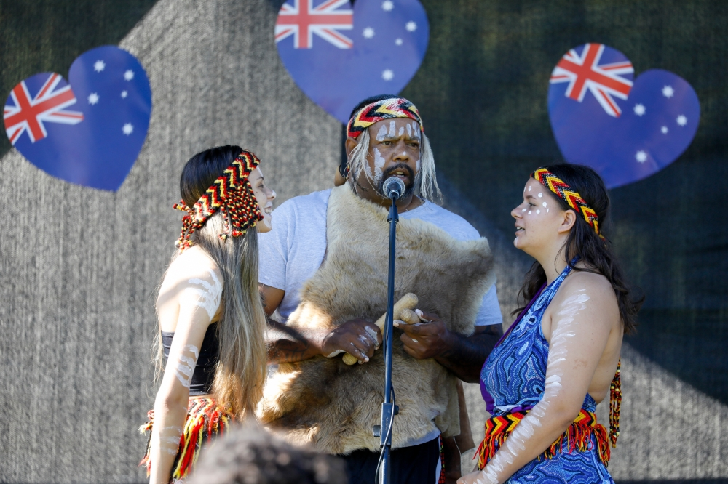
Image 7: Australia Day, January 2021

Economy Highlights 2019-20
- Awarded 12 Sustainability Grants to the value of $38,000
- Awarded 20 Local Economic Development Grants to the value of $85,000
- Received a $37k Urban Canopy Grant for areas in Beeliar and Bibra Lake
- Received a Keep Australia Beautiful grant for the Clean Ocean Catch program
- Further strengthened regional collaboration
- Successful trial of a commercial food waste service (approved as a permanent service)
- Continued participation in the Metronet working group, advancing the Cockburn/Thornlie train line
- Developed Cockburn Restart Hub to assist businesses with Covid-19 recovery
- Hosted a Small Business Friendly Local Government economic development Showcase at Cockburn ARC and sponsored the Curtin Ignition program
- Delivered Clean Ocean Cuppas program with coastal café’s
- Continued to support local business with masterclasses, briefings, enewsletters, events, workshops, and the #ShopLocalCockburn campaign

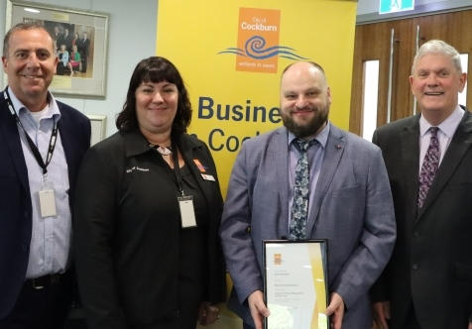

Image 8: CEO Tony Brun, Business Engagement Officer Sarah Kahle, Local Economic Development Grant Recipient Torsten Giese (Barrett Communications) and Mayor Logan Howlett (L-R)

Planning and Review
Measurable targets and Key Performance Indicators (KPIs) are set by the Senior Leadership Team to support the City in achieving the sustainability outcomes articulated in the Strategic Community Plan. The KPIs are aligned to the Corporate Business Plan and form the Sustainability Action Plan 2017- 2022.

The Sustainability Policy, Strategy and Action Plan are reviewed on a four yearly basis to align with the Community Strategic Plan (CSP).
The action plan is due for review in 2022 along with the Sustainability Strategy. New KPIs will be set and aligned to the Strategic Community Plan and the City’s vision.

Document | Reporting and Review
State of Sustainability | Annual progress report  2018, 2019, 2020, 2021
Sustainability Policy | 2019, 2022
Strategy | 2022
Action Plan | 2022

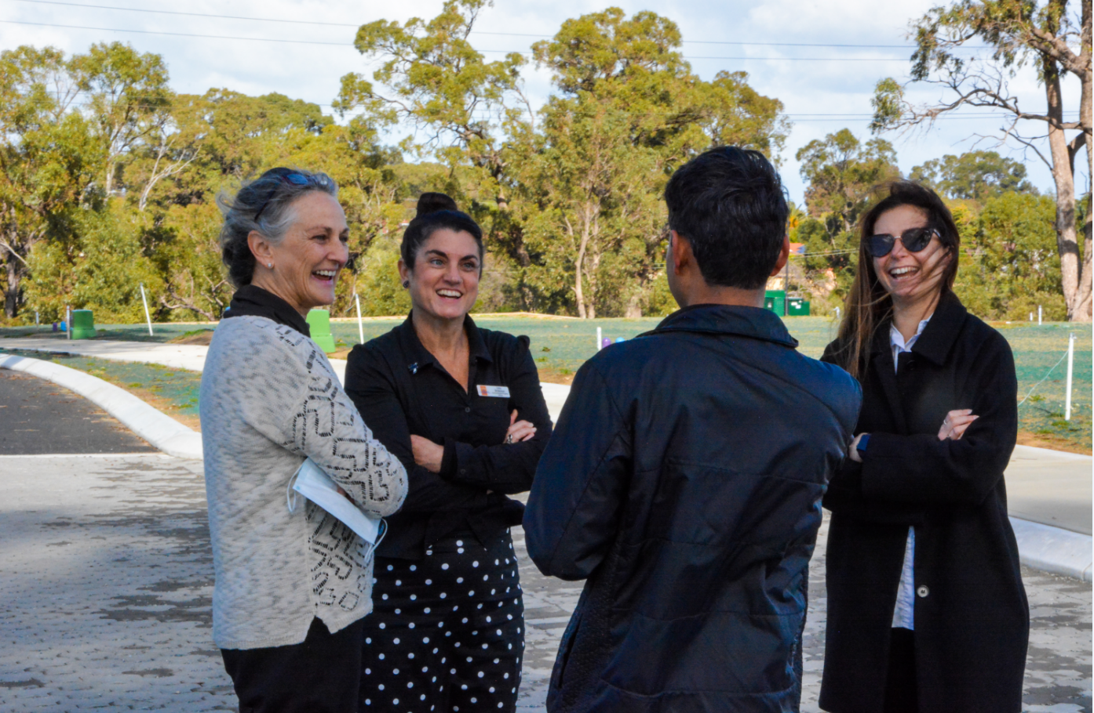

Image 9: Development WA and City of Cockburn staff inspecting permeable paving at the 115 Hamilton Hill development, June 2021

Appendix A - Integrated Reporting Platform Overview
The Integrated Reporting Platform provides the framework for sustainability planning, monitoring and reporting. The hierarchy of documentation is outlined below:
Strategic Community Plan 2020 – 2030
Sets the City’s direction based around five key outcome for Cockburn: local economy; environmental responsibility; community lifestyle and security; city growth and moving around; listening and leading.
Sustainability Policy
Provides a set of 11 principles to guide the City’s decision-making processes.
Sustainability Strategy 2017 – 2022
Identifies the Integrated Reporting Platform and articulates the City’s 16 sustainability objectives.
Sustainability Action Plan 2017 – 2022
76 Key Performance Indicators (KPI’s) set to achieve to the City’s sustainability objectives. Aligned to the Corporate Business Plan.
State of Sustainability Report (Annual)
Annual progress report that provides a balanced representation on the City’s sustainability performance.
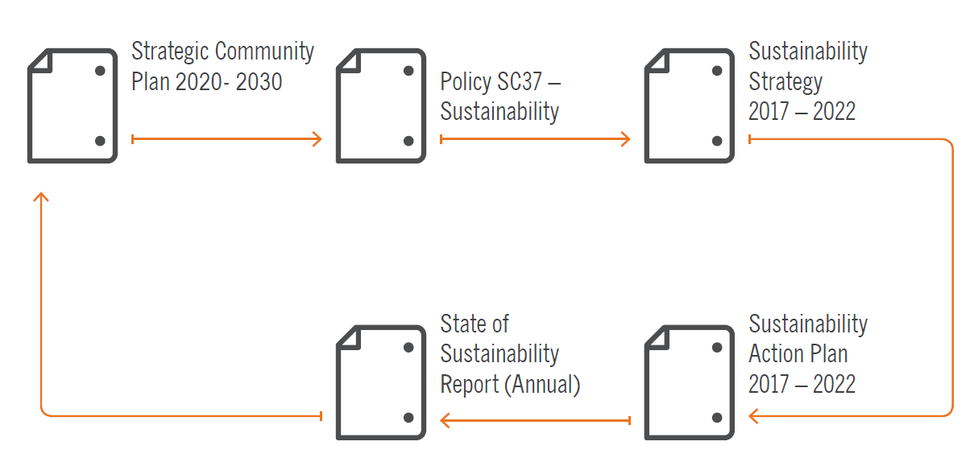

Image 10: The City of Cockburn’s Integrated Reporting Platform

Appendix B – Sustainability Action 2017-2022
The purpose of the Action Plan is to set out key performance indicators (KPIs) for the key sustainability focus areas of Governance, Environment, Society and Economy.
The City’s progress in achieving its KPIs is illustrated through the use of a simple traffic light system, which is explained as follows:
Indicates the City has achieved, or is on track to achieving, the KPI.
Indicates while the City is making progress toward the KPI, more work is needed.
Indicates the City is not yet making progress toward the KPI.

Governance
Governance is the cornerstone of the City’s approach to sustainability. It ensures an integrated decision-making process, which takes into account the triple bottom line and employs the precautionary principle to ensure that future generations of the Cockburn community are taken into consideration. We listen, lead, and work together with residents for a sustainable future.

Governance Performance
The City identified 18 KPIs to measure its progress towards achieving governance excellence. 72% of governance KPIs were achieved in 2019-2020, with a further 28% significantly progressed.
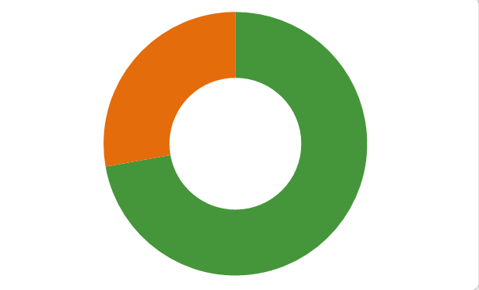
0% not started (in red)
28% in progress (in orange)
72% achieved (in green)

SCP Strategic Objectives | KPI # | Governance Key Performance Indicator | Lead Service Unit | Timeframe | Progress 2020-2021
Best practice Governance, partnerships and value for money | GOV 1.1 | Support and develop the City’s business systems to enhance the effectiveness and efficiency of Council’s operations through the use of technology. | Business Systems | Ongoing | Increased the number of online services available to the public allowing improved access to information. We have provisioned access to Online Rates and eProperty, Building Applications and Public Wi-Fi.  - Website front page redesigned  - Animal registrations online  - Animal transfers transfer online  - Building application forms online  - Online fire permit applications  - Digitisation of firebreak inspection process  - SINE contractor sign-in system implemented. No need for manual signing in.  - Barking dog diary now available online  - Online Building Applications – 90% off all building applications are now electronic rather than paper.  - ESRI system deployed for CoSafe work orders eliminating all paper-based processes.
Best practice Governance, partnerships and value for money | GOV 1.2 | Increase the City's use of smart and integrated technology solutions to measure, monitor and reduce waste across the City's Operations and to increase resource efficiency. | Business Systems | Ongoing | The City’s Information & Technology strategy is being redeveloped with a focus on enabling and empowering the organisation and our customers through mobile workforce enablement, moving spend from “run” to “grow”, implementing Smart Cities technology.
Best practice Governance, partnerships and value for money | GOV 1.3 | Consolidate the existing 70+ strategies and strategic documents into a cohesive framework of strategies and list of operational documents linked to the Strategic Themes and objectives. | Corporate Strategy | 2021-2022 | Strategies and strategic documents to be reviewed during FY22 and streamlined by Division to effectively prioritise realistic, achievable, and funded/resourced actions only. This will be determined in consultation with Elected Members and approved by Council.
Best practice Governance, partnerships and value for money | GOV 1.4 | Finalise and implement the Strategic Risk Register. | Governance, Risk and Compliance | 2016-2017 | Risk Management and Safety System (RMSS) has been implemented as the City’s online risk register. To date 7 strategic risks and 277 operational risks have been identified.
Best practice Governance, partnerships and value for money | GOV 1.5 | Review and update the Risk Management Strategy. | Governance, Risk and Compliance | 2018 and 2020 | The Risk Management Strategy has now been replaced with the City’s Enterprise Risk Management Framework, recently revised and approved by Council in July 2021.
Best practice Governance, partnerships and value for money | GOV 1.6 | Engage, enhance and execute the strategic procurement framework to optimise Value for Money (cost, quality, and sustainability) across the City’s procurement expenditure. | Procurement | Ongoing | The adoption of the Local and Regional Economy principle within the Policy has significantly increased the expenditure to local providers as well as enhanced the sourcing process at the City.
Best practice Governance, partnerships and value for money | GOV 1.7 | Provide policy, programs and advice which shape the City’s workforce to ensure it is capable of achieving business objectives now and in the future. | Human Resources | 2019-2020 | As part of the City’s Transformation program 7.7 FTE for 2020-2021 were reallocated to support program delivery. The Executive has since created 9 new FTE as part of the Transformation review.
Best practice Governance, partnerships and value for money | GOV 1.8 | Promote Sustainability throughout the organisation via Sustainability Committee and delivery of minimum of two staff initiatives per annum. | Sustainability and Climate Change | Ongoing | The Sustainability Committee continued to meet bi-monthly, and has evolved into a task team with its first priority to progress a paper-lite office.
Sustainable resource management including waste, water and energy | GOV 2.1 | Management of City assets through Asset Management Plans including condition assessment and review of service levels for Road Infrastructure; Drainage; Buildings; Fleet and Plant; Parks and Environment; Footpaths. | Asset Management | Ongoing | Development cycle for Asset Management Plan 2020-2021 to 2023-2024 completed by June 30th 2021. Signed off by the Senior Leadership Team, currently awaiting ExCo sign off.
 | GOV 2.2 | Develop Asset Management Plan for marine and coastal assets. | Asset Management | 2017-2018 | Asset Management Plan completed and adopted by Council 2019/20.
 | GOV 2.3 | Continue to engage with State and Federal Government Agencies in order to secure partnership funding arrangements. | Stakeholder Management | Ongoing | Engagement is ongoing with regular and topic based meetings occurring as required. An Advocacy and Stakeholder Engagement Framework is going to August 2021 Ordinary Council Meeting. Individual advocacy plans will be developed for each project.
 | GOV 2.4 | In liaison with Recreation & Community Safety and Community Development & Services, plan and deliver new and refurbished buildings and facilities. | Recreation Services | Ongoing | The Community Sport and Recreation Facilities Plan provides the strategic framework for the delivery of $209 million of community facilities and reserves over the next 15 years. This features the ESD/Sustainability Policy applying a financial allocation of 3% of project cost for Environmentally Sustainable Design in new facilities over $1million.  - 20kW photo voltaic solar PV sytem planned for Frankland Park Sports Facility  - Upgraded the Solar PV system on the Coogee Beach SLSC by 12kW  - Installed a 13.2 kW Solar PV system on the Beeliar Community Centre  - LED sports lighting installed at Goodchild Park and Meller Park  - 30kW photo voltaic solar PV system planned for Treeby Community and Sports Centre  - The City has won the Institute of Public Works Engineering Australasia (IPWEA) Awards - WA Division - Winner, Excellence in Environment & Sustainability Award - Coogee Maritime Trail
An integrated, accessible and improved transport network | GOV 3.1 | Review and update the Integrated Transport Plan, incorporating the Road Safety Strategy and Travel Smart Plan. | Transport and Traffic | 2018-2019 | The Integrated Transport Strategy, incorporating the Road Safety Strategy and TravelSmart Plan was adopted by Council 12 November 2020.
An integrated, accessible and improved transport network | GOV 3.2 | In conjunction with Environmental Management, review and integrate the Footpath Plan and Trails Master Plan. | Transport and Traffic  Sustainability and Environment | 2016-2017 | A decision has been made to retain the Trails Master Plan as a standalone document. The TMP will be updated in 2022.
An integrated, accessible and improved transport network | GOV 4.1 | Ensure planning and development of the public transport network within the City meets community and industry needs while minimising environmental impact. | Transport and Traffic | Ongoing | The City is liaising with Department of Transport, Public Transport Authority, Metronet and Main Roads to ensure that the public transport is better connected, promoted and utilised.  Detailed access audits of Cockburn Central and Aubin Grove station were completed in conjunction with major stakeholders.  Work has started on the Thornlie-Cockburn Metronet 17.5km rail project and also the North Lake Road Bridge and Cockburn Central carpark redevelopment.
An integrated, accessible and improved transport network | GOV 4.2 | Advocate for improvements to public transport. | Transport and Traffic | 2019-2020 | There have been a large number of the public events promoting Travel Smart and road safety initiatives.  The City is participating in the Metronet working group to progress the Cockburn-Thornlie train line.
An integrated, accessible and improved transport network | GOV 4.3 | Review current parking approaches and create the City wide Parking Strategy. | Transport and Traffic | 2017-2018 | Parking Plan completed.
An integrated, accessible and improved transport network | GOV 4.4 | Review and update the City’s District Traffic Study 2013. | Transport and Traffic | 2017-2018 | District Traffic Study review and update has been completed.

10.2 Environment
The environment is the foundation for sustainability in the City of Cockburn. We consider conserving biological diversity and ecological integrity of utmost importance.
Our natural areas and resources must be sustainably managed now and in the future. We work to ensure that the impact on our environment is positive, and take our legacy into account in planning and development decisions.

Environment Performance

The City has identified 31 KPIs to measure progress toward achieving best practice in Environmental Management.

68% of the environmental KPIs were achieved in 2020-21, with a further 32% significantly progressed.

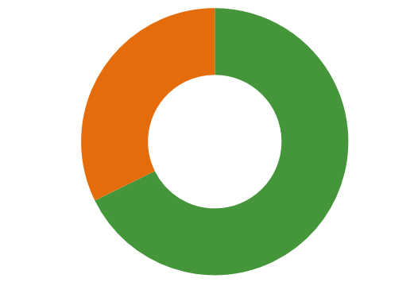
0% not started (in red)
32% in progress (in orange)
68% achieved (in green)

SCP Strategic Objectives | KPI # | Environment Key Performance Indicator | Lead Service Unit | Timeframe | Progress
A safe and healthy community that is socially connected  Protection and enhancement of our natural areas, bushland, parks and open spaces | ENV 1.1 | Ensure the City’s property interests and land portfolio are managed to maximise social, economic and environmental outcomes. | Land and Leasing | Ongoing | The City continues to undertake land administrative processes and decisions consistent with the objectives of the Land Management Strategy (2017-2022) which prescribe decision making based upon maximising sustainability outcomes.
 | ENV 1.2 | Protect the quality of the environment and improve and manage public health by implementing the City’s Public Health Plan. | Public Health | Ongoing | The review of the Public Health Plan was delayed by the COVID-19 pandemic. The review has commenced and is now scheduled for completion in 2021-2022.
 | ENV 1.3 | Maintain and improve wellbeing in the community by ensuring the standard of premises and activities complies with accepted public health standards and practices. | Public Health | Ongoing | The City’s Public Health Service Unit continues to coordinate the implementation of legal requirements to promote well-being, prevent disease and protect public health and the environment.
 | ENV 1.4 | Irrigation Maintenance – water management through irrigation planning and maintenance. | Environment, Parks and Streetscapes | Ongoing | Achieved Platinum Waterwise Council status. Implemented a new innovation incorporating fertilizer and wetting agent dosing units to irrigation systems, resulting in water savings through best practice turf management
 | ENV 1.5 | Natural Area Management – enhance local ecological services values through rehabilitation, revegetation and maintenance of natural areas. | Environmental Management Planning and Policy. | Ongoing | - Revegetated 4.8ha bushland with 76,500 seedlings  - 87,282 plants installed in the Roe 8 rehabilitation project. 277 volunteer hours contributed.  - 8 landowner biodiversity grants  - Habitat creation program with Birdlife WA  - 13 community and school planting events  The City has gone plastic free along our coastline and some wetlands this year installing 17,500 seedlings with biodegradable tree guards in our revegetation program.  Work with PhD student from Murdoch University on turtle nesting protection in Bibra Lake reserve including installation of turtle protection enclosures and tagging turtles.  Continue with Turtle Trackers Program, 30 active volunteers engaged.  Installed 12 Bombora structures on the Coogee Maritime Trail  Undertook weed mapping, weed management and vegetation condition mapping across selected reserves.  Completed trial cool burn for revegetation purposes at Bibra Lake.
 | ENV 1.6 | Develop a contemporary Public Health Plan which includes relevant parts of the Mosquito Management Plan, Contaminated Sites Strategy and Tobacco Action Plan. | Public Health | 2021-22 | The review of the Public Health Plan is now scheduled for completion in 2021-2022 and will incorporate relevant parts of the Mosquito Management Plan, Contaminated Sites Strategy and Tobacco Action Plan.
 | ENV 1.7 | Review the Open Space Strategy which will include a progress report. The next version of this ten year strategy will incorporate the Playground Shade Sail Strategy and specific management plans. | Environment, Parks and Streetscapes | 2017-2018 | The Public Open Space Strategy has been reviewed in accordance with the 5 year review process for strategies.  The Playground Shade Sail Strategy will be incorporated at the 10 year mark of the Public Open Space strategy.
 | ENV 1.8 | Develop a Climate Change Strategy. Incorporating the Greenhouse Gas Emission Reduction Strategy 2011 – 2020; Climate Change Adaptation Plan; Coastal Vulnerability Strategy; the Water Action Plan; and the Water Conservation Plan 2013. | Sustainability and Climate Change | 2019-2020 | Climate Change Strategy endorsed by Council in September 2021. New corporate targets established for net zero emissions, zero non-hazardous waste to landfill and 100% renewable energy by 2030.
 | ENV 1.9 | Review and update the Sustainability Strategy 2013 – 2017. | Sustainability and Climate Change | 2017-2018 | Strategy revised and adopted by Council in August 2017.
 | ENV 1.10 | Commence planning of the Wetlands Precinct. | Sustainability and Environment | 2019-2020 | Construction nearing completion. Due for completion in August 2021.
Protection and enhancement of our natural areas, bushland, parks and open spaces | ENV 2.1 | Landscape design, development and construction of infrastructure and park equipment. | Project Services | Ongoing | Received a high commendation for the construction of the Yangebup Pump Track, at the PLA awards in the category of Playspace Award.  Delivered bicycle pump track at Market Garden Park, Spearwood.  Landscape designs completed and implemented at Poole Reserve, Mears Park, Windmill Park, Blackthorn Park & Hagan Park. Streetscape improvements to Barwon Turn, Prespa Loop and Cockburn Road median island.  Playground shade sails installed at various locations.  Designed and implemented the Greenslade Urban Forest project.
 | ENV 2.2 | Develop and implement an Urban Forest Plan. | Environment, Parks and Streetscapes | Ongoing | The Urban Forest Plan 2018 - 2028 was endorsed by Executive and presented to Elected Members. Actions are currently being implemented. 1,400 street trees planted in 2020-2021.
Sustainable resource management including waste, water and energy | ENV 3.1 | Sustainability – coordinating events and activities designed to educate and support the community toward sustainable living. This includes environmental awareness, emission reduction, using renewable energy and waste education. | Sustainability and Climate Change | Ongoing | - Over 30 environmental education events  - 11 sustainability related events  - 55 free energy audits 35 of which were following up on actions taken in previous audits  - 56 Bird Bath Subsidies  - 12 sustainability grants issued  - 12 environmental education grants issued  - $15,000 Native Plant Subsidy Scheme for residents and local schools  - Sustainable Living e-newsletter quarterly release, will be expanded to 6 times a year to align with Nyungar six seasons  - Climate change sessions with schools  - Provide online presentation on climate change education to international audience.  Greening Greenslade Urban Forest Project – A water sensitive urban design project that transformed a hot asphalt carpark into a unique area .  Christmas on the Green 4 different workshops that were delivered 3 times in 2 hours. Reaching over 240 people  Sump revitalisation project – a community nominated drainage infrastructure was transformed into a native oasis that will provide food for endangered Black Cockatoos and an enjoyable natural space.
 | ENV 3.2 | Continue to monitor the waste-to-energy sector locally, nationally and internationally and be an active stakeholder in discussions around the development of a local waste-to-energy system. | Waste Services | Ongoing | The 20 year Waste Supply Agreement with New Energy is now complete.  The Energy from waste plant is due for commissioning in 2022.  There is a potential for the City to commence delivery of commissioning tonnes to the East Rockingham Energy from Waste Facility as early as January 2022
 | ENV 3.3 | Plan and implement initiatives to reduce building and facility and plant non-renewable energy consumption and GHG emissions. | City Facilities | Ongoing | Upgraded the Solar PV system on the Coogee Beach SLSC by 12kW (July 2020)  Installed a 13.2 kW Solar PV system on the Beeliar Community Centre (July 2020)  Electric Waste Truck Trial commenced.  Green Hydrogen Feasibility Study underway  Maintained a Zero Emissions Fleet via the carbon offset program. Fuel use has decreased over the past year.  Light fleet now includes two Electric Vehicles.
 | ENV 3.4 | Investigate options for reduction of energy costs and greenhouse gas emissions through changeover of street lights to LED and smart technology. | Sustainability and Climate Change | Ongoing | 169 LED streetlights were upgraded as part of a trial between the City and Western Power. In total there are over 14,000 WP streetlights, of which 700 (4%) are currently LED.  Council approved a City-wide rollout of the LED streetlight replacement program. The City applied for state and federal grant funding for the LED upgrade and smart technology.  Additionally the City upgraded 231 council owned streetlights to LED.
 | ENV 3.5 | Review and update the Waste Management and Education Strategic Plan 2013 – 2023. | Waste Services | 2019-2020 | The revised Waste Strategy 2020-2030 was adopted by Council in October 2020.
 | ENV 3.6 | Extend the implementation of a third household bin for the re-use of garden organics (GO) subject to Council decision. | Waste Services | 2019-2020 | The roll out of the garden waste bin is complete. The changing of dark green lids on general waste bins that remained on the 2 bin system to red lids is 85% complete.
 | ENV 3.7 | Ensure greater recovery from bulk verge hard waste collections. | Waste Services | Ongoing | Community consultation is underway for improvements to the hard bulk verge waste collection services and to consider changing to a pre-booked system.
 | ENV 3.8 | Work toward Cockburn becoming a 'plastic bag free City' through advocacy for a State-wide ban and investigations into the applicability and compliance mechanisms around developing a local law if no state-wide legislation is enacted. | Waste Services | 2019-2020 | State-wide legislation adopted. Single-use plastic bag ban implemented effective 1 July 2018.  The City supported a variety of community groups in making re-usable bags and delivered workshops to assist with the transition.  The Waste Wise Events Policy was reviewed in May 2021 to further reduce single use plastics at events.
 | ENV 3.9 | Ensure the City and its contractors utilise recycled inert road base material, where practical, for all path and road construction work. | Civil Infrastructure | 2016-2017 | The City is supporting ongoing initiatives to use recycled road material, which satisfy Australian Standards and Main Roads WA requirements. For example, Frasers Property trialed Reconophalt on selected roads in North Coogee in 2019.  All road resurfacing works in 2020/2021 used Reconophalt as the preferred treatment.  In 2020 recycled concrete was used for the base layer for Verde Drive and Prinsep Road roadworks. The 1.5 km long roadway required 3,000 cubic metres of subbase material. The source of material was from the demolished concrete from Subiaco Stadium.
 | ENV 3.10 | Roll out Public Place Recycling Bin enclosures to all parks. | Waste Services | 2016-2017 to 2019-20 | Contract awarded. Bins will be rolled out according to annual budget constraints.
 | ENV 3.11 | Promote sustainable building / precinct design and management across all City assets and within the residential and commercial development industries. | Sustainability and Climate Change | Ongoing | The Sustainability Policy was endorsed by Council which will ensure all new Council facilities (exceeding $1 million) set aside a minimum of three percent (3%) of the total project cost for innovative Environmentally Sustainable Design (ESD) initiatives.  ESD has been incorporated into the design and planning stages of the Wetlands Precinct redevelopment, Frankland Parks Sporting and Community Facility, Treeby Community and Sports Centre, Aboriginal Cultural and Visitors Centre and the Cockburn Resource Recovery Precinct.
 | ENV 3.12 | Develop an assessment of potential uses for intercepted water from the Port Coogee Groundwater Interception Drain (GID). | Environment, Parks and Streetscapes | 2017-2018 | DWER has approved alternative uses for the water. Currently used for irrigation at Port Coogee. Potential to be used for Golf Course if this goes ahead. Alternative uses may need to be identified if Golf Course does not go ahead.
 | ENV 3.13 | Develop an initial investigation into the availability of ground water and vegetation condition ratings in preparation for a Coogee Golf Complex. | Environment, Management, Planning and Policy | 2017-2018 | Completed.
 | ENV 3.14 | Develop a feasibility study for the Henderson Waste Recovery Park including potential for a precinct approach, relocated entry and Materials Recovery Facility. | Waste Services | 2017-2018 | There was no commercial interest in developing a dirty Materials Recovery Facility, though the City is now proceeding with the preparation of a DA for the construction of a Community Recycling Centre which will incorporate leased areas to support complimentary waste contractors. A budget for the enabling earthworks has been allocated for 2021-2022.
Address Climate Change | ENV 4.1 | Street Tree Management – assessment, monitoring and management of street trees. | Environment, Parks and Streetscapes | Ongoing | 1,400 street trees were planted. Street tree audit commenced with completion due 2021.
Address Climate Change | ENV 4.2 | Water Management and education to reduce consumption and improve quality. | Sustainability and Climate Change | Ongoing | Achieved Platinum Waterwise Council status.  Supported 68 residents in the Waterwise Verge Rebate  Worked with developers to install permeable paving and water sensitive urban design at 115 Hamilton Hill  Installed a waterwise demonstration garden and water sensitive urban design on Greenslade street
Address Climate Change | ENV 4.3 | Continue regional collaboration on coastal issues through leadership of the Cockburn Sound Coastal Alliance. | Coastal Management and Planning | Ongoing | The City continues to coordinate ongoing liaison and activity of the CSCA to facilitate information sharing and collaboration on implementing Coastal Adaptation measures.  A joint data collection initiative was undertaken early 2021 by the CSCA (led by CoC) to share costs for the collection of a full coverage coastal hydrographic & beach survey of Cockburn Sound coastline, for respective LGAs to use for coastal monitoring purposes
Address Climate Change | ENV 4.4 | Develop and implement the City’s Coastal Management & Adaptation Plan (in conjunction with Strategic Planning & Recreation Services). | Coastal Management and Planning | 2016-2017 to 2019-2020 | Implementation of the Coastal Adaptation (CAP) progressing via the following actions:  - Periodic sand nourishment at C Y O’Connor Beach to address erosion is ongoing as an interim measure  - Council adopted the Coogee Beach Foreshore Management Plan (FMP) to manage increasing coastal hazards at this site, and has resolved to fund these major management measures via lease revenue from the adjacent Coogee Beach Holiday Park  - Planning and obtaining grant funding for installation of a trial engineered fringing reef off C Y O’Connor Beach (north of Catherine Point) to be delivered FY22 as the first stage in implementing shoreline protection as per the CAP strategy for this area  - Engineering design for shoreline stabilisation structures at CY O’Connor Beach was undertaken through 2019/20, is currently on hold pending Engineered Fringing Reef design, and will then recommence for completion FY22.  - The Coastal Monitoring Program is ongoing to track shoreline movements and changes in coastal conditions, reporting annually and identifying any changes or issues of concern.  - Continued engagement and collaboration with the Cockburn Sound Coastal Alliance and WALGA CHRMAP forum.
Address Climate Change | ENV 4.5 | Review and develop the City’s Bushfire Risk Management Plan. | Fire and Emergency Services | 2017-2018 | The Bushfire Risk Management Plan has a detailed and tiered process that provides a basis for determining and treating the risk of fire, calculating fuel loads and providing further awareness to communities on the risks associated with Bushfire. The plan has been developed to align with legislative requirements.  The process takes a holistic approach to risk management and aids in identifying the appropriate treatment measures, prescribed burning being one of the last resorts.  The Plan is on track for review in 2021 and will be amended where applicable.
10.3 Society
Society is the heart of sustainability in Cockburn. Our people, from our residents, ratepayers and businesses, to schools, visitors and employees, inform the way we develop, now and into the future.
We consider social sustainability, cultural and creative growth and community engagement of paramount importance as we acknowledge that this is an integral part of providing equity within and between generations.
Society Performance
The City identified 18 KPIs to measure progress towards achieving a more socially equitable, diverse and inclusive community.
72% of societal KPIs were achieved in 2020-2021, with a further 28% significantly progressed.
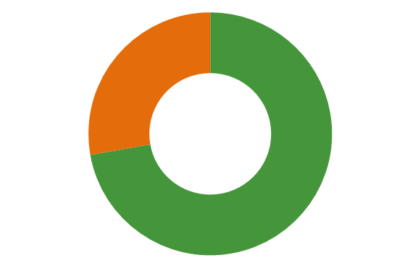
0% not started (in red)
28% in progress (in orange)
72% achieved (in green)

SCP Strategic Objectives | KPI # | Society Key Performance Indicator | Lead Service Unit | Timeframe | Progress
Aboriginal and Torres Strait Islander cultures and other diverse cultures and heritage are recognised & celebrated | SOC 1.1 | Provide community events and work to preserve and celebrate the City’s built and cultural heritage. | Cultural Services | Ongoing | The cultural grant program has been reviewed. Continued promotion of the Museum.  All City’s community events continue to recognize our Aboriginal culture, our multicultural diversity, the richness of our art, as well as our heritage. This included the two day cultural Coogee Live event
 | SOC 1.2 | Continue to capture, preserve and record historical records significant to the district. | Lifelong Learning | Ongoing | The Local History website was launch in February 2019. Local History Officer position approved as a 0.5 FTE ongoing. Awarded a commendation at the 2020 WA Heritage Awards for the Cockburn history website
 | SOC 1.3 | Provide information, events, community development, liaison, and activities which respond to the needs of Aboriginal community groups and families. Review and implement the Reconciliation Action Plan 2017 – 2020. | Family and Community Development | Ongoing | The City’s Reconciliation Action Plan (RAP) is reported on annually to Reconciliation Australia and to Elected Members. Actions are implemented within each appropriate year. A process for review of the current RAP and commencement of development of the next RAP is in place for 2021.  Actions are delivered in response to identified community need and interest, including annual Reconciliation Week, NAIDOC Week and other events. The City’s development of an Aboriginal Cultural and Visitors Centre is well underway and in progress, with continued engagement with the community.
 | SOC 1.4 | Finalise and implement the Community Development Strategy. | Family and Community Development | Ongoing | The review process of the Community Development Strategy 2016-2020 has been completed and the Community Development Strategy 2021 – 2025 has been finalised and commenced implementation.  There has been a change of staff in the Cultural Diversity Officer position and actions under the Cultural Diversity Strategy 2018-2021, continue to be implemented and reviewed.
 | SOC 1.5 | Implement the Culture, Art, Heritage and Event Strategy 2016 - 2020. Consider including a multicultural approach in a future version. | Cultural Services | Ongoing | History website launch February 2019. The Audit and Photography of the City’s artwork continues. Developed a Memorial walk in Cockburn Central. A streamlined approval process for events has been reviewed. Fremantle Biennale being delivered in Cockburn, November 2021.
An attractive, socially connected and diverse built environment | SOC 2.1 | Prepare structure plans, amendments to the Local Planning Scheme, formulate strategies and adopt policies which provide guidance and direction for the growth of the City. | Strategic Planning | Ongoing | Structure plans across various development areas in Cockburn have progressed including the higher growth areas of Hammond Park and Treeby.  Gazetted and implemented an important amendment to the local planning scheme and Local Planning Policy 1.2 known as ‘Better Neighbourhoods’ which seeks to ensure homes delivered in infill situations provide good functional design, aligning homes built with the household types they need to cater for while also protecting local character and values (e.g trees)
 | SOC 2.2 | Finalise a model to report on achievements within each Revitalisation Strategy and ensure clear transition to the operational Business Units of the City to achieve implementation. Ensure sustainability consideration in decision-making. | Strategic Planning | 2019-2020 | A funding model has been developed that enables accurate reporting according to the (current) four different revitalisation strategy areas, and also enables this information to inform the budgeting process. Reporting can provide both the monetary value and number of actions commenced, complete or not started
 | SOC 2.3 | Review and update the Housing Affordability and Diversity Strategy 2013. | Strategic Planning | 2017-2018 | Completed.
 | SOC 2.4 | Ensure the drainage structure throughout the City caters for new development and revitalization. | Subdivisional | Ongoing | Ongoing initiatives implemented through design and implementation stages of development. Coordination of drainage system approvals is done by actively involving City’s Design and Operation teams in the review process.
 | SOC 2.5 | Review and update the Drainage Management and Maintenance Strategy 2008 - 2013 in conjunction with Finance to ensure drainage management principles are agreed across the organization. | Civil Infrastructure | 2017-2018 | Completed. Adopted by Council in July 2018.
High quality and effective community engagement and customer service experiences | SOC 3.1 | Take an agile and flexible approach to support the City in engaging our community, with the aim of driving towards sustainable outcomes through integrated use of social media, smart technology and the internet of things. | Business systems | Ongoing | The City is currently investigating a LoRaWAN network to facilitate smart technology and IoT. This network will be available for public use.
 | SOC 3.2 | Continue to develop external partnerships for Sustainable Service Delivery by facilitating the introduction of the Success Library model of program delivery to Coolbellup and Spearwood libraries. | Lifelong Learning | Ongoing | Curtin University continues to collaborate with the library service running programs at Success Library on Health and Wellbeing.
 | SOC 3.3 | Ensure the Community Engagement Policy and Framework principles and intent are implemented and embraced throughout the Organisation. Ensure reports to Council are supported by community engagement that meets the Policy and Framework requirements. | Communications and marketing | Ongoing | Community engagement staff continue to work, educate and empower staff across the organisation with the provision of  - IAP2 training  - Step by step guide of the engagement process and key considerations  - Engagement plan templates  - Best practice recommendations  - Promotion of Engagement Policy and Framework  - One on one meetings to discuss project needs  Community engagement staff monitor alignment of engagement activities with the Policy and Framework.  The New Project Portfolio Management System has been piloted and will allow engagement to be further integrated with project timeframes, budget and delivery.  The Community Engagement Policy is being reviewed and will be enhanced to align with the City’s maturing approach to engagement. This process will be guided by input from Councillors, key staff and the community.  Additional human resources required to undertake engagement to the level the City wishes.
 | SOC 3.4 | Delivering communication materials and services to ensure the community is engaged with and informed about services and programs. This includes marketing, media, public relations, customer service, graphic design and photography, and social media. | Communications and marketing | Ongoing | Customer satisfaction surveys continue to be undertaken (quarterly to annually) for most business units. The Marina has been added and CoSafe is to follow. The Community scorecard has been undertaken to understand community priorities and perceptions. It has been workshopped with Senior Management to review that actions are in place to manage priorities and perceptions and this has been reported back to the community.
An attractive, socially connected and diverse built environment | SOC 4.1 | Review and update the Local Commercial and Activity Centres Strategy 2011. | Strategic Planning | 2018-2019 | Scheduled for 2021/22 with high level direction provided in the new Local Planning Strategy.
 | SOC 4.2 | Prepare the new Local Planning Strategy and Scheme for the District. | Strategic Planning | 2018-2019 | The City has drafted a new Local Planning Strategy. Preliminary targeted community engagement occurred in late 2018 and 2019/20 has been focused on the document drafting phase . A resolved Local Planning Strategy will then lead the City to prepare a new Town Planning scheme. Currently awaiting WAPC consent to advertise.
 | SOC 4.3 | Regulate development and subdivision within the City to ensure protection of appropriate levels of amenity and protect public interest. | Statutory Planning | Ongoing | Local Planning Policy 1.2 Residential Design Guidelines updated in June 2019 to ensure that development contributes to tree canopy cover and minimisation of the heat Island effect. Furthermore, the City’s Town Planning Scheme No. 3 was amended in February 2021 to include specific provisions to ensure tree retention and provision for grouped dwelling developments.  Local Planning Policies 1.8 - Flagpoles and Camera Poles, 3.7 - Signs and Advertising, 3.6 - Licensed Premises (Liquor), 5.6 - Renewable Energy and 5.18 - Subdivision and Development are being reviewed.
 | SOC 4.4 | Cash In-Lieu Plan provides a coordinated approach to the expenditure of funds for public open space (Planning Development Act) | Environment, Parks and Streetscapes | 2017 - 2019 | Plan is being implemented in accordance with delivery program.

10.4 Economy
A viable economy underpins the sustainable development of the City and must be resilient in the face of uncertainty and risk. The City’s economy is directly integrated with its society and environment.
We consider a circular economy, which values both human and environmental resources, as an enabler of future resilience and sustainability across our community.

Economy Performance
The City identified nine key performance indicators (KPIs) to measure progress towards achieving best practice financial management.
67% of the economy KPI’s were achieved in 2019-2020, with a further 33% significantly progressed.
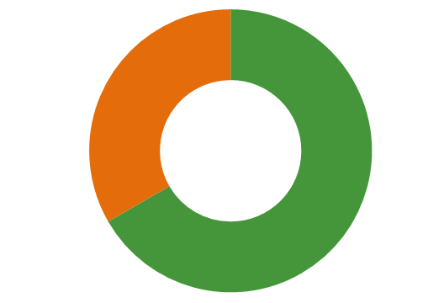
0% not started (in red)
33% in progress (in orange)
67% achieved (in green

SCP Strategic Objectives | KPI # | Economy Key Performance Indicator | Lead Service Unit | Timeframe | Progress
Increased investment, economic growth and local employment | ECO 1.1 | Continue regional collaboration through active participation in the South West Group (SWG) and the National Growth Areas Alliance (NGAA). | Corporate Affairs | Ongoing | The City maintains active membership of the SWG and NGAA and participate on issues where they are closely relevant to the City.  The City has furthered our regional collaboration by also maintaining our membership with Economic Development Australia Growth Areas Perth & Peel, and joining Committee for Perth, Committee for Economic Development of Australia(CEDA).
Increased investment, economic growth and local employment | ECO 1.2 | Collaborate with the South West Metropolitan Librarian’s Group to develop a feasibility study towards a strategic partnership for collaboration and rationalisation for public libraries across local government boundaries. | Branch Libraries | 2017-2018 | Key reform priorities have been progressed. A major milestone was the transfer of state owned library stock to local government. Work on a feasibility study to consider the viability of a statewide library card has been completed and the proposal put on hold indefinitely.
Increased investment, economic growth and local employment | ECO 1.3 | Continue regional collaboration on coastal issues with adjacent Councils, state government agencies and the community via the Cockburn Sound Coastal Alliance. | Coastal Management and Planning | Ongoing | Active participation ongoing in the Local Government Coastal Hazard Risk Management and Adaptation Planning (CHRMAP) Forum meetings and initiatives along with other coastal councils, facilitated through WALGA.
Best practice Governance, partnerships and value for money | ECO 2.1 | Facilitate efficient and cost effective procurement in a centre led procurement model; provide support services in competitive sourcing and contract management. Ensure organisational compliance with statutory and internal procurement requirements. | Procurement Services | Ongoing | Refinement to the 360 eProcurement system has enabled greater efficiencies while maintaining requirements. The creation of templates and online tools has empowered staff to improve outcomes.  The restructure of the Procurement Team has increased the support to stakeholders with a business partner approach to deliver further improvements on the procurement process.  Local and regional expenditure reporting on the percentage of spend to providers has been implemented to increased transparency.
Best practice Governance, partnerships and value for money | ECO 2.2 | Implement Project Portfolio Management Framework to improve internal measurement of business performance. | Project Services | 2018-2019 | The Project Portfolio Management Framework has been successfully implemented into the Governance and Community, and the Engineering and Works Directorates.
Thriving local commercial centres, local businesses and tourism industry | ECO 3.1 | Review and update the Economic Development Directions Strategy 2014. | Strategic Planning | 2018-2019 | Strategy review resulted in creation of an Economic Development Framework (adopted by Council 8 July 2021).
 | ECO 3.2 | Implement the Cockburn Central Activity Centre Plan in conjunction with relevant Business Units. | Strategic Planning | Ongoing | The Cockburn Central Activity Centre Plan and the subsequent Cockburn Central East Structure Plan provides the planning framework to facilitate the Armadale Road and North Lake Road Bridge project (Construction is underway and almost complete).  The action plan also sought to influence the delivery of the Thornlie train line of which is now part of the State Governments commitments to Metronet. City representatives have been included in the Metronet working group  Ongoing liaison between business units for key development proposals to ensure appropriate outcomes are promoted and recommended (acknowledging the City may not always have a decision making role).
 | ECO 3.3 | Provides capacity building and community engagement to strengthen and support community groups within the City including residents associations. | Family and Community Development | Ongoing | Continued funding opportunities and support to residents associations, community groups and not-for-profits  Community training 2020-21  - Event Planning & Budgeting  - Conflict is Complex – Open Space Forum as part of the Leadership workshop series  - Canva training  - Volunteer Management (Online/zoom workshop)  - Grant & Acquittal writing  - Courageous Conversations  Community networking 2020-21  - Eat & Greet event  - Connecting Women in Cockburn  The City’s Community funding program financially supports local groups to host projects, programs and activities for the benefit of the wider community. These include community, cultural, sustainability and environmental education grants, donations and a range of sponsorship opportunities.
Increased investment, economic growth and local employment | ECO 4.1 | Enable social procurement objectives with a focus on supporting indigenous, disability and local enterprises. | Procurement Services | Ongoing | The City’s procurement process encourages the diversification of the supplier database by encouraging opportunities for individuals and businesses. Probity reviews are now conducted on Purchase Orders to increase awareness and educate others to the benefits of social procurement.

