Tender Title: |  | RFT 11/2026 – SOLAR PV & BESS SUPPLY & INSTALLATION
Request ID: |  | 79318
Tender Description: |  | The purpose of this contract is to procure a complete, end-to-end solution that delivers fully operational, grid-connected solar PV and BESS installations. The contractor is required to design, engineer, supply, install, commission and provide training for all systems specified in the Scope of Works & Technical Specification, as well as deliver performance guarantees and first-year maintenance.  The required outcome is the delivery of reliable, safe, and high-performing renewable-energy systems that meet the City’s technical, operational and sustainability objectives within the agreed timeframe.
Advert Approval: |  | Decision to Advertise: Director Infrastructure Services  Decision Date: Friday, 8 May 2026
Closing Date and Time: |  | 2:00PM (AWST) Tuesday, 7 July 2026
Opening Date and Time: |  | 2:00PM (AWST) Tuesday, 7 July 2026
 | Tenderer’s Name:
1 | RJ & HR Pty Ltd t/as Solar 365
2 | Magellan Powertronics Pty Ltd t/as Magellan Power

Advertisement
Method 1: City of Cockburn website | Method 2: City of Cockburn Libraries Public Noticeboards
Method 3: The Western Australian,  Wednesday, 13 May 2026  Page #: 42 | Tender Awarded by: Anton Lees  Director Infrastructure Services
Copy of Statewide Notice:  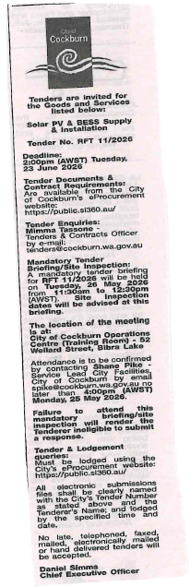 | Director Infrastructure Services
 | Date of Council Meeting:
Not Applicable
Date:
Minutes:
Item No:
Name of Successful Tenderer(s): | Magellan Powertronics Pty Ltd t/as Magellan Power
Amount of Successful Tender(s): | $ 245,754.00 (Ex GST)

