Policy Type

Local Planning Policy

Policy Purpose

The City is required to make recommendations to the Western Australian Planning Commission (WAPC) regarding applications to subdivide land within the industrial zones of Town Planning Scheme No. 3 (TPS 3). However, TPS 3 contains no standards or guidance on industrial subdivision. This policy provides relevant criteria and standards as the basis for consistent responses to the WAPC.
The purpose of this policy is to provide guidelines for Council recommendations for industrial subdivision applications with regard to minimum lot area and dimensions, fencing and access. The policy is not applicable to build strata proposals where development has already occurred on the land.

Policy Statement

- Where reticulated sewerage is available, the minimum recommended lot size is 1000m², with a minimum frontage width of 25m.

1. NB: Requirements for the provision of deep sewer are determined by the WAPC on advice from the Water Corporation and Department of Health.
(2) Where proposed lots have frontage to a road from which there is no access restriction, reciprocal or shared access points may be recommended. This form of access will generally be required for roads designated in Council’s Functional Road Hierarchy (date) as District Distributor B -District Distributor A, Primary Distributor or Regional Distributor (refer to attachment A).
(3) Where an industrial subdivision is adjacent to a residential zone, an adequate separation distance should be provided within the industrial land. Permanent buffer strips should retain all existing vegetation or alternatively, be planted with fast growing species to provide adequate screening. Where the buffer is required for public usage, the land should be ceded free of cost for public open space. Where the land is required for buffer purposes alone, an alternative method such as a Certificate of Title restriction may be required as a subdivision condition for the purpose of protecting the buffer.
(4) The Subdivider will be required to construct uniform fencing of a type deemed appropriate by the City as part of the subdivision where proposed lots back onto a road reserve or public open space reserve.

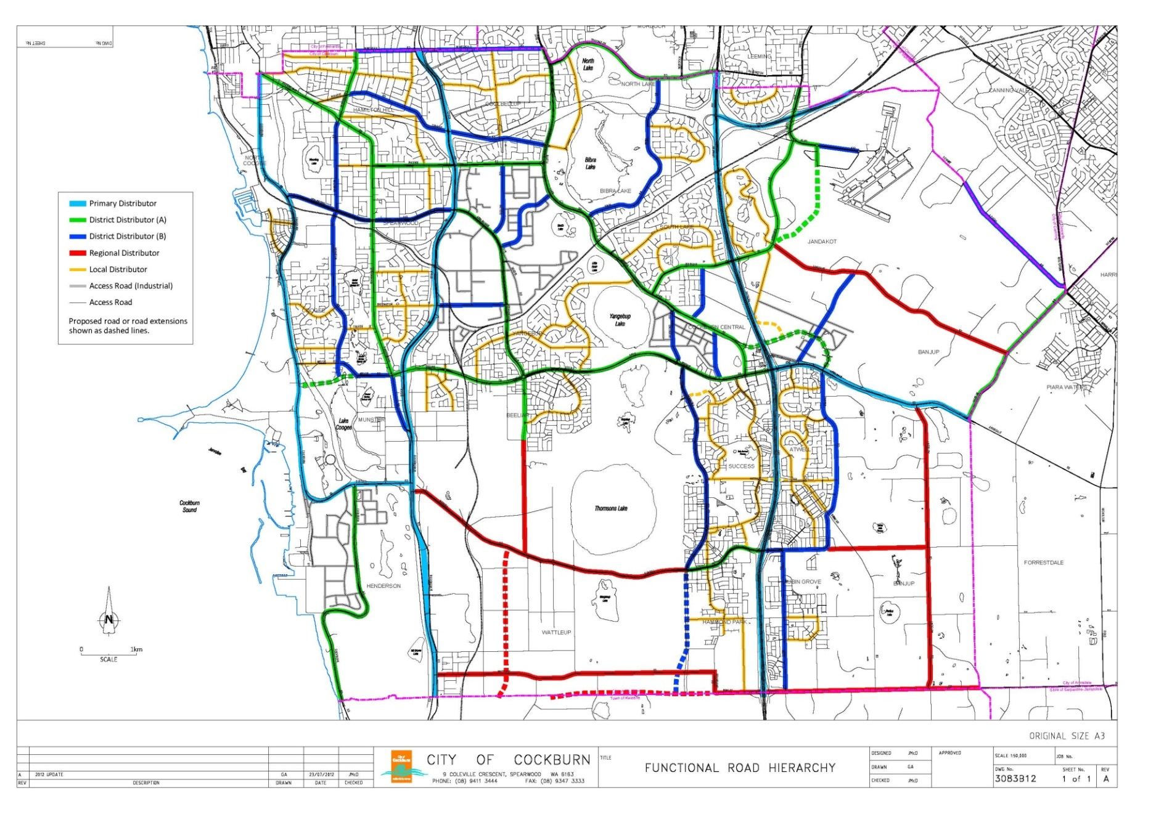

Strategic Link: | Town Planning Scheme No. 3
Category | Planning - Town Planning & Development
Lead Business Unit: | Statutory Planning
Public Consultation:  (Yes or No) | Yes
Adoption Date:  (Governance Purpose Only) | 10 November 2022
Next Review Due:  (Governance Purpose Only) | November 2024
ECM Doc Set ID:  (Governance Purpose Only) | 4513812

