Tender Title: |  | RFT 27-2020  Construction Services - Frankland Park Sports & Community Facility
Request ID: |  | 36830
Tender Description: |  | For the construction of Frankland Park multipurpose sporting and community facility at Frankland Avenue, Hammond Park.
Advert Approval: |  | Decision to Advertise: Director of Govenernance & Community Services  Decision Date: Monday, 12 October 2020
Closing Date and Time: |  | 2:00pm (AWST) Thursday, 12 November 2020
Opening Date and Time: |  | 2:00pm (AWST) Thursday, 12 November 2020
 | Tenderer’s Name:
1 | ST HILLERS PROPERTY PTY LIMITED t/a ST HILLIERS
2 | PINDAN CONSTRUCTIONS PTY LTD t/a PINDAN CONSTRUCTIONS PTY LTD
3 | DEVLYN AUSTRALIA PTY LTD t/a Devlyn Construction
4 | BE Projects (WA) Pty Ltd t/a BE Projects (BE Projects)
5 | CROTHERS PTY LTD t/a Crothers Pty Ltd
6 | SHELFORD CONSTRUCTIONS PTY LTD t/a SHELFORD CONSTRUCTIONS PTY LTD
7

Advertisement
Method 1 : City of Cockburn | Method 2 : NA
Method 3 :  The West Australian | Tender Awarded by:
Copy of Statewide Notice:  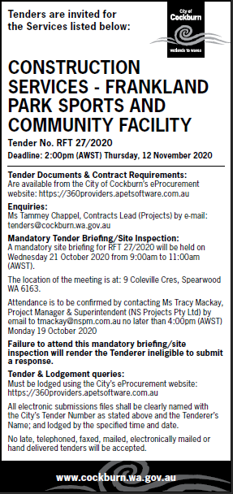 | OCM  Choose an item.  Thursday, 10 December 2020
 | Date of Council Meeting:
Thursday, 10 December 2020
Minutes: 0261
Item No: 17.1
Name of Successful Tenderer(s): | Shelford Constructions Pty Ltd
Amount of Successful Tender(s): (ex GST) | $8,577,860

