CITY OF COCKBURN

SUMMARY OF MINUTES OF SPECIAL COUNCIL MEETING HELD ON THURSDAY, 3 DECEMBER 2015 AT 6:00 PM

Page

1. DECLARATION OF MEETING 1
2. APPOINTMENT OF PRESIDING MEMBER (If required) 1
3. DISCLAIMER (To be read aloud by Presiding Member) 1
4. ACKNOWLEDGEMENT OF RECEIPT OF WRITTEN DECLARATIONS OF FINANCIAL INTERESTS AND CONFLICT OF INTEREST (by Presiding Member) 2
5 (SCM 03/12/2015) - APOLOGIES & LEAVE OF ABSENCE 2
6 (SCM 03/12/2015) - PUBLIC QUESTION TIME 2
7. DECLARATION BY COUNCILLORS WHO HAVE NOT GIVEN DUE CONSIDERATION TO MATTERS CONTAINED IN THE BUSINESS 4
8 (SCM 03/12/2015) - PURPOSE OF MEETING 4
9. COUNCIL MATTERS 4
9.1 (MINUTE NO 5679) (SCM 03/12/2015) - RESPONSE TO DRAFT WESTERN TRADE COAST PROTECTION AREA LEGISLATION - LOCATION: LAND WITHIN THE CITY OF COCKBURN INCLUDING LATITUDE 32, THE MUNSTER URBAN DEFERRED AREA, PART OF THE WATTLEUP RURAL AREA AND PART OF THE WATTLEUP FUTURE URBAN AREA - OWNERS: VARIOUS, APPLICANT: DEPARTMENT OF STATE DEVELOPMENT (111/006) (A TROSIC) 4
10. (MINUTE NO 5680) (SCM 03/12/2015) - RESOLUTION OF COMPLIANCE (SECTION 3.18(3), LOCAL GOVERNMENT ACT 1995) 25
11. CLOSURE OF MEETING 25

CITY OF COCKBURN

MINUTES OF SPECIAL COUNCIL MEETING HELD ON THURSDAY, 3 DECEMBER 2015 AT 6:00 PM

PRESENT:

ELECTED MEMBERS

Mr L Howlett - Mayor (Presiding Member)
Mrs C Reeve-Fowkes - Deputy Mayor
Mr K Allen - Councillor
Ms L Wetton - Councillor
Dr C Terblanche - Councillor
Mr S Portelli - Councillor
Ms L Smith - Councillor
Mr S Pratt - Councillor
Mr P Eva - Councillor

IN ATTENDANCE

Mr S. Cain - Chief Executive Officer
Mr D. Green - Director, Governance & Community Services
Mr S. Downing - Director, Finance & Corporate Services
Mr C. Sullivan - Director, Engineering & Works
Mr A. Trosic - Acting Director, Planning & Development
Ms S Seymour-Eyles - Manager, Corporate Communications
Ms M. Waerea - PA to the CEO

1. DECLARATION OF MEETING
The Presiding Member declared the meeting open at 6.00pm and welcomed all those in attendance.

2. APPOINTMENT OF PRESIDING MEMBER (If required)
N/A

3. DISCLAIMER (To be read aloud by Presiding Member)
Members of the public, who attend Council Meetings, should not act immediately on anything they hear at the Meetings, without first seeking clarification of Council's position. Persons are advised to wait for written advice from the Council prior to taking action on any matter that they may have before Council.

4. ACKNOWLEDGEMENT OF RECEIPT OF WRITTEN DECLARATIONS OF FINANCIAL INTERESTS AND CONFLICT OF INTEREST (by Presiding Member)
Nil

5 (SCM 03/12/2015) - APOLOGIES & LEAVE OF ABSENCE
Clr Bart Houwen - Apology

6 (SCM 03/12/2015) - PUBLIC QUESTION TIME
ITEMS NOT IN WRITING, ON THE AGENDA

Ms Matthews, Britannia Ave, Beeliar

Item9.1 – Response to Draft Western Trade Coast Protection Area Legislation.

Q1. Can you please clarify in very simple terms, the objection on the grounds of page number 2, recommendation (1) point number 6 “The draft legislation provides inadequate explanation as to the rights of landowners going forward”. If you could please clarify this?

A1. This added into the report following the community briefing held on 23 November. It was a concern that a number of people on the night raised that there was no clarity given about the rights of landowners in respect of if their land was included within this so called protection area. Does that trigger a right to seek compensation or are there no rights associated with that? We believe for the landowners to be fully informed of implications of this type of legislation that that issue should’ve been specifically discussed because it is reasonable to suggest that that would’ve been a very reasonable question that most landowners would’ve been asking. The fast that there is nothing written in that leaves a degree of dissatisfaction with the process.

Q2. If I may elaborate on that. On page 5 of the repost, the draft legislation says “prohibit classes of sensitive land use in the Protection Area, such as residential housing, short-stay accommodation, schools, hospitals and child care centres”. It also says “notwithstanding that:

- Sensitive development may already occur and/or;
- Sensitive development may be what the prevailing State level strategic planning has advocated for.”

Recently landowners have been unable to subdivide and build a second house on the property. When will the Council know that this draft legislation can take place?

A2. The draft legislation was released for advertising to the City’s complete surprise in late October this year. We have only know for a a little over a month and have been with great urgency, preparing letters to landowners and organising community briefings and this Special Council Meeting tonight. Remembering it is not the City of Cockburn’s proposal, we expected the State Government to be doing all this and more, but they really haven’t been focused on the engagement consultation process. My reading of the legislation is that there is a perception that any existing development can lawfully continue. So if you have an existing home or second home, no new sensitive development such as schools and hospitals etc will be permitted including extensions.

Q3. Ms Matthews referred to a letter she had received from a community group.

A3. It is not a letter from the City of Cockburn we are unable to comment on the content of the letter.

The City of Cockburn is in charge for the planning of the community. Planning for this locality is currently zoned for ‘Rural Living’. There may be considerations into the future at State Government level if the legislation is enacted. We have been on record several times now saying we don’t support industrial development throughout the Britannia Ave community and also Munster, Wattleup and other rural areas.
Mr McFadyen, Britannia Ave, Beeliar

Item9.1 – Response to Draft Western Trade Coast Protection Area Legislation.

Q1. I would like to thank Andrew Trosic for the support to the community and information provided over the last few weeks. What are Council’s intentions and the timeframe that you think this will happen?

A1. There is a recommendation before Council put forward by the City’s administration. The Presiding Member will be proposing an amendment to this. Essentially Council is working towards supporting the community as much as possible. The current recommendation talks about arranging to meet with the Department of State Development and several Ministers and the alternative will just add a bit more urgency to that.

7. DECLARATION BY COUNCILLORS WHO HAVE NOT GIVEN DUE CONSIDERATION TO MATTERS CONTAINED IN THE BUSINESS
Nil

8 (SCM 03/12/2015) - PURPOSE OF MEETING
The purpose of the meeting is to consider the City’s formal response to the draft Planning and Development Legislation Amendment (Western Trade Coast Protection Area) Bill 2015.

9. COUNCIL MATTERS
9.1 (MINUTE NO 5679) (SCM 03/12/2015) - RESPONSE TO DRAFT WESTERN TRADE COAST PROTECTION AREA LEGISLATION - LOCATION: LAND WITHIN THE CITY OF COCKBURN INCLUDING LATITUDE 32, THE MUNSTER URBAN DEFERRED AREA, PART OF THE WATTLEUP RURAL AREA AND PART OF THE WATTLEUP FUTURE URBAN AREA - OWNERS: VARIOUS, APPLICANT: DEPARTMENT OF STATE DEVELOPMENT (111/006) (A TROSIC)
RECOMMENDATION
That Council:

(1) object to the Draft Western Trade Coast Protection Area Legislation for the following reasons:

- The draft legislation is being based upon a report and process carried out by the Western Australian Planning Commission in 2010 which has not, inter alia, been subject to consultation with affected landowners. The report has also not been made publicly available, including its technical studies relied upon, preventing the ability for community engagement and scrutiny of such an important document in the process of arriving at the draft legislation;
- The draft legislation proposes a buffer that, to the City’s knowledge, has not been subject to third party independent scientific peer review in which to be able to gauge the degree of scientific/technical rigor;
- The draft legislation contains no evidence to demonstrate that certain land areas within the City of Cockburn are not suitable for sensitive development. That is, the lack of scientific evidence such as through a buffer definition study which is scientifically robust and subject to an open/transparent public process;
- The draft legislation is inconsistent with the prevailing State level strategic planning, which should be expected to inform the statutory planning framework;
- The mapping associated with the draft legislation is not discernible enough in terms of the specific land impacted;
- The draft legislation provides inadequate explanation as to the rights of landowners going forward.

(2) recommend to the State Government that specific to the Munster land adjoining the eastern foreshore of Lake Coogee, an alternative scenario be provided which enables a sustainable form of residential development to occur which builds an environmental buffer to Lake Coogee while providing an acceptable mechanism in which to limit the proximity of development directly to the edge of Lake Coogee. This recognises an appropriate precautionary based principle to have a setback of between 50-100m from the edge of the Lake, shaped by existing development;

(3) recommend that the State Government exclude the entirety of the Wattleup residential precinct from the Protection Area, on the basis that:

- The Protection Area is inconsistent with the extensive State level strategic planning that has taken place for residential development in this area;
- There has been no buffer definition study to support the claims that this subject land ought to be within the Protection Area;
- The resulting thin sliver of land between the future Rowley Road and existing Wattleup Road could not effectively accommodate industrial or commercial (non-sensitive) development;

(4) recommend that the State Government exclude the entirety of the rural interface between the future Latitude 32 industrial area and the central wetlands system, on the basis that:

- Strategic planning to deliver Latitude 32 has been underpinned by the objective which assures impacts do not extend beyond the boundary of Latitude 32;
- Protecting and building resilience for the sensitive environmental wetlands will be achieved through the securing of an ongoing transitional land use of rural development, including single houses on such rural land. The draft legislation will prevent this, by designating the precinct as unsuitable for sensitive development and therefore creating difficulties for rural land use and amenity to be maintained in to the future;

(5) recommend to the State Government that in respect of the Rural Living zoned land north of Cockburn Cement either:

- The impacts associated with Cockburn Cement be reduced to its property boundary, enabling contemplation of further sensitive (residential) development or;
- The area be retained for Rural Living; and

(6) seek the Department of State Development, the Minister for Planning and the Minister for Water to meet with the Council in order to discuss its concerns regarding the Draft Legislation.

COUNCIL DECISION
MOVED Mayor L Howlett SECONDED Clr S Portelli that Council:

(1) - (5) As recommended;

Modify the wording of Part (6) to now read as:

(6) seek, as a matter of urgency, the Minister for Planning, the Minister for Water and the Department of State Development to meet with the Council in order to discuss its concerns regarding the Draft Legislation.

Include a new Part (7) as follows:

(7) requests the State Government to release the 2010 report of the Western Australian Planning Commission, including all technical supporting information, to enable the community and appropriate third party peer reviewers to review the report and provide feedback as to how the State Government should embark on a new process, modelled upon a buffer definition study as provided under State Planning Policy 4.1.

CARRIED 9/0

Reason for Decision

It needs to be a matter of urgency that the State Government Politicians, who are proposing the draft legislation, be invited to meet with Council in order to address the many concerns both Council and the broader community have in respect of the draft legislation.

It is also appropriate that the State Government release the 2010 report of the Western Australian Planning Commission, including all technical supporting information, to enable the community and appropriate third party peer reviewers to review the report and provide feedback as to how the State Government should embark on a new process, modelled upon a buffer definition study as provided under State Planning Policy 4.1.

Background

The City of Cockburn has received advice from the Department of State Development regarding its proposed legislation for the Western Trade Coast Protection Area. The purpose of this draft legislation is (according to the Department) to:

“formalise the boundary of the Western Trade Coast Protection Area and restrict new sensitive land uses within this area.”

The City of Cockburn, together with the City of Rockingham and City of Kwinana, will be significantly impacted by this draft legislation. The draft legislation comprises two key elements:

1. Amendments to the Hope Valley Wattleup Act 2000 and the Planning and Development Act 2005 to formalise the existing buffer as the Western Trade Coast Protection Area; and
2. Regulations to set out classes of land use that will be prohibited within the Western Trade Coast Protection Area.

The City of Cockburn has continually advocated over many years changes to areas which the State Government suggests as being within a buffer. The City’s position is in its opinion supported by the available science and decision making that has occurred by the State Government, particularly within its planning, environmental and health areas. The changes advocated by the City have also concerned parts of the City whereby the prevailing State Government strategic planning has indicated a preferred land use outcome (residential) which will now be prevented by the imposition of a buffer. Whereas prevailing strategic planning particularly at regional levels undertaken by the State Government is expected to inform statutory (law) changes, this does not appear to be the case in respect of the Western Trade Coast Protection Area.

It is important that in considering this draft legislation, the City of Cockburn make its position clear as the draft legislation appears final in nature. That is, it seeks to affect an outcome that will:
“prohibit classes of sensitive land use in the Protection Area, such as residential housing, short-stay accommodation, schools, hospitals and child care centres.”

It will effectively implement a statutory framework that will prevent sensitive development taking place, notwithstanding that:

- Sensitive development may already occur and/or;
- Sensitive development may be what the prevailing State level strategic planning has advocated for.

This draft legislation therefore presents a number of significant impacts on the City and its community.

As will be explained within the report, it is recommended that the City object to the draft legislation, on the basis that:

- The draft legislation is being based upon a report and process carried out by the Western Australian Planning Commission in 2010 which has not, inter alia, been subject to consultation with affected landowners. The report has also not been made publicly available, including its technical studies relied upon, preventing the ability for community engagement and scrutiny of such an important document in the process of arriving at the draft legislation;
- The draft legislation proposes a buffer that, to the City’s knowledge, has not been subject to third party independent scientific peer review in which to be able to gauge the degree of scientific/technical rigor;
- The draft legislation contains no evidence to demonstrate that certain land areas within the City of Cockburn are not suitable for sensitive development. That is, the lack of scientific evidence such as through a buffer definition study which is scientifically robust and subject to an open/transparent public process;
- The draft legislation is inconsistent with the prevailing State level strategic planning, which should be expected to inform the statutory planning framework;
- The mapping associated with the draft legislation is not discernible enough in terms of the specific land impacted;
- The draft legislation provides inadequate explanation as to the rights of landowners going forward.

Submission

Nil.

Report

The City of Cockburn has maintained a significant degree of involvement in the consideration of issues associated with buffers affecting its City. This draft legislation, known as the Western Trade Coast Protection Area, will have a significant impact on parts of the community. This impact will be both on community members who own land within the area designated as the Western Trade Coast Protection Area, as well as community members who own land adjoining/nearby the Protection Area.

The draft legislation is presented by the State Government in the following light:

“The Western Trade Coast Protection Area encompasses the industrial area known as the Western Trade Coast (WTC), which includes the Kwinana Industrial Area, Rockingham Industry Zone, Latitude 32 Industry Area and the Australian Marine Complex, as well as a buffer of surrounding land which separates industry from residential areas.

There is no proposal to extend the Protection Area beyond the existing buffer, only to define the current buffer in legislation.

The WTC Protection Area will provide necessary clarification and long term certainty for land use planning within its boundaries for both industry and land-owners.

The Protection Area follows the line of the Kwinana Industrial (including Air Quality) Buffer which was endorsed by the Western Australian Planning Commission in September 2010. This buffer evolved from work done by the Environmental Protection Authority in the early 1990s studying air quality in and around the Kwinana Industrial Area. The Western Australian Planning Commission reviewed the boundary over eight years, with input from government agencies, industry and the public prior to endorsement.”

The City has a number of areas of concern in respect of the draft legislation. These namely focus upon:

- Reliance on the report and process carried out by the Western Australian Planning Commission in 2010;
- The lack of evidence to demonstrate that certain land areas within the City of Cockburn are not suitable for sensitive development, despite these forms of development already occurring and being permitted to continue as non-conforming uses;
- Inconsistency with the prevailing State level strategic planning.

Reliance on the report and process carried out by the Western Australian Planning Commission in 2010

The fact sheet which accompanies the draft legislation provides the basis to which it has been formulated. Specifically under the section titled “How was the WTC Protection Area boundary determined” the document reveals that the draft legislation follows the line of the Kwinana Industrial (including Air Quality) Buffer. This line was endorsed by the Western Australian Planning Commission in September 2010.

This is a point of concern to the City and its community. By way of background, Petition 136 was tabled to the State Parliament on 27 September 2011, and contained 434 signatories. The petition provided as follows:

“We the undersigned residents of Western Australia are opposed to the extension of the Kwinana Industry Area Buffer Zone in the Mandogalup are to 1500m from the Alcoa Slurry ponds.

The extension of the buffer zone:
• Represents a health risk to the population in the area;
• Has been developed without consultation with the community and is almost exclusively developed to meet industry needs;
• Is in conflict with the area previously identified for future urban development and other land uses;
• Significantly reducing the value of the properties in the area; and
• Has denied the residents and business operators in the area with any natural justice, due process, recourse, or appeal.

Your petitioners therefore respectfully request the Legislative Council to call on the Government to consult with residents before a final decision is made on the buffer zone, provide a full copy of all reports, evidence, and a full list of reasons to support the decision to extend the buffer zone, and in the even the buffer is extended to the 1500 metre point, to fully compensate residents for loss of the full market value of the properties and local businesses and quiet enjoyment of the area before the buffer extension was proposed.”

This was a significant point of community action, and followed on from reports that had been presented to Council discussing similar concerns about the process which the State Government had embarked upon to, inter alia, extend the buffer without following a public process.

As a result of Petition 136, it was referred to the Standing Committee of Environment and Public Affairs of the Legislative Council, for inquiry and reporting on.

The reporting of the Standing Committee has raised concerns of the September 2010 process embarked upon by the WAPC. Extracts from the full report include the following findings:

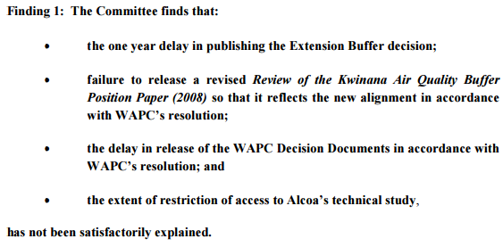

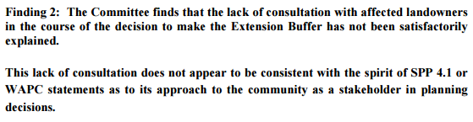

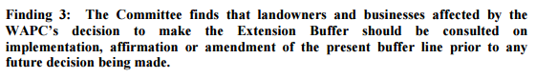

These findings made by the State Government Parliamentary Committee question the process that the WAPC embarked upon in arriving at the decision to endorse the 2010 version of the Kwinana Industrial (including Air Quality) Buffer. The draft legislation appears completely reliant upon the 2010 decision making process of the WAPC, stating that “The Protection Area follows the line of the Kwinana Industrial (including Air Quality) Buffer which was endorsed by the Western Australian Planning Commission in September 2010.” The City therefore questions whether legislation of this significance should be based upon a process which, according to the State Government Parliamentary Committee, did not appear to be “consistent with the spirit of SPP4.1 or WAPC statements as to its approach to the community as a stakeholder in planning decisions.” The lack of satisfactory explanation of areas of concern as expressed in Findings 1 and 2 of the State Government Parliamentary Inquiry is also of concern.

In the absence of adequate explanation of the findings made in the Parliamentary Inquiry, the City is of the view that the draft legislation cannot proceed. This appears to be consistent in respect of the recommendations made by the Committee, which were:

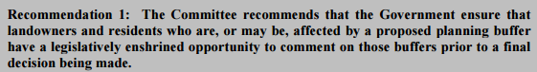
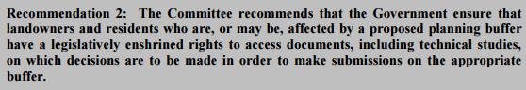
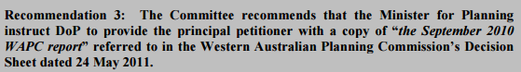
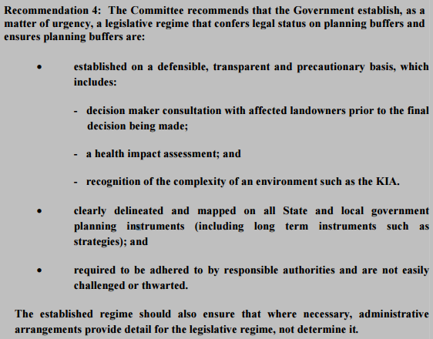
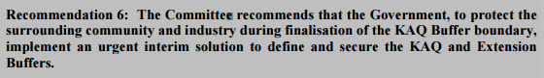

The process of this draft legislation appears to be generally inconsistent with these recommendations. While the draft legislation is being presented to the community for comment prior to formal introduction to Parliament (Recommendation 1), this is being done in a very limited way. The absence for example of a simple letter to all impacted and nearby landowners has not occurred, raising the real prospect that many impacted and nearby landowners remain unaware of the draft legislation. There is also an absence of detailed information which explains the technical basis of the buffer (Recommendation 2). The draft legislation also does not appear to contain any legislatively enshrined rights for landowners/residents to access documents, including technical studies, on which decisions are to be made in order to be able to make informed submissions on a buffer proposal.

At the very least the 2010 WAPC report including all technical studies it relied upon should have been made available as part of the suite of documents available for public consultation. Indeed the State Government Parliamentary Inquiry made its top two recommendations about:

- All landowners/residents having a legislatively enshrined opportunity to comment on buffers prior to a final decision being made;
- All landowners/residents having a legislatively enshrined right to access documents, including technical studies, on which decisions are to be made in order to make submissions on the buffer.

The absence of these administrative arrangements being secured by the draft legislation, and rather the draft legislation imposing a buffer without exposure of technical studies, means that the draft legislation does not reflect the expectations set of it through the State Government Parliamentary Inquiry. Nor does it reflect the expectations the community has of government processes to be open and transparent.

In specific terms, the exclusion of the 2010 WAPC report document and the associated technical studies relied upon does not fulfil the expectation that the Parliamentary Committee had of the State Government process. Also in respect of Recommendation 4, there is a clear expectation that a legal status for the buffer be established on a defensible and transparent manner. The recommendation also goes on to emphasise the importance of health impact assessment and recognition of the complexity of an environment such as the Kwinana Industrial Area. The draft legislation appears to be based upon a buffer that has not been established in either a defensible or transparent manner, and in the absence of public disclosure of full technical studies that have benefited from independent peer review, means that the buffer is unclear as to the extent of any scientifically robust health impact or environmental impact assessment.

If the above had of been done, the community which includes affected landowners would have been given a far greater opportunity to provide an informed response on the draft legislation.

The lack of evidence to demonstrate that certain land areas within the City of Cockburn are not suitable for sensitive development

The second key area of concern for the City is the way in which the draft legislation affects certain land precincts in a manner which is inconsistent with the levels of strategic planning undertaken by State and Local Government for development outcomes to occur. These are explained following:

Munster land adjoining Lake Coogee

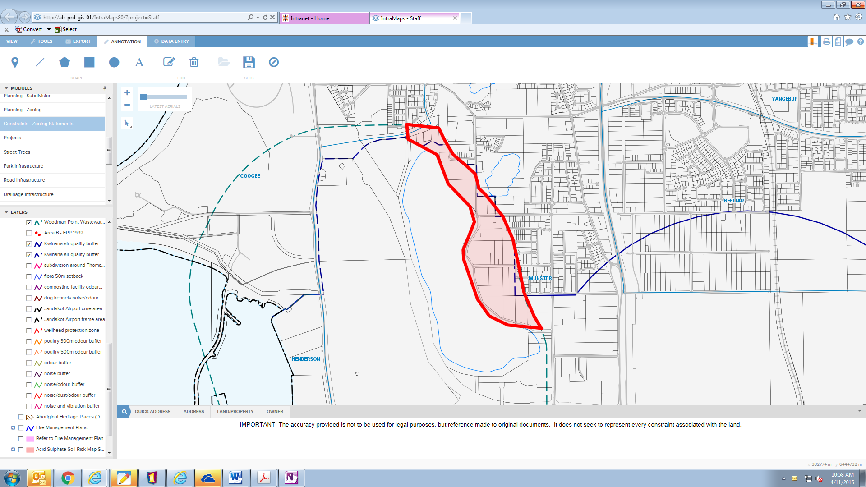

Firstly, the mapping associated with the draft legislation is unclear. Accordingly, officers have drawn a high level map which approximately follows the boundary shown in the draft legislation.

Council will recall the number of reports that have been considered on the issue of the Munster land adjoining the eastern foreshore of Lake Coogee, and its influence from the Woodman Point Waste Water Treatment Plant. Council and the community have been consistent in its long held position regarding this land precinct, in that it has continually advocated for capital improvements to the WPWWTP, in order to reduce its odour impacts to the eastern foreshore of Lake Coogee. The City understands that the significant capital investment that has taken place over the last decade has addressed odour impacts significantly, and this is expected given the millions of dollars of tax payer money that has been spent to deal with the odour issue. To put the investment in perspective:

- In 2002, a $150 million upgrade to the plant to increase its capacity to 160 million litres per day;
- In 2011, a $137 million upgrade to increase solids treatment capacity to 177 million litres per day, and decrease the plant’s odour emission levels by 50 per cent;
- Planned for 2018, a $20 million reuse and grit removal upgrade;
- From 2020, a further $550 million upgrade to primary, secondary and support processes to provide for 220 million litres per day.

Notwithstanding the $290 million spent to date in capital investment improvement, the position of the State Government is such that odour impacts are still occurring, and may be likely to continue to occur into the future. This position is now being made effectively final by the draft legislation, by placing the Munster land adjoining Lake Coogee within the area affected by the draft legislation.

This position is a concern, especially in light of the policy framework that depicts how buffers should be determined. Specifically, State Planning Policy 4.1 (State Industrial Buffer Policy) provides the following relevant objective:

(1) To provide a consistent Statewide approach for the definition and securing of buffer areas around industry, infrastructure and some special uses;

This consistent Statewide approach is provided by the Policy as follows:

“The identification of an off-site buffer area requires the application of both environmental criteria and planning criteria to determine the actual size and boundaries of the buffer area. This will require the boundaries of buffer areas to meet the requirements of the Environmental Protection Authority, the Western Australian Planning Commission and the Department of Minerals and Energy.

Where an industry or authority responsible (developer) for the operation of an established facility and the Western Australian Planning Commission consider that either existing or potential land use in the vicinity has the potential to compromise the operation of that facility, the developer shall undertake a buffer definition study to define the extent of the buffer area required to secure the facility. Such a study will identify the likely emissions, hazard and risk, noise or lighting and model the development to show the extent of these outside the development site. The study should also show how amelioration could occur, and if this is not possible, the buffer distances required to enable the use to be developed. The incompatible uses that need to be avoided in the buffer area would also be identified.

The Western Australian Planning Commission shall evaluate the buffer definition study recommendations when considering land use decisions that may need to be made in the relevant area.”

A principal concern for the City and its community is that the position of the State Government, in respect of the WPWWTP, is not supported by any Buffer Definition Study that the City or community are aware of. This therefore makes the draft legislation seemingly inconsistent with the policy objective of the State Government to “provide a consistent Statewide approach for the definition and securing of buffer areas around industry, infrastructure and some special uses.”

Council should be concerned by this on a number of levels:

- Firstly, the Council and community’s position is that public and political advocacy has resulted in significant upgrades to the WPWWTP ($290 million in the last 15 years). The likelihood of this succeeding in the future may be diminished if the land impacted by odours is now designated as within the Western Trade Coast Protection Area, with the prohibition on new forms of sensitive development. This action may reduce the potential to continue to improve the WPWWTP by way of new technology, especially as the processing volume of the plant continues to increase in response to population and economic growth. This is significant given the planned expansion for the plant foreshadowed to begin from 2020;
- Secondly, it has been explained to Council by Water Corporation that waste flows in to the plant are far more concentrated now (greater density of solids), as a result of the water saving initiatives that have seen the likes of reduced potable water usage in toilets, laundries, kitchens, fixtures etc. There needs to be continued investment in the plant, and this investment ought to have been focused on bringing the buffer impacts back to the eastern foreshore of Lake Coogee, rather than the current 750m line;
- Thirdly, as mentioned above, the absence of a formal Buffer Definition Study undertaken by the Water Corporation means that the City and the community cannot be assured that the ‘Protection Area’ proposed in the draft legislation actually relates to a scientifically robust and transparent position. This is an expectation made in Recommendation 4 of the State Parliamentary Committee Inquiry in to the buffer, stating that a legal status for the buffer needs to be established on a defensible and transparent manner. The recommendation goes on to emphasise the importance of health impact assessment and recognition of the complexity of an environment such as the Kwinana Industrial Area. In the absence of this, the draft legislation appears based upon a buffer area that has not been established in either a defensible or transparent manner, and in the absence of public disclosure of the 2010 WAPC report is unknown as to whether it features any scientifically robust health impact or environmental impact assessment.

The prohibition of sensitive development is also layered against a recent WAPC document which indicated the area as subject for Industrial Investigation (Draft Perth and Peel at 3.5million strategic plan). This is an unsatisfactory outcome for the community, and from a planning viewpoint there are many issues that compound to show just how unsuitable/unrealistic this land would be for industrial development. This includes its lack of access, its direct interface with residential development and its location adjoining a very important conservation category wetland. There is no planning logic to be contemplating industrial development in this thin sliver of an area.

In considering this issue again as part of the draft legislation, a Key Principle espoused by the Draft Perth and Peel at 3.5million strategic plan is to “Avoid, protect and mitigate environmental attributes (with the emphasis on avoiding and protecting) when allocating proposed land uses”. It does not seem consistent with the above principles to indicate this land within Munster for ‘Industrial Investigation,’ and therefore within the draft legislation Protection Area. The Protection Area is therefore unsuitable for this area.

The planning objective to protect the sensitive environmental wetland of Lake Coogee is considered to be directly threatened by placing the land within the Protection Area, given the inference that Industrial Development may result as per the WAPC’s Draft Perth and Peel at 3.5million strategic plan. Should we want significant environmental features of our city to not only be protected but to become more resilient in the face of climate change and reduced rainfall, it is important that this issue be carefully considered and further inform the draft legislation.

The City objects to the land in Munster being impacted by the draft legislation, on the basis of the shortcomings that have been revealed above. In offering a solution to the State Government, the City believes that a sustainable form of residential development which builds a real environment buffer to Lake Coogee also provides an acceptable mechanism in which to limit the proximity of development to the edge of Lake Coogee. Discussion with the Water Corporation has previously talked about a reality that impacts do not stop at a line on a map. This explains the need to take a precautionary approach, balanced against scientific rigor and transparency, in arriving at a line on a map. The City believes its suggestion achieves this.

Sustainable urbanism

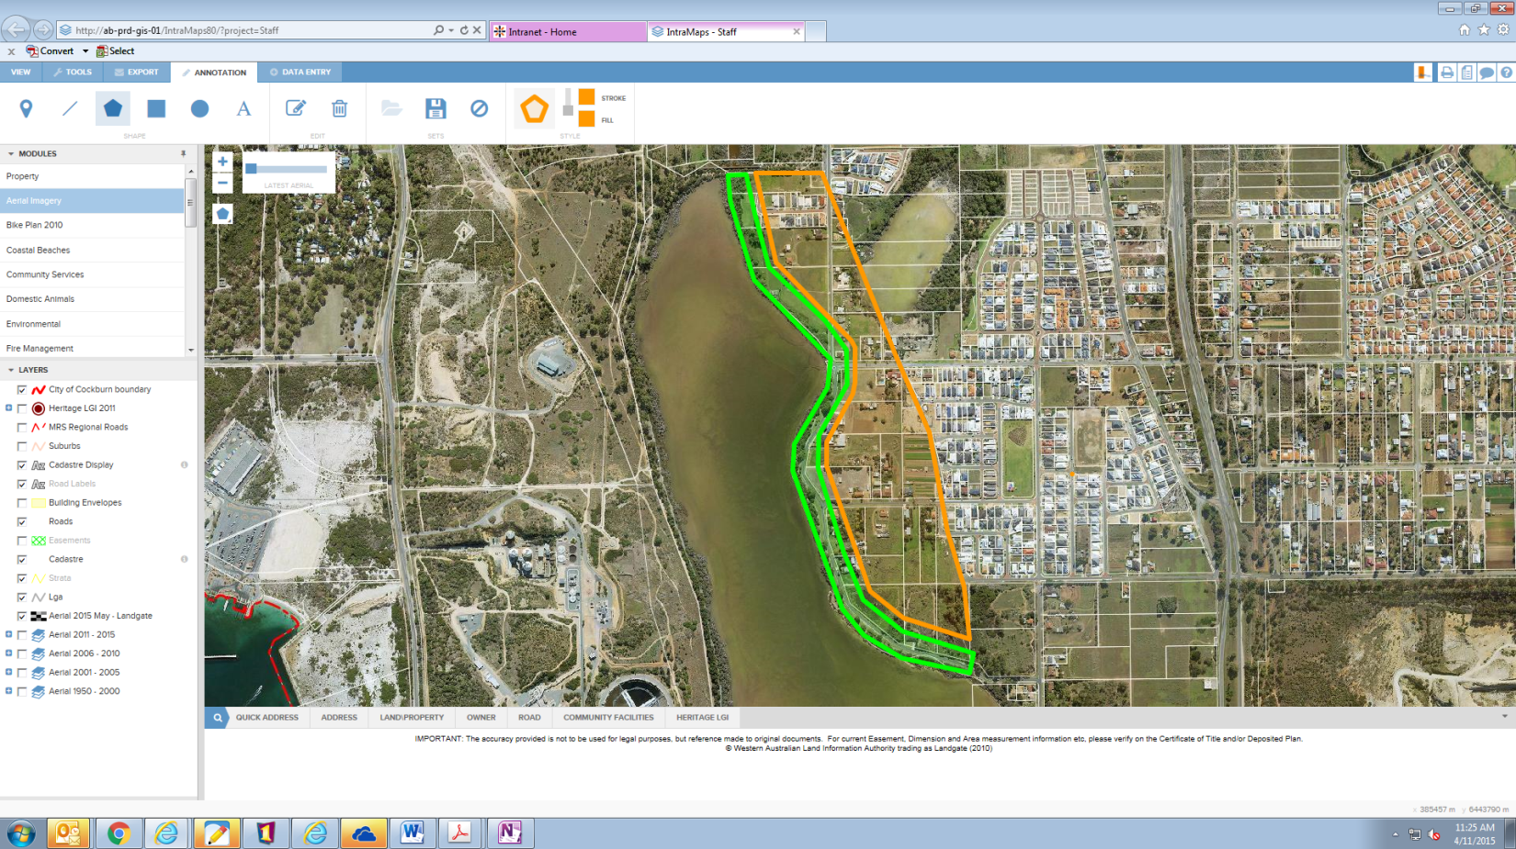
WPWWTP and industrial buffer
Environmental and industrial buffer between 50m to 100m shaped by existing development

The City’s solution would advocate:

- An environmental buffer to Lake Coogee between 50-100m (shaped by existing development);
- This buffer would remove the direct sensitive development interface with the eastern foreshore of Lake Coogee and therefore WPWWTP, and this recognises the reality that impacts do not simply stop at a line on the map;
- The resulting land made available to complete the Munster urban area would be based upon sustainable development principles, such as mixed residential densities, walkable and accessible by pedestrians, water sensitive urban design, rehabilitation of degraded areas and re-establishment of a riparian zone buffer with dampland species leading to a dry upland species which will build resilience for Lake Coogee.

The City’s option is considered the right solution, compared to the solution offered in the draft legislation which will likely lead to a completely incompatible form of development taking place, leading to both social and environmental impacts.

This recognises that while the WPWWTP ought to manage its buffers within its boundary, if it cannot do this then we have instead achieved a buffer scenario which will see impacts managed across the water body and new foreshore reserve of between 50-100m on the eastern foreshore of Lake Coogee.

It is also worth noting that the impacts associated with the WPWWTP are odour in nature, whereby odour capital investment improvements can be reasonably expected to address and treat emissions. The City has direct experience with this through its involvement with the Southern Metropolitan Regional Council, whereby it has had to contribute funding along with other member local governments to undertake capital investment improvements to address odour issues.

Rural area between Latitude 32 and Thomsons Lake wetland chain

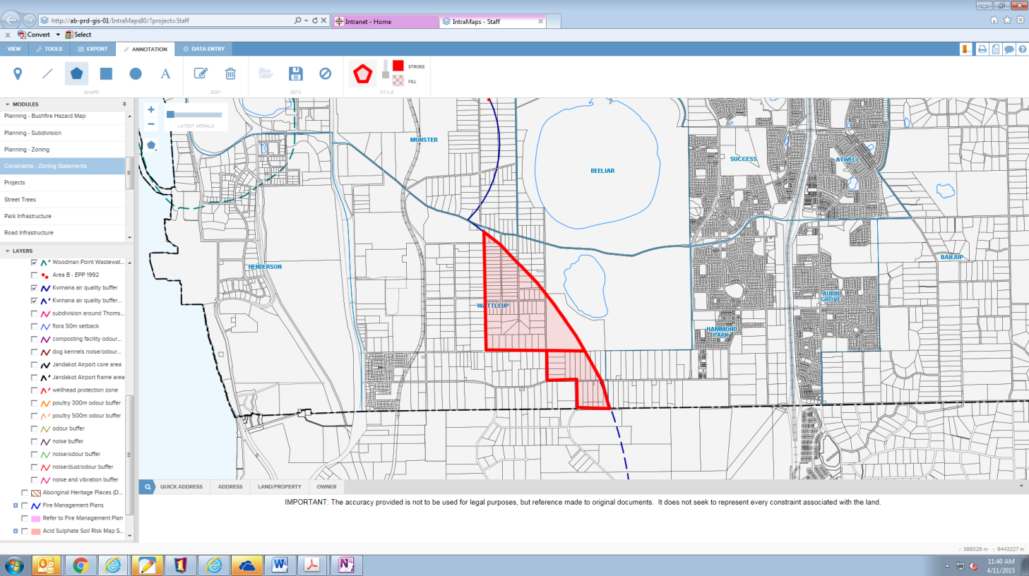

The draft legislation proposes the Wattleup rural land holding separating Latitude 32 from the sensitive Thomsons Lake wetland chain as being within the Protection Area. This aspect of the draft legislation is also objected to, and continues to cause great concern among landowners. The rural interface between the future Latitude 32 industrial area and the central wetlands system has been a long standing feature of the strategic planning undertaken by the State Government to deliver Latitude 32. That is, impacts being associated with Latitude 32 being restricted to the boundary of Latitude 32, not beyond as is proposed by the draft legislation.

In the Fremantle Rockingham Industrial Area Regional Strategy (FRIARS) the rural area to the east of Latitude 32 was retained as a transition/buffer between industrial and conservation areas. This principle was strongly supported by the landowners in that area, and it is known that many still hold that view and do not wish to relocate or develop for industrial purposes. It was also an important principle in retaining the rural area in the FRIARS study that the industrial area would be planned and developed in such a way that all impacts (including noise, dust, odour and risk) would be contained within the industrial area and there would be no impacts on residents in the rural or residential areas.

It is a concern that the draft legislation seeks to abandon this long held strategic planning objective. The planning objective to protect the sensitive environmental wetlands through a precinct of rural development on the western side is considered a very relevant objective to hold. As in the case of Munster and Laker Coogee, should we want significant environmental features of our city to not only be protected but to also become more resilient, it is crucial that we look to protect such areas and ensure they be used to shape more intensive development - rather than be shaped by development as appears the current situation contemplated by the draft legislation. The environmental qualities of the area would stand to be adversely impacted particularly when balancing issues associated with managing bushfire risk and enabling development of private land to occur. The timing of the draft legislation to place the land within the Protection Area, together with the WAPC’s Perth and Peel at 3.5million strategic plan which identifies the land for industrial investigation, reveals the current thinking in respect of the precinct. This is objected to by the City.

Wattleup residential locality

The draft legislation contains two maps. One showing the Wattleup residential land as being partially within the Protection Area, the other showing the land entirely outside the Protection Area. This carries the note in the Fact Sheet document that “The inclusion or exclusion in the Protection Area of a portion of land in this area is subject to a decision by the Minister for Planning.”

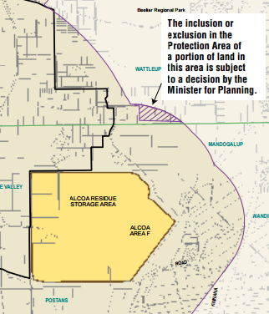

The City reveals detailed information following as to why this land ought to be excluded from the Protection Area, enabling its long term strategic planning for residential development to be realised.

In respect of the subject locality and the subject land, it is evident to the City that strategic planning has been based upon residential development occurring. That is, the land is suitable for residential development. This has been represented through key strategic planning documents including:

- City of Cockburn Local Planning Strategy (forming part of TPS3 gazetted on 20 December 2002);
- City of Cockburn Town Planning Scheme No. 3 (gazetted on 20 December 2002)
- Network City: Community Planning Strategy For Perth And Peel (2004)
- Southern Suburbs District Structure Plan Stage 3 (adopted on 11 August 2005)
- Jandakot Structure Plan (2007)
- Review of the Kwinana Air Quality Buffer - Position Paper (2008)
- Directions 2031 and Beyond (2010) Reducing water runoff and impacts on water quality would also represent threats to the environmental corridor.

It provides a significant contrast that these public documents, developed in conjunction with the community over a number of years, are effectively being reconsidered by virtue of this draft legislation which is reliant upon a 2010 WAPC report that has not been made public; has not been subject to independent third party peer review; is not a buffer definition study and; which has doubts about its reliance expressed by the State Administrative Tribunal.

In terms of statutory decision making of the WAPC relating to this land, it is worth noting that in mid to late 2008, the WAPC assessed the proposal to lift the Urban Deferred zoning for that area north of Rowley Road and west of Frankland Reserve, Wattleup. In doing so, the WAPC considered the issues of potential impacts on this land, from all sources including Alcoa's residue disposal area to the southwest, as well as potential dust from sand quarries to the south within the City of Kwinana as well as conflicts with existing agricultural uses nearby the locality.

In considering these issues, and the advanced state of planning for the subject locality the WAPC unconditionally agreed that the subject locality should be included in the Urban zone under the Metropolitan Region Scheme (“MRS”). Thus paving the way for residential development to occur. Amendment No. 1165/27 to the MRS was the amendment specifically gazetted on 31 October 2008 to unconditionally affect this change.

It is therefore ad hoc for this legislation to the proposing a different outcome for the subject land, being to restrict it from residential development. Notwithstanding that the WAPC previously considered the issues of compatibility in land use and determined to enable it to proceed to an Urban zoning, it is important to recognise the impracticalities of a non-residential sliver of land being proposed in this area. This is specifically a result of the conflicts with residential development that would result in commercial/industrial traffic having to access the subject land via the residential road network, due to direct access from the future Rowley Road Primary Regional Roads reservation being prohibited. Also considering:

- the inability for business to be visible and accessible from the future Rowley Road Primary Regional Roads reservation;
- conflicts with residential development from aspects of commercial and industrial development including noise and;
- conflicts with the planned extent of local commercial and activity centres within the City;

means that the subject land should be excluded from the draft legislation.

Rural living locality north of Cockburn Cement

The draft legislation depicts the continuation of the 500m buffer understood to be associated with the operation of Cockburn Cement. The City has been committed to ensuring Cockburn Cement fully addresses its operation, such as to reduce impacts (dust of otherwise) to within its property boundary. This has seen significant capital investment in the industry over the past five years, and the expectation is that this should continue until all such impacts are managed so that they do not occur outside the property. This is especially relevant to the City’s Rural Living residents shown following within the proposed protection area:

Rural Living area with 108 properties
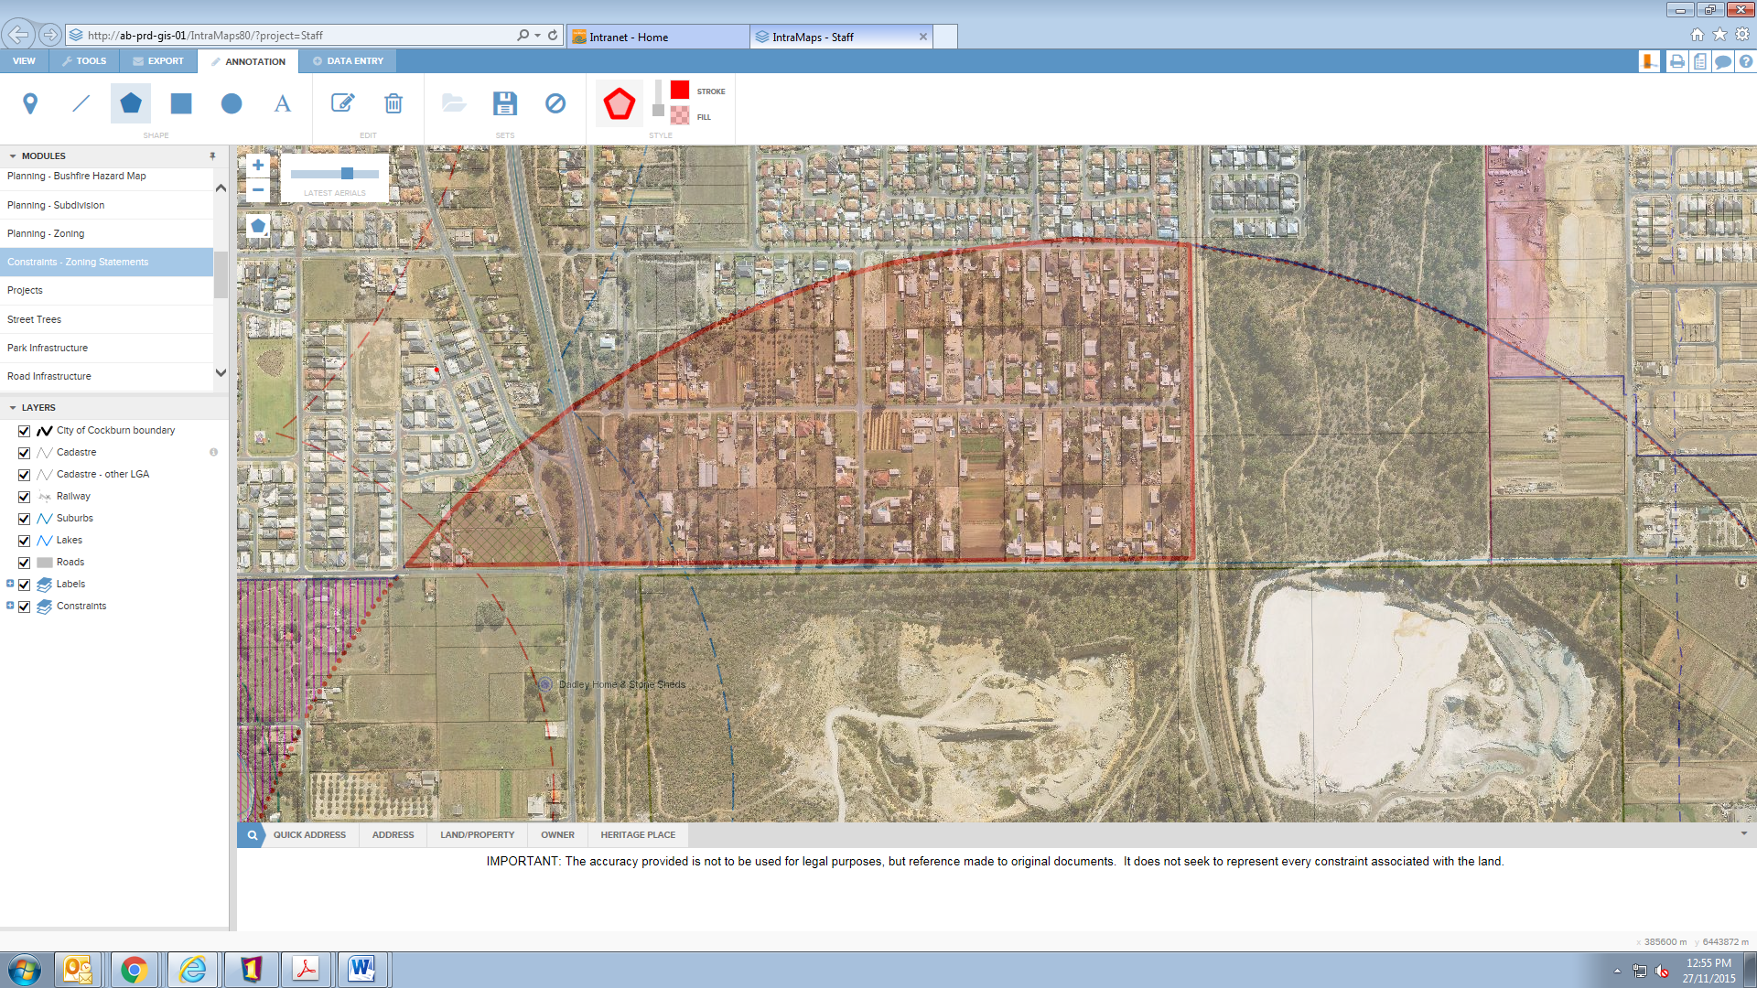
Cockburn Cement

The City is concerned that, similar to its position on the Woodman Point Waste Water Treatment Plant, retention of a buffer in the long term which is not supported through a buffer definition study may weaken public and political advocacy to drive continued upgrades to industry in order to manage impacts. The likelihood of this succeeding in the future may be diminished if the draft legislation does not take the opportunity to carefully examine what can viably be expected to occur by way of technology based investment. It seems inappropriate that the draft legislation should be contemplating an area, with 108 allotments, is not suited to future sensitive development. Given the interface between residential development immediately north of East Churchill Avenue, it is inappropriate to be contemplating an industrial or commercial (non-sensitive) development outcome south of this road.

The City takes the position that either:

- The impacts associated with Cockburn Cement be reduced to its property boundary, enabling contemplation of further sensitive (residential) development or;
- The area be retained for Rural Living.

Inconsistency with the prevailing State level strategic planning.

As has been revealed, the draft legislation places it in conflict with the prevailing State level strategic planning that has taken place. In the matter of Wattleup Road Development Company Pty Ltd and Western Australian Planning Commission [2011] WASAT 160, it was found for example that “subdivision [which] is consistent with the strategic and statutory planning framework for the site…would usually be a powerful and compelling consideration in deciding whether to grant subdivision approval in the exercise of planning discretion.”

The State Administrative Tribunal then goes on to note that “consistency with the strategic and statutory planning framework [however] does not set aside environmental planning considerations in cases where they properly arise for consideration in a planning assessment. In particular, consistency with the planning framework does not negate the precautionary principle in circumstances where it applies.”

This points to the need to carefully understand the basis to which a decision has been made, specifically understanding the basis of the 2010 WAPC report. The absence of this report being made public places the community in a position where it cannot take an informed view as to the degree to which a precautionary planning principle should influence such a departure from the committed strategic planning framework as has been explained throughout this report.

Landowner rights

Residents have also raised questions about the options for compensation, should the State Government’s draft legislation occur. The associated Facts Sheet does not discuss this issue, which no doubt has caused a large amount of concern to landowners, This needs to be clarified by the State Government.

Concluding points

It is recommended that Council OBJECT to the draft legislation, on the basis that:

- The draft legislation is being based upon a report and process carried out by the Western Australian Planning Commission in 2010 which has not, inter alia, been subject to consultation with affected landowners. The report has also not been made publicly available, including its technical studies relied upon, preventing the ability for community engagement and scrutiny of such an important document in the process of arriving at the draft legislation;
- The draft legislation proposes a buffer that, to the City’s knowledge, has not been subject to third party independent scientific peer review in which to be able to gauge the degree of scientific/technical rigor;
- The draft legislation contains no evidence to demonstrate that certain land areas within the City of Cockburn are not suitable for sensitive development. That is, the lack of scientific evidence such as through a buffer definition study which is scientifically robust and subject to an open/transparent public process;
- The draft legislation is inconsistent with the prevailing State level strategic planning, which should be expected to inform the statutory planning framework;
- The mapping associated with the draft legislation is not discernible enough in terms of the specific land impacted;
- The draft legislation provides inadequate explanation as to the rights of landowners going forward.

In making this objection, Council should also recommend its alternative scenario from the Munster land, being a sustainable form of residential development which builds a real environment buffer to Lake Coogee while providing an acceptable mechanism in which to limit the proximity of development to the edge of Lake Coogee. Finally it is also recommended that the State Government exclude the entirety of the Wattleup residential precinct from the Protection Area, as well as the Wattleup Rural Interface precinct. Finally, the City also recommends the Rural Living precinct north of Cockburn Cement still be enabled for sensitive development, given the established community which exists.

Strategic Plan/Policy Implications

Growing City
- To grow our City in a sustainable way by: using land efficiently, protecting the natural environment and conserving biodiversity.

- Development that is soundly balanced between new and existing areas.

Community & Lifestyle
- Community environments that are socially cohesive and embrace diversity.

Leading & Listening
- Effective and constructive dialogue with all City stakeholders.

Budget/Financial Implications

There are no specific financial implications associated with the consideration of this item.

Legal Implications

Planning and Development Act 2005

Community Consultation

There has been limited public consultation undertaken in respect of this proposal. To ensure the City’s community are fully informed, the City sent out over 2000 letters to landowners. In addition, a public meeting took place on 23 November 2015. This was hosted by the City of Cockburn, however the State Government were not able to attend.

The issues raised on the night have been addressed in this report.

Attachment(s)

Fact Sheet associated with the draft legislation

Advice to Proponent(s)/Submissioners

N/A

Implications of Section 3.18(3) Local Government Act, 1995

Nil.

10. (MINUTE NO 5680) (SCM 03/12/2015) - RESOLUTION OF COMPLIANCE (SECTION 3.18(3), LOCAL GOVERNMENT ACT 1995)
RECOMMENDATION
That Council is satisfied that resolutions carried at this Meeting and applicable to items concerning Council provided services and facilities, are:-

(1) integrated and co-ordinated, so far as practicable, with any provided by the Commonwealth, the State or any public body;

(2) not duplicated, to an extent Council considers inappropriate, services or facilities as provided by the Commonwealth, the State or any other body or person, whether public or private; and

(3) managed efficiently and effectively.

COUNCIL DECISION
MOVED Deputy Mayor C Reeve-Fowkes SECONDED Clr P Eva that the recommendation be adopted.

CARRIED 9/0

11. CLOSURE OF MEETING
Meting closed at 6:20pm.

CONFIRMATION OF MINUTES

I, ………………………………………….. (Presiding Member) declare that these minutes have been confirmed as a true and accurate record of the meeting.

Signed: ………………………………………. Date: ……../……../……..

