Tender Title: |  | PROVISION OF BUSHLAND MAINTENANCE
Request ID: |  | 63385
Tender Description: |  | The City of Cockburn seek suitably qualified and experienced contractor/s to undertake a range of bushland maintenance services across twenty-seven (27)  bushland reserves to improve biodiversity values, increase vegetation condition ratings and meet community expectations.
Advert Approval: |  | Decision to Advertise: Director Infrastructure Services  Decision Date: Tuesday, 22 April 2025
Closing Date and Time: |  | 2:00PM (AWST) Tuesday, 20 May 2025
Opening Date and Time: |  | 2:00PM (AWST) Tuesday, 20 May 2025
 | Tenderer’s Name:
1 | Environmental Industries (Environmental Industries Pty Ltd)
2 | Green Skills (Green Skills Inc)
3 | Landcare Weed Control (John Derrick Lodge)
4 | Natural Area (Natural Area Holdings Pty Ltd)
5 | SERCUL (South East Regional Centre For Urban Landcare Inc)
6 | UGC Group (UGC Holdings Pty Ltd)
7
8
9
10

Advertisement
Method 1: City of Cockburn website | Method 2: City of Cockburn Libraries Public Noticeboards
Method 3:  The Western Australian, Wednesday, 30 April 2025 | Tender Awarded by:
Copy of Statewide Notice:  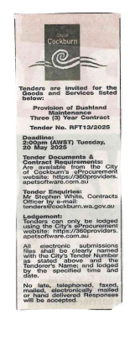 | OCM  Choose an item.  Tuesday, 8 July 2025
 | Date of Council Meeting:
Date: 08 July 2025
Minutes: 0135
Item No. 14.3.3
Name of Successful Tenderer(s): | - Green Skills Inc (Group 1 only)  - South East Regional Centre for Urban Landcare Inc (SERCUL) (Group 2 only)
Amount of Successful Tender(s): (ex GST) | $546,610 (Ex GST) - Group 2 Only  $573,450 (Ex GST) – Group 1 Only

