Tender Title: |  | RFT 03/2026 – ELECTRICAL COMPLIANCE TESTING  - Electrical Test and Tag  - Residual Current Device Testing  - Exit and Emergency Lighting Testing  - Microwave Emissions Testing
Request ID: |  | 79058
Tender Description: |  | The City of Cockburn (the Principal) is seeking a suitably qualified and experienced Contractor for the electrical compliance testing of Electrical Test and Tag, Residual Current Device (RCD), Exit and Emergency Lighting (EEL) and Microwave Emissions in accordance with the relevant Australian Standards (AS/NZS).  A full list of sites is provided as a separate MS Excel Spreadsheet RFT03-2026 – B05 Building Location and Details – Electrical Compliance Testing. This includes the City of Cockburn Administration Buildings, Cockburn Aquatic and Recreation Centre (Cockburn ARC) at Cockburn Central West and Port Coogee Marina.
Advert Approval: |  | Decision to Advertise: Director Infrastructure Services  Decision Date: Wednesday, 4 February 2026
Closing Date and Time: |  | 2:00PM (AWST) Wednesday, 25 February 2026
Opening Date and Time: |  | 2:00PM (AWST) Wednesday, 25 February 2026
 | Tenderer’s Name:
1 | Aerison Pty Ltd
2 | Airmaster Corporation Pty Ltd
3 | AWB CO. Pty Ltd
4 | Electrical Compliance Onsite Pty Ltd
5 | DARPA Holdings Pty Limited
6 | Grosvenor Engineering Group Pty Ltd
7 | Northlake Electrical Pty Ltd
8 | Platinum Electricians Pty Ltd
9 | Testel Australia Pty Ltd
10 | The Local Guys – Services Pty Ltd

Advertisement
Method 1: City of Cockburn website | Method 2: City of Cockburn Libraries Public Noticeboards
Method 3: The Western Australian,  Wednesday 4 February 2026  Page 41 | Tender Awarded by:  Ben Moore  A | Director Infrastructure Services
Copy of Statewide Notice:  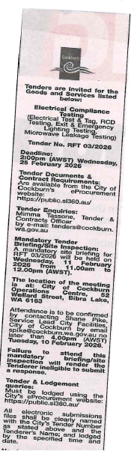 | Director Infrastructure Services  Director Corporate & System Services  Tuesday, 14 April 2026
 | Date of Council Meeting:
Not applicable
Item No:
Name of Successful Tenderer(s): | Northlake Electrical Pty Ltd
Amount of Successful Tender(s): (ex GST) | $325,000 (Ex GST)

