Tender Title: |  | TRAFFIC MANAGEMENT SERVICES
Request ID: |  | 70177
Tender Description: |  | The City of Cockburn is seeking suitably qualified, experienced, and accredited Traffic Management Contractor to provide the Principal with Traffic Management  Services across various locations within the Principals local government area.
Advert Approval: |  | Decision to Advertise: Director Infrastructure Services  Decision Date: Monday, 14 July 2025
Closing Date and Time: |  | 2:00PM (AWST) Thursday, 31 July 2025
Opening Date and Time: |  | 2:00PM (AWST) Thursday, 31 July 2025
 | Tenderer’s Name:
1 | Contra-Flow T/as Contra-Flow Pty Ltd
2 | ESM Traffic T/as Event Safety Management Pty Ltd
3 | Evolution Traffic T/as Evolution Traffic Management Pty Ltd
4 | Kimberley Traffic T/as Kimberley Civil & Drainage Pty Ltd
5 | Luxworks Traffic T/as Luxworks Traffic Control & Management Pty Ltd
6 | Overwatch Traffic T/as Overwatch Traffic Services Pty Ltd
7 | Raubex Construction T/as Raubex Construction Pty Ltd
8 | WARP Traffic T/as WARP Pty Ltd
9 | LGC Traffic T/as Welstand Services Pty Ltd
10 | CQ Traffic T/as Workforce Road Services Pty Limited

Advertisement
Method 1: City of Cockburn website | Method 2: City of Cockburn Libraries Public Noticeboards
Method 3:  The Western Australian, Wednesday, 16th July 2025 2025 | Tender Awarded by:
Copy of Statewide Notice:  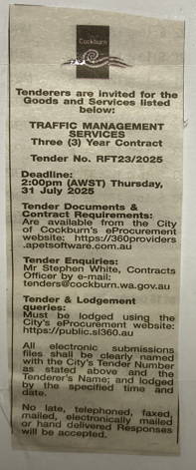 | OCM  Choose an item.  Tuesday, 2 September 2025
 | Date of Council Meeting:
Date: 02 September 2025
Minutes:
Item No. 14.3.3
Name of Successful Tenderer(s): | Contra-Flow T/as Contra-Flow Pty Ltd
Amount of Successful Tender(s): (ex GST) | $2,018,760.00 (Ex GST)

