Tender Title: |  | CONSTRUCTION SERVICES  Stormwater Drainage Improvements - Bucat Street  Hamilton Hill
Request ID: |  | 70153
Tender Description: |  | The City is seeking the services of a suitably qualified, registered and experience construction contractor to undertake stormwater drainage improvements on Bucat Street, Hamilton Hill under the City’s Drainage Improvement Works programme for FY24/25.
Advert Approval: |  | Decision to Advertise: Director Infrastructure Services  Decision Date: Thursday, 23 October 2025
Closing Date and Time: |  | 2:00PM (AWST) Thursday, 20 November 2025
Opening Date and Time: |  | 2:00PM (AWST) Thursday, 20 November 2025
 | Tenderer’s Name:
1 | Aaro Group t/a Aaro Group Pty Ltd
2 | Dowsing Group

Advertisement
Method 1: City of Cockburn website | Method 2: City of Cockburn Libraries Public Noticeboards
Method 3:  The Western Australian, Wednesday, 29th October 2025 | Tender Awarded by:
Copy of Statewide Notice:  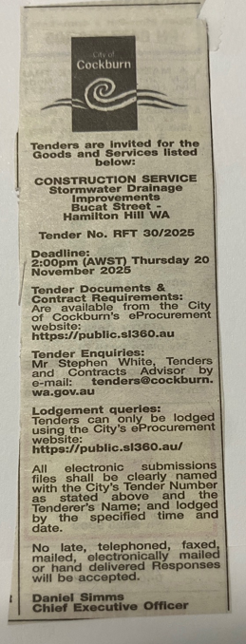 | Director Infrastructure Services  Director Corporate & System Services  Tuesday, 16 December 2025
 | Date of Council Meeting:
Date: N/A
Minutes: N/A
Item No. N/A
Name of Successful Tenderer(s): | Aaro Group Pty Ltd
Amount of Successful Tender(s): (ex GST) | $596,824.41

