17 August 2018
Mobile technology keeps Cockburn safer (and saves 1,000 sheets of A4 every week!)
Enhanced community safety is just one benefit of the successful roll-out of 24/7 mobile technology for CoSafe officers patrolling the City of Cockburn.
The project has enabled the City to improve CoSafe incident attendance and planned inspections, provide timely online lodgement of external referrals for CrimeStoppers, Main Roads WA and public utilities, plus automated daily reports.
Saving about 1,000 sheets of A4 paper every week is another improved efficiency and cost saving of the sustainability project.
In-vehicle mounted tablets promote increased efficiency and services to the community by improving information capture and eliminating double-handling of data while providing a bank of accessible documentation about safety- related issues in the community.
Rangers and Community Safety Manager Michael Emery said the $70,000 project meant CoSafe officers received their jobs via text and lodged them via real time connected tablets, enabling them to respond immediately without having to write down any details or fill in paper forms that need inputting at a later time.
“This means they can get going straight away; we know seconds can sometimes be the difference between a good outcome and disaster,” Mr Emery said.
“There is also no longer any need for forms or notes to be manually entered into the City’s records system with information input happening in real time.
“The new system was developed over three months by Asset Services from the City’s Infrastructure Services Business Unit, included more than 70 hours of training for CoSafe officers who automatically receive and generate more than 1,100 work instructions online every week.
“Along with all CoSafe vehicles now having CCTV installed, the program further enhances the safety of our officers and the quality of information collected by CoSafe.”
It’s the latest in the City’s ongoing Mobile Strategy being delivered by Asset Services which has introduced mobile technology to the City’s Engineering and Works Directorate, embarking on a landmark pilot project with its Parks team in 2014.
The City has since deployed about 60 tablets across its operational workforce including the Parks, Bushland, Roads and Workshop teams.
“Cockburn was the first WA council to pilot and implement Technology One mobile technology, which is a big sustainability tick for the City,” Mr Emery said.
“It’s a win-win for our residents, and it’s great for our employees to learn new, innovative and valuable skills with cutting-edge technology to make their work more efficient.”
Caption: CoSafe Officer Jared Isaacs demonstrates new mobile technology now installed in all CoSafe patrol vehicles. Picture: Nadia Ucich.
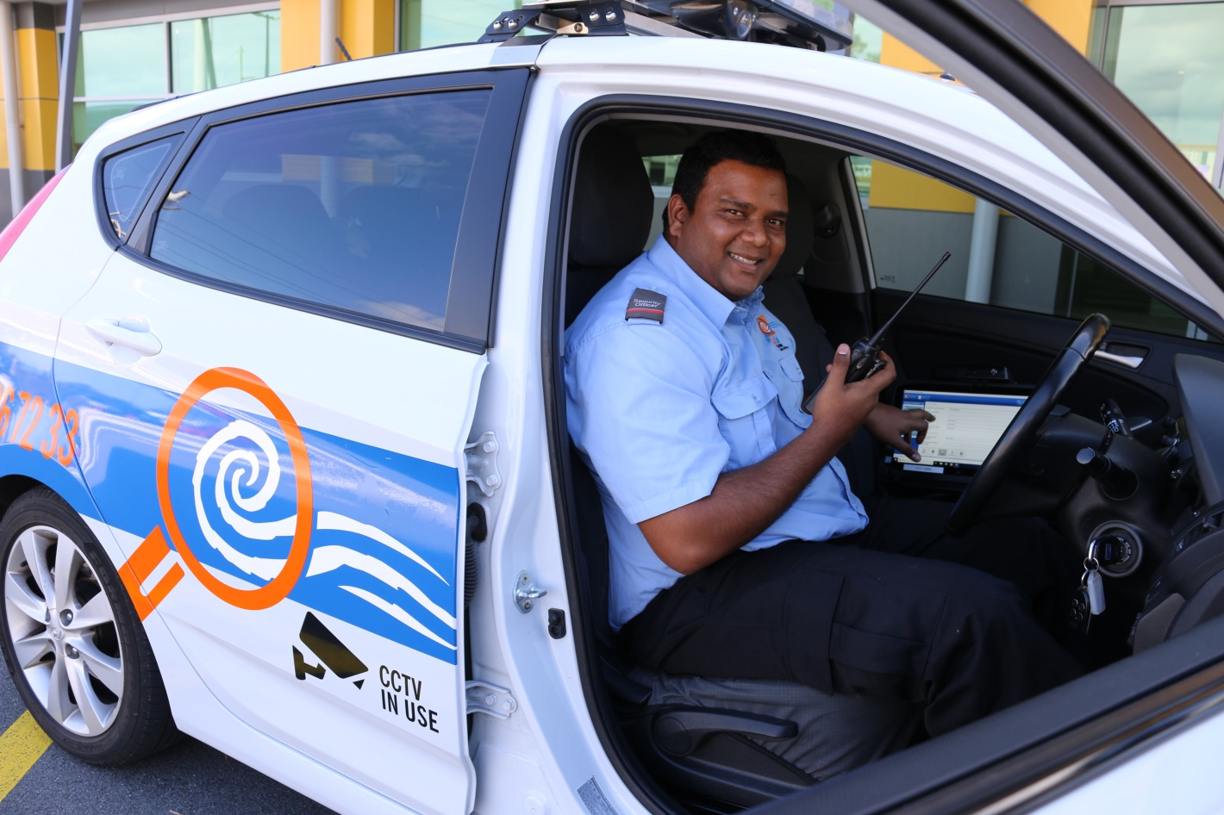

–––––
ENDS

For more information contact:
Media and Communications Officer
City of Cockburn
T: 08 9411 3551
E: media@cockburn.wa.gov.au

