Tender Title: |  | RFT 16-2020  Consultancy Services - Engineering Traffic Services (Three (3) years)
Request ID: |  | 36339
Tender Description: |  | Consultant to provide transport planning, transport engineering, transport surveys and transport & traffic modelling services to the Principle.
Advert Approval: |  | Decision to Advertise: Director of Engineering & Works  Decision Date: Thursday, 10 September 2020
Closing Date and Time: |  | 2:00pm (AWST) Thursday, 1 October 2020
Opening Date and Time: |  | 2:00pm (AWST) Thursday, 1 October 2020
 | Tenderer’s Name:
1 | ARUP PTY LIMITED t/a Arup (Perth Office)
2 | Cardno (WA) Pty Ltd t/a CARDNO (WA) PTY LTD (WEST PERTH)
3 | DONALD VEAL CONSULTANTS PTY LTD
4 | GTA CONSULTANTS (WA) PTY LTD t/a GTA Consultants (GTAPerth)
5 | KC TRAFFIC AND TRANSPORT PTY LTD t/a KCTT
6 | SMEC AUSTRALIA PTY. LIMITED
7
8
9
10

Advertisement
Method 1 : City of Cockburn | Method 2 : NA
Method 3 :  The West Australian | Tender Awarded by:
Copy of Statewide Notice:  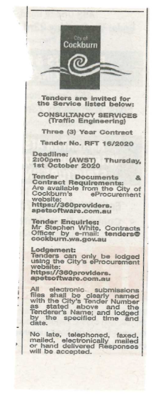 | OCM  Choose an item.  Click here to enter a date. or
 | Date of Council Meeting:
Thursday, 10 December 2020
Minutes: 0260
Item No: 16.1
Name of Successful Tenderer(s): | SMEC Australia Pty Ltd
Amount of Successful Tender(s): (ex GST) | $965,525

