Tender Title: |  | RFT 12-2020  Project Management Services - Aboriginal Cultural & Visitor's Centre
Request ID: |  | 36135
Tender Description: |  | For the design and construction of a new Aboriginal Culture and Visitors Centre. Centre is to be located near the corner of Progress Drive and Gwilliam Drive, Bibra Lake
Advert Approval: |  | Decision to Advertise: Director of Govenernance & Community Services  Decision Date: Wednesday, 10 June 2020
Closing Date and Time: |  | 2:00pm (AWST) Thursday, 25 June 2020
Opening Date and Time: |  | 2:00pm (AWST) Thursday, 25 June 2020
 | Tenderer’s Name:
1 | CUSHMAN & WAKEFIELD PTY LTD (Property & Development Services)
2 | ALLIED PROJECTS PTY LTD t/a Allied Projects (Project Management)
3 | NS PROJECTS PTY LTD t/a NS Projects Ltd Pty
4 | TURNER & TOWNSEND THINC PTY LTD t/a Turner & Townsend (Perth)
5 | RPS AAP CONSULTING PTY LTD
6 | Insight Project Services Pty Ltd
7 | CBRE (GCS) PTY LIMITED
8 | DCWC SERVICES PTY. LTD.
9 | JOHNSTAFF PROJECTS (WA) PTY LTD t/a Johnstaff Projects (WA) Pty Ltd (Perth)
10 | BRETT DAVID INVESTMENTS PTY. LTD.
11 | Core Business Australia Pty Ltd (Core Business Australia)

Advertisement
Method 1 : City of Cockburn | Method 2 : NA
Method 3 : | Tender Awarded by:
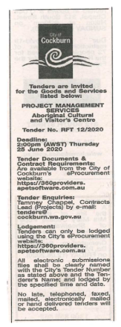  Copy of Statewide Notice: | Director of Govenernance & Community Services  Choose an item.  Friday, 7 August 2020
 | Date of Council Meeting:
Click here to enter a date. or
Not applicable
Item No:
Name of Successful Tenderer(s): | RPS AAP Consulting Pty Ltd
Amount of Successful Tender(s): (ex GST) | $73,185.00

