3 May 2023

Wise approach prevents mountain of rubbish at two-day Coogee Live festival with less than 150kgs of waste disposed of in landfill

Main points:
- Record-breaking use of reusable dishes and cutlery at Coogee Live saved 32,000+ items from the rubbish dump
- Despite 26,000+ attendees, less than 150kgs of landfill waste was created at the two-day beachside festival
- About 580kgs of recyclable and compostable waste was diverted from landfill
- Waste wise event used six waste sorting stations to replace 80 rubbish and recycling bins along 1.5km stretch of Coogee Beach on 11-12 March
You’d think 26,000+ people would create a mountain of waste during a two-day festival, but less than 150kgs of rubbish was disposed of in landfill after the City of Cockburn’s Coogee Live event this March.
About 580kgs of recyclable and compostable waste and a record-breaking 32,000+ food containers and cutlery were diverted from landfill thanks to the cooperation of festivalgoers, food vendors and the City’s dedicated Waste Education and Events teams.
City of Cockburn Waste Education Coordinator Maryline Cassou said the volumes of reuse recorded at Coogee Live was unprecedented for events with food trucks in WA.
The waste wise event recruited 20 food truck and bar vendors across 18 trading hours who pledged not to supply food and drinks in single-use plastic products, opting for reusable dishware and cutlery supplied by Go2Cups, or compostable containers.
With the help of waste champions at six waste sorting stations, festivalgoers were able to divert their waste into separate bins for reusable dishes and cutlery for washing, and other items for composting, donation, recycling or general waste.
The stations replaced the 80 rubbish and recycling bins usually found along a 1.5km stretch of Coogee Beach and coastal reserve for the duration of the weekend festival.
Patrons used more than 32,000 reusable dishes and cutlery, filling 52x120-litre bins and 16 five-litre buckets for washing and reuse across the two days.
Free water stations also helped reduce the purchase of drinks in single-use plastic, enabling people to refill their own reusable bottles.
The City partnered with St Patrick’s Community Support Centre which collected the contents of dedicated Containers for Change bins. The proceeds of 2,098 recyclable containers went towards specialist support services for people facing homelessness.
WRITE Solutions collected about 400kgs of compostable containers and food waste, filling 15x240-litre bins with raw material for transformation into garden compost products.
“This means we’re on the right track and that the community is receptive to methods that help them reuse, recover and recycle, and reduce the unnecessary disposal of items in landfill,” Ms Cassou said.
City of Cockburn Head of Library and Cultural Services Brittany Cover said the City’s Events team had learned so much from the 2023 festival, with improvements that can be made for future City events, particularly Coogee Live, next summer.
“Coogee Live was also a carbon neutral event. This means carbon emissions released as a result of the event, from things like patron travel, food consumption and onsite generators, were offset by the City investing in planting mixed native trees and shrubs throughout the state,” Ms Cover said.
Mayor Logan Howlett said the City was one of the first, if not the first, local government in WA to use Go2Cups reusable dishware at its events.
“The City began partnering with Go2Cups in 2018 when we made the courageous decision to remove disposable coffee cups from all its events, saving an estimated 10,000 coffee cups from landfill to date,” Mayor Howlett said.
“The City has also discouraged single-use plastics at its events for several years by providing free water stations. This has reduced the need for people to buy thousands of single-use plastic water bottles which often end up in a rubbish or recycling bin.
“Our community should be proud of its ability to adapt to change and embrace more sustainable practises in their everyday lives.”
The City WasteWise Events Policy adheres to the WA Plan for Plastics and the WA Waste Authority’s Waste Avoidance and Resource Recovery Strategy 2030.
Coogee Live is the City’s flagship family event and was named the Best Community Event in Australia at the 2021 Australian Event Awards.
ENDS

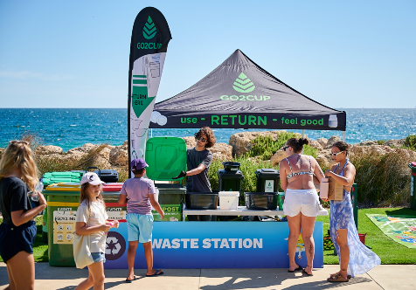

For more information contact:
Media and Communications Officer
City of Cockburn
T: 08 9411 3551
E: media@cockburn.wa.gov.au

