Policy Type

Council

Policy Purpose

The Policy serves to ensure that the City of Cockburn complies with the obligation to ensure that there is an appropriate structure for administering the City, as outlined in s5.2 of the Local Government Act, 1995 (the Act).

The City of Cockburn is administered through a structure of seven Divisions, 13 Business Units and 54 Service Units. This structure is managed by a Chief Executive Officer, one Senior Officer, four Chiefs, three Executives and several Heads of Business Units, Strategic Managers and Managers. The structure is aligned to the activities and functions of the City and is reviewed regularly. It is changed when the City embarks on new business opportunities, divests itself of service functions or when there is a need to reorganise functions into different units for better management and alignment with our purpose.

Policy Statement

(1) Council recognises its responsibility pursuant to s5.2 of the Act, and considers the attached Structure for Administering the City of Cockburn an appropriate structure for administering its local government.

(2) Council approval is required to implement any variation to the Structure for Administering the City of Cockburn in relation to the seven divisions, however the CEO may undertake minor variations as they see fit with regards to the allocations of functions and resources across those seven divisions as aligned with the City’s purpose and the purpose of each division.

(3) The Structure for Administering the City of Cockburn describes the principal functions that Council directs are to be undertaken by each Business and Service Unit.

(4) In accordance with the Act, the CEO’s function is to manage the day-to-day operations of the local government and be responsible for employing those employees not designated as “senior employees”.

(5) Consistent with the functions described in (4) above, Council notes the CEO will allocate employees across functions and activities, where he or she considers doing so increases organisational efficiency.

(6) The Executive Committee (Ex-Co) roles:

- Executive Governance and Strategy
- Chief Financial Officer
- Chief of Built and Natural Environment
- Chief of Community Services
- Chief of Operations
- Executive Corporate Affairs
- Executive People Experience and Transformation

are deemed by Council to be senior roles and designated as a Senior Employee, pursuant to Section 5.37 of the Act.

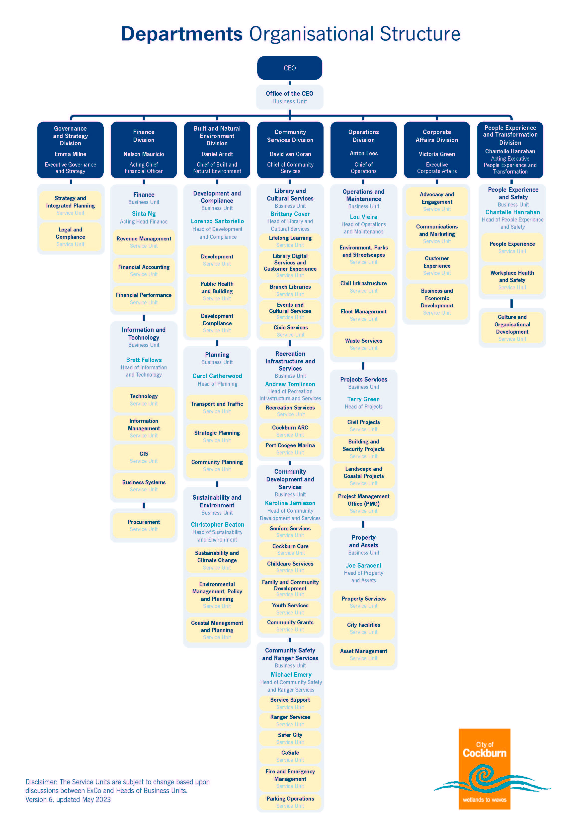

Governance and Strategy Division
Executive Governance and Strategy
Corporate Strategy  Service Unit | Legal and Compliance  Service Unit
To support the City in the development and integration of corporate planning  - Corporate Integrated Planning and Reporting  - Corporate Performance  - Services Planning | To ensure that Council’s Compliance and Risk Management responsibilities are fulfilled in a timely manner within statutory and best practice standards.  - Policies and Local Laws  - Compliance and Returns  - Internal Audit  - Risk Management

Finance Division
Chief Financial Officer
Finance Business Unit
Head of Finance
Revenue Management Service Unit | Financial Accounting Service Unit | Financial Performance Service Unit
Providing revenue management services, ensuring systems and processes support ratepayers and debtors making payments easily and affordably. | Providing transactional finance, treasury and statutory financial reporting, while ensuring compliance with audit, financial legislative and tax requirements. | Ensuring sustainable financial performance through facilitating best practice budgeting and financial planning outcomes for the City.
Procurement Business Unit
Procurement Coordinator
Purchasing Service Unit
To provide effective centre-led procurement services and support for competitive sourcing and the associated contract management, whilst also ensuring organisational compliance with statutory tendering and internal procurement requirements.

- Contracts and Compliance

Finance Division
Chief Financial Officer
Information and Technology Business Unit
Head of Information and Technology
Technology Service Unit | Information Management Service Unit | GIS Service Unit
Supports the rest of the organisation using technology to achieve their strategic objectives. Functions include:  - Service desk & Customer support  - Maintaining ICT laptops, desktops, mobile fleet  - Maintaining networks, servers, storage and other ICT infrastructure  - Improve the City’s cyber security | Provision of a records management service to the organisation including but not limited to:  - Processing/registration of incoming and outgoing mail  - ECM system administration, support and training  - Assisting with the development of records and information management policies  - Providing advice about records management practices  - Providing a records management service that complies with the City of Cockburn’s Recordkeeping Plan, Records Management Policy, Recordkeeping Guidelines and WA State Records Office requirements  - Managing the City’s archives, including the disposal of records in accordance | Develop, support and maintain all spatial products and services in the City including but not limited to:  - Internal/external mapping and spatial support  - Development of Esri and IntraMaps.
Business Systems Service Unit
Develop, support and maintain the City’s business systems to enhance effectiveness and efficiency of Council’s operations through the use of technology.
- Review and improve business processes to increase quality and efficiency.
- Advise the business on technology and non-technology solutions.
- Integrate existing systems with new systems to consolidate data and information to add value to existing solutions.

Built and Natural Environment Division
Chief of Built and Natural Environment
Development and Compliance Business Unit
Head of Development and Compliance
Development Compliance Service Unit | Public Health and Building Service Unit | Public Health Service Unit
Assess development proposals and subdivision of land in line with the planning framework and incidental requirements. Ensuring an up-to-date framework to facilitate good outcomes for the community. | To ensure that the conduct and operation of premises and activities within the district comply with accepted standards and practices for public health and building and to ensure that the quality of the environment is protected and improved. | To ensure that land, buildings and structures within the district provide acceptable levels of public safety, amenity and comply with all relevant Planning and Building Standards and regulations.
Planning Business Unit
Head of Planning
Community Planning Service Unit | Transport and Traffic Service Unit | Strategic Planning Service Unit
Assess the prioritisation of all major infrastructure needs from the different service units (recreation, public open space, cultural, civic, etc.) against projected urban growth and income sources, and creates an overarching plan to implement and facilitate these needs for the entire community. | Provides technical support that contributes to the management of a safe and efficient transport network by investigating and responding to complaints, enquiries, requests and submissions received by the City. The Team assists with the delivery of transport related actions, plans, policies, and strategies across the City. | Provides a wide range of roles related to long term land use planning of the City’s neighbourhoods, natural areas, activity and employment centres. This includes structure plans and amendments to the local planning scheme. They also manage the City’s development contribution plans and provide a cartography function to other units.

Built and Natural Environment Division (Contd. )
Chief of Built and Natural Environment
Sustainability & Environment Business Unit
Head of Sustainability and Environment
Sustainability and Climate Change Service Unit | Environmental Management, Policy and Planning Service Unit | Coastal Management and Planning Service Unit
To develop strategies and plans which guide the City’s sustainability and climate change aspirations to make a better tomorrow. | To develop environmental and planning policies, undertake studies and provide advice on environmental matters for the protection and management of areas of environmental significance and lead towards a sustainable built environment. | To develop coastal adaptation plans, foreshore management plans and adopt planning controls to mitigate the impacts of coastal erosion.

Community Services Division
Chief of Community Services
Library and Cultural Services Business Unit
Head of Library and Cultural Services
Lifelong Learning Service Unit | Branch Libraries Service Unit | Library Digital Services and Customer Experience Service Unit
Provide and support a range of inclusive library programs, environments and collections that support the early and continued development of literacy skills in the children and young people of the City of Cockburn. | Manage a public facility that provides spaces and staff to enable capacity building, community collaborations and to deliver collections and services specific to the catchment demographic of the branch. | Provide and support a range of relevant digital and technology systems and to promote and market events and programs to ensure the needs and expectations of our community are met.
Cultural Services Service Unit | Civic Services Service Unit
To provide a range of entertainment, cultural and heritage events and activities, to the community that properly and positively reflect the City’s commitment to deliver quality and cost-effective programs, services and activities. Manage the arts, culture and events occurring in the City, including the calendar of municipally funded annual events. | To focus on the civic and ceremonial functions, including planning, security, and building amenities:  • Civic functions
Recreation Infrastructure and Services Business Unit
Head of Recreation Infrastructure and Services
Recreation Services Service Unit | Cockburn ARC Service Unit | Port Coogee Marina
Provide community need identification and assessment for the future provision and design of sport, recreation, and community facilities. | Provision of a range of affordable centre-based aquatic, indoor sports and recreation programs / services from Cockburn ARC. | To manage the Port Coogee Marina Facility including business development, penholder liaison and daily service operations.

Community Services Division (Continued)
Chief of Community Services
Community Safety and Ranger Services Business Unit
Head of Community Safety and Ranger Services
Rangers Service Unit | CoSafe Service Unit | Fire and Emergency Management Services
To provide Improved safety to our growing communities by applying state and local laws for a variety of matters local governments are responsible for managing. The Ranger’s team use a host of education, prevention and mitigation strategies to improve proactive compliance before regulatory enforcement is required | Provides a community safety responses service to our community at times when they feel unsafe or when they witness anti-social behaviour. CoSafe work with a range of organisations and law enforcement agencies to improve the overall perception of safety within our community and provide added reassurance to the community. | The team work with the City’s and DFES volunteers to establish a safer and more resilient community through Prevention, Preparedness, Response and Recovery from a range of emergencies that may impact the Cockburn residents. The team work collaboratively with stakeholders to ensure hazards are identified, communicated and managed appropriately
Safer Cities Service Unit | Parking Operations Service Unit | Service Support
To assist in the planning, design, management and delivery of inclusive and high-quality crime prevention and community safety programs and policies in partnership with local communities, government agencies and non-government organisations | To provide a responsive and proactive service for parking compliance and enforcement. | To facilitate responsive information and provide support to each service unit.

Community Services Division (Continued)
Chief of Community Services
Community Development and Services Business Unit
Head of Community Development and Services
Seniors Service Unit | Family and Community Development Service Unit | Youth Services Service Unit
Administer Council funded services, programs and facilities aimed at providing and developing increased social support, activity and leisure opportunities for the senior citizens of Cockburn. | To provide a range of individual, family and child focussed services for residents, via a community development approach or direct service delivery including information, referral, advocacy or direct assistance and support. To provide capacity building mechanisms to strengthen and support community groups and volunteers operating within the City of Cockburn. | Administer grant and Council funded services, programs and facilities aimed at providing and developing increased social support, amenity, activity and leisure opportunities for the young people of Cockburn. Youth services offers three streams of services for young people – youth work, youth centre programs and youth development.
Cockburn Care Service Unit | Child Care Services | Community Grants Service Unit
Administer grant and fee funding provided to Council for the operation of the Home Support Program (CHSP), Home Care Packages (HCP), National Disability Insurance Scheme (NDIS) including Social Club services and Kwobarup Aboriginal Club for NDIS participants. Provide programs and Services for residents who are aged or have a disability to assist them in maintaining their independence. | To equitably and effectively administer fees provided to Council for the operation of the Family Day Care. | To provide a central City of Cockburn coordinating service for the distribution of grants, donations and sponsorship to community organisations and individuals. To seek grants from Commonwealth, State Government and other sources for services and facilities for residents of the City. To carry out research on matters related to issues of concern and interest to the City of Cockburn and to promote the interests of the City.

Operations Division
Chief of Operations
Operations and Maintenance Business Unit
Head of Operations and Maintenance
Environment, Parks and Streetscapes Service Unit | Civil Infrastructure Service Unit | Fleet Management Service Unit
The operational maintenance of Public Open Space, Natural Areas and Streetscapes to provide functional and attractive locations for recreational activities by the Community. | This service unit will review, implement and manage all activities associated with the extensive civil infrastructure including roads, drains, sumps, footpaths and cycle ways. | To repair, maintain, replace and manage the City‘s fleet, plant and equipment.
Waste Services Service Unit
To operate a landfill site at Henderson to accept waste in accordance with the requirements of a Class II site under the Environmental Protection Act and maximise the financial return.

To provide a regular, reliable and safe waste and recycling collection service for every premise within the district and dispose of it in an environmentally acceptable manner.

Operations Division (Continued)
Chief of Operations
Projects Services Business Unit
Head of Projects
Civil Projects Service Unit | Building and Security Projects Service Unit | Project Management Office (PMO) Service Unit
To initiate, design and deliver approved civil projects. | To initiate, design and deliver approved building and security projects. | To manage the development and delivery of project and asset management frameworks, systems, processes and procedures. Provision of services for best practice asset and project management, including in the delivery of the City’s major building and facility and other infrastructure capital works programs and operational activities.
Landscape and Coastal Projects Service Unit
To initiate, design and deliver approved landscape and coastal projects.
Property and Assets Business Unit
Head of Property and Assets
Land and Leasing Services Unit | City Facilities Service Unit | Asset Management Service Unit
The service unit is tasked with the effective implementation and management of City owned land assets, including strategic purchasing and disposal of land, resumption of private land (via taking order) for roads and infrastructure projects, dealing with crown land and land under management order from the State, managing caveats, easements and other encumbrances on City owned or managed land, and dealing with pedestrian access way closures.  The service unit also administers leases and licenses which span commercial, community and tourism purposes across the City’s portfolio, in order to achieve the best use for each asset. In particular, this includes the management of the City of Cockburn Integrated Health Facility. | The service unit is tasked with delivering effective facilities services across all City owned buildings, to ensure that they remain functional, safe, modern and useful to the City and the community.  This includes planned and preventative building maintenance, minor capital works programs, upgrades and repairs, contractor management, works cost management, and preventative and legislative maintenance to mitigate public liability risk and ensure maximum safety for the occupants and visitors to each City owned building. | The service unit is tasked with the implementation and management of the City’s asset management and capital planning systems.  The service unit is responsible for the collection and analysis of information that contributes towards asset condition assessment, financial management, level of service measures, asset replacement programs, anticipated useful life assessments, asset revaluations for long term planning, and forward works programming.  The information generated by the service unit is critical to the implementation of the City’s corporate business plan, strategic community plan and long-term financial plan.

Corporate Affairs Division
Executive Corporate Affairs
Advocacy and Engagement Service Unit | Communications and Marketing Service Unit | Customer Experience Service Unit
To manage our key stakeholder and influencer understanding of City, and Council, priorities and issues.  To provide advice and guidance on best practice community engagement and consultation on major projects, services and areas of interest. | To provide a range of communications material and services that ensures that the community is informed about the City’s services and programs.  To ensure whole of City marketing services are undertaken to enhance our brand, reputation and recognition. | To provide a range of services that deliver quality, timely and cost-effective customer service to the community.
Business and Economic Development Service Unit
To plan and implement the Business Engagement and Economic Development Framework.

People Experience and Transformation Division
Executive People Experience and Transformation
People Experience and Safety Service Unit | Workplace Health and Safety Service Unit
To provide HR policy, programs and advice that shapes the workforce to ensure it can achieve the business objectives now and in the future.  To pay employees and maintain accurate information regarding leave, personal details and entitlements.  - People Experience (Human Resources)  - Organisational Development  - Payroll | To provide advice and support in the areas of safety, worker’s compensation and rehabilitation.  - Workplace Health and Safety  - Injury Management and Rehabilitation  - Workers Compensation
Strategic Manager Culture & Organisational Development
Culture & Organisational Development Service Unit
To lead our cultural and organisational development program through culture initiatives, staff training, staff surveys, improved systems and processes, ideas and leadership capability building to deliver sustainable outcomes.

- Culture Development
- Change Management
- Innovation
- Leadership Capability
- Organisational Development

Strategic Link: | Workforce Plan
Category: | Governance
Lead Business Unit: | Human Resource
Public Consultation:  (Yes or No) | No
Adoption Date:  (Governance Purpose Only) | 13 July 2023
Next Review Due:  (Governance Purpose Only) | July 2025
ECM Doc Set ID:  (Governance Purpose Only) | 4131297

