City of Cockburn   
Annual Report 2019-2020

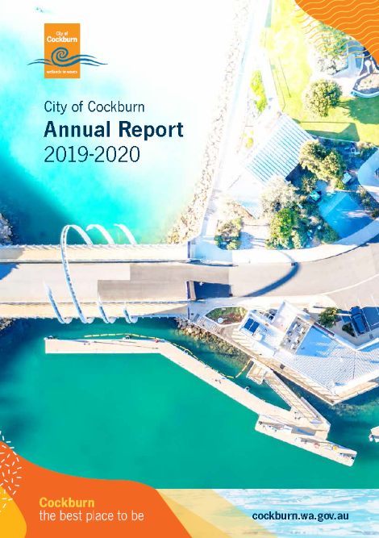

**Cockburn: the best place to be**

[City of Cockburn website: cockburn.wa.gov.au](http://cockburn.wa.gov.au/)

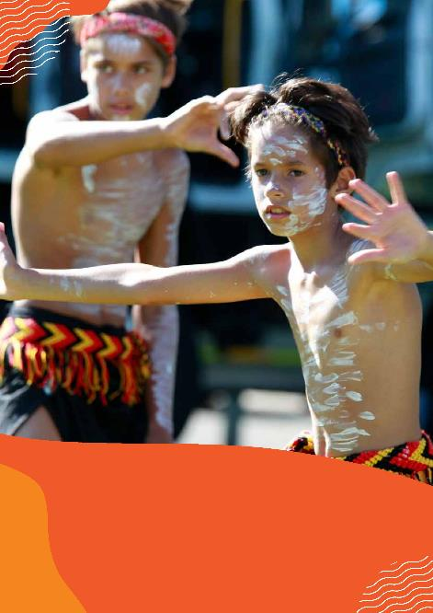 **Bindjareb Middars, Australia Day Coogee Beach Festival - January 2020**

**Front Cover: Port Coogee Marina offices, public jetty and Maraboo Bridge**

# Acknowledgement of Country

The Mayor, Councillors and staff of the City of Cockburn acknowledge the Whadjuk Nyungar people of Beeliar boodja as the traditional custodians of this land. We pay our respect to the Elders, past, present and emerging.

# Contents

Elected Members and Executive Team 2019-20 4

Mayor’s Message 9

Report of the Acting Chief Executive Officer 12

COVID-19 Report 15

A Snapshot of our City 24

Cultural Diversity in Cockburn 25

Achievement of Community Objectives 29

The Year Ahead 2020-21 43

Rates Allocation 49

Organisational Structure 51

Remuneration of Senior Employees 55

Governance & Community Services Directorate 57

Engineering & Works Directorate 95

Planning & Development Directorate 124

Finance & Corporate Services Directorate 137

Financial Report 148

# Elected Members and Executive Team 2019-20

## Elected Members

**Headshot of Logan K. Howlett. Logan K. Howlett, JP**, His Worship the Mayor

**Headshot of Lara Kirkwood. Lara Kirkwood**, Deputy Mayor from October 2019 and Councillor, East Ward

**Headshot of Lee-Anne Smith. Lee-Anne Smith, OAM**, Councillor, East Ward and Deputy Mayor until October 2019

**Headshot of Chamonix Terblanche. Chamonix Terblanche**, Councillor, East Ward

**Headshot of Kevin Allen. Kevin Allen**, Councillor, West Ward

**Headshot of Michael Separovich. Michael Separovich**, Councillor, West Ward

**Headshot of Carol Reeve-Fowkes. Carol Reeve-Fowkes**, Councillor, West Ward until October 2019

**Headshot of Phoebe Corke. Phoebe Corke**, Councillor, West Ward from October 2019

**Headshot of Philip Eva. Philip Eva, JP**, Councillor, Central Ward

**Headshot of Chontelle Stone. Chontelle Stone**, Councillor, Central Ward

**Headshot of Stephen Pratt. Stephen Pratt**, Councillor, Central Ward until October 2019

**Headshot of Tom Widenbar. Tom Widenbar**, Councillor, Central Ward from October 2019

## Executive Team

**Headshot of Stephen Cain. Stephen Cain**, Chief Executive Officer until April 2020

**Headshot of Daniel Arndt. Daniel Arndt**, Director Planning and Development/ Acting CEO

**Headshot of Charles Sullivan. Charles Sullivan**, Director Engineering and Works

**Headshot of Don Green. Don Green**, Director Governance and Community Services

**Headshot of Stuart Downing. Stuart Downing**, Director Finance and Corporate Services

**Headshot of Gail Bowman. Gail Bowman**, Executive Manager Strategy and Civic Support

## Vision

**Cockburn:** **the best place to be**

## Purpose

Together, we strive to create a sustainable, connected, healthy and happy Cockburn community.

## Council Meeting Attendance of Elected Members 2019-20

| **Elected Members** | **Ordinary Council Meetings (11)** | **Special Council Meetings (8)** | **Delegated Authorities and Policies Committee (DAP) Meetings (4)** | **Audit and Strategic Finance Committee Meetings (4)** |
| --- | --- | --- | --- | --- |
| Mayor Logan Howlett | 11 | 8 | 4 | 3 of 4 |
| Cr Lee-Anne Smith | 7 | 6 | 1 of 1 | 1 of 1 |
| Cr Kevin Allen | 9 | 6 | N/A | 4 of 4 |
| Cr Carol Reeve-Fowkes | 2 of 4 | 0 of 0 | 1 of 1 | 0 of 1 |
| Cr Stephen Pratt | 4 of 4 | 0 of 0 | N/A | 0 of 0 |
| Cr Philip Eva | 9 | 8 | N/A | N/A |
| Cr Chamonix Terblanche | 10 | 8 | 1 of 3 | 2 of 3 |
| Cr Lara Kirkwood | 11 | 8 | N/A | N/A |
| Cr Chontelle Stone | 10 | 7 | 3 of 3 | N/A |
| Cr Michael Separovich | 11 | 8 | 4 | 3 of 3  (2 x Deputy) |
| Cr Phoebe Corke | 7 of 7 | 8 | N/A | N/A |
| Cr Tom Widenbar | 7 of 7 | 8 | 2 of 3 | 1 of 3 |

## Ward Populations*

* West Ward: 37,589
* Central Ward: 40,134
* East Ward: 42,348

*Estimated 2020

Source: .id

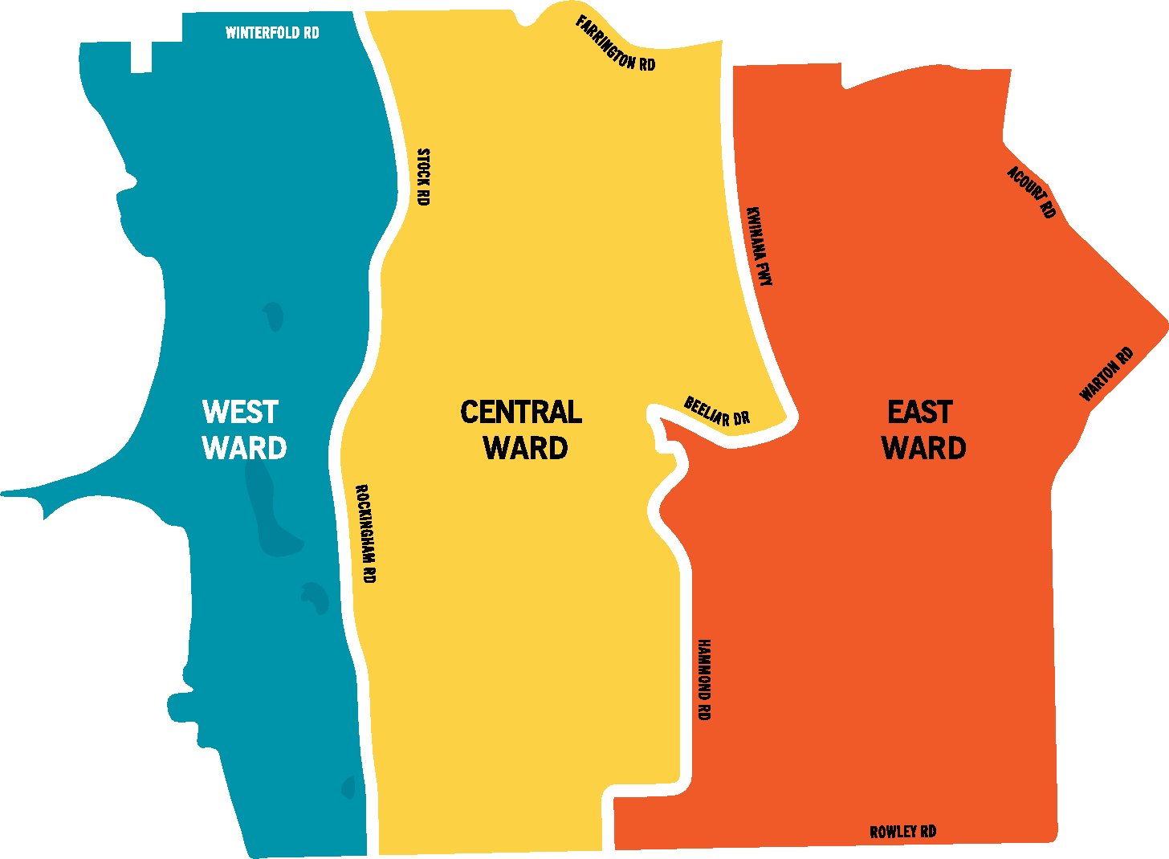

The map above illustrates the areas that comprise West Ward, Central Ward, and East Ward. For more information, please contact City of Cockburn.

West Ward has Winterfold Road at its northern border and Stock Road and Rockingham Road at its eastern border.

Central Ward is to the east of West Ward. It has Stock Road and Rockingham Road at its western border, Farrington Road at its northern border, and Kwinana Freeway, Beeliar Road, and Hammond Road at its eastern border.

East Ward is to the east of Central Ward. It has Kwinana Freeway, Beeliar Road, and Hammond Road at its western border, Acourt Road and Warton Road at its eastern border, and Rowley Road at its southern border.

# Mayor’s Message

I am delighted to provide my twelfth annual report statement to the Cockburn community in a financial year that ended in a way nobody would have anticipated. We were thrust in to living through a once-in-a-lifetime pandemic, COVID-19. As I write, Western Australia remains one of the safest places in the world to be. In this report we will outline what this pandemic meant to City operations and how we supported and continue to support our residents and business community. I am proud to say that an independent COVID-19 resilience study of WA local governments has shown that Cockburn locals feel on average more hopeful and enthusiastic about the future than their Perth and state counterparts.

City employees did a fantastic job adapting services, setting up a dedicated COVID-19 hotline to provide support to the vulnerable in our community, and enabling the technology for over 90 per cent of our workforce to work safely from home.

The City continues to support the community wherever it can and, while there is a pathway to recovery, there is still much to learn about this pandemic, its spread and hope for a vaccine to provide that level of immunity for us all to return to a new ‘normal’. We continue to refine our response, recovery and communication plans in case of further outbreaks, learning from the experiences of other states and countries.

For many council activities we maintained business as usual and I am pleased to say that a formal major review of the Strategic Community Plan including extensive community consultation was undertaken this financial year as part of the planning cycle. This is the document that sets the direction for the City for the next 10 years to 2030.

This plan articulates our revised vision, which is to make Cockburn the best place to be. It details our high level objectives under five key outcomes areas: Local Economy; Environmental Responsibility; Community, Lifestyle and Security; City Growth and Moving Around; and Listening and Leading. The plan was developed through significant community consultation and reflects community aspirations and priorities.

Each year this report tracks how the City is achieving the objectives set out in our Strategic Community Plan.

A key reporting tool is an annual survey of our residents, using an independent research company to gain insight into what the community thinks of services in the City of Cockburn. The City uses these results, together with other information, to measure the City’s progress against its Strategic Community Plan, as well as to evaluate and adjust its priorities and programs.

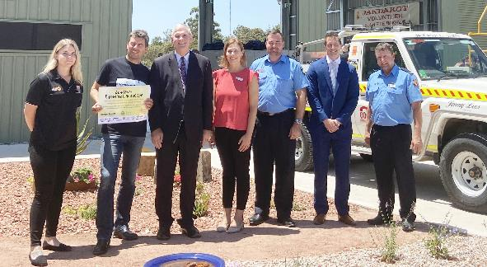  
**(From left to right): Janaya Meneghini - City of Cockburn, Chris Ferreira - The Forever Project, Mayor Howlett, Deputy Mayor Lara Kirkwood, Jarrod Fowler - The Captain of the Jandakot Volunteer Bush Fire Brigade, Mike Emery - City of Cockburn and Shane Harris - Former Captain, now Deputy of the Jandakot Volunteer Bush Fire Brigade at the Jandakot Volunteer Bush Fire Brigade Station official opening - January 2020**

Our community continues to tell us through this research that we are doing a good job, and when benchmarked against other WA local governments who undertake the same survey, the City is leading the way in mobile security patrols, services and facilities for families and children, and for Cockburn ARC in regard to aquatic and recreation centres.

Our community rated us as an organisation with a performance index score of 69, which shows Cockburn as the leader among similar Councils and 13 points above the WA average. However, we are always aware that there is room for improvement in everything we do and we always strive to do better. The report highlights what community priorities the City should focus on. These include safety and security, traffic management and the development of local areas.

The City continues to provide financial support through its Cockburn Community Fund to community groups, organisations and individuals around the City of Cockburn. Last financial year, a total amount over $1.16 million was awarded, ranging from $350 in youth academic assistance for a young person to attend the National Youth Science Forum, to a $15,000 sponsorship for Small Business Support Services.

Supporting our local business community has been a big part of our focus over the last year. Prior to, and throughout the COVID-19 pandemic we have been supporting businesses with a range of activities to develop their skills, encourage them to prosper, and assist in their recovery. We have been promoting some of the great opportunities ahead for local businesses to form part of the supply chains for major defence and construction programs, and to become a supplier to the City, as part of changes to its Procurement Policy.

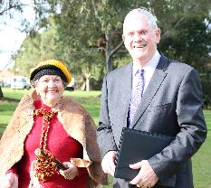  
**Nyungar Elder Marie Taylor and Mayor Howlett at the Hiroshima Day Tree Planting - August 2019**

The City has included a dedicated Local Economy outcome in our new Strategic Community Plan, which ensures we will continue to plan for, and create, opportunities for local businesses and local centres to thrive.

On behalf of Council, I would like to acknowledge outgoing Chief Executive Officer Stephen Cain for his 15 years of dedicated service and to wish him all the best for the future.

And finally, I would like to thank the hundreds of dedicated volunteers out there in the City who give up thousands of hours each year to help make Cockburn the best place to be.

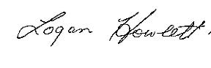

His Worship the Mayor

**Logan K. Howlett, JP**

# Report of the Acting Chief Executive Officer

The City’s population forecast for 2021 is 123,203 and is forecast to grow to 161,479 by 2036 (Source: .id). As our population continues to grow it is critical that we manage to grow our infrastructure and manage our assets accordingly.

However, with finite resources, it is also critical that we ensure we are delivering our services in the most sustainable, customer-focused way. With that in mind, the City continues to refine its business processes to ensure that our customers can self-serve as many transactions as possible via digital means, while we continue to offer traditional customer service at the front counter and over the telephone.

Across the City we have several thousand processes, many of which span multiple business units. We continue to prioritise those which we can improve quickly, and those which provide the most improvement. This is one of the biggest challenges that every level of government faces. Last financial year we went live with online animal registrations and made significant customer-led improvements to our website which receives over 739,965 visits per year.

We are also working on a smart city security and access control system for city facilities, to enable electronic access to remove the need for picking up keys at our administration centre. The solution will further improve security at our facilities through the use of artificial intelligence and motion sensor technology.

Cyber security has been identified as an organisational risk. We have placed great emphasis on implementing our cyber security policy and framework across all that we do in the organisation. In the last financial year we had implemented a number of key cyber security measures prior to COVID-19, most importantly multi-factor authentication for our staff when logging in from other devices, which gave us great peace of mind as we sent more than 90 per cent of the workforce home to work.

While COVID-19 meant that the City had to close popular face-to-face community services for several weeks, we continued to maintain our parks, undertake roadworks and progress our capital works programs.

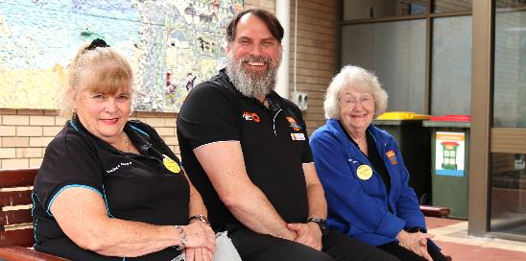  
**Acting CEO Daniel Arndt at Cockburn Seniors Centre**

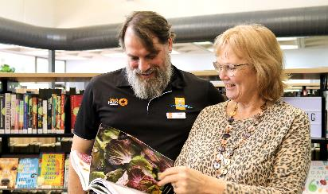  
**Daniel Arndt at Spearwood Library**

In August 2019 we officially opened the Lakelands Hockey and Sporting Facility, home of the Fremantle Cockburn Hockey Club.

I am pleased to say that work is well underway on the $6 million new Cockburn Wetlands Precinct in Bibra Lake, due for completion in 2021. This will be home to Native ARC, The Wetlands Centre Cockburn and the Bibra Lake Scouts. Detailed planning continued for the Aboriginal Cultural and Visitors Centre in Bibra Lake, Frankland Park Sports and Community Facility, Treeby Community and Sports Centre, Beale Park redevelopment and the Malabar Park BMX facility.

The City continues its ongoing work upgrading parks and playgrounds, and as part of our ongoing revegetation programs, planted 140,000 plants across city conservation areas and within the Roe 8 wildlife corridor, as well as 1,300 street trees.

Road and transport projects continued to dominate our capital investment last year, as the City seeks to improve traffic flow and connectivity across Cockburn. The Federal and State-funded Armadale Road duplication has now finished and the new Armadale Road to North Lake Road Bridge project has begun. City-funded projects, including the Verde Drive extension and construction of a roundabout at the intersection of Verde Drive and Prinsep Road, have also begun. Jandakot Road duplication between Berrigan Drive and Solomon Road was completed with stage two anticipated to be completed by the end of 2021.

The METRONET-funded Thornlie-Cockburn Link will also commence construction this coming year and is due for completion in 2022.

As we create new strategies, buildings and facilities, we actively seek the involvement and input of our local communities. Last year we engaged with residents, ratepayers and visitors on over 60 projects and had more than 61,000 visitors to our engagement website Comment on Cockburn. We held dozens of pop-ups, feedback sessions, listening posts and workshops. The engagement process provides opportunities for interested and impacted community members to shape important decisions, and develops a shared understanding of the different needs, aspirations and interests of our diverse community.

The City has continued to work with the South West Group of councils to advocate for regional priorities that provide the greatest benefit to the member councils and communities in the south west metropolitan region. The City is also participating in the South West Group’s Smart Region Program which exists to help member councils effectively and intelligently use data and technology to accelerate achievement of outcomes in their strategic community plans and improve the quality and efficiency of council service delivery.

I would like to echo Mayor Howlett’s words in acknowledging the contributions of the outgoing CEO Stephen Cain and wish him every success in the future.

Daniel Arndt signature.

**Daniel Arndt**

Acting Chief Executive Officer

# COVID-19 Report

The social, health and economic landscape of the world as we know it, abroad and right here at home in Cockburn began to change dramatically in March 2020 as our community braced for the arrival of the novel coronavirus.

Just three days before the World Health Organisation declared COVID-19 a pandemic on 11 March, the City hosted the popular two-day Coogee Live event, with a record-breaking 18,000 plus people attending the coastal festival.

It was the last City-run event for several months as the devastating effects of the virus began to impact, with the WA Government declaring a state of emergency on 15 March and a public health state of emergency on 23 March.

But even at this early stage, the City had already advanced organisational plans to safely guide Cockburn through this unparalleled health crisis, and help stop the spread of the virus.

Led by our Environmental Health team and Acting CEO, the City quickly held its first COVID-19 Crisis Management Team (CMT) meeting to begin planning for the inevitable closure of facilities, high-risk events and services in an effort to keep our community healthy and safe.

Comprising representatives from the City’s executive management team and relevant business units, the CMT met regularly, coordinating the closure of facilities and services and ensuring comprehensive communication to local residents and staff.

Almost consecutively, the City formed the Cockburn Local Response and Recovery Coordination Group (LRRG) to assess all likely activities requiring consideration during the response, monitoring and recovery phase of the pandemic. The group developed the COVID-19 Revive Cockburn Plan to guide the committees’ response to community recovery activities. The LRRG ensured that any program undertaken was relevant to preventing the spread of COVID-19, the health and safety of individuals and the community, assisting to minimise economic losses by local businesses, adequately providing for vulnerable people, and advocating to the State and Federal Government for funding as required.

It also helped plan and implement replacement services so our community could still function in a strange new time of isolation at home. One key role was to communicate health practises including social distancing, regular handwashing, remaining at home if unwell, having a COVID-19 test if symptoms persisted and downloading the Federal Government’s COVIDSafe app.

It seems this thorough planning was what our community needed. Results in an independent COVID-19 resilience study of WA local governments from 5 June to 8 July showed Cockburn locals felt on average more hopeful and enthusiastic about the future than their Perth and WA counterparts.

## What actions did we take?

The City immediately began communicating via its public website and via its social media channels. It established COVID-19 specific website pages with links to support available to residents and the business community, information about the 2020-21 Budget, phased closures and re-openings, recovery grants, the COVID-19 telephone helpline, links to reputable health sites, and messages from the Mayor.

Social media, letters, emails, e-newsletters, phone calls, media releases and advertisements in local newspapers regularly communicated the myriad of changes brought about by the new COVID-19 to our community.

The City also communicated regularly with staff via its internal website and email, as fears grew in local government circles that staff employment was at risk, a situation that fortunately did not arise at Cockburn.

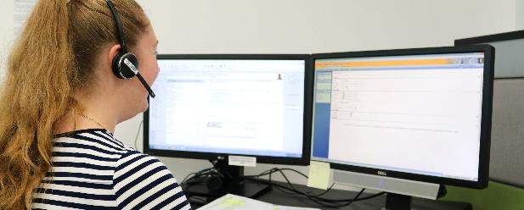  
**City of Cockburn COVID-19 Helpline**

## Cockburn Vulnerable Communities Plan

By 8 April, the City had established a Vulnerable Communities Plan. A key component was a communications plan to reach out to locals who may be among vulnerable communities identified by the Health Department, including people over 70, some Aboriginal and Torres Strait Islander people and people with certain medical or health conditions. In addition to this was people in financial difficulty.

The plan resulted in letters to 40,000 plus households, 46,000 emails, and contact with more than 1,100 people via the COVID-19 telephone helpline in the first nine days of its establishment.

In all, the helpline reached 58,000 residents through outbound and inbound telephone calls, emails and mail. About six per cent of those people were in need of help ranging from food, grocery items, driving/transport, pet walking and care, home assistance and social connection.

The helpline ran for about a month, staffed by employees redirected from business areas forced to close due to the virus, and still operates now via the City’s customer service centre. It is ready to fully activate immediately if needed.

The plan also helped local carers develop stay at home plans for family members and clients, made telephone wellbeing checks on vulnerable people, collated a services directory for use by helpline staff and helped not-for-profit organisations remain sustainable during the shutdown period, including the provision of two rounds of COVID-19 Response Grants.

These grants were available to Cockburn-based groups, organisations and businesses that served local residents, had a high level of community support, were financially stable and could identify how they would use the grant to help meet community needs amid the pandemic.

Existing home care packages, home and community care help and Cockburn Care home and community support services continued in line with Health Department guidelines and advice to reduce infection risk.

Cockburn Support Services such as financial and mental health counselling, Cockburn Parenting Services, the Volunteer Resource Centre, and Family and Community Development continued via telephone or online.

The Family Day Care Service and In-home Child Care Service continued to operate under strict guidelines.

While the Cockburn Seniors Centre building closed, staff stayed in touch with members via telephone, online interactions, email, and mail-outs.

The Youth Centre building closed, putting a temporary end to its programs and events but some continued via online meetings.

Safety plans for vulnerable young people were developed with in-person outreach where needed under strict physical distancing requirements, and also via telephone.

## Financial relief

The Council adopted the 2020-21 Budget in July with Cockburn households continuing to pay some of the lowest rates in Perth, despite economic challenges posed by the pandemic.

Cockburn’s average residential improved rate of $1,584 for 2020-21 is the lowest among neighbouring councils.

However, the impact of COVID-19 on the City’s budget exceeded $6m, including $2.15m from a zero average rate increase, and $1.73m from the rates concession.

Hallmarks of the City’s financial relief package included:

* A zero percentage increase to rates which included a COVID-19 concession
* Freezing of all City fees and charges at 2019-20 levels
* Eliminating instalment and penalty interest on rates as well as other associated fees and charges
* Removing the mandatory waste service levy from commercial/industrial properties not using the City’s waste service
* Sporting clubs COVID-19 support
* Providing options for rent relief to tenants of City-owned or controlled premises, commensurate with demonstrated COVID-19 impacts.

## COVID-19 Response Grants

The first round of COVID-19 Response Grants resulted in 11 successful grants valued at $48,025. The grants were designed to help local not-for-profit, incorporated community groups, organisations and businesses, to provide much-needed support for the City’s most vulnerable people and recovery from impacts of the COVID-19 pandemic.

Projects funded included an array of emergency crisis relief (food wellness boxes, comfort packs to vulnerable community members), events (parent and child woodworking workshops, community playgroups), equipment (storage and freezers for emergency relief, health promotion and equipment for people with disability) and mindfulness and resilience programs.

Additional funding of $113,543 was carried forwarded to 2020-21 for the second phase of funding COVID-19 Recovery Grants.

## Procurement

COVID-19 hastened the need for the City to overhaul its Procurement Policy, which it launched in June 2020. It is now mandated for officers to seek a quote from a local supplier when one is available, for purchases valued above $20,000. The concept of 'buying local' continues for lower value quotes where possible.

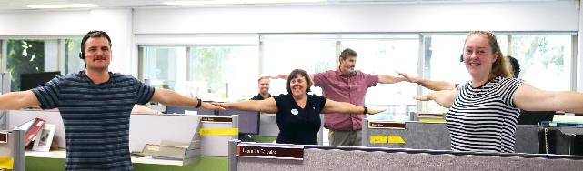  
**City of Cockburn staff social distancing**

## Help for businesses

#ShopLocalCockburn became our catchcry, following the May launch of the online Restart Hub that helped reboot the beating heart of the local business community as COVID-19 restrictions eased.

While some businesses were among recipients of the COVID-19 Response Grants, the City also enabled businesses to register on an Open for Business digital map, so residents could see what shops and services were operating.

The online Restart Hub provided COVID-19 safety plan guidance for operation and reopening, opportunities to become a City of Cockburn supplier, business directory access, sign up to a regular business enewsletter, and access to business courses and qualified business advisors on how to rebuild.

## Sporting club COVID-19 grants and support:

Ten clubs applied for a one-off grant and funding of $12,250. The City also waived approximately $100,000 in ground hire fees for the 2020 winter season to help local clubs stay afloat.

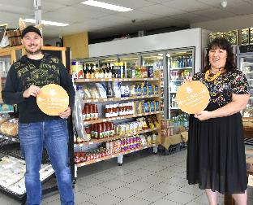  
**Anthony Iemma - Coogee Continental and Sarah Kahle - City of Cockburn with social distancing stickers - April 2020**

## City staffing

Unlike many other local governments challenged financially by the pandemic, the City did not stand any employee down without pay, force any employee to take leave or seek wage freezes or cuts.

Cockburn was the only WA local government to keep paying its casual staff until 10 May some 250 casuals, mostly employed at Cockburn ARC, were paid for up to six weeks after the facility closed on 20 March 2020. Casual staff were redirected to other parts of the City to assist in delivering services, such as installing 'closed' signs on playgrounds and barbecues.

The City made the difficult decision to cease payment after 10 May when it was no longer able to absorb the significant financial impact of paying casuals who were unable to undertake the duties of their former roles from a home setting, or who could not be deployed into other roles.

Casual employees were retained on the City’s employee register so that when services and facilities returned, they were easily slotted back into their former roles.

Despite around 90 per cent of office based City staff working from home during the shutdown, for the majority of the permanent workforce it was business as usual, with some areas busier than ever.

City staff worked tirelessly to deliver the necessary works on our roads, parks and environment, and ensuring waste was efficiently managed.

**Ways to reduce your risk of COVID-19**



The diagram above illustrates four ways people can reduce the risk of contracting or spreading COVID-19:

* Cover coughs and sneezes with your elbow
* Use hand sanitiser
* Wash your hands
* Stay at home if unwell

## What was popular during the pandemic?

### Cockburn ARC

All memberships were suspended when Cockburn ARC closed on 20 March 2020 until it reopened with a significantly pared back user-pays approach on 25 May during the phase two recovery.

Membership numbers were not only maintained but exceeded the same period in the previous year by one per cent.

Swim school numbers also increased by one per cent between June 2019 and July 2020, despite COVID-19 closures.

During the shutdown period, ARC and community members avidly supported a variety of group fitness instructor video classes hosted on the website and promoted through ARC and City social media channels.

These group fitness videos were available to view by members and all sections of the community, with more than 6,000 views – an indication of their popularity and the desire for people to stay active during this time.

### Cockburn Libraries

Like many libraries across the country, Cockburn’s rose to the challenge of COVID-19 by creating alternatives and by continuing library deliveries to our most vulnerable.

At Cockburn, eLoans increased by 42 per cent and 420 people took advantage of a new ‘online’ membership category while the library was closed for eight weeks. Additional titles were purchased to meet this increased demand.

The home library service for people with limited mobility was maintained where possible, a lifeline for people who are housebound. Several library staff also worked with the City’s telephone helpline, calling library clients aged over 75 who appreciated contact at this unsettling time.

**Virtual fun:** A special copyright arrangement allowed libraries to record or livestream story times, pram jams and STEAM (Science, Technology, Engineering and Maths) programs, with Cockburn staff developing creative, fun, online experiences for families with small children at home. More than 4,000 visitors enjoyed 55 virtual programs.

**Reservation pick-up service:** Library clients reserved items using the online catalogue and then physically collected the items from the Success Library downstairs loading bay, while practicing social distancing.

It resulted in an immediate 14 per cent spike in reservations with 5,046 items issued from the library collection in the first couple of weeks.

**Mystery bags:** In its first 24 hours, Cockburn Libraries was inundated with more than 90 requests for a 10-item mystery bag borrowing option. Library clients completed an online form nominating their reading preferences that guided staff who collated the bags available for collection at the Success Library downstairs loading bay. More than 360 members loaned 4,000 plus items while using this option.

**Administration fee cancelled:** As part of measures introduced to reduce financial hardship in the community caused by COVID-19, the City permanently deleted the $5 administration fee which library members once received when returning long overdue library materials.

**Working from home:** One library officer, also a talented musician, conducted an online song writing course. He observed a marked improvement in the skill level of most participants. One participant, who was openly dealing with mental health issues, subsequently arranged to record a few songs he created, with the library officer’s help.

# A Snapshot of our City

Based on Australian Bureau of Statistics 2016 Census data.

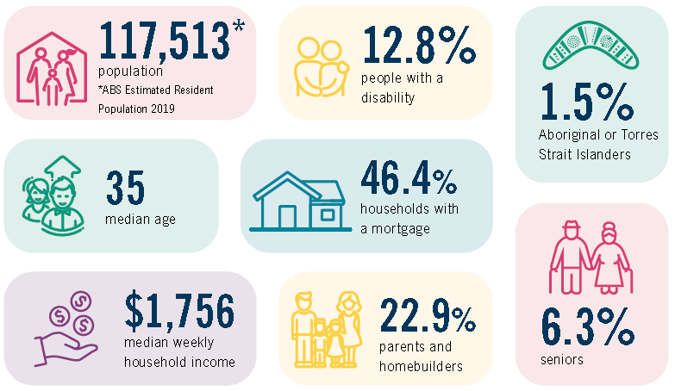

* Population: **117,513** (ABS Estimated Resident Population 2019)
* People with a disability: **12.8%**
* Aboriginal or Torres Strait Islanders: **1.5%**
* Median age: **35**
* Households with a mortgage: **46.4%**
* Median weekly household income: **$1,756**
* Parents and homebuilders: **22.9%**
* Seniors: **6.3%**

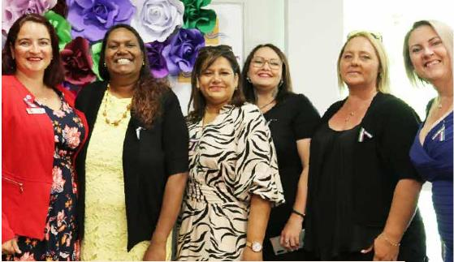  
**Cr Chontelle Stone, Marissa Verma - Bindi Bindi Dreaming and other guests at International Women's Day - March 2020**

# Cultural Diversity in Cockburn

## Diversity statistics in Cockburn from the 2016 Census

Australian Census 2016 results show that the City of Cockburn is becoming more culturally diverse. Overall, 34.1 per cent of the population was born overseas.

**The most common ancestries**



* English: 25%



* Australian: 21%



* Italian: 7%



* Irish: 6%



* Scottish: 6%

**The most common countries of birth**



* Australia: 60%



* England: 7%



* New Zealand: 3%



* Philippines: 2%



* South Africa: 2%



* India: 2%

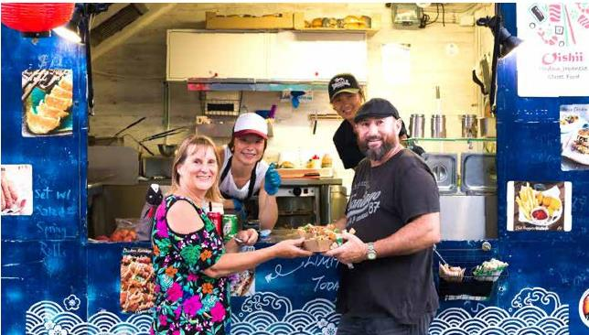  
**Community Concert - February 2020**

## The common languages other than English spoken at home

In 2016, 21.4 per cent of residents spoke a language other than English at home, again above the average for WA (19 per cent).

Hello in Mandarin language.

* Mandarin: 3%

Hello in Italian language.

* Italian: 2%

Hello in Croatian.

* Croatian: 1%

Hello in Portuguese.

* Portuguese: 1%

Hello in Tagalog.

* Tagalog: 1%

**The most common responses for religion**

* No Religion: 32%
* Catholic: 29%
* Anglican: 11.5%
* Not Stated: 9%
* Christian 3%

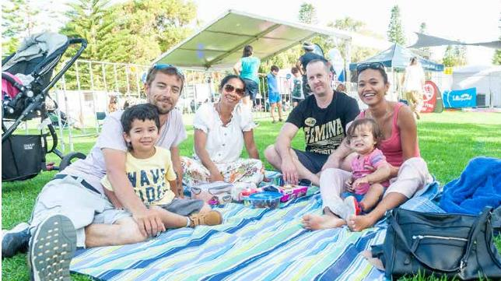  
**Coogee Live event - March 2020**

# Achievement of Community Objectives

## Strategic Community Plan

The City’s Strategic Community Plan 2016-2026 sets the strategic direction for the organisation. A formal major review of the plan including extensive community consultation was undertaken this financial year as part of the planning cycle. The Corporate Business Plan 2016-2020 and Annual Business Plan detail area-specific projects related to the Strategic Community Plan, some of which are detailed below.

The Strategic Community Plan has five key community objectives:

1. **City Growth**
2. **Moving Around**
3. **Community, Lifestyle and Security**
4. **Economic, Social and Environmental Responsibility**
5. **Leading and Listening.**

The City measures its achievements of these plans by using a number of methods. Following are the key highlights from 2019-20, with the majority of the City’s achievements documented throughout this report.

Other measures that demonstrate the City’s progress towards the achievement of the objectives outlined in the Strategic Community Plan include:

* Community Scorecard results
* Customer satisfaction survey results
* Awards
* Visitors
* Jobs and labour statistics
* Community engagement
* State of Sustainability Report and the Internal Audit Report.

## Highlights from the Year

### City Growth

**Planning for the City’s population growth while maintaining our strong financial position**

* The first stage of the concept and business planning for the new Council and Administration Centre in Cockburn Central was completed
* The draft Local Planning Strategy has been developed which closely aligns with the Strategic Community Plan 2020-2030
* Review of the Local Commercial Activity Centres Strategy and the Economic Development Framework has commenced in readiness for Council and community consideration next financial year.

### Moving Around

**Facilitating safe, efficient, connected and sustainable movement around the City**

* The City continued to play an active role in the Westport Local Government Reference Group with the release of the Westport Taskforce Report identifying a number of options for the outer harbour which require further research
* The draft Integrated Transport Plan has been significantly progressed providing a strategic framework for the City’s transport related plans
* The City participated in reference groups for several major road works under the control of Main Roads WA including Armadale Road Bridge and duplication, the Kwinana Freeway widening, and the North Lake Road Bridge
* Completed a number of major roads projects including Verde Drive extension and roundabout and the design of Jandakot Road duplication stage two between Berrigan Drive and Solomon Road.

### Community, Lifestyle and Security

**Providing safe, attractive, healthy programs and infrastructure for a diverse range of activities and people**

* Two major community facilities were constructed and opened, the new Lakelands Hockey and Sporting Facility, and the new Jandakot Volunteer Bushfire Brigade facility
* The draft Library Services Strategy has been completed in readiness for Council consideration in the new financial year
* The detailed designs of Frankland Park Sport and Community Facility, Malabar Park BMX Facility, and Treeby Community and Sports Centre are underway for construction to commence next financial year
* Following extensive community consultation the building concept design for the Aboriginal Cultural and Visitors Centre was completed
* Additional CCTV cameras and infrastructure were installed in Port Coogee and Cockburn Central West adding to the City’s extensive CCTV network
* A review of operational hours specific to the ARC Health Club resulted in the provision of a 24-hour access gym service.

### Economic, Social and Environmental Responsibility

**Enabling a sustainable future economically, socially and environmentally including business activity, job opportunities and sustainable use of resources**

* The State of Sustainability Report was completed, which details a comprehensive update on the initiatives that have been achieved in this area. These initiatives are across all four areas of sustainability – Governance, Environment, Society and Economy
* The roll out of the third bin was completed in readiness for the East Rockingham Waste from Energy facility
* The City received a State Government grant to determine the feasibility of producing fuel from hydrogen for the City’s motor vehicle fleet
* Construction of the Cockburn Wetlands Precinct redevelopment has commenced
* Accessible playground equipment, playground renewals, parks lighting upgrades and shade sails have been installed in a variety of parks across the district.

### Leading and Listening

**Being accountable to our community and engaging through multiple effective communication channels**

* The major review of the Strategic Community Plan is substantially complete with the City hearing from over 3,000 people during the various consultation phases, identifying the community aspirations for the next 10 years
* Review of the City’s key performance indicator reporting system has been substantially progressed with a new system planned to go live by early next financial year
* The City undertook over 100 community engagement consultations in relation to a wide variety of projects, strategies and programs.

## Community Scorecard Results 2020

The City annually measures residents’ perceptions of the services, infrastructure and facilities in Cockburn to gauge satisfaction levels. This year’s independent survey was undertaken by Catalyse using a representative sample of residents.

These measurements relate back to the City’s key objectives which are outlined on page 29 and covered in more detail in the City’s Strategic Community Plan.

### Results from the Community Scorecard 2020

| **Overall performance** | **Performance Index Score\*** |
| --- | --- |
| The City as a governing organisation | 69 |
| Sport and recreation facilities | 75 |
| Enjoy living in the City of Cockburn | 77 |
| Maintenance of local roads | 64 |
| Customer service | 68 |
| Preservation and promotion of local history and heritage | 68 |
| Management of the environment | 64 |
| Safety and security | 60 |
| Mobile security patrols | 62 |
| Promotion and adoption of sustainable practices | 63 |
| Community buildings, halls and toilets | 64 |
| Streetscapes | 56 |
| Footpath and cycleways | 58 |
| Development of their local area | 55 |
| Traffic management | 54 |
| Feel included and connected to the community | 63 |
| Cockburn ARC | 84 |

| **Percentage of population who agree** | **Agreement Index Score\*** |
| --- | --- |
| The City has developed and communicated a clear vision | 45 |
| The City has a good understanding of the community’s needs | 54 |

**\***The Performance Index Score is not a percentage score. It is calculated by taking into account the entire scale from strongly disagree to strongly agree. The Agreement Index Score is explained as a score out of 100 using the formula (average score – 1) ÷ 4 x 100.

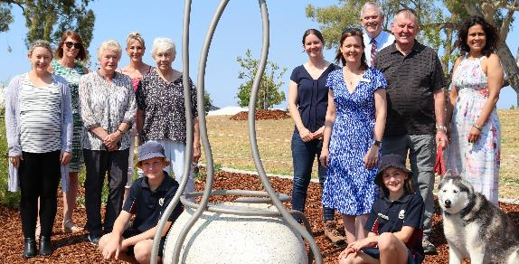  
**Unveiling of artwork and Cockatoo Perch at Goodwill Park - December 2019**

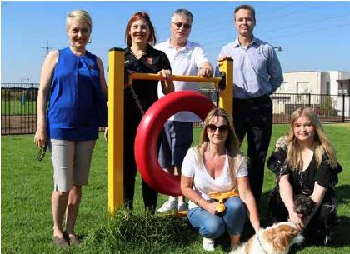  
**Back row (from left to right): Cr Chamonix Terblanche, Deputy Mayor Lara Kirkwood, Steven Greenwood – Hammond Park Community Association, Anton Lees - City of Cockburn. Front row (from left to right): residents Sharon Bloice and Ellise Greenwood at Baler Court dog park Hammond Park - December 2019.**

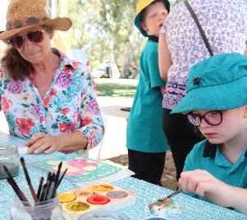  
**Celebrate Ability Day - November 2019**

## Customer Satisfaction Results

The City undertakes independent customer satisfaction surveys across a number of service units each year. The percentage of satisfied customers is reported throughout this report, under the relevant service unit. The percentage relates to the number of customers who scored the service seven or more out of 10. The surveys were conducted by Research Solutions.

## Awards and Achievements

| **Award or Agency** | **Place and Category** |
| --- | --- |
| 2019 #shoWcAse in Pixels Award | Winner, Best Digital/Professional |
| 2019 National Growth Areas Alliance (NGAA) Awards | Winner, Research and Practice |
| 2019 Regional Awards of Excellence – Strategic Planning Award | Winner, Community Sport and Recreation Facilities Plan |
| 2020 Institute of Public Works Engineering Australasia (IPWEA) Awards – WA Division | Winner, Excellence in Environment & Sustainability Award – Coogee Maritime Trail |
| BIZLINK Employer of the Year Award 2019 | Winner |
| 2020 Australian Fitness Awards | National Winner, Fitness Australia Not-for-profit Business of the Year Award – Cockburn ARC |
| WA Local Government 2019 Convention | Winner, Most Accessible Community in Western Australia – Metropolitan Council |
| Western Australian Coastal Awards for Excellence 2019 | Joint Winner, Coastal Design, Heritage and Tourism Award – Coogee Maritime Trail |
| Public Sector Commissioner Award | Young Leader of the Year 2019 |

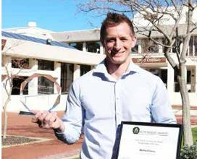   
**Michael Emery - City of Cockburn, Public Sector Commissioner Award 2019**

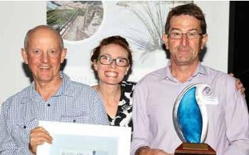  
**(From left to right): Craig Wilson - Coastcare, Vicky Hartill and Chris Beaton - City of Cockburn at WA Coastal Awards 2019**

## Community Engagement

The City undertakes community engagement throughout the year to seek feedback on various initiatives and to inform the community of its priorities.

The City’s focus is to inform, consult and provide opportunities for active participation in City projects and activities.

The City uses a variety of methods to seek feedback including listening posts, workshops, surveys, meetings, one-on-one conversations and more.

These projects are communicated using a number of mediums. Some examples include direct mail, newspaper advertisements, e-newsletters, social media and signage.

Over the past 12 months, the City has attracted community input via Comment on Cockburn including:

* **61,300** site visits
* **7,574** registered site users
* **1,800** new user registrations
* **3,380** survey responses

Some of the key projects undertaken during this period were:

**City Growth**

* Port Coogee Marina Expansion
* Cockburn ARC Health Club Expansion
* Better Neighbourhoods, Better Homes.

**Moving Around**

* Solomon Road Upgrades
* Gaebler Road Upgrades
* Fawcett Road Footpath and Resurfacing.

**Community, Lifestyle and Security**

* Arts and Cultural Spaces in Cockburn
* Future Council and Administration Building
* Treeby Community and Sports Centre.

**Economic, Social and Environmental Responsibility**

* Climate Change Strategy
* CCTV Policy Review
* Animal Management and Exercise Plan.

**Leading and Listening**

* Strategic Community Plan
* Your budget requests
* City of Cockburn draft Budget.

## State of Sustainability Report

The City of Cockburn’s 10th annual State of Sustainability Report is a snapshot of the City’s collective efforts in working towards a sustainable future.

The City had 76 indicators for sustainability across the organisation along with a number of high-level targets across five key sustainability areas including water conservation, waste minimisation, energy and emissions reduction, biodiversity and liveability. One hundred per cent of the key performance indicators were in progress or achieved during 2019-20 reflecting the City’s commitment to pursuing sustainability excellence.

Below is a snapshot of the City’s sustainability highlights for 2019-20.

### Sustainability Highlights

* Exceeded the renewable energy target with 26 per cent of Council buildings receiving power from solar photovoltaic (PV) systems
* Installed additional solar photovoltaic systems on the Coogee Beach Surf Life Saving Club and Beeliar Community Centre
* Sustainability Policy training module completed by all staff, via the online learning management system
* Procurement Policy updated to support local business, including compliance to the Modern Slavery Act and reinforce accessibility requirements for people with a disability
* Rehabilitated four hectares of bushland across the City with 68,000 seedlings
* Completed the roll-out of household garden waste bins
* Maintained a zero emissions fleet via the carbon offset program and delivered the City’s first carbon neutral event (Coogee Live)
* Integrated the City’s first electric vehicle into the fleet and installed two additional EV charging stations, including a fast-charge station in Cockburn Central
* Delivered a plastic-free revegetation program along our coastline
* Installed a possum bridge on Beeliar Drive to connect two nature reserves
* Launched the Turtle Tracker Program and installed 12 turtle protection enclosures
* Completed our sustainable and climate resilient future community engagement to guide the 2020 Climate Change Strategy
* Adopted the Environmentally Sustainable Design (ESD) Policy provision to ensure all new Council facilities set aside three per cent for innovative ESD initiatives
* Updated the Verge Improvement Guidelines and supported 30 residents in the Waterwise Verge Incentive Scheme
* Maintained Gold Waterwise Council status
* Concept design completed for the Aboriginal Cultural and Visitors Centre
* Implemented the 360 eProcurement system to help develop the local economy
* Awarded 18 Sustainability Grants to enhance sustainability outcomes in the community.

#### Governance – 18 KPIs (Key Performance Indicators)

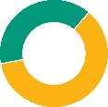

* **61% complete**
* **39% in progress**
* **0% not started**

Governance is the cornerstone of the City’s approach to sustainability. It enables the City to listen to and guide its residents and ratepayers in building a sustainable future.

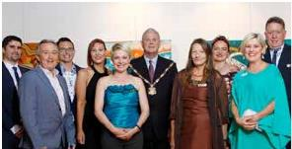  
**Elected Members**

#### Environment – 31 KPIs



* **55% complete**
* **45% in progress**
* **0% not started**

The environment is the foundation for sustainability in the City of Cockburn. Our natural areas and resources must be sustainably managed now and in the future.

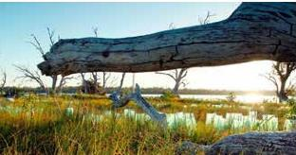   
**Bibra Lake wetland revegetation program**

#### Society – 18 KPIs



* **61% complete**
* **39% in progress**
* **0% not started**

Society is at the heart of sustainability in Cockburn. Our people, from our residents, ratepayers, volunteers and businesses, to schools, visitors and employees, are the driving force behind the way we develop, now and into the future.

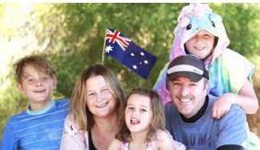   
**Australia Day Coogee Beach Festival 2020**

#### Economy – 9 KPIs

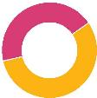

* **44% complete**
* **56% in progress**
* **0% not started**

A viable economy underpins the sustainable development of the City and must be resilient in the face of uncertainty and risk. The City’s economy is directly integrated with its society and environment.

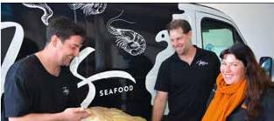   
**Fins Seafood with Sarah Kahle - City of Cockburn Business Engagement Officer**

# The Year Ahead 2020-21

Below are examples of major projects and services as detailed in the Corporate Business Plan 2020-2025.

| **Project** | **$Million** |
| --- | --- |
| Roads, footpaths, drains and cycleways including Karel Avenue and Rockingham Road / Phoenix Road roundabout; and Hope Road shared path | 27.3  (Includes State and Federal Government funding) |
| Parks, parks infrastructure and streetscapes | 24.25 |
| Implement Bibra Lake Management Plan | 0.52 |
| Expansion of Port Coogee Marina | 5.3 |
| Design and commence construction of the Aboriginal Cultural and Visitors Centre | 0.5 |
| Goodchild Park upgrade | 0.8 |
| Commence rollout of Smart City facility security and access control system | 0.3 |
| Henderson Waste Recovery Park upgrades | 3 |
| Implement Manning Park Master Plan | 0.49 |
| Construct Malabar Park BMX Facility | 1.65 |
| Construct Frankland Park Sport and Community Facility | 7.7 |
| Beale Park redevelopment | 0.5 |
| Len Packham Park sport lighting | 0.5 |
| Cockburn Coast Oval construction | 1.5 |
| Design and construct Treeby Community and Sports Centre | 3.1 |
| Design for Cockburn ARC – health and fitness expansion | 0.5 |
| Community grants and donations | 1.45 |
| Free community events | 0.9 |

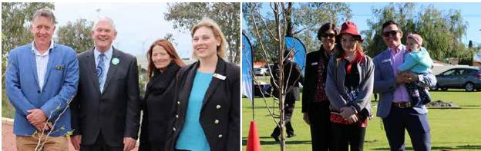  
**Left: Cr Philip Eva, Mayor Howlett, Cr Phoebe Corke, Deputy Mayor Lara Kirkwood at International Day of Peace - September 2020. Right: Tracey Irving - Spearwood Primary School, Spearwood Primary School Student, Cr Tom Widenbar at Hiroshima Day - August 2020.**

## Major Strategies, Plans and Studies

Following is a snapshot of major activities planned for 2020-21.

They are grouped under the most relevant outcome area from the Strategic Community Plan.

### Local Economy



**A sustainable and diverse local economy that attracts increased investment and provides local employment.**

* Develop and implement the Economic Development Framework and Action Plan
* Develop a business grants and sponsorship program for COVID-19 recovery and to support business development
* Complete a review of key City processes that businesses frequently use to identify process improvements
* Trial a new commercial food waste collection service.

### Environmental Responsibility



**A leader in environmental management that enhances and sustainably manages our local natural areas and resources.**

* Undertake a feasibility study for the use of hydrogen powered waste trucks
* Implement the new Climate Change Strategy 2020-2030
* Implement and review the Urban Forest Plan 2018-2028
* Review and update the Waste Management and Education Strategy 2013-2023
* Oversee implementation of the Roe 8 Rehabilitation Management Plan
* Implement the Bibra Lake and Manning Park master plans.

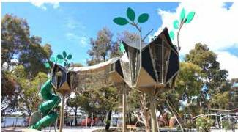   
**Bibra Lake Regional Playground**

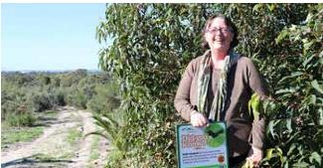   
**Dr Felicity Bairstow - Rehabiltating Roe 8 Advisory Committee at Roe 8 Corridor**

### Community, Lifestyle and Security



**A vibrant, healthy, safe, inclusive and connected community.**

* Review and update the Community Development Strategy and develop a Volunteering Strategy
* Undertake Cockburn Coast Oval construction
* Complete construction of the Cockburn Wetlands Precinct facilities
* Complete design and commence construction of the Frankland Park Sport and Community Facility, Malabar Park BMX Facility, and the Treeby Community and Sports Centre
* Install CCTV at priority locations and review the Community Safety and CCTV Strategy
* Complete the design of the Aboriginal Cultural and Visitors Centre
* Complete the planning for the expansion of the Port Coogee Marina.

### City Growth and Moving Around



**A growing City that is easy to move around and provides great places to live.**

* Prepare the new Local Planning Strategy and Scheme for the district
* Review and update the Integrated Transport Plan, incorporating the Road Safety Strategy and TravelSmart Plan
* Complete the Jandakot Road duplication and Verde Drive and Prinsep Road extensions
* Construct new and refurbished footpaths, and cycle paths
* Commence the review of the Land Management Strategy.

### Listening and Leading



**A community-focused sustainable, accountable and progressive organisation.**

* Complete the Operations Centre Building upgrade stage two
* Implement the Sustainability Strategy 2017-2022
* Develop and implement two Smart Cities projects in partnership with the South West Groups – Smart Street lighting and LoRaWAN network
* Implement COVID-19 financial measures including zero per cent rates, fees and charges increase for 2021
* Review the Community Engagement Policy and Framework
* Review and implement the Workforce Plan 2017-2022.

# Rates Allocation

The City uses rates to fund a range of services, with the following (percentage of total spend) allocated for 2020-21.

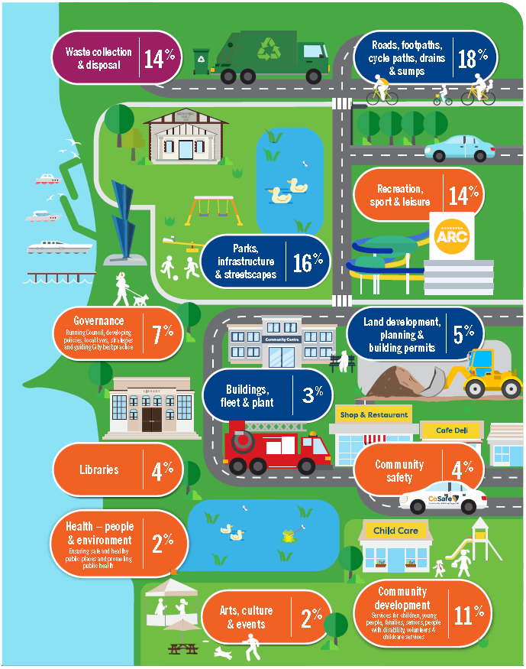

* Waste collection & disposal: 14%
* Roads, footpaths, cycle paths, drains & sumps: 18%
* Recreation, sport & leisure: 14%
* Parks, infrastructure & streetscapes: 16%
* Governance (Running Council, developing policies, local laws, strategies and guiding City best practice): 7%
* Land development, planning & building permits: 5%
* Buildings, fleet & plant: 3%
* Libraries: 4%
* Community safety: 4%
* Health – people & environment (Ensuring safe and healthy public places and promoting public health): 2%
* Arts, culture & events: 2%
* Community development (Services for children, young people, families, seniors, people with disability, volunteers & childcare services): 11%

# Organisational Structure

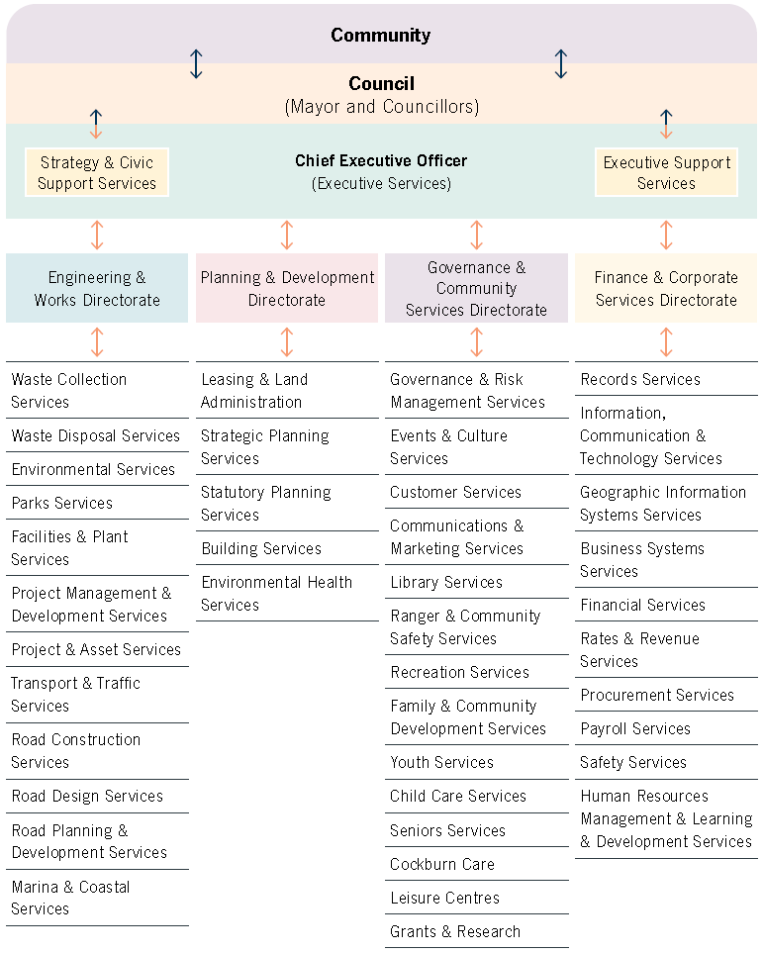

The chart above displays the organisational structure of the City of Cockburn. Arrows point in both directions at each level. The chart is presented below as a series of bulleted lists.

At the top of the chart is:

* **Community**, followed by
  + **Council (Mayor and Councillors)**, followed by
    - **Chief Executive Officer (Executive Services)**

**Chief Executive Officer (Executive Services)** is divided into two sections:

* Strategy & Civic Support Services
* Executive Support Services.

Four directorates fall under **Chief Executive Officer (Executive Services)**:

* Engineering & Works Directorate
* Planning & Development Directorate
* Governance & Community Services Directorate
* Finance & Corporate Services Directorate

Each of these four directorates are further divided into a number of areas as follows.

**Engineering & Works Directorate:**

* Waste Collection Services
* Waste Disposal Services
* Environmental Services
* Parks Services
* Facilities & Plant Services
* Project Management & Development Services
* Project & Asset Services
* Transport & Traffic Services
* Road Construction Services
* Road Design Services
* Road Planning & Development Services
* Marina & Coastal Services

**Planning & Development Directorate:**

* Leasing & Land Administration
* Strategic Planning Services
* Stratutory Planning Services
* Building Services
* Environmental Health Services

**Government & Community Services Directorate:**

* Governance & Risk Management Services
* Events & Culture Services
* Customer Services
* Communications & Marketing Services
* Library Services
* Ranger & Community Safety Services
* Recreation Services
* Family & Community Development Services
* Youth Services
* Child Care Services
* Seniors Services
* Cockburn Care
* Leisure Centres
* Grants & Research

**Finance & Corporate Services Directorate:**

* Records Services
* Information, Communication & Technology Services
* Geographic Information Systems Services
* Business Systems Services
* Financial Services
* Rates & Revenue Services
* Procurement Services
* Payroll Services
* Safety Services
* Human Resources Management & Learning & Development Services

# Remuneration of Senior Employees

## Annual Salary of Senior Employees

| **Annual Salary Range ($)** | **Number of Employees** |
| --- | --- |
| 100,000 – 109,999 | 45 |
| 110,000 – 119,999 | 40 |
| 120,000 – 129,999 | 21 |
| 130,000 – 139,999 | 12 |
| 140,000 – 149,999 | 3 |
| 150,000 – 159,999 | 3 |
| 160,000 – 169,999 | 4 |
| 170,000 – 179,999 | 2 |
| 180,000 – 189,999 | 3 |
| 190,000 – 199,999 | 2 |
| 200,000 – 209,999 | 2 |
| 210,000 – 219,999 | 2 |
| 220,000 – 229,999 | 0 |
| 230,000 – 239,999 | 0 |
| 240,000 – 249,999 | 1 |
| 250,000 – 259,999 | 0 |
| 270,000 – 279,999 | 1 |
| 280,000 – 289,999 | 1 |
| 290,000 – 299,999 | 0 |
| 300,000 – 309,999 | 1 |
| 310,000 – 319,999 | 0 |
| 320,000 – 329,999 | 0 |
| 330,000 – 339,999 | 1 |
| 370,000 – 379,999 | 1 |

1. The amounts include salary, super, motor vehicle allowances and performance payments. In five cases, senior employees have a motor vehicle provided and do not take a motor vehicle allowance. The nominal value of the motor vehicle equates to $17,000 (two employees), $20,300 (two employees), $22,650 (one employee). These nominal values are not included in the above figures
2. The former chief executive officer received a confidential termination payment in addition to the reported base salary
3. Due to the role of chief executive officer being vacant for a substantial portion of the 2019-20 year, two directors undertook acting duties. This is reflected in the reported salaries.

# Governance & Community Services Directorate

The aim of the Governance and Community Services directorate is to improve residents’ quality of life and to ensure good governance. The directorate is responsible for providing community safety and development initiatives, events, ranger services, recreation and community development and services, as well as communications including the operation of the customer contact centre.

## Highlights



**743** people from 62 countries became Australian citizens in Cockburn



**1.05 million** attendances at Cockburn ARC



**572,908** items issued by Cockburn libraries\



**8,935** jobs attended by rangers

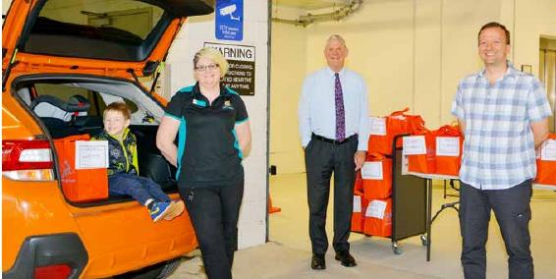  
**Cockburn Libraries mystery bags during COVID-19 - May 2020**

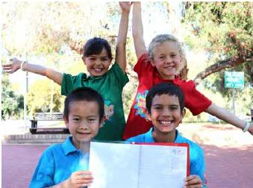 **Cockburn Children’s Reference Group - October 2019**

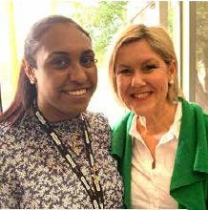 **City of Cockburn Odiya Pilot and Cr Lee-Anne Smith at a Long Table Lunch - October 2019**

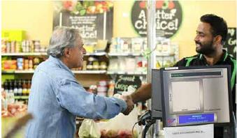 **BNB Fresh local business**

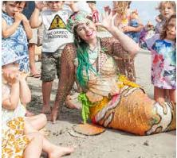 **Coogee Live event - March 2020**

## Governance

### Compliance

The Department of Local Government, Sport and Cultural Industries (DLGSCI) requires all local governments to complete a *Compliance Audit Return 2019* (CAR). The City’s submitted CAR indicated a conformity rating of 99 per cent. The City sought clarification from DLGSCI on 21 May 2020, on the accuracy of the information provided to the City by DLGSCI regarding one per cent non-compliance. To date, no response has been received by the City.

The City utilises an online compliance management users system for statutory forms such as financial disclosures, gifts, travel contributions and delegated authorities.

### Legislative Review

The City has completed a review of its Local Laws to ensure compliance with the National Competition Policy.

### Freedom of Information

The *Freedom of Information (FOI) Act 1992* gives members of the public the right to access documents held by local governments, subject to limitations. The City prepared, as required by section 96 of the FOI Act, an up-to-date information statement and made it available to the public. The City had 25 FOI requests in 2019-20.

### Public Interest Disclosure

The *Public Interest Disclosure (PID) Act 2003* promotes accountability within state and local government agencies and organisations by facilitating the disclosure of public interest information involving misconduct, offences and misuse of public resources or risks to public health or safety. The Act aims to protect informers who make public interest disclosures. Since the last published report, the City has had no disclosures under the PID Act.

### National Competition Policy

In 2007, all Australian governments recommitted to the Competition Principles. Agreement (CPA), (11 April 1995). The CPA is an inter-governmental agreement between the Commonwealth and state/territory governments that sets out how governments will apply National Competition Policy Principles to public sector organisations within their jurisdiction. The National Competition Policy itself concluded in 2005-06 and has been succeeded by Australia’s National Reform Agenda which is an addition to, and continuation of, the National Competition Policy reforms.

The Competition Principles Agreement (as amended 13 April 2007) sets out nominated principles from the agreement that now applies to local government. The provisions of clause 5 within the CPA require local government to report annually on the implementation, application and effects of Competition Policy. Competition Policy does not require contracting out or competitive tendering. It does not preclude local government from continuing to subsidise its significant business activities from general revenue, nor does it require privatisation of government functions. It does require local governments to identify their significant business activities and apply competitive disciplines to those businesses which compete with the private sector.

A number of the City’s services are exempt from the Competition Policy, as it applies only to business activities that generate income in excess of $200,000 from fee revenue that is directly generated from external users and an operating expenditure greater than $2m. Activities undertaken by the City which have previously been considered for market testing, owing to the competitive nature of the service include:

* Domestic waste collection
* Waste disposal business
* Cockburn ARC (leisure centre).

The City has resolved to retain the in-house provision of Cockburn ARC, domestic waste collection and waste disposal business.

### Risk Management

Over the past 12 months, the City continued to implement its Risk Management Framework and revised the strategic and operations risk registers to identify opportunities for improvement.

### Business Continuity

The declaration of the state of emergency in WA on 15 March 2020, as a result of the COVID-19 pandemic, required the City to implement its Infectious Disease Pandemic Business Continuity Plan. This plan, developed in accordance with guidelines from the WA Department of Health, enabled the City to identify and manage resources to continue its critical operations and delivery of essential services to the community.

### Internal Audit Plan

In accordance with the City’s Strategic Internal Audit Plan 2019-2020, the *Privacy of Data and Information* audit was conducted by ES2; a WALGA preferred Perth-based WA enterprise security and solution services provider. In the absence of applicable State legislation, the audit was conducted to:

* Determine what type of personal and sensitive information is held by the City of Cockburn and what the privacy considerations for the data held are; and
* develop appropriate documented processes for the collection, use, disclosure and securing of personal information in accordance with the requirements of the proposed WA privacy and responsible information sharing legislation.

The audit has led the City to develop and implement a Privacy Management Policy to manage personal and sensitive information and to position the City for compliance with Australian privacy principles and any proposed state legislation. This policy is in development.

### Complaints of Minor Breaches

The *Local Government Act 1995* (Section 5.121) requires a Register of Complaints against Elected Members to be maintained. For 2019-20, two official complaints were received and a censure imposed by the Standards Panel. It is necessary to have the details entered into the complaints register and published on the City's website.

#### Complaint 1 – made by the then CEO Stephen Cain, Complaints Officer

City of Cockburn Councillor Lee-Anne Smith, the then Deputy Mayor of the City of Cockburn, committed a minor breach of Regulation 7 (1) (a) of *the Local Government (Rules of Conduct) Regulations 2007 (WA)* when on 9 August 2019 she made false comments in an interview on ABC Radio Perth in respect to a notice of motion raised by her in relation to off-road motor vehicle use which was discussed (but not passed) at the Ordinary Council Meeting of 8 August 2019.

On 20 November 2019 the Local Government Standards Panel ordered Cr Smith to publicly apologise to the Council and the City of Cockburn at the next Ordinary Council Meeting. Due to Cr Smith’s suspension, as the result of another matter, the public apology was provided at the 9 April 2020 Ordinary Council Meeting.

#### Complaint 2 – made by the then CEO Stephen Cain, Complaints Officer

City of Cockburn Cr Lee-Anne Smith, the then Deputy Mayor of the City of Cockburn, committed a minor breach of Regulation 7 (1)(b) of the *Local Government (Rules of Conduct) Regulations 2007 (WA)* when on or before 1 October 2019, following a reasonable request, she did not remove material from Facebook relating to a petition that was put forward regarding the Bartram Road footbridge.

On 10 June 2020 the Local Government Standards Panel ordered Cr Smith to publicly apologise to the Council and the City of Cockburn at the next Ordinary Council Meeting. The public apology was provided at the 13 August 2020 Ordinary Council Meeting.

## Library Services

Delivers exciting and an ever-changing collection of materials, as well as a calendar of interesting events, activities and programs for all ages and interests through the City's three libraries; Coolbellup, Spearwood and Success.

**Achievements**

**(note: library statistics were severely impacted by the COVID-19 shut down)**

Customer service rating (see customer satisfaction results, page 36 for details): 94 per cent.

* Annual library visits decreased by 22 per cent to 287,109
* The number of items issued decreased by 18 per cent to 572,908
* Annual attendances to library events and services decreased by 31 per cent to 18,132
* Library Strategic Plan for 2020-2025 was developed
* Cockburn History website received a commendation in the 2020 Western Australian Heritage Awards in recognition of the ongoing commitment to the preservation of the City’s stories
* After hours return chutes using RFID technology installed at both Spearwood and Success libraries
* A newly created ‘Newmarket’ collection to showcase popular and trending books has been launched at Spearwood and Success libraries
* Better Beginnings is about promoting the importance of reading to babies and encouraging early literacy and this year the library service distributed early literacy kits to 1,714 children through 13 schools and five child health clinics
* A range of virtual programs ran including a weekly virtual storytime, virtual STEAM sessions and weekly creative kids activities for children at home, while the library was unable to hold face-to-face events
* A special storytime aimed at father figures, called Blokes do storytime launched and held monthly on Saturday mornings
* Adult events held included Nyungar language classes, author talks, tech help, health and wellbeing, English conversation classes and sessions on sustainable lifestyles.

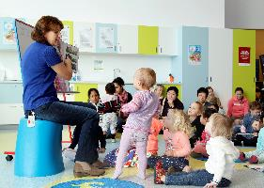   
**Storytime session at Success Library**

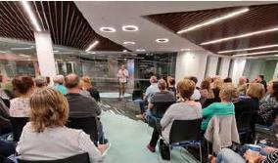   
**Peter Rowsthorn at Success Library**

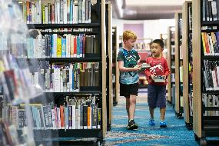   
**Spearwood Library**

## Recreation and Community Safety Services

### Ranger & Community Safety Services

Ranger & Community Safety Services work to improve the safety and security of the City’s residents and visitors. This is done by proactively educating residents on community safety, implementing mitigation strategies and applying local and state laws.

#### Ranger Services

**Achievements**

* Finalised the development of a five-year Animal Management and Exercise Plan
* Created an online registration process for dog and cat registrations
* The rangers attended 8,935 jobs, with dog (2,589) and parking-related (1,744) matters the most significant
* During the year, City rangers attended 1,255 dog wandering and dog pick-up requests, of which 428 were collected and impounded. Of these:
  + 364 dogs were released to owners
  + 61 dogs were sent to rescue and rehoming
  + Three dogs were euthanised (on medical grounds)
  + 376 cats were captured, of which
  + 45 were released to owners
  + 329 were sent to rescue and rehoming
  + Two cats were euthanised (on medical grounds).

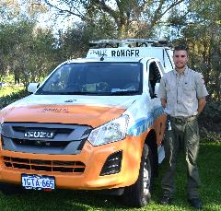   
**Ranger at Bibra Lake Fun Run - September 2019**

#### Community Security & Safety Service (CoSafe)

After an extensive review, the City’s Community Security & Safety Service (CoSafe) has been extensively changed ready to commence in the 2020-21 financial year. The new service includes the employment of internal staff to oversee the service 24 hours, seven-days-a-week. The new CoSafe service not only reports suspicious activities and anti-social behaviour, but also provides limited municipal law enforcement response for ranger-related matters outside of normal operating hours.

**Achievements**

* Commenced a complete restructure of the CoSafe service, with increased service and an annual cost reduction of more than $400,000 per year
* Average response time of eight minutes to community request for assistance
* Completion of a new state-of-the-art CCTV Operations Centre to monitor the City’s CCTV network
* Finalised implementation of artificial intelligence software on selected CCTV cameras to increase community safety and provide better response by CoSafe.

#### Safer City

With a recent restructure of the Ranger & Community Safety Services, the Safer City team has begun the coordination and review of the community safety initiatives.

**Achievements**

* Reviewed the City’s Crime Prevention and Community Safety Plan
* Provided support to the Neighbourhood Watch and Crime Prevention Reference groups.

#### Emergency Services

The City’s Fire and Emergency Management team has continued to promote preparedness and disaster recovery to the community.

**Achievements**

* Completed construction on the Jandakot Volunteer Bush Fire Brigade building
* Planned autumn hazard reduction burns throughout the City
* Completed evacuation centre training for staff and the City’s Local Emergency Management Committee
* Provided ongoing support to the City’s Local Emergency Management Committee and Bushfire Advisory Reference Group
* Provided bushfire response support to regional bushfires throughout WA
* Provided support to volunteer’s who deployed to eastern state bushfires.

### Recreation Services

Provide and facilitate a range of sport, recreation and leisure opportunities for residents of the City.

**Achievements**

* Customer service ratings (see customer satisfaction results, page 36 for details):
  + Facility booking and management services: 91.2 per cent
  + Management of facilities: 87.3 per cent
  + Sports field hire and facility booking service: 97.3 per cent
  + Management of sports fields: 91.9 per cent
* Implemented online payments for casual facility bookings.

#### Recreation Future Planning

In 2018-19, Council adopted the Western Suburbs Sporting Precinct Study (WSSPS) which investigated the development of seven different sport and recreation reserves in the western suburbs.

Following the adoption of the WSSPS, the Community, Sport and Recreation Facilities Plan 2018-2033 was adopted by Council. This plan will guide the development of community, sport and recreation facilities over the next 15 years.

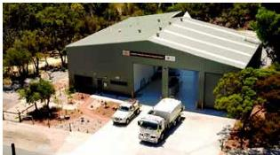   
**Jandakot Volunteer Bush Fire Brigade station - January 2020**

#### Capital Works

The City progressed and completed a number of capital works projects, in particular the completion of the $6.53m Lakelands Hockey and Sporting Facility in August 2019.

New sports floodlighting was installed at Botany Park, Atwell Reserve and the new Treeby sporting reserve.

Planning and design has progressed for a new community and sporting facility at Treeby, the Malabar Park (Cockburn BMX) redevelopment and Frankland Park development, with construction scheduled to commence for all three in 2021.

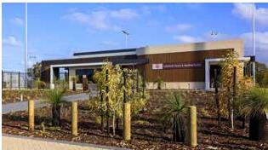   
**Lakelands Hockey and Sporting Facility - August 2019**

#### Club Development

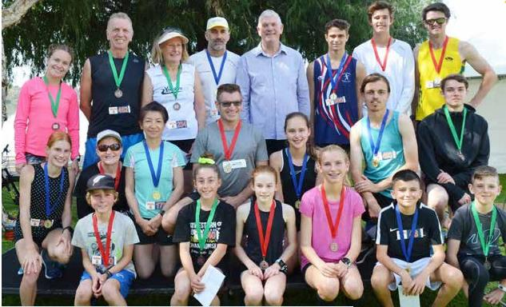  
**Bibra Lake Fun Run winners and Mayor Howlett - September 2019**

**Achievements**

* The City continued to provide ongoing support through its club development initiative, ‘Champion Clubs’ which included:
  + Four workshops and events for local sporting club volunteers
  + Contribution of $43,004 to 24 clubs for sporting equipment and capital works
  + KidSport – contributed $111,203 (768 vouchers) towards 120 local sporting clubs (Impacted by COVID-19)
  + 617 people registered for the Bibra Lake Fun Run
  + The City’s Junior Sport Travel Assistance Program helped fund 66 junior athletes to represent WA or Australia in their chosen sport at a national and/or international event, equating to $27,600 in grants (Impacted by COVID-19).

#### Cockburn Aquatic and Recreation Centre (Cockburn ARC)

With a focus on member and community engagement in 2019, Cockburn ARC then moved its attention to supporting its member base and community throughout COVID-19 and the subsequent recovery phases.

The centre closed due to COVID-19 on Friday 20 March 2020, with all memberships automatically suspended. It reopened with very restricted numbers under a pay-as-you-go model in phase two restrictions on Monday 25 May. Participation increased from phase three on Saturday 6 June, where the gym, pools and group fitness studios were able to operate under a cap of 100 members per zone. Members were provided complimentary access until full membership recommenced from Thursday 25 June.

**Achievements**

* 1.05 million people attended the centre over the year, while this was a decline of 25 per cent overall from the previous year, the centre was closed for 78 days due to COVID-19. Average attendances while open were over 3,500 per day and it remained the most attended facility in Perth
* Following consultation with members, the centre introduced 24/7 operating hours in the health club, with security on-hand during non-staffed hours
* While memberships were suspended during COVID-19, by the end of June membership numbers exceeded those of the same period the previous year
* In 2019, the centre held several activations for their members and the community including Group Fitness High ARChiever month, Tour de’ARC Indoor Cycle, Aquathon, Noah’s ARC Day, and partnered with Fremantle Football Club and the City’s events team to host a Christmas Collective community event on Victor George Kailis Oval
* In May 2020, Cockburn ARC was named Fitness Australia’s Not-for-Profit Business of the Year
* The centre continues to rate highly with the community, having a net promoter score of 67. As part of the City’s annual community scorecard analysis, Cockburn ARC scored a 98 per cent positive rating from all respondents resulting in a Performance Index Score of 86, three points more than the previous year.

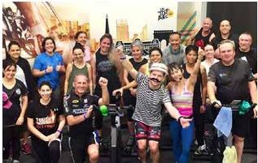   
**Tour de’ARC Indoor Cycle - July 2019**

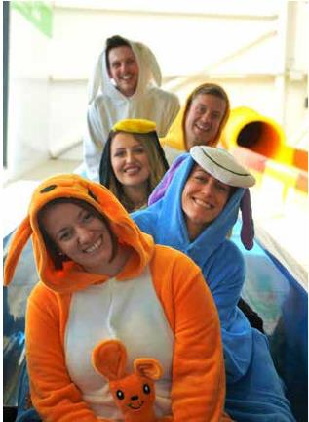   
**Noah’s ARC Day - August 2019**

## Community Development and Services

### Youth Services

The City provides a broad range of activities and programs that are accessible to all young people aged 10-24 years that live in the City.

Youth Services administers grant and Council-funded services, programs and community development. To increase support, activity and leisure opportunities for young people, Youth Services provides a range of events and facilities.

Customer service rating Youth Centre (see customer satisfaction results, page 36 for details): 94 per cent.

Completed a Youth Digital Engagement Strategy and recruited a part-time youth engagement officer.

#### Youth Support Services

**Achievements**

* Employed three full-time youth workers to support at-risk young people aged 12-18 years and their families
* Facilitated a successful motocross program in collaboration with Motorcycle Australia, Coastal Motocross Club and the WA Police
* Supported 68 young people to develop and work intensively towards the achievement of individualised case plan goals.

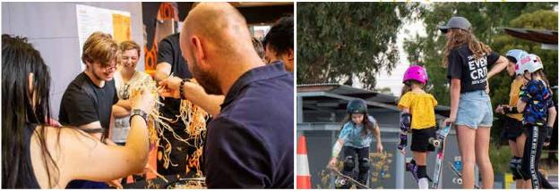 **Left: Chinese New Year at Youth Centre. Right: Skateboarding clinic.**

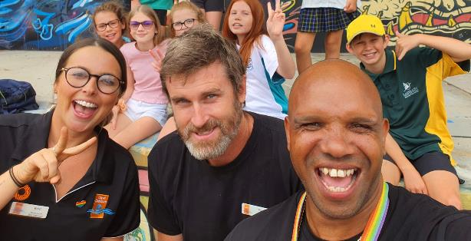  
**Cockburn Youth Services team (from Left-Right) Kerri Mulford, Paul De Bruin and Tim Kelly.**

#### Youth Centre

**Achievements**

* Supervised six placement students, one of whom was later employed by the centre
* Youth Pride event attended by 130 young people. A number of specialised LGBTIQA+ youth support agencies attended, helping build knowledge of specialist support networks for local young people
* Keys4Life program delivered to 54 young people including specialised and personalised sessions for young parents
* Online programming during COVID-19 shutdown had 115 contacts with young people
* Cockburn Youth Centre Drama Program participated in Perth Fringe Festival producing and presenting Bright Star for the festival. Cockburn Youth Centre also became an official Fringe World venue
* 11,530 centre contacts with young people from July 2019 to June 2020.

#### Youth Development

**Achievements**

* Expanded the Youth Advisory Committee (YAC) to 13 members
* Promoted 12 young person-focused ‘good news stories’ including the City’s Young Citizen of the Year. This young person was selected for an international youth exchange to Hong Kong
* Received and processed Cockburn Youth Fund application from students from Kennedy Baptist College for a beach clean-up at Woodman Point. Successful event with 40 participants
* Facilitated a successful eight-week Youth Leadership Program with 15 young people; young people improved school results and engagement and gained local employment
* Launched PEAK, the new online youth leadership program for 11 young people during COVID-19 peak and quarantine
* Delivered an online Youth Week WA 2020 event with six stories of inspiring local young people.

#### Youth Programs and Events

**Achievements**

* 311 young women attended six skateboarding clinics
* 949 youth participated in three school holiday excursion programs
* Provided 174 supervised driving hours to young people through the RYDE supervised driving program
* 435 young people attended the after school Blissco mobile youth sessions
* 36 riders competed in two Pump Track Time trials held at Yangebup Pump Track - the first of its kind in WA.

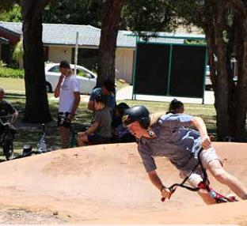   
**Yangebup Pump Track - November 2019**

### Child Care & Seniors Services

#### Child Care Services

This service unit administers income from fees for the operation of the Family Day Care (FDC) service and In-home Child Care (IHC) service. Child Care Services (CCS) operate in compliance of relevant legislation and focus on continuing quality improvement. To support the child care legislative inclusion of sustainability, the services work in liaison with Little Green Steps which shares office space within the CCS venue. As essential services during COVID-19 restrictions, the CCS staff had a significantly increased workload due to the specific requirements of the pandemic.

#### Family Day Care Service

The City supports the assessment, monitoring, advice and training provided to educators by qualified and experienced staff who guide and monitor educators providing quality early childhood education and care from their approved family day care residence. Compliance of the Service Educator Registration Membership Agreement, the National Quality Framework legislation, Early Years Learning Framework curriculum and National Standards is required.

**Achievements**

* Family Day Care Service (FDC) provided 300,0000 hours of early childhood education and care
* At 30 June 2020 the FDC Service operated with 55 FDC educators registered under the Service Educator Membership Agreement and its policies.

#### Family Daycare In-home Child Care Service

The City supports the continuing assessment, monitoring, advice and training provided to educators by qualified and experienced staff. Staff guide and monitor educators who provide quality early childhood education and care for children within the child’s own home. In the Commonwealth’s changed criteria for In-home Care eligibility and the ceased funding arrangement, the service operates on a small fee for service from educators and parents of children in care.

**Achievements**

* In-home Child Care (IHC) service provided 44,369 hours of early education and care within the IHC Service
* At 30 June 2020 the service was operating with 16 IHC educators registered under the Service Educator Membership Agreement and its policies.

### Cockburn Care

Cockburn Care delivers grant and fee-funded support services aimed at increasing the wellbeing of frail, aged people and people with disability. Services include personal care, day centre programs, supported transport, home help services, home maintenance and social support. These services enable frail seniors and people with disability to remain living in the community.

**Achievements**

* Customer service rating (see customer satisfaction results, page 36 for details): 98.5 per cent
* Provided essential home services and home care package services throughout all phases of COVID-19 shutdowns
* Restructured to increase home care package service scope and hours of services
* Provided a total of 34,256 hours of service and 4,699 transport trips.

#### COVID-19 Essential Service Provision

Maintaining services during the shutdown required:

* Development of policy and procedure in response to a global pandemic
* Individual negotiation of essential services with every client and their family
* Training and support for the frontline workforce
* Courage and commitment from the entire workforce.

#### Home Services

A variety of basic services are provided including help with cleaning, shopping, paying bills, social support, respite, personal care and transport.

**Achievements**

Provided 11,818 hours of client services.

#### Social Clubs

Social clubs provide a range of activities, refreshments and outings, and also function as respite for carers. Programs are customised for seniors, younger people with disability and people with dementia. Transport is provided in specially equipped vehicles to allow easy access for people with physical disability.

**Achievements**

Provided 13,917 hours of client services across three funding streams.

#### Home Care Packages

Home care packages are individually funded to meet the needs of seniors with extensive and complex support needs.

**Achievements**

Provided 8,922 hours of client services.

#### Kwobarup Aboriginal Club

This social club caters specifically for Aboriginal people and runs an art program, activities and outings.

**Achievements**

Provided 2,375 hours of client services.

#### National Disability Insurance Scheme

This scheme provides individually-funded, customised services for people with disability. The City-run Cockburn Care provides centre-based social club services.

**Achievements**

Provided 4,505 hours of client services.

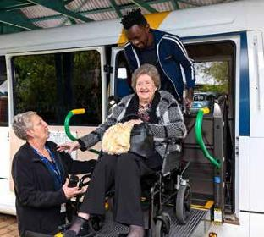   
**Cockburn Care - Jean Willis Centre**

### Seniors Services

Seniors Services administer a range of City-funded services, programs, events and facilities aimed at providing and developing increased amenity, age-friendly and leisure opportunities for seniors.

The Age-Friendly Reference Group commenced in October 2018. The group is working on age-friendly initiatives and supporting the implementation of the City of Cockburn Age-Friendly Strategy 2016-2021.

#### Cockburn Seniors Centre

**Achievements**

Customer service rating (see customer satisfaction results, page 36 for details): 99 per cent

* 1,102 members
* Average 1,700 visits per month
* 94 volunteers contributed more than 250 hours per week
* 477 people attended Healthy Living classes for over 50s
* Seniors Centre closed for 10 weeks between March and June 2020 due to COVID-19.

### Family & Community Development

This area administers grant and City-funded services, programs, community development, community engagement and events aimed at increasing the capacity, activity and wellbeing of individuals and families.

#### Community Development

This service aims to build capacity in the community by working directly with community members, volunteers and not-for-profit and community groups. A range of services and resources are provided to not-for-profit groups to support and contribute to a community in which people feel a sense of belonging, connection and contribution.

**Achievements**

* 51 households registered for Neighbour Day as part of the Get to know your Neighbour Program
* Six training workshops to develop skills to build capacity within the community were attended by 127 community leaders and volunteers
* 19 community-led projects and events were delivered through the Project Support Program initiative.

#### Cockburn Volunteer Resource Centre

**Achievements**

* 1,674 one-on-one individual volunteer consultations were conducted, 2,047 referrals were made to place prospective volunteers into community roles
* 222 volunteer organisations were assisted
* The 2019 Inspirational Volunteer Awards attracted 73 nominations from 41 organisations
* 2,048 Very Important Volunteer (VIV) Cards were issued, supported by 86 local businesses.

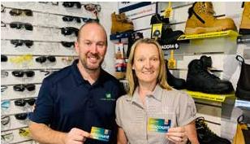   
**Local business Visual Workwear took park in the VIV Program**

#### Support Services

Support Services include the City’s grant-funded Financial Counselling and Cockburn Support services. Together, these services provide counselling, information, advocacy, options and referrals to people living in the City.

**Achievements**

* The Financial Counselling Services assisted 610 individuals and families in face-to-face consultations and the provision of a range of workshops
* Cockburn Support Service helped 622 individuals and families in face-to-face consultations, support groups and workshops.

#### Children’s Development

A community development role responding to the needs of children and families in the City, as well as networking and advocating about issues and service gaps related to children up to the age of 12.

**Achievements**

* Customer service rating (Perth Market Research): 88 per cent very satisfied with Froggy’s outdoor playgroup, 87 per cent with the skate park clinics and 92 per cent with Teddy Bears Picnic event
* Compiled a Play Space Plan to help guide future play provision decisions in the City
* Organised a community art mural project with a local artist and school children to paint two quarter basketball courts and backboards with their own designs – one in MacFaull Park, Spearwood and one in Tapper Reserve, Atwell
* Froggy’s Fun on the Green outdoor playgroup, attracted 1,379 adults and 1,763 children in term three, four (2019) and term one (2020). It closed during COVID-19 lockdown, but opened on a smaller booking system basis late in term two. 81 parents and 100 children attended
* 1,242 6-12 year olds participated in summer skate park clinics across four skate parks
* 80 parents, including 30 fathers attended a free first aid parent workshop.

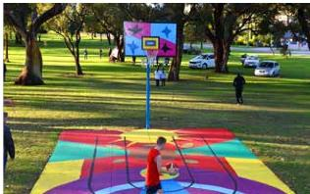   
**McFaull Park Mural Project**

#### Cockburn Parenting Service

A service for parents of children from birth to 18 years of age, support for parents and carers to manage the challenges of parenting, build knowledge, skills and confidence, understand children’s development and identify local community supports. This service is delivered through the provision of parenting courses, workshops, parent and child groups, family events and individual consultations.

**Achievements**

* Delivered 26 parenting courses or workshops to parents, including Parenting by Connection, Circle of Security, Engaging Adolescents, and Tuning in to Kids. The service offered online parenting courses this year and will continue to offer online as well as face-to-face groups
* Community education sessions including Talking with your Teen, Building Resilience, Toilet Training and First Aid were delivered to 290 people
* Support, information, parent education and referral was provided to 1,057 individuals through groups, workshops, and consultations.

#### Cultural Diversity

A community development role working with people of culturally and linguistically diverse (CaLD) backgrounds to ensure Cockburn is a welcoming and inclusive environment for all. The City provides opportunities to enhance a sense of belonging and enable CaLD residents to fully participate in social, cultural, civic, and economic life.

**Achievements**

* The Coogee Live festival was held over the first weekend in March 2020 with cultural dance classes and a range of multicultural performers. This coincided with Harmony Week which is celebrated annually
* English classes for the community are delivered weekly at Spearwood and Success libraries and a third session with crèche provided at Coolbellup Hub
* A joint initiative between the City and Multicultural Futures has led to consideration of a future multicultural hub to be located in Cockburn. A report on good practice for multicultural hubs has been provided by Multicultural Futures
* The City became a member of Welcoming Cities in 2019. The City’s Cultural Diversity Strategy and the implementation of its actions is guided by Welcoming Cities National Standards
* Citizenship ceremonies are held monthly at the City with the cultural diversity officer ensuring provision of information on the City’s support services
* Close contacts are built and maintained with a number of cultural groups and faith-based groups across Cockburn. Some of the key ones include the Chinese, Filipino and Muslim communities. Staff are able to assist with supporting their endeavours and projects, and building capacity of their communities.

#### Aboriginal Community Development

This service provides information and support to Aboriginal community groups and individuals to strengthen relationships, increase communication and encourage the development of ideas and activities. The service works in partnership with the Aboriginal Reference Group and implements the Reconciliation Action Plan.

**Achievements**

* NAIDOC Week 2019 had the theme ‘Voice, Treaty, Truth’, celebrating the Aboriginal languages, stories and culture that are precious to our nation, and aiming for the true stories of colonisation to be told, heard and acknowledged
* NAIDOC Week annual flag-raising ceremony was held with a Welcome to Country, storytelling by local Aboriginal community members and leaders, and a morning tea
* Reconciliation Week 2020 had the theme of ‘In This Together’, which coincided with COVID-19, so all activities were delivered online including the film ‘In My Blood it Runs'
* Aboriginal cultural competency training was delivered to more than 73 staff
* Work continued with the concept design for the City’s proposed Aboriginal Cultural and Visitors Centre, with a new grant application submitted to Lotterywest
* The City’s annual Reconciliation Action Plan report was submitted to Reconciliation Australia
* An Aboriginal health and wellbeing day was held in Success, an Aboriginal women’s health event at Coolbellup, and the weekly My Time Aboriginal parents and grandparents group continued successfully.

#### Disability Access & Inclusion

The service provides a point of contact for staff and the community, offering information and advice, raising awareness and supporting projects that enhance participation for people with disability. The City’s Disability Access and Inclusion Plan (DAIP) provides a framework for translating the principles and objectives of the *Disability Services Act 2003* into achievable initiatives (outcomes below).

**Outcome 1: People with disability can access City of Cockburn services and events**

* Auslan (Australian sign language) interpreting was provided for the Celebrate Ability event and the ANZAC Day Dawn Service
* Auslan theatrical interpreting was provided at the Christmas on the Green event, enabling the deaf and hard of hearing community to participate
* Audio description and video captioning was provided at the Coogee Live event, for a visual acrobatic show on the beach. An accessible tactile tour was run by Disability in the Arts, Disadvantage in the Arts, Australia (DADAA). A silent movie with headsets was also provided
* The Blue Tree painting event was held to raise awareness of mental health and suicide in the Cockburn community, inviting residents to help paint the tree and receive mental health awareness packs and local Cockburn support services information
* City employees participated in an RU OK Day morning tea and information was available to raise awareness of depression
* The City’s annual Celebrate Ability event to celebrate International Day of People with Disability was held at the Bibra Lake Regional Playground. A quiet zone was set up to offer an area for sensory management
* Multisensory Storytime was planned monthly for children on the autism spectrum and with sensory concerns, at Success Library
* The City purchased a floating beach wheelchair and a Sand Rider beach wheelchair, available for free community use from Ngarkal Beach, at Port Coogee Marina. The City’s Beach Trekker wheelchair was refurbished and donated to the Coogee Beach Surf Life Saving Club (CBSLSC) at Coogee Beach. This now allows access to beach wheelchairs and other accessible equipment in multiple locations along the Cockburn coast
* A rolling beach walker was purchased which provides stability to individuals when walking on sandy beaches and rough terrain. People with mobility concerns can now more easily access the community and the beaches of Cockburn
* Treeby Community Association and the City worked collaboratively to complete the first accessible community garden in Cockburn, which accommodates children and people with a disability
* Recreation matting and the beach wheelchairs were provided at outdoor events to enhance access, and beach matting was laid again at Port Coogee Marina for the summer season
* Park playgrounds were upgraded with accessible play equipment, accessible pathways and park furniture, including a bird’s nest swing being installed at Princeton Park
* The City’s Disability Reference Group was consulted on a range of projects
* Accessibility checkpoints are now built into City procurement processes.

**Outcome 2: People with disability have equal opportunity to access the buildings and other facilities at the City of Cockburn**

* A disability access audit on all of the City’s buildings and facilities was completed by access consultants with recommendations provided to the City. A priority list of works was created to provide the recommended improvements to access
* A design concept for the City’s New Council and Administration Centre (NCAC) has accessibility requirements considered from the start, co-designing with staff with disabilities, the community, and the City’s Disability Reference Group
* The Cockburn Aquatic and Recreation Centre (ARC) engaged access consultants to conduct a comprehensive disability access audit of areas and facilities utilised by the community, sporting groups and the general public, with recommendations identified
* In 2019 a new audio visual system was installed at the Cockburn Administration Building in Spearwood, improving the City’s connection to the integrated hearing loop system
* Cockburn Care upgraded the audio visual infrastructure at the Centre to improve accessibility and raised the Portcullis driveway at the front door to dramatically improve physical safety and access for people with mobility issues
* Accessible pathway improvements were provided at the Henderson Reuse Shop
* An accessible after-hours chute was installed at Spearwood and Success public libraries
* A ‘step up’ was installed in front of the City’s recycle paint return container and an XXL rehab floor raiser was installed to assist staff with disability working at the Henderson Recycle depot
* At the Port Coogee accessible fishing jetty, two ACROD parking bays were installed to support access for people with disability and community fishing clubs such as FishAbility
* Cockburn Seniors Centre upgraded its customer service front desk to improve wheelchair accessibility for staff and clients and make the centre more accessible and welcoming.

**Outcome 3: People with disability receive information that is readily accessible from the City of Cockburn**

* The City of Cockburn is believed to be the only local government to achieve Website Content Accessibility Guidelines (WCAG) 2.1 AA Accreditation, the highest level of website accessibility compliance in WA. The City has undergone automated testing and a full manual technical review by Web Key IT Pty Ltd. The website is tested by a team of experienced web analysts, all of whom have a disability. Over the past 12 months the City has met 17 additional criteria to achieve the WCAG 2.1 accreditation. The City’s webpages are tested against all criteria in WCAG 2.1 and the achievement badge is displayed proudly on the City’s website
* The City’s annual Community Scorecard shows the City’s website as the number one tool residents use to find out what is going on in their community.
* The website offers read speaker, tabbing, an accessible mapping system and staff are increasingly laying out information in more accessible formats
* The City’s communications team promotes awareness of creating accessible communications across the organisation
* The City developed a Website Content Management and Governance Plan and it employs a digital strategist and in-house website developer to continually improve the usability of the website
* The City places great importance on inclusivity and accessibility, and in 2019 won the Most Accessible Metropolitan Local Government Award, for the second time. The City was nominated for the Centre for Accessibility Australian Access Awards
* The City has introduced an electronic check-in system (the SINE visitor sign-in system) in various locations. SINE captures the details of every person to be accounted for during an emergency including people with disability who may require extra assistance to evacuate
* The City’s community grants application requires applicants to adhere to the City’s accessibility guidelines, with grant applications now linked to the City’s Disability Access and Inclusion Plan. Successful recipients must complete an accessible events checklist
* Beach wheelchair hire forms in an accessible format have been added to the City’s website. The City’s communications team have been converting paper forms to online accessible forms and PDF documents into HTML pages across the whole organisation
* Internal accessibility training is provided regularly to staff who undertake web editing. One successful outcome has been the creation of an online accessible map of Cockburn
* A video using Auslan with open captioning and audio description, was created to promote the many ways ‘to have a say’ with projects, events and issues within the City for the deaf and hard of hearing community. It encourages the community to get involved with City consultations via platforms such as Comment on Cockburn and to request available support when required.

**Outcome 4: People with disability receive the same level of quality service as other people in the community from staff at the City of Cockburn**

* ‘Access All’ training for City staff is conducted annually to support the creation of accessible documents, flyers and other communications for people with disability. For the first time Easy English Awareness Training was included for staff to consider communications with people who may have low levels of English and/or intellectual disability
* Autism Awareness Training was conducted for City staff and local community services, including WA Police and Co-Safe. As a result, visual communication cards have been made available at various customer service points throughout the city.

**Outcome 5: People with disability have equal opportunity to lodge complaints to the City of Cockburn**

* The City developed a new complaints handling procedure to align with current policy. This procedure assists staff and complainants to understand the correct procedure for dealing with complaints. The aim is to ensure that making a complaint is accessible to every member of the community and ensures staff consider age, disability, diversity and culture. Information on how to make a complaint is provided via the City’s customer service team and online via the City’s website. Alternative options are also offered
* The City’s Disability Access and Inclusion Officer supported staff and customers with a range of requests and complaints relating to disability issues.

**Outcome 6: People with disability have equal opportunity to participate in public consultation conducted by the City of Cockburn**

* The City’s Disability Reference Group (DRG) provided their feedback on a range of projects and strategies including the Strategic Community Plan 2020-30, Aboriginal Cultural and Visitors Centre draft concept design, Yangebup and Little Rush Lake Master Plan, Smart Park Revitalisation Project and others
* The DRG and the City’s communications team co-designed an advertising flyer to generate group membership and awareness, and then undertook the co-design of a significant marketing campaign between the City and the National Disability Service (NDS) to raise awareness of the misuse of ACROD bay parking
* In 2019 the City hosted an accessibility tour of the Bibra Lake Regional Playground and Cockburn ARC with members from the Ministry of Wellbeing, Sarawak, Malaysia. The tour highlighted the accessible features designed and embedded in the City’s planning and implementation of projects
* A goal-setting workshop was held in March 2020 for the members of the DRG. A consultant led the group to develop and create disability access and inclusion goals for the year ahead
* The City successfully facilitated monthly DRG meetings as well as regular information sessions via video conference during the COVID-19 shutdown period.

**Outcome 7: People with disability have the same opportunities as other people to obtain and maintain employment with the City of Cockburn**

* The City has recently employed two people with disability to participate in traineeships in the procurement team. The City employs 4.5 per cent of people with disability across the organisation in a part-time or full-time capacity. Cockburn has 17 supported wage employees including one staff member who has worked at the library for 21 years. In 2019 the City received the Employer of the Year Award from BIZLINK
* The City’s Procurement Policy was recently updated to include ‘local supply and local buy’, supporting local people with businesses to provide services to the City. People with disability starting their own microenterprises locally will have the opportunity to be involved such as the recently secured provider, Brandons Shredding Boxes
* The City has also introduced procurement policy improvements which assist WA Disability Enterprises and other social service organisations to enable easier access to the City’s services and processes
* The City provided subsidised native plants from a not-for-profit organisation, Apace, which provides a range of socially beneficial activities to the community with a focus on supporting the wellbeing of those disadvantaged through disability, poverty, sickness and unemployment.

### Grants & Research

The Grants & Research team provides a centralised coordination service for the distribution of the City’s grants, donations and sponsorships to community groups, organisations and individuals. The team also seeks grants and awards from Commonwealth, State Government and other sources for services and facilities for residents of the City.

Each year, the City allocates up to two per cent of the rates income to a range of grants, donations, sponsorships and subsidies called the Cockburn Community Fund. In 2019-20, $1.45m was made available to the community through this fund.

**Achievements**

* Created additional resources and opportunities to assist the community with grant writing
* Assisted with the development, coordination and submission of many successful grant applications and award nominations
* Created COVID-19 Response Grants to provide much-needed support for the City’s most vulnerable people.

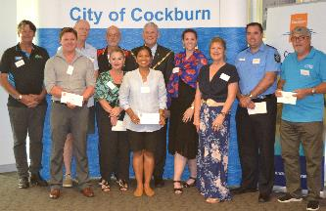  
**Community grants recipients with Mayor Howlett - September 2019**

## Corporate Communications

Responsible for the delivery of communication to ensure the community is engaged, informed and aware of the City’s facilities and services. This includes marketing, communications, public relations, events, graphic design, business engagement, customer service, and arts and culture.

### Marketing & Media

Develop a range of communications and marketing material to ensure the community is engaged and informed about the City’s services and programs.

**Achievements**

* Undertook the annual community scorecard survey to determine how the City is tracking on achieving objectives in the Strategic Community Plan, community priorities and areas of concern. Developed strategies to address these and reported back to staff, Elected Members and the community
* Undertook significant COVID-19-related communications.

### Events, Arts, Culture & Heritage Services

Provide community events and works to preserve and promote the heritage of the district, including the Azelia Ley Homestead Museum. Oversees art and cultural projects in the City.

#### Events & Culture

**Achievements**

* Cockburn Central community concert
* Side Splitter Comedy Festival
* Coogee Live community festival
* Undertook initial stages of a feasibility study relating to arts and cultural spaces in Cockburn
* Events from 16 March until 26 April 2020 were cancelled due to COVID-19.

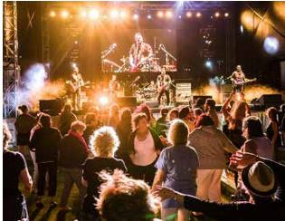   
**Community Concert, Ross Wilson - February 2020**

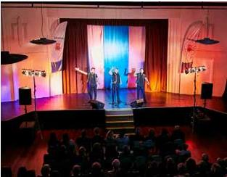   
**Side Splitter Comedy Festival - October 2019**

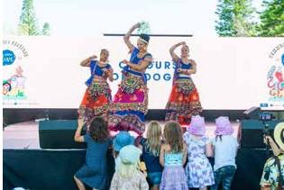   
**Coogee Live - March 2020**

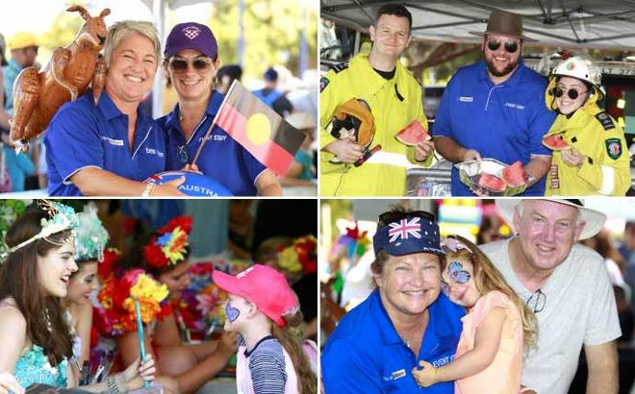   
**Australia Day Coogee Beach Festival - January 2020**

#### Civic Events

Civic events are run by the Strategy & Civic Support Department.

**Achievements**

Eight citizenship ceremonies – 743 people from 62 countries became Australian citizens. The top 10 represented countries were (from highest to lowest): United Kingdom, Philippines, India, Malaysia, Ireland, South Africa, China, Iran, New Zealand and Italy.

#### Azelia Ley Homestead Museum

**Achievements**

More than 6,000 people from schools and organised tours visited the museum throughout the year. More than 9,500 people attended events in the museum grounds including the Teddy Bears Picnic and vintage machinery day.

### Customer Service

Customer Service provides information to the general public and community through telephone, email and social media. The team raises customer requests, deals with enquiries at the front counter and completes cashier transactions.

**Achievements**

Customer service rating (see customer satisfaction results, page 36 for details):

* Front counter 98 per cent
* Contact centre 83.6 per cent
* 99,054 calls were received in the contact centre
* 6,196 enquiries were made at the front counter
* 18,994 customer requests were raised
* 5,961 transactions were processed at the front counter.

# Engineering & Works Directorate

This directorate is responsible for delivering and maintaining a safe road, cycleway and path network, developing and maintaining parks and managing the natural environment. The directorate collects and disposes of waste from all residential, industrial and commercial properties in the City, provides and maintains buildings and other facilities on Council property for community use, and promotes and implements sustainability. This directorate also maintains the City's plant and vehicle fleets.

It ensures Council assets are managed in a cost-effective way for optimal service delivery through a balance of creation, preservation, enhancement and disposal. This directorate also manages Port Coogee Marina.

## Highlights



**5,919** tonnes of waste diverted from landfill and recycled at Henderson Waste Recovery Park



**4,157 million** bins lifted in the year by the City’s trucks



**5,000** trees pruned under power lines



**231** playgrounds maintained



**893** kilometres of verges maintained

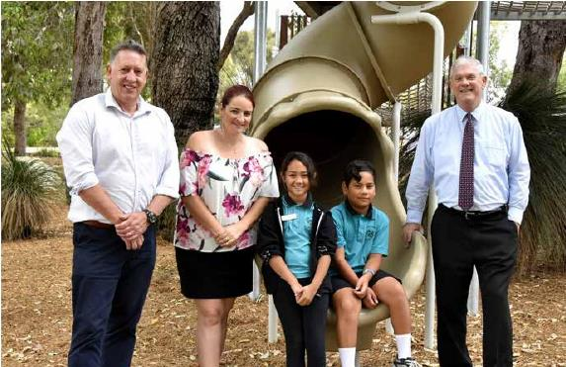   
**(From left to right) Cr Phil Eva, Cr Chontelle Stone, Coolbellup Community School Students and Mayor Howlett at Len Packham Reserve Nature Playground - December 2019**

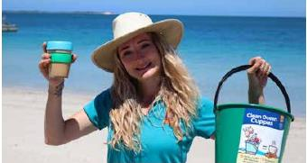   
**Waste Education - Clean Ocean Cuppas Program**

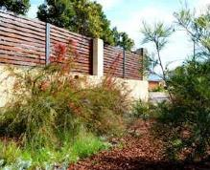   
**Sustainable verges in Beeliar**

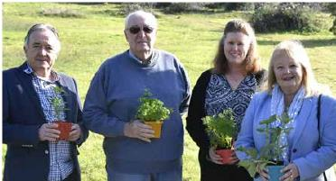   
**(From left to right) Cr Kevin Allen, Daryll Smith - Coogee Beach Progress Association, Karen Moulton - President Coogee Beach Progress Association and Coogee Community Garden, Cr Carol Reeve-Fowkes at Rotary Park - Community Garden approval - August 2019**

## Spend on Asset Development and Operational Activities

| **Asset Development** | **$Million** |
| --- | --- |
| Landfill site | 0.4 |
| Plant – new and replacement | 4.2 |
| Parks and environment | 9.7 |
| Roads, footpath and drainage | 14.1 |
| Developer contributed infrastructure | 14.2 |
| Buildings | 4.1 |
| Marina and coastal | 0.5 |
| **Total** | **47.2** |

| **Operational Activities** | **$Million** |
| --- | --- |
| Plant maintenance | 3.2 |
| Facilities maintenance | 6.8 |
| Marina and coastal | 1.1 |
| Waste disposal | 8.4 |
| Roads, footpaths and drainage maintenance | 8.3 |
| Parks and environment maintenance | 17.7 |
| Waste collection | 7.1 |
| **Total** | **52.6** |

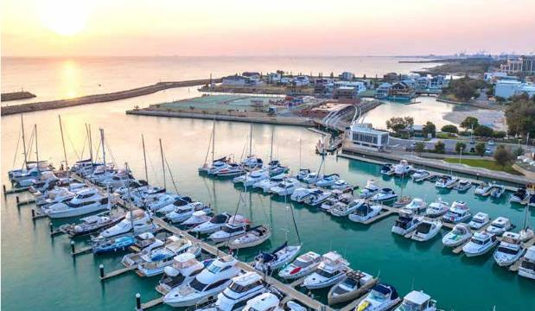  
**Port Coogee Marina**

## Waste Services Business Unit

### Waste Disposal Services

The City operates a landfill site at the Henderson Waste Recovery Park (HWRP) to receive waste in accordance with the licence of a Class IIl site under the *Environmental Protection Act 1986*, Part V. The service aims to maximise financial returns and provide quality customer service.

**Achievements**

Customer service rating (see customer satisfaction results, page 36 for details): 99 per cent

* 7.7 per cent of recyclable items (5,919 tonnes) were recovered and diverted from landfill including 71 tonnes of recyclable items sold at the Re-use Shop
* Completed the concept design for the redevelopment of HWRP and submitted a works approval application to the Department of Water and Environmental Regulation
* 27 tonnes of toxic household hazardous waste were diverted from landfill
* 3.2 million cubic metres of landfill gas was captured, down by 14 per cent from the previous year
* Obtained a licence amendment and commenced construction of the cap to Cell 6.

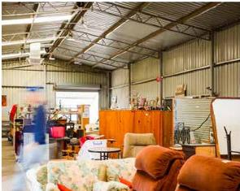   
Re-use Shop at Henderson Waste Recovery Park

### Waste Collection Services

Provide a regular, reliable and safe municipal waste and recycling collection service for eligible properties within the district. Waste Collection Services ensure an environmentally acceptable manner of waste disposal.

**Achievements**

* An average of 79,948 bins per week were emptied, an increase of 12 per cent from the previous year. This equates to 4,157 million bins emptied over the year by 15 waste trucks
* Reduced general waste tonnages by 16.8 per cent over the year, largely due to the introduction of the 24,720 garden waste bins that collected 4,882 tonnes of green waste. This decrease occurred despite the allowance for an extra 750 tonnes from an additional 950 new residential properties
* 2,781 tonnes of hard waste and 1,603 tonnes of green waste were collected in the City’s verge collection program. This represented a decrease of 5.1 per cent from the previous year
* Recovered and recycled 2,384 (60 tonnes) mattresses, 201 tonnes of scrap metal and seven tonnes of e-Waste
* 228 tonnes of waste were collected by our illegal dumping crew
* Approved 24 waste management plans for developments
* Installed 12 public place recycling enclosures.

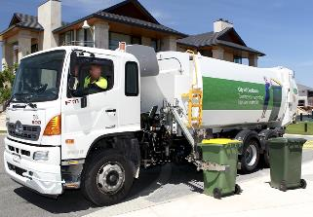   
**City of Cockburn waste collection truck**

### Waste Education

The City undertakes an extensive waste education program to lead and support a community that avoids waste generation, reduces environmental impacts, and considers the waste that is produced as a valuable resource to be recovered, reused and recycled.

**Achievements**

* Developed a series of innovative waste education materials
* Improved diversion of waste to landfill by improving the correct use of bins through doorknocking and bin auditing during the three bin roll-out program. 13,518 residences doorknocked and 45,725 bins audited
* Introduced compostable dog bags
* Managed the State Government changes to recycling rules by rolling out an information campaign and updating all material
* Received Waste Authority grants for a cardboard compactor and a commercial food waste trial
* Introduced WA’s first Seabin at Port Coogee Marina
* Created waste truck videos to explain to developers the importance of good road layout and building design to accommodate waste management
* Introduced the Waste Wise Events Policy
* Supported the roll-out of the State’s plastic bag ban through video and community events.

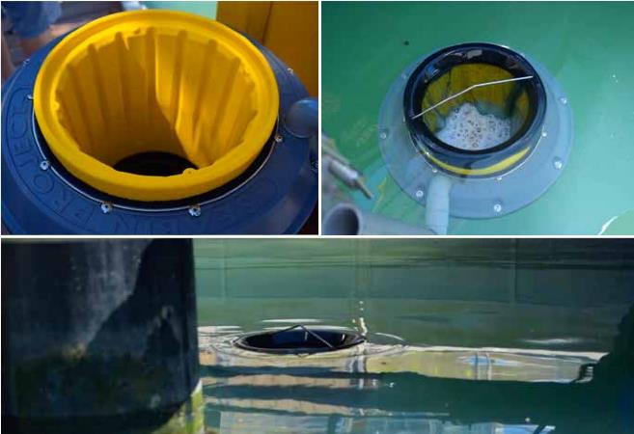  
**Seabin at Port Coogee Marina**

## Parks & Environment Services

The Parks & Environment Business Unit is responsible for facilitating sustainability throughout the organisation and the community. The business unit designs, constructs, rehabilitates and maintains the City’s open spaces, manages water resources, greenhouse gas emissions, bushland and wetland areas, high quality playing fields, passive parks, foreshore areas, streetscapes and park infrastructure.

### Parks Services

Parks Services manages the development of strategies and policies, and provides advice on park and horticultural-related matters. The unit assesses district and local structure plans and constructs and maintains parks, ovals and streetscapes on Council-owned land in accordance with agreed service levels.

**Achievements**

Customer service rating (see customer satisfaction results, page 36 for details): 74.8 per cent

This rating refers to the level of satisfaction with how customer requests were dealt with and not from satisfaction with parks themselves.

#### Parks Operations

Perform a range of ground maintenance activities across the City and provide functional and attractive public amenities for use by residents and visitors to the City.

**Achievements**

* Maintained over 610 hectares of turf and landscaping at sporting ovals, passive parks and community facilities
* Managed park infrastructure valued at $69 million
* Managed 231 playgrounds
* Maintained 130 hectares of streetscapes, including roundabouts, median strips and verges
* Maintained 893 kilometres of road verges
* Undertook annual turf analysis, soil assessments and sport oval renovations
* Undertook annual yardstick parks assessment (comparisons with other local governments).

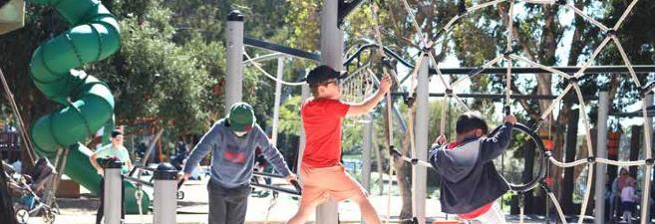   
**Bibra Lake Regional Playground - September 2019**

#### Street Tree Management

**Achievements**

* Completed 1,862 tree maintenance customer requests
* Pruned over 5,000 trees under power lines.

#### Groundwater Operating Strategy

Provides strategic direction for the City’s monitoring and management of groundwater abstraction in accordance with the Department of Water and Environmental Regulation licence conditions.

**Achievements**

* Monitored 239 bore locations to inform individual water budgets for each park
* Maintained 14 filter systems which remove iron from abstracted groundwater
* Monitored the water quality of five significant locations adjacent to environmentally sensitive areas: Kurrajong Reserve, Kevin Bowman Reserve, Manning Reserve, Bibra Lake picnic area and Waterbuttons Park
* Produced an annual report for the Department of Water and Environmental Regulations outlining the City’s abstraction per licence, water quality and impact on water draw from aquifers
* Installed irrigation dosing unit at Atwell Oval, enabling scheduled applications of wetting agent and fertiliser improving turf quality and resulting in water savings.

#### Parks Construction

Designs and constructs a wide range of park infrastructure and facilities, and renews equipment that has reached the end of its useful life.

**Achievements**

* Constructed and/or renewed 11 playgrounds including Goodwill Park, Capricorn Park, Turnbury Park, Allendale Park, Broadwater Park, Greenslade Reserve, Samuel Caphorn Reserve, Kurrajong Park, Aubin Grove Community Centre, Bakers Square and Goodchild Reserve
* Replaced irrigation system at Poole Reserve
* Renewed 11 groundwater pump units and 11 electrical control cabinets
* Upgrades to Powell Reserve, Gull Way Reserve, Pausin Crescent Reserve, Tempest Park and Perena Rocchi Reserve
* Planted 1,300 street trees
* Streetscape enhancements to Cockburn Road and Barwon Turn
* Constructed a clay pump track at Market Garden Park
* Completed deck renewal works at C.Y. O'Connor Reserve.

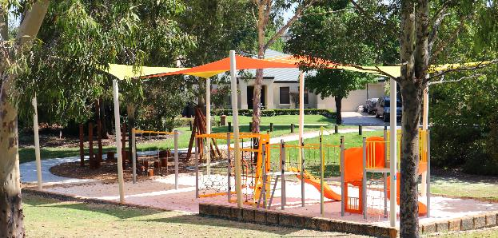  
**Allendale Park - December 2019**

#### Shade Sail Strategy

Identifies the criteria for installing shade sails and planting trees around playgrounds.

**Achievements**

Installed shade sails at the following parks: Jan Hammond Park, Dixon Park, Broadwater Park, Zodiac Park, Steiner Park, and Bourbon Park.

#### Bibra Lake Management Plan

The plan guides best practice sustainable management of the Bibra Lake Reserve for maximum environmental, recreational and community benefit.

**Achievements**

Completed extensive revegetation works and installed additional turtle breeding enclosures along the base of the foreshore retaining wall.

#### Coogee Beach Master Plan

The plan ensures the sustainability of the coastal environment and provides strategic direction for ongoing upgrades to the Coogee Beach precinct.

**Achievements**

Landscape design drawings compiled for the enabling works to the Coogee Beach Café precinct.

#### North Coogee Foreshore Management Plan

The plan provides for the development of the northern section of the C.Y. O'Connor Reserve to improve the amenity of adjacent residents and the wider community.

**Achievements**

Construction works completed for the delivery of sewer, potable water, electrical cabling and toilet facility.

#### Revitalisation Strategies

Facilitate the urban renewal of each precinct including the enhancement of existing public open space and streetscapes.

**Achievements**

* Completed planting program to streets in Spearwood
* Works completed for the construction of the Len Packham nature playground, Coolbellup
* Completed upgrades to Windmill Park, Bibra Lake
* Completed upgrades to Mears Park, including BBQ, shelter, landscape planting and connecting pathways
* Made improvements to Duffield Reserve, Blackthorn Park and Bassett Reserve
* Completed upgrade of Monaco Park, including landscaping, shelter and path.

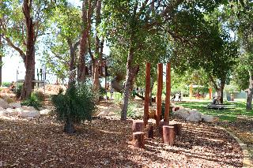   
**Len Packham nature playground, Coolbellup**

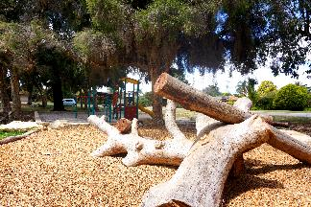   
**Windmill Park, Bibra Lake**

### Environmental Services Unit

Incorporates the combined disciplines of natural area management, environmental education, climate change adaptation and mitigation, and sustainability. Maintains and enhances environmental values and sustainable outcomes for the City.

#### Natural Area Management

Seeks to enhance and protect the environmental values of nature reserves by undertaking rehabilitation and intensive maintenance programs, managing approximately 1,200 hectares of conservation reserves.

**Achievements**

* Revegetated four hectares of degraded bushland with more than 68,000 plants
* Continued the feral animal control program at reserves throughout the City
* Completed dieback mapping and treatment at the following reserves: Bloodwood, Kreamer, Levi, Little Rush Lake, Rose Shanks, Triandra, Mather, Success. Veldt grass control measures in Bandicoot, Banksia Eucalypt Woodland, Bibra Lake, Denis De Young, Little Rush Lake, Manning, Success and Yangebup reserves to reduce fuel loading and prevent biodiversity loss
* Fire control measures implemented on a number of reserves to minimise fire risk
* Upgrade of North Lake Road and Osprey Drive fauna underpasses
* Vertebrate Fauna Survey (Level 1) undertaken at Boorn Park and Djidi Djidi Reserve
* Completed condition rating of 17 reserves encompassing 435 hectares.

#### Capital Works Projects

**Achievements**

* Engaged project manager and architect for the Cockburn Wetlands Precinct Project
* Installed 22 new artificial reef structures for the Coogee Maritime Trail including replica cannon
* Dive Trail won the WA Coastal Awards for Excellence, Coastal Design, Heritage and Tourism Award and the 2020 Institute of Public Works Engineering Australasia Awards - WA Division - Winner, Excellence in Environment & Sustainability Award - Coogee Maritime Trail
* Completed the nutrient stripping basin, bird hide and boardwalk extension at Yangebup Lake
* Developed the Manning Park Mountain Bike Concept Plan
* Upgraded the Banksia Eucalypt Woodland viewing platform upgrade
* Installed a possum bridge across Beeliar Drive (between Spearwood Avenue and Hammond Road), linking Yangebup and Kogalup lakes
* Installed heavy duty gates on a number of reserve access points
* Upgraded fence at Rose Shanks Reserve
* 12 turtle protection enclosures installed along the western edge of Bibra Lake in preparation for turtle nesting season
* Installed Woodland to Wetlands Trail, Bibra Lake
* Installed 20 bird and five fauna identification interpretive signs along the old jetty and bird hide, Bibra Lake.

#### Grants

**Achievements**

* Supported seven landowners to maintain and protect remnant bushland and wetlands through the Landowner Biodiversity Conservation Grants
* Delivered Stage 3 of the Local Projects Local Jobs Urban Greening Project with community participation. This included the installation of native trees in Visko Park and the tramway trail
* Supported three schools with Environmental Education Grants
* Awarded 18 Sustainability Grants to enhance sustainability outcomes in the community.

#### Community Events

**Achievements**

* Community planting events were restricted due to COVID-19 however seven events were held with over 660 volunteers attending
* Supported community clean up at C.Y. O'Connor Beach as part of Clean Up Australia Day with over 96 people participating
* Facilitated volunteer activities in the City’s conservation reserves
* Native Plant Subsidy Scheme: 6,620 plants were provided at a discounted rate to residents with 680 additional plants made available for schools
* Habitat for Homes: 50 residents took part in the Bird Bath Subsidy Scheme
* Hosted one guided indigenous walk at Manning Park, Banksia Eucalypt Woodland and Bibra Lake.

#### Climate Change, Energy and Emissions Reduction

**Achievements**

* Maintained a zero emissions fleet via the carbon offset program
* Offered free energy audit advisory visits for 29 households, community and child care centres
* Completed Our Sustainable And Climate Resilient Future community engagement project to guide the 2020 Climate Change Strategy
* Exceeded the renewable energy target with 26 per cent of Council buildings receiving power from solar photovoltaic systems
* Over 500 electricity, gas and water meters were uploaded to the Kinesis platform to monitor the City’s corporate energy and water use online
* Climate change risk assessment updated and risks integrated into the City's risk management system.

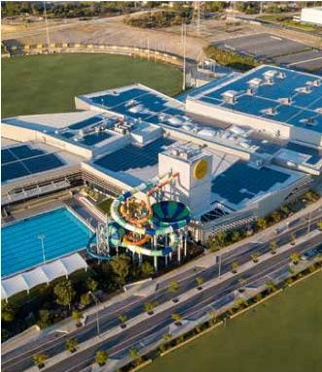   
**Solar panels installed at Cockburn ARC**

#### Sustainability

**Achievements**

* Coordinated the Sustainability Committee to facilitate sustainable outcomes in the workplace
* Awarded 18 sustainability grants to community groups, small business, collective households and schools
* Environmentally Sustainable Design (ESD) Policy provision adopted to ensure all new Council facilities set aside three per cent for innovative ESD initiatives
* ESD requirements document published to provide guidance to staff and contractors
* Sustainability Policy training module launched to all staff, via the online learning management system to raise awareness on the policy
* Invested in carbon offsets to deliver the City’s first carbon neutral event, Coogee Live 2020
* Delivered 34 home eco audits and three eco audits for childcare centres
* Hosted two sustainability internships delivering projects on Nature in our City and Domestic Cat Management.

#### Water Campaign

**Achievements**

* Submitted the annual Waterwise Council Report on water reduction targets to the Water Corporation. The City maintained its gold Waterwise Council status
* Delivered the Waterwise Verge Subsidy Scheme to 31 households. The City claimed $7,000 from the Water Corporation through participating in the Waterwise Council Program on a spend of just over $14,000
* Active member of WA’s Water Sensitive Cities Transition Network
* Subsidised 6,620 plants through the Native Plant Subsidy Scheme
* Revised the City’s Verge Improvement Guidelines to facilitate the establishment of appropriate verges.

#### Environmental Education

**Achievements**

* Launched the Grow It Local Festival with Paul West
* Conducted seven environmental education excursions/incursions
* Ran 13 events for 300 participants for the Get Wild About Wetlands holiday program
* Joined ClimateClever Schools Program supporting two schools to take part
* Delivered Pilot Turtle Trackers Program in partnership with Murdoch University, Native ARC Inc and The Wetlands Centre Cockburn. This included 30 turtle trackers, 44 days of patrolling, 25 nests protected (an average of 10 eggs in each nest)
* Supported six environmental education community events with over 120 participants including guided snorkel tours, beach treks, Nearer to Nature fishing clinics and Educated by Nature kids in nature sessions
* Provided education stalls at Teddy Bears Picnic, Spring Fair, Celebrate Ability Day, Australia Day and Coogee Live events
* Three Little Green Steps Sustainability in Early Years workshops delivered
* Participated in the South West Group's Fox Tracking Program.

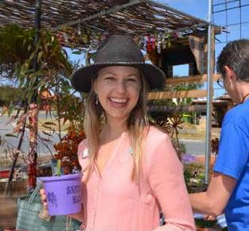   
**Grow It Local Festival - November 2019**

#### Roe 8 Rehabilitation Project

Funded by Main Roads WA

**Achievements**

* Continued implementation of the 10-year Rehabilitation Management Plan
* Of the 26 key performance indicators within the management plan 65 per cent are rated as on track, 34 per cent are on watch and none have been recorded as needing attention
* Conducted monthly meetings with Rehabilitating Roe 8 Advisory Committee
* Developed Rehabilitating Roe 8 Cultural Heritage Management Plan
* Community questionnaire completed. 62.9 per cent of respondents support the Rehabilitating Roe 8 Project with planting days and environmental education ranked highest in importance for community engagement
* Citizen Science Program completed undertaking fauna monitoring in partnership with Greening Australia
* Signage Plan completed
* Community engagement campaign #corridorlife launched
* 71,310 plants were placed into the corridor
* 2013 volunteer hours contributed, valued at $60,400
* 628 attendees at community events
* Completed fauna monitoring program
* Completed vegetation monitoring program in partnership with Murdoch University
* Completed weed mapping of sites
* 22.5 hectares of weed control completed including targeting of woody weeds
* Ran four environmental education workshops
* Three schools engaged in on-ground activities and environmental education
* Aboriginal archaeological survey approval received.

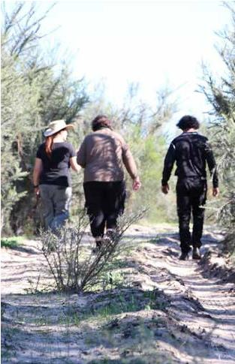   
**Roe 8 corridor**

## Infrastructure Services

### Project & Asset Services

To manage the development and delivery of project and asset management frameworks, systems, processes and procedures, and provision of services for best practice asset and project management including in the delivery of the City’s major building, facility and other infrastructure capital works programs and operational activities.

**Achievements**

* Supported the development of the following key projects from the Community, Sport and Recreation Facilities Plan 2018-2033 including:
  + Aboriginal Cultural and Visitor Centre
  + Treeby Community and Sports Centre
  + Frankland Park Sport and Community Facility
  + Malabar Park BMX Facility
  + Managed the development of the operation’s centre refurbishment and the construction phase of the Cockburn Wetlands Precinct and Jandakot Volunteer Bushfire Brigade
  + Finalised the asset survey and defect audits for buildings, road, footpaths and parks infrastructure.
* Ongoing implementation of the Project Portfolio Management Framework and Technology One system
* Managed the installation of Beach Emergency Numbers (BEN) at 32 public access locations along the Cockburn coastline and in co­operation with the Rottnest Island Authority coordinated the manufacture of 40 signs for installation on Rottnest Island
* Reviewed the asset revaluation methodology for road and footpath infrastructure, resulting in a $1.6m reduction in annual depreciation from 2018-19 year end
* Completed final draft of initial Marina and Coastal Asset Management Plan.

### Marina & Coastal Services

Manage the Port Coogee Marina Facility including business development, penholder liaison and daily service operations, as well as plan and deliver coastal infrastructure and management initiatives.

**Achievements**

* Continued to provide customer service to marina pen holders and maintained occupancy rate of over 90 per cent
* Purchased site spill response resources
* Installed new 45m public jetty with 75 per cent grant funded from the Department of Transport
* Prepared marina expansion business case and undertook community consultation. Request for tender released to progress detailed design of boardwalk and jetty layout
* Three new finger jetties installed on F Jetty creating five new marina berths
* Marina precinct carpark refurbished and footpath constructed
* Completed marina boardwalk major corrosion treatment
* Installed Ngarkal Beach swimming pontoon to assist in wave attenuation
* Replaced Coogee Beach Jetty corrosion protection and railing
* Upgraded Ngarkal Beach accessible toilet and change room
* Provided new Ngarkal Beach storage areas for the Coogee Beach Surf Life Saving Club and the City’s beach wheel chairs
* Undertook community consultation and prepared draft Coogee Beach Foreshore Management Plan
* Undertook C.Y. O'Connor Beach sand back passing of 15,000m3 of sand to the south of Catherine Point
* Continued to monitor the Cockburn coastline to identify erosion and monitor coastal assets
* C.Y. O'Connor Protection Modelling and Design initial vision and values community consultation and coastal modelling progressed with consultant
* Initial architectural concepts prepared for the OMEO Park amenities and location chosen following community consultation.

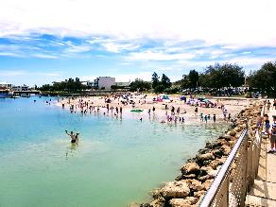   
**Ngarkal Beach, North Coogee**

### Facilities & Plant Services

Plan and deliver the Council’s building and facility operational and minor capital works program as well as the City’s plant and fleet acquisition and maintenance services.

**Achievements**

* Undertook upgrades and refurbishments at Coogee Beach Surf Life Saving Club, Cockburn Seniors Centre, the Jean Willis Centre, Success Regional Sports Centre, Bibra Lake Community Centre and Banjup Hall, as well as sign installation across the City
* Undertook disability access improvement works
* Reviewed and updated the asbestos audit and associated improvement works across the City’s building portfolio
* Replaced underperforming air conditioning systems for reduced running costs and energy emission reduction benefits
* Installed sensors and data management software to improve data capture and fault finding of the City’s photo-voltaic (solar) systems
* Replaced light fleet and heavy plant assets as per the adopted budget and 10-year Master Vehicle Plan.

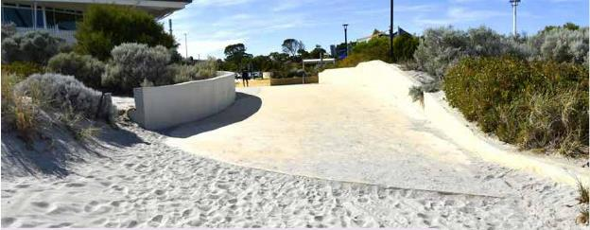  
**Coogee Beach Surf Life Saving Club, accessible beaches - March 2020**

## Engineering Services

### Road Construction Services

Construct and maintain roads, drains and associated infrastructure.

**Achievements**

Customer service rating (see customer satisfaction results, page 36 for details): 72 per cent

* This rating refers to the level of satisfaction with how requests were dealt with, and not from satisfaction with roads themselves
* Completed Verde Drive extension, Solomon Road to Armadale Road and construction of a roundabout at the intersection of Verde Drive/ Prinsep Road
* Completed Prinsep Road extension to Verde Drive
* Completed the Spearwood Avenue bridge and duplication between Barrington Road and Yangebup Road
* Completed new footpaths in Pilatus Street, Fawcett Road, Solomon Road, Branch Circus, Harmony Avenue, Lombe Gardens, Phoenix Road, Rockingham Road and Sciano Avenue
* Completed drainage improvements at Junction Boulevard, Brittania Avenue, Menas Place, Rinaldo Reserve, Hamilton Road and Jewel Gardens
* Completed drainage sump upgrades at Hartley Road and Amity Boulevard (Powell Reserve)
* Completed the construction of Osprey Drive traffic calming, Sumich Gardens/Sain Road intersection improvement, Coolbellup Avenue traffic calming and a traffic study for the parking, line marking and children crossings projects
* Completed the annual bus shelter upgrade program with the Perth Transport Authority.

### Road Design Services

Provide design services for roads, paths and drains. Conduct development assessments and traffic management treatments under the responsibility of the City in accordance with Australian Standards and industry best practice.

**Achievements**

* Completed 80 per cent of the design of the Hammond Road upgrade Bartram Road to Branch Circus
* Completed the design of the drainage improvements and sump projects
* Assisted Main Roads WA with the design of the Armadale Road duplication, Armadale Road to North Lake Road Bridge and Beeliar Drive and Stock Road intersection project.

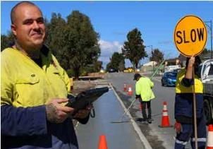   
**City of Cockburn maintenance team**

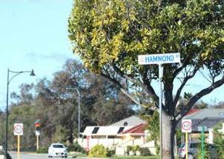   
**Hammond Road upgrade**

### Road Planning & Development Services

Ensure development occurs in accordance with all relevant Australian Standards, WA Planning Commission conditions and Council’s development guidelines and specifications.

**Achievements**

* Completed road design projects including a detailed plan for Jandakot Road duplication, Hammond Road upgrade and Frankland Avenue extension
* Completed the design for the black spot projects Farrington Road/Bibra Drive and Beeliar Drive/Wentworth Parade
* Completed 60 per cent of Frankland Avenue from Gaebler Road to Frankland Avenue
* Engineering construction drawings for new subdivisions were reviewed, approved and construction managed successfully
* New crossover applications and building permit applications including residential premises were assessed.

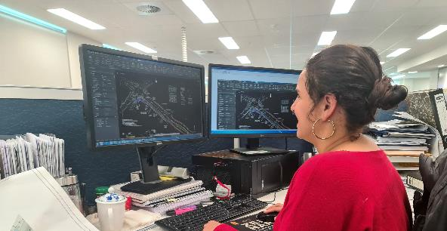   
**Sabina - City of Cockburn, Development Engineer**

### Transport & Traffic Services

Ensure planning and development of the transport network within the City meets community and industry needs while minimising the impact on the environment.

**Achievements**

* Completed Integrated Transport Strategy by incorporating the Road Safety Strategy and Travel Smart Plan
* Completed assessments of the requests for traffic calming on Bartram Road, Coolbellup Avenue, Gaebler Road and Interim Road
* Completed the LED speed display signs, parking signage and line marking projects
* Completed the public events, information campaigns and education resources about traffic congestion, road safety and alternative transport mode choices to reduce the dependency on trips by private car
* Completed the submissions for the Black Spot Program 2021-2022 Federal and State Black Spot funding, and Bicycle Program funding Corridor Planning Study.

# Planning & Development Directorate

This directorate is responsible for managing statutory and strategic planning for the City and overseeing heritage, urban design and sustainable development. It manages building approvals, development compliance and environmental and public health services, as well as the acquisition and sale of the City’s land assets.

## Highlights



**$349 million** - Value of building works approved



**$213 million** estimated construction value of development applications received over the year



Men’s health program Man v Fat total weight loss was **464 kilograms**



**821** - Number of development applications assessed

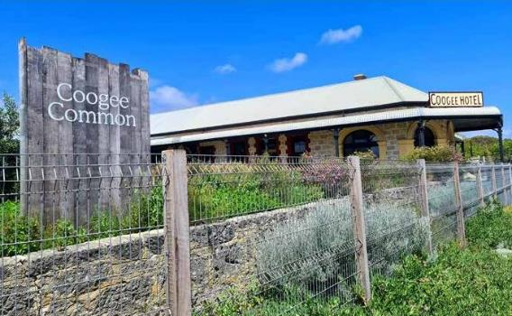   
**Coogee Common - a modern business that reflects the City's heritage**

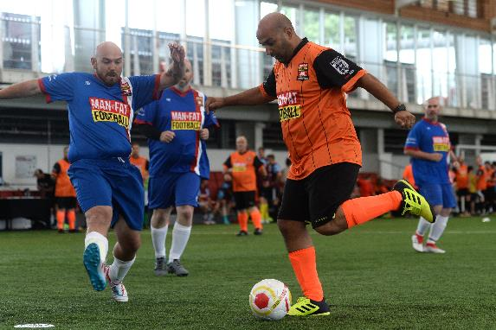  
**Major new men’s health program Man v Fat**

## Building Services Business Unit

Ensure that buildings and structures within the City provide acceptable levels of public safety and comply with all relevant building legislation, codes, standards and regulations.

**Achievements**

* Customer service ratings (see customer satisfaction results, page 36):
  + Building services: 91.9 per cent
  + Swimming pool inspections: 87.7 per cent
* 2,247 building permits issued
* Total value of building works $349m
* Fee income $712,912
* Average time of 14 working days to issue all building permits
* The average issuance time for a building permit in 2019-20 was:
  + Certified – eight working days
  + Uncertified – 20 working days.

### Electronic Lodgement System

Over the past year, 60 per cent of all building permit applications were lodged online. Work will continue through the 2020-21 financial year to prepare for further process upgrades to facilitate the increased uptake of online submissions.

Other Building Services approvals issued include:

* 117 occupancy permits
* 52 demolition permits
* Eight built strata title clearances.

2,848 mandatory private swimming pool inspections were carried out in 2019-20.

### Building Act

The introduction of the new *Building Act (2011)* in April 2012 has continued to provide challenges for Building Services. The Act and associated building regulations are changed generally each year by the State Government. These changes require an ongoing review of business and information system processes.

Building approvals for the previous four years are as follows:

| **Year Ending** | **Number of Permits** | **$million Value** | **$million Fee** | **Residential** | **Commercial** | **Industrial** | **Other** |
| --- | --- | --- | --- | --- | --- | --- | --- |
| 30/06/17 | 2,573 | 481 | 0.925 | 1,038 | 89 | 8 | 1,650 |
| 30/06/18 | 2,489 | 422 | 0.82 | 941 | 79 | 36 | 1,438 |
| 30/06/19 | 2,230 | 506 | 0.848 | 988 | 27 | 46 | 1,433 |
| 30/06/20 | 2,247 | 349 | 0.712 | 1,076 | 80 | 14 | 1,169 |

### Environmental Health Business Unit

Environmental Health promotes wellbeing in the community to ensure premises and activities comply with accepted public health standards and practices. The unit works to protect the quality of the environment and improve and manage public health by implementing the City’s Public Health Plan.

**Achievements**

* Customer service rating (see customer satisfaction results, page 36 for details): 69 per cent
* This rating refers to the level of satisfaction with how requests were dealt with, and not from satisfaction with roads themselves
* The Environmental Health team devoted significant resources to managing how the City dealt with the pandemic (see COVID-19 Report, page 15).

#### Healthy Lifestyles

The City continues to collaborate and partner with Cockburn Integrated Health and the Cockburn Healthy Lifestyle Service. In the last 12 months, there have been over 327 clients actively attending health consults and 154 of these clients registered for a HEAL (Healthy Eating Activity and Lifestyle) Program.

* 115 out of 154 registered participants completed one of 12 HEAL programs
* 57.1 per cent reduced their weight and BMI
* 38.3 per cent reduced their BMI and waist circumference
* 62.5 per cent maintained or reduced their waist circumference (46.4 per cent reduced and 16.1 per cent maintained)
* 64.2 per cent increased and 26.8 per cent maintained their vegetable intake
* 41.8 per cent increased and 38.2 per cent maintained their fruit intake
* Provided 710 free health checks at City-run events of which 376 participants were found to be at risk of developing Diabetes Type 2 and/ or had BMI over 30
* The City continues to support eight Heart Foundation walking groups
* Four Food Sensations Programs were delivered online during COVID-19
* Major new men’s health program Man v Fat continued with a total weight loss of 464kg.

The City continues to work with LiveLighter to encourage eating healthily and reducing sugary drink consumption.

Signed memorandum of understanding with Act-Belong-Commit (A-B-C) for 2020-21. The City continues to build community and staff awareness of activities that promote good mental health and build a more mentally healthy Cockburn.

‘Proud to Be Smoke Free’ signage was installed at all City owned sports clubs, community centres and skate parks. The yearly cigarette butt audit of playgrounds saw a reduction of butts around the pilot sites for 2020.

#### Public Health Plan

The City’s Public Health Plan provides the blueprint for City officers to implement improved public health outcomes for the community. Approximately 95 per cent of the actions in the Public Health Plan have been completed. The new *Public Health Act* 2016 places an obligation on all local governments in WA to develop a Public Health Plan that is consistent with the State Public Health Plan.

## Environmental Health Services

### Environmental Health Initiatives

#### Food

**Achievements**

Ten infringements were issued for non-compliance with the Food Standards Australia New Zealand Food Safety Standards and Food Code. One $1,000 infringement was issued to a company and nine $250 infringements to individuals. Two infringements were withdrawn, one due to prosecution. All other infringements issued under the Food Act 2008 were paid and totalled $2,000.

* One Food Act prosecution was undertaken with a fine of $20,000
* Officers conducted 1,608 inspections of 912 food premises resulting in 40 improvement notices being issued for serious items to be completed
* Approved 44 new (or amendments to) food businesses
* Approved 365 temporary food permits
* Conducted two training sessions for 38 potential food handlers.

#### Noise

The City has a unique noise environment with the presence of a freeway and other busy roads, a passenger rail line, freight rail line, aircraft from Jandakot Airport, substantial industrial areas and intense city centre areas. Development near these sources must be designed to minimise noise intrusion, especially at night.

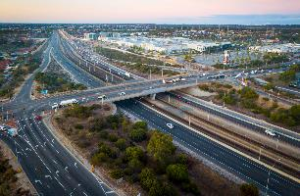   
**Kwinana Freeway, Cockburn Central**

**Achievements**

* 55 Noise Management Plan approvals were issued for night time works on essential infrastructure
* 1,491 noise complaints were received by the City, with 1,082 received outside normal working hours. This is an increase of 423 complaints from last year, with 656 noise complaints (41 per cent) being received in the four-month period from 1 March to 30 June 2020, during the COVID-19 lockdown period
* A breakdown of noise complaints follows with about 63 per cent being due to noisy music or parties.

| **Type of noise complaint** | **Received within work hours** | **Received outside work hours** |
| --- | --- | --- |
| Air conditioning | 9 | 1 |
| Alarms | 6 | 10 |
| Birds | 24 | 1 |
| Construction | 64 | 55 |
| Industrial | 9 | 2 |
| Music | 160 | 774 |
| Power tools | 43 | 61 |
| Swimming pools | 10 | 1 |
| Transport | 40 | 32 |
| Vibration | 11 | 1 |
| Other | 33 | 144 |
| **Total** | **409** | **1,082** |

Seven infringements were issued for noise. Noise infringements are issued for $250 for a first offence, and $500 for second and subsequent offences.

#### Mosquito Program

Mosquito activity last season was low across Perth due to local weather conditions.

There are a total of 662 infrastructure locations within 20 suburbs that are potential breeding sites and may need treatment depending on climate, water levels and larvae activity.

The following suburbs were Ross River Virus (RRV) priority treatment areas: Success, Atwell, Aubin Grove, Hammond Park, Yangebup and Beeliar.

**Achievements**

* The City received five notifications for RRV from the WA Department of Health for follow-up patient interviews
* 22 complaints were received from residents in relation to what they perceived as being abnormally high numbers of mosquitoes localised in their area or unkept residential swimming pools
* In total, 320 sites in 20 suburbs received larvicidal treatments throughout the mosquito breeding season
* Over a period of six months, mosquito traps were set in Thomson’s Lake Reserve as part of a project with the WA Department of Health to determine the number and species of mosquitoes and the presence of the RRV.

The City implemented a trapping and monitoring program where five locations were selected based on previous complaints. Fortnightly traps were set over a period of four months for numbers and species and if needed, feedback given to residents in the case of complaints within their proximity.

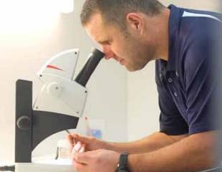   
**Stuart Greer - City of Cockburn, Environmental Health - mosquito management**

#### Industrial Premises

The industrial premises officer works with proprietors to achieve compliance with a range of minimum environmental management standards.

**Achievements**

* 42 premises were visited in regard to mechanical servicing, metal fabricating, plastic/ fibreglass fabricating, abrasive blasting, cabinet making, vehicle wrecking, granite cutting, spray painting, boat building, vehicle battery acid distribution, demolition storage, waste control and equipment hire
* Received 45 complaints relating to industrial premises
* No infringements were issued.

#### Dust

The City is rapidly developing, with dust a common cause for complaint in Cockburn in comparison to other areas in Perth. The City rigorously applied its suspension of bulk earthworks during summer to minimise dust, with 21 dust management plans approved over this period. Three infringement penalties of $500 were issued for failure to abate dust/sand from a property.

## Statutory Planning Business Unit

Provides control and management of development, land use and subdivision functions within the City to ensure standards of amenity are maintained. Statutory Planning also undertakes compliance and enforcement action against non-approved development.

**Achievements**

* Customer service rating (see customer satisfaction results, page 36 for details): 74.4 per cent
* Received 1,066 development applications, a 4.7 per cent increase from the previous year
* Assessed 821 applications, an increase of 1.8 per cent over the previous year
* 611 development applications were required to be determined within 60 days. The City determined 64.48 per cent of those applications within 60 days
* 210 development applications were required to be determined within 90 days. The City determined 67.62 per cent of those applications within 90 days
* Submitted six development applications for determination under the Joint Development Assessments Panel, down from seven last year
* 2,583 new lots were approved (green title, survey strata and built strata), an increase of 8.7 per cent from the previous year
* Approved 32 new local development plans for small lot development, a decrease from 40 in the previous year
* Logged 212 development compliance matters, a decrease of 12.2 per cent over the previous year. Resolved 226 compliance matters, a decrease of 4.8 per cent over the previous year
* The estimated construction value of all development applications received over the year decreased by 41 per cent over the previous year to $213 million
* Issued 2,583 zoning statements, an increase of 8.7 per cent over the previous year
* Commenced Process Alignment Strategy in line with the pending State Government planning reform legislative changes, expected to be finalised early 2021
* Commenced cash-in-lieu policy project to assist local businesses to comply with parking requirements by providing an additional option under future change of use applications.

### Strategic Planning Business Unit

The Strategic Planning business unit comprises the Strategic Planning service unit and the Land and Lease Administration service unit.

#### Strategic Planning

Prepares structure plans scheme amendments, formulates strategies, and adopts policies which provide formal guidance and direction for the planning and development of the district. Maintains the City’s development contribution plans, provides cartographic and geographic information services (GIS) expertise relevant to planning, and administers geographic naming and street numbering.

**Achievements**

* Customer service rating (see customer satisfaction results, page 36 for details): 94.1 per cent
* Ensured comprehensive application and review of the City’s development contribution plans
* Created internal training modules for relevant City staff relating to development contribution plans to reduce risk
* Finalised an amendment to the local planning scheme to introduce additional exemptions to the liability for development contributions to cater for the types of developments undertaken by Cockburn landowners and increase alignment with the intent of the State’s Infrastructure Contribution Policy
* Finalised an amendment to the local planning scheme to introduce a new Development Contribution Plan 15 for the Treeby East oval and clubrooms
* Progressed the structure plans for the Department of Communities and Perron landholdings along Armadale Road, Treeby
* Submitted an amendment to the local planning scheme for the Australian Marine Complex – proposed to change to a ‘Strategic Industry’ zone
* Finalised a number of structure plan rationalisations in preparation for a new local planning scheme
* Significantly progressed the drafting phase for the City’s new Local Planning Strategy, including targeted analysis for specific issues such as bushfire and retail planning and rural land capability
* Provided services related to geographic naming, which helps enable further implementation of the City’s Reconciliation Action Plan
* Assisted the GIS team progress plans to transition the City’s spatial mapping system to a new provider.

#### Land & Lease Administration

Administers leases and licences which span commercial, community and tourism purposes, and purchases and develops land according to the adopted strategy of the City. Manages public requests for pedestrian access-ways, including closures and ensures that all property interests and the City’s land portfolio are appropriate and sufficient.

**Achievements**

* Contributed to the planning of the Jandakot Road upgrade by facilitating the land acquisition process for stage one road widening requirements
* Continued to work with Main Roads WA to acquire land associated with the Armadale Road and North Lake Road bridge project including the upgrade of Verde Drive and Prinsep Road
* Prepared land assets ready for disposal in accordance with the Land Management Strategy 2017-2022
* Prepared lease documentation for new City assets and tenants including Fremantle-Cockburn Hockey Club Artificial Turf sub-lease; Port Coogee Community Association licence; Coogee Beach Surf Life Saving Club Ngarkal Beach facility licence and Treeby Community Garden Association licence
* Managed leasing requirements for the City’s community, recreation and commercial assets.

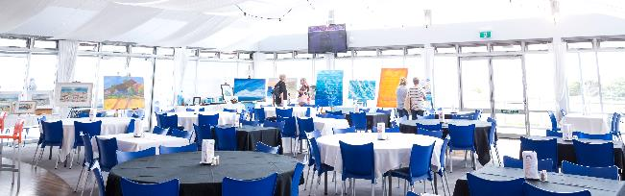  
**Coogee Beach Surf Life Saving Club**

# Finance & Corporate Services Directorate

This directorate is responsible for managing the City’s finances including annual budgeting, financial reporting, long-term financial planning, procurement, rates/revenue, banking, treasury and taxation. The directorate also delivers information services, technology and business systems, as well as human resource management including recruitment, payroll, learning/development and occupational health and safety.

## Highlights



**Implementation** of ESRI mapping system



**33 per cent** increase in cyber security compliance



**Achievement** of the lowest Lost Time Injury frequency rate in City history

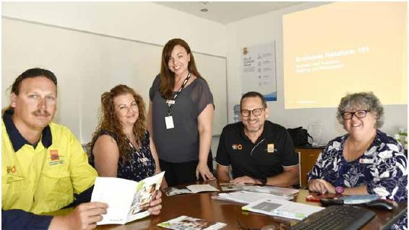   
**(From left to right) Ryan - Waste Services, Sam - Occupational Safety & Health Advisor, Lisa - Learning & Development Assistant, Cliff - Manager Human Resources and Sandra - Learning & Development Coordinator undertaking in-house workplace training - Febuary 2020**

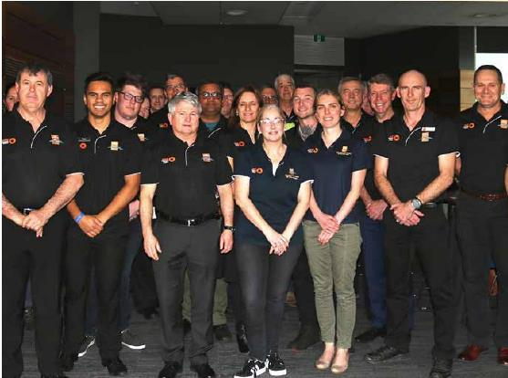  
**City of Cockburn Safety Committee - July 2019**

## Finance & Corporate Services Directorate

Provide policy, programs and advice which shape the City’s workforce to ensure it is capable of achieving business objectives now and in the future.

**Achievements**

* Achievement of the lowest Lost Time Injury frequency rate in City history
* Negotiation and implementation of the City’s new Enterprise Agreement 2019-2022 with no industrial relations issues
* Introduction of paperless payroll processes
* Introduction of the Organisation Management Module in CiAnywhere
* Realignment of payroll to a Monday to Sunday cycle resulting in significant improvements to the process
* Introduction of paid Domestic Violence Leave into the City’s Enterprise Agreement
* Received BIZLINK, a disability service employer, Employer of the Year Award.

### Financial Services Business Unit

#### External Audit

The Office of the Auditor General (OAG) is responsible for auditing the local government sector and completed the City’s 2019-20 financial audit through the appointed contractor for the City, KPMG.

An audit entrance meeting was held between the OAG, KPMG and the City in July 2020 to review and sign off on the audit plan. Key focus areas in the plan included:

* Valuation of infrastructure and fixed assets
* Revenue from rates, fees and charges and operating grants and subsidies
* Landfill site rehabilitation liability
* Contracts and procurement
* Personnel costs and related liabilities, and
* Cash and cash equivalents.

The audit plan also addressed the new Australian Accounting Standards applicable to the 2019-20 reporting year, these being AASB 15 Revenue from Contracts with Customers, AASB 1058 Income of not-for-profit and AASB 16 Leases. The implementation of these new standards had a major impact on the accounting treatment of various transactions and was an area for audit risk.

Finally, the audit plan also considered the impacts of COVID-19 and included a risk assessment of potential audit matters.

The field work for the audit was carried out in two stages, with an interim visit in June 2020 and a final year end visit in September/October 2020. A management letter was issued in August 2020 following the interim visit that included two findings, with one significant finding relating to the assessment of the new accounting standards. However, management was confident at the time of its preparedness for this matter, as ultimately vindicated in the financial audit outcome.

The OAG’s audit management letter and audit report were presented to the Audit & Strategic Finance Committee meeting held in November 2020, together with the City’s annual financial report for 2019-20.

**Achievements**

* Successfully implemented the requirements of the new accounting standards
* The 2020 financial report received an unqualified audit opinion.

### Accounting Services

Responsible for establishing and maintaining systems and processes for recording, transacting, interpreting and communicating the City’s financial data. These include financial performance measurement, budgeting and integrated financial planning services. The unit also delivers various accounting services to meet the City’s business, taxation, cash management and accounts payable needs.

**Achievements**

* Migration of the production of the City’s annual budget, monthly financial report and annual financial report (in progress) to the local government industry template models (developed by Moore Australia) and automating the data transfer (in progress)
* Applied the new Australian Accounting Standards to the City’s annual budget and financial report (AASB 16, 15, and 1058)
* Implemented mid-month payment runs to ensure more timely payments to the City’s suppliers and creditors
* Automated the Executive Management Reporting (EMR) process for project management, providing efficiency gains and better integration with financial ledgers and the Project Portfolio Management (PPM) framework.

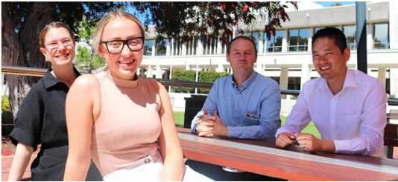   
**(From left to right) Olivia, Sophie, Aaron and Bernard – Accounting Services**

### Procurement Services

Facilitate efficient and cost-effective procurement for all stakeholders through an effective centre-led procurement model, providing support services in competitive sourcing and contract management. The service also works to ensure organisational compliance with statutory and internal procurement requirements.

**Achievements**

* Established a new sourcing process that incorporates a new supplier register with locality categorisation, ensuring greater integrity and validation of the quotation process
* Digitised various procurement forms and templates to improve efficiency
* Updated legal documentation, including general terms and conditions
* Revised the City’s Procurement Policy to reflect COVID-19 induced legislative changes, and to leverage local and regional business opportunities, aligning with a Strategic Community Plan objective to support and promote the benefits of buying locally.

## Rates & Revenue Services

Delivers property rating services and manages the City’s revenue raising and collection activities, while ensuring statutory compliance across all areas. Maintains and controls the City’s central property database and prepares the electoral roll.

**Achievements**

* Prepared various rating models to determine a rating strategy for addressing the triennial GRV revaluation and Council’s commitment to a zero rates increase for all property owners, resulting in the adoption and implementation of a COVID-19 concession
* Implemented a process to automate RevenueWA (former Office of State Revenue) pensioner data matching at the end of financial year to increase work efficiency
* Introduced the Enterprise Cash Receipting decentralised system to out centres such as Ranger Services and the Henderson Reuse Shop
* Made significant improvement to the rates debt recovery module to enhance debt recovery workflows, debt management and internal reporting
* Introduced pre-authorisations on credit cards for bond payments on bookings for City-owned facilities, reducing cash handling and improving Payment Card Industry compliance (minimised risk exposure).

### Information Services Business Unit

Information Services is the business unit responsible for providing, maintaining and developing the City’s core services relating to information and communication technology.

### Information Technology Services

Provides technology services and support that enables the delivery of the City’s core information services. This includes the management of key projects that enhance and further secure the City’s key information delivery to its staff, partners and community.

**Achievements**

* Stage two renovations of administration data centre (server room) completed
* Facilitated hardware and configuration of Cockburn COVID-19 helpdesk
* Facilitated IT components for deployment of over 300 staff to work from home during COVID-19
* Implemented Council Chambers audio visual equipment upgrade and live streaming of Council meetings.

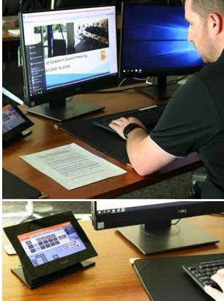   
**Nick from IT works on the Council Chambers audio visual equipment upgrade**

### Cyber Security

Provides technology services, awareness and training that enforces the City’s cyber security policies. This includes the management of key projects that enhance and further secure the City’s key information assets for its staff, partners and community.

**Achievements**

* A 33 per cent increase in cyber security compliance based on ISO 27001
* Regular cyber security training for staff at all levels of the organisation
* Cyber security community outreach through social media
* Partnership with the Joint Cyber Security Centre
* Partnership with ScamWatch.

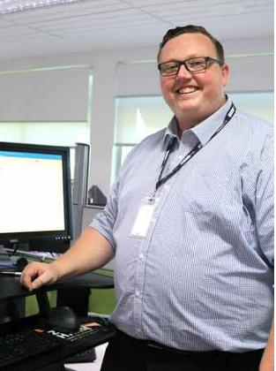   
**Elliot - Cyber Security Officer**

### Business Systems

Provides solution development and business analysis services in support of the City’s core information systems.

**Achievements**

* Website design and search improvements
* Online animal registration and transfer from other councils
* Online barking dog diaries
* Electronic cash receipting upgrade
* Website accessibility re-accreditation
* Undertook full Enterprise Resource Planning Technology One upgrade
* Created vulnerable persons database to support COVID-19 activity.

### Geographic Information Systems (GIS) Services

Deliver the support, maintenance and development of GIS systems and datasets that provide stakeholders with the tools to analyse, visualise and explore corporate location-based information.

**Achievements**

* Migrated existing corporate mapping system into ESRI ArcGIS environment
* Implemented new workflow for CoSafe using ESRI mobility apps
* Integrated ESRI mapping system with Technology One
* Developed better visibility of spatial information with graphical charts using ESRI dashboard
* Developed graffiti data collection tool in ESRI ArcGIS environment.

## Records Services

Provide a high standard of technologically advanced records management services to support the governing functions of Council.

**Achievements**

* Completed stages two and three of the Knowledge Management Project
* Reviewed and implemented improvements to archiving processes
* Digitised hard copy Council Minute books
* Upgraded Enterprise Content Management (ECM) to 2018A release.

### Recordkeeping Compliance

Evaluation of Recordkeeping Systems

Work was undertaken with the organisation’s Strategic Planning Business Unit to review their recordkeeping practices through the Knowledge Management Project. This resulted in a number of changes to processes to improve recordkeeping within the business unit and reduce the amount of information being stored outside of the recordkeeping system.

The City’s Records Management Policy is reviewed every two years with the next review due in December 2020.

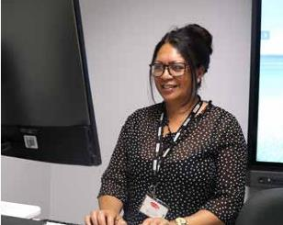   
**Mary - Records Services**

### Recordkeeping Training Program

All new staff are required to undertake an online Records Awareness Training (RAT) course. The interactive course outlines the recordkeeping roles and responsibilities of all employees at the City of Cockburn. Participants must undertake and pass a short assessment at the completion of the course. Employees must then repeat the course every two years.

An online course outlining the specific recordkeeping responsibilities of managers and supervisors has also been implemented.

Regular training for new and existing staff is also held on the use of the organisation’s electronic document and records management system called ECM.

### Evaluation of the Recordkeeping Training Program

All participants who attend ECM training are asked to complete a training feedback form. The feedback forms are regularly reviewed and suggestions for improvements are incorporated into the training program.

### Recordkeeping Induction Program

New staff must complete the Records Awareness Training (RAT), and where relevant, ECM training as part of their induction.

New managers/supervisors are also required to complete the online Recordkeeping Training for managers and supervisors.

# Financial Report

To view the [City of Cockburn’s Annual Financial Report 2019-2020 on the City’s website: https://www.cockburn.wa.gov.au/Council/About-Council/Strategic-Planning#annualreport](https://www.cockburn.wa.gov.au/Council/About-Council/Strategic-Planning#annualreport)

Sculpture of 2 gardeners outside the City of Cockburn Administration Building.  
**City of Cockburn Administration Building, Spearwood**

# Contact

9 Coleville Crescent, Spearwood WA 6163

PO Box 1215, Bibra Lake DC WA 6965

**Telephone**: 08 9411 3444

**Email:** [customer@cockburn.wa.gov.au](mailto:customer@cockburn.wa.gov.au)

[**City of Cockburn website:** www.cockburn.wa.gov.au](https://www.cockburn.wa.gov.au/)

Facebook logo. [**City of Cockburn Facebook:** www.facebook.com/CityOfCockburn](https://www.facebook.com/CityOfCockburn/)

Twitter logo. [**City of Cockburn Twitter:** twitter.com/CityOfCockburn](https://twitter.com/CityOfCockburn/)

Instagram logo. [**City of Cockburn Instagram:** www.instagram.com/cityofcockburn](https://www.instagram.com/cityofcockburn/)

YouTube logo. [**City of Cockburn YouTube:** www.youtube.com/CityOfCockburn](https://www.youtube.com/CityofCockburn)

Disability symbol. This information is available in alternative formats upon request.