Tender Title: |  | PROVISION OF HERBICIDE, INSECTICIDE, WETTING AGENT SPRAYING  (Parks, Streetscapes, Bushland Reserves / Firebreaks) Three (3) Year Contract
Request ID: |  | 70245
Tender Description: |  | The City of Cockburn is seeking suitably qualified and experienced contractor(s) to supply and apply herbicides, insecticides, turf growth regulators and liquid wetting  agents within the City’s boundaries and properties.
Advert Approval: |  | Decision to Advertise: Director Infrastructure Services  Decision Date: Tuesday, 22 April 2025
Closing Date and Time: |  | 2:00PM (AWST) Tuesday, 20 May 2025
Opening Date and Time: |  | 2:00PM (AWST) Tuesday, 20 May 2025
 | Tenderer’s Name:
1 | Environmental Industries (Environmental Industries Pty Ltd)
2 | Gecko Contracting (GAS Assets Pty Ltd)
3 | Natural Area (Natural Area Holdings Pty Ltd)
4 | SERCUL (South East Regional Centre For Urban Landcare Inc)
5 | UGC Group (UGC Holdings Pty Ltd)
6 | Website Weed and Pest (Website Weed & Pest (WA) Pty Ltd)
7
8
9
10

Advertisement
Method 1: City of Cockburn website | Method 2: City of Cockburn Libraries Public Noticeboards
Method 3:  The Western Australian, Wednesday, 30 April 2025 | Tender Awarded by:
Copy of Statewide Notice:  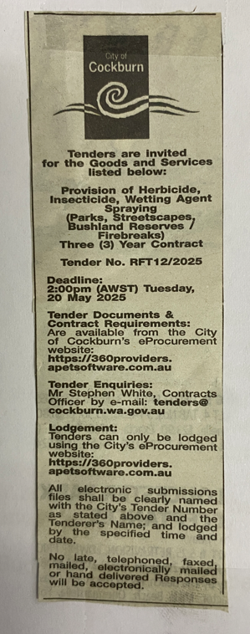 | OCM  Choose an item.  Tuesday, 8 July 2025
 | Date of Council Meeting:
Date: 08 July 2025
Minutes: 0134
Item No. 14.3.2
Name of Successful Tenderer(s): | - Gas Assets Pty Ltd T/as Gecko  Contracting (Parks & Streetscapes only)  - South East Regional Centre for Urban Landcare Inc (SERCUL) (Bushland Reserves / Firebreaks only)
Amount of Successful Tender(s): (ex GST) | - $626,469 (Ex GST)  - $621,420 (Ex GST)

