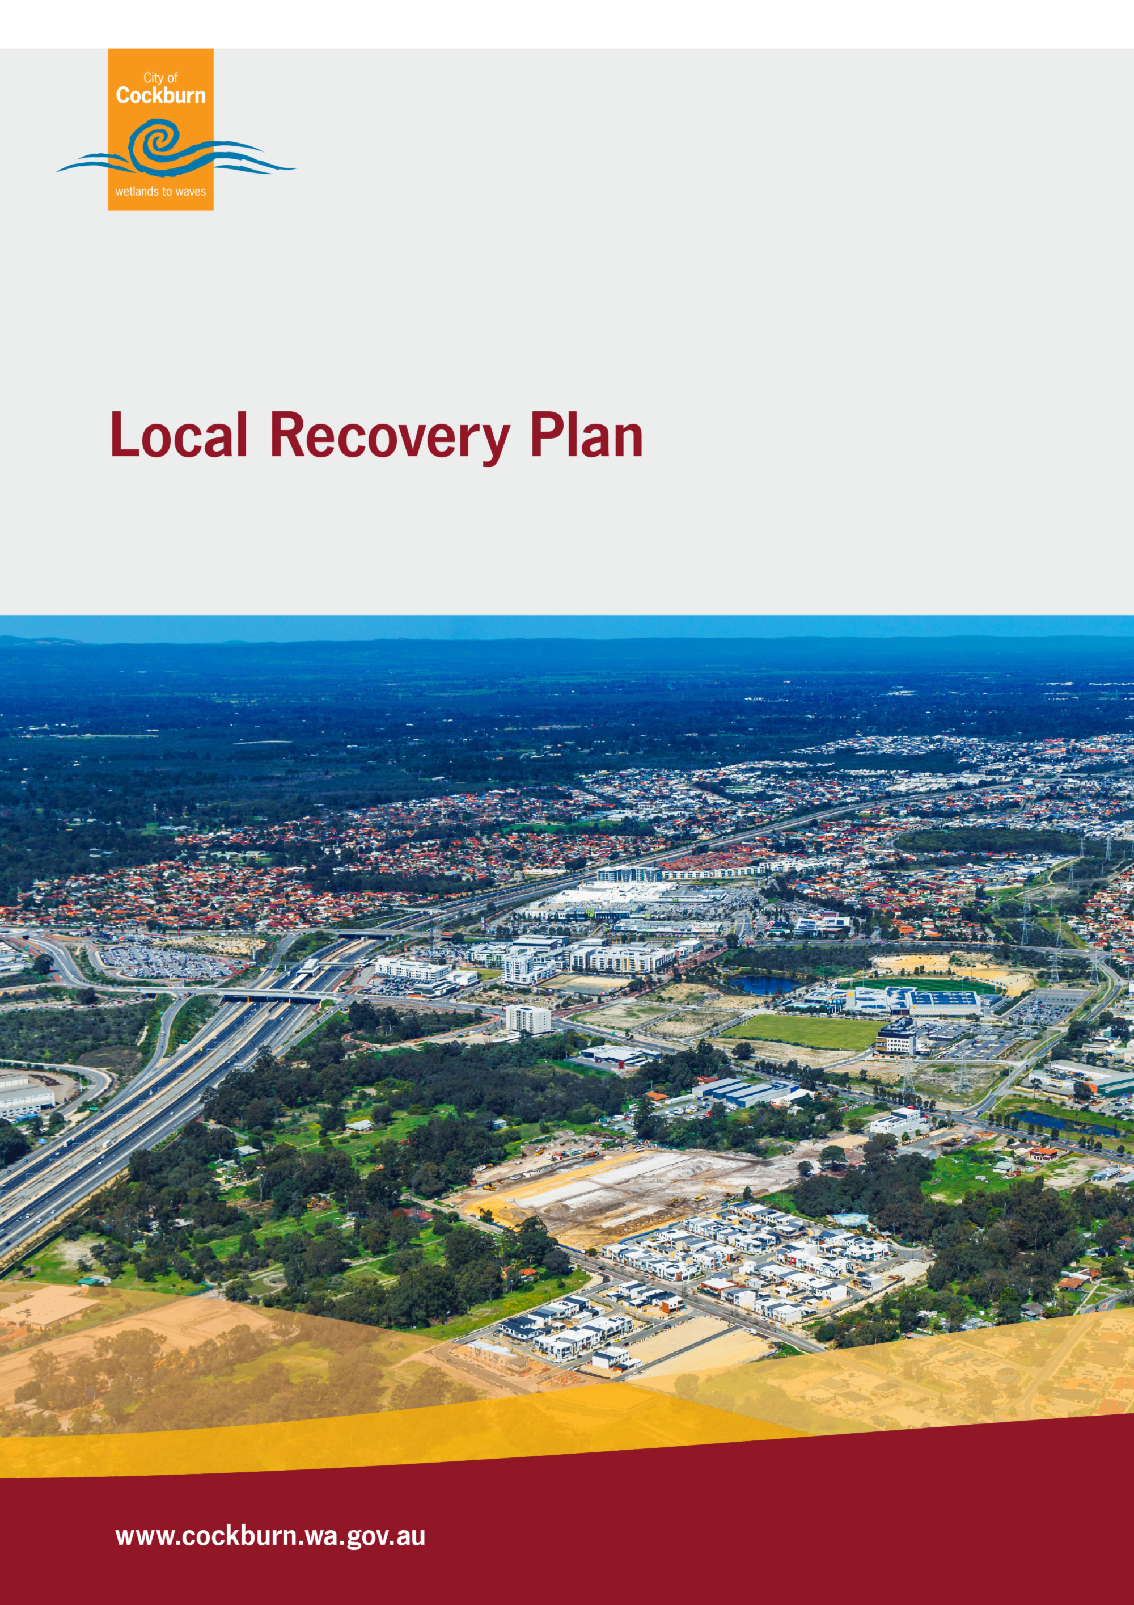

Authority
The Local Recovery Plan has been prepared in accordance with section 41(4) of the Emergency Management Act 2005 (EM Act) and forms a part of the Cockburn Local Emergency Management Arrangements. This plan has been endorsed by the Cockburn Local Emergency Management Committee and has been tabled for information and comment with the South Metropolitan District Emergency Management Committee. This plan has been approved by the City of Cockburn.
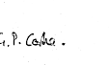 |  | 17/12/2025
City of Cockburn Deputy Mayor Phoebe Corke  On behalf of the Mayor, Chair of the Cockburn Local Emergency Management Committee |  | Date
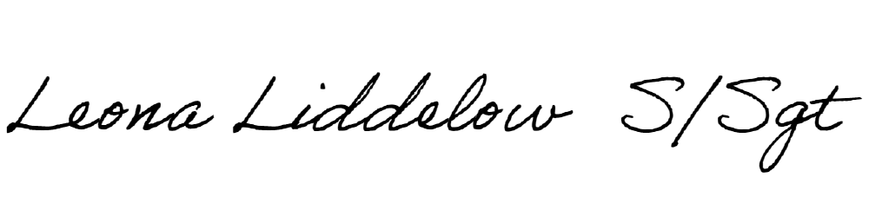 |  | 17/12/2025
Deputy Chair, WA Police Senior Sergeant Leona Liddelow  Cockburn Local Emergency Management Committee |  | Date

Endorsed by Council 9 December 2025 (2025/MINUTE NO 0217)

Acknowledgement of Country
The City of Cockburn and the Cockburn Local Emergency Management Committee acknowledges the Nyungar people of Beeliar Boodjar. Long ago, now and in the future they care for Country. We acknowledge a continuing connection to Land, Waters and Culture and pay our respects to Elders, past and present.

Table of Contents
Document Amendments 5
Glossary of Terms 5
Part One: Introduction 7
1.1 Purpose 7
1.2 Objectives 8
1.3 Scope 8
1.4 Review Process 8
Part Two: Local Emergency Management Arrangements and related documents 10
2.1 Local Emergency Management Arrangements 10
2.2 Related documents 10
2.3 Collaborative Agreements and Commitments 11
Part Three: What is Recovery? 13
3.1 Recovery Management Principles 13
3.2 Recovery Management Functional Areas 14
3.3 Transition to Recovery 15
Part Four: How is Recovery Coordinated and Who Does What? 17
4.1 Local Recovery Coordinator 17
4.2 Local Recovery Coordination Group 19
4.2.1 Functions 19
4.2.2 Composition 21
4.3 Local Recovery Coordination Group Subcommittees 22
4.4 State Recovery Coordination 22
4.5 Developing a Local Operational Recovery Plan 22
Part Five: Resources and Facilities 27
5.1 Local Recovery Centre 27
5.2 Staff Considerations 28
5.3 Financial Arrangements 28
5.3.1 Internal Funding and Record Management 29
5.3.2 External Funding Arrangements 31
5.3.3 Donations of Goods 34
5.4 Temporary Memorial Management 35
5.5 Volunteer Management 35
5.6 Waste Management and Clean Up 37
5.6.1 Clean Up Decision-Making Considerations 38
5.7 Communications 39
Part Six: Stand Down and Evaluation 41
6.1 Debriefing 41
6.2 Recovery Evaluation 41
Appendices 42
Appendix One: Local Recovery Coordinator Position Description 43
Appendix Two: Local Recovery Coordinator Kit 45
Appendix Three: Local Recovery Coordination Group Profile and Checklist 45
Appendix Four: Local Operational Recovery Plan Template 45
Appendix Five: Local Recovery Coordination Group Subcommittee Roles and Functions 46

Document Amendments
Approval Date | Review Type | Amendment Details | Reviewer
2018 | Major |  | M.Emery
2025 | Major | Annexation of Local Recovery Plan from Local Emergency Management Plan and comprehensive update and review, with additional sections on resources and appendices to support. | C.Mora

Feedback and comments from the community and stakeholders help to improve the accuracy and effectiveness of these arrangements.
Feedback can provided to:
Cockburn Local Emergency Management Committee
City of Cockburn
PO Box 1215, Bibra Lake DC,
Western Australia, 6965
Or via email to: customer@cockburn.wa.gov.au

Glossary of Terms
Terminology used throughout this document shall have the meaning as prescribed in either section 3 of the Emergency Management Act 2005 (the Act) or as defined in the State EM Glossary or the WA Emergency Risk Management procedure.
Refer to the Local Emergency Management Plan for a local glossary.



Part One: Introduction

Recovery is the support of emergency affected communities in the reconstruction and restoration of physical infrastructure, the environment and community, psychosocial and economic wellbeing (section 3(d) of the Emergency Management Act 2005)
Recovery should be seen as a community development process, which should seek to develop and enhance the community rather than just return it to the previous level of resilience. This can be achieved with a well-managed recovery process.
Community disaster recovery includes recovery in the spheres of physical, environmental, economic and social wellbeing. Recovery can provide an opportunity to improve these aspects beyond previous conditions, by enhancing social and natural environments, infrastructure and economies – contributing to a more resilient community.
This Local Recovery Plan is established in accordance with the Emergency Management Act 2005 section 41(4) which requires a local government to prepare a recovery plan and nominated a Local Recovery Coordinator.
This Local Recovery Plan has been developed by the City of Cockburn in consultation with the Cockburn Local Emergency Management Committee (LEMC). The LEMC membership includes representatives of agencies, organisations, community groups and subject matter experts.

1.1 Purpose
The purpose of the Local Recovery Plan is to describe the arrangements for effectively managing recovery at a local level, including accountability and responsibility, to be used by City of Cockburn staff and Cockburn Local Emergency Management Committee in preparing a Local Operational Recovery Plan and undertaking recovery activities.
In accordance with the Emergency Management Act 2005, recovery management is the coordinated process of supporting “emergency affected communities in the reconstruction and restoration of physical infrastructure, the environment and community, psychosocial and economic wellbeing” (section 3).

1.2 Objectives
The objectives of the Local Recovery Plan are to:
- Outline the principles and objectives of recovery management
- Describe the roles, responsibilities, available resources and procedures for the management of recovery from emergencies for the City of Cockburn
- Establish a basis for the coordination of recovery activities at the local level
- Promote effective liaison between all Hazard Management Agencies
- Emergency services and supporting agencies, which may become involved in recovery, and
- Provide a framework for recovery operations.

1.3 Scope
The scope of this Local Recovery Plan is limited to the boundaries of the City of Cockburn (excluding Rottnest Island) and forms a part of the Cockburn Local Emergency Management Arrangements.
This Plan is intended to be used by City of Cockburn staff and Cockburn Local Emergency Management Committee, and is not intended for people directly impacted by disasters.
These arrangements are to serve as a guideline to be used at the local level. Incidents may arise that require action or assistance from the District, State or Federal level, in which case these arrangements should be used to guide advocacy and recovery efforts in the Cockburn community.

1.4 Review Process
The Local Recovery Plan must be reviewed regularly to ensure information is up to date and relevant. The Local Recovery Plan should be reviewed:
- After an event or incident that requires the activation of an Incident Support Group (ISG) or significant recovery coordination
- After training or drills that exercise the arrangements
- Changes to State or Local policy
- Any other time the City of Cockburn considers appropriate, or
- A unanimous decision by the Cockburn Local Emergency Management Committee (LEMC).
The review may entail only minor administrative amendments or a more significant change to document structure, which requires tabling at the District Emergency Management Committee and State Emergency Management Committee.

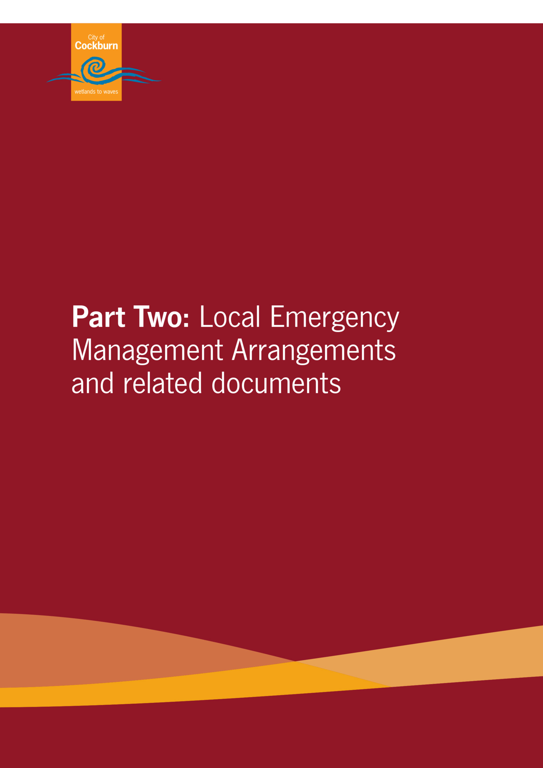

Part Two: Local Emergency Management Arrangements and related documents

2.1 Local Emergency Management Arrangements
This Local Recovery Plan is to be read in conjunction with and alignment to the Cockburn local emergency management arrangements.
The Local Recovery Plan is consistent with State Emergency Management Policies.
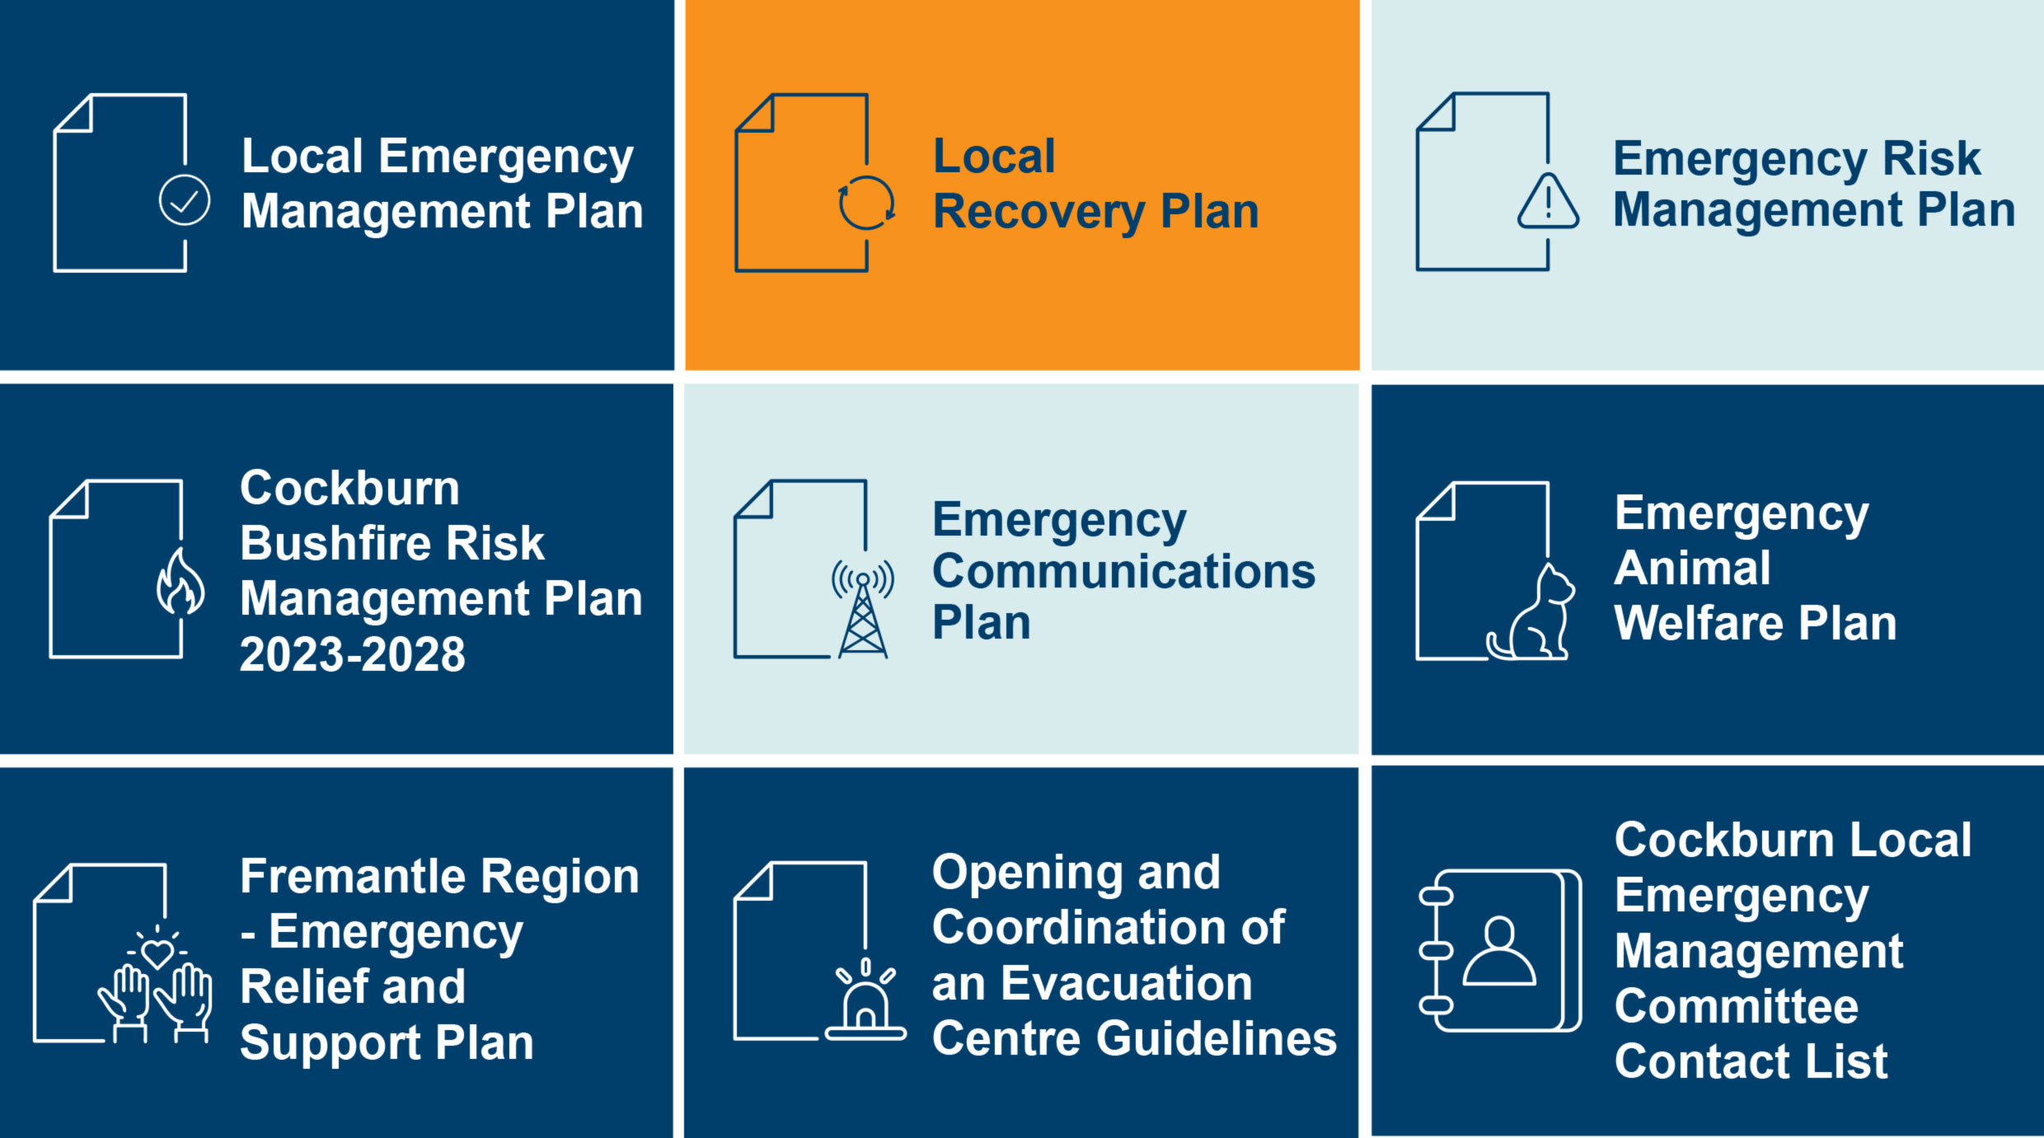

2.2 Related documents
- Business Continuity Plan (ECM Doc Set ID: 11538591)
- Crisis and Incident Communications Plan (ECM Doc Set ID: 11505805)

2.3 Collaborative Agreements and Commitments
All of the City’s emergency management agreements, understandings and commitments are outlined in the Local Emergency Management Plan.

The City of Cockburn is a partner in the Memorandum of Cooperation - Provision of Emergency Support 2025 – 2030 (ECM Doc Set ID: 12476615) with Perth local governments in the South Metropolitan area. The following Local Governments are for the provision of additional resources in emergency management:
- City of Armadale  - City of Cockburn  - City of Fremantle  - City of Kwinana  - City of Mandurah | - City of Melville  - Shire of Murray  - City of Rockingham  - Shire of Serpentine Jarrahdale  - Shire of Waroona
The Memorandum of Understanding formalises cooperative arrangements between local governments for the sharing of emergency management information and knowledge, as well as the provision of support for disaster recovery activities.
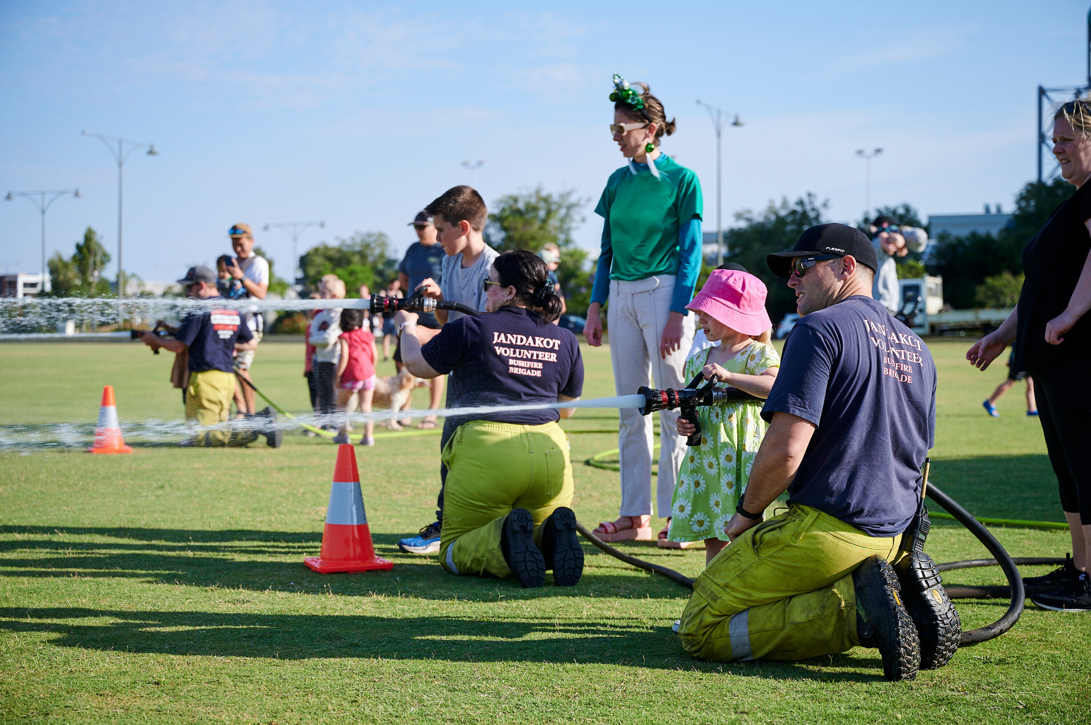

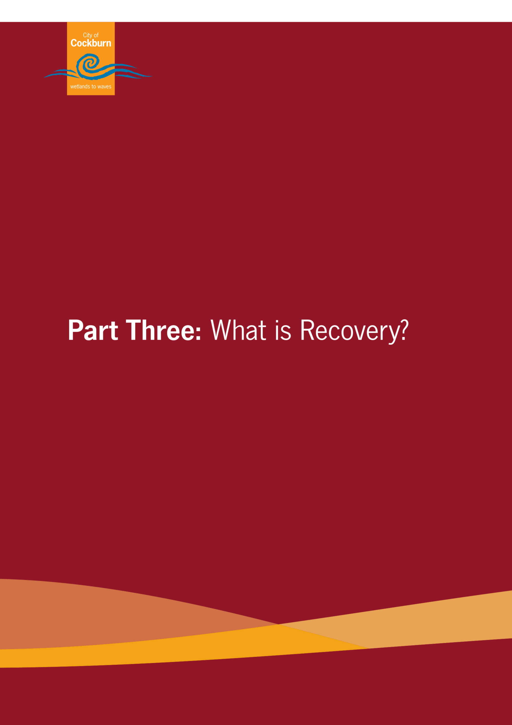

Part Three: What is Recovery?
Managing recovery is a legislated function of the City of Cockburn and the Local Recovery Plan is a sub-plan of the Local Emergency Management Arrangements documenting the recovery process.
Local government, being the closest form of government to local communities, are best to lead, manage and coordinate community recovery during and following an emergency event. This responsibility is undertaken in close cooperation with or directly supported by State Government departments, supporting agencies, community members, community groups, and community service organisations.

3.1 Recovery Management Principles
This Plan and its Local Recovery Coordination Group
will consider all aspects of recovery, incorporating the National Principles for Disaster Recovery:
- Understanding the context
- Recognise complexity
- Use community-led approaches
- Coordinate all activities
- Communicate effectively
- Recognise and build capacity.

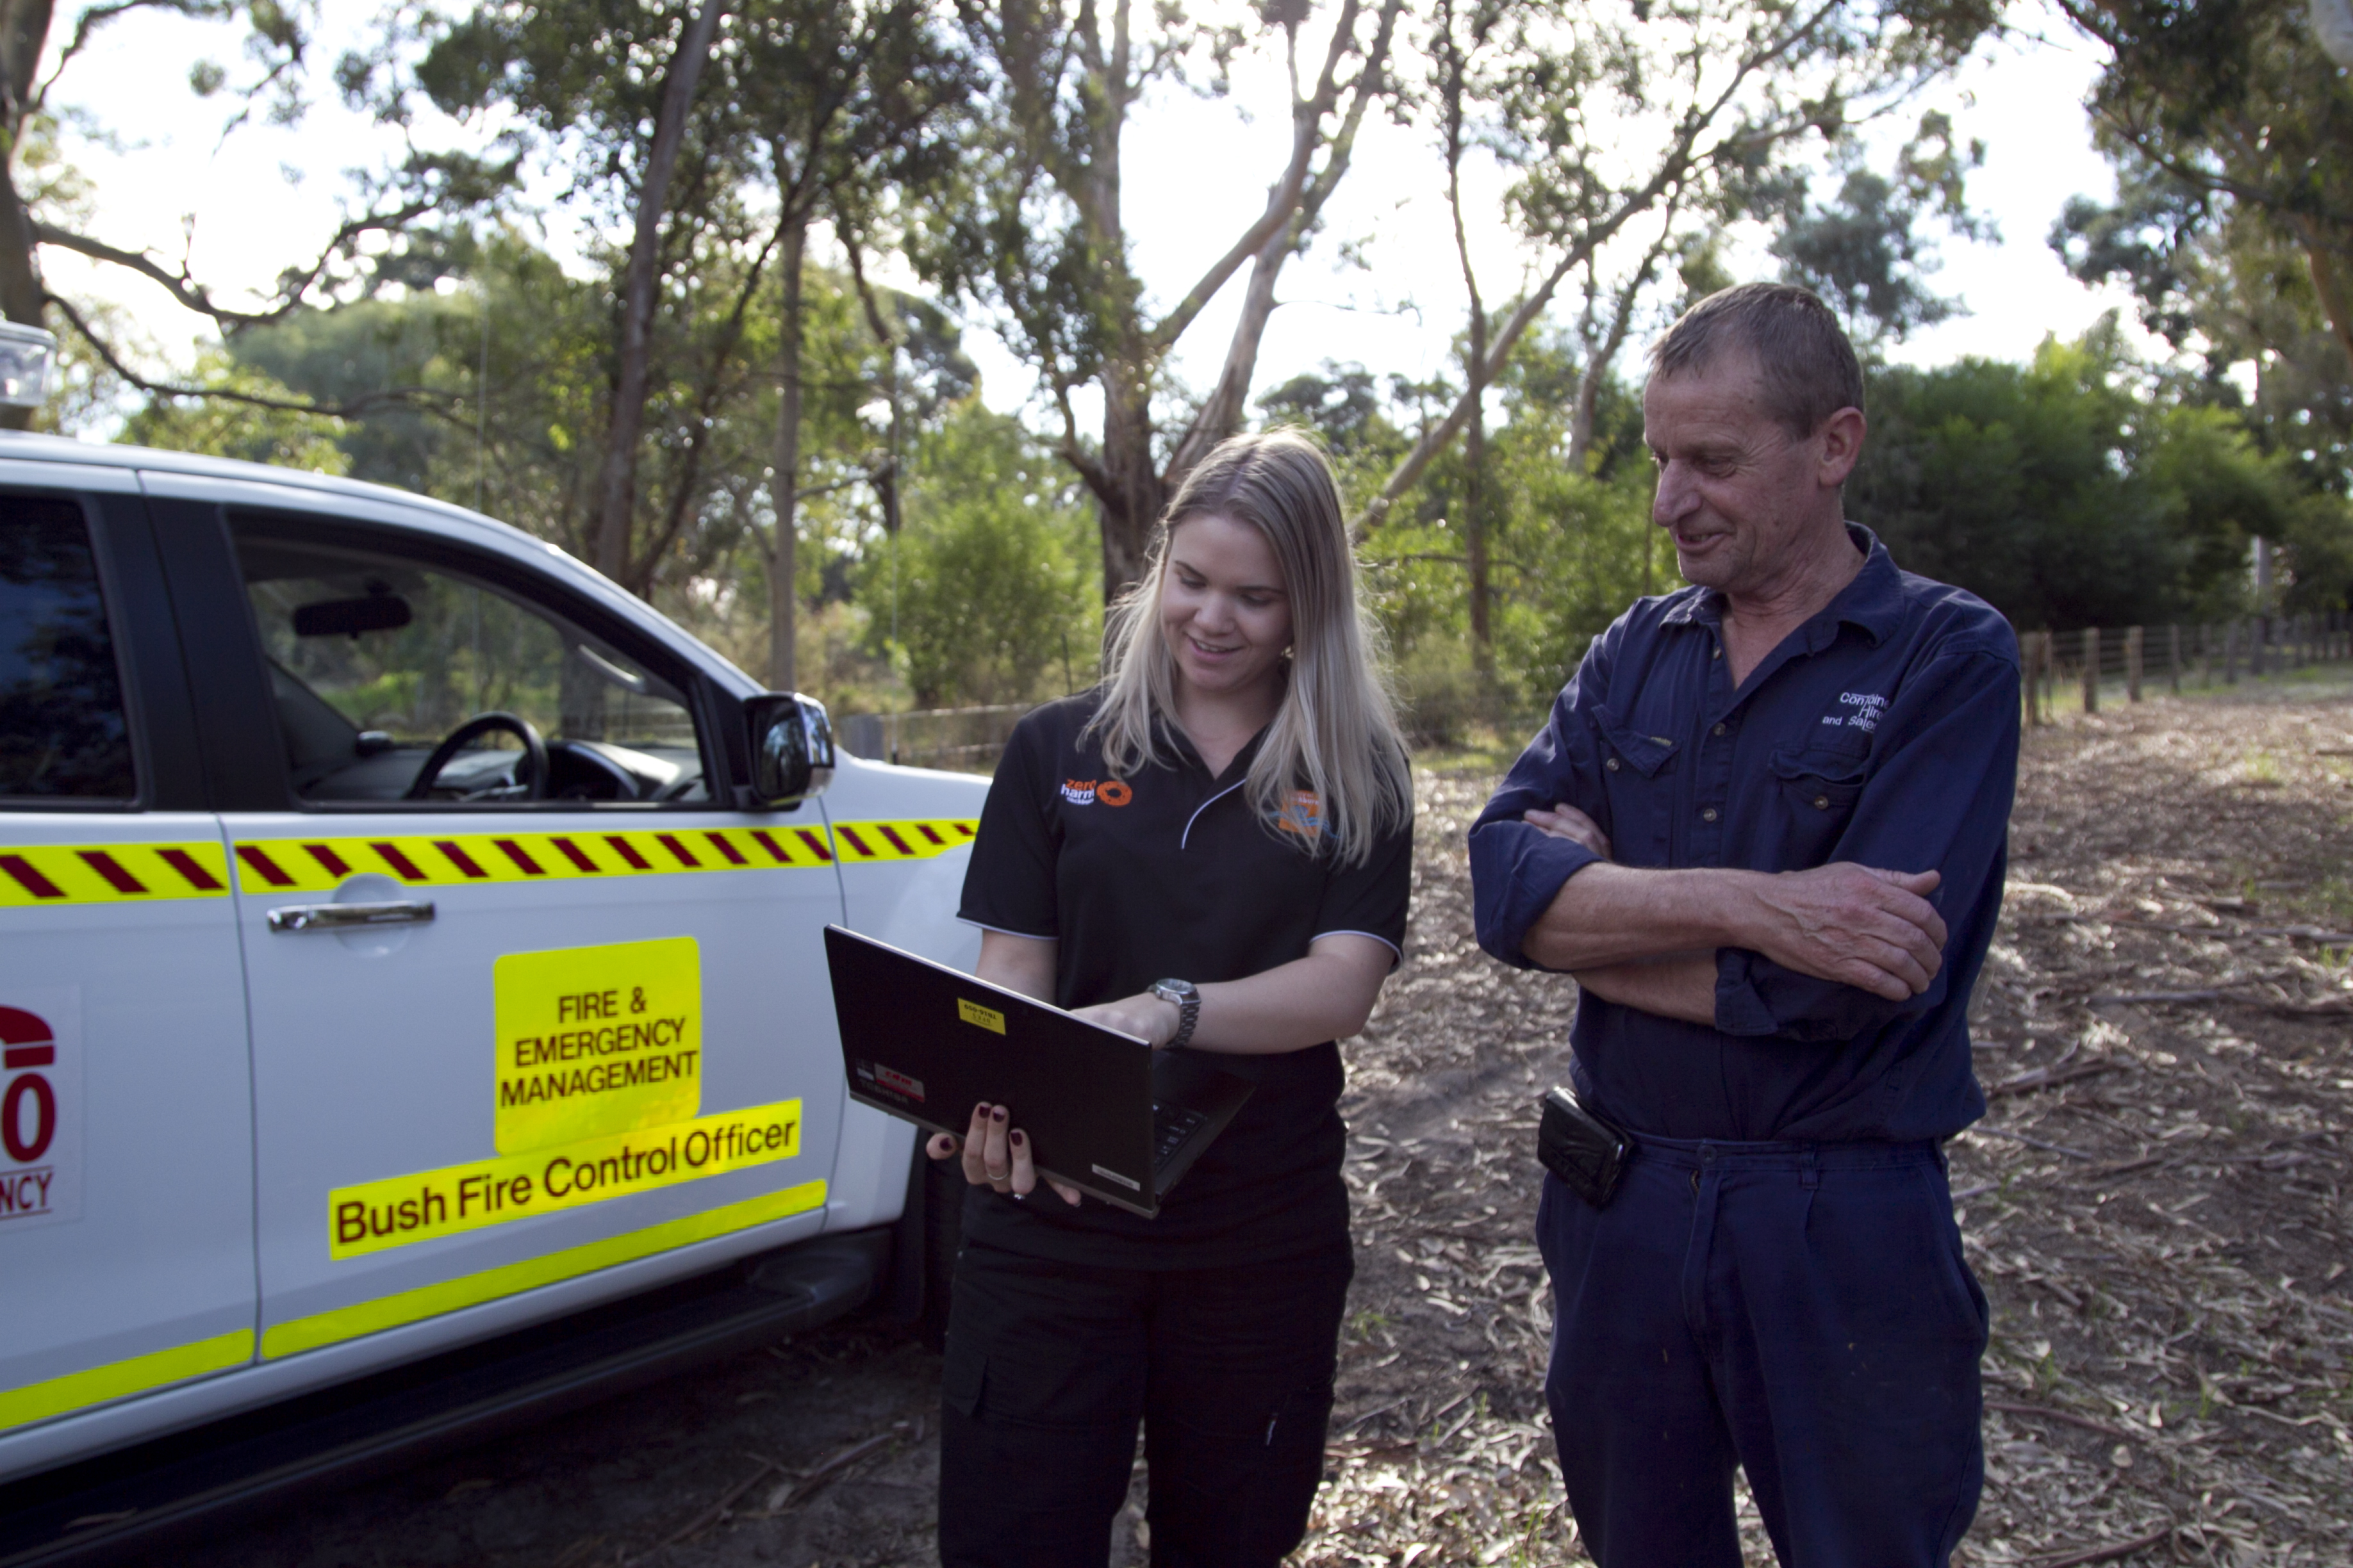

3.2 Recovery Management Functional Areas
There are four key functional areas that require coordination of plans to be implemented as part of the recovery process on the various needs of the community. These are Social, Economic, Natural and Built Environments, as expanded on below.
 | 
Social | Economic
- Community impact and needs  - Outreach  - Communications  - Events  - Local Recovery Centre  - Health and wellbeing  - Resilience and social connectedness  - Family and personal support  - Donations and volunteers | - Tourism  - Jobs and employment  - Business impacts (Agriculture, industry, small business etc)  - Local population and security  - Donated funds  - Lord Mayor’s Distress Relief Fund (LMDRF)
 | 
Natural Environment | Built Environment
- Air and water quality  - Bushland and reserves  - Flora and fauna health  - Pollution management  - Beaches and waterways | - Transport and roads  - Waste services  - Parks and gardens  - Utilities and essential services  - Building and development

3.3 Transition to Recovery
Recovery starts as soon as an incident occurs and is the responsibility of the City of Cockburn. However, there may be a formal process to transition to recovery for significant incidents whereby the Controlling Agency will liaise with the City of Cockburn to prepare for a transition from response to recovery and at an agreed point will transfer responsibility to the City to coordinate activities.
The handover must be appropriately documented, and an Impact Statement prepared in accordance with State Procedures. The CEO or Local Recovery Coordinator should accept any formal handover.
To aid the transition to recovery all Controlling Agencies should complete an impact statement on the affect area of the emergency. An Impact Statement is a key element of the handover process from the response to recovery between the controlling agency and local government. The acceptance of this handover of responsibility is at the discretion of the CEO on advice from the Local Recovery Coordinator and Local Recovery Coordination Group, in consultation with the Hazard Management Agency / CA. Acceptance of this Impact Statement and its responsibilities should not occur unless the CEO, the Local Recovery Coordinator and the Local Recovery Coordination Group are fully aware of the extent of the impacts on the community and are willing to take on the responsibilities going forward.
The Controlling Agency/ Hazard Management Agency with the responsibility for the response to an emergency will initiate recovery activity during the response to that emergency. To facilitate recovery, the Controlling Agency/ Hazard Management Agency will:
- Liaise with the Local Recovery Coordinator where the emergency is occurring and include them in the incident management arrangements including the Incident Support Group and the Operations Area Support Group
- Undertake and initial impact assessment for the emergency and provide that assessment as an Impact Statement to the Local Recovery Coordinator and the State Recovery Coordinator
- Coordinate completion of the Impact Statement, prior to cessation of the response, in accordance with the approved procedure, and in consultation with the Incident Support Group, all affected local governments and the State Recovery Coordinator
- Provide risk management advice to the affected community (in consultation with the Hazard Management Agency) and
- Conduct a formal “handover” of control of the emergency to a designated recovery controller.
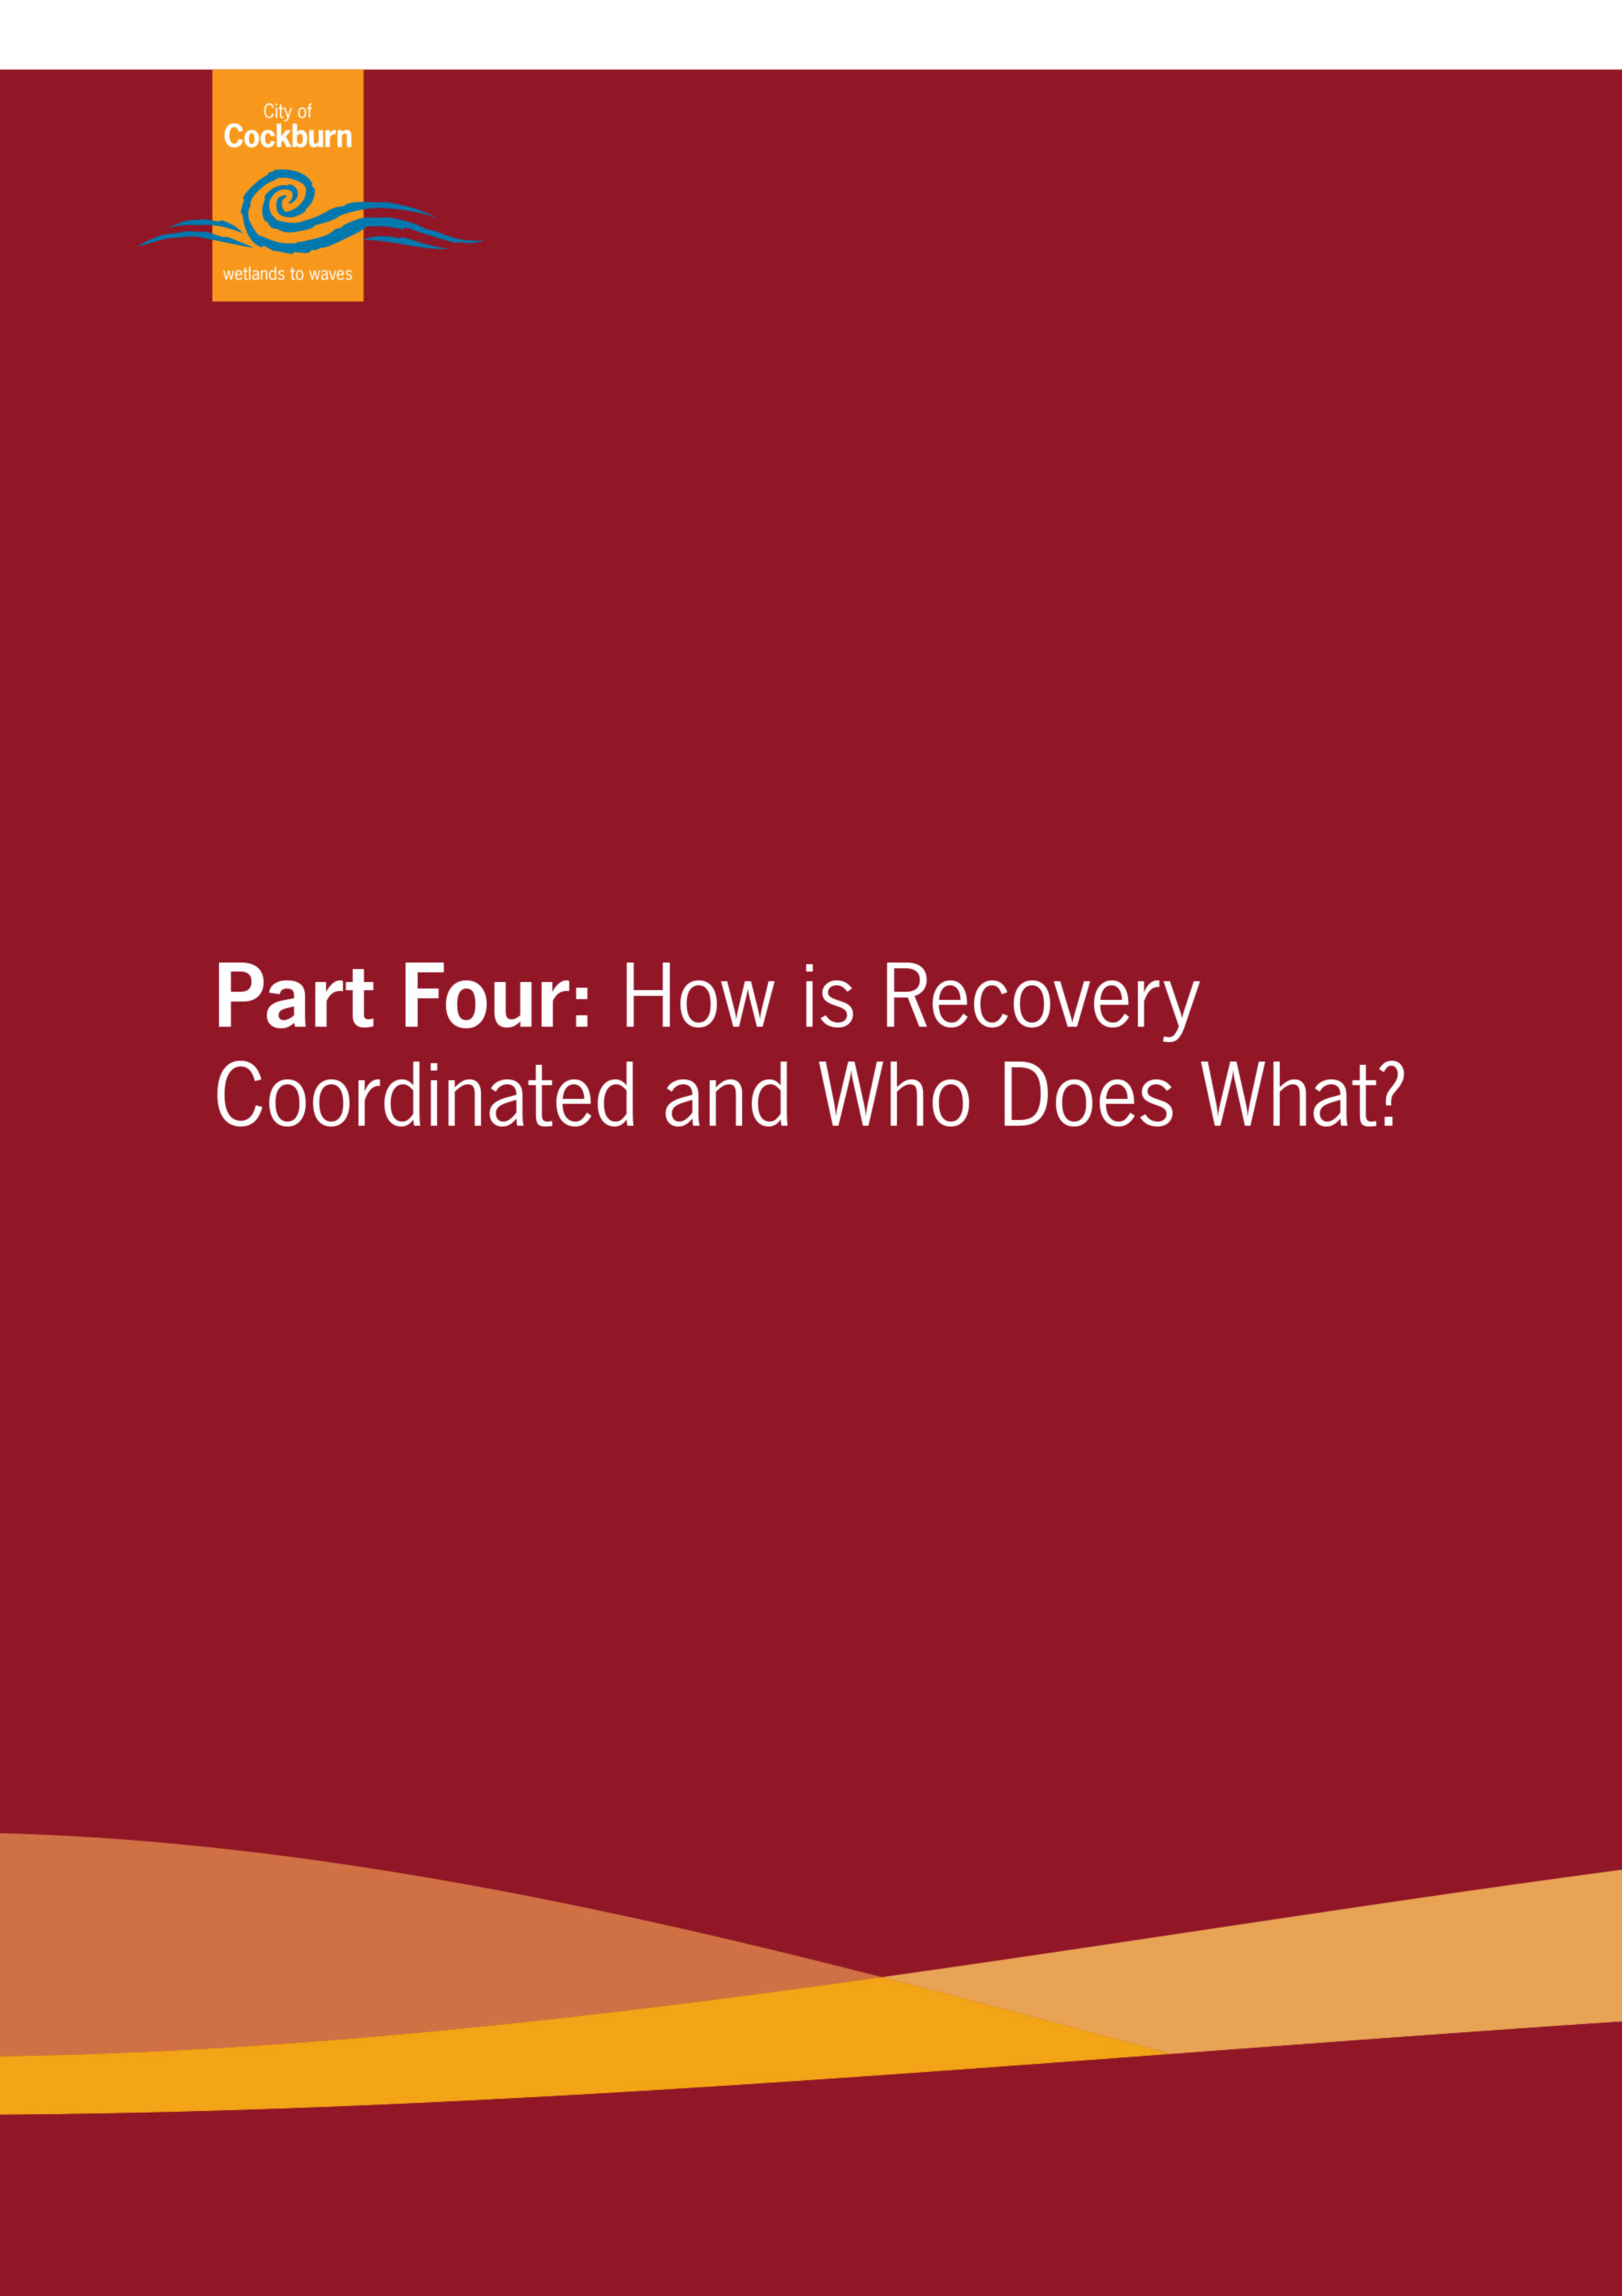

Part Four: How is Recovery Coordinated and Who Does What?
Recovery activities are to be coordinated by the City of Cockburn through the Local Recovery Coordinator and Local Recovery Coordination Group.
The role of the City of Cockburn is to:
- Manage recovery following an emergency affecting the community in its district (s.36(b) the Emergency Management Act 2005)
- Ensure that a Local Recovery Plan for its district is prepared, maintained and tested (s.41(4) the Emergency Management Act 2005),
- Identify and appoint Local Recovery Coordinator/s
- Determine the establishment of a Local Recovery Coordination Group when appropriate and establish the group's roles and responsibilities in line with the State Emergency Management Committee Local Recovery Guidelines
- Coordinate local level recovery activities via the Local Recovery Coordination in conjunction with the Local Recovery Coordination Group and in accordance with plans, strategies and policies that it determines, and
- Consider the potential membership of a Local Recovery Coordination Group prior to emergencies occurring.

4.1 Local Recovery Coordinator
The Local Recovery Coordinator is responsible for the development and implementation of recovery arrangements for the City, in conjunction with the Local Recovery Coordination Group.
The nominated Local Recovery Coordinators for the City of Cockburn are as follows:
Local Recovery Coordinator – Fire and Emergency Management Manager
Deputy Local Recovery Coordinator – Service Manager Rangers and Community Safety
Two positions (or the equivalents) have been selected to ensure continuity during leave and ordinary business arrangements. The Local Recovery Coordinator will report directly to a member of the Executive Leadership Team.
The Chief Executive Officer may appoint an alternate Local Recovery Coordinator depending on the scale and nature of recovery.

Figure 1: summarises the position the role of the Local Recovery Coordinator before, during and after an emergency.
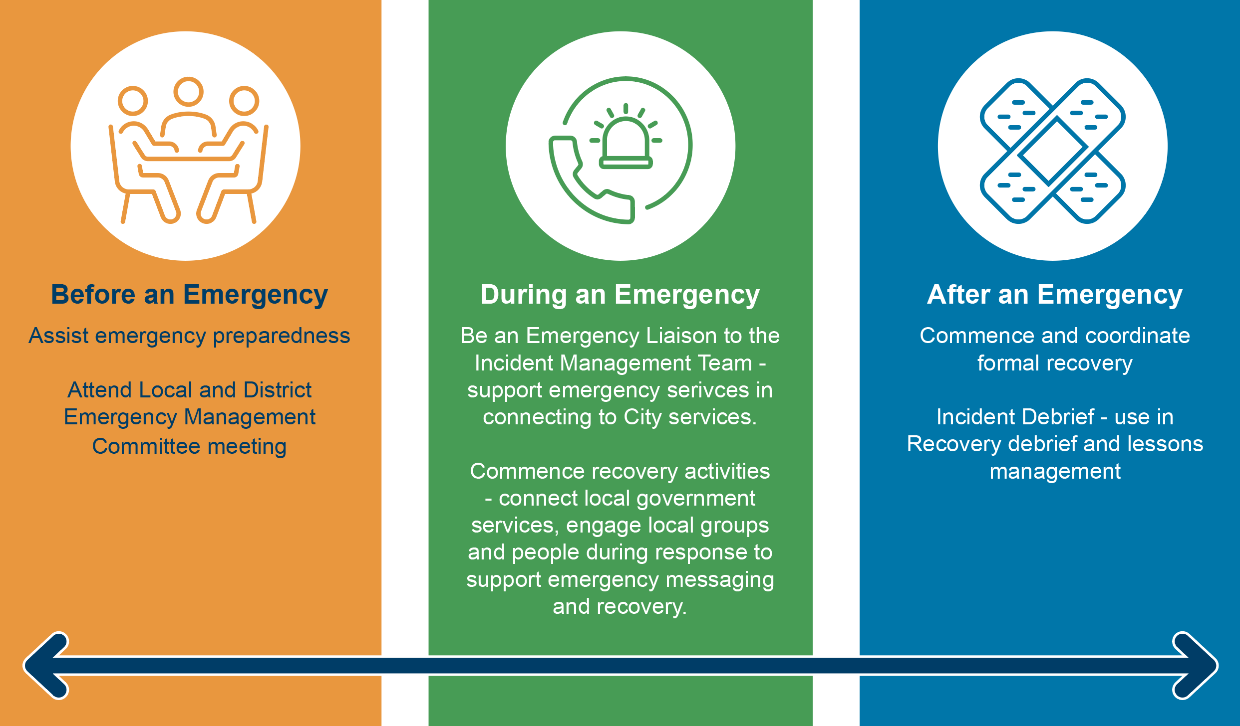
During emergency response, the Local Recovery Coordinator is responsible for liaising with the Hazard Management Agency/Controlling Agency and participating in the incident management and coordination arrangements, including ensuring that the local arrangements are followed and recognised to best reflect local expectations.
The Local Recovery Coordinator can be effective only with an appropriately resourced support structure, designed to facilitate and coordinate relief and recovery efforts. As the Local Recovery Coordinator has no specific statutory powers, it is essential to collaborate with agencies and representatives who have the authority to accomplish dedicated tasks.
Incidents of a small nature that have minimal impact or only have short-term impacts will be coordinated through emergency response, with the Local Recovery Coordinator supporting any recovery and remediation activities and may not require a full activation of recovery.

The following are available in this Plan to support the Local Recovery Coordinator:
- Appendix One: Local Recovery Coordinator Position Description
- Appendix Two: Local Recovery Coordinator Kit
- LEMC Contact List
Refer to the LEMC Contact List for contact details of the Local Recovery Coordinator and Deputy’s.

4.2 Local Recovery Coordination Group
The Cockburn Local Recovery Coordination Group is to coordinate and support local management of the recovery process by assessing the consequences of the event and coordinating recovery activities to rebuild, restore and rehabilitate the social, built, economic and natural environments within the community during an emergency event.
The Local Recovery Coordination Group may be convened by the CEO and/or the Local Recovery Coordinator.
If activated, the Local Recovery Coordination Group can be more appropriately named to reflect the recovery efforts, community needs and impact, hazard experienced and the locality. It is recommended that the Group is not referred to as a committee, so as not to be confused with a committee of Council established per the Local Government Act 1995 and required to follow Council Standing Orders.

4.2.1 Functions
The functions of the Local Recovery Coordination Group are:
- Establishing sub-committees as required
- Assessing requirements, based on the Impact Statement, for recovery activities relating to the social, built, economic and natural wellbeing of the community with the assistance of the responsible agencies where appropriate
- Developing a Local Operational Recovery Plan for the coordination of the recovery process for the event that:
  - Takes into account the City of Cockburn’s Strategic Community Plan, long-term planning and goals
  - Includes an assessment of the recovery needs and determines which recovery functions are still required
  - Develops a timetable and identifies responsibilities for completing the major activities
  - Considers the needs of youth, the aged, the disabled, and culturally and linguistically diverse people
  - Allows full community participation and access, and
  - Allows for the monitoring of the progress of recovery
- Overseeing the delivery of projects that support the social, built, economic and natural environments of recovery to ensure that they are community-owned and targeted to best support the recovery of impacted communities
- Facilitating the recovery of services, public information, information exchange and resource acquisition
- Providing advice to the State and City of Cockburn to ensure that recovery programs and services meet the needs of the community
- Negotiating the most effective use of available resources including the support of State and Commonwealth agencies, and
- Monitoring the progress of recovery, and receiving periodic reports from recovery agencies;
  - Ensuring a coordinated multi-agency approach to community recovery
  - Providing a central point of communication and coordination for the actions of a wide range of recovery-related services and projects being progressed outside of the direct control of the Local Recovery Coordination Group, and
  - Making appropriate recommendations, based on lessons learnt, to the Local Emergency Management Committee to improve the community’s recovery preparedness.

The above can be read in conjunction with the Appendix Three: Local Recovery Coordination Group Profile and Checklist and provides guidance for the Local Recovery Coordination Group and lists possible actions to be taken within the first 48 hours, week, and 12 months.

4.2.2 Composition
The Local Recovery Coordination Group is to comprise of the below.
Core Membership (required)
- Local Recovery Coordinator (will chair the meetings of the Group)
- Executive Officer (Local Government officer to be appointed by the Local Recovery Coordinator)
- Council Spokesperson (City of Cockburn Mayor or Deputy Mayor)
- Local Emergency Coordinator (Officer-In-Charge WA Police of relevant Fremantle sub-district – Cockburn, Murdoch or Fremantle)
- Community representative/s (see section 4.5.1 on community engagement)
- Hazard Management Agency/s representative
Additional Members may include as required:
- District Emergency Management Advisor
- State Recovery
- Controlling Agency/s representatives
- Emergency relief and support agencies
- Local Recovery Coordination Group subcommittee Chairs
- Representatives from affected public utilities
- Representatives from industries or sectors impacted (i.e. business, tourism, attractions, heavy/light industry)
- Local Government officers based on subject matter expertise
- Neighbouring Local Government/s Local Recovery Coordinators
The Local Recovery Coordination Group is a strategic group and its composition may vary depending on the nature, location and complexity of an emergency event and its subsequent recovery. Members may be appointed in accordance with the identified recovery needs of the community. Refer to the section on Developing an Local Operational Recovery Plan for information regarding identifying community needs, and community champions and groups.
The Local Recovery Coordinator is to determine the initial membership of the group until a terms of reference is endorsed by the Local Recovery Coordination Group.
The following is available to support the Local Recovery Coordination Group:
- Appendix One: Local Recovery Coordinator Position Description
- Appendix Two: Local Recovery Coordinator Kit
- Appendix Three: Local Recovery Coordination Group Profile and Checklist
- Appendix Four: Local Operational Recovery Plan Template
- Appendix Five: Local Recovery Coordination Group Sub-Committees Roles and Functions

4.3 Local Recovery Coordination Group Subcommittees
Where required, it may be appropriate to consider establishing one or more subcommittees to assist the Local Recovery Coordinator and Local Recovery Coordination Group by addressing specific components of the recovery process.
Consideration will be given to establishing subcommittees across the four recovery environments (social, built, economic and natural) depending on the nature and extent of the recovery. The subcommittees may include the following or a combination of the suggested subcommittees;
- Social (Chair – Director Community and Place)
- Economic (Chair – Director Sustainable Development and Safety)
- Natural (Chair – Group Manager Growth and Sustainability)
- Built (Chair - Director Infrastructure Services)
Each sub-committee (if established) will report their activities through their nominated Chair to the Local Recovery Coordination Group. The Local Recovery Coordination Group Sub-Committees' functions are contained in Appendix Five.

4.4 State Recovery Coordination
During the recovery process, the State Government may provide support and assistance to the City. In conjunction with the City of Cockburn and the State Emergency Coordinator, the State Recovery Coordinator is to consider the level of State involvement required, based on a number of factors pertaining to the impact of the emergency. More information about State Recovery is available within the State Emergency Management Framework, including the State EM Plan – Appendix G.

4.5 Developing a Local Operational Recovery Plan
The Local Recovery Coordination Group is responsible for preparing the Local Operational Recovery Plan to guide specific emergency recovery activities. Recovery planning is about a coordinated approach to identify and address the community’s needs.
“After an emergency, an affected community needs to face a new reality, and decide about its needs and priorities. It will be important to consider the community values, aspirations, development plans and patterns of local leadership that existed before the emergency and to support the community to integrate these into recovery processes. This integration ensures that the longer-term recovery process leads to ongoing and sustainable development.”
(Australian Institute of Disaster Resilience, Community Recovery Handbook 2018)
In the first instance, recovery should focus on immediate needs, which could include physiological needs (food, water and shelter) or safety and security from hazards, through the provision of relief and support services and evacuation/accommodation arrangements.
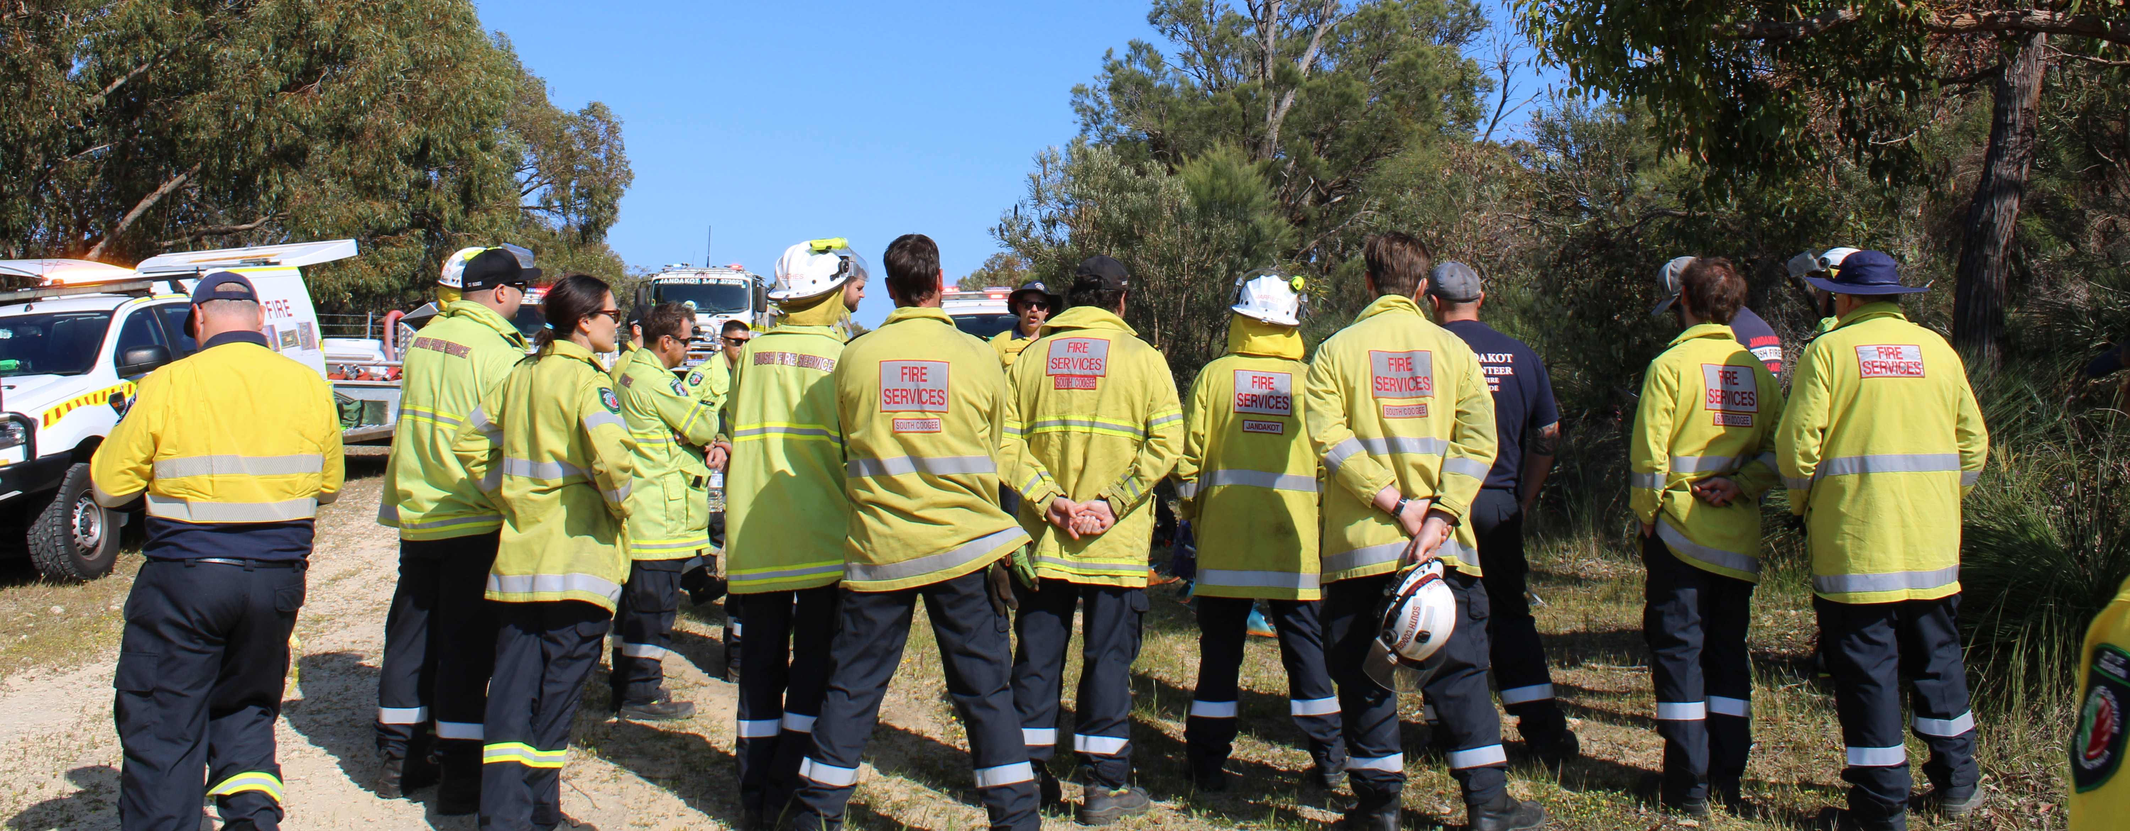
Recovery is a long journey to ensure the community restores a level of health, connectedness and development as outlined in the Local Operational Recovery Plan that will be developed at the time. Figure 2 shows the recovery process intersecting with community development processes. Figure 3 shows the priorities for the City of Cockburn to consider in immediate and long-term recovery community needs assessment and recovery activities that will form the Local Operational Recovery Plan to be used following an emergency.
Figure 2: Effect of disaster on ongoing community development and interface with relief and recovery (Australian Institute of Disaster Resilience, Community Recovery Handbook 2018).
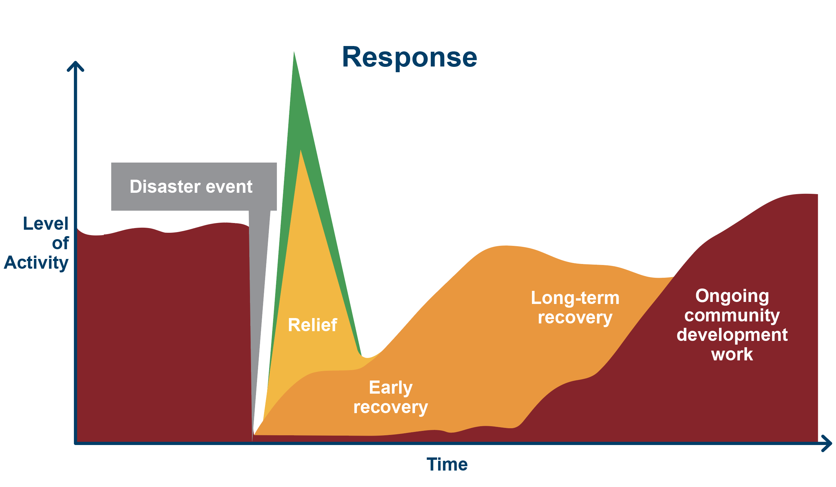
Figure 3: Pyramid to demonstrate a combination of Maslow’s Hierarchy of Needs and community development and recovery processes to prioritise recovery needs assessments and activities.

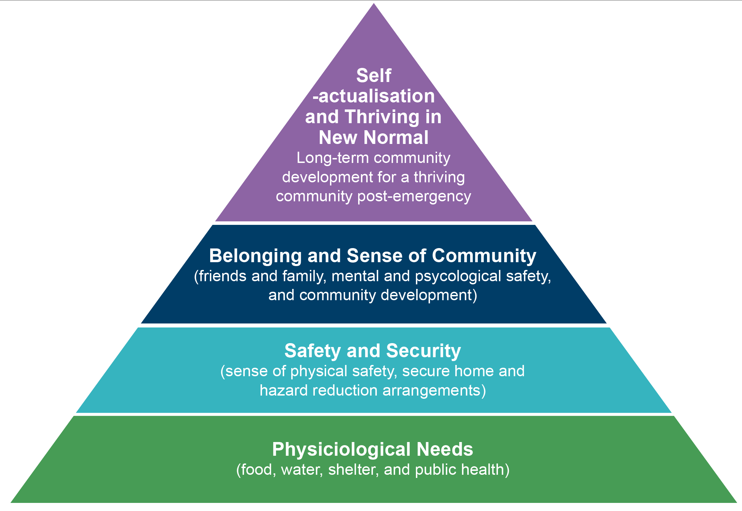
Some examples of Local Operational Recovery Plans include:
- Northland Regional Council (New Zealand) – Cyclone Gabrielle 2023 Regional Recovery Plan for Northland | Te Mahere Whakaoranga mō Te Tai Tokerau
- Western Australia State Recovery, Department of Fire and Emergency Services – Wooroloo Bushfire State Recovery Plan

4.5.1 Community Engagement
Enabling the community to lead and participate in the formal recovery coordination process via the Local Recovery Coordination Group is essential to the success of recovery.
The people and places within the City of Cockburn are diverse, and as such, their needs and supports will need to be adaptable and broad. There are several teams that can support building community connections and working with the community immediately and in long-term recovery.
Role/Objective | City of Cockburn Services that can support
Doorknocking and attending public venues to communicate with the general public | CoSafe and Ranger Services  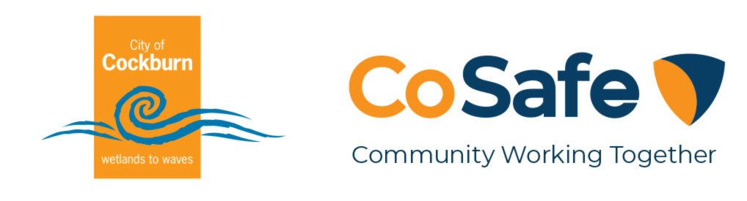  Community and Resident groups via Community Development
Connecting to community and resident groups | Community Development
Connecting to sporting and recreation clubs and groups | Recreation Services and City Facilities
Connecting to volunteers and volunteer opportunities | Volunteer Resource Centre
Communicating with specific sections/intersections of the community. | First Nations Development, Disability Access and Inclusion, Youth Services, Seniors Centre, and Children's Development.

For more information about working with the community, see sections 5.5 Volunteer Management and 5.7 Communications.

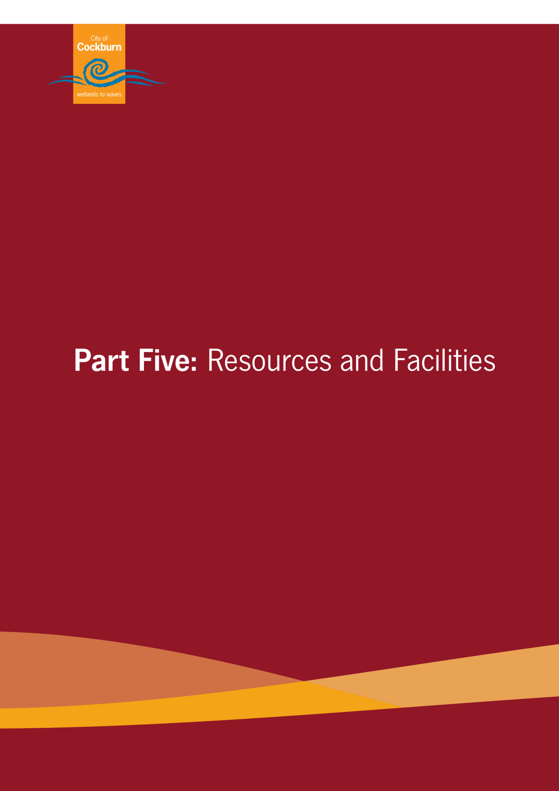

Part Five: Resources and Facilities

5.1 Local Recovery Centre
Depending on the extent of the incident, a Recovery Centre may be established by the Local Recovery Coordination Group to provide a central location for the public to receive assistance from all the relevant agencies. This could be in the form of support services and information being available in one central location or even mobile.
The Recovery Centre model is an effective method of providing the affected community with access to information, progress of recovery and assistance from relevant recovery service providers at a central point or ‘one stop shop’ if a significant event occurs.
The Recovery Centre is to be;
- located as close as possible to the affected community area
- accessible and available for public use, and
- used with consideration for long-term use (consider interruption to existing activities and exposure to hazards).
Consultation with the Department of Communities and other relevant stakeholders may be required to determine the most suitable site. If opened, the evacuation centre may make a natural transition into being the Recovery Centre. Where this option is not viable, other facilities may be considered more appropriate due to accessibility and availability.
Consider what facilities and spaces hold meaning for the community and where the community already gathers, such as community centres, shopping centres, sporting grounds and meeting places.
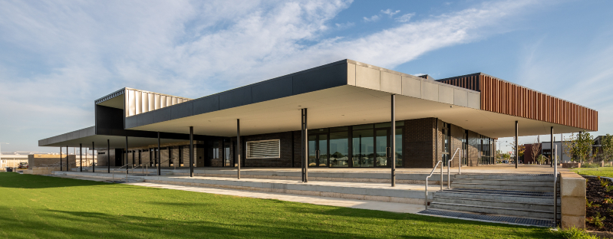
For a list of City-managed facilities that could be used in an emergency, including a Local Recovery Centre, please refer to the Resource Register.

5.2 Staff Considerations
As detailed throughout, City of Cockburn staff will play a significant role in coordinating recovery and recovery activities. Additional staff may be required to ensure that the City of Cockburn can effectively deliver recovery activities, such as hosting a Recovery Centre, and continues to fulfil its obligations and services to the community. Consideration needs to be taken for the demands of recovery operations as well as the continuity of regular business processes.
The extent of the recovery operations should not be underestimated as recovery can be a lengthy process. Depending on the nature of the event, some services may be required for months or even years to follow.
All staff should be regularly briefed and kept up to date with the recovery progress. Staff communicate with a broad range of community members on a daily basis, so can confidently understand and relate to the extensive activities and actions the City and its Local Recovery Coordination Group are currently engaged in. Situation Reports should be posted prominently within the workplace and all actions should be integrated with the actions of the City’s Business Continuity Response Plan (ECM Doc Set ID: 11538591) and decisions of the Disruption Management Team.
As staff members often live and work in the same community, they may have also been personally impacted by the disaster. All City of Cockburn staff have ready access to the Employee Assistance Programs and support services. Consult with the Business Continuity Plan, and if activated the Disaster Management Team (DMT), on personnel and fatigue issues.
Disaster Recovery Funding Arrangements, should they be activated, have provisions for funding for overtime and temporary employees associated with the disaster. For more information, refer to section 5.3.2.1 Disaster Recovery Funding Arrangements WA.

5.3 Financial Arrangements
The primary responsibility for safeguarding and restoring public and private assets affected by an emergency rests with the owner. Additional support for communities and individuals may be available through defined State or Commonwealth government assistance schemes or provided by the City of Cockburn. It is important to note that such assistance is not provided as an alternative to commercial insurance or other mitigation strategies.
The Chief Executive Officer, delegated authority, and/or Local Recovery Coordinator should be approached immediately when an emergency incident requiring resourcing by the City of Cockburn occurs to ensure the desired level of support is achieved. The Local Recovery Coordinator should be able to provide situation-specific advice on funding support.
There are several avenues to fund emergency recovery activities, such as;
- City of Cockburn Municipal Funds (new or existing)
- Insurance appropriate for the asset (City or private), and
- Disaster Recovery Funding Arrangements WA.
Financial support can also be provided to the community or community activities through;
- Disaster Recovery Funding Arrangements WA
- Services Australia, and
- Lord Mayor’s Distress Relief Fund.
Arrangements for funding emergency response activities are detailed in the State Emergency Management Policy in section 5.12 Funding for Emergency Response (page 33) and in the State Emergency Management Plan in section 5.4 Funding for Emergency Responses (page 51). While recognising these arrangements, the City of Cockburn is committed to expending such necessary funds within its current budgetary constraints as required to ensure public and staff health and safety.
“To ensure accountability for expenditure incurred, the Hazard Management Agency or Controlling Agency directing an emergency management agency or other agencies or organisations supporting the emergency response, is responsible for payment of costs associated with an emergency response, unless other arrangements are established as described in Situations A-D.”
State Emergency Management Policy, section 5.12.
The City of Cockburn maintains arrangements in place to ensure its assets are under the Local Government Insurance Scheme (LGIS).

5.3.1 Internal Funding and Record Management
Records must be saved in the City’s record management system to ensure effective recovery coordination and capturing of information and lessons from emergencies.
Subject file “173/003 - Major incidents” should be used in the first instance and a new subject file should be created if a significant recovery effort is undertaken, such as the activation of Disaster Recovery Funding Arrangements, to coordinate and file corporate records including photos and evidence of recovery activities to support cost-recovery.
Figure 4: Flow chart for emergency procurement and steps for compliant and authorised purchasing.
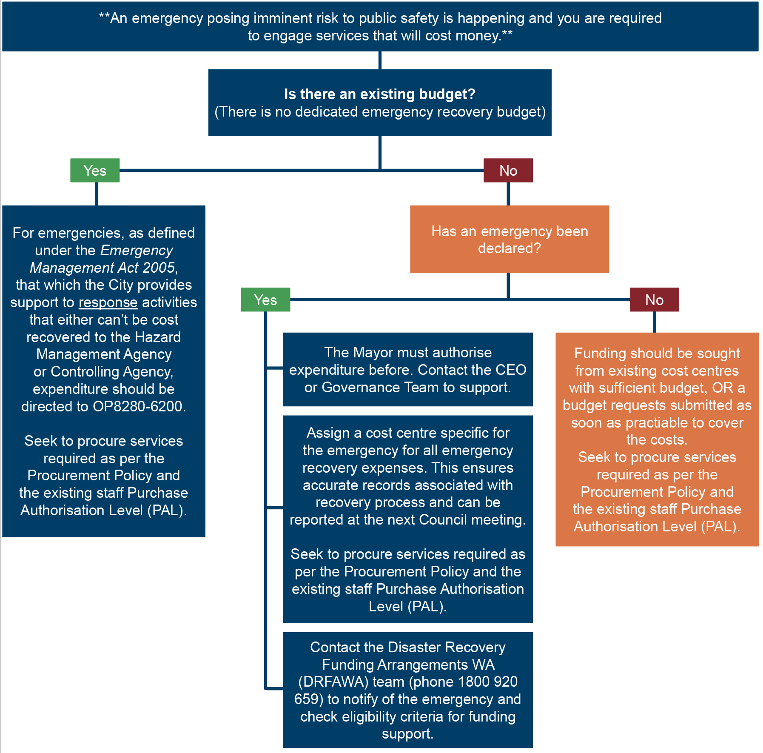
The following are key considerations relating to procurement in an emergency:
- Approvals should be in line with financial authority. If unsure, Procurement Services can assist with identifying who has appropriate authority.
- The Procurement Policy and Procurement Framework should be followed wherever possible.
- Many of the City’s works contracts make provision for services that are required urgently or out of hours.
- Where no existing contractual arrangement exists, the supply may be obtained from any supplier capable of providing the emergency requirements, with due consideration to the City’s commitment to achieve value for money.
- The City may utilise WALGA preferred suppliers, State or Federal Panels and this process should be undertaken in consultation with Procurement Services.
- If time is critical, consultation should be undertaken with the Procurement Services to discuss options to speed up the commencement of the service provision.
- "Emergency” Purchases/Procurements (not included in budget) – section 6.8(1)(c) of the Local Government Act 1995 applies. Expenditure must be authorised in advance by the Mayor.
- Tenders are not required to be called for the expenditure of municipal funds approved by the Mayor in an emergency.
Key Supporting Documents:
- Australian Government – Department of Finance - Preferred Supplier Contracts
- City of Cockburn Register of Delegations
- City of Cockburn Procurement Policy
- City of Cockburn Procurement Framework
- WALGA Preferred Supplier Program (PSP)
- WA State Government - Department of Finance - Common Use Agreements (CUA’s)

5.3.1.1 City Insurance
The owner has primary responsibility for safeguarding and restoring public and private assets affected by an emergency. City of Cockburn’s assets are registered for insurance and financial reporting in line with the Department of Local Government Integrated Planning and Reporting Asset Management Guidelines.
Please note that the City’s insurance department must be notified within 30 days of the incident occurring or as soon as the loss is noticed so that our submission to the City's insurer is compliant.
Any damaged City of Cockburn assets, property or fleet claims should have the appropriate form completed and directed to insurance@cockburn.wa.gov.au for processing. This is not to be used for private assets or property.

5.3.2 External Funding Arrangements
The State EM Policy 6 – Recovery and State EM Plan 6.10 – Financial Assistance outlines the State's recovery funding arrangements. Relief programs include:
- Disaster Recovery Funding Arrangements Western Australia (DRFAWA)
- Services Australia (Centrelink)
- Public Appeals – Lord Mayor’s Distress Relief Fund (LMDRF)
- Premiers Natural Disaster Recovery Fund
The primary responsibility for safeguarding and restoring public and private assets affected by an emergency rests with the owner. Additional support for communities and individuals may be available through defined State/Commonwealth government assistance schemes or spontaneous philanthropic funding ventures. The City should only direct the community to official and legitimate funding channels.

5.3.2.1 Disaster Recovery Funding Arrangements WA
The Federal and State governments have joint arrangements for the provision of emergency and recovery assistance. In WA, these are implemented as the Disaster Recovery Funding Arrangements Western Australia (DRFAWA).
DRFAWA guidelines, templates and fact sheets are available on the Department of Fire and Emergency Services (DFES) website: https://www.dfes.wa.gov.au/recovery-funding
The below criteria must be met prior to activation of an eligible disaster, including:
- A coordinated, multi-agency response is required
- The cost of emergency assistance to individuals and communities, and/or damage to essential public assets, is estimated to exceed $240,000 (costs for the event as a whole - not costs for each local government impacted)
- It must be a terrorist event or one of 10 natural hazards, including: bushfire, earthquake, flood, storm, cyclone, storm surge, landslide, tsunami, meteorite strike, or tornado.
Once all three criteria have been met, a recommendation is submitted to the Fire and Emergency Services Commissioner to activate DRFAWA. Once endorsed, a public notification of DRFAWA activation is issued by DFES.
The types of funding assistance available under the DRFAWA for eligible disasters are referred to as assistance measures and are separated into four categories. These are explained in Figure 5.

Figure 5: the Disaster Recovery Funding Arrangements Categories for funding.
Category A | Category B | Category C | Category D
Includes emergency assistance for communities, individuals and families. | Includes assistance to small businesses and primary producers, State Government agencies and local governments, including assistance to repair or reconstruct essential public assets and counter-disaster operations. | Is intended to support a holistic approach to the recovery of regions, communities or sectors severely affected by an eligible disaster. This assistance may be provided via community recovery funds and/or recovery grants for small businesses and primary producers due to exceptional circumstances. | Assistance is made available to alleviate distress or damage due to exceptional circumstances.

Enquiries can be made to the DRFAWA Administrators via:
email: drfawa@dfes.wa.gov.au
phone: 1800 920 659
For further information about DRFAWA funding, go to www.dfes.wa.gov.au/recovery
To assist with the calculation of disaster costs, and therefore whether the incident will be eligible for DRFAWA funding, funds should be directed to the cost centres outlined under section 5.3.1. Internal Funding.
ACTIVATION: Contact the DFES Recovery Funding Team on 1800 920 659 as soon as possible to discuss the situation.

5.3.2.2 Services Australia (Centrelink)
When a major disaster has significantly affected individuals and families, the Australian Government may provide the Disaster Recovery Payment, a one-off, non-means-tested recovery payment to eligible adults and children.
For more information, visit https://www.servicesaustralia.gov.au/natural-disaster

5.3.2.3 Public Appeals – Lord Mayor’s Distress Relief Fund (LMDRF)
Any request to initiate a public fundraising appeal shall be directed to the Lord Mayor’s Distress Relief Fund (LMDRF). All cash donations resulting from public appeals should also be directed to the LMDRF, as detailed in State Emergency Management Procedure 5.1 – “Management of Public Fundraising and Donations”. Calls for public donations to assist with any emergency should be initiated by the Board of the LMDRF. Such calls may be either on the initiative of the Board itself or by the Board in consultation with any Government or statutory body. The commencement of an appeal fund does not override the statutory obligations, on the part of various government agencies, to provide welfare, relief and reconstruction assistance to those affected by emergencies.
For more information, visit https://appealswa.org.au/
ACTIVATION: Contact the City of Perth via 1300 998 227 or email lmdrf@appealswa.org.au

5.3.3 Donations of Goods
Donations of goods should be discouraged or coordinated through the Local Recovery Coordination Group or GIVITs donation management service. Cash/financial donations provide the opportunity to utilise local services, which in turn assists with the recovery of local businesses. Monetary donations will be referred to the LMDRF, if established.
GIVIT offers a free Donations Management Service that supports charities, front-line services, agencies and governments by coordinating the deluge of donations that commonly occurs post-emergency and ensures offers of good quality goods and services are allocated to meet specific need.
GIVIT’s online portal allows the public and corporates to see exactly what is required by communities and enables people to pledge items and services to meet these needs.
GIVIT’s virtual warehouse removes the need for front-line services to physically collect, sort and store donations. This reduces the administrative and financial burden for local governments.
For more information, visit https://www.givit.org.au/about-us/givit-disaster-resources
ACTIVATION: Contact GIVIT directly or liaise with Department of Fire and Emergency Services State Recovery to assist with activating GIVIT.

5.4 Temporary Memorial Management
Memorials following an emergency or event impacting the community can help comfort and healing, as they serve as a tangible record of life and a reminder of the event/s. Allowing the organic establishment of memorials, whether in parks, roadside or otherwise, is an important part of grieving and the recovery process and therefore shouldn’t be discouraged.
To allow the community to memorialise events in a safe and controlled manner, the City should make efforts to identify the memorial manager, if the City of Cockburn doesn’t absorb management themselves. Memorial management should be conducted in alignment to the Australian Red Cross and Main Roads WA guidelines as detailed below.
- Australian Red Cross: Psychosocial guidelines for temporary memorial management November 2017
- Main Roads WA: Roadside Memorials Policy and Guidelines

5.5 Volunteer Management
Using local spontaneous volunteers can aid with community recovery and help build community resilience. Potential spontaneous volunteers can be highly skilled and may have local knowledge, an understanding of available resources and the trust of the affected community.
The City of Cockburn supports the community being involved in the recovery process and acknowledges that many community members may hold valuable skills that can be utilised.
There are likely to be two types of volunteers:
- Those already affiliated with a specific organisation (e.g. Emergency services, Australian Red Cross, Disaster Relief Australia), and
- Members of the community who offer their services after the event has occurred.
Existing volunteers will be utilised under the structure of their specific organisation.
The Local Recovery Coordination Group may assist with the coordination and tasking of volunteer agencies, however, the management of these volunteers will remain solely with their respective organisation. All spontaneous volunteers should be directed to an official volunteer organisation or through the Cockburn Volunteer Centre or Volunteering WA if they are active for the incident.
It is important to note that volunteers are covered under the Work Health Safety Act 2020 and therefore have work health and safety duties. For more information, visit https://www.worksafe.wa.gov.au/volunteer-organisations
Resources to support volunteer management:
- Spontaneous Volunteer Engagement in Recent Emergencies In WA (Volunteer WA) (Ahmed, 2023) – Planning for spontaneous volunteers from page 9.
Cockburn Volunteer Centre – locally managed volunteers
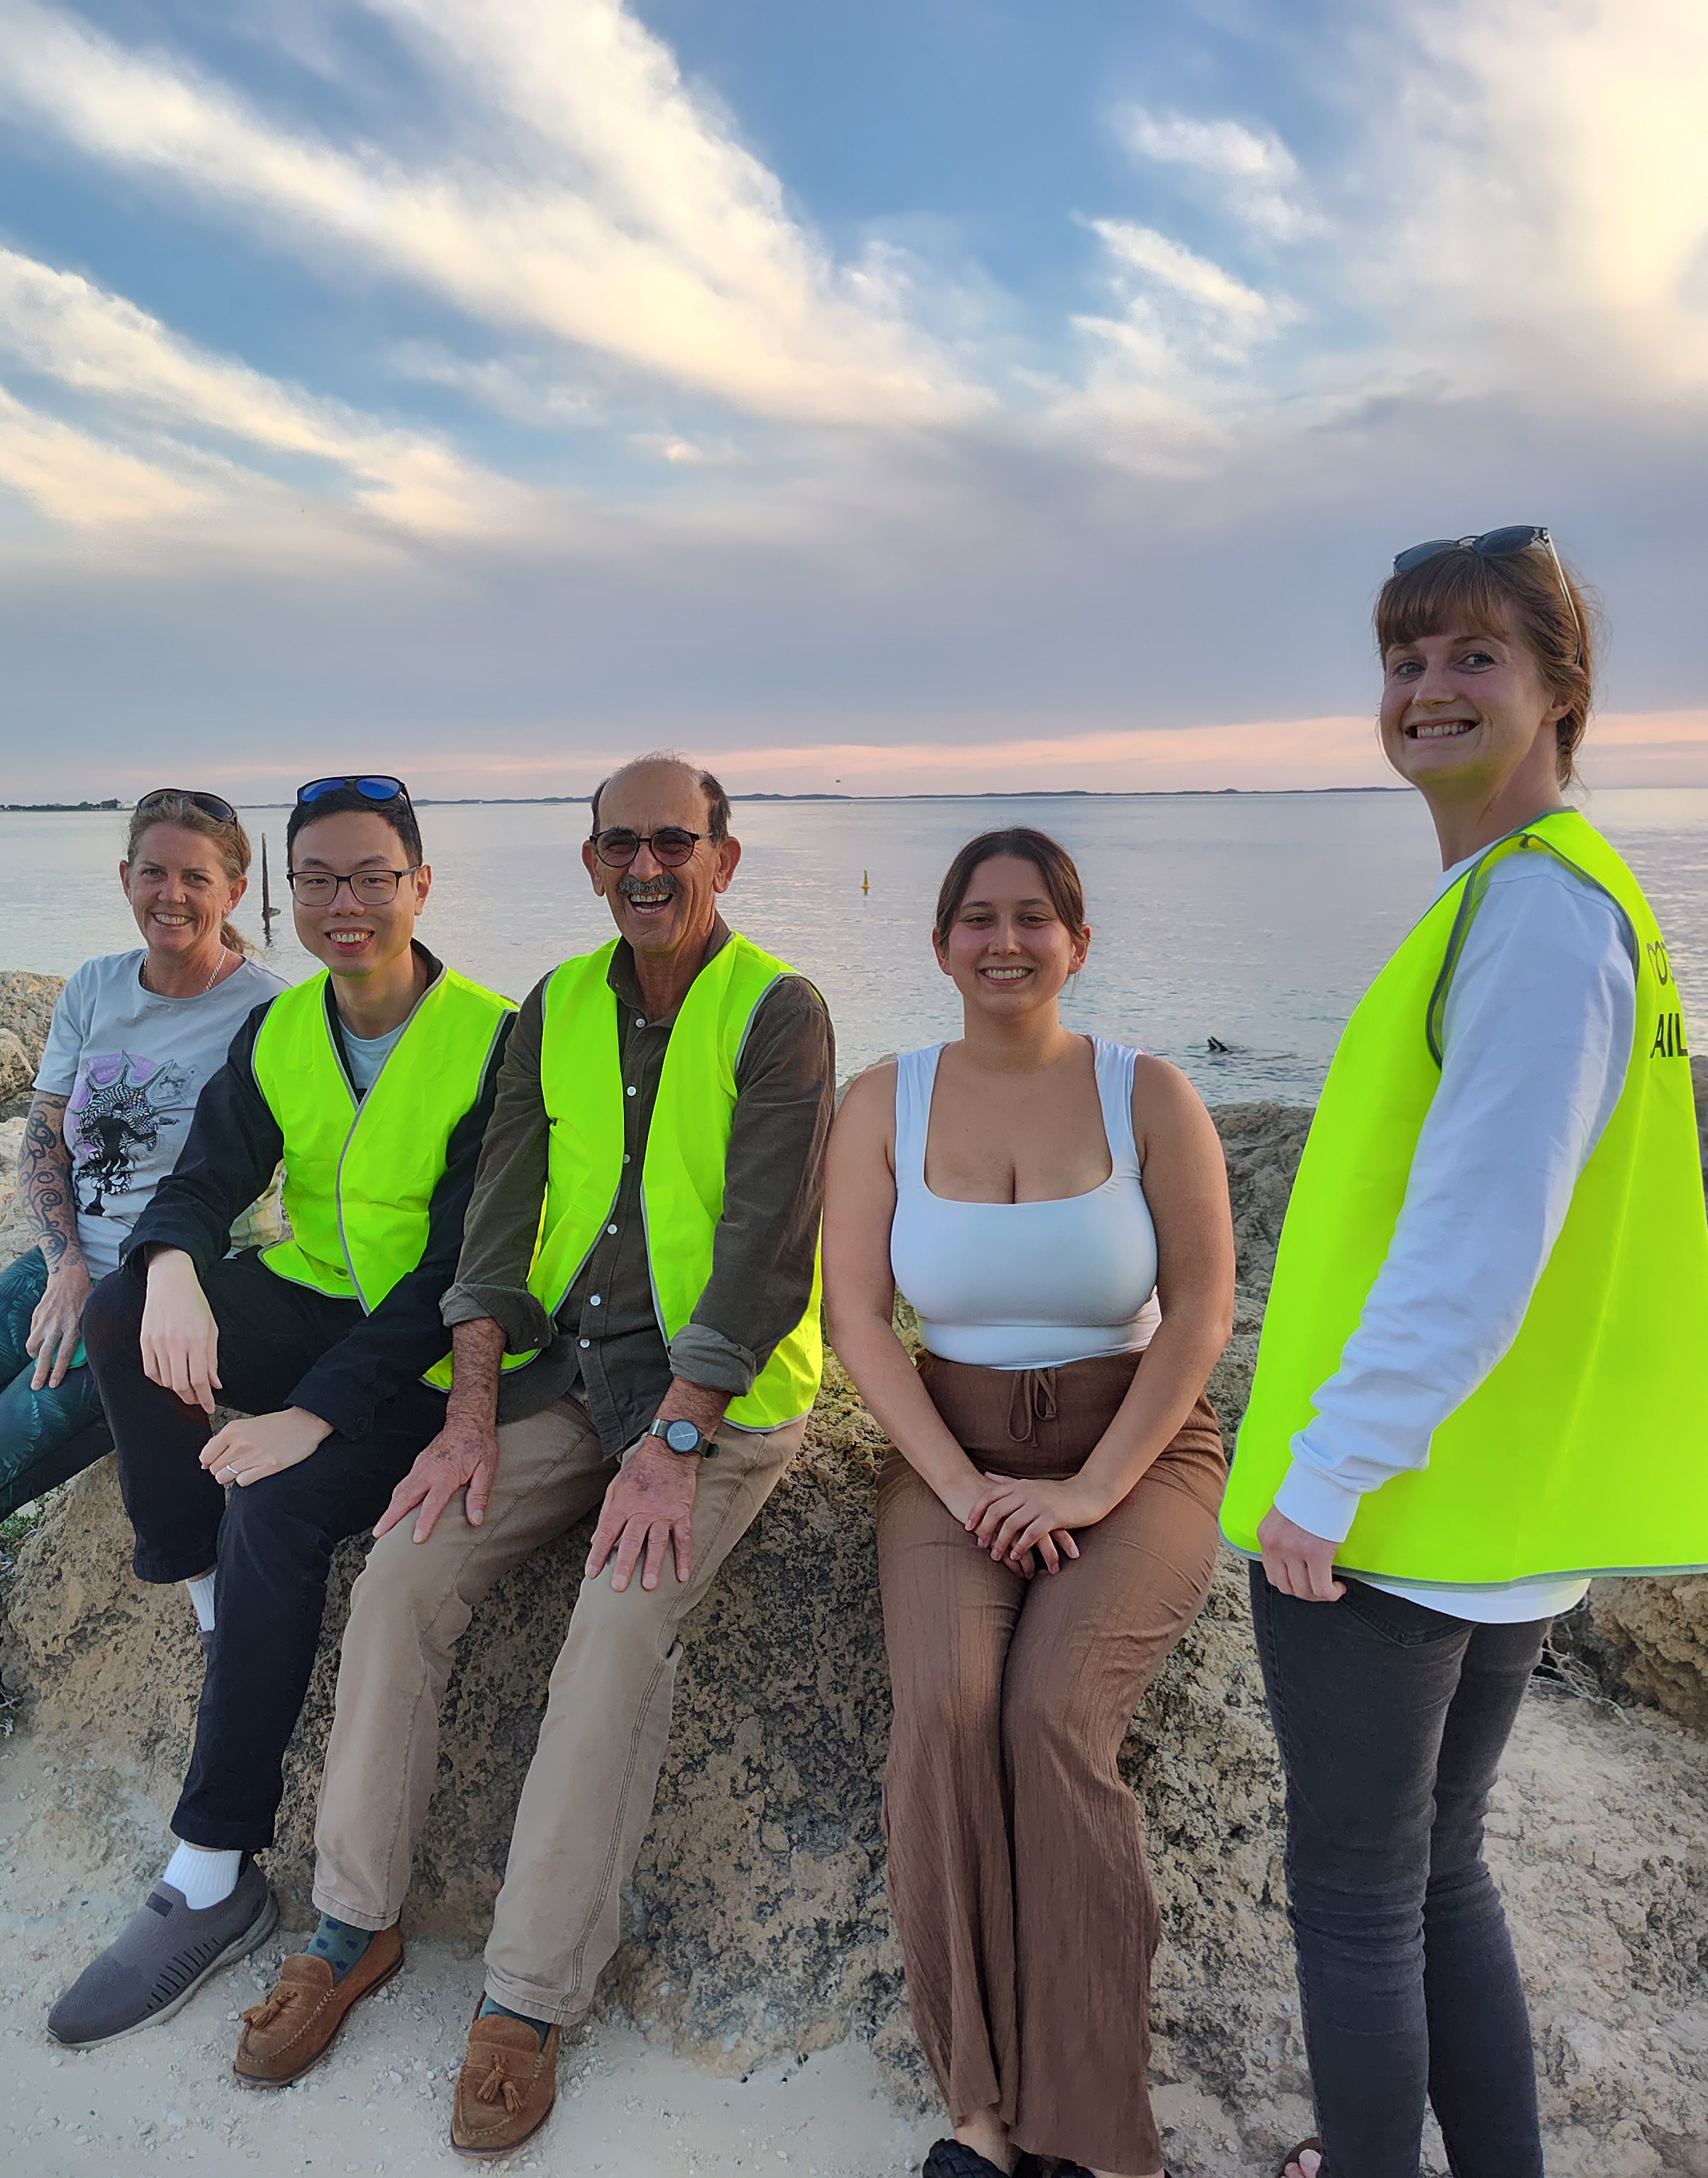
Should the Local Recovery Coordinator or Local Recovery Coordination Group activate the Cockburn Volunteer Centre to manage community volunteers, the following steps must be taken;
- Needs a position description (template is recorded – ECM Doc Set ID: 11219093)
- Completion of the Volunteer Registration Form (ECM Doc Set ID: 9528411)
- Medical Declaration Form (ECM Doc Set ID: 8141265)
- National Police Clearance Check obtained (costs covered by the VRC)
- Completion of an induction with the volunteer supervisor (the relevant City of Cockburn Service area for the volunteering activities being undertaken)
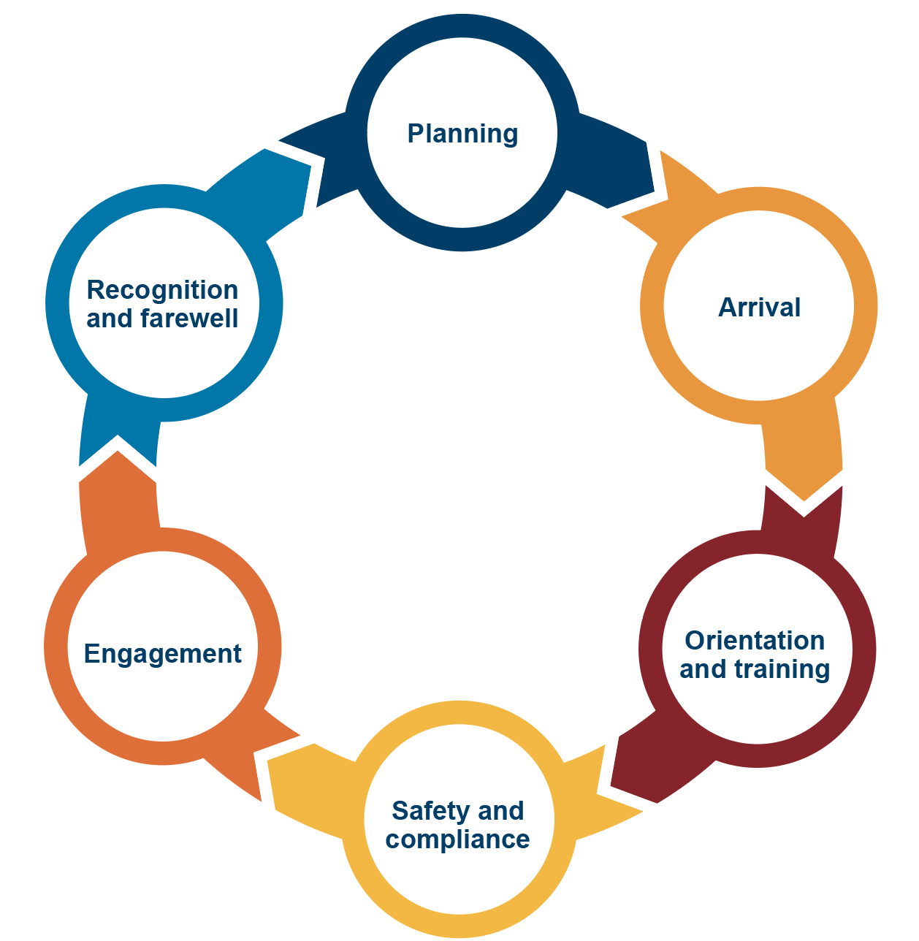
Figure 6: Lifecycle of a spontaneous volunteer in emergencies (Ahmed, 2023)

Reviewing and recognising volunteering efforts is an important step in closing out those recovery activities and identifying areas of improvement to be incorporated in the recovery evaluation.
For more information, contact the Cockburn Volunteer Centre or refer to the Communities Responding to Disasters: Planning for Spontaneous Volunteers Handbook

5.6 Waste Management and Clean Up
Effective waste management in recovery is important to ensure the recovery can occur in a timely manner and potential risks to human health and the environment are mitigated or eliminated. In the first instance, the responsibility of waste management rests with the owner or insurer, however in a significant emergencies impacting multiple property owners, the City may provide services to support the management of waste and clean up.
The City of Cockburn should implement waste collection and disposal programs guided by the following principles:
- Eliminating or mitigating the risk to people (including staff), the environment and infrastructure
- Adjust or increase services to assist with the capturing of resources
- Document and evidence services undertaken to support cost recovery
- Inform and advise the community on safe waste disposal practices
- Ensure services are accessible and do not increase burden on individual or community recovery (financially or timely), and
- Assess requirements for restoration and remediation services with the assistance of responsible agencies.

5.6.1 Clean Up Decision-Making Considerations
Considerations to be made by the City of Cockburn and the Local Recovery Coordination Group in undertaking waste management include the role of the City of Cockburn (is it a State Departments responsibility?), geographic location, the type of material encountered, staff capability, local and regional waste recovery park capacities and licensing, funding, available resources and prior involvement with local recovery efforts.
The Local Recovery Coordination Group (or relevant subcommittee) may consider the following in making decisions about waste management;
- Costs to the City for waste accepted via Henderson Waste Recovery Park is $82 per cubic metre (as of 2025)
- Residents receive 6 trailer passes annually with rates that are non-transferable between properties
- Material can be exempted from the Landfill Levy if it is generated from an emergency event. The exemption is not provided automatically. A form must be completed and approved by the Department of Water and Environmental Regulation
- that the City waive costs of waste disposal/collection to those impacted by emergencies or offer additional services at a reduced or no cost to ratepayers
- Capacity of Henderson Waste Recovery Park (including costs, frees and capability associated) and alternative locations (such as Rockingham Landfill)
The regulatory body prescribes requirements for the Henderson Waste Recovery Park license, including hazardous waste disposal, that should be adhered to in emergencies. This may include handling asbestos, hazmat considerations, landfill overflow, and biosecurity measures.

Liaise with the relevant service manager for further advice and information regarding the City’s waste services, or refer to the WALGA Emergency Waste Arrangements for more information.

5.7 Communications
Recovery communication is the practice of sending, gathering, managing, evaluating and disseminating information. As an emergency is occurring, which is commonly referred to as the emergency response phase, the Hazard Management Agency/Controlling Agency manages communications to the public and media. The local government coordinates the recovery of the affected community, including communications, once the emergency response has concluded.
The City understands successful recovery is built on effective communication between the affected community and recovery partners. The City will be guided by the Emergency Communication Plan to ensure communication is timely, credible, easy to understand, accessible for diverse audiences and addresses a variety of communication needs.
During recovery, City of Cockburn’s spokesperson will be the Mayor. The Mayor may delegate authority for specific person/s to act as a spokesperson.
For more information about communication channels, messaging, templates and resources, please refer to the Emergency Communications Plan.
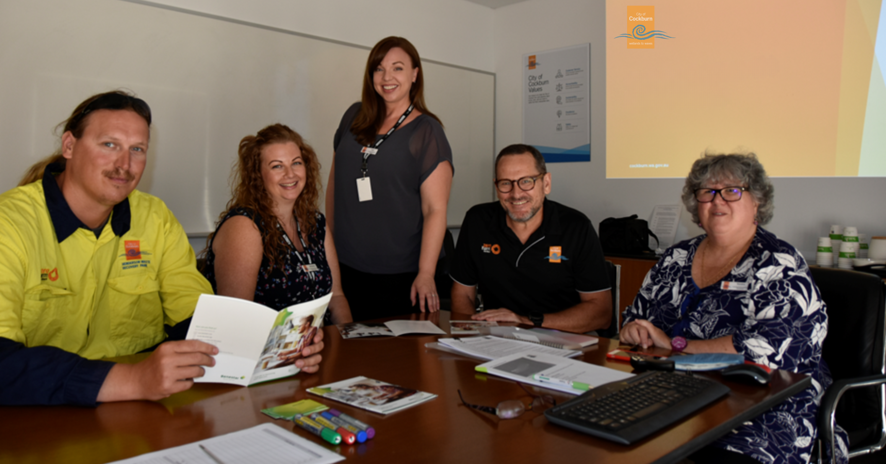
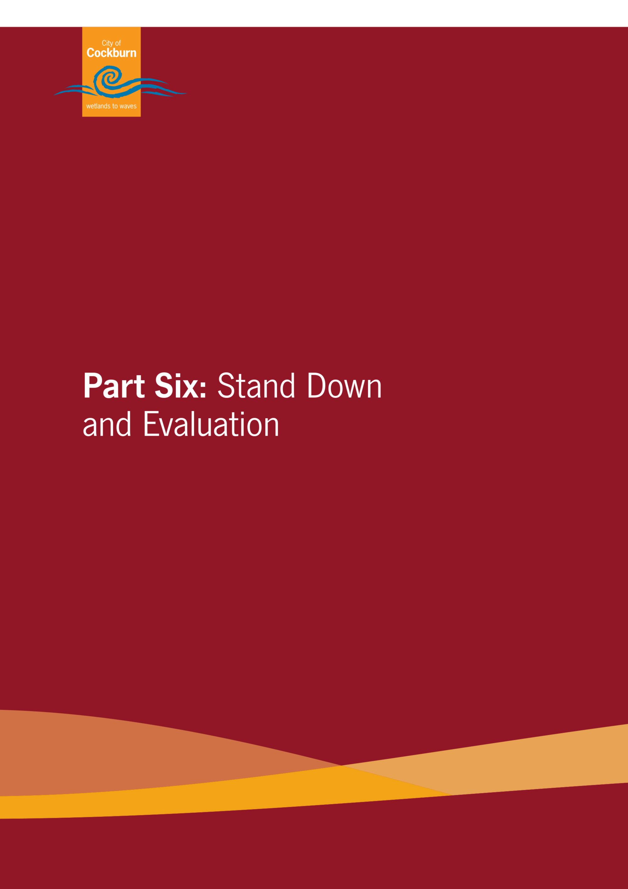

Part Six: Stand Down and Evaluation
There is no definite end period to recovery, however, the City will decide when normal service delivery will resume. This decision will be made depending on the severity and nature of the emergency and the impact on the City and the community and should only commence when the Local Recovery Coordination Group determines that the recovery objectives have been met.

6.1 Debriefing
Following any operational activity, it is important to identify and adopt any lessons learnt so actions can be taken to continuously improve the effectiveness of these Plans and recovery activities. Debriefs, reviews and post-incident analysis should be conducted by the Local Recovery Coordination Group as soon as practicable after the cessation of recovery activities.
When the Local Recovery Coordination Group undertakes a post-incident analysis, debrief or review, the details of the outcomes should be presented to a meeting of the LEMC.
See the City of Cockburn Emergency Debrief Form (ECM Doc Set ID: 12470898).

6.2 Recovery Evaluation
It is the responsibility of the Local Recovery Coordinator to monitor the progress of recovery and provide periodic reports to the Local Recovery Coordination Group and the State Recovery Coordination Group, if established. An evaluation of the effectiveness of the recovery activities in relation to the recovery plan should be conducted within 12 months of the emergency per the State EM Policy (6.10 – Review of Recovery Activities).



Appendices
One: Local Recovery Coordinator Position Description
Two: Local Recovery Coordinator Kit
Three: Local Recovery Coordination Group Profile and Checklist
Four: Local Operational Recovery Plan Template
Five: Local Recovery Coordination Group Sub-Committees Roles and Functions

Appendix One: Local Recovery Coordinator Position Description
The Local Recovery Coordinator is responsible for the development and implementation of recovery arrangements for the local government, in conjunction with the Local Recovery Coordination Group. The Local Recovery Coordinator should be experienced in emergency management and/or community development, where possible.
Role objectives;
- Advocate for the City
- Advocate for the community
- Coordinate recovery objectives and outcomes, and
- Support Strategic Community Plan objectives in the recovery process.

Essential training for the position may include completion of the WALGA Emergency Management training, Department of Communities Evacuation Centre Training, and Red Cross Recovery courses.

Pre-Event
- Prepare, maintain and test the Local Recovery Plan in conjunction with the local government for endorsement by the Council of the local government.
- Ensure community engagement in recovery arrangements and increase community involvement in recovery preparedness, awareness and resilience.
- Identify at-risk groups within the community, such as youth, the aged, people with disabilities, Aboriginal people, and culturally and linguistically diverse people.
- Consider potential membership of the Local Recovery Coordination Group prior to an event occurring.
- Work in partnership with Hazard Management Agency’s to increase recovery awareness and promote recovery planning with key agencies.
During Event
- Consult with the Controlling Agency regarding attending appropriate response meetings such as: Incident Management Team, Incident Support Group and Operational Area Support Group meetings.
- Ensure local government actively participates in Incident Support Group meetings and provides advice to the Hazard Management Agency and Supporting Organisations relating to the Local Emergency Management Arrangements.
- Consider membership of the Local Recovery Coordination Group, during an emergency, that is event specific, based on the four recovery environments: social, built, economic and natural, or as required.
- Engage key stakeholders to commence early recovery activities in accordance with the Local Recovery Plan and as required.
- Maintain situational awareness, and provide advice to the City of Cockburn Executive and Mayor on the incident and any requirement to convene an Local Recovery Coordination Group.
- Ensure the Controlling Agency with responsibility for the response to an emergency, starts recovery activities during that emergency.
- Consult with the Controlling Agency on completing the Impact Statement prior to the transfer of responsibility for recovery to the affected local government(s).
- Liaise with the State Recovery Coordinator on the City’s capacity to manage recovery and liaise with State Recovery Coordination roles and groups to ensure local recovery objectives are achieved.
Post-Event
- Provide advice to the Mayor and Chief Executive Officer (CEO) on the need to convene the Local Recovery Coordination Group and provide advice to the Local Recovery Coordination Group, if established.
- Ensure the local government provides Local Recovery Coordination Group with Executive Officer and administrative support, such as meeting agenda, minutes, financial and administrative recordkeeping.
- Determine the required resources for effective recovery in consultation with the Local Recovery Coordination Group.
- Coordinate local level recovery activities for the event, according to the plans, strategies and policies determined by the Local Recovery Coordination Group.
- Monitor the progress of recovery and provide periodic reports to the Local Recovery Coordination Group and State Recovery Coordination Group, if established.
- Liaise with the State Recovery Coordinator on issues where State level support is required or where there are concerns with services from government agencies locally.
- Arrange for the conduct of an operational debriefing of all participating agencies and organisations as soon as possible after the arrangements have ended.
- Facilitate an evaluation/debrief of the effectiveness of recovery activities (including during response), within 12 months of the emergency, to ensure lessons are captured and available for future managers, as well as attend any agency after-actions reviews.
- Provide recovery evaluations to the State Recovery Coordinator and the State Emergency Management Committee (SEMC)

Appendix Two: Local Recovery Coordinator Kit
The following templates and checklists are available through the State Emergency Management Framework and printed in the Local Recovery Coordinator Kit (located at the desk of the Fire and Emergency Management Manager) –
- LEMC Contact List
- Local Emergency Management Plan
- Local Recovery Plan
- Local Operational Recovery Plan Template
- Local Animal Welfare in Emergencies Plan
- City of Cockburn Fire Control Order
- Local Recovery Coordinator Profile and Checklist
- Local Recovery Coordination Group Profile and Checklist
- DRFAWA factsheet on activation process
- Two yellow high-vis Incident Management vests
- Department of Fire and Emergency Services Incident Diary
- Other operational plans, documents and procedures as determined
- Other PPE/C as required

Appendix Three: Local Recovery Coordination Group Profile and Checklist
Refer to the most up to date version on the State Emergency Management Committee website:
https://www.wa.gov.au/government/publications/local-recovery-guideline-and-resources

Appendix Four: Local Operational Recovery Plan Template
Refer to the most up to date version on the State Emergency Management Committee website:
https://www.wa.gov.au/government/publications/local-recovery-guideline-and-resources

Appendix Five: Local Recovery Coordination Group Subcommittee Roles and Functions
The following statements are suggestions for the role and functions of the recovery coordination sub-committees should they be established. These roles are to be the responsibility of the Local Recovery Coordination Group if subcommittees are not established.
Social Recovery
- To provide advice and guidance to assist in the restoration and strengthening of community well-being post the event;
- To facilitate understanding on the needs of the impacted community in relation to community wellbeing;
- To assess and recommend priority areas, projects, and events to assist with the recovery process in the immediate and short-term regarding the restoration and strengthening of community wellbeing;
- To assess and recommend medium and long term priority areas to the City for consideration to assist in the restoration and strengthening of community wellbeing; and
- To ensure the affected community is informed and involved in the recovery processes so actions and programs match their needs.
Natural Environment Recovery
- To provide advice and guidance to assist in the restoration of the natural environment post the event;
- To assess and recommend medium and long term priority areas to the City of Cockburn for consideration to assist in the restoration of the natural environment in the medium to long term;
- Management and disposal of waste
Built Environment Recovery
- Assist in assessing requirements for the restoration of services and facilities in conjunction with the responsible agencies where appropriate;
- To provide advice and assist in the coordination of the restoration of infrastructure assets and essential services damaged or destroyed during the emergency; and
- To assess and recommend priority infrastructure projects to assist with the recovery process in the immediate and short, medium and long term
Economic Recovery
- To make recommendations to the LMDRF on the orderly and equitable disbursement of donations and offers of assistance to individuals having suffered personal loss and hardship as a result of the event.
- The development of eligibility criteria and procedures by which payments from the LMDRF will be made to affected individuals which:
  - ensure the principles of equity, fairness, simplicity and transparency apply;
  - ensure the procedures developed are straightforward and not onerous to individuals seeking assistance;
  - recognise the extent of loss suffered by individuals;
  - complement other forms of relief and assistance provided by government and the private sector;
  - recognise immediate, short, medium and longer term needs of affected individuals; and
  - ensure the privacy of individuals is protected at all times
- Oversee strategies to retain ratepayers, community attraction, and a diverse local economy
- Facilitate the disbursement of financial donations from the corporate sector to affected individuals, where practical; and
- Ensure Business Continuity is considered at all times during the recovery.


City of Cockburn
Whadjuk Boodjar
9 Coleville Crescent, Spearwood WA 6163
PO Box 1215, Bibra Lake DC WA 6965
Telephone: 08 9411 3444
Email: customer@cockburn.wa.gov.au
City of Cockburn website: www.cockburn.wa.gov.au
 City of Cockburn Facebook: www.facebook.com/CityofCockburn
 City of Cockburn Instagram: www.instagram.com/cityofcockburn
 City of Cockburn Youtube: www.youtube.com/CityofCockburn
 City of Cockburn LinkedIn: www.linkedin.com/company/city-of-cockburn

