Policy Type

Local Planning Policy

Policy Purpose

The Rural zone, the Rural Living Zone and the Resource Zone under Town Planning Scheme No. 3 (TPS 3) are retained for rural pursuits, rural living or resource protection purposes. In addition, portions of the City are affected by the Kwinana Air Quality buffer and inappropriate subdivision within these areas has the potential to compromise strategic planning objectives.

The City is required to make recommendations to the Western Australian Planning Commission (WAPC) regarding applications to subdivide land within these zones and as the matter is not addressed by TPS 3, this Policy provides the basis for consistent responses to the WAPC on subdivision proposals.

The purpose is to recommend against the ad hoc subdivision of land that is proposed to be retained for rural pursuits, rural living or resource protection under the Town Planning Scheme or which is affected by the Kwinana Air Quality Buffer.

Policy Statement

- Resource Zone:

- The Council may support subdivision in this area if the proposal is in accordance with the Jandakot Groundwater Protection Policy (SPP No. 2.3) and the land is being suitable and capable of subdivision for the proposed purpose.

- On land within any area not subject to Council’s Local Planning Policy 2.2 Subdivision in Jandakot and Treeby, the following applies:

- A minimum lot size of 2ha;
- A building envelope no larger than 2000m² being provided on each lot created which complies with TPS 3; and
- The onsite effluent disposal being located within the building envelope and complying with the provisions of TPS 3 relating to the Resource zone and Section 15 SPP2.3.

- On land within the area subject to LPP 2.2 Subdivision in Jandakot and Treeby, the Council may also support subdivision provided that it complies with LPP 2.2 and meets the requirements set out in point 2 above.

- Rural Living and Rural Zones

- The Council will not support any further subdivision of land in these zones.
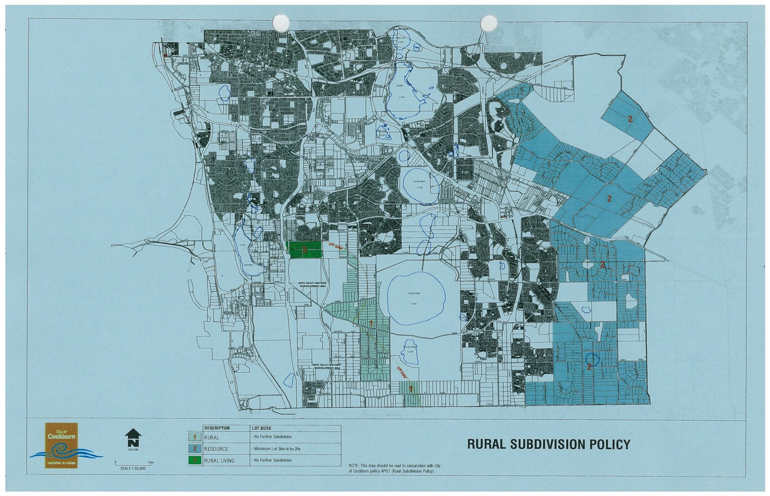

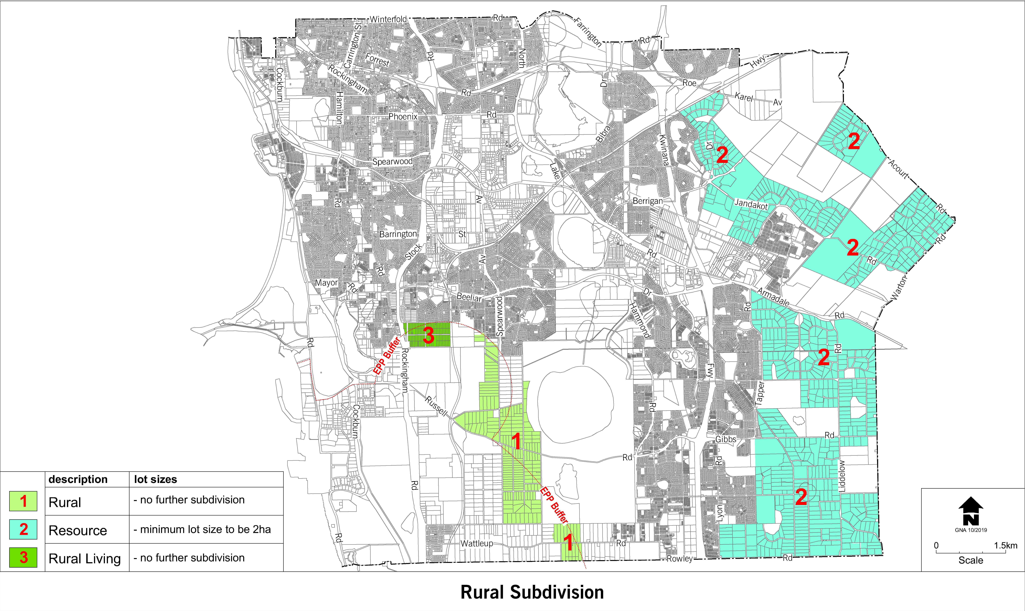

Strategic Link: | Town Planning Scheme No. 3
Category | Planning - Town Planning & Development
Lead Business Unit: | Statutory Planning
Public Consultation:  (Yes or No) | Yes
Adoption Date:  (Governance Purpose Only) | 10 November 2022
Next Review Due:  (Governance Purpose Only) | November 2024
ECM Doc Set ID:  (Governance Purpose Only) | 4514270

