Tender Title: |  | RFP 07/2024 – Safety Management Software
Request ID: |  | 55102
Tender Description: |  | The City of Cockburn (The Principal) is seeking proposals (RFP) from suitably qualified and experienced providers to supply and implement industry leading software and support to replace the current Safety Management System.  As part of the City’s commitment to Workplace Health & Safety (WHS), incident and hazard management, recording, reporting, and safe working requirements. That will allow the City to effectively and efficiently centralise and integrate the operation of our WHS processes and meet statutory obligations.
Advert Approval: |  | Decision to Advertise: Chief Executive Officer  Decision Date: Wednesday, 20 November 2024
Closing Date and Time: |  | 2:00PM (AWST) Thursday, 12 December 2024
Opening Date and Time: |  | 2:00PM (AWST) Thursday, 12 December 2024
 | Tenderer’s Name:
1 | The Trustee for AM2 Trust & The Trustee for FM2 Trust t/a Netsight Consulting Pty Ltd
2 | THOUGHTWARE AUSTRALIA PTY LTD
3 | BEAKON PTY LTD (Sales)
4 | Work Metrics (Work Metrics
5 | SKEFTO INNOVATIONS PTY LTD t/a Skefto
6 | IDEAGEN PTY LIMITED t/a Ideagen Pty Ltd (Bid Management)
7 | EVOTIX PTY LIMITED
8 | HSI APAC PTY LTD t/a HSI Donsafe
9 | ATTURRA BUSINESS APPLICATIONS t/a Atturra (Safety Solutions)

Advertisement
Method 1: City of Cockburn website | Method 2: City of Cockburn Libraries Public Noticeboards
Method 3:  The Western Australian, Saturday,  23 November 2024 | Tender Awarded by:
Copy of Statewide Notice:  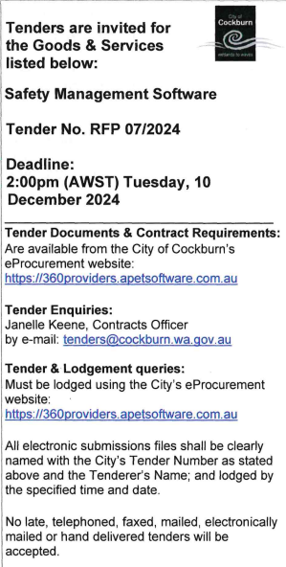 | Daniel Simms, Chief Executive Officer  Carissa Bywater, Director corporate and System Services  12 March 2025
 | Date of Council Meeting:
 | N/A

Name of Successful Tenderer(s): | SKEFTO INNOVATIONS PTY LTD
Amount of Successful Tender(s): (ex GST) | $549,512.00 Ex GST

