13 September 2018
Single use plastics: Tell us how you really feel
The City of Cockburn is asking its community to share ideas on how we can all reduce single use plastics.
As several councils around Australia, including three in Perth, take steps to permanently reduce single use plastics in their neighbourhoods, the City is investigating ways to get on board.
The City has formed a working group including Waste Services, Environmental Services, Events and Communications, and Recreation Services personnel to consider reducing single use plastics, including a ban on the release of helium balloons like that adopted by the Town of Cottesloe in September 2017.
Single use plastics including bottles, cigarette butts, straws, cutlery, cups, balloons, packaging and bags are designed to be used once, before disposal.
The City is gathering public input on reducing all single use plastics, with a survey open on its Comment on Cockburn webpage until 28 September and a community chat event planned for 19 September.
Waste Education Officer Nicki Ledger said the City’s Sustainable Event Guidelines stated balloons were not to be given away or released at City-run events but it could not be enforced as it was not written into a local law.
“Although some balloons are made of latex rubber instead of plastic, they can also take many months to break down in the environment,” Miss Ledger said.
“We've looked across Australia at what other local governments and communities have achieved. A number of councils have banned single use plastic items, including the Cities of Brisbane and Darebin.
“In 2018, the City of Bayswater and Town of Bassendean limited single use plastics at events. And Cottesloe was the first council in WA to ban the release of helium balloons via an amendment to a local law.”
If you want to attend the community chat at Last Drop Beeliar 6-7.15pm on Wednesday, 19 September, RSVP by emailing comment@cockburn.wa.gov.au. Numbers are limited.
To complete the survey, go to https://comment.cockburn.wa.gov.au/plastics-how-can-we-reduce-them
DID YOU KNOW
In Western Australia:
- The average household produces about 100kg of plastic waste per year
- Only 3% of plastics are recovered for recycling
- Cigarette butts, drink containers and takeaway food packaging make up 70% of the waste on our beaches
- Drink containers make up 35% of our litter
- Around 5 million plastic bags are littered every year.
Caption (pic below): This haul of single use plastics was collected during a short walk at Woodman Point.

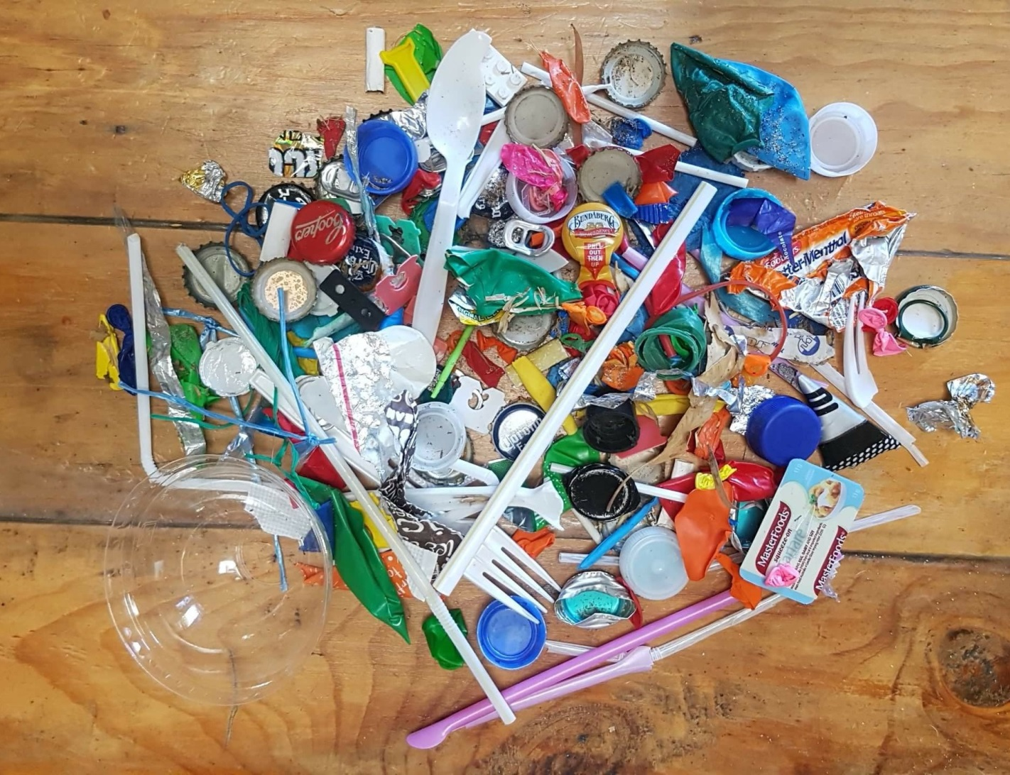

______
ENDS

For more information contact:
Media and Communications Officer
City of Cockburn
T: 08 9411 3551
E: media@cockburn.wa.gov.au

