APPLICATION FOR PIONEERS LUNCHEON
(Criteria: Resident of Cockburn for 60 years or more)
FULL NAME
DATE OF BIRTH
ADDRESS
PHONE NUMBER
HOW MANY YEARS YOU’VE LIVED continuously IN COCKBURN
ADDRESSES WHERE YOU HAVE LIVED IN COCKBURN AND THE APPROXIMATE YEARS  PROOF OF AGE & ADDRESS | ___________________________________________________  ___________________________________________________  ___________________________________________________  ___________________________________________________  ___________________________________________________  ___________________________________________________  __________________________________________________
REFEREE 1. | (Name and contact number)
REFEREE 2 | (Name and contact number)
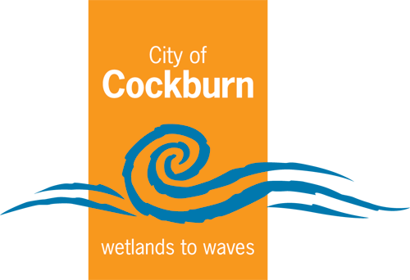
Send to: Civic Support Coordinator
City of Cockburn
PO Box 1215
BIBRA LAKE DC WA 6965

Or email: customer@cockburn.wa.gov.au

