Tender Title: |  | RFT 24/2024 – Water Treatment & Aquatic Systems – Preventive Maintenance Services – Cockburn ARC
Request ID: |  | 55020
Tender Description: |  | The City of Cockburn (The Principal) requires commercial water treatment & plant services at the Cockburn Aquatic & Recreation Centre (Cockburn ARC).  Tenderers must demonstrate they have previous experience in providing maintenance services for aquatic facilities.  All work shall be executed to the satisfaction of the Principal in strict accordance with the Contract, the Specification, the Schedule of Rates and with any working instructions provided by the Principal as the service proceeds.  The objective of this Specification is to ensure Cockburn ARC is provided with a level of service which ensures the ongoing maintenance and care of the water treatment systems serving the swimming pools, and water slides.
Advert Approval: |  | Decision to Advertise: Director Infrastructure Services  Decision Date: Monday, 28 October 2024
Closing Date and Time: |  | 2:00PM (AWST) Tuesday, 9 April 2024
Opening Date and Time: |  | 2:00PM (AWST) Tuesday, 9 April 2024
 | Tenderer’s Name:
1 | Aquatic Services WA Pty Ltd
2 | Commercial Aquatics Australia

Advertisement
Method 1: City of Cockburn website | Method 2: City of Cockburn Libraries Public Noticeboards
Method 3:  The Western Australian, Saturday, 23 March 2024 | Tender Awarded by:
Copy of Statewide Notice:  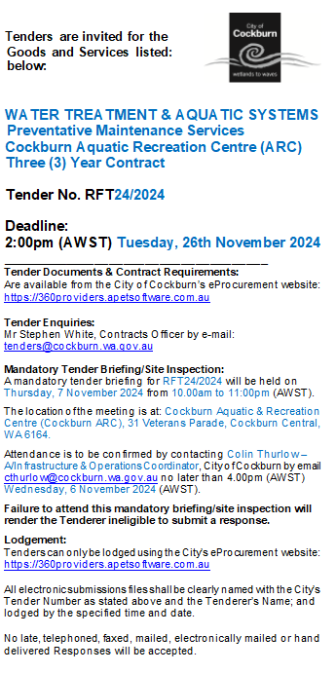 | Kylie Johnson, Director Community and Place  Carissa Bywater, Director Corporate and System Services  Tuesday, 11 March 2025
 | Date of Council Meeting:
 | N/A

Name of Successful Tenderer(s): | Aquatic Services WA Pty Ltd
Amount of Successful Tender(s): (ex GST) | $889,909.00 Ex GST

