Tender Title: |  | Atwell Reserve Redevelopment Design Team and Superintendency Services
Request ID: |  | 71404
Tender Description: |  | The City of Cockburn (the principal) requires the services of an appropriately qualified, skilled, experienced, and registered (WA) Architect to undertake the design, documentation and Superintendency consultant role for the design and construction of the Atwell Reserve Redevelopment project.
Advert Approval: |  | Decision to Advertise: Director Infrastructure Services  Decision Date: Friday, 7 November 2025
Closing Date and Time: |  | 2:00PM (AWST) Thursday, 4 December 2025
Opening Date and Time: |  | 2:00PM (AWST) Thursday, 4 December 2025
 | Tenderer’s Name:
1 | Mode Design Corp Pty Ltd
2 | Hoffman Maine Architects
3 | Ailtire Architects
4 | Cast Studio
5 | Bollig Design Group
6 | Christopher Paterson Heritage and Architecture Pty Ltd
7
8
9
10

Advertisement
Method 1: City of Cockburn website | Method 2: City of Cockburn Libraries Public Noticeboards
Method 3:  The Western Australian, Wednesday 12 November 2025 | Tender Awarded by:
Copy of Statewide Notice:  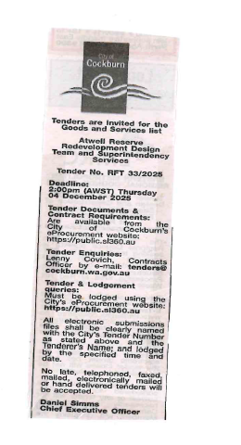 | Director Infrastructure Services  Friday, 20 February 2026
 | Date of Council Meeting:
 | N/A
Name of Successful Tenderer(s): | Mode Design Corp Pty Ltd
Amount of Successful Tender(s): (ex GST) | $210,810.00

