Tender Title: |  | M900019 (RFT 09/2021)  Bushland Maintenance – Three (3) Year Contract
Request ID: |  | 38310
Tender Description: |  | Bushland Maintenance (including reserve inspection, chemical and manual weed control (including grass weed control), firebreak maintenance (chemical control only), litter and rubbish removal, minor tree pruning.)
Advert Approval: |  | Decision to Advertise: Chief of Built and Natural Environment  Decision Date: Friday, 30 April 2021
Closing Date and Time: |  | 2:00PM (AWST) Wednesday, 26 May 2021
Opening Date and Time: |  | 2:00PM (AWST) Wednesday, 26 May 2021
 | Tenderer’s Name:
1 | Environmental Industries Pty Ltd t/a Environmental Industries Pty ltd (Maintenance)
2 | UGC Holdings Pty Ltd t/a UGC Group
3 | Green Skills Inc t/a Green Skills Inc (Murdoch Office Environmental Technology Centre Murdoch University)
4 | Skyline Landscape Services Group Pty Ltd t/a Skyline Landscape Services (WA)
5 | Adelby Pty Ltd t/a Adelby Pty Ltd (Office)
6 | South East Regional Centre For Urban Landcare Inc t/a Sercul
7 | Natural Area Holdings Pty Ltd t/a Natural Area Consulting Management Services (n/a)
8
9
10

2
Advertisement
Method 1: City of Cockburn | Method 2: Yammer
Method 3:  The Western Australian,  Wednesday, 5th of May 2021 | Tender Awarded by:
Copy of Statewide Notice:  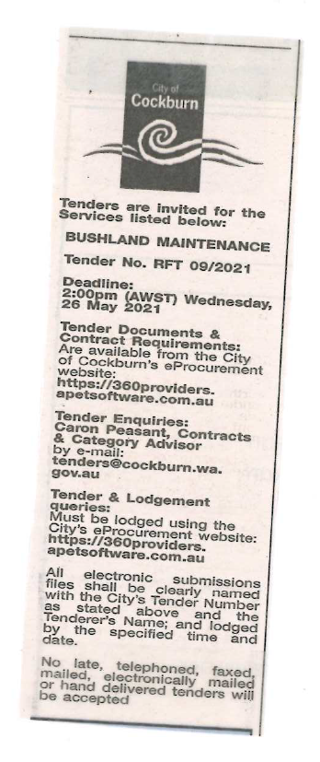 | Chief of Built and Natural Environment  Tuesday, 6 July 2021
 | Date of Council Meeting:
 | Not applicable
Name of Successful Tenderer(s): | - Natural Area Holdings for six reserves (Clementine Parco, Genoa, Twin Bartram, Calleya-Solomon Rd and Corsia) for Three (3) years.  - Green Skills Incorporated for six reserves (Apara Court, Chaplin, Holdsworth, Cooper, Santorini and Shoreline) for Three (3) years.
Amount of Successful Tender(s): (ex GST) | - Estimated contract value of $197,247 (Ex GST)  - Estimated contract value of $215,400 (Ex GST)

3

