16 March 2023

Carpark features wildlife habitat landscaping

Unique Cockburn Central carpark to provide ecological links

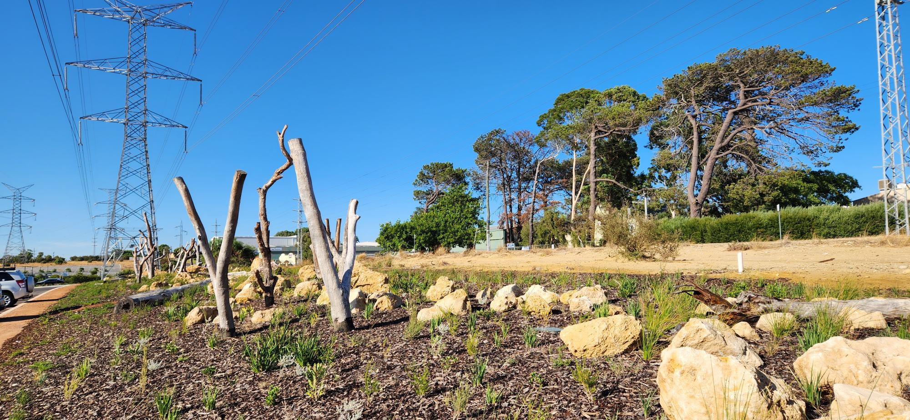
A new 199-lot carpark in Cockburn Central has incorporated habitat landscaping to create ecological linkage options for local wildlife.
The unique project has replaced degraded weed-filled land beneath Western Power powerlines and will serve as a baseline example for similar carpark developments in the City.
City of Cockburn Acting Head of Sustainability and Environment Julia Christensen said it was the first time a carpark beneath powerlines had incorporated landscaping specifically designed to act as a habitat, stop-off point or link for fauna.
“The City of Cockburn’s Natural Area Management Strategy identifies a number of ecological links across the City. Some of these are powerline easements which traverse, not only Cockburn, but the Perth metropolitan area,” Ms Christensen said.
“Often power line easements become carparks devoid of vegetation and in an effort to showcase how we can incorporate carparks and retain green linkages, the City has developed a carpark that also acts as an ecological link.
“It has large areas featuring plants endemic to the Swan Coastal Plain. These will provide a food source and areas of respite for some birds, or homes for small invertebrates, insects and reptiles.
“The vegetation will also help reduce the heat island affect in the area.”
Vegetation planted beneath powerlines is affected by height restrictions. The new Cockburn Central carpark features low growing shrubs and ground covers interspersed with limestone boulders and hollow logs to act as shelter and habitat.
The City’s Bushland Operations team will maintain landscaping at the $2.2m carpark recently opened near the new Bethesda Clinic adjacent to Cockburn ARC.
A baseline fauna survey of the landscaped area is planned for October and further studies will be completed in future years to monitor its success.
For more information, please contact the City of Cockburn’s Environmental Services team on 9411 3444.

ENDS

For more information contact:
Media and Communications Officer
City of Cockburn
T: 08 9411 3551
E: media@cockburn.wa.gov.au

