Tender Title: |  | RFT 16/2024 – ROCK REVETMENT & EDGE WALL REPAIRS (Port Coogee Breakwater & Catherine Point Groyne)
Request ID: |  | 50800
Tender Description: |  | The City of Cockburn (The Principal) is seeking a suitably qualified and experienced contractor for the revetment and edge wall repairs in Port Coogee Marina as per the supplied reference design and specifications.  The works are required to ensure the existing breakwaters are maintained to a standard that ensures the breakwater integrity is sufficient to protect infrastructure within Port Coogee.
Advert Approval: |  | Decision to Advertise: Director Planning and Sustainability  Decision Date: Wednesday, 11 September 2024
Closing Date and Time: |  | 2:00PM (AWST) Thursday, 10 October 2024
Opening Date and Time: |  | 2:00PM (AWST) Thursday, 10 October 2024
 | Tenderer’s Name:
1 | Italia Stone Group Pty Ltd t/as Italia Stone Group
2 | O’Brien Civil Pty Ltd
3 | WA Limestone Pty Ltd
4
5
6
7
8
9
10
11

Advertisement
Method 1: City of Cockburn | Method 2: Yammer
Method 3:  The Western Australian, Saturday 18th September 2024 | Tender Awarded by:
Copy of Statewide Notice:  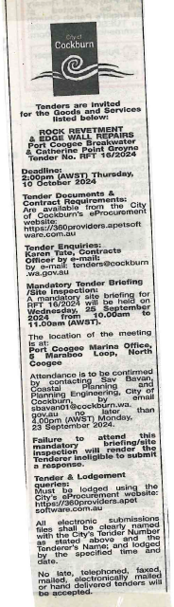 | Director of Infrastructure Services  Director Planning and Sustainability  13th December 2024
 | Date of Council Meeting:
 | N/A
Name of Successful Tenderer(s): | Italia Stone Group Pty Ltd
Amount of Successful Tender(s): (ex GST) | $508,000.62 Lump Sum Amount

