Policy Type

Local Planning Policy

Policy Purpose

To provide site specific design guidelines for the ‘Newmarket Precinct’ as identified in the Cockburn Coast District Structure Plan (DSP). All applications for subdivision and development shall have due regard with the Design Guidelines. These Design Guidelines shall be read in conjunction with the City of Cockburn Town Planning Scheme No.3 (TPS 3), Residential Design Codes, and other applicable Local Planning Policies and Local Development Plans.

The objectives of the Design Guidelines are:
- To encourage a diverse population that contributes to the interest and vitality of the precinct and the DSP area generally by providing a genuine mix of dwelling types to cater for a range of living options;
- To promote the redevelopment of the Cockburn coast into a vibrant and sustainable environment that integrates living, working and leisure opportunities;
- To encourage a residential and mixed use focus, with ground floor office and commercial opportunities along Cockburn Road and Rockingham Road, and to encourage mixed use development in areas where it is considered that the market could, at some time, sustain some commercial use;
- To encourage lower level of car dependence for those travelling to and within the Cockburn Coast area by promoting public and non-motorised transport options;
- To encourage the foundation for a highly connected, legible, and active street environment that is safe, and weather protected.;
- To ensure that any development that occurs within the Newmarket Precinct deals with both the designation and distribution of height across the Precinct in a comprehensive manner;
- To promote innovative, high quality development that contributes to a lively streetscape;
- To ensure the efficient and effective upgrade of infrastructure to support orderly development and meet the demands arising from new development.

Policy Statement

(1) Land Use

  - Mixed Use
Mixed use developments which are pedestrian oriented at ground floor should be provided adjacent to Cockburn Road and Rockingham Road to encourage opportunities for commercial use and/or home based business ‘designed in’ to developments.

  - Residential Convertible dwellings
In relation to ground floor dwellings fronting Cockburn Road and Rockingham Road, as a minimum, 3.6m floor to ceiling should be provided. This will assist in facilitating the conversion of ground floor (street) frontage to non-residential use when the demand arises for such product as Cockburn Coast develops. Other considerations to be contemplated in the design and development of new buildings include:
- ‘Back of house’ access for servicing to enable conversion to active ‘lifestyle’ type use (food and beverage establishments);
- Making provision for future mechanical services (flues and exhaust vents) to enable active use;
- The design, location and/or size of wet areas and toilet facilities (public building requirements);
- Non load bearing walls to allow future changes to internal floor layouts;
- Internal layouts which facilitate self-containment of the ground floor for independent use; and
- Potential future changes in use taken into consideration in the provision of parking.

  - Local Activity Node
It is intended that the local activity nodes will contain the majority of Cockburn Coast's retail space in a street based form, and large mall based retail with large expanses of car parking will not be supported. Built form within the local activity node will be expected to have a strong interface with Cockburn Road through nil to minimum setbacks to the lot boundary.

(2) Transport

2.1 Road Network
- The higher order road layout should be in accordance with the DSP.
- Any development seeking alterations and/or additions to the lower order road network must be supported by detailed design work as would normally take place in preparing a local structure plan. This detailed design work should demonstrate that proposed alterations and/or additions are consistent with best practice planning outcomes, and align with the intent of the District Structure Plan. This detailed design work should have regard for the function of Cockburn Road and the primary regional road (Cockburn Coast Drive), and ensure both the higher and lower order road networks are not prejudiced in any way.
- To ensure appropriate permeability, development on Lot 2 Bellion Drive, Hamilton Hill (Vol 1300 Folio 625) will require the ceding of land and construction of an additional road network connection between Boyd Crescent and Bellion Drive at the time of development or following the construction of Cockburn Coast Drive (whichever comes first). It is expected that the land and construction of this road would be provided by the landowner.
- Provision of a traffic impact assessment may be required in support of development applications.

2.2 Pedestrian and Cyclist Movement
- Development should provide a positive contribution through pedestrian-oriented uses at ground level, with consideration for non-motorised transport options, particularly along Cockburn Road.
- Development should facilitate close interaction with the pedestrian activity along footpaths. Buildings should be designed to focus on pedestrian and cyclist amenity and safety, while accommodating on street parking and slow vehicle speeds in certain locations.
- Provision of end-of-trip facilities is required for commercial uses.

2.3 Car Parking
- Where the local government has either provided or has made firm proposals for providing public car parking in the vicinity of the land subject of the application, a cash-in-lieu payments for a reduction in onsite parking in accordance with the provisions of TPS 3 may be considered.
- Where possible parking should be located in a basement or part basement arrangement (depending on the topography of the land).
- Onsite parking should be provided behind building frontages or screened from public view.
- Grade level car parking areas should be suitably landscaped, and this is particularly relevant where adjoining buildings look into or across the rear of a development site.
- Access to onsite parking should be easily identifiable and suitably signed.
- Consideration should be given to onsite servicing and waste management at the development application stage.

(3) Built Form

3.1 General
- All development should be ‘urban’ in form where it meets the public domain, characterised by nil street setbacks.
- Active building frontages are encouraged, and the number of doors and windows open to the street should be maximised.
- Awnings and street trees should be provided for weather protection wherever possible.
- To further assist the function of the pedestrian environment, all building and tenancy entrances should be well located and clearly defined through the use of elements distinctive to the architectural style of the development.
- Development should express strong architectural themes, demonstrating variation, distinctiveness, high visual interest, sustainability and climate responsiveness.
- Development should address public streets and other public areas, and should be an attractive and functional component of the Precinct and Cockburn Coast area as a whole.
- Development should maintain consistent street setbacks and street edge configurations.
- All visible walls should be articulated, or otherwise architecturally treated, in order to create visual interest and to avoid a broad expanse of featureless wall.

3.2 Primary Controls

Control | SU24  (Mixed Use/R60) | SU25  (Residential R60) | SU27  (Mixed Use R160) | SU29  (Local Activity Node R60)
Building Height (storeys) | Abutting Cockburn & Rockingham Roads – 4-5  Other – 3-4 | 3-4 (17m) | 4-5 (21m)* | 4-5 (21m)*
Boundary Wall Height (storeys) | 1 | 1 | 2 | 1
Minimum Primary & Secondary Street Setback | Nil (ground floor commercial)  2m (Residential) | 2m | Nil | Nil (ground floor commercial)  2m (Residential)
Minimum Side Setback | 2m | 3m | Nil | 2m
Minimum Rear Setback | 3m | 3m | 3m | 3m
Plot Ratio | Abutting Cockburn & Rockingham Roads – 2.0  Other - 0.8 | 0.8 | 2.0 | 0.8

Note: Maximum heights (metres) are the total heights of the physical building (including services such as lift over-runs, water tanks and heating/cooling equipment that may add to the building height). Calculated as 3.5m for each floor (floor-to-floor measurement) and an additional 3m for buildings above 12m in height (buildings above 12m may need to provide services such as lift over-runs, water tanks and heating/cooling equipment that should be factored into the total height of the building).
*can only be supported if a 3m terrace setback or loft level is provided.

3.3 Development Abutting Cockburn Coast Drive and Rollinson Road Link
- Cockburn Coast Drive and the Rollinson Road link (east of Cockburn Road) will not accommodate direct road access, however buildings should be oriented and designed to provide an outlook to the road and Beeliar Regional Park.
- Use of balconies at upper levels is encouraged to provide surveillance of Beeliar Regional Park, while providing residents with access to the views and vistas of the scenic surrounds.

2.4 Landmark & Gateway Sites
- Only one landmark site and one gateway site will be considered within the precinct.
- The landmark site should be located at the south western corner of the intersection the Cockburn Coast Drive and Rockingham Road as an entry statement to the project area. It should be at a strategic location focussed along the prominent ridgeline which forms the visual backdrop to the Precinct and broader Cockburn Coast area.
- The gateway site should be located on the north-east side of the intersection between Cockburn Road and future Rollinson Road extension to Cockburn Coast Drive. This road link will form one of the key entrances into the Cockburn Coast area.
- The landmark site development is permitted to be up to 16 storeys (and not exceeding 49m in height).
- The gateway site development is permitted to be up to eight storeys (and not exceeding 32m in height).
- Notwithstanding the timing of development, the appropriateness of the design of development will be assessed in the context of the ultimate streetscape it will form part of.
- To achieve variety in the built form development should comprise a base (i.e. low rise podium), main body and coronation (top), articulated by architectural elements.
- Gateway development located on the northeast side of the intersection between Cockburn Road and the future Rollinson Road extension should address that intersection in an appropriate manner.
- Development should endeavour to incorporate an area for public benefit, such as plazas, arcades or public viewing platform, providing a demonstrable benefit to the general public as a result of the development.

(4) Standards of Development

It is envisaged that conditions will be imposed on subdivision and development applications within the Newmarket Precinct requiring proponents to undertake upgrades to infrastructure and streetscapes in accordance with the City’s Engineering guidelines and standards. This will typically include (where relevant) the following works as they relate to the development:
- Streets/roads abutting the development site (including kerbing, draining and resurfacing);
- Service, utility and drainage upgrades;
- Streetscape elements abutting the development site (such as pavement, lighting, trees, furniture);
- Footpaths and dual use-paths abutting the development site;
- Traffic management devices;

APPENDIX A – NEWMARKET PRECINCT LOCATION PLAN

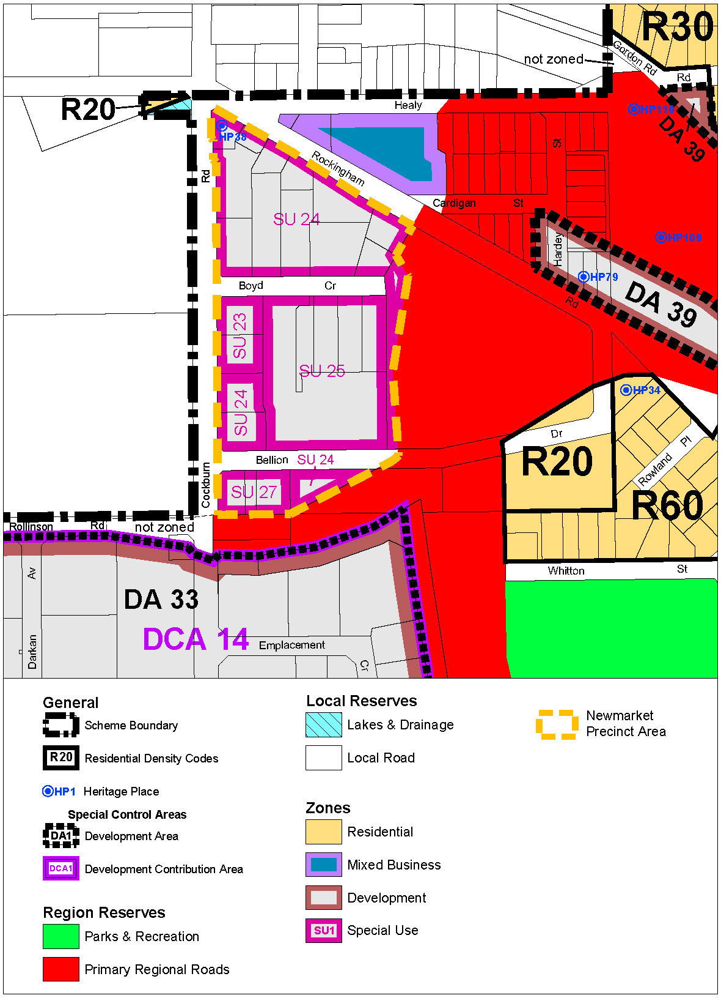

Bookmark 2
Bookmark 3
Strategic Link: | Town Planning Scheme No.3
Category | Planning – Town Planning & Development
Lead Business Unit: | Development Assessment and Compliance
Public Consultation:  (Yes or No) | Yes
Adoption Date:  (Governance Purpose Only) | 10 November 2022
Next Review Due:  (Governance Purpose Only) | November 2024
ECM Doc Set ID:  (Governance Purpose Only) | 4517282

