Tender Title: |  | RFP 05/2024 – Processing Services for Recyclable Materials
Request ID: |  | 50079
Tender Description: |  | The City of Cockburn (the Principal) provides a weekly 240 litre MGB Recycling collection service for residential and commercial properties throughout its Local Government District.  The Principal collects approximately 11,000 tonnes of Recyclable Materials annually and is seeking the services of a suitable contractor to receive and process this co-mingled material.
Advert Approval: |  | Decision to Advertise: Chief Executive Officer  Decision Date: Wednesday, 17 July 2024
Closing Date and Time: |  | 2:00PM (AWST) Tuesday, 13 August 2024
Opening Date and Time: |  | 2:00PM (AWST) Tuesday, 13 August 2024
 | Tenderer’s Name:
1 | CLEANAWAY OPERATIONS PTY LTD
2 | VEOLIA RECYCLING & RECOVERY (PERTH) PTY LTD
3 | RESOURCE RECOVERY GROUP

Advertisement
Method 1: City of Cockburn website | Method 2: City of Cockburn Libraries Public Noticeboards
Method 3:  The Western Australian, Saturday,  20 July 2024 | Tender Awarded by:
Copy of Statewide Notice:  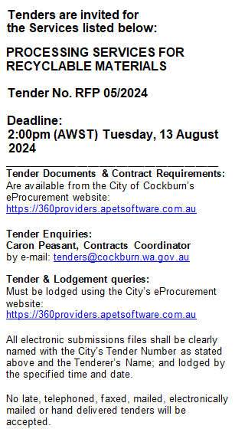 | Ordinary Council Meeting
 | Date of Council Meeting:
 | Tuesday, 8 October 2024

Name of Successful Tenderer(s): | VEOLIA RECYCLING & RECOVERY PTY LTD
Amount of Successful Tender(s): (ex GST) | $4,820,200.00 Ex GST

