Policy Type

Local Planning Policy

Policy Purpose

The Cockburn Coast Design Guidelines for the Robb Jetty and Emplacement Precinct have been prepared to guide the development and urban form (including subdivision) of Robb Jetty Local Structure Plan and Emplacement Local Structure Plan (LSP) areas.

The Design Guidelines will guide the creation of a quality development that ensures the design principles of the Robb Jetty and Emplacement LSP’s are achieved.

Policy Statement

Appendix 1 contains the Cockburn Coast Design Guidelines for the Robb Jetty and Emplacement Precinct.

Development applications will be assessed under the Design Guidelines in conjunction with the Residential Design Codes of Western Australian (R-Codes), the approved structure plan, an approved local development plan and any other relevant local planning policy.

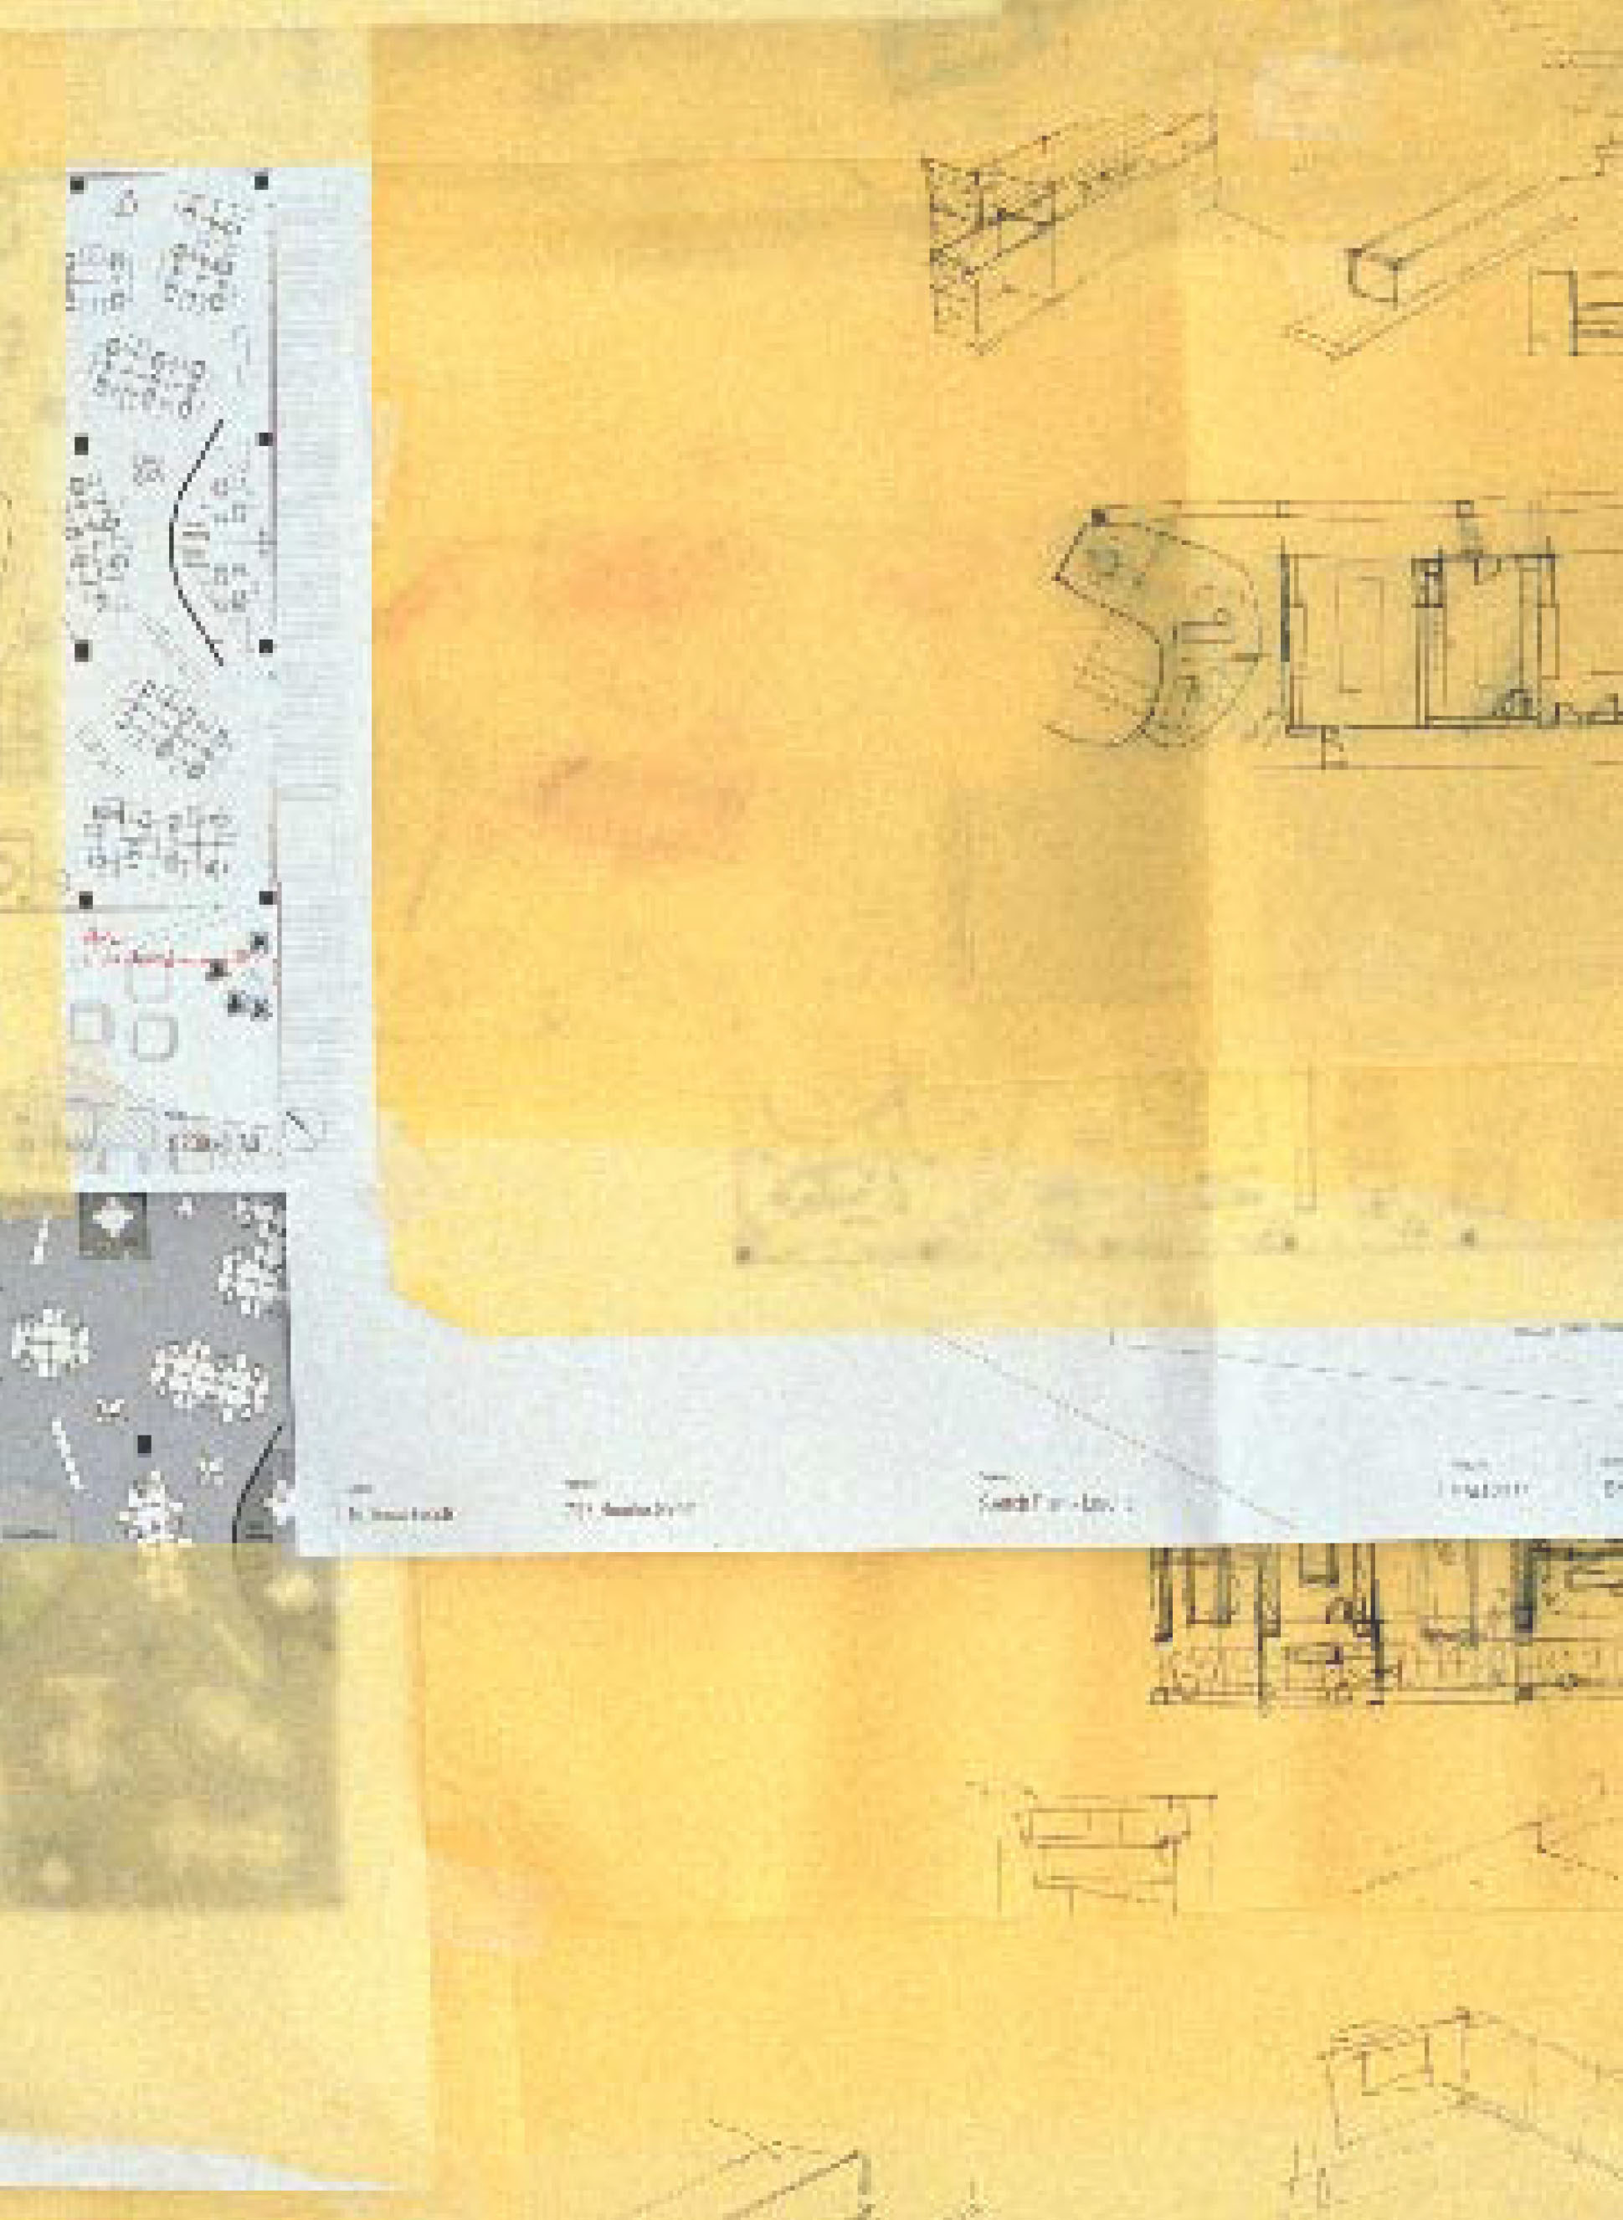
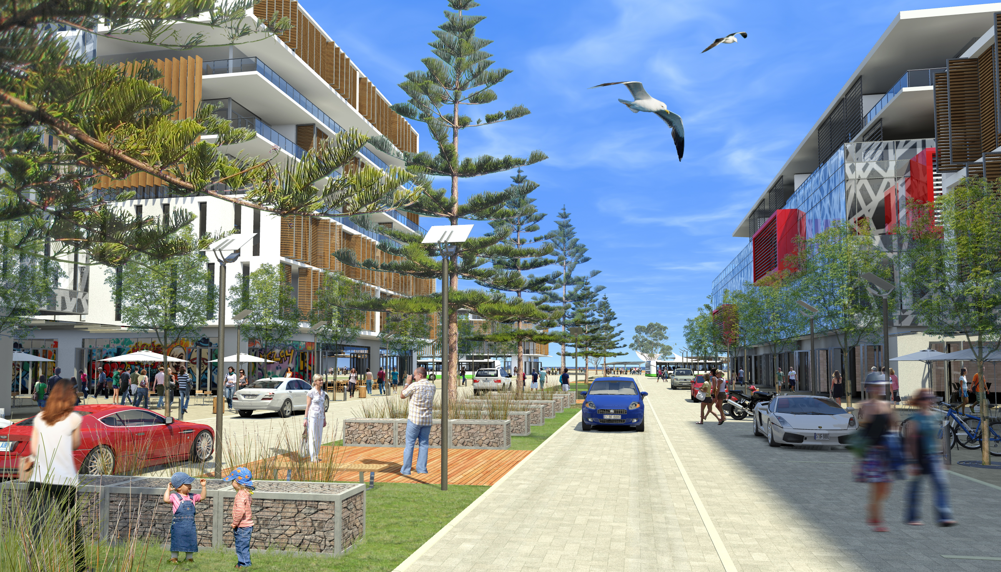

COCKBURN COAST
DESIGN GUIDELINES
FOR ROBB JETTY AND EMPLACEMENT

Appendix 1: LPP 4.6 Cockburn Coast Design Guidelines for Robb Jetty and Emplacement

1. Background 4
1.1 Introduction 4
1.2 Vision for Cockburn Coast 4
1.3 Context 6
1.4 Approach 7
1.5 Objectives 7
1.6 Purpose 8
1.7 Design Guideline Policy Area 8
1.8 Relationship to Relevant Planning Documents 9
1.9 Relationship to the Robb Jetty LSP and Emplacement LSP 9
1.10 Guideline Framework 9
1.11 Discretion 10
1.12 Definitions 10
1.13 Development Process 10

2. Typology Specific Guidelines 11
2.1 Activity Centre – Main Street Typology 13
2.2 Mixed Use – Cockburn Road Typology 18
2.3 High Density Residential Typology 24
2.4 Medium Density Residential Typology 30
2.5 Mixed Residential Typology 35

3. General Provisions 43
3.1 Built Form Requirements 43
3.1.1 Building Height 43
3.1.2 Facades 44
3.1.3 Roof Form 46
3.1.4 Lighting 46
3.1.5 Acoustics and Vibration 47
3.1.6 Active Edges and Street Relationship 48
3.1.7 Heritage Considerations 48
3.2 Service Infrastructure and Access 50
3.2.1 Internal Access 50
3.2.2 Parking 50
3.2.3 Parking Location and Access 50
3.2.4 Sleeved Parking 51
3.2.5 End of Trip Facilities 51
3.2.6 Site Services 52
3.3 Sustainability Requirements 53
3.3.1 Sustainable Travel 53
3.4 Laneways 53
3.4.1 Residential and Commercial Laneways 53
3.5 Communal Open Space 55

1. Background
1.1 Introduction
The Cockburn Coast Design Guidelines for the Robb Jetty and Emplacement precincts (henceforth referred to as the Design Guidelines) have been prepared to guide the development and urban form (including subdivision) of Robb Jetty Local Structure Plan (Robb Jetty LSP) and Emplacement Local Structure Plan (Emplacement LSP) areas. The design guidelines are focused on the creation of a quality development that ensures the design principles of the Robb Jetty and Emplacement LSP’s are achieved.

The design guidelines will bring to fruition a lively and sustainable urban centre set amongst dense residential development. The design guidelines introduce standards for development to create the intended character and amenity within the Robb Jetty LSP and Emplacement LSP areas. Although some of the criteria are mandatory, the general approach is to provide a series of broad principles for development to follow while allowing flexibility in design outcomes over the project life span.

The design guidelines are a performance orientated assessment tool. Each design element is expressed as a design objective and one or more assessment criteria. Where a stated assessment criterion is proposed to be varied, development must demonstrate that it meets the related design objective. In this way a performance approach to design and assessment is facilitated.

The design guidelines are divided into two main sections:

Typology Specific Guidelines
A series of built form typologies are established in defined areas where specific guideline provisions apply that may expand on or vary the general provisions.

General Provisions
Contain the design guideline general provisions which are applicable to all development.

1.2 Vision for Cockburn Coast
Capitalising on a rare opportunity, these design guidelines set out to inform the development of an exciting mixed use community that celebrates the best of the Western Australian coastal lifestyle.

Cockburn Coast will be different from its neighbouring suburbs; it will be a place that offers choice and variety of living, recreation and working opportunities. Core to the success of the redevelopment is a well-connected Bus Rapid Transit (BRT) system which is intended to link the development to its surrounding areas. As well as connecting the design guideline area to its surrounds, this system will provide an internal system of movement which encourages more sustainable personal transportation choices.

The City of Cockburn’s Cockburn Coast District Structure Plan (DSP) and Cockburn Coast District Structure Plan Part 2 (DSP2) nominates three local structure plan areas being Robb Jetty, Emplacement and Power Station. Each of these areas is distinct in character and function. These design guidelines introduce standards for development to create the intended character and amenity within the Robb Jetty and Emplacement LSP areas following a detailed local structure planning process.

Robb Jetty LSP Area

The Robb Jetty LSP area forms the north-western portion of the site and stretches from Rollinson Road in the north, to the Parkland Corridor in the south and Cockburn Road in the east. The area stretches west of Robb Road but excludes the beach.

The Robb Jetty LSP area will contain elements of mixed use development along significant road links including Cockburn Road an activity centre main-street, and a Mixed Business’ precinct, but is otherwise set aside for medium to high density residential development. The area will also house supporting community facilities in the form of the two storey urban primary school and the area’s key active playing field. A coastal character is proposed to complement the adjacent foreshore and areas of open space contained within it.

The BRT public transport alignment is set to pass through the heart of the area and be well connected to Fremantle and the rapidly emerging Cockburn Central. A variety of small but connected public spaces will offer a range of experiences from the quiet to the communal, the sheltered to the open and the organic to the formal.

Emplacement LSP Area

The Emplacement LSP area forms the north-east portion of the project area and stretches from the northern boundary of the master plan area, to the middle parkland corridor to the south, to Cockburn Coast Drive in the east, and Cockburn Road in the west.

The distinct character of the Emplacement LSP area is a product of its elevated topography and this landform influences how it shall be treated. Development will be responsive to the topography and shall aim to retain as much of the existing natural character of the site as possible. The Emplacement LSP area will be predominantly mixed use in its north, residential in its south, and contain the east-west linear parks, providing strong connections from Beeliar Park and through Robb Jetty LSP area to the coastal foreshore.

The Emplacement LSP area will be the new highpoint, a manufactured horizon line that offers the opportunity for a new architectural topography and an integrated landscape of nature and built form.

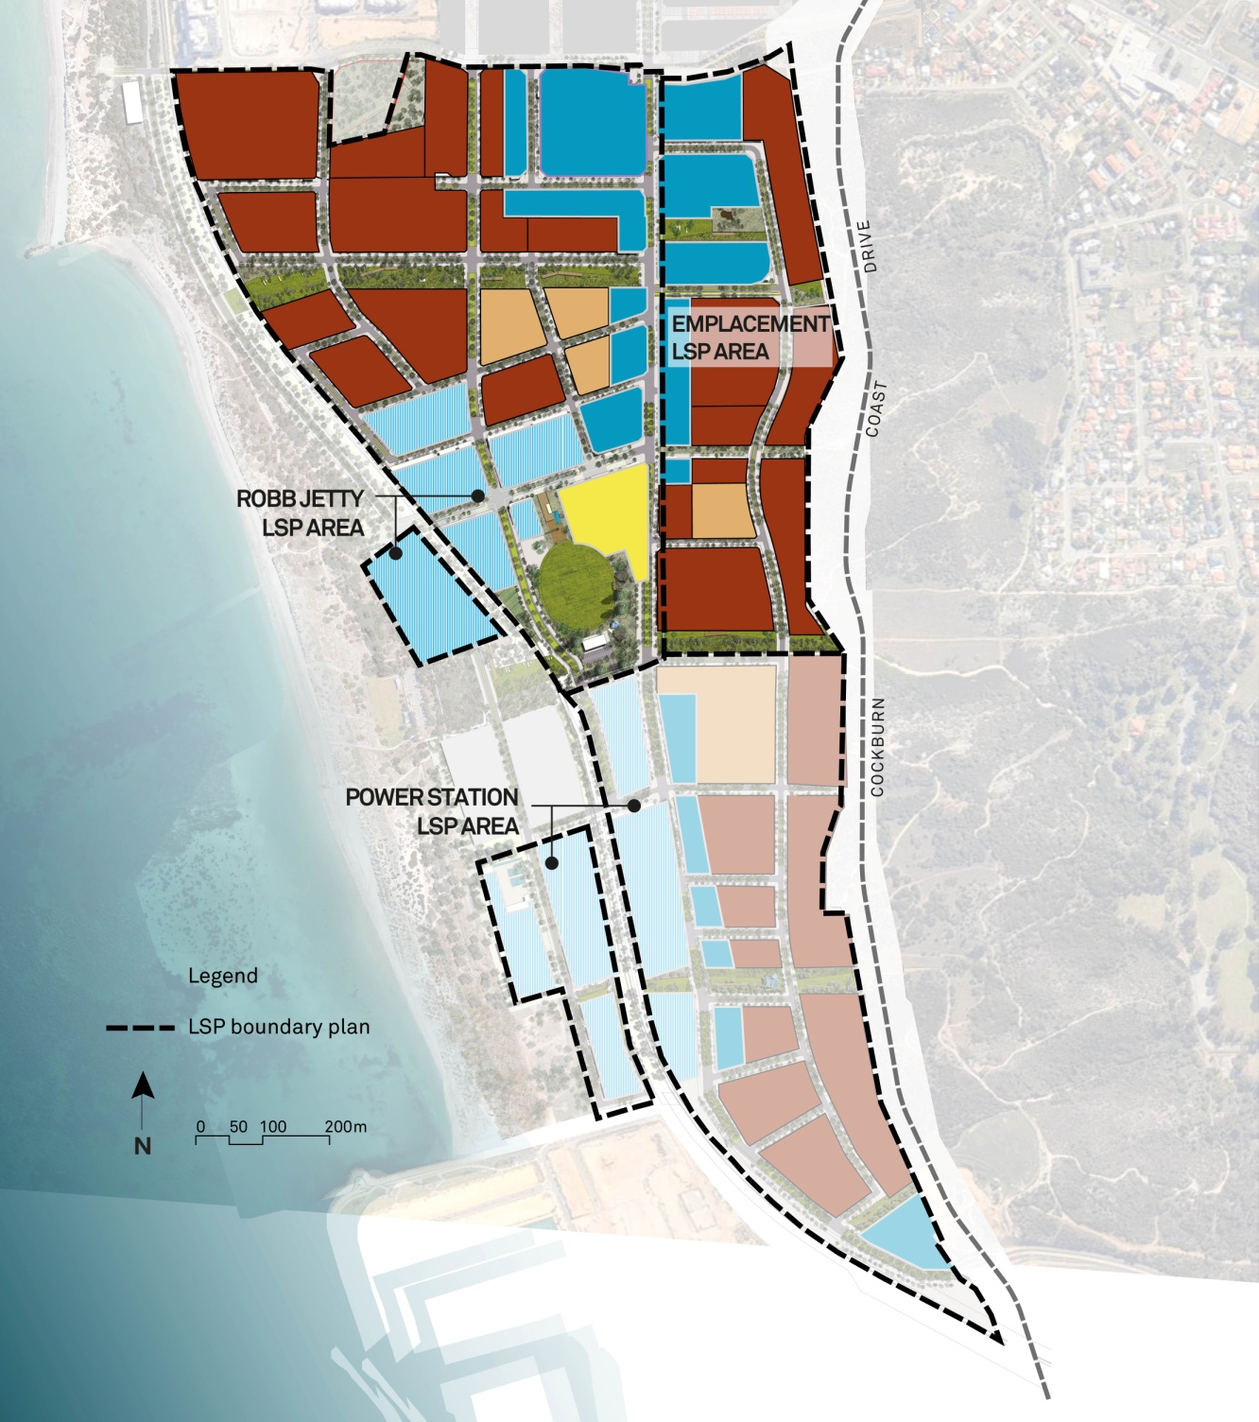
Figure 01_Cockburn Coast Local Structure Plan areas

1.3 Context
The design guidelines complete a complex process of strategic planning to capitalise on the opportunity for redeveloping Cockburn Coast identified in the Western Australian Planning Commission’s strategic planning document ‘Directions 2031 and Beyond’. The adoption of the DSP and later DSP2 2012 served to solidify the recognition of the Cockburn Coast’s potential and identifies a number of key drivers and opportunities that underpin the vision and intent of the DSP and DSP2. Following an amendment (Amendment 89) to the City of Cockburn Town Planning Scheme No. 3 (The Scheme), which aligns the City of Cockburn’s (the City) planning framework with that as proposed in the DSP and DSP2, local structure plans were produced for the Robb Jetty LSP and Emplacement LSP areas which establishes a development agenda and expands on the foundations of the DSP and DSP2.
These design guidelines bring to fruition a vision established and carried forward through a number of strategic planning documents and processes.
1.4 Approach
The DSP established a vision which remains relevant to the ongoing planning of Cockburn Coast:
“To create a vibrant, landmark destination that is connected, integrated, diverse and accessible.”
The vision seeks to create a place that offers new and exciting living, employment and recreation opportunities, whilst providing an appropriate level of compatibility and support for adjoining residents and existing enterprises in the area. These design guidelines are set to establish this vision by creating a sustainable community that celebrates the area’s past as well as taking on creative ideas, innovation and development. Cockburn Coast will be an easily accessible place, with an integrated transit system offering contemporary lively cafes, restaurants, shops, residential and commercial areas, tourism, cultural and recreation activities.
Integral to the vision of Cockburn Coast is the intention to establish a new benchmark for sustainable urban development. This means creating a place where people not only want to live and work today, but also in the future. Sustainable communities cater to the different needs of all its residents; they are safe and inclusive and offer equality of opportunity, they are sensitive to their environment and contribute to a high quality of life.

1.5 Objectives
The development of Cockburn Coast is guided by a number of key objectives or drivers which will bring to fruition the vision of a sustainable landmark destination. These objectives have influenced the preparation of the design guidelines and underpin their purpose, being to:
- create a hierarchy of coastal nodes providing for the needs of local residents and visitors alike;
- create physical and emotional links between the urban environment and the coast allowing the coastal experience to translate into the urban setting;
- provide attractive, pedestrian-oriented streets and public spaces that create an environment for positive community engagement and business exchange;
- enable buildings and public realm to engage with pedestrians and facilitate a comfortable and safe urban environment;
- allow for activation at ground level by retail and hospitality uses in key streets identified by the Local Structure Plans;
- optimise residential development potential whilst maintaining the intended character of the Cockburn Coast;
- minimise the impact of car parking on the pedestrian experience and quality of the public realm;
- create a sustainable environment that allows for the implementation of green infrastructure; and
- promote the use of sustainable modes of transport and a health way of living through active engagement with the urban environment.

1.6 Purpose
These design guidelines have been prepared to guide development within the Robb Jetty LSP and Emplacement LSP areas under the Scheme. Implementation of the guidelines will ensure the realisation of Cockburn Coast as an urban environment providing both local and district centre activity centres.

1.7 Design Guideline Policy Area
These design guidelines apply to the area of land within the Robb Jetty LSP and Emplacement LSP, henceforth referred to as the policy area. The policy area is bound by:

- Rollinson Road to the north;
- South Fremantle Power Station and the Western Power Switchyard to the south;
- Beeliar Regional Park to the east; and
- The foreshore reserve to the west.

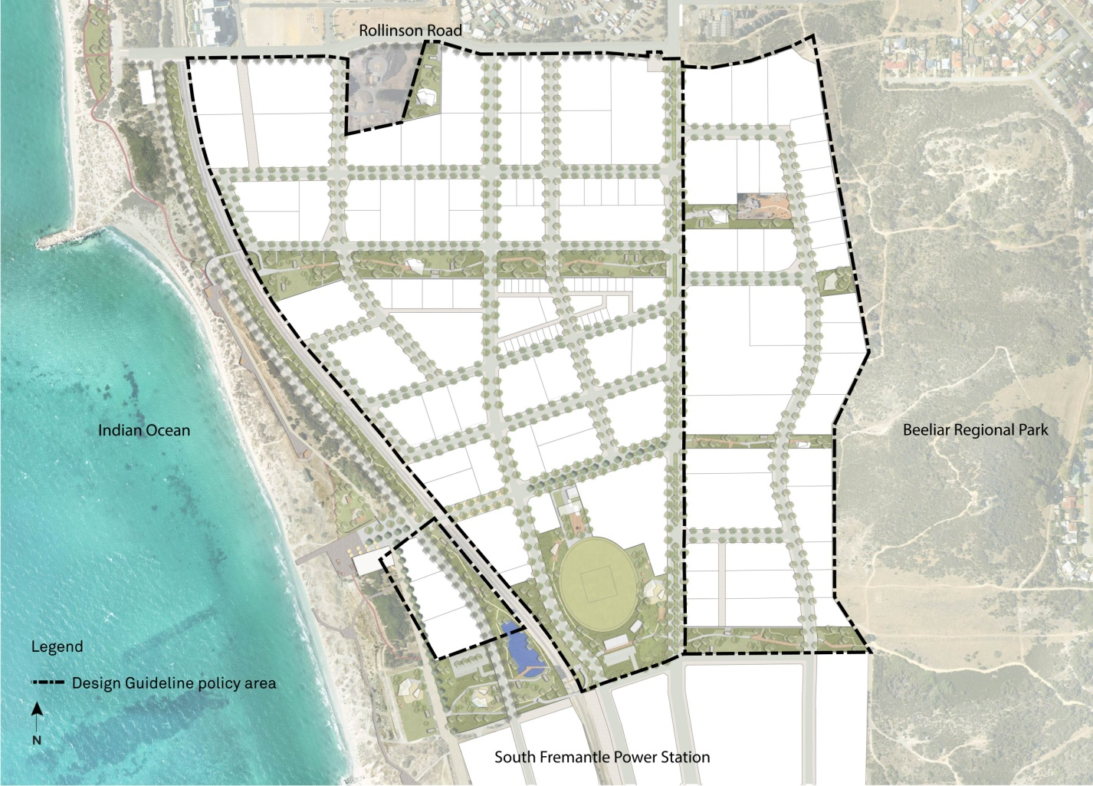
Figure 02_Design Guidelines Policy Area

1.8 Relationship to Relevant Planning Documents
The design guidelines are adopted under the provisions of section 4 of the Planning and Development Regulations 2015 Procedures for Making Local Planning Policy. The provisions of these design guidelines vary the requirements of the State Planning Policy 7.3 Residential Design Codes (R-Codes). Where these design guidelines are silent the provisions of the R-Codes and relevant local planning policies apply. It should be noted that the plot ratios of the R-Codes are varied and plot ratio will not form part of the assessment criteria for proposals in these precincts.

These design guidelines should be read in conjunction with the Scheme, the Robb Jetty LSP, the Emplacement LSP, any relevant Local Development Plan (LDP) and the R-Codes. In determining any application for development approval, the City will utilise these design guidelines in conjunction with the Scheme, any relevant LDP and policies.

1.9 Relationship to the Robb Jetty LSP and Emplacement LSP
The Robb Jetty LSP and Emplacement LSP set out a number of development objectives relating to the DSP2 redevelopment area. In particular they establish land use, movement, activity, urban form and resource enhancement development standards to ensure Cockburn Coast operates as an effective urban environment.

These design guidelines build upon both LSPs and provide more detailed guidance on development standards in the form of an adopted local planning policy.

1.10 Guideline Framework
The detailed design guidelines contained in the General Provisions section are set out with the following framework:

Design Objective:
Statements outlining the design philosophy and intent of the assessment criteria. It is mandatory for development to meet the design objective.

Assessment Criteria:
Standards that sets out the specific criteria to satisfy an associated design objective. Compliance with the applicable assessment criteria will achieve the design objective. However individual criteria are not mandatory and alternative solutions for complying with the design objective will be considered on a performance basis subject to supporting evidence.

The typology specific section of the design guidelines contains character statements. The character statements guide both the design objective and assessment criteria and as such, all development shall be consistent with the relevant character statement.

1.11 Discretion
An important provision within the design guidelines is the opportunity for the applicant or owner to meet the design objective through an alternative solution.

The City may approve a development application or Local Development Plan where the applicant or owner has departed from the recommended assessment criteria. Variations may be considered where, in the City’s opinion, the applicant or owner has demonstrated that the alternative solution is consistent with the Robb Jetty LSP or Emplacement LSP where relevant and meets the design objective. Variations will be considered where a proposal does not include an affordable housing component, but will be considered more favourably where it does.

Where a development proposal is determined to be inconsistent with a design objective in a manner that may impact on the public realm or adjoining properties then the proposal may be refused or referred to Council for determination.

Where the applicant or owner has provided a sufficient affordable housing component, a relaxation of the assessment criteria may be considered where the alternative solution is consistent with the relevant LSP and meets the design objective. These design guidelines provide further guidance on those criteria considered suitable for variation.

Each application for development approval will be assessed on an individual basis and the approval of an alternative solution will not set a precedent for other developments.

1.12 Definitions
Noise Sensitive Premises (as defined in the Environmental Protection (Noise) Regulations 1997) includes premises occupied solely or mainly for residential or accommodation purposes, and premises used for the purpose of a hospital, sanatorium, educational establishment, public worship, aged care or child care.

Commercial Laneway includes any laneway within the mixed use or activity centre typology areas as set out by these design guidelines.

All definitions included in the R-Codes are applicable to land affected by these Design Guidelines.

1.13 Development Process
Owners, developers and/or agents are encouraged to arrange pre-application meetings with the City’s Planning Department prior to lodgement of a formal development application. Once a development application is lodged, it will be assessed by the City to verify it meets all applicable design objectives and assessment criteria.

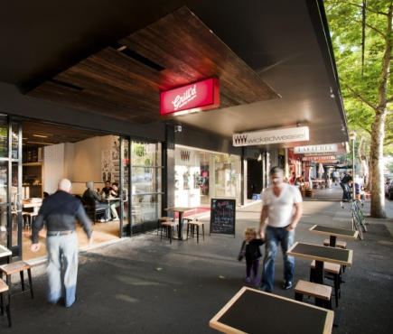
Mixed Use – Cockburn Road Typology
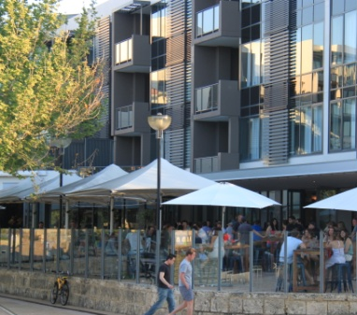
Activity Centre – Main Street Typology

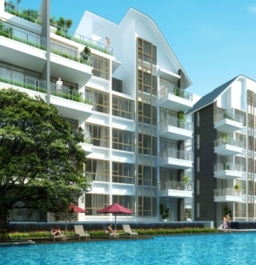
Medium Density Residential Typology
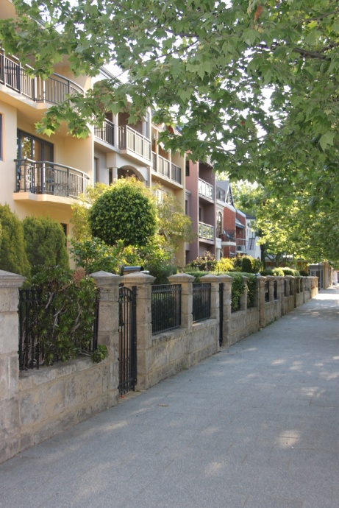
High Density Residential Typology

2. Typology Specific Guidelines
The policy area is divided into a number of built form typologies each with their own distinct character and function. There are also a number of landmark and gateway sites identified by the built form typology location plan. These sites are to be developed with a diverse and active facade to facilitate way finding and reflect the natural hierarchy and land use of the area.

Activity Centre - Main Street Typology
Development in this area addresses and activates the identified pedestrian oriented “main” street whilst a high quality public realm creates a comfortable place in which locals meet and conduct business. This area provides a key link between the ocean and urban environment as well as providing for the retail and local service needs of the local community.
Mixed Use - Cockburn Road Typology
A range of retail and commercial functions complemented by residential development are to be accommodated within this mixed use area. The presence of Cockburn Road informs the scale and built form of development and necessitates the promotion of an active ground floor.

High Density Residential Typology
The most intensely developed residential typology to afford the greatest access to the proposed bus rapid transit system. High density residential development is to create a new skyline in Cockburn Coast.

Medium Density Residential Typology
Providing a mix of housing opportunities near the Activity Centre, this typology will feature soft landscape public realm and contemporary urban development ranging from terrace housing to medium scale apartment style buildings.

Mixed Residential Typology

A special urban precinct designed around exploring contemporary urban forms, featuring a mix of housing opportunities, with living choices ranging from high density apartments to compact terrace housing, punctuated by innovative shared access streets and open spaces.

Mixed Business Typology

Facilitating a transition from the existing industrial businesses to lighter industrial or commercial uses that do not have a detrimental impact on the amenity of future surrounding residential uses. All new built form proposals shall address an interface that is compatible and complementary with surrounding existing or future residential or mixed use development.

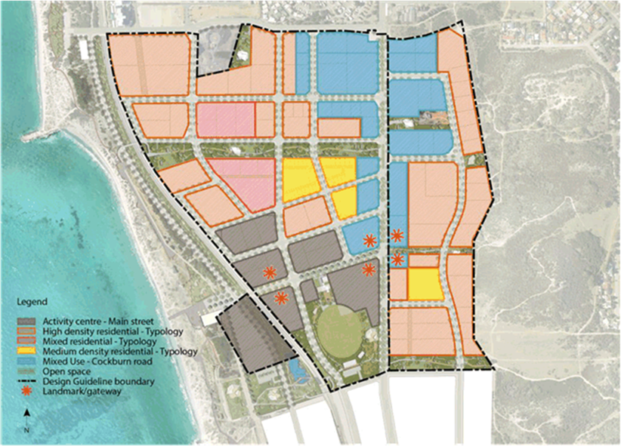
Mixed Business
Figure 03_Built Form Typologies

2.1 Activity Centre – Main Street Typology
The activity centre typology is primarily a place for local residents and businesses, a walkable village that is intimate in scale and ‘soft’ in character. The beach comes to the main street and a variety of small but connected public spaces offer a range of experiences from the quiet to the communal. Buildings and land use will facilitate the creation of a central shopping and activity zone resulting in a walkable community hub.

The Main Street provides a convenient and inviting local shopping experience intended to be serviced by a rapid bus transit system. Street trading and active retail is concentrated in the western portion of the area creating a vibrant community hub. A diverse and contiguous streetscape will be developed with civic, business and retail services ensuring a suitable business mix. The oval and park within the activity centre typology represents the traditional village green and is therefore the focus of active recreation at Cockburn Coast. It is a place to be shared harmoniously by many for diverse purposes.

The built form is encouraged to take advantage of the abundant natural assets and create a comfortable outdoor environment that encourages social interactions in a relaxed and personal environment. Future built form should embody the feeling of seamless transition, from indoor to outdoor, from formal to informal, from exposed to protected. Respectful of nature, built form should reflect the natural characteristic of the vegetation and landscape.

Buildings generally of 5 to 8 storeys in height will promote a pedestrian friendly place through podium style built form and a focus on ground floor activation. Development embodies a warm architectural finish through the use of natural materials, whilst street awnings, wide footpaths and soft landscaped edges create a sense of intimacy and shelter pedestrians.

Opportunities for laneway development enhance and celebrate the distinctive environment by reflecting the neighbourhood character whilst allowing for it to be developed as a secondary small street. Laneways containing commercial uses will be characterised by small scale tenancies, evolving over time to provide an intimate and unique experience.

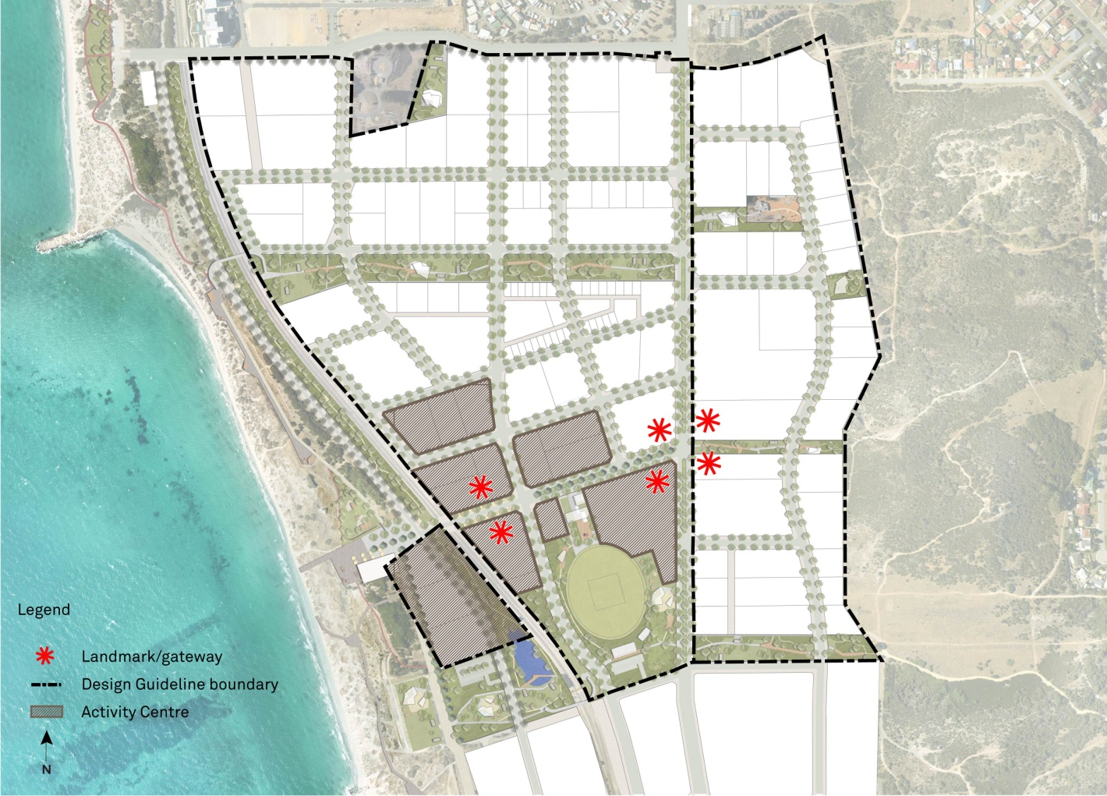
Figure 04_Activity Centre built form typology

Building Setbacks

Design Objective
- Building setbacks create tightly framed streetscapes and public open spaces
- Building setbacks help create highly urban streetscapes

Assessment Criteria
- Building setbacks are to be in accordance with the following table

Setback | Street  (minimum and maximum) | Side/Rear(minimum) | Laneway  (minimum) | Public Open Space (minimum)
Levels 1-5 | Nil | Nil | Nil | 4m to wall and 2m to balconies (cantilevered/Light weight only)
Levels 6+ | 5m to wall and  2m to balconies (cantilevered/light weight only | 3m | 3m | 5m to wall and 2m to balconies (cantilevered/light weight only)
* Where there is a commercial laneway the minimum setback above 3 storeys should be a distance equivalent to the width of lane unless a variation to the assessment criteria outlined in clause 3.4.1(ii)c of the general provisions is granted
Table 01_ Building Setbacks for Activity Centre

- The public open space setback area shall include space for landscaping and if necessary an outdoor living area. Where additional outdoor living area is to be provided, the additional outdoor living area shall be absorbed into the building space (i.e. building shall cantilever over the outdoor living area)
- Projections are permitted within the 4m setback to public parkland to maximum of 2m into the setback area
- Balconies will be supported within the nil setback on levels 1-5 where a substantial facade is provided to ensure a continuous built form
- Balconies for Levels 6+ proposed to be setback between 2-5m shall be lightweight/cantilevered only

Building Articulation

Design Objective
- To ensure that building facades add positively to the public realm and its interest. Building articulation will encourage interaction with the street and passive surveillance of adjacent spaces
- To promote a pedestrian scale of buildings at street level
- The building design shall demonstrate an appropriate level of articulation to avoid building bulk appearing excessive
- Building articulation will express a vibrant and modern design aesthetic

Assessment Criteria
- Permanent blank walls are not permitted to any street frontage. Major openings are required to provide for surveillance and interaction with the public realm
- For commercial street level frontages a minimum of 80% of the frontage shall be glazed. For the street frontage for all upper floors a minimum of 40% of the frontage shall be glazed
- Mixed use buildings should provide separate entries for non-residential and residential uses for legibility of pedestrian access
- The facade detail may be simplified on loading areas, parapet walls and walls to ‘back of house’ areas
- Corner buildings are to address both frontages through the provision of:
- distinct roof form at corners;
- variation in materials and colours; and
- varied balcony treatments.

Building Levels

Design Objective
- To ensure development maintains a positive relationship with the street such that pedestrian movement, sight lines and streetscape character are maximised
- To allow for the safe use of ceiling fans for cooling

Assessment Criteria
- Floor to floor heights on the ground floor should be 4.5m to allow for commercial use. Apartments shall achieve minimum floor to ceiling levels as outlined in Clause 4.3 of the Residential Design Codes Volume 2 – Apartments.
- All other floors shall maintain a 3.1m floor to floor height for residential use and a 3.6m floor to floor height for commercial use
- The ground floor should be flush with the adjacent footpath at the boundary
- All development is to achieve a minimum finished floor level of +3.8AHD to ensure development takes into account coastal erosion and accretion patterns. Non habitable rooms and the provision of basement parking are exempt from the finished floor level stated above

Awnings

Design Objective
- To encourage a pedestrian scale of development
- To provide shelter from environmental conditions
- To encourage a seamless flow of the use and function of a building from internal to external
- To maintain a safe separation between passing traffic and awnings

Assessment Criteria
- Awnings over footpaths are to be provided for no less than 80% of the primary and secondary street frontage. This requirement does not apply to laneways
- The vertical clearance of awnings shall be consistent and generally 3.2m from pavement level
- Awnings shall project 3.5m from the building line except where this results in a setback between to the awning and the outer edge of the road pavement of less than 0.6m
- Adjoining awnings are to form continuous coverage over the footpath
- Awnings are to be provided with non-structural veranda posts along the Robb Jetty Main street. In this respect awnings are to be suspended by cantilevered construction and not use load bearing posts

Building Height

Design Objective
- Building heights help create a compact urban built environment
- Consistent building heights create a recognisable urban character
- Building heights mean the Activity Centre Typology area is highly visible from a distance
- Building heights do not visually overwhelm the streetscape
- Building heights avoids continual overshadowing of the streetscape

Assessment Criteria
- Building heights shall be in accordance with the Building Height Plan (Figure 14)
- Development shall be a minimum of three storeys and six storeys (depending on site)

Building Materials

Design Objective
- To encourage a style of development that is consistent with the coastal location
- To provide for a consistency in the standard of finish and materials throughout Cockburn Coast.
- To foster a sense of place through an identifiable character and style of development

Assessment Criteria
- Extensive use of concrete tilt panels is discouraged. Where concrete tilt panels are used, they shall be integrally coloured (colour tinted concrete)
- Moulded textures imprinted in the external surfaces of any concrete panels are encouraged
- Painted finishes and rendered textures over concrete panels are not permitted
- The use of natural materials such as stone, timber and other such natural products is encouraged in both interior and exterior finishes

Open Space

Design Objective
- To ensure that development provides an attractive and engaging interface with the public open space
- To maximise the potential for passive surveillance

Assessment Criteria
- Where an area of public open space is provided the surrounding development must address the open space by maximising passive surveillance from habitable rooms; buildings must front onto the open space through placement of doors, windows and balconies to create a safe and comfortable pedestrian environment

Landmark Sites

Design Objective
- To encourage a sense of place and identity
- To increase the legibility of place
- To demarcate the natural hierarchy of an area by identifying those places which are of significance

Assessment Criteria
- Sites in key locations have been nominated as landmark sites as shown in Figure 04 Built Form Typologies shall:
  - Promote prominent architectural form on corner elements to provide a reference point in the built form and landscape;
  - Encourage additional height elements where appropriate to create a point of difference with the balance of the development area and demarcate points of entry and prominence; and
  - Variations to setback requirements will be considered in order to create prominent feature elements.

Fencing

Design Objective
- To ensure that fencing does not detract from the function and appearance of the streetscape

Assessment Criteria
- Fencing is not permitted forward of the building line adjacent to the primary or secondary street frontage
- The interface between private lots and the public open space may be fenced to a maximum height of 1.2m from natural ground level, but must be visually permeable above a height of 1.0m above natural ground level

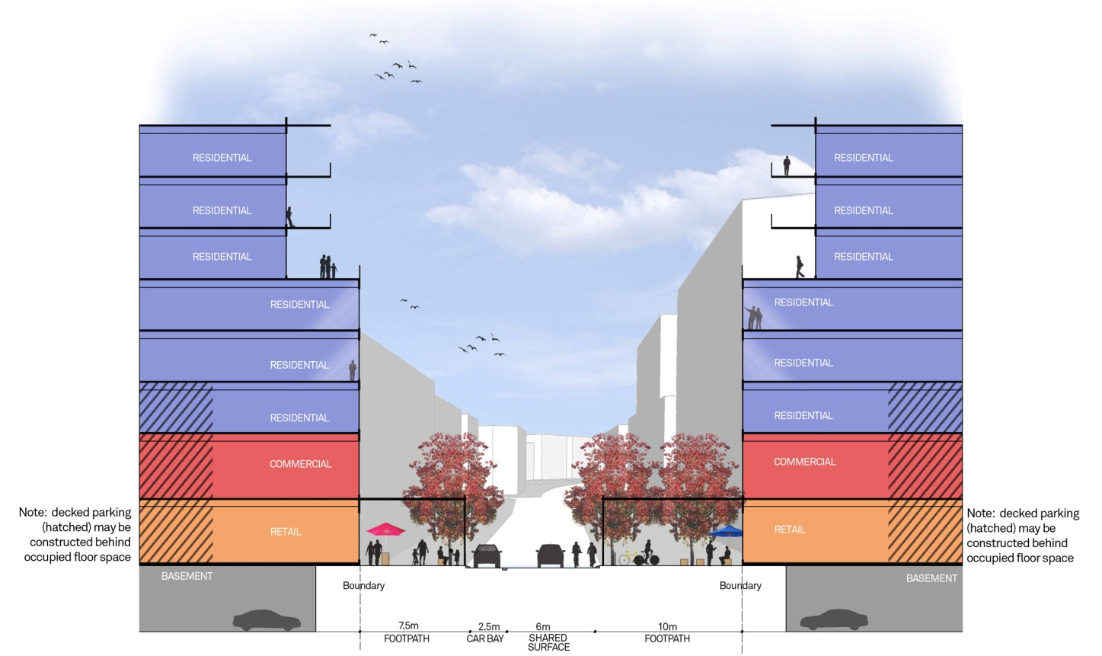
Figure 05_Typical cross section for activity centre development

2.2 Mixed Use – Cockburn Road Typology
Cockburn Road is the main arterial road through Cockburn Coast and the policy area. Cockburn Road will be the focus of a mixed use form of development allowing for commercial, residential and retail uses. An active ground floor through retail and commercial uses will be encouraged with primarily residential development occupying the upper levels. The impact of the busy Cockburn Road will be softened by landscaping and an active footpath. Alfresco dining opportunities will be encouraged and facilitated by the built forms and land uses. The Mixed Use – Cockburn Road Typology as shown in Figure 06 below, applies to the Mixed Use and zone as shown on the approved Robb Jetty Local Structure Plan.
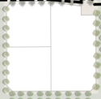
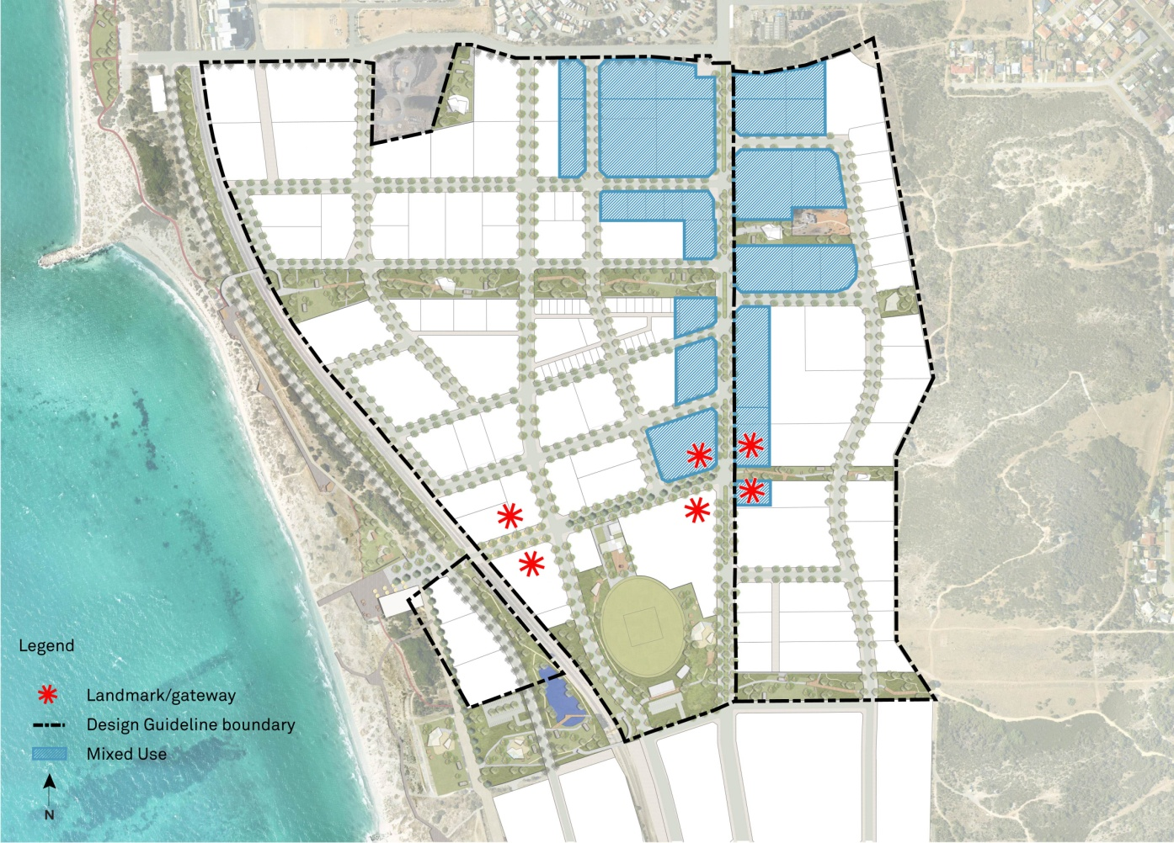
Figure 06_Mixed Use built form typology

Building Setbacks

Design Objective
- Building setbacks promote tightly framed streetscapes and public open spaces
- Building setbacks help create highly urban streetscapes

Assessment Criteria
- Building setbacks are to be in accordance with the following table

Table 02_ Building Setbacks for Mixed Use development
Setback | Street  (minimum and maximum) | Side/Rear  (minimum) | Laneway  (minimum) | Public Open Space (minimum)
Levels 1-3 | Nil | Nil | Nil | 4m to wall and 2m to balconies (cantilevered/light weight only)
Levels 4+ | 5m to wall and 2m to balconies (cantilevered/light weight only | 3m | 3m | 5m to wall and 2m to balconies (cantilevered/light weight only)
* Where there is a commercial laneway the minimum setback above 3 storeys should be a distance equivalent to the width of lane unless a variation to the assessment criteria outlined in clause 3.4.1(ii)c of the general provisions is granted

- Buildings shall be setback 4m from any boundary adjoining public parkland. This setback area shall include space for landscaping and if necessary an outdoor living area. Where additional outdoor living area is to be provided, the additional outdoor living area shall be absorbed into the building space (i.e building shall cantilever over the outdoor living area)
- Projections are permitted within the 4m setback to public parkland to maximum of 2m into the setback area
- Balconies will be supported within the nil setback on levels 1-5 where a substantial facade is provided to ensure a continuous built form

Building Articulation

Design Objective
- To ensure that building facades add positively to the public realm and its interest. Building articulation will encourage interaction with the street and passive surveillance of adjacent spaces
- To promote a pedestrian scale of buildings at street level
- The building design shall demonstrate an appropriate level of articulation to avoid building bulk appearing excessive
- Building articulation will express a vibrant and modern design aesthetic

Assessment Criteria
- Permanent blank walls are not permitted to any street frontage. Major openings are required to provide for surveillance and interaction with the public realm
- For commercial street level frontages a minimum of 80% of the frontage shall be glazed. For the street frontage for all upper floors a minimum of 40% of the frontage shall be glazed
- Mixed use buildings should provide separate entries for non-residential and residential uses for legibility of pedestrian access
- The facade detail may be simplified on loading areas, parapet walls and walls to ‘back of house’ areas
- Corner buildings are to address both frontages through the provision of:
- distinct roof form at corners;
- variation in materials and colours; and
- varied balcony treatments.

Building Levels

Design Objective
- To ensure development maintains a positive relationship with the street such that pedestrian movement, sight lines and streetscape character are maximised
- To allow for the safe use of ceiling fans for cooling

Assessment Criteria
- Floor to floor heights on the ground floor should be 4.5m to allow for commercial use of the ground floor
- All other floors shall maintain a 3.1m floor to floor height for residential use and a 3.6 metre floor to floor height for commercial use. Apartments shall achieve minimum floor to ceiling levels as outlined in Clause 4.3 of the Residential Design Codes Volume 2 – Apartments.
- The ground floor should be flush with the adjacent footpath at the boundary
- All development is to achieve a minimum finished floor level of +3.8AHD to ensure development takes into account coastal erosion and accretion patterns. Non habitable rooms and the provision of basement parking are exempt from the finished floor level stated above

Awnings

Design Objective
- To encourage a human scale of development
- To provide shelter from environmental conditions
- To encourage a seamless flow of the use and function of a building from internal to external
- To maintain a safe separation between passing traffic and awnings

Assessment Criteria
- Awnings over footpaths are to be provided for no less than 80% of the primary and secondary street frontages. This requirement does not apply to laneways
- The vertical clearance of awnings shall be consistent and generally 3.2m from pavement level
- Awnings shall project 3.5m from the building line except where this resulting in a setback between to the awning and the outer edge of the road pavement of less than 0.6m
- Adjoining awnings are to form continuous coverage over the footpath
- Any veranda post provided to an awning shall be non-structural. In this respect awnings are to be suspended by cantilevered construction and not use load bearing posts

Building Height

Design Objective
- Building heights help create a compact urban built environment
- Consistent building heights create a recognisable urban character
- Building heights do not visually overwhelm the streetscape
- Building heights avoids continual overshadowing of the streetscape

Assessment Criteria
- Building shall be in accordance with the Building Height Plan (Figure 14)
- Development shall be a minimum of three storeys

Building Materials

Design Objective
- To encourage a style of development that is consistent with the coastal location
- To provide for a consistency in the standard of finish and materials throughout Cockburn Coast
- To foster a sense of place through an identifiable character and style of development

Assessment Criteria
- Extensive use of concrete tilt panels is discouraged. Where concrete tilt panels are used, they shall be integrally coloured (colour tinted concrete)
- Moulded textures imprinted in the external surfaces of any concrete panels are encouraged
- Painted finishes and rendered textures over concrete panels are not permitted
- The use of natural materials such as stone, timber and other such natural products is encouraged in both interior and exterior finishes

Open Space

Design Objective
- To ensure that development provides an attractive and engaging interface with the public open space
- To maximise the potential for passive surveillance

Assessment Criteria
- Where an area of public open space is provided the surrounding development must address the open space by maximising passive surveillance from habitable rooms; buildings must front onto the open space through placement of doors, windows and balconies to create a safe and comfortable pedestrian environment

Landmark Sites

Design Objective
- To encourage a sense of place and identity
- To increase the legibility of place
- To demarcate the natural hierarchy of an area by identifying those places which are of significance

Assessment Criteria
- Sites in key locations have been nominated as landmark sites as shown in Figure 06 Built Form Typologies. Development on Landmark Sites shall:
  - Promote prominent architectural form on corner elements to provide a reference point in the built form and landscape;
  - Encourage additional height elements where appropriate to create a point of difference with the balance of the development area and demarcate points of entry and prominence; and
  - Variations to setback requirements will be considered in order to create prominent feature elements.

Fencing

Design Objective
- To ensure that fencing does not detract from the function and appearance of the streetscape

Assessment Criteria
- Fencing is not permitted forward of the building line to the primary and secondary street frontages
- The interface between residential development and the public open space may be fenced to a maximum height of 1.2m from natural ground level, but must be visually permeable above a height of 1.0m above natural ground level

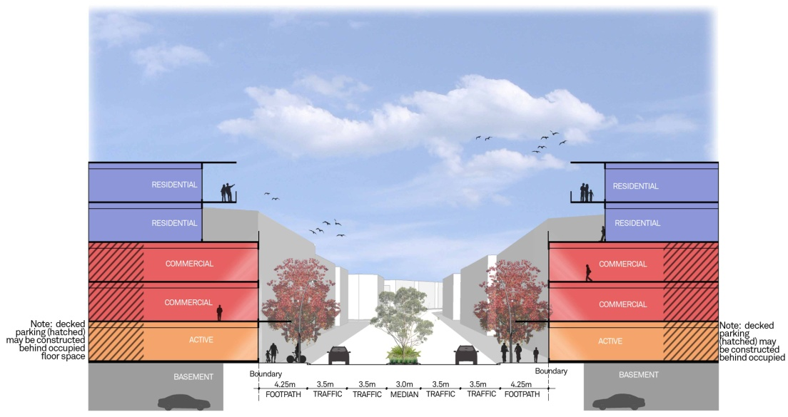
Figure 07_Typical cross section for mixed use development

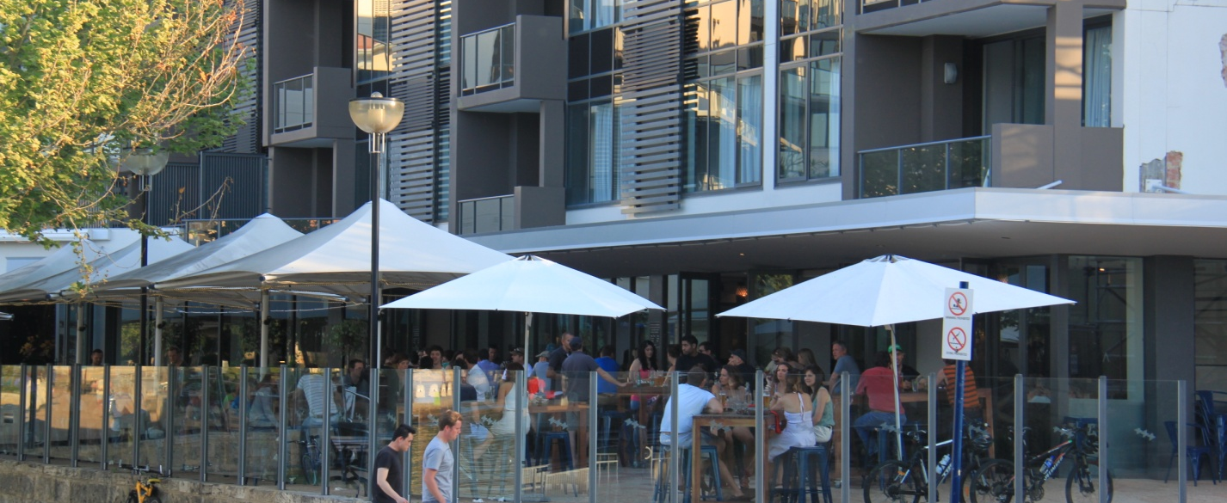

Mixed use development will encompass active street edges that create a
comfortable pedestrian environment
2.3 High Density Residential Typology
High density housing opportunities along the Emplacement escarpment and within the Robb Jetty LSP area will create a new skyline for the Cockburn Coast. A manufactured horizon line of apartment buildings six to eight storeys in height will offer the opportunity for a new architectural topography and an integrated landscape of nature and built form. Residents will enjoy the expansive views but also the sense of containment and grounding in the environment. Facades and balconies shade and veil occupants whilst the ground level public realm is internalised and places focus on the residential communities’ common interest.
Landscaped front setbacks and tree lined verges will combine to create a soft and comfortable urban setting for apartment buildings. Pocket parks and integrated greenery with built form create a calming natural feel throughout the area despite the intensity of development, acting as a backyard space and providing a link to the coast.

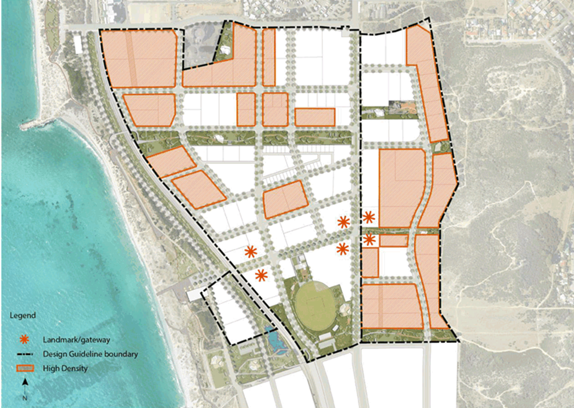
Figure 8_High Density built form typology

Building Setbacks

Design Objective
- Building setbacks frame streetscapes and public open spaces
- Building setbacks accommodate landscaping which slightly widen and softens the streetscape

Assessment Criteria
- Building setbacks are to be in accordance with the following table

Setback | Street  (minimum) | Side/Rear  (minimum) | Laneway  (minimum) | Public Open Space (minimum)
Levels 1-3 | 3m | Nil | Nil | 4m to wall and 2m to balconies (cantilevered/light weight only)
Levels 4+ | 5m to wall and 2m to balconies (cantilevered/light weight only | 3m | 3m | 5m to wall and 2m to balconies (cantilevered/light weight only)
Table 03_ Building Setbacks for high density residential development

- Buildings shall be setback 4m from any boundary adjoining public parkland. This setback area shall include space for landscaping and if necessary an outdoor living area. Where additional outdoor living area is to be provided, the additional outdoor living area shall be absorbed into the building space (i.e. building shall cantilever over the outdoor living area)
- Projections are permitted within the 4m setback to public parkland to maximum of 2m into the setback area

Building Articulation

Design Objective
- To ensure that building facades add positively to the public realm and its interest. Building articulation will encourage interaction with the street and passive surveillance of adjacent spaces
- To promote a pedestrian scale of buildings at street level
- The building design shall demonstrate an appropriate level of articulation to avoid building bulk appearing excessive
- Building articulation will express a vibrant and modern design aesthetic

Assessment Criteria
- Permanent blank walls are not permitted to any street frontage. Major openings are required to provide for surveillance and interaction with the public realm
- The facade detail may be simplified on loading areas, parapet walls and walls to ‘back of house’ areas
- Built form is to address parks, pedestrian access ways and in particular laneways by providing windows, balconies and suitable facade articulation facing these areas. These elevations are to match the design quality of the dwellings primary street elevation
- Corner buildings are to address both frontages through the provision of:
  - distinct roof form at corners;
  - variation in materials and colours; and
  - varied balcony treatments

Building Levels

Design Objective
- To ensure development maintains a positive relationship with the street such that pedestrian movement, sight lines and streetscape character are maximised
- To allow for the safe use of ceiling fans for cooling

Assessment Criteria
- All development shall maintain a minimum floor to floor height of 3.1m. Apartments shall achieve minimum floor to ceiling levels as outlined in Clause 4.3 of the Residential Design Codes Volume 2 – Apartments.
- All development is to achieve a minimum finished floor level of +3.8AHD to ensure development takes into account coastal erosion and accretion patterns. Non habitable rooms and the provision of basement parking are exempt from the finished floor level stated above
- Where residential dwellings are proposed on the ground floor adjacent to a street or public open space, a grade separation from 0.5m to 1.2m between the finished floor level of the ground floor and the adjacent street or public open space is encouraged in order to create a visual distinction between the public and private space

Building Height

Design Objective
- Building heights will respond to the pedestrian scale, urban character, intended dwelling density, land use mix as well as the natural topography of the area
- The built form of an area shall provide a pedestrian scaled street interface with taller upper floors setback from the street alignment
- The built form shall minimise overshadowing to adjacent streets and public spaces

Assessment Criteria
- Development shall be in accordance with the Building Height Plan (Figure 14)
- Development shall be a minimum of three storeys

Building Materials

Design Objective
- To encourage a style of development that is consistent with the coastal location
- To provide for a consistency in the standard of finish and materials throughout Cockburn Coast
- To foster a sense of place through an identifiable character and style of development

Assessment Criteria
- Extensive use of concrete tilt panels is discouraged. Where concrete tilt panels are used, they shall be integrally coloured (colour tinted concrete)
- Moulded textures imprinted in the external surfaces of any concrete panels are encouraged
- Painted finishes and rendered textures over concrete panels are not permitted
- The use of natural materials such as stone, timber and other such natural products is encouraged in both interior and exterior finishes

Open Space

Design Objective
- To ensure that development provides an appropriate interface with the public open space
- To maximise the potential for passive surveillance

Assessment Criteria
- Where an area of public open space is provided the surrounding development must address the open space by maximising passive surveillance from habitable rooms; buildings must front onto the open space through placement of doors, windows and balconies to create a safe and comfortable pedestrian environment

Fencing

Design Objective
- To ensure that the provision of fencing does not detract from the function and appearance of the streetscape

Assessment Criteria
- The interface between private lots and the public open space may be fenced to a maximum height of 1.2m from natural ground level, but must be visually permeable above a height of 1.0m above natural ground level
- Fencing shall generally not be permitted in the primary or secondary street setback areas

Landscaping

Design Objective
- To ensure an attractive streetscape environment
- To aid the sustainability of a building through the provision of permeable surface

Assessment Criteria
- The front setback area shall include provision for elements of soft landscaping
- In ground landscaping is preferred over shallow landscaping above basements
- Paving that is contiguous with foot paths and other paving in the public realm shall be of the same style and materials, matching exactly wherever possible

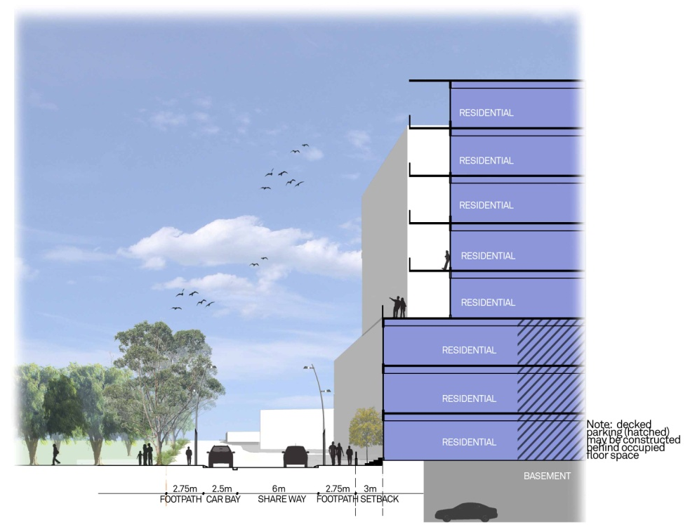
Figure 9_Typical cross section of high density residential adjoining road

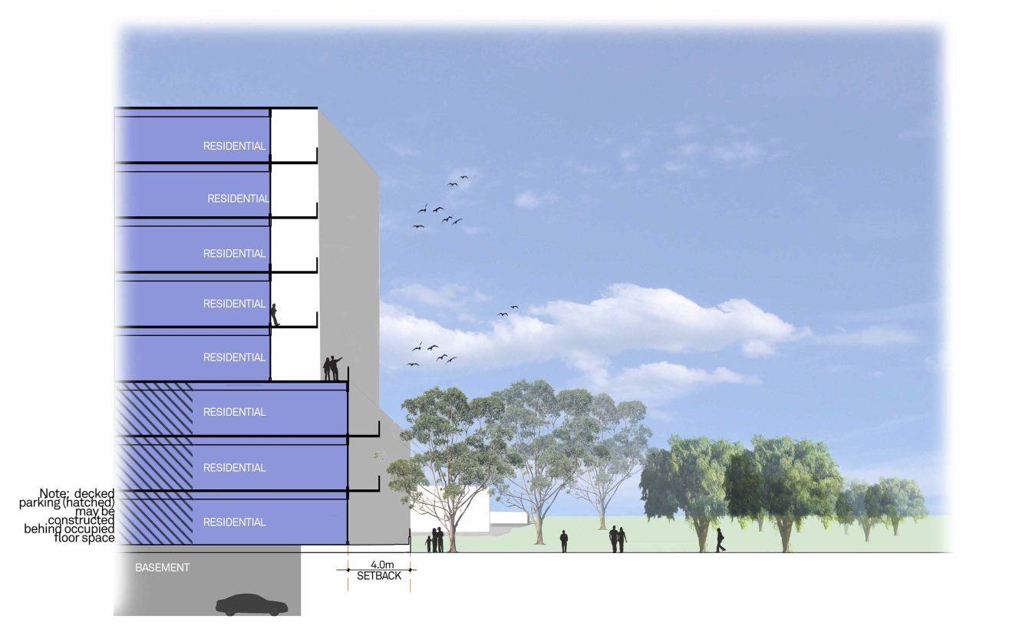

Figure 10_Typical cross section of high density residential directly adjoining public open space
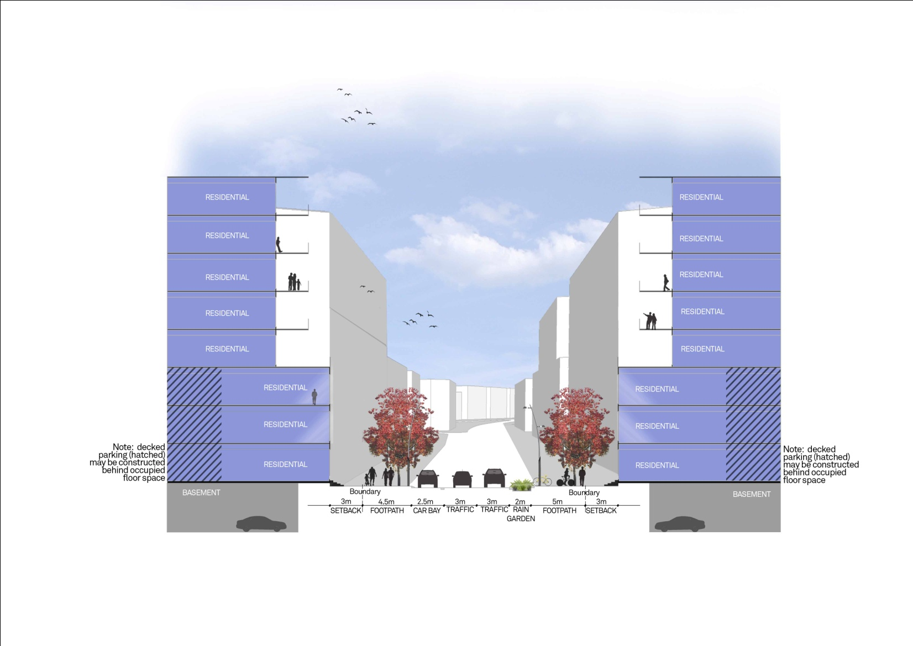

Figure 11_Typical cross section for high density residential development
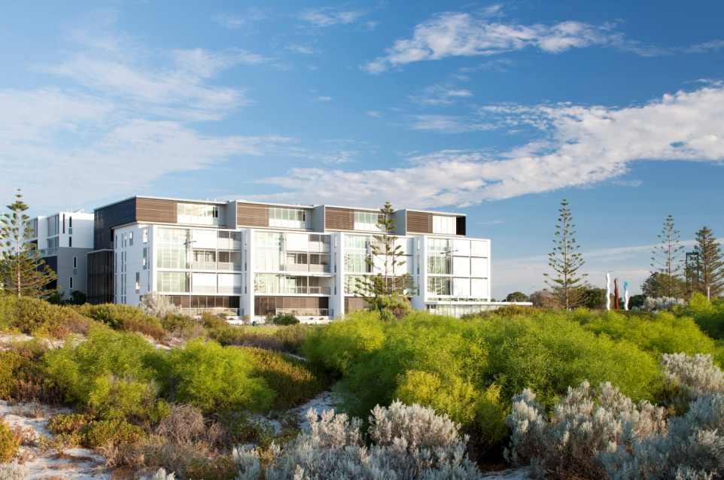
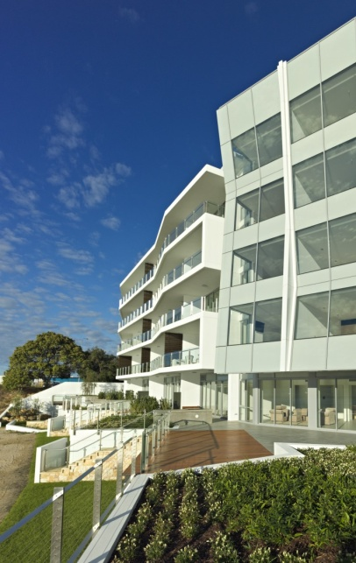

High density Residential Development showing the use of natural materials in the facade and a provision of high quality building articulation in keeping with the objectives of these design guidelines

2.4 Medium Density Residential Typology
The Robb Jetty area provides an important medium density housing area. Leafy streets and small softly landscaped front setbacks will combine to create a comfortable urban setting for contemporary apartment buildings. Future built form will embody a seamless transition from indoor to outdoor, from formal to informal , from exposed to protected. Built form will be respectful of nature and reflect the natural characteristics of the vegetation and landscape within Cockburn Coast.

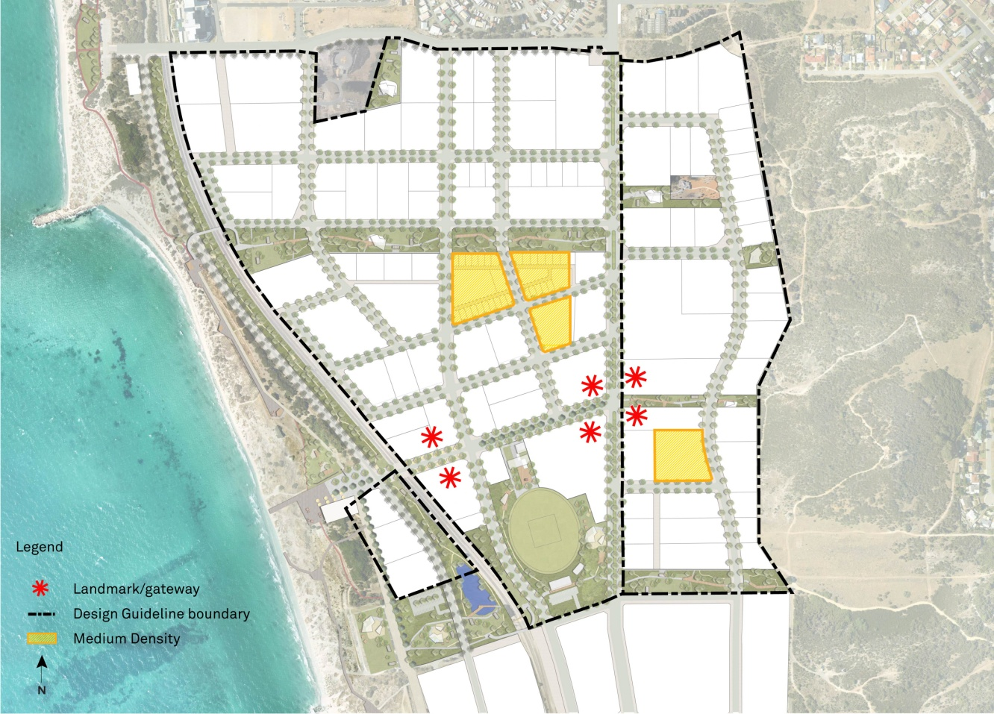
Figure 12_Medium Density built form typology

Building Setbacks

Design Objective
- Building setbacks create intimate streetscapes
- Building setbacks accommodate landscaping which slightly widen and softens the streetscape

Assessment Criteria
- Building setbacks are to be in accordance with the following table

Setback | Street  (minimum) | Side  (minimum) | Laneway  (minimum) | Public Open Space (minimum)
Levels 1-3 | 2m (primary)  1m (secondary) | Nil | Nil | 3m to wall and 2m to balconies (cantilevered/light weight only)
Levels 4+ | 5m to wall and 2m to balconies (cantilevered/light weight only | 3m | 3m | 5m to wall and 2m to balconies (cantilevered/light weight only)
Table 04_ Building Setbacks for medium density residential development

- Buildings shall be setback 3m from any boundary adjoining public parkland. This setback area shall include space for landscaping and if necessary an outdoor living area. Where additional outdoor living area is to be provided, the additional outdoor living area shall be absorbed into the building space (i.e. building shall cantilever over the outdoor living area)
- Projections are permitted within the 3m setback to public parkland to maximum of 2m into the setback area

Building Articulation

Design Objective
- To ensure that building facades add positively to the public realm and its interest. Building articulation will encourage interaction with the street and passive surveillance of adjacent spaces
- To promote a pedestrian scale of buildings at street level
- The building design shall demonstrate an appropriate level of articulation to avoid building bulk appearing excessive
- Building articulation will express a vibrant and modern design aesthetic

Assessment Criteria
- The facade detail may be simplified on loading areas, parapet walls and walls to ‘back of house’ areas
- Built form is to address parks, pedestrian access ways and in particular laneways by providing windows, balconies and suitable facade articulation facing these areas. These elevations are to match the design quality of the dwellings primary street elevation
- Balconies are encouraged but shall not run continuously along the facade. Separate individual balconies are appropriate
- The primary frontage shall provide pedestrian access to the major entry (front door) of the building(s)
- Corner buildings are to address both frontages through the provision of:
  - distinct roof form at corners;
  - variation in materials and colours; and
  - varied balcony treatments.

Roof Form

Design Objective
- The roof form should be designed as a contemporary and integrated architectural structure as befits this unique metropolitan coastal location

Assessment Criteria
- Use of skillion roofs and modern materials is actively promoted
- Use of pitched roofs and dark tiles is discouraged
- Lighting or similar features may be used to accentuate the roofscape and provide a positive architectural feature at night
- Flat roofs are acceptable where concealed behind a building parapet.

Building Levels

Design Objective
- To ensure development maintains a positive relationship with the street such that pedestrian movement, sight lines and streetscape character are maximised
- To allow for the safe use of ceiling fans for cooling

Assessment Criteria
- All development shall maintain a minimum floor to floor height of 3.1m. Apartments shall achieve minimum floor to ceiling levels as outlined in Clause 4.3 of the Residential Design Codes Volume 2 – Apartments.
- All development is to achieve a minimum finished floor level of +3.8AHD to ensure development takes into account coastal erosion and accretion patterns. Non habitable rooms and the provision of basement parking are exempt from the finished floor level stated above
- Where residential dwellings are proposed on the ground floor adjacent to a street or public open space, a grade separation from 0.5m to 1.2m between the finished floor level of the ground floor and the adjacent street or public open space is encouraged in order to create a visual distinction between the public and private space

Building Height

Design Objective
- Building heights will respond to the pedestrian scale, urban character, intended dwelling density, land use mix as well as the natural topography of the area
- The built form of an area shall provide a pedestrian scaled street interface with taller upper floors setback from the street alignment
- The built form shall minimise overshadowing to adjacent streets and public spaces

Assessment Criteria
- Building shall be in accordance with the Building Height Plan (Figure 14)
- Development shall be a minimum of three storeys, with the exception of Lots 235-239 and 247-259 where the minimum height is two storeys as shown in a relevant Local Development Plan. For the purposes of assessing the number of storeys, a loft can be considered as a third storey, provided the building design gives the appearance of three storeys from the primary street frontage
- Single storey development shall not be supported

Building Materials

Design Objective
- To encourage a style of development that is consistent with the coastal location
- To provide for a consistency in the standard of finish and materials throughout Cockburn Coast
- To foster a sense of place through an identifiable character and style of development

Assessment Criteria
- Extensive use of concrete tilt panels is discouraged. Where concrete tilt panels are used, they shall be integrally coloured (colour tinted concrete)
- Moulded textures imprinted in the external surfaces of any concrete panels should also be applied
- Painted finishes and rendered textures over concrete panels are not permitted
- Warm exterior finishes are encouraged through the use of natural materials such as stone, timber, and other such natural products

Open Space

Design Objective
- To ensure that development provides an appropriate interface with the public open space
- To maximise the potential for passive surveillance

Assessment Criteria
- Where an area of public open space is provided the surrounding development must address the open space by maximising passive surveillance from habitable rooms; buildings must front onto the open space through placement of doors, windows and balconies to create a safe and comfortable relationship to the public open space

Fencing

Design Objective
- To ensure that fencing does not detract from the function and appearance of the streetscape

Assessment Criteria
- The interface between private lots and the public open space may be fenced to a maximum height of 1.2m from natural ground level, but must be visually permeable above a height of 1m above natural ground level.

Landscaping

Design Objective
- To ensure an attractive streetscape environment
- To aid the sustainability of a building through the provision of permeable surface

Assessment Criteria
- The front setback area shall include provision for elements of soft landscaping
- In ground landscaping is preferred over shallow landscaping above basements, particularly in front setback areas which provides the opportunity for tree planting

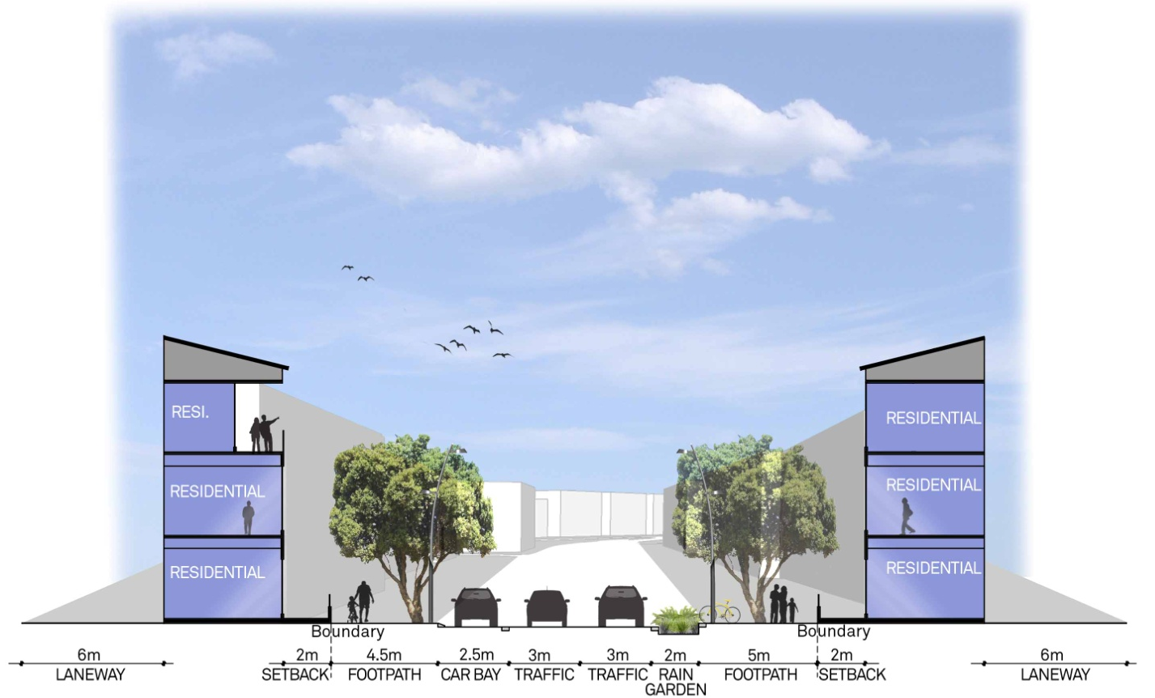
Figure 13_Typical cross section for medium density built form typology

2.5 Mixed Residential Typology
The Robb Jetty Precinct encourages the exploration of innovative approaches to higher density living, emphasising the need to reflect the Cockburn Coast vision of offering choice and variety of living and working opportunities in a form and density that supports the planned Bus Rapid Transit (BRT) system. The Mixed Residential typology area addresses the ‘missing middle’ by offering a range of medium density housing typologies. This Typology area evolved from an intensive, design-led, exploration of ground-breaking urban forms. It is intended that the urban form will be unique in the overall precinct and present a point of difference to development elsewhere in the Cockburn Coast district.

In addition to mid-rise apartment living around the western and southern edges, the area will feature a diverse mix of high quality compact single housing options, around a public realm design that blurs the lines between streets and open space. Streets will be designed with visual amenity, landscape and pedestrian movement assuming equal importance to the private vehicle. As a compact, high-density area the built form will be close, special setbacks will apply, and the relationship between private living space and public open space (POS) will be strong.

As a special precinct, the City is prepared to vary some requirements of the Robb Jetty Local Structure Plan (LSP), to facilitate the exploration of creative ideas, on the basis that planning for the area will undergo a rigorous process of consultative, design-led enquiry, including but not limited to, the following steps:

1. Vision definition, explaining how the precinct will differ from other precincts in the Robb Jetty LSP area;
2. An integrated design process, involving qualified architects, landscape architects, urban designers, and civil engineers;
3. Independent design input or peer review from an independent expert in urban design or architecture, such input to be formally documented;
4. Regular engagement with technical staff from the City of Cockburn and Department of Lands, Planning and Heritage, in the form of workshops and briefings, from the initial formation of a design vision to completion of a masterplan concept;
5. Preparation of a masterplan which illustrates a cohesive design that blends the built form, movement systems, open space and servicing, including, but not limited to, the following key elements:
a) An overall urban form - in terms of dwelling styles, streets and open space – that displays a unique innovation precinct to address the ‘missing middle’ and provide a range of living choices that will present a new living choice to the precinct;
b) Illustration of proposed dwelling forms, building height and massing;
c) Demonstration that the dwelling yield identified in the Robb Jetty LSP is maintained;
d) Demonstration that the plan will offer a community benefit outcome equal to, or better than, the urban pattern envisaged under the Robb Jetty LSP;
e) Demonstration that the plan will not compromise the planned function or amenity of adjoining typology areas; and
f) An implementation strategy that ensures the public realm design will be developed in accordance with the plan and that the built form will be delivered in an orderly and progressive manner.

It is also required that any development application in the Mixed Residential Typology area is to be considered by the Design Review Panel (DRP)
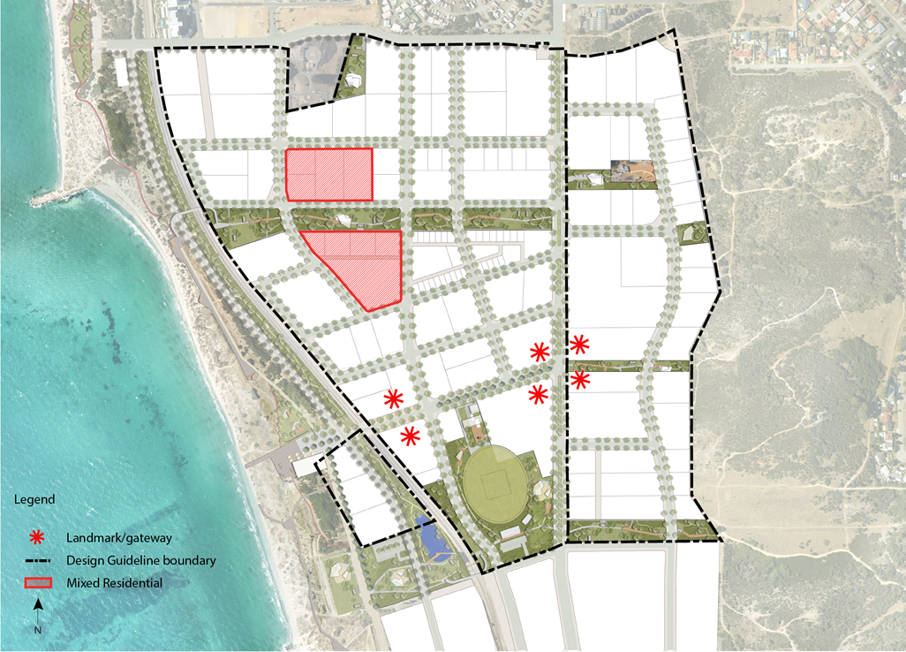
Figure 14 Mixed Residential built form typology

Building Setbacks

Design Objective
- Building setbacks frame streetscapes and public open spaces
- Building setbacks accommodate landscaping which slightly widens and softens the streetscape

Assessment Criteria
- Building setbacks are to be in accordance with the following table

Setback | Primary Street  (minimum) | Secondary  (minimum) | Laneway  (minimum) | Public Open Space – Northern Drainage Swale (minimum) | Public Open Space – Central Spine (minimum)
Levels 1-3 | 3m | Nil | Nil | 3m to wall and 2m to balconies (cantilevered/light weight only) | 2m to wall and nil to balconies (cantilevered/light weight only)
Levels 4+ | 5m to wall and  2m to balconies (cantilevered/ light weight only | 3m to wall and 2m to balconies (cantilevered/ light weight only) | 3m | 5m to wall and 2m to balconies (cantilevered/light weight only) | 4m to wall and 2m to balconies (cantilevered/light weight only)
Table 05_ Building Setbacks for mixed residential development

- Buildings shall be setback from any boundary adjoining public parkland as specified in the above table. This setback area shall include space for landscaping, and if necessary, an outdoor living area. Where an additional outdoor living area is to be provided, the additional outdoor living area shall be absorbed into the building space (i.e. building shall cantilever over the outdoor living area)

Building Articulation

Design Objective
- To ensure that building facades add positively to the public realm and its interest. Building articulation will encourage interaction with the street and passive surveillance of adjacent spaces
- To promote a pedestrian scale of buildings at street level
- The building design shall demonstrate an appropriate level of articulation to avoid building bulk appearing excessive
- Building articulation will express a vibrant and modern design aesthetic

Assessment Criteria
- Permanent blank walls are not permitted to any street frontage. Major openings are required to provide for surveillance and interaction with the public realm
- The facade detail may be simplified on loading areas, parapet walls and walls to ‘back of house’ areas
- Built form is to address parks, pedestrian access ways and in particular laneways by providing windows, balconies or suitable facade articulation facing these areas. These elevations are to match the design quality of the dwellings primary street elevation
- Corner buildings are to address both frontages through the provision of:
- distinct building form at corners;
- variation in materials and colours; and
- varied balcony treatments

Roof Form

Design Objective
- The roof form should be designed as a contemporary and integrated architectural structure as befits this unique metropolitan coastal location

Assessment Criteria
- Use of skillion roofs and modern materials is actively promoted
- Use of dark tiles is discouraged
- Lighting or similar features may be used to accentuate the roofscape and provide a positive architectural feature at night
- Flat roofs are acceptable where concealed behind a building parapet

Building Levels

Design Objective
- To ensure development maintains a positive relationship with the street such that pedestrian movement, sight lines and streetscape character are maximised
- To allow for the safe use of ceiling fans for cooling

Assessment Criteria
- All development shall maintain a minimum floor to floor height of 3.1m. Apartments shall achieve minimum floor to ceiling levels as outlined in Clause 4.3 of the Residential Design Codes Volume 2 – Apartments.
- All development is to achieve a minimum finished floor level of +3.8AHD to ensure development takes into account coastal erosion and accretion patterns. Non habitable rooms and the provision of basement parking are exempt from the finished floor level stated above
- Where residential apartments are proposed on the ground floor adjacent to a street or public open space, a grade separation from 0.5m to 1.2m between the finished floor level of the ground floor and the adjacent street or public open space is encouraged in order to create a visual distinction between the public and private space
- Where single dwellings are proposed on the ground floor adjacent to a street or public open space, a transition between the public and private realm is encouraged to create a visual distinction,

Building Height

Design Objective
- Building heights will respond to the pedestrian scale, urban character, intended dwelling density, land use mix as well as the natural topography of the area
- The built form of an area shall provide a pedestrian scaled street interface with taller upper floors setback from the street alignment
- The built form shall minimise overshadowing to adjacent streets and public spaces

Assessment Criteria
- Development shall be in accordance with the Building Height Plan (Figure 14)
- A Local Development Plan shall be prepared to stipulate more specific height limits for designated sites within the area

Building Materials

Design Objective
- To encourage a style of development that is consistent with the coastal location
- To provide for a consistency in the standard of finish and materials throughout Cockburn Coast
- To foster a sense of place through an identifiable character and style of development

Assessment Criteria
- Extensive use of concrete tilt panels is discouraged. Where concrete tilt panels are used, they shall be integrally coloured (colour tinted concrete)
- Moulded textures imprinted in the external surfaces of any concrete panels are encouraged
- Painted finishes and rendered textures over concrete panels are not permitted
- The use of natural materials such as stone, timber and other such natural products is encouraged in both interior and exterior finishes

Open Space

Design Objective
- To ensure that development provides an appropriate interface with the public open space
- To maximise the potential for passive surveillance

Assessment Criteria
- Where an area of public open space is provided the surrounding development must address the open space by maximising passive surveillance from habitable rooms; buildings must front onto the open space through placement of doors, windows and balconies to create a safe and comfortable pedestrian environment

Fencing

Design Objective
- To ensure that the provision of fencing does not detract from the function and appearance of the public realm

Assessment Criteria
- The interface between private lots and the public open space may be fenced to a maximum height of 1.2m from natural ground level, but must be visually permeable above a height of 1m above natural ground level
- For apartment development, fencing shall generally not be permitted in the primary or secondary street setback areas

Access and Parking

Design Objective
- The design and location of vehicle crossovers should minimise the impact on the pedestrian amenity of the street environment
- Provide sufficient visitor parking for the proposed development precinct
- Promote street design that creates a shared environment for pedestrian, cyclists and vehicle movement

Assessment Criteria
- Open carports are permitted for terrace style or single dwellings where it is considered to improve streetscape character and surveillance, provided that storage and drying areas are suitably screened from public view
- Tandem parking will be permitted where two or more parking bays are provided for the exclusive use of the same dwelling
- Car park entries, driveway crossovers, service areas and bin refuse collection points should be constructed from materials consistent with the road pavement and landscape design treatments of the of the adjacent street
- Where terrace style or single residential lots are proposed the required visitor parking provision shall be located in streets that are immediately adjacent, or in close proximity, to the development

Waste Management

Design Objective
- Services required for the function of all proposed development shall be appropriately considered

Assessment Criteria
- Building design shall demonstrate compliance with an approved integrated Waste Management Strategy or as otherwise approved by the City
- Rubbish bin storage areas shall be integrated into the development and located to minimise the impact on adjoining residences and the public realm

Landscaping

Design Objective
- To ensure an attractive streetscape environment
- To aid the sustainability of a building through the provision of permeable surface

Assessment Criteria
- The front setback area shall include provision for elements of soft landscaping
- In ground landscaping is preferred over shallow landscaping above basements
- Paving that is contiguous with foot paths and other paving in the public realm shall be of the same style and materials, matching exactly wherever possible

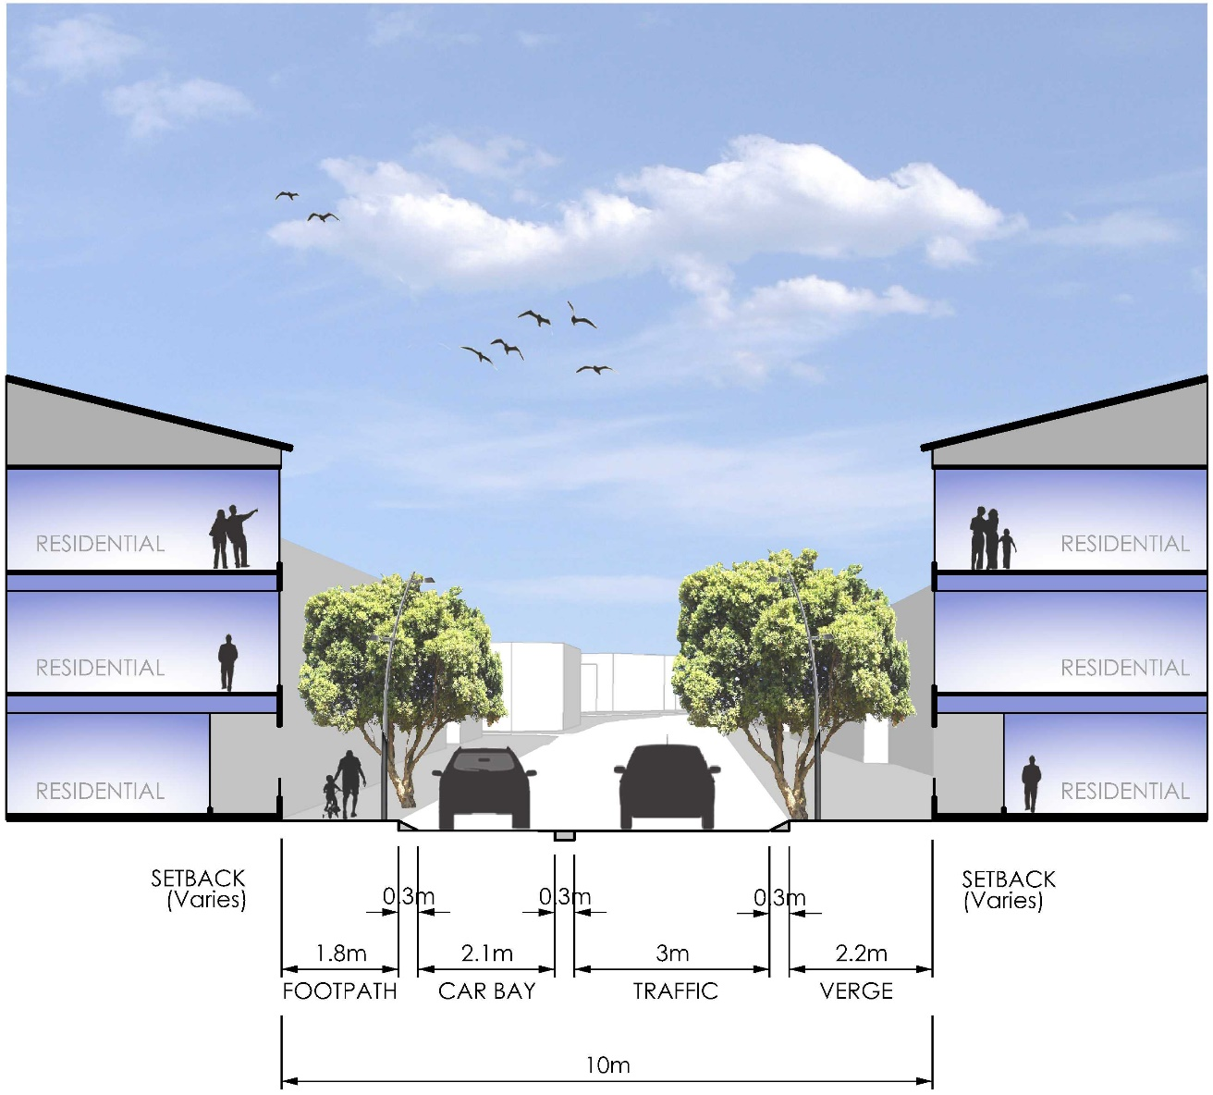
Figure 16_Typical cross section of Mixed Residential adjoining road

Mixed Residential Development showing the use of natural materials in the facade and a provision of high quality building articulation in keeping with the objectives of these design guidelines

3. General Provisions
3.1 Built Form Requirements
Built form should provide a pedestrian scale and define streets and public spaces whilst contributing towards creating an urban presence. The built form will contribute towards the intended streetscape character and typology. Taking cues from the natural assets of the site building height responds to site topography, maximising views to the ocean particularly for residential development.

For private open space, visual privacy, storage for grouped and multiple dwellings requirements refers to the relevant section of the R-Codes. For private open space for single houses refer to the relevant Local Development Plan (LDP) or if not specified in the LDP refer to the City of Cockburn’s Local Planning Policy LPP 1.16 Single House Standards for Medium Density Housing in the Development Zone. Other elements not listed in the relevant LDP or LPP 1.16 shall be assessed as per the Residential Design Codes.

3.1.1 Building Height

Design Objective
- Building heights will respond to the pedestrian scale and urban character of Cockburn Coast, intended dwelling density and land use mix as well as the natural topography
- The built form of an area shall provide a pedestrian scaled street interface with taller upper floors setback from the street alignment
- The built form shall minimise overshadowing to adjacent streets and public spaces

Assessment Criteria
- Heights to be in accordance with the typology specific built form requirements and the Building Height Plan below in Figure 15
- The proposed Primary School may be approved with a minimum of two storeys

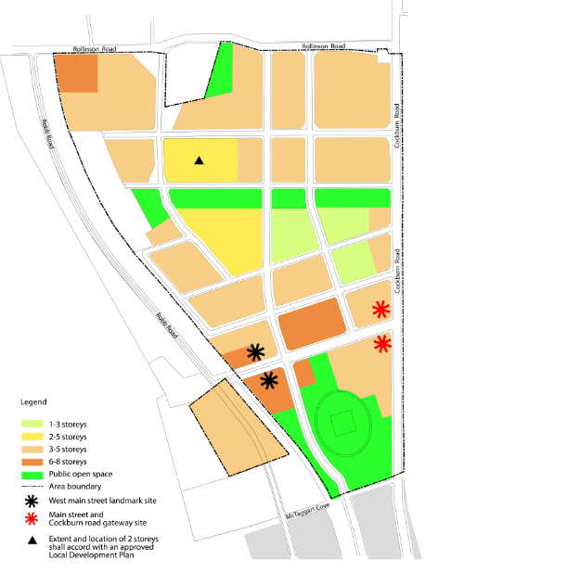
Figure 15 Building Height Plan

3.1.2 Facades

Design Objective
- Building facades add significantly to the public realm and its interest. A vibrant and modern design aesthetic for Cockburn Coast will require the provision of visually engaging building exteriors which encourage interaction with the street and passive surveillance of adjacent spaces

Assessment Criteria
- Fenestration, entrances, balconies and awnings shall be provided in a manner that creates visual cohesiveness, interest and interaction with the public realm
- An exposed parapet or boundary wall must have the same standard of finish as the primary facade. Detailing for permanently exposed blank walls shall include texture, patterns or suitable alternatives to the finish of the wall to address the objective
- External ducting, air conditioners, plants, pipes, lift over-runs, service doors and similar building services must be screened from public view or adjacent property and incorporated into the building at the initial design stage
- Ground floor lobbies shall be clearly delineated, well lit and safe to access
- Facade design shall address crime prevention through environmental design (CPTED) principles

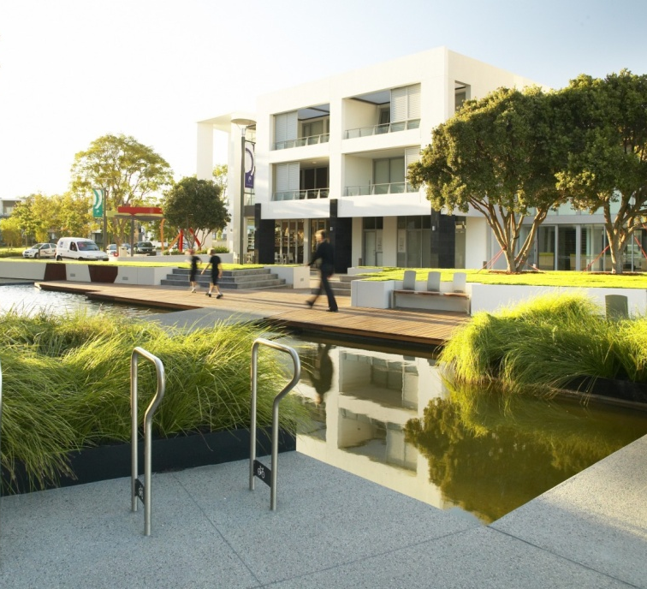
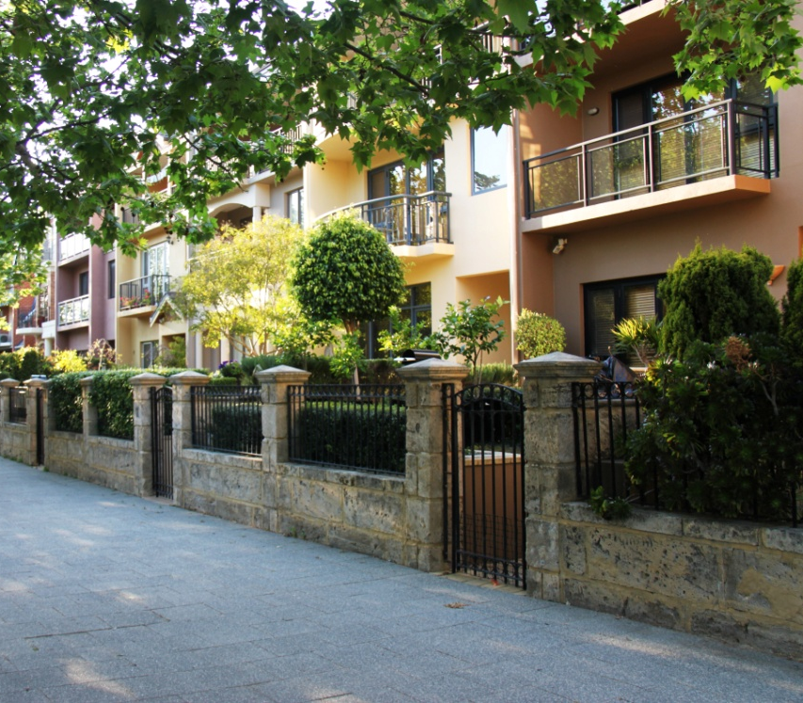

Buildings shall provide a break up of bulk and scale through articulated facades

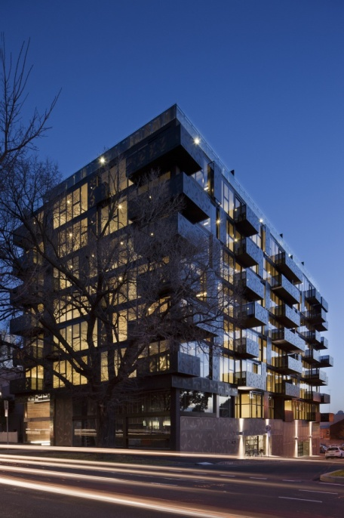
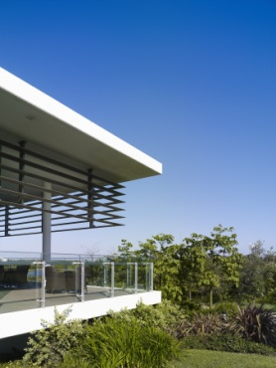

Building facades are to be finished with fine grain architectural elements

3.1.3 Roof Form

Design Objective
- The roof form as seen from the street or adjoining sites should be designed to make a contemporary and positive architectural contribution to the streetscape and skyline. Where appropriate the roof form can be designed to enhance the architecture and contribute to creating local landmarks through the use of integrated architectural form and detailing

Assessment Criteria
- Roof designs must conceal roof plant and equipment including lift over run structures from view from the public realm and street level
- Lighting or similar features may be used to accentuate the roofscape to provide a feature at night
- Flat roofs are acceptable where concealed behind a building parapet
- Flat roof areas that are accessible concealed behind a building parapet and provide a minimum dimension of 2.4m may be used as an outdoor living area or communal open space, however shall not count towards the private open space area requirement.

3.1.4 Lighting

Design Objective
- To ensure perceived and actual safety for all users of the area is achieved by providing lighting around public spaces that allows for a high degree of visibility of pedestrians at all times

Assessment Criteria
- Lighting to be integrated into built form to highlight architectural features
- Ensure inset spaces, access, egress and signage is well lit
- Lighting is to be incorporated into building awnings over the footpath and building entrances

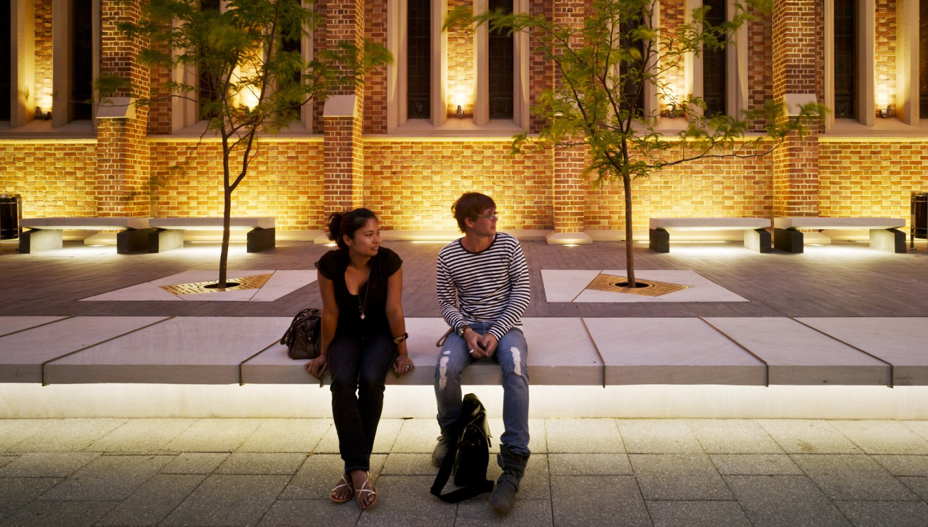
Innovative lighting built into the facade of a building can contribute to an activated and interesting façade

3.1.5 Acoustics and Vibration

Design Objective
- To facilitate a sustainable mixed use environment where a variety of land uses can co-exist
- To ensure appropriate noise intrusion and noise emission mitigation measures are incorporated into building design and construction and where necessary, building refurbishment

Assessment Criteria
- Design of Noise sensitive premises must be give consideration to the following:
  - the identification of existing/potential environmental noise sources;
  - development orientation and layout taking into account the location of existing/potential environmental noise sources;
  - the location of bedrooms away from noise sources;
  - the location of balconies and windows away from noise sources;
  - the use of built form (blade walls, etc) to screen noise sources; and
  - the use of building design elements (balcony balustrades, decorative screens, etc) to provide some reduction in noise impact on windows.
- Notifications are required to be applied to the created land title and any subsequent strata titles of any noise sensitive premises pursuant to section 70A of the Transfer of Land Act 1893, together with section 165 of the Planning and Development Act 2005 to inform prospective land owners and residents of the likelihood of higher noise levels associated within the inner city environment
- An acoustic and vibration (as deemed required in the local structure plan) report and associated plans are required detailing compliance with the above design objectives and assessment criteria for noise sensitive and commercial developments. The report is to be prepared by a qualified and experienced acoustic consultant and submitted as part of a DA and should address the requirements of State Planning Policy 5.4 Road and Rail Transport Noise and Freight Considerations in Land Use Planning (and associated guidelines), the City of Cockburn’s Local Planning Policy LPP 1.12 Noise Attenuation.

3.1.6 Active Edges and Street Relationship

Design Objective
- The activation of streets and other publicly accessible spaces are fundamental to providing an attractive and safe pedestrian environment throughout Cockburn Coast
- All development must be designed to activate streets and laneways. This can be achieved by utilising major openings to residential and commercial land uses, alfresco dining areas, pedestrian shelters and legible building entries to create a vibrant, diverse and safe environment

Assessment Criteria
- Passive surveillance of communal areas and public spaces shall be integrated into building design, providing for overlooking of the street, public space and communal open space
- Pedestrian entrances are to be highly visible
- Ground floor non-residential frontages should be designed as shop fronts with no less than 80% of the shop front glazed with clear glass
- Car park entries are to be located appropriately to avoid disruption of the pedestrian experience
- Inactive ground floor uses are to be avoided within the Activity Centre and Mixed Use areas particularly on the Robb Jetty Main Street and surrounding the identified landmark development sites

3.1.7 Heritage Considerations

Design Objective
- Development of site adjacent to a heritage place shall be respectful of the recognised cultural heritage significance; and should not adversely affect the heritage significance

Assessment Criteria
- New buildings adjacent to a Heritage Place should conform with the provisions of the City’s Heritage Conservation Guidelines policy to ensure that they respect the heritage significance of the place
- Any new work adjacent to a significant tree should not affect the appearance or health of the tree

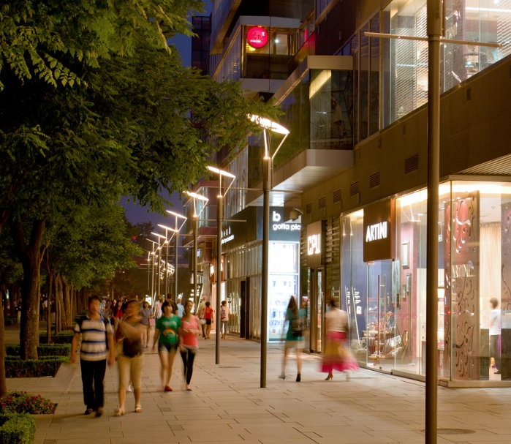

Ground floor commercial land uses will provide active street edges

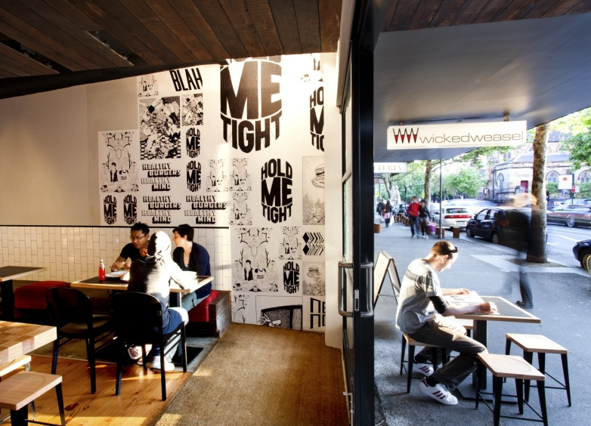

3.2 Service Infrastructure and Access
Service infrastructure and access arrangements are an important part of allowing development to function effectively. However, these elements can often create unsightly urban environments and therefore appropriate treatment and coordination of these elements is required to make them an integral part of new development

3.2.1 Internal Access

Design Objective
- Internal access within street blocks to perform as one coordinated and efficient movement network

Assessment Criteria
- Internal access ways servicing development to be designed to facilitate adjoining development and where logical allow for reciprocal access arrangements

3.2.2 Parking

Design Objective
I. Development will encourage and support alternative modes of transport to the car by limiting and screening the provision of car parking on site

Assessment Criteria
- Vehicle crossovers for non-residential development are required to be built underneath the building or provide design elements above the crossover to reduce the street impact and pedestrian environment
- Reciprocal use of commercial car parking bays for uses within a comprehensive development with different peak usage requirements (such as restaurants and offices) may be considered
- Residential parking is to be provided in accordance with the City of Cockburn Town Planning Scheme No.3 and the Residential Design Codes of Western Australia.

3.2.3 Parking Location and Access

Design Objective
- The number of vehicle crossovers into a development is to be minimised to create a pedestrian friendly environment
- Parking is to be located so as minimise the visual impact on the public realm

Assessment Criteria
- All on site car parking facilities are to be concealed from public view to ensure car parking does not dominate streetscapes or create conflict with pedestrian and vehicle movement
- Car parking entry is to be subservient to pedestrian entries and shall address street spaces, building returns and recesses
- Where terrace style or single residential lots are proposed vehicle access must be provided at the rear of the dwellings
- Car parking is to be concealed from public view by habitable frontages, or high quality landscaping along minor/secondary streets
- Parking facilities should not be visible from public open space
- Where garage doors service only one dwelling they should be no wider than 6m

3.2.4 Sleeved Parking

Design Objective
- To screen multi storey car parks from the public realm and to provide active frontages to the street

Assessment Criteria
- All multi storey car parking structures should be sleeved by development to ensure car parking is screened from view of the public realm
- Sleeve above ground car parking structures with other uses, such as offices, residential and retail
- Where it is not possible for car parking structure to be screened any car parking structures that contain three or more levels must be appropriately designed and screened from adjacent or nearby buildings and the street through the use of innovative wall detailing, decorative screening, patterning and vegetation

3.2.5 End of Trip Facilities

Design Objective
- To encourage the use of bicycles, walking and other alternative means of transport to reduce the use of private motor vehicles and contribute to public health

Assessment Criteria
- Provision of adequate bicycle and change room facilities. Secure lockers, bicycle storage and showers shall be provided within buildings
- Developments are to be provided with end of trip facilities in accordance with the following table

Commercial | 1 Secure bicycle storage per 150m² of Net Lettable Area (NLA); and
Accessible showers | There must be a minimum of two female and two male showers, located in separate changing rooms, for the first 10 bicycle parking bays. Additional shower facilities to be provided at a rate of one male and one female shower for every 10 bicycle parking bays or part thereof.
Changing facilities | Including secure lockers at 1.5 for each bicycle parking bay.
Visitor Bicycle Storage | A minimum of 1 space per 750m² of NLA. Located and signed near the main public entrance to the building.
Residential | Bicycle parking facilities for multiple dwellings, short stay accommodation and serviced apartments shall be provided at a minimum of 1 bay per unit.
Table 05_ End of trip facility provision rates

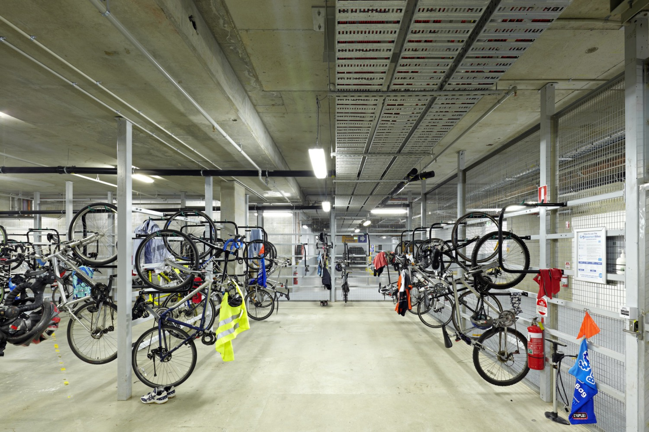
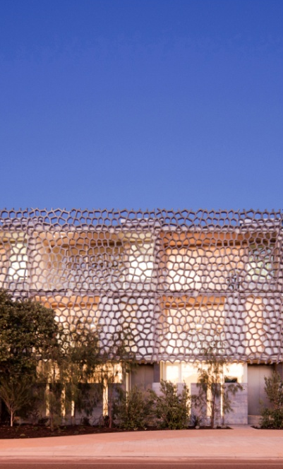
Use of screening can minimise the impact of parking structures
End of trip facilities

3.2.6 Site Services

Design Objective
- Services and related elements required for the function of the building shall be appropriately screened or integrated into the building design

Assessment Criteria
- Air-conditioning units must not be visible from the streets and laneways
- Service pipes and wired services are to be concealed from public view
- All meters to be contained within development lots to the requirements of the appropriate authorities
- Provide secure and accessible facilities for mail delivery
- Commercial utility and waste storage areas are to be screened or located behind buildings and not visible from public view and residential apartments
- Fire booster cabinets and associated infrastructure are to be discretely designed into development and must not dominate any frontage

3.3 Sustainability Requirements
Integral to the sustainability of the development will be the provision of affordable housing and facilities to encourage alternative modes of transport to the private car. This will promote a healthy lifestyle that encourages people to actively engage with the urban environment and create a robust and diverse community

3.3.1 Sustainable Travel

Design Objective
- To reduce greenhouse gases through the reduction of motorised transport to and from Cockburn Coast and encourage residents and site visitors to improve their physical health through walking, cycling or other physically active forms of transport either solely or in combination with public transport

Assessment Criteria
- Demonstrate that pedestrians and cyclists have been prioritised within the development
- Surface finishes of all driveways and pathways to be safe and comfortable for pedestrians and cyclists
- Grade changes between private and public spaces to be complementary and accessible

3.4 Laneways
3.4.1 Residential and Commercial Laneways

Design Objective
- To create unique and attractive built form and character along laneways through sensitive and innovative design
- To encourage activity and interaction between public laneways and adjacent private uses at the ground level
- To reinforce the primary function of laneways as key service and vehicle access spaces within the development
- Encourage development to provide highly articulated and well detailed facades that create visual interest, particularly at the lowers levels
- Encourage development to orientate windows and balconies to overlook lane ways

Assessment Criteria
- Residential Laneways
- For lots with a laneway frontage of 8m or greater, pedestrian access to the laneway from the lot should be provided
- Buildings are to provide an elevation to the laneway that is articulated and similarly detailed to the front façade

- Commercial Laneways
- Laneways within the activity centre and mixed used zones are encouraged to be activated at ground floor level, but shall not be done so to the detriment to the activation of the primary or streetscape facade of the building
- Buildings shall maintain a nil setback to the laneway for the first three storeys
- The minimum setback above 3 storeys should be a distance equivalent to the width of the lane, unless it can be demonstrated that a lesser setback protects the quality of the pedestrian space at ground level including:
  - by maintaining or providing greater access to sunlight;
  - by maintaining or providing greater wind protection; and
  - by avoiding a sense of enclosed space.
- Buildings are to provide an elevation to the laneway that is articulated and similarly detailed to the front facade
- Development should contain a door which addresses the laneway or is accessed via its own pedestrian access gate

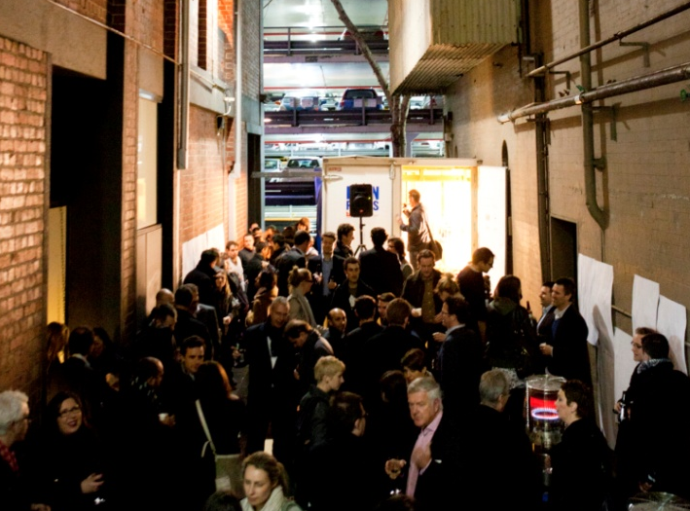
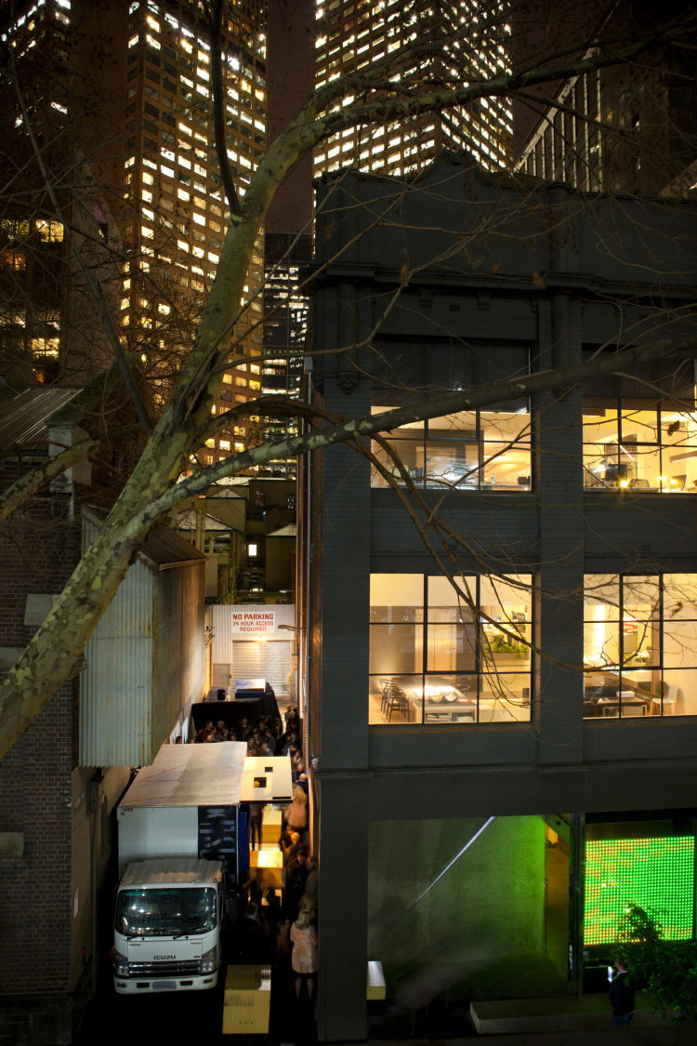

Activated laneways encourage vitality and interaction between public laneways and adjacent private uses

3.5 Communal Open Space
Design Objective
- To provide an adequate area of quality communal open space for multiple dwelling developments which will enhance residential amenity and provide opportunities for soft landscape areas.

Assessment Criteria
- Communal open space is provided for multiple dwellings in accordance with Clause 3.4 of the Residential Design Codes Volume 2 – Apartments.

Strategic Link: | Town Planning Scheme No. 3
Category | Planning - Town Planning & Development
Lead Business Unit: | Development Assessment and Compliance
Public Consultation:  (Yes or No) | Yes
Adoption Date:  (Governance Purpose Only) | 12 November 2024
Next Review Due:  (Governance Purpose Only) | November 2026
ECM Doc Set ID:  (Governance Purpose Only) | 4518689

