Tender Title: |  | RFT 10/2025 – Cockburn Road Footpath Construction – Ocean Road to Beach Road
Request ID: |  | 55496
Tender Description: |  | The Cockburn Road from Rockingham Road to Russell Road is a State Road controlled and managed by Main Roads Western Australia (MRWA) and therefore the works shall be carried out in accordance with the MRWA’s quality management and specifications.  Cockburn Road is a Primary Distributor Road. As listed in MRWA traffic data, in 2019/20, the average daily traffic volume of the Cockburn Road is 15,279 vehicles. The Contractor shall develop their work program demonstrating construction activities for Cockburn Road, which will be undertaken during the periods specified in the roadworks traffic management report.  All the construction works related to the MRWA assets are to be carried out in accordance with the MRWA’s specifications and Standard Drawings. Tenderers should also be aware that the MRWA quality assurance requirements are applicable to this project, and accordingly, submissions will only be accepted from companies that are able to meet those requirements.
Advert Approval: |  | Decision to Advertise: Director Infrastructure Services  Decision Date: Monday, 17 March 2025
Closing Date and Time: |  | 2:00PM (AWST) Tuesday, 15 April 2025
Opening Date and Time: |  | 2:05PM (AWST) Tuesday, 15 April 2025
 | Tenderer’s Name:
1 | Bos civil Pty Ltd
2 | Civcon Civil and Project Management t/a Civcon Civil and Project Management
3 | Concity
4 | Dowsing Group
5 | PCH Civil Pty Ltd t/a PCH Civil

Advertisement
Method 1: City of Cockburn | Method 2: Yammer
Method 3:  The Western Australian,  Wednesday, 19 March 2025 | Tender Awarded by:
Copy of Statewide Notice:  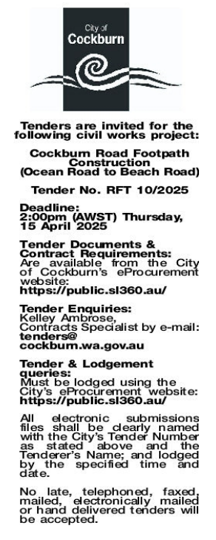 | Non-Award
 | Date of Council Meeting:
 | Not applicable
Name of Successful Tenderer(s): | Not Applicable
Amount of Successful Tender(s): (ex GST) | Not Applicable

