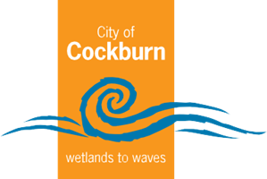
City of Cockburn Whadjuk Boodja

Annual Report 2022-2023
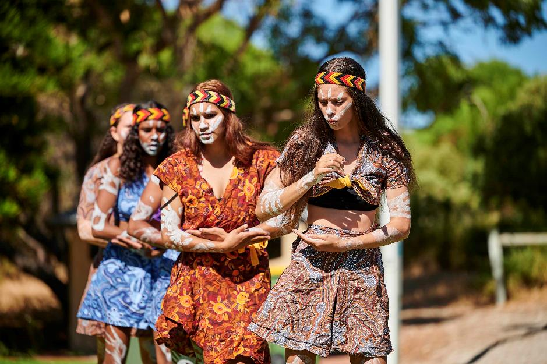
Cockburn, the best place to be
City of Cockburn website: www.cockburn.wa.gov.au

Acknowledgement of Country
The Mayor, Councillors and staff of the City of Cockburn acknowledge the Whadjuk Nyungar people of Beeliar boodja as the traditional custodians of this land. We pay our respect to the Elders, past and present.

Above: Cockburn NAIDOC Community Event - July 2022.
Front Cover: Australia Day Coogee Beach Festival 2023. Binjareb Middars Aboriginal dancers - January 2023.

Contents
Annual Report 2022-2023 1
Acknowledgement of Country 2
Contents 3
About the Annual Report 4
Key Community Outcomes 5
Mayor’s Report 7
Chief Executive Officer’s Report 9
A Snapshot of our City 11
Cultural Diversity in Cockburn 12
Elected Members 14
Elected Members Fees, Expenses and Allowances 18
Elected Members Meeting Attendance 21
Our Administration 24
Remuneration of Employees 25
Organisational Structure 27
Awards and Achievements 32
City Performance for the 2022-23 Financial Year 35
Governance Report 50
Recordkeeping Compliance Report 53
Breaches by Elected Members 55
Building and Development Applications Report 56
Community Engagement and Customer Satisfaction 59
Climate Change and Sustainability Snapshot 63
Disability Access and Inclusion Report 69
The Plan for the Future 72
Integrated Planning and Reporting Framework 75
The Year Ahead 79
Financial Report 83
Contact Us 85

About the Annual Report
The Local Government Act 1995 requires local governments to adopt an annual report by 31 December each year or within two months of the Auditor General’s report on the City’s financial statement being available. The City of Cockburn meets this requirement by producing a detailed report annually.
The City’s Annual Report is an important part of the Integrated Planning and Reporting Framework. It details the City’s financial and operational performance in the 2022-23 financial year and documents the City’s progress towards the Corporate Business Plan 2020-21 to 2023-24 and the Strategic Community Plan 2020-2030.
The Corporate Business Plan outlines the City’s activities each financial year that deliver against the Strategic Community Plan 2020-2030. The Strategic Community Plan provides the City’s long-term strategic direction and guides the organisation’s decision-making, services and financial commitments. The Strategic Community Plan outlines the City’s promise to its community via its Vision, Purpose and Key Community Outcomes.

Vision:
Cockburn, the best place to be

Purpose:
Support our communities to thrive by providing inclusive and sustainable services which reflect their aspirations.
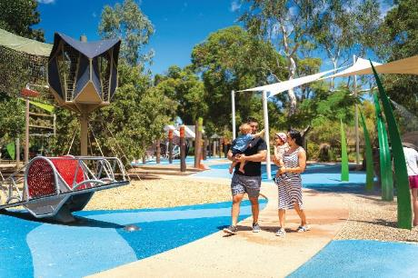 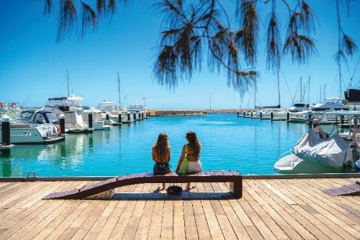
Left: Bibra Lake Regional Playground. Right: Port Coogee Marina, North Coogee.

Key Community Outcomes
These are the five key community outcomes which the City seeks to deliver through the Strategic Community Plan.

Local Economy
A sustainable and diverse local economy that attracts increased investment and provides local employment.

Community, Lifestyle and Security
A vibrant, healthy, safe, inclusive and connected community.

Environmental Responsibility
A leader in environmental management that enhances and sustainably manages our local natural areas and resources.

City Growth and Moving Around
A growing City that is easy to move around and provides great places to live.

Listening and Leading
A community focused, sustainable, accountable and progressive organisation.

The City of Cockburn Annual Report includes a snapshot of performance against the Key Community Outcomes and an overview of the City’s outlook for the future.
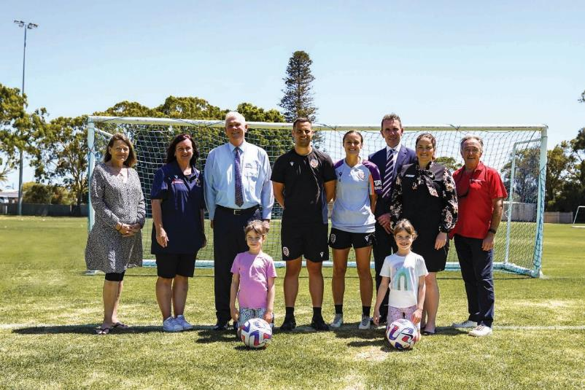
Perth Glory Sponsorship, Beale Park - December 2022: (Left to Right) Cr Phoebe Corke, Heidi Lazzaro - Cockburn City Soccer Club President, Mayor Logan Howlett, Alex Epakis - Head Coach of the Perth Glory A-League Women's team, Natasha Rigby - Perth Glory Captain, Anthony Radich - Perth Glory CEO, Cr Chontelle Stone and Cr Kevin Allen with two juniors (Grace and Ava).
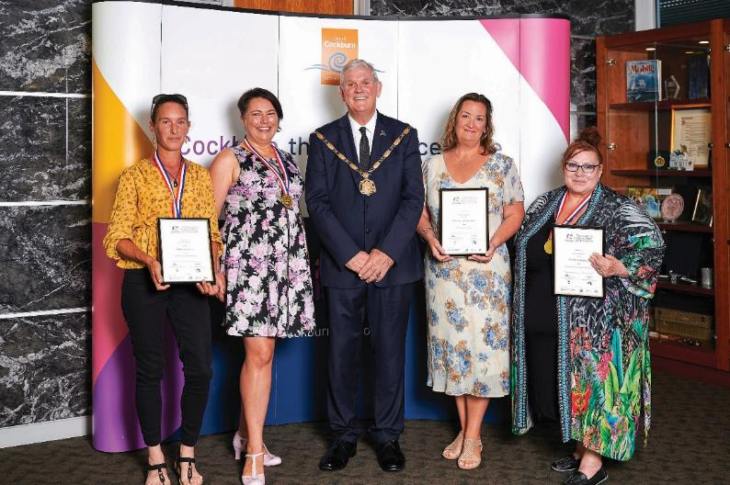
2023 Australia Day Community Citizen of the Year Awards - January 2023: (Left to Right) Serena Gamble, Tracy Pearson, Mayor Logan Howlett, Samantha Williams and Serene Anderson.

Mayor’s Report
I am delighted to present my 15th annual report after another year of great achievements for the City, despite us once again operating in a challenging environment.
I acknowledge that the current climate has been difficult for our residents but as usual our community has responded admirably, with individuals and community groups helping each other through providing meals, organising clothes swaps, community events and running Facebook pages where you can give back to the community.
With the current climate in mind, Council worked hard to ensure a balanced budget that was fiscally responsible, but which also continued to deliver high-quality services. I am happy to say that Cockburn households continue to pay some of the lowest rates in Perth. To make this possible Council once again prioritised the maintenance of existing assets and infrastructure over new projects.
Projects that we were able to progress planning for included Malabar BMX Park, Beale Park redevelopment and Cockburn ARC health and fitness expansion. The Hammond Road duplication was almost completed too.
I am proud to say that the City also gave $1.2 million back to the community last year through its comprehensive grants and donations program. The program ranges from grants to enable our young sportspeople to travel interstate to sporting events, grants for residents to enhance their verges and donations to support not-for-profit organisations across the City.
It was a big year for the City in the area of economic development. We acknowledged Prime Minister Anthony Albanese’s AUKUS announcement and a $6 billion investment in the nation’s defence capability and workforce over the next four years.
The City’s international relationships went from strength to strength with our collaboration with Indonesia winning a National Growth Areas Alliance award commendation. Our partnership has a strategic focus to foster trade connections between blue economy, shipbuilding, maritime, education, training, health and medical sectors in Cockburn and Indonesia.
Cockburn ARC, which remains one of the best recreation and aquatic centres in Australia, continued to reap awards including being named a winner at the Australian Swim Schools Association’s 2023 National Excellence Awards, taking home the Swim School category for its Swim ARCademy program.
Each year the City’s comprehensive events season just gets better and better – we saw record attendances at Coogee Live, Sidesplitter Comedy Festival and the Teddy Bear’s Picnic, and the ever-popular Kasey Chambers headlined our Community Concert. Council has committed to more exciting additions to this program next year.
As ever, volunteers have been the backbone of our community. I was delighted to present Serena Gamble with the overall title of Community Citizen of the Year for 2023, as well as James Wild in the youth category and Serene Anderson in the senior category. Yangebup Family Centre received the Active Citizenship – Group or Event award.
With that in mind, I would like to thank the hundreds of dedicated volunteers in the City who gave up thousands of hours to help make Cockburn the best place to be.
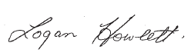
His Worship the Mayor
Logan K. Howlett, JP

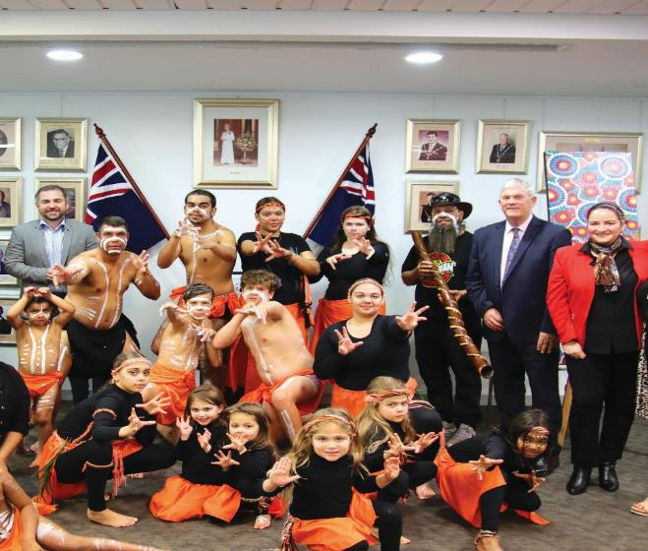
NAIDOC - Flag Raising and Breakfast - July 2022: (Left to Right) David Scaife MLA, Little Doorum Dancers, Ryan Humphries, Mayor Logan Howlett and Cr Chontelle Stone.

Chief Executive Officer’s Report
Service delivery and strategic planning were the focus for Cockburn this year.
Council and the Administration prioritised a number of strategic projects including a review of the new Local Planning Strategy, simplifying approvals processes for small business and the development of a new Disability Access and Inclusion Plan.
Our staff are our most valuable assets, and we continue to implement strategies to attract, retain and upskill our workforce to fulfil our vision of being an employer of choice. With a culture of workplace safety being a priority for our organisation, we undertook a review of our work, health and safety initiatives and continue to implement changes.
We have continued to experience high inflation and construction costs, rising interest rates and a tight labour market. These prevailing conditions have led Council to further delay or defer some capital works projects and the administration will continue to work with Elected Members to prioritise capital works projects.
Results from our annual community perception survey rated us with a performance index score of 71, making Cockburn a leader among similar Councils.
This research highlights what our community is happy with and what they want the City to focus on. Safety and security continue to be priority areas for residents and businesses, as well as streetscapes. We will continue to work with State and Federal governments, stakeholders, industry and the community to address these areas.
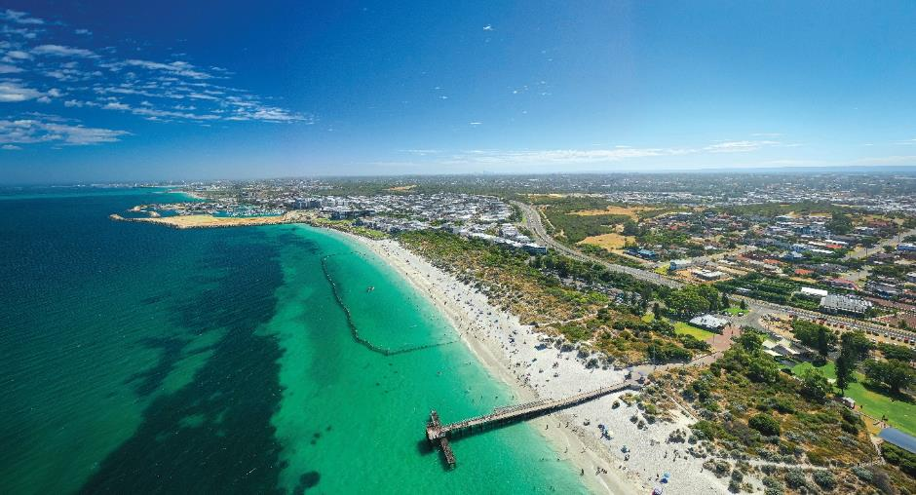
Coogee Beach.
The community rated the following services particularly well – Cockburn ARC, Library Services and our bin collections. Management of local roads, our youth services, marine facilities and work in the economic development and job creation fields were high performers when benchmarked against other local governments.
The City further strengthened its strategic partnerships, including with the Shire
of Carnarvon, Curtin University and the Fremantle Football Club. We ran a number of successful events with Fremantle Football Club, including a joint International Women’s Day event for young women.
In closing I would like to thank Council and staff for their support this year.
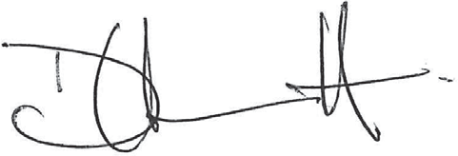
Daniel Arndt
Acting Chief Executive Officer

A Snapshot of our City
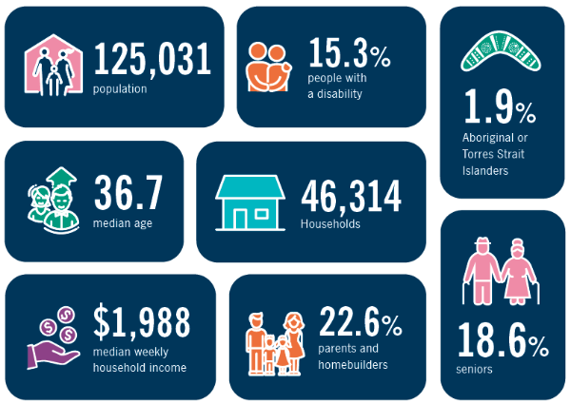
- Population: 125,031
- 15.3% people with a disability
- 1.9% Aboriginal or Torres Strait Islanders
- Median age: 36.7
- 46,314 households
- Median weekly household income: $1988
- 22.6% parents and homebuilders
- 18.6% seniors
Source: Australian Bureau of Statistics 2021 Census data.
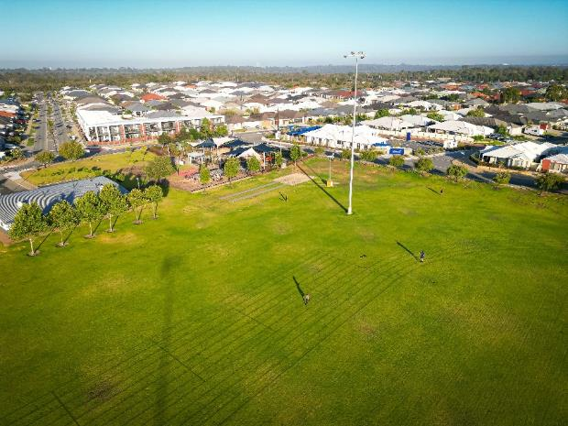 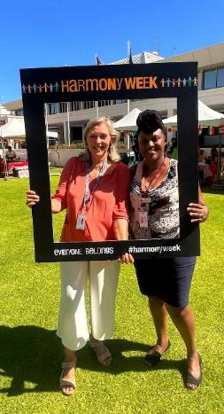
Left: Botany Park, Hammond Park. Right: Harmony Week - March 2023 City of Cockburn's staff: Deborah and Liz.

Cultural Diversity in Cockburn

Diversity statistics in Cockburn from the 2021 Census
Australian Census 2021 results show that the City of Cockburn is becoming more culturally diverse. Overall, 34.2 per cent of the population was born overseas.

The most common ancestries

- 35% English
- 29% Australian
- 9% Italian
- 9% Scottish
- 8% Irish

The most common countries of birth

- 62% Australia
- 7% England
- 3% New Zealand
- 2% Philippines
- 2% South Africa
- 2% India

The common languages, other than English, spoken at home
In 2021, 26.1 per cent of residents spoke a language other than English at home, above the average for WA (21.2 per cent).
- 2.6% Mandarin
- 2% Italian
- 1.2% Croatian
- 1.2% Portuguese
- 1.2% Tagalog

Source: Australian Bureau of Statistics 2021.

Elected Members
Logan K. Howlett, JP, His Worship the Mayor
- Gender: Male
- Linguistic Background: English
- Country of Birth: Australia
- Identifies as Aboriginal or Torres Strait Islander? (Yes or No): No
Tom Widenbar, Deputy Mayor and Councillor, Central Ward
- Gender: Male
- Linguistic Background: English
- Country of Birth: Australia
- Identifies as Aboriginal or Torres Strait Islander? (Yes or No): No
Philip Eva JP, Councillor, Central Ward
- Gender: Male
- Linguistic Background: English
- Country of Birth: England
- Identifies as Aboriginal or Torres Strait Islander? (Yes or No): No
Chontelle Stone, Councillor, Central Ward
- Gender: Female
- Linguistic Background: English
- Country of Birth: Australia
- Identifies as Aboriginal or Torres Strait Islander? (Yes or No): Yes
Carol Reeve-Fowkes, Councillor, East Ward (from July 2022)
- Gender: Female
- Linguistic Background: English
- Country of Birth: England
- Identifies as Aboriginal or Torres Strait Islander? (Yes or No): No
Tarun Dewan, Councillor, East Ward
- Gender: Male
- Linguistic Background: Hindi/English
- Country of Birth: India
- Identifies as Aboriginal or Torres Strait Islander? (Yes or No): No

Lara Kirkwood, Councillor, East Ward (resigned February 2023)
- Gender: Female
- Linguistic Background: English
- Country of Birth: South Africa
- Identifies as Aboriginal or Torres Strait Islander? (Yes or No): No
Kevin Allen, Councillor, West Ward
- Gender: Male
- Linguistic Background: English
- Country of Birth: Australia
- Identifies as Aboriginal or Torres Strait Islander? (Yes or No): No
Michael Separovich, Councillor, West Ward
- Gender: Male
- Linguistic Background: English
- Country of Birth: Australia
- Identifies as Aboriginal or Torres Strait Islander? (Yes or No): No

Phoebe Corke, Councillor, West Ward
- Gender: Female
- Linguistic Background: English
- Country of Birth: England
- Identifies as Aboriginal or Torres Strait Islander? (Yes or No): No

Age Range | Number of Elected Members
18-24 | 0
25-34 | 2
35-44 | 2
45-54 | 4
64+ | 2

Elected Members Fees, Expenses and Allowances
In accordance with r29C(2)(f) of the Local Government (Administration) Regulations 1996, the City is required to publish the fees, expenses and allowances paid to Elected Members during the financial year. Below is a list of fees, expenses and allowances that have been paid to the Mayor and Councillors for the 2022-23 financial year.
Elected Members | Mayoral Allowance or Deputy Mayoral Allowance | Annual Meeting Attendance Allowance | Mileage Expenses | Childcare Costs | Information and Communication Technology Allowance | Other Approved Expenses | Amount
Mayor Logan Howlett | $91,997.04 Mayoral Allowance | $48,704.03 | Nil | Nil | $2,783.00 | $598.90 | $144,082.97
Deputy Mayor Cr Tom Widenbar | $22,999.20 Deputy Mayoral Allowance | $32,469.97 | $683.40 | $6,010.10 | $3,500.00 | $1,020.92 | $66,683.59
Cr Philip Eva | Nil | $32,469.96 | $187.94 | Nil | $3,100.00 | $411.81 | $36,169.71
Cr Chontelle Stone | Nil | $32,469.96 | $107.41 | Nil | $2,750.00 | Nil | $35,327.37
Cr Lara Kirkwood  Resigned February 2023 | Nil | $21,646.64 | $357.56 | $4,109.00 | $3,059.50 | $74.74 | $29,247.44
Cr Carol Reeve- Fowkes | Nil | $31,766.44 | $651.85 | Nil | $4,375.00  Pro-rata payment of $875 for 8 July 2022 to 31 October 2022, plus $3500 for 2022-23 election. | $120.98 | $36,914.27
Cr Tarun Dewan | Nil | $32,469.96 | $2,227.99 | Nil | $2,801.50 | $1,898.30 | $39,397.75
Cr Kevin Allen | Nil | $32,469.96 | $198.46 | Nil | $2,745.00 | Nil | $35,413.42
Cr Michael Separovich | Nil | $32,469.96 | $144.77 | Nil | $3,500.00 | Nil | $36,114.73
Cr Phoebe Corke | Nil | $32,469.96 | $1,412.18 | Nil | $3,500.00 | $747.93 | $38,130.07

Elected Members Meeting Attendance

Council Meetings
1 July 2022 – 30 June 2023
Elected Members | Ordinary Council Meeting (11) | Special Council Meeting (11)
Mayor Logan Howlett | 11 | 11
Deputy Mayor Cr Tom Widenbar | 11 | 11
Cr Philip Eva | 10 | 9
Cr Chontelle Stone | 11 | 9
Cr Lara Kirkwood (Resigned February 2023) | 7 | 4
Cr Carol Reeve-Fowkes | 11 | 11
Cr Tarun Dewan | 11 | 9
Cr Kevin Allen | 10 | 7
Cr Michael Separovich | 11 | 11
Cr Phoebe Corke | 11 | 11

Committee Meetings
1 July 2022 – 30 June 2023
Elected Members | Audit Risk and Compliance Committee (5) | Governance Committee (5) | Organisational Performance Committee (4) | Expenditure Review Committee (5)
Mayor Logan Howlett | Not a member | Not a member | 4 | Not a member
Deputy Mayor Cr Tom Widenbar | 3 | 5 | Not a member | 4
Cr Philip Eva | Not a member | 2 | 1 | Not a member
Cr Chontelle Stone | Not a member | 5 | 4 | 4
Cr Lara Kirkwood (Resigned February 2023) | Not a member | 1 | Not a member | Not a member
Cr Carol Reeve-Fowkes | Not a member | 4 | 3 | 5
Cr Tarun Dewan | 4 | Not a member | 4 | 4
Cr Kevin Allen | 4 | Not a member | Not a member | Not a member
Cr Michael Separovich | 1 (Deputy) | 5 | 4 | 5
Cr Phoebe Corke | 5 | 5 | 4 | 5
Mr Glyn Geen  (Independent Member) | 4 | Not a member | Not a member | Not a member
Note: Committee Meeting: Code of Conduct and Complaints Committee (total: 0) for 1 July 2022 – 30 June 2023, as not required.

Our Administration

Executive Team 2022-23
Daniel Arndt, Acting Chief Executive Officer
Emma Milne, Executive Governance and Strategy
Nelson Mauricio, Acting Chief Financial Officer
Carol Catherwood, Acting Chief Built and Natural Environment
David van Ooran, Chief Community Services
Anton Lees, Chief Operations Officer
Victoria Green, Executive Corporate Affairs
Chantelle Hanrahan, Acting Executive People Experience and Transformation

Remuneration of Employees
Number of employees of the City entitled to an annual salary of $130,000 or more.
Annual Salary Range ($) | Number of Employees
130,000 – 139,999 | 8
140,000 – 149,999 | 2
150,000 – 159,999 | 6
160,000 – 169,999 | 4
170,000 – 179,999 | 3
180,000 – 189,999 | 4
190,000 – 199,999 | 8
200,000 – 209,999 | 0
210,000 – 219,999 | 0
220,000 – 229,999 | 1
230,000 – 239,999 | 2
240,000 – 249,999 | 0
250,000 – 259,999 | 0
260,000 – 269,999 | 1
270,000 – 279,999 | 2
280,000 – 289,999 | 0
290,000 – 299,999 | 0
300,000 – 309,999 | 0
310,000 – 319,999 | 0
320,000 – 329,999 | 0
330,000 – 339,999 | 0
340,000 – 349,999 | 0
350,000 – 359,999 | 0
360,000 – 369,000 | 0
370,000 – 379,999 | 0

Chief Executive Officer (CEO)
The remuneration paid to the CEO during 2021-22 was $124,508.87 including superannuation. Tony Brun, former CEO, resigned 7 November 2022.
Senior staff acted on higher duties after that time.

Organisational Structure
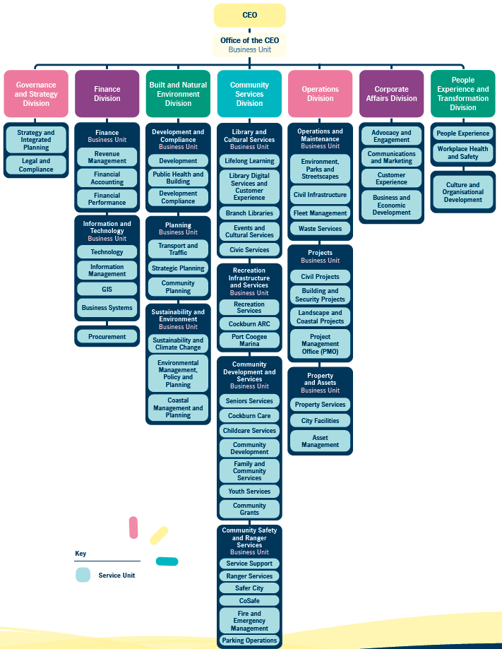
The hierarchical diagram above, which shows the organisational structure of the City, is described below as a series of bulleted lists. Please contact City of Cockburn for more information or clarification.
Organisational Structure:
The CEO is at the top of the hierarchy, with 7 divisions below the office of the CEO.
- CEO
  - Office of the CEO (Business Unit)
    - Governance and Strategy Division
    - Finance Division
    - Built and Natural Environment Division
    - Community Services Division
    - Operations Division
    - Corporate Affairs Division
    - People Experience and Transformation Division
Each of these 7 divisions has business units and/or service units that fall under them.
- Governance and Strategy Division
  - Strategy and Integrated Planning (Service Unit)
  - Legal and Compliance (Service Unit)
- Finance Division
  - Finance (Business Unit)
    - Revenue Management (Service Unit)
    - Financial Accounting (Service Unit)
    - Financial Performance (Service Unit)
  - Information and Technology (Business Unit)
    - Technology (Service Unit)
    - Information Management (Service Unit)
    - GIS (Service Unit)
    - Business Systems (Service Unit)
  - Procurement (Service Unit)
- Built and Natural Environment Division
  - Development and Compliance (Business Unit)
    - Development (Service Unit)
    - Public Health and Building (Service Unit)
    - Development Compliance (Service Unit)
  - Planning (Business Unit)
    - Transport and Traffic (Service Unit)
    - Strategic Planning (Service Unit)
    - Community Planning (Service Unit)
  - Sustainability and Environment (Business Unit)
    - Sustainability and Climate Change (Service Unit)
    - Environmental Management, Policy and Planning (Service Unit)
    - Coastal Management and Planning (Service Unit)
- Community Services Division
  - Library and Cultural Services (Business Unit)
    - Lifelong Learning (Service Unit)
    - Library Digital Services and Customer Experience (Service Unit)
    - Branch Libraries (Service Unit)
    - Events and Cultural Services (Service Unit)
    - Civic Services (Service Unit)
  - Recreation Infrastructure and Services (Business Unit)
    - Recreation Services (Service Unit)
    - Cockburn ARC (Service Unit)
    - Port Coogee Marina (Service Unit)
  - Community Development and Services (Business Unit)
    - Seniors Services (Service Unit)
    - Cockburn Care (Service Unit)
    - Childcare Services (Service Unit)
    - Community Development (Service Unit)
    - Family and Community Services (Service Unit)
    - Youth Services (Service Unit)
    - Community Grants (Service Unit)
  - Community Safety and Ranger Services (Business Unit)
    - Service Support (Service Unit)
    - Ranger Services (Service Unit)
    - Safer City (Service Unit)
    - CoSafe (Service Unit)
    - Fire and Emergency Management (Service Unit)
    - Parking Operations (Service Unit)
- Operations Division
  - Operations and Maintenance (Business Unit)
    - Environment, Parks and Streetscapes (Service Unit)
    - Civil Infrastructure (Service Unit)
    - Fleet Management (Service Unit)
    - Waste Services (Service Unit)
  - Projects (Business Unit)
    - Civil Projects (Service Unit)
    - Building and Security Projects (Service Unit)
    - Landscape and Coastal Projects (Service Unit)
    - Project Management Office (PMO) (Service Unit)
  - Property and Assets (Business Unit)
    - Property Services (Service Unit)
    - City Facilities (Service Unit)
    - Asset Management (Service Unit)
- Corporate Affairs Division
  - Advocacy and Engagement (Service Unit)
  - Communications and Marketing (Service Unit)
  - Customer Experience (Service Unit)
  - Business and Economic Development (Service Unit)
- People Experience and Transformation Division
  - People Experience (Service Unit)
  - Workplace Health and Safety (Service Unit)
  - Culture and Organisational Development (Service Unit)

Awards and Achievements
Award or Agency | Place and Category
WA Coastal Awards for Excellence 2022 | Special Commendation: Coastal Management and Adaptation – engineered fringing reef at C.Y. O’Connor Beach
Institute of Public Administration Australia Western Australia 2022 Achievement Awards | Finalist:  Best Practice in Collaboration between Government and any other Organisation – C.Y. O’Connor Beach engineered fringing reef project  Best Practice in Health and Wellbeing – Cockburn Healthy Lifestyle Service in partnership with the City of Cockburn
IAP2 Core Values Awards 2022 | Finalist: Indigenous category and awarded the Judges Encouragement Award – for Creating Cockburn’s Aboriginal Cultural and Visitors Centre
Local Government Professionals National Federation Awards 2022 | Finalist: Highly Commended for Environmental Leadership and Sustainability Award – Renewable Energy Program
Planning Institute Australia – WA Planning Excellence Awards 2022 | Finalist: Climate Change and Resilience – City of Cockburn’s Climate Change Strategy
COTA WA Seniors Awards 2022 | Winner: WA Age Friendly Local Government Award
Parks and Leisure Australia – WA Awards 2023 | Finalist: Community Facility of the Year – Frankland Park Sporting and Community Facility
National Growth Areas Alliance (NGAA) Awards 2023 | Partnerships & Building Connections - Commendation Award: City of Cockburn, Cockburn-Indonesia Trade Relationship (May 2023)
Water Corporation | City of Cockburn 10-year Gold Waterwise Council

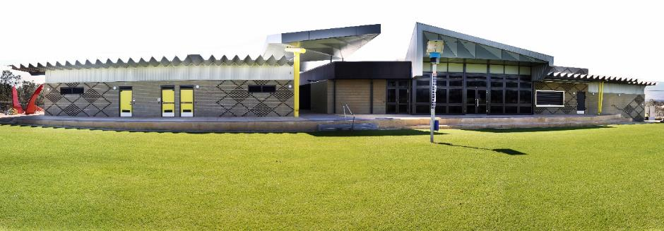
Frankland Park Sporting and Community Facility.
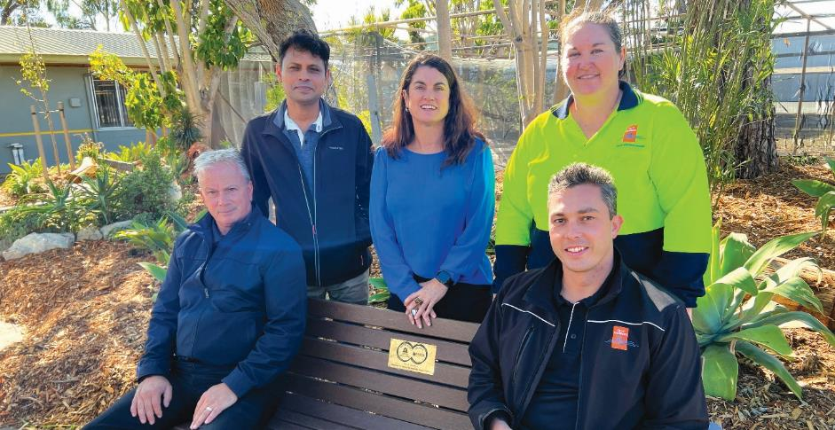
City of Cockburn 10-year Gold Waterwise Council - May 2023: (Left to Right) Mladen - Irrigation Supervisor, Sabbir – Senior Development Engineer, Lisa – Sustainability and Water Projects Officer, Alison – Parks Operations Coordinator and Daniel – City Facilities Technical Officer.

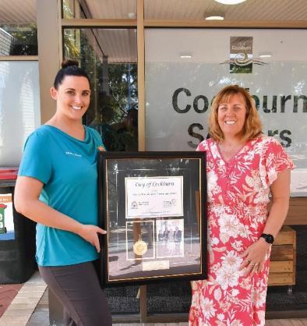 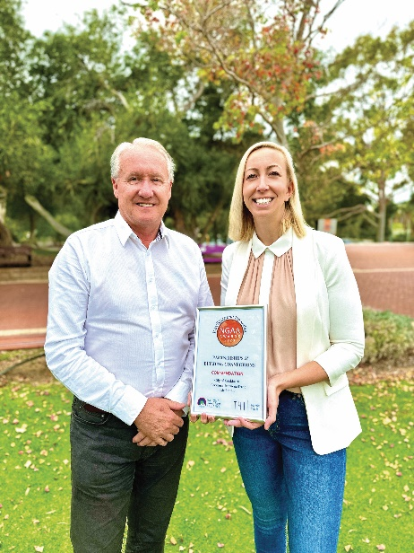
Left: WA Age Friendly Local Government Award - November 2022: Kayla - Senior Centre Programs Booking Officer and Julie - Senior Centre Coordinator. Right: Partnerships & Building Connections, Commendation Award - May 2023: Michael - Manager Business and Economic Development and Victoria - Executive Corporate Affairs.

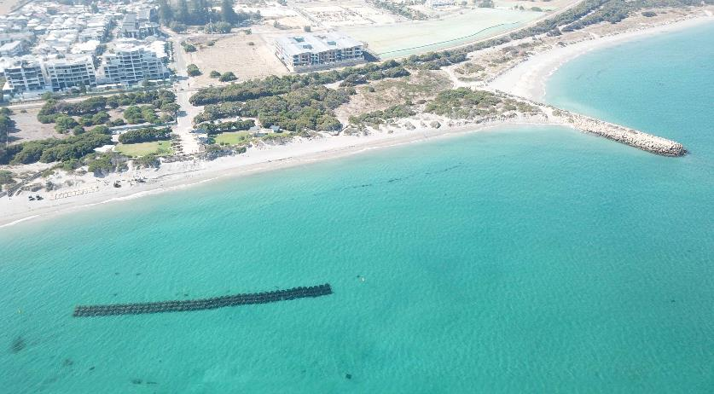
C.Y. O’Connor Beach Engineered Fringing Reef.

City Performance for the 2022-23 Financial Year
The City measures performance against the key community outcomes outlined in the Strategic Community Plan and by tracking progress of the priority projects outlined in the Corporate Business Plan (CBP). This section outlines the City’s performance against each community outcome for the 2022-23 financial year.

Local Economy
1.1 Increased investment, economic growth, and local employment
a. Annual estimated value of issued development applications
- 2021-22: $315 Million
- 2022-23: $227 Million
b. Number of new local jobs generated
- 2016: 41,679
- 2021: 50,040
(Source: Australian Bureau of Statistics 2021 Census data.)
1.2 Thriving local commercial centres, businesses and tourism industry
a. Improved satisfaction with efforts to support and retain existing businesses
- 2021-22 Score: 57
- 2022-23 Score: 55
1.3 A City that is ‘easy to do business with’
a. Improved satisfaction with the ease of doing business in the City
- 2020-21 Score: 58
- 2022-23 Score: 53

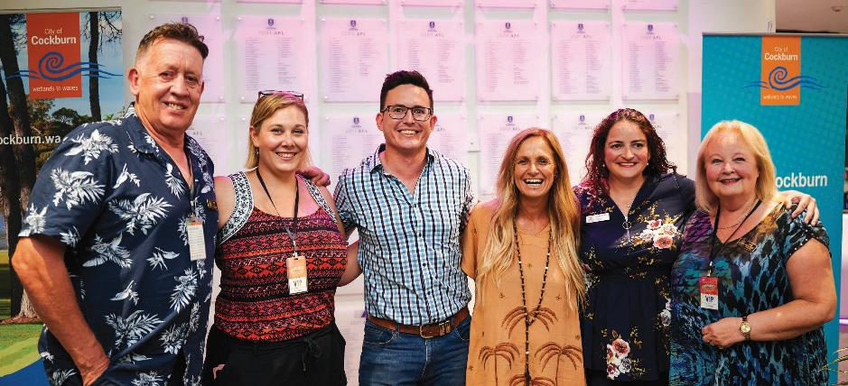
Cockburn Community Concert - February 2023: (Left to Right) Cr Philip Eva JP, Cr Lara Kirkwood, Deputy Mayor Cr Tom Widenbar, Kasey Chambers, Cr Chontelle Stone and Cr Carol Reeve-Fowkes.

Financial year 2022-23: CBP KPIs – Key Projects
Strategy | Project | Progress | Notes
1.1 | Position Cockburn as a leader in the Blue Economy | Completed | N/A
1.1 | Develop visitor economy approach | Reforecast to FY24 | Resourcing limitations, blue economy and defence industry were prioritised for delivery in FY23
1.2 | Deliver business grants program supporting Economic Development Principles, Policy and Guide | Completed | N/A
1.3 | Small Business Friendly Approvals Project Implementation | Completed | N/A

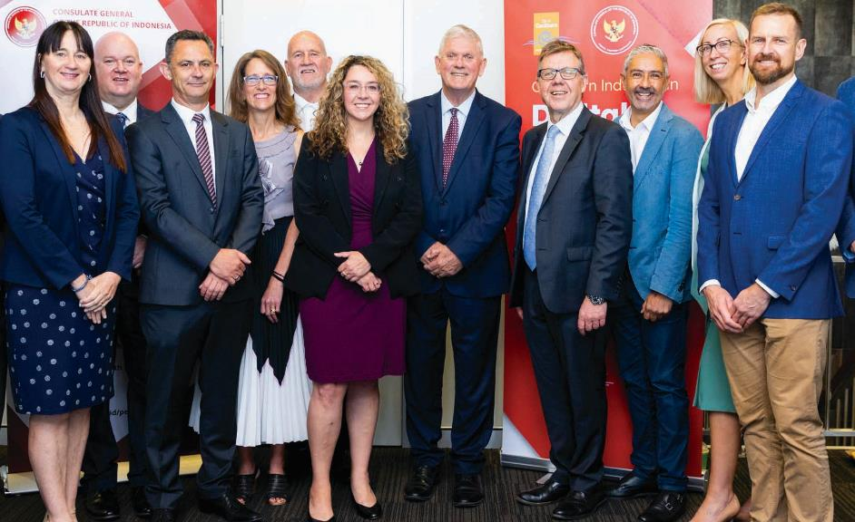
Indonesian Digital Exchange - December 2022: (Left to Right) Terina Grace - Black Swan Health, Steve Hall - Electrical and Communications Association of WA, Brett Peek - Austal, Michelle Clement - Western Australian Defence Science Centre, Kim Woods - South Metropolitan TAFE, Jessica Shaw MLA - Parliamentary Secretary to the Deputy Premier, Mayor Logan Howlett - City of Cockburn, Michael Carter - CCIWA, Dr Ian Martinus - Change Management Consultant, Victoria Green - City of Cockburn Executive Corporate Affairs and Andrew Outhwaite - For Blue.

Environmental Responsibility
2.1 Improved satisfaction with environmental management and with provision of parks and open spaces
a. Community satisfaction with conservation and environmental management
- 2021-22 Score: 62
- 2022-23 Score: 63
b. Community satisfaction with playgrounds parks and reserves
- 2021-22 Score: 74
- 2022-23 Score: 73

2.2 Progress against KPIs identified in the State of the Sustainability Report
a. Per cent of sustainability strategy targets achieved each financial year: Sustainability reporting has now been superseded by the Climate Change Strategy reporting, refer to outcome 2.3
2.3 Progress against actions in the City's Climate Change Strategy
a. Climate Change Strategy reporting
- 51% ongoing or complete, 29% in progress and 20% to be commenced
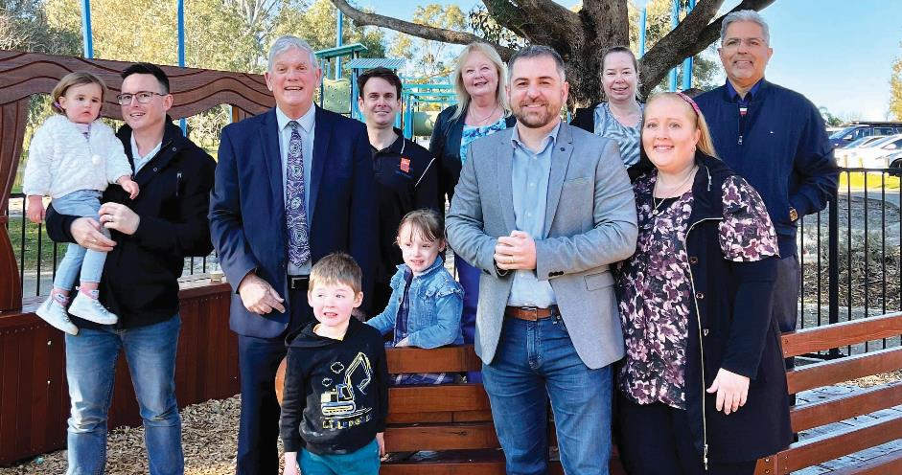
Tapper Park nature play area opening - August 2022: (Left to Right) Deputy Mayor Cr Tom Widenbar, Mayor Logan Howlett, Craig - Project Manager, Cr Carol Reeve-Fowkes, David Scaife MLA, Michelle Dunlop - Atwell Community Association, Jonelle Gilroy - President Atwell Community Association and Cr Tarun Dewan.

Financial year 2022-23: CBP KPIs – Key Projects
Strategy | Project | Progress | Notes
2.1 | Coogee Beach Masterplan review | Not completed | Resourcing limitations due to labour market conditions impacted project delivery
2.1 | Review Urban Forest Plan 2018-2028 | Completed | N/A
2.1 | Undertake Yandjet Park Yangebup Improvements | Reforecast to FY24 | Resourcing, contracts and materials shortages impacted project delivery timeline
2.2 | EV chargers at all City infrastructure with Solar | Reforecast to FY24 | Resourcing limitations due to labour market conditions impacted project delivery
2.2 | Waterwise Council Action Plan 2018-2028 | Completed | N/A
2.2 | Henderson Waste Recovery Park Redevelopment | Completed | N/A
2.3 | Develop the Coastal Management and Development Plan | Not completed | Development of the Coastal Managemennt Development Plan has been superceded by development of the Coastal Hazard Risk Management and Adaptation Plan
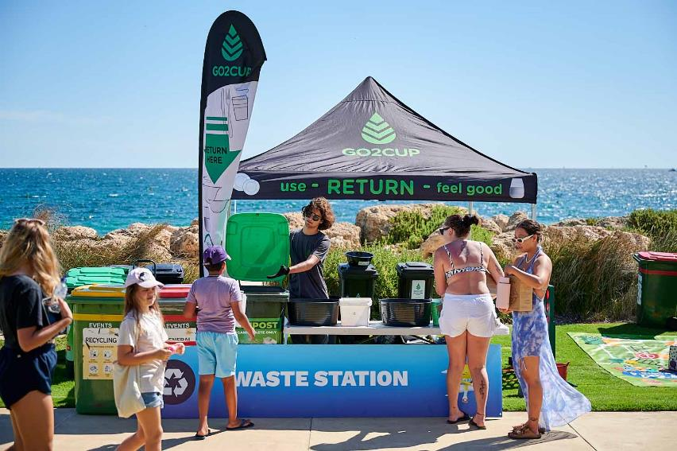
Record-breaking use of reusable dishes and cutlery at Coogee Live saved 32,000+ items from the rubbish dump, March 2023.

Community, Lifestyle and Security
3.1 Improved satisfaction with the City's provision of community, recreation and cultural services and facilities
a. Community buildings, halls, and toilets
- 2021-22 Score: 66
- 2022-23 Score: 65
b. Sport and recreation facilities
- 2021-22 Score: 71
- 2022-23 Score: 72
c. Festivals, events, and cultural activities
- 2021-22 Score: 71
- 2022-23 Score: 68
3.2 Improved satisfaction with safety, security and health, and social connection activities
a. Opportunities to be included and connected to your community
- 2021-22 Score: 65
- 2022-23 Score: 62
b. Safety and security
- 2021-22 Score: 56
- 2022-23 Score: 52
c. Mobile security patrols
- 2021-22 Score: 62
- 2022-23 Score: 56
d. Access to health and community services
- 2021-22 Score: 68
- 2022-23 Score: 66
3.3 Improved satisfaction with recognition and celebration of Aboriginal and Torres Strait Islander and other diverse cultures and heritage
a. Recognition and respect for Aboriginal people, culture and heritage:
- 2021-22 Score: 68
- 2022-23 Score: 66

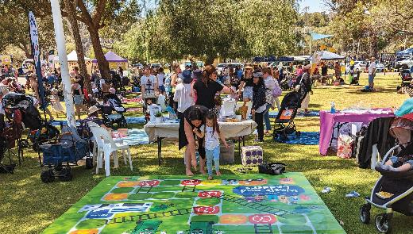 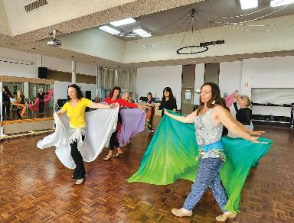
Left: Teddy Bears Picnic Event - October 2022. Right: Belly dancing classes at Cockburn Seniors Centre - October 2022.

Financial year 2022-23: CBP KPIs – Key Projects
Strategy | Project | Progress | Notes
3.1 | Review the Disability Access and Inclusion Plan | Completed | N/A
3.1 | Malabar BMX Park Redevelopment | Reforecast to FY24 | Resourcing limitations, internal resource not sufficient to delivery Malabar within FY23
3.1 | Beale Park Redevelopment | Reforecast to FY24 | N/A
3.1 | Port Coogee Community Space | Completed | N/A
3.1 | Wally Hagan Recreation Centre Redevelopment | Completed | N/A
3.1 | Cockburn ARC – Health and Fitness Expansion | Reforecast to FY24 | Resourcing constraints and conflicting priorities
3.1 | Beeliar Reserve Redevelopment | Reforecast to FY24 | Resourcing, contracts and materials shortages impacted project delivery timeline
3.1 | Tempest Park Redevelopment | Reforecast to FY24 | Resourcing, contracts and materials shortages impacted project delivery timeline
3.1 | Santich Park – Upgrade | Reforecast to FY24 | Resourcing, contracts and materials shortages impacted project delivery timeline
3.1 | Manning Park Master Plan Implementation | Reforecast to FY24 | Funding for Manning Park Masterplan was not included in the FY23 budget. To be addressed through the FY24 budgeting process
3.1 | Review the Community, Sport & Recreation Facilities Plan 2018-2033 | Reforecast to FY24 | Key resource changes, reforecast to allow for greater level of stakeholder engagement and alignment with major review of the CBP
3.1 | Multicultural Centre for Sport and Education – ARC Precinct | Completed | N/A
3.2 | Smart Buildings Project (Project BETTI) | Completed | N/A
3.3 | Aboriginal Cultural and Visitors Centre Development | Not completed | Significant cost escalation required value engineering to be undertaken. The project timeline will be defined once scope is confirmed
3.3 | Review the Reconciliation Action Plan 2018-2021 | Reforecast to FY24 | Reconciliation Australia timeframes have reforecast adoption to FY24

City Growth and Moving Around
4.1 Improved satisfaction with your local shopping area/centre and Cockburn as a place to live
a. Place to live
- 2021-22 Score: 79
- 2022-23 Score: 77
b. Satisfaction with how your local shopping area/centre is being developed
- 2021-22 Score: 58
- 2022-23 Score: 58
4.2 Improved satisfaction with development of Cockburn Central
- 2021-22 Score: 62
- 2022-23 Score: 58
4.3 Improved satisfaction with the City's transport network, cycleways, footpaths and parking
a. Traffic management and control on local roads
- 2021-22 Score: 58
- 2022-23 Score: 56
b. Footpaths and cycleways
- 2021-22 Score: 60
- 2022-23 Score: 59

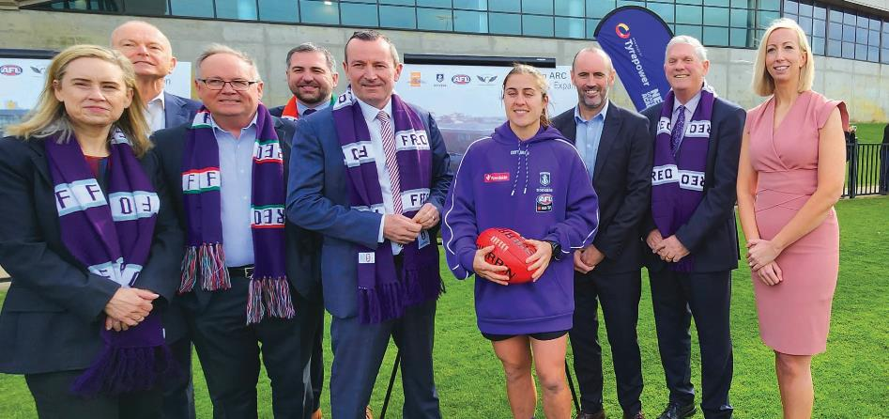
Cockburn ARC Expansion Announcement - September 2022: (Left to Right) Simone McGurk - Women's Interests Minister Hon., Dale Alcock - Fremantle Football Club President, David Templeman - Sport and Recreation Minister Hon., David Scaife Cockburn MLA, Mark McGowan - Premier, Gabby O'Sullivan - Fremantle AFLW forward, Simon Garlick - Fremantle Football Club CEO, Mayor Logan Howlett - City of Cockburn and Victoria Green - City of Cockburn Acting CEO.

Financial year 2022-23: CBP KPIs – Key Projects
Strategy | Project | Progress | Notes
4.1 | Prepare the new Local Planning Strategy for the District | Completed | N/A
4.1 | Prepare the new Local Planning Scheme for the District | Reforecast to FY24 | Scheme review is dependent on outcomes of Local Planning Strategy review. Scheme review will commence once Local Planninng Strategy is complete
4.1 | Cockburn Central Town Centre parking facility feasibility study - AT GRADE | Completed | N/A
4.1 | Reconnecting Hamilton Hill (post Roe 9) Urban Renewal Project | Completed | N/A
4.2 | Cockburn Central Carparking Project (Cockburn Central West car parking - Poletti Road) | Completed | N/A
4.3 | Review and update the City’s District Traffic Study 2018 | Completed | N/A
4.3 | Advocacy for Cockburn Road Upgrade, Pedestrian Crossing and Car Parking | Completed | N/A
4.3 | Semple/Berrigan Realignment | Not completed | Contracts and materials shortages impacted project delivery
4.3 | Hammond Road Duplication | Not completed | Project has reached 90% completion at the end of the FY23
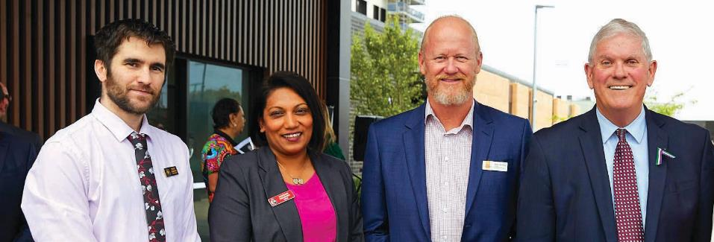
Bethesda Clinic community open day - February 2023: (Left to Right) Cr Michael Separovich, Shareenah Virahsawmy - Health Hub Manager Australian Federal Police, David van Ooran - City of Cockburn Chief of Community Services and Mayor Logan Howlett.

Listening and Leading
5.1 Improved satisfaction with the City's governance and financial sustainability
a. The City of Cockburn as the organisation that governs the local area
- 2021-22 Score: 67
- 2022-23 Score: 65
b. Value for money from Council rates
- 2021-22 Score: 58
- 2022-23 Score: 58
5.2 Improved satisfaction with the City's community engagement, communications and customer service
a. How the community is consulted about local issues (ability to have a say on local issues)
- 2021-22 Score: 60
- 2022-23 Score: 49
b. Value for money from Council rates
- 2021-22 Score: 66
- 2022-23 Score: 64
c. How the community is informed about City services and local issues (how the community is informed about what's happening in the local area)
- 2021-22 Score: 60
- 2022-23 Score: 59
d. Customer satisfaction surveys
- 2021-22 Score: 89%
- 2022-23 Score: 86%
5.3 Improved employee satisfaction with the City as an employer that effectively embraces change, innovation and technology
a. Employee culture survey – Employer rating score: how likely are staff to promote the City as an employer
- 2021-22 Score: 86
- 2022-23 Score: 75
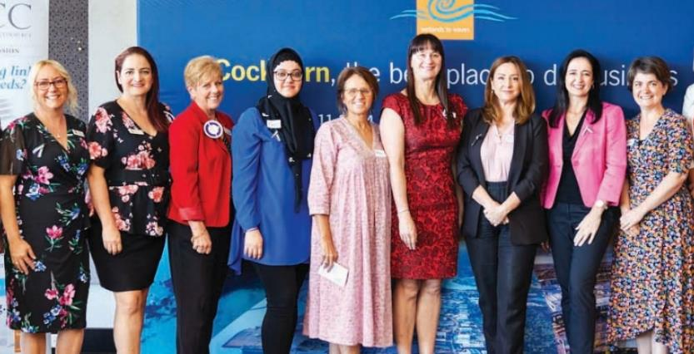
International Women's Day - March 2023: (Left to Right) Lisa Kniebe - City of Cockburn, Cr Chontelle Stone, Karen Woodcock - Dress for Success, Ala Mojaddidi - Business Foundations, Kelley Chisholm - Business Station, Terina Grace - Black Swan Health, Martine Hoosen - Bookwiz Academy & Advisory, Alicia Menkveld - Savvy in Business, Genelle Surace - Small Business Development Corporation (SBDC).

Financial year 2022-23: CBP KPIs – Key Projects
Strategy | Project | Progress | Notes
5.1 | Deliver Corporate Strategy Framework | Not completed | Internal resource not sufficient to deliver FY23
5.1 | Review Organisational Risk Management Maturity | Completed | N/A
5.1 | Review and Implement the Corporate Governance Framework | Completed | N/A
5.1 | Refine the long-term financial planning methods to better integrate with the City’s Strategic Community Plan objectives and Implement COVID-19 financial measures | Reforecast to FY24 | Item reforecast to FY24 to align with major CBP review, major SCP review, major Workforce Plan review. Alignment will enable integration
5.2 | Progress community priorities highlighted in MARKYT Community Scorecard 2021 | Completed | N/A
5.3 | Develop and Implement Smart Cities projects in partnership with South West Group | Completed | N/A
5.3 | Review requirements for required website upgrades | Completed | N/A
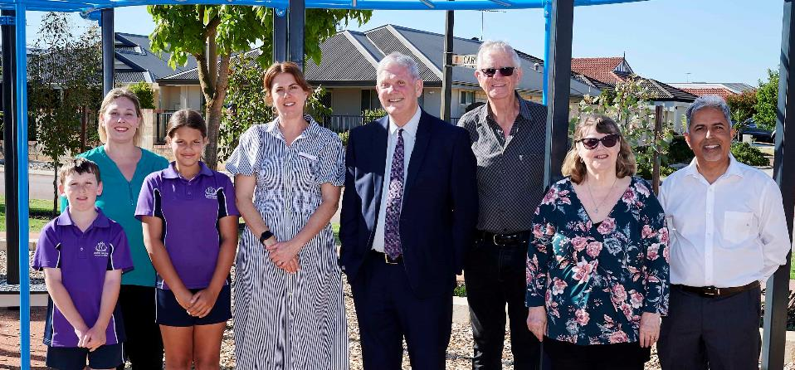
Radiata Park, Aubin Grove - November 2022: (Left to Right) Aubin Grove Primary School students, Cr Lara Kirkwood, Mesha Steel - Aubin Grove Primary School Principal, Mayor Logan Howlett, Geoff Webb - Aubin Grove Community Association President, Debra de Groot - Aubin Grove Community Association Secretary/Treasurer and Cr Tarun Dewan.

Governance Report

Compliance
Regulations 14 and 15 of the Local Government (Audit) Regulations 1996 requires every local government to conduct a Compliance Audit for the period 1 January to 31 December each year and to complete a Compliance Audit Return (CAR) as produced by the Department of Local Government, Sport and Cultural Industries (DLGSCI). The CAR must be submitted to DLGSCI no later than 31 March each year.
The City submitted all completed 94 CAR questions into the DLGSCI file uploading facility on 28 March 2023.
The City utilises an online compliance management system for statutory forms such as financial disclosures, gifts, travel contributions and delegated authorities.

Legislative Review
Section 3.16 of the Local Government Act 1995 requires that all of the Local Laws of a local government must be reviewed within an eight-year period after their commencement to determine if they should remain unchanged or be repealed or amended. The City commenced a review of the Standing Orders Local Law 2016, and has deferred the review pending the finalisation of model meeting procedures to be delivered with the Local Government Act Reform.

Freedom of Information
The Freedom of Information (FOI) Act 1992 (the FOI Act) gives members of the public the right to access documents held by local governments, subject to limitations. The City prepared, as required by section 96 of the FOI Act, an up-to-date information statement and made it available to the public. The City received 22 FOI requests during the 2022-23 financial year.

Public Interest Disclosure
The Public Interest Disclosure (PID) Act 2003 promotes accountability within state and local government agencies and organisations by facilitating the disclosure of public interest information involving misconduct, offences and misuse of public resources or risks to public health or safety. The Act aims to protect informers who make public interest disclosures. In the 2022-23 financial year, the City had no disclosures under the PID Act.

Audits – External and Internal

External
The Western Australian Office of the Auditor General is responsible for auditing the local government sector and conducted four performance audits focused on local government in the following areas:
- Financial Audit Results – Local Government 2020-21, 17 August 2022
- Funding Volunteer Emergency and Fire Services, 22 December 2022
- Information Systems Audit – Local Government 2021-22, 29 March 2023
- Regulation of Air-handling and Water Systems, 21 April 2023.
The City has adopted the recommendations from the audit findings.

Internal
No internal audits were completed during the financial year. An internal audit will be conducted in 2023 to examine the ‘Acting through’ principles of the Local Government Act 1995 and their application within the City of Cockburn Administration. An Internal Audit Plan 2024–2026, accepted by Council, includes four internal audits planned to be conducted between 2024 and 2026, as follows:
- Contract management
- Effectiveness of service delivery planning and review processes
- Fleet management
- Climate change strategy – adaptation.

Competition Principles Agreement
Embedded into the principles of Australia’s National Competition Policy is competitive neutrality, which requires that the prices charged by Local Government operations should aim to recover the full costs of a business activity. The intent is to avoid artificial subsidies that do not provide for commercial operators to compete.
A number of the City’s services are exempt from the Competition Policy, as it applies only to business activities that generate income in excess of $200,000 from fee revenue that is directly generated from external users and an operating expenditure greater than $2 million. Activities undertaken by the City which have previously been considered for market testing, owing to the competitive nature of the service include:
- Domestic waste collection
- Waste disposal business
- Cockburn ARC (Aquatic and Leisure Centre).
The City has resolved to retain the in-house provision of Cockburn ARC, domestic waste collection and its waste disposal business.

Risk Management
The City procured the services of Moore (Australia) Pty Ltd to conduct a review of its risk management maturity. Following the review, the City has drafted a risk management improvement plan to implement the recommendations from the Moore review over the next two years.

Business Continuity
A review of the City’s business continuity management, facilitated by an external service provider, was conducted. The City’s approach to business continuity was also a subject of the City’s external Risk Maturity Review and will be the subject of further work in 2023-24.
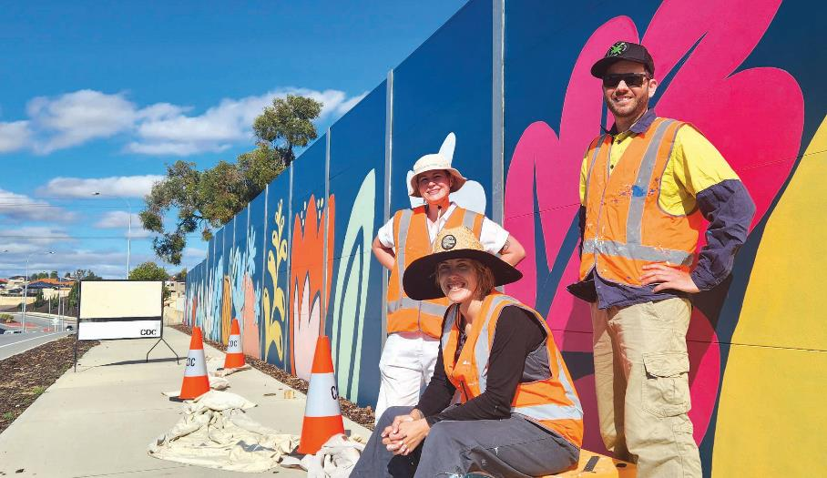
Spearwood Avenue street mural - April 2023: (Left to Right) Sally Ridge, Haylee Fieldes (Fieldey) and Mitchell Low.

Recordkeeping Compliance Report

Evaluation of Recordkeeping Systems
Work was undertaken with the organisation’s Procurement and Rates and Revenue service units to review their recordkeeping practices through the knowledge management project. This resulted in a number of changes to processes to improve recordkeeping within the teams and reduce the amount of information stored outside the recordkeeping system.
The City’s Recordkeeping Plan was reviewed in April 2022 and an amended Recordkeeping Plan was subsequently submitted to the State Records Commission and approved on 2 May 2023. The Plan must be reviewed again by 2 May 2028.

Recordkeeping Training Program
All new staff are required to complete an online Records Awareness Training (RAT) course. The interactive course outlines the recordkeeping roles and responsibilities of all employees at the City of Cockburn. Participants must undertake and pass a short assessment at the completion of the course.
An online course outlining the specific recordkeeping responsibilities of Managers and Supervisors has also been implemented.
Regular training for new and existing staff is held on the use of the organisation’s electronic document and records management system, called ECM.

Evaluation of the Recordkeeping Training Program
All participants who attend ECM training are asked to complete a training feedback form. The feedback forms are regularly reviewed and suggestions for improvements are incorporated into the training program.

Recordkeeping Induction Program
New staff must complete the RAT – and where relevant, ECM training – as part of their induction.
New managers/supervisors are also required to complete the online Recordkeeping Training for managers and supervisors.

Capital Grants, Subsidies and Contributions
As per regulation 19BE of the Local Government (Administration) Regulations 1996, below are the amounts of capital grants, subsidies and contributions received by the City of Cockburn in the last three financial years for replacing and renewing assets.
- Financial year 2022-23 (Audited): $18,946,612
- Financial year 2021-22 (Audited): $11,713,792
- Financial year 2020-21 (Audited): $15,713,474

Trading Undertakings
There is no information about trading undertaking to be included in the Annual Report in accordance with regulation 19BB of the Local Government (Administration) Regulations 1996.

Land Transactions
There is no information about land transactions to be included in the Annual Report in accordance with regulation 19BC of the Local Government (Administration) Regulations 1996.
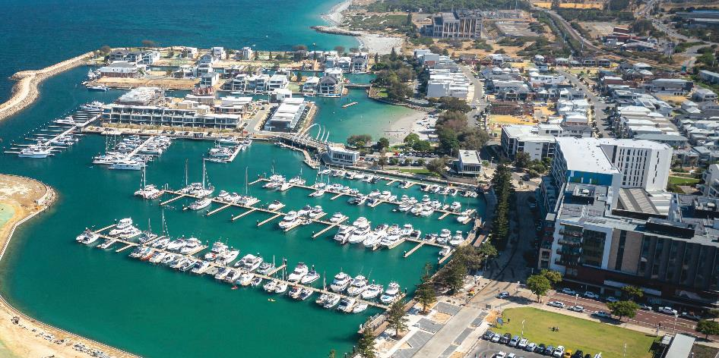
Port Coogee Marina, North Coogee.

Breaches by Elected Members

Minor breach complaints
Five minor breach complaints were received in 2022-23 and were reported to the Local Government Standards Panel. Two complaints were upheld. The cost of the complaints for the City was $5,192.
One complaint was upheld by the State Administrative Tribunal against a former Councillor, Lee-Anne Smith, for breach of regulation 7(1)(b) of the Local Government (Rules of Conduct) Regulations 2007 (WA). Former Councillor Smith made derogatory, sarcastic comments, and intended to cause detriment to Mr Stephen Cain, who was the CEO of the City of Cockburn at the time. The former councillor was required to make a public apology by way of a public notice in the West Australian newspaper on 17 June 2023.
Former Councillor Lee-Anne Smith also breached regulation 11 of the Local Government (Rules of Conduct) Regulations 2007 (WA) on three occasions when she failed to make an impartiality declaration at the City of Cockburn’s Special Council Meetings held on 4 November 2019, 4 December 2019, and 13 January 2020.
The second complaint was sanctioned by the Local Government Standards Panel against Councillor Michael Separovich who committed one minor breach under the Local Government Act 1995 (WA) (“the Act”) and Regulation 20 of the Local Government (Model Code of Conduct) Regulations 2021 (“the Regulations”).
The sanction by the Local Government Standards Panel was that Councillor Michael Separovich:
- Publicly apologise by notice of public censure in the West Australian newspaper, when he threatened Mr Donald Mervyn Green, in relation to a minor breach complaint that was made against him by a member of the public.
- Make the monetary payment of $1,860.

Building and Development Applications Report

Building
- 2167 building permits issued
- Total value of building works: $410 million
- The average issuance time for a building permit in 2022-23 was:
  - Certified: 7 working days
  - Uncertified: 19 working days
Building approvals for previous years compared to 2022-23 are as follows:
Year Ending | Number of Permits | $million Value | $million Fee | Residential | Commercial | Industrial | Other
30 June 2020 | 2,247 | 349 | 0.71 | 1,076 | 80 | 14 | 1,169
30 June 2021 | 3,444 | 616 | 1.24 | 1,993 | 121 | 9 | 1,321
30 June 2022 | 2,554 | 502 | 0.97 | 1,132 | 129 | 18 | 1,276
30 June 2023 | 2,167 | 410 | 1.42 | 832 | 225 | N/A | 1,054

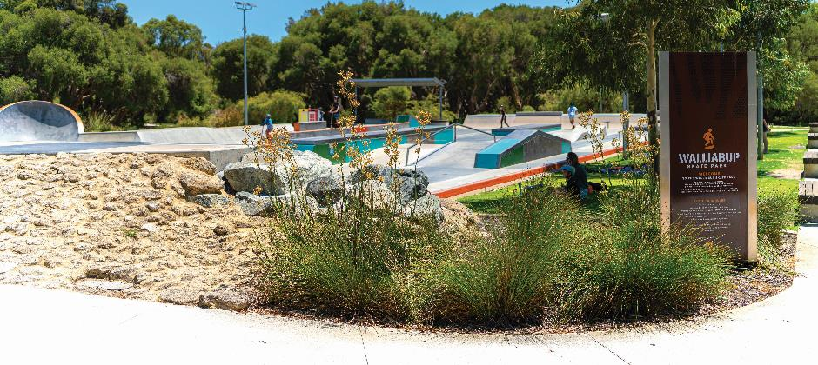
Walliabup Bibra Lake Skate Park.

Development Applications
- 809 development applications received, a 7.11 per cent decrease from the previous year
- 491 development applications were required to be determined within 60 days. The City determined 75.56 per cent of those applications within 60 days
- 158 development applications were required to be determined within 90 days. The City determined 65.45 per cent of those applications within 90 days
- 552 new lots were approved (green title, survey strata and built strata), an increase of 24.38 per cent from the previous year
- The estimated construction value of all development applications received over the year was $323 million, an increase of 20.97 per cent or $56 million.

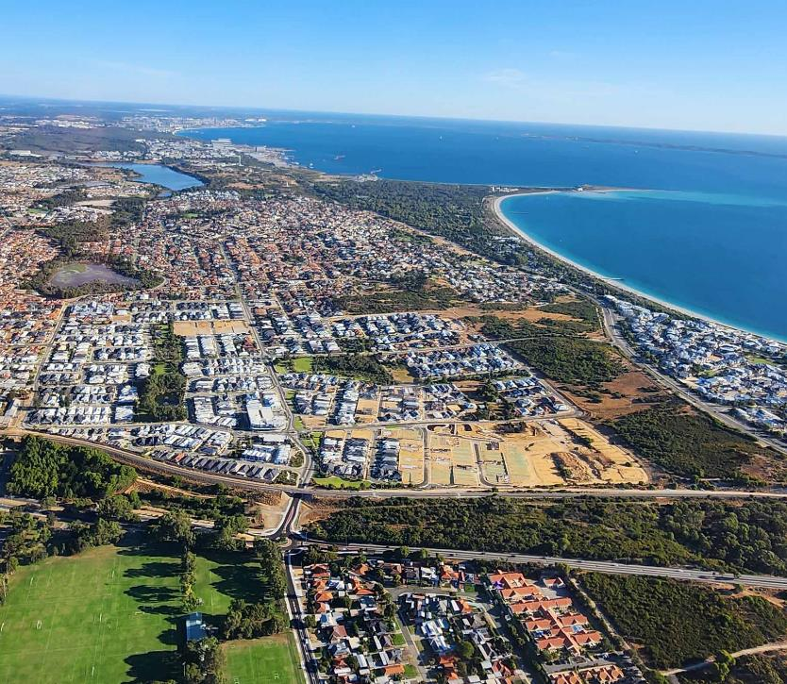
Cockburn from the air.

Community Engagement and Customer Satisfaction
The City is committed to engaging with its community and providing exceptional service. This section summarises the engagement undertaken in this financial year and outlines the results of the customer surveys.

Community Engagement Report
The City undertakes community engagement throughout the year to seek feedback on various initiatives and to inform the community of its priorities.
The City’s focus is to inform, consult and provide opportunities for active participation in City projects and activities. The City uses a variety of methods to seek feedback including listening posts, workshops, surveys, meetings, one-on-one conversations and more.
These projects are communicated using a number of mediums. Some examples include direct mail, newspaper advertisements, e-newsletters, social media and signage.
Over the past 12 months, the City has attracted community input via its Comment on Cockburn community engagement website which had:
- 55,943 site visits
- 1,167 new user registrations
- 2,100 project participants
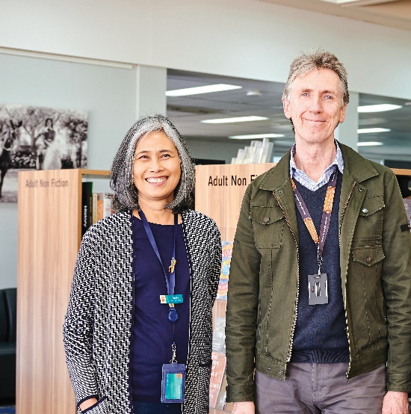 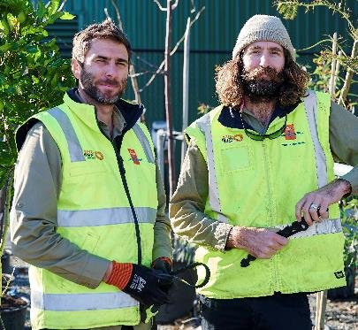
Left: Spearwood Library: Sandra - Library Technician and Clive - Branch Manager Spearwood Library. Right: Parks and Environmental: Steven - Urban Forest Officer and Logan - Parks Supervisor.

Customer Satisfaction
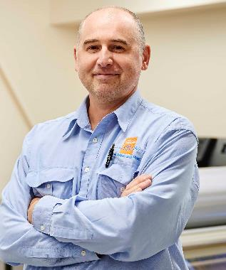
Property and Assets: James - Leading Hand Maintenance.
The City undertakes independent customer satisfaction surveys (see Note below) across a number of service units each year. The percentage of satisfied customers reported is the number of customers who scored the service seven or more out of 10.
Service | % Satisfied customers
Henderson Waste Recovery Park Domestic | 98
Youth Centre | 98
Front Counter | 98
CoSafe | 97
Library - overall visit experience | 96.5
Library - satisfaction with customer service | 96.3
Ranger Services (customer requests) | 96.3
Henderson Waste Recovery Park Commercial | 94.2
Sports Field Hire and Booking Services | 93.2
Swimming Pool Inspection Service | 92.6
Cockburn Care | 92
Seniors Services | 91.7
Building Services | 88.6
Port Coogee Marina (customer service) | 86.6
Contact Centre | 86.1
Development Services | 84.7
Facility Booking and Management Services | 82.4
Port Coogee Marina (infrastructure) | 81.7
Community Centres and management of them | 80.7
Sports Fields and management of them | 77
Public Health Services (customer requests and food premise inspections) | 71.9
Civil Infrastructure (construction and maintenance) | 70.9
Environment, Parks and Streetscapes (customer requests) | 63.7
Note: Undertaken by Research Solutions in 2022-23. Survey frequencies and timing vary according to service area.

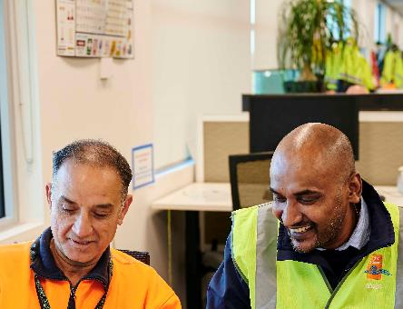 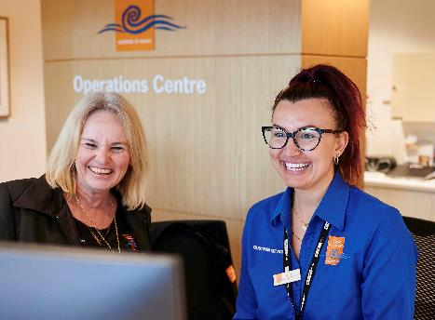
Left: Road Construction: Mustafa - Operations Supervisor and Saravana, Civil Infrastructure Coordinator. Right: Customer Experience: Tracy and Gemma - Customer Experience Officers.

Climate Change and Sustainability Snapshot
The City’s Climate Change Strategy 2020-2030 sets a vision to continue being a leader in climate resilience and sustainability. We aim to become a carbon-neutral City and commit to working together to adapt to our changing climate.
The Strategy’s Climate Resilience Roadmap, which forms our reporting framework until 2030, has 14 objectives and aspirational targets which are supported by a detailed action plan.
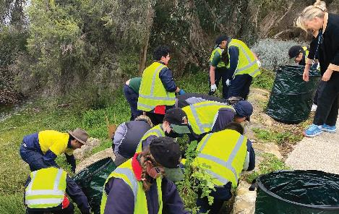 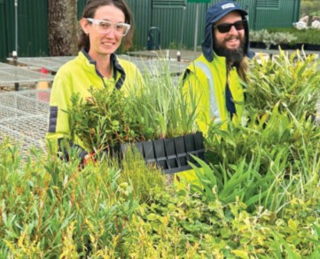
Left: Leeming Senior High School weeding at Bibra Lake - July 2022. Right: Community Planting - June 2023: Katelyn - Leading Hand Bushland Maintenance and Perri - Bushland Maintenance Officer.

Highlights
Leadership, Education and Collaboration
- 42 free Home Eco Audits provided to residents, and 14 Sustainability Grants awarded
- Waste Wise Events Policy reviewed, strengthened and endorsed by Council
- Investment into the Greenhouse Action Fund continued.
Mtigation
- Reduced the City’s carbon emissions from electricity by 4% and petrol by 40%
- 14% renewable electricity with solar PV on 26 buildings
- Maintained a zero emission fleet with EV and hybrid fleet vehicles plus biodiversity offsets for remaining emissions
- Delivered two carbon-neutral events, Coogee Live and Christmas on the Green
- 64% increase in recovered waste materials (e.g., green waste, recycling.
Adaptation
- Retained Gold Waterwise Council and Gold Waterwise Aquatic Centre status
- 41 Waterwise Verge Rebates supported, and 9 Landowner Biodiversity Grants awarded
- Area of conservation reserves increased by 1.9 ha
- Planted approximately 1,250 trees and 65,000 seedlings, increasing City wide canopy cover to 18%
- Public Health Plan and Bushfire Risk Management Plan updated to consider climate change risks.

Climate Resilience Roadmap
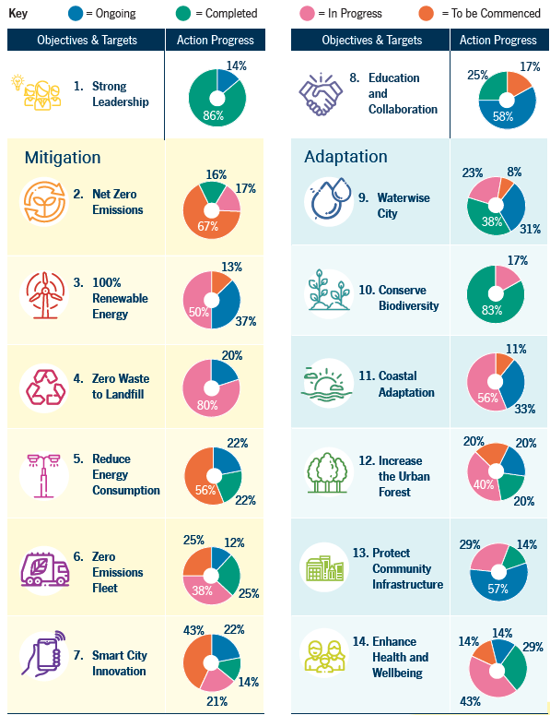
The infographic above, which shows action progress on the City’s climate objectives and targets, is described below as a series of lists. Numbers 2 to 7 are categorised in the infographic as Mitigation objectives, while Numbers 9 to 14 are categorised as Adaptation objectives.
Please contact City of Cockburn for more information or clarification.
- Strong Leadership
  - 14% ongoing
  - 86% completed
- Net Zero Emissions
  - 16% completed
  - 17% in progress
  - 67% to be commenced
- 100% Renewable Energy
  - 37% ongoing
  - 50% in progress
  - 13% to be commenced
- Zero Waste to Landfill
  - 20% ongoing
  - 80% in progress
- Reduce Energy Consumption
  - 22% ongoing
  - 22% completed
  - 56% to be commenced
- Zero Emissions Fleet
  - 12% ongoing
  - 25% completed
  - 38% in progress
  - 25% to be commenced
- Smart City Innovation
  - 22% ongoing
  - 14% completed
  - 21% in progress
  - 43% to be commenced
- Education and Collaboration
  - 58% ongoing
  - 25% completed
  - 17% to be commenced
- Waterwise City
  - 31% ongoing
  - 38% completed
  - 23% in progress
  - 8% to be commenced
- Conserve Biodiversity
  - 83% completed
  - 17% in progress
- Coastal Adaptation
  - 33% ongoing
  - 56% in progress
  - 11% to be commenced
- Increase the Urban Forest
  - 20% ongoing
  - 20% completed
  - 40% in progress
  - 20% to be commenced
- Protect Community Infrastructure
  - 57% ongoing
  - 14% completed
  - 29% in progress
- Enhance Health and Wellbeing
  - 14% ongoing
  - 29% completed
  - 43% in progress
  - 14% to be commenced

Disability Access and Inclusion Report
The City’s Disability Access and Inclusion Plan (DAIP) provides a framework for translating the principles and objectives of the Disability Services Act 2003 into achievable initiatives. Below are the highlights for implementation of the DAIP for the 2022-23 financial year.
Outcome 1: People with disability can access City of Cockburn services and events
- Cockburn ARC hosted a Sports for All series of events in lead-up to International Day for People with Disability
- Cockburn ARC purchased a some accessible gym-related pieces of equipment to ensure all members of the community can participate in the centre
- A new program was launched through the Cockburn Seniors Centre to assist seniors to learn and explore new technologies such as phones and tablets.
Outcome 2: People with disability have equal opportunity to access buildings and other facilities at the City of Cockburn
- A simple but effective initiative which has received positive feedback, was undertaken to improve the acoustics in the Seniors Centre for members
- During the development of the Community, Sport and Recreation Facilities Plan the disability reference group was engaged to discuss the utilisation of current facilities and how to improve participation and access for people with disabilities
- Further work has taken place over the past summer, to make our beaches more accessible with the installation of a new mobi-mat at C.Y. O’Connor Beach.
Outcome 3: People with disability receive information that is readily accessible from the City of Cockburn
- The City hosted a further round of accessible documents training delivered by Visibility
- The City is currently reviewing the website to continue to enhance the accessibility of information and maintain its commitment to the Web Content Accessibility Guidelines 2.1 rating
- The City has updated its Corporate Writing Style Guide to include several processes to ensure the accessibility of information. This includes audio descriptions and captioning for videos, appropriate language, and accessible templates.
Outcome 4: People with disability receive the same level of quality service as other people in the community from staff at the City of Cockburn
- A series of Auslan workshops was introduced to continue to develop the skills of staff to better interact and communicate with the Deaf community
- 60 staff attended a workshop on supporting people from the LGBTIQA+ community
- 97 staff attended disability awareness sessions and 27 completed the online refresher training.
Outcome 5: People with disability have equal opportunity to lodge complaints to the City of Cockburn
- Key findings from the annual community scorecard were included in the review of the Disability Access and Inclusion Plan.
Outcome 6: People with disability have the same opportunities as other people to participate in any public consultation by the City of Cockburn
- The City’s Disability Reference Group continued to play an important role in the community engagement process, with contributions to a number of projects including the DAIP review, Community Sports & Recreation Facilities Plan, Disability Transport Framework and Cockburn Aboriginal Cultural and Visitors Centre
- The City of Cockburn undertook the process of reviewing and updating its Disability Access & Inclusion Plan for 2023-2028. As part of the process, a series of community engagement sessions were undertaken in several formats. The community were able to provide comment through in person sessions, online sessions and hardcopy feedback forms, surveys, direct email, or phone contact.
Outcome 7: People with disability have the same opportunities as other people to obtain and maintain employment with the City of Cockburn
- The City has undertaken the development of its Diversity, Equity, Inclusion and Belonging Framework which outlines the plan to ensure all employees at the City of Cockburn are valued and included and receive equal opportunity in their employment. As part of this framework, a focus will include the employment of people with disability, stipulating a path by which the organisation can recruit and retain employees with disabilities
- The City has engaged an organisation to assist in the development of this work.
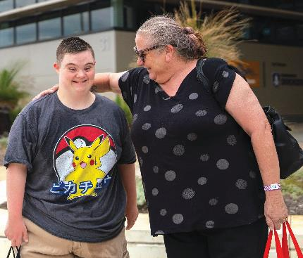 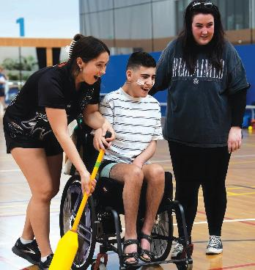
Left: The City adopted the 2023-2028 Disability Access and Inclusion Plan (DAIP) - June 2022. Right: Cockburn Disability Sports Day - October 2022.

The Plan for the Future
This section of the annual report outlines the City’s plans for the future, identifies emerging issues and provides an overview of the Strategic Community Plan and the Corporate Business Plan.

Emerging Issues

Economic Challenges
The Australian economy is facing challenges as global growth remains slow and the cost of living increases. The country's GDP growth is expected to be slow due to rising interest rates, declining real wealth and higher living costs. The increase in net arrivals following the reopening of the international border has supported employment growth; however, GDP per capita figures have declined for two consecutive quarters. (See Note 1.) The unemployment rate is expected to rise as a result of output growth slowing. The City has experienced cost pressures over the last financial year; however, it remains well positioned in the current dynamic economic environment. (See Note 2.)

Environmental Challenges
Climate change impacts have been identified as a key factor for future planning. The City will need to be prepared for a possible rise in sea level, an increase in erosion impacts on vulnerable coastal areas, an increase in temperatures and a drying climate. Managing development and climate impacts on the City’s tree canopy, decrease in groundwater availability and bushfire mitigation are also key environmental challenges for the future. (See Note 3.) The City is actively investing in green infrastructure, promoting energy efficiency and renewable energy, supporting public transportation, and protecting and restoring natural areas.

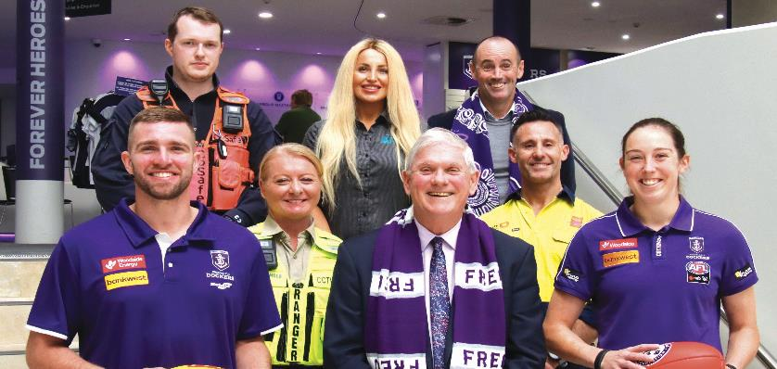
City and Dockers Memorandum of Understanding - June 2023: (Left to Right) Luke Ryan - Fremantle Dockers, Jason - CoSafe Team Leader, Emily - Cockburn Ranger Team Leader, Rebecca - ARC Member Relations Team Leader, Mayor Logan Howlett, Simon Garlick - CEO Fremantle Dockers, Dave - Cockburn Parks team member and Aine Tighe - AFLW Dockers

City Growth and Moving Around Challenges
Traffic congestion is a challenge in Cockburn and the greater Perth area, and it will continue to be a priority area due to population growth. (See Note 4.) Steps taken at a local, state and federal level by improving public transportation, investing in new transportation infrastructure, implementing intelligent transportation systems, and other road improvement works aim to reduce congestion. The City will need to identify strategic partnerships and work collaboratively with the other local governments and the Federal and State governments to address this issue.

Community, Lifestyle and Security Challenges
Services to enhance safety and security, and services to support our ageing, culturally diverse and growing community, continue to be important priorities into the future. Community safety and crime prevention issues are complex in nature and require all levels of government and the community to work together to achieve significant change over the life of this plan. (See Note 5.) An increase in mental health and social issues will require the City to continue to increase provision or facilitation of responsive local social support and mental health services for the community.

Listening and Leading Challenges
Financial sustainability challenges will continue, including pressure for rate capping, increasing ratepayer expectations and demand to decrease ‘red tape’, and increased
materials costs. Over the next 10 years it is anticipated that society will continue its digital transformation journey that will enable new innovative products and services, drive efficiency and allow better decision-making. Legacy systems are also an emerging issue that are creating challenges for large organisations to be agile and adapt to change. Cybersecurity continues to be a global and local risk that will need to be managed into the future.
The City, like all local governments, faces challenges related to the balance between local autonomy and state control, disparities in resources among different levels of government, transparency and accountability concerns. The City will require governance to continue managing these challenges and the expectations of ratepayers. (See Note 6.)
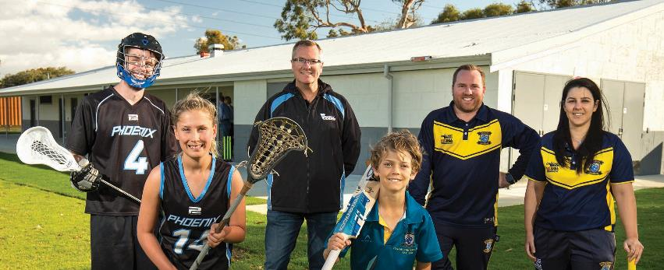
Upgrade to Goodchild Park clubrooms complete - November 2022: (Left to Right) Phoenix Lacrosse Club rep, Junior Phoenix Lacrosse Club rep, Colin Moir - President Phoenix Lacrosse Club, Junior Cockburn Cricket Club rep, Cockburn Cricket Club - James Matkovich and Jorja Goddin
Sources:
Note 1: Australian National Accounts: National Income, Expenditure and Product, June 2023, Australian Bureau of Statistics: https://www.abs.gov.au/statistics/economy/national-accounts/australian-national-accounts-national-income-expenditure-and-product/jun-2023
Note 2: Australia Economic Outcome OECD, June 2023, Australia projection note OECD Economic Outlook June 2023 by OECD: https://issuu.com/oecd.publishing/docs/australia-oecd-economic-outlook-june-2023?fr=sOWVkYTUwNTY2MTA
Note 3: Western Australian Climate Projections, September 2021: https://www.wa.gov.au/system/files/2022-01/Western_Australian_Climate_Projections_Summary.pdf
Note 4: National, state and territory population, September 2023 Australian Bureau of Statistics: https://www.abs.gov.au/statistics/people/population/national-state-and-territory-population/mar-2023
Note 5: Megatrends PWC, October 2022: https://www.pwc.com/gx/en/issues/assets/pdf/pwc-megatrends-october-2022.pdf
Note 6: Technology Trends Outlook 2023, July 2023: https://www.mckinsey.com/capabilities/mckinsey-digital/our-insights/the-top-trends-in-tech#new-and-notable

Integrated Planning and Reporting Framework
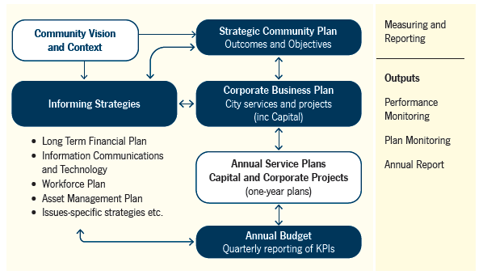
The flow chart above illustrates the Integrated Planning & Reporting Framework.
The flow chart is multi-directional. At each step, arrows point forward to one or more boxes and back to the previous box or boxes. The flow chart is described below as a series of lists. Please contact City of Cockburn for more information or clarification.
- Community Vision and Context
  - forward to Informing Strategies
  - forward to Strategic Community Plan: Outcomes and Objectives
- Informing Strategies
  - forward and back to Corporate Business Plan: City services and projects (including Capital)
  - forward and back to Annual Budget: Quarterly reporting of KPIs
- Strategic Community Plan: Outcomes and Objectives
  - forward and back to Informing Strategies
  - forward and back to Corporate Business Plan: City services and projects (including Capital)
- Corporate Business Plan: City services and projects (including Capital)
  - forward and back to Strategic Community Plan: Outcomes and Objectives
  - forward and back to Informing Strategies
  - forward and back to Annual Service Plans, Capital and Corporate Projects (one-year plans)
- Annual Service Plans, Capital and Corporate Projects (one-year plans)
  - forward and back to Corporate Business Plan: City services and projects (including Capital)
  - forward and back to Annual Budget: Quarterly reporting of KPIs
- Annual Budget: Quarterly reporting of KPIs
  - forward and back to Informing Strategies
There is a bulleted list under Informing Strategies:
- Long Term Financial Plan
- Informing Communications and Technology
- Workforce Plan
- Asset Management Plan
- Issues-specific strategies etc.
To the right of the flow chart is a section marked Measuring and Reporting:
- Outputs
  - Performance Monitoring
  - Plan Monitoring
  - Annual Report

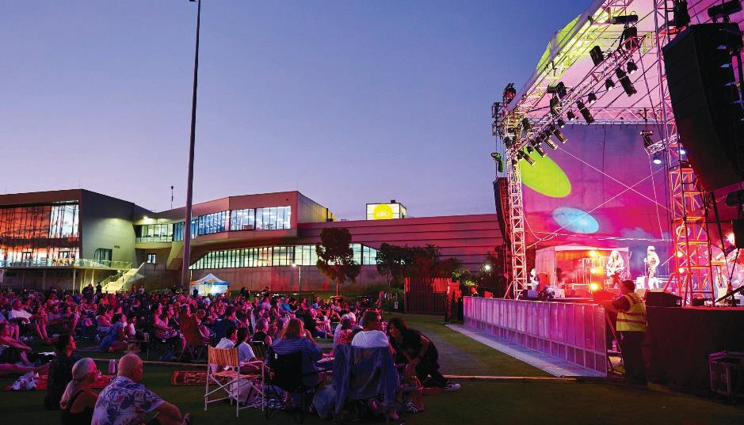
Cockburn Community Concert with Kasey Chambers - February 2023

Strategic Community Plan
The City’s Strategic Community Plan 2020-2030 sets the strategic direction for the organisation. A minor review of the plan was undertaken in 2021 and the next major review is scheduled for 2025. The City continues to deliver on the vision and outcomes identified through the Strategic Community Plan.

Corporate Business Plan
The Corporate Business Plan 2020-2021 to 2023- 2024 outlines the City’s activities to deliver against the Strategic Community Plan 2020-2030. The Corporate Business Plan hinges on the acceptance of priorities, outcomes and strategic objectives included in the Strategic Community Plan.

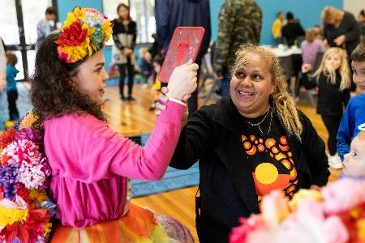 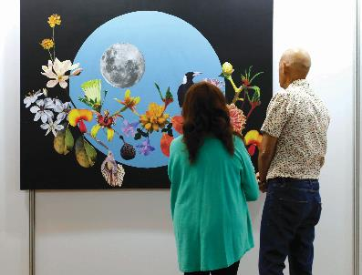
Left: Cockburn NAIDOC Community Event - July 2022. Right: Show Off 18 Art Exhibition - March 2023.
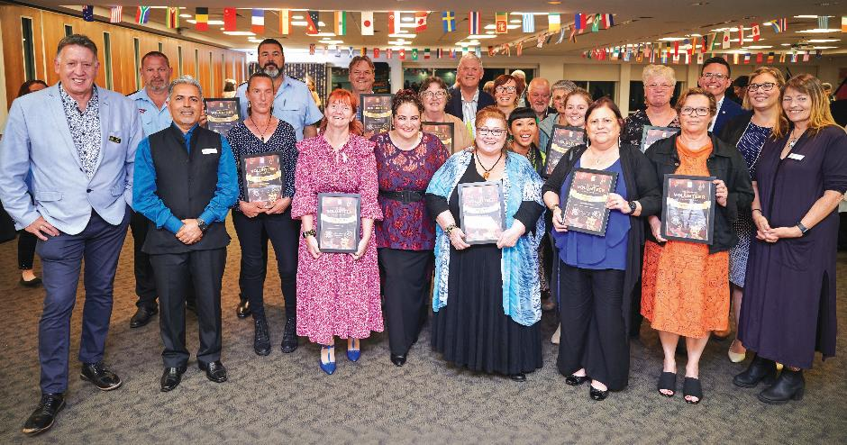
Volunteer of the Year Awards - October 2022: (Left to Right) Cr Philip Eva JP, Brad Marston - Marine Rescue Cockburn, Cr Tarun Dewan, Serena Gamble - Feed It Forward, Deputy Commander Brett Barbarich - Marine Rescue Cockburn, Kate De’Laney - Pregnancy and Infant Loss Australia, Gary Allen - Cooby Cares, Cr Chontelle Stone, Felicity Bairstow - The Wetlands Centre Cockburn, Mayor Logan Howlett, Serene Anderson - Friends of the Community (FoC), Vicky - City of Cockburn Environmental Education Officer, Joyce Gadalon, Brian Bell, Janet Bell, Morgan Campbell - Turtle Tracker, Connie (Concettina) Celenza - Fremantle All Abilities Netball Club, Marie Brand - Yangebup Progress Association, Jane Snare - Cooby Youth Space, Deputy Mayor Cr Tom Widenbar, Cr Lara Kirkwood and Cr Phoebe Corke.

The Year Ahead
Below are the priority projects the City is undertaking in the 2023-24 financial year to deliver against each of the community outcomes, as outlined in the Corporate Business Plan. For full details on the City’s priority projects please refer to the City of Cockburn Corporate Business Plan 2020-2021 to 2023-2024 which is on the City's website.

Local Economy
Increased investment, economic growth and local employment
- Position Cockburn as a leader in the Blue Economy
- Develop Visitor Economy Approach
- Development of investment attraction program and prospectus
- Cockburn Blue Innovation Hub – operationalising
- Development of the international engagement program
- Development of strategic partnership program.

Environmental Responsibility
Protection and enhancement of our natural areas, bushland, parks and open spaces
- Yandjet Park improvements.
Sustainable resource management including waste, water and energy
- EV chargers at all City infrastructure with solar
- Cockburn Resource Recovery Park Redevelopment Stage 2.
Address Climate Change
- Implement Climate Change Strategy 2020-2030
- Coastal Hazard Risk Management and Adaptation Plan.

Community, Lifestyle and Security
Accessible and inclusive community, recreation and cultural services and facilities that enrich our community
- Development of new Youth Plan
- Development of new Arts and Culture Strategy
- Develop Public Art Masterplan
- Commence Malabar BMX Park Redevelopment
- Wally Hagan Recreation Centre Redevelopment business case
- Cockburn ARC – Health and Fitness Expansion (Commence works)
- Beale Park Redevelopment
- Coogee Golf Course Review
- Beeliar Reserve Redevelopment
- Tempest Park Redevelopment
- Santich Park – upgrade
- Review the Community, Sport & Recreation Facilities Plan 2018-2033
- Commence Omeo Public Amenities & Shelters Development
- Development of new Age-friendly Plan
- Review Public Health Plan 2013-2018.
A safe and healthy community that is socially connected
- Development of the Bushfire Risk Management Plan
Aboriginal and Torres Strait Islander cultures and other diverse cultures and heritages are recognised and celebrated
- Aboriginal Cultural and Visitors Centre Development (Commence works)
- Review the Reconciliation Action Plan 2018-2021.

City Growth and Moving Around
An attractive, socially connected and diverse built environment
- Local Planning Scheme Review (Commence Preparation)
- Preparation of Coogee Beach Masterplan
- Civic Facilities Planning.

An integrated, accessible and improved transport network
- Review and update the City’s District Traffic Study 2018
- Phoenix and Rockingham Road Roundabout (Commence works).
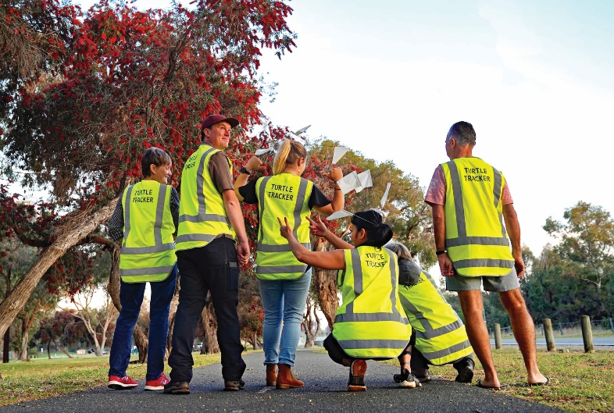
Turtle trackers - October 2022: Trained Turtle trackers volunteers.

Listening and Leading
Best practice governance, partnerships and value for money
- Local Law review
- Risk maturity improvement program delivery
- Major Strategic Review Program – Corporate Business Plan, Strategic Community Plan, Long-term Financial Plan and Workforce Plan
- Develop approaches for the implementation of changes to the Integrated Planning and Reporting Framework as part of Local Government Reform.
High quality and effective community engagement and customer service experiences
- Implementation of Customer Experience Improvement Program.
Employer of choice focusing on equity, innovation and technology
- WHS compliance program
- SaaS migration to the cloud
- IT Personnel Hardware Refresh (previously called Staff Mobility Enablement). Zero client desktop replacement.

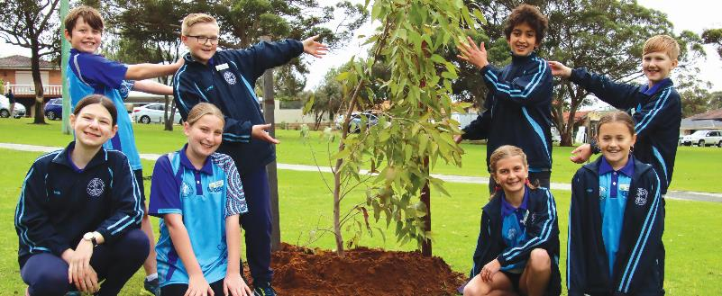
Hiroshima Tree Planting - August 2022: Coogee Primary School.
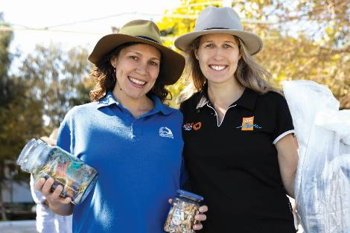 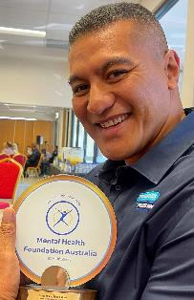
Left: Beach Clean-up - September 2022: Isabella - Perth NRM and Clare - City of Cockburn. Right: Retired UFC Heavyweight Soa ‘The Hulk’ Palelei is Quintessentially Cockburn - October 2022: https://www.cockburn.wa.gov.au/City-and-Council/Events-and-News/News-From-The-City/Soa-Palelei-is-Quintessentially-Cockburn
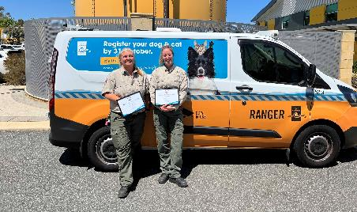 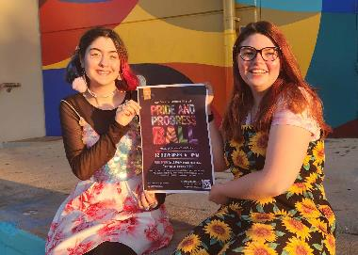
Left: RSPCA WA Humane Awards, bronze medal - October 2022: City Rangers Sam and Isabelle. Right: Cockburn Youth Service Pride & Progress Ball - October 2022: Leila and Bree.
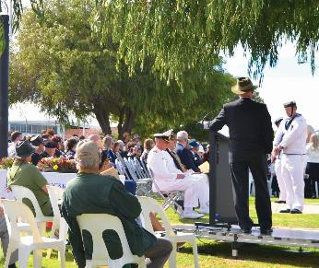 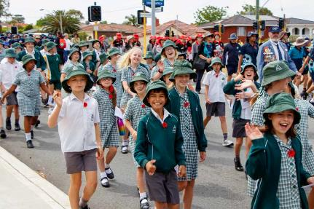
Left: ANZAC Day at Memorial Hall - April 2022. Right: Remembrance Day Youth Parade - November 2022.
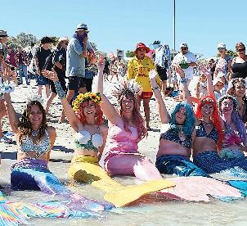 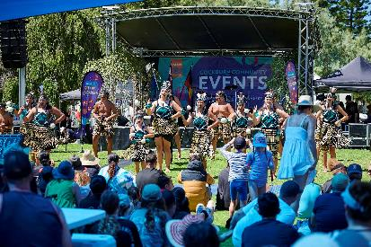
Left: Coogee Live - March 2023. Right: Australia Day Festival - January 2023.

Financial Report
To view the City of Cockburn’s Annual Financial Report 2022-23 on the City’s website (to be provided after the Financial Report is adopted by Council) visit the link below and scroll down:
City of Cockburn: Corporate Strategic Planning: https://www.cockburn.wa.gov.au/Strategies-and-Plans
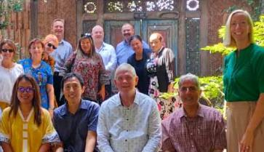 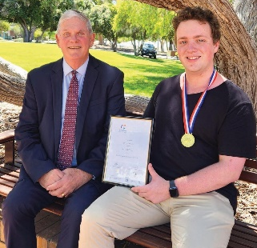
Left: Cockburn-Indonesian Digital Exchange Forum- December 2022. Right: Mayor Logan Howlett and South Coogee Volunteer Bush Fire Brigade volunteer James Wild, youth winner of our 2023 Australia Day Community Citizen of the Year Awards - January 2022.
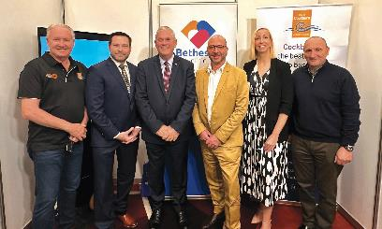 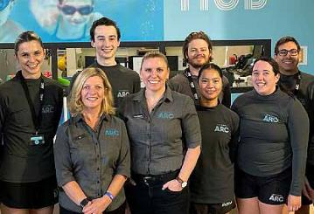
Left: MedCon23 - June 2023. Right: Cockburn ARC’s Swim ARCademy Shines at Austswim WA Awards - June 2023.
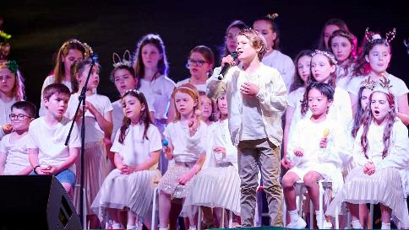 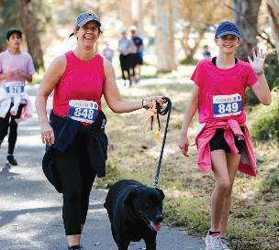
Left: Christmas on the Green - December 2022. Right: Bibra Lake Fun Run - September 2022.

Contact Us
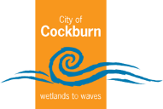
City of Cockburn
Whadjuk Boodja
9 Coleville Crescent, Spearwood WA 6163
PO Box 1215, Bibra Lake DC WA 6965
Telephone: 08 9411 3444
Email: customer@cockburn.wa.gov.au
City of Cockburn website: www.cockburn.wa.gov.au
 City of Cockburn Facebook: www.facebook.com/CityofCockburn
 City of Cockburn Instagram: www.instagram.com/cityofcockburn
 City of Cockburn Youtube: www.youtube.com/CityofCockburn
 City of Cockburn LinkedIn: www.linkedin.com/company/city-of-cockburn

This information is available in alternative formats upon request.
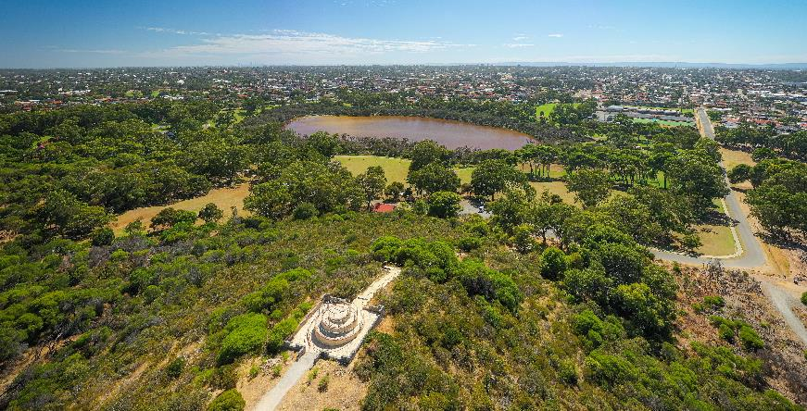
Manning Park, Hamilton Hill.

