Tender Title: |  | RFT 06/2024 – Tree & Tubestock Watering Services – Reserves and Rehabilitating Roe 8
Request ID: |  | 49777
Tender Description: |  | The City of Cockburn (The Principal) is seeking a suitably qualified and experienced Contractor for the application of water, via truck/s and mobile tank/s, to the Principal’s reserves and the Roe 8 corridor. Items requiring watering include the following but not limited to tubestock.  The water will be supplied by the Principal. The majority of watering will be on a scheduled basis; however, some ad-hoc watering may also be required.  The Contractor; under the proposed Contract, will be required to provide all labour, plant, tools and equipment, materials, transportation/cartage, administrative costs, travelling expenses etc. and anything else necessary for the completion of the works/services.
Advert Approval: |  | Decision to Advertise: Acting Chief Operations Officer  Decision Date: Wednesday, 20 March 2024
Closing Date and Time: |  | 2:00PM (AWST) Tuesday, 30 April 2024
Opening Date and Time: |  | 2:00PM (AWST) Saturday, 23 March 2024
 | Tenderer’s Name:
1 | Environmental Industries Pty Ltd
2 | Raymond N Kerridge & Karen Woodard t/a Tree Watering Services
3 | Baroness Holdings Pty Ltd t/a Tree Planting and Watering
4 | South East Regional Centre For Urban Landcare Inc t/a SERCUL
5 | Taylor, Ashley t/a Perth Environmental
6
7
8

Advertisement
Method 1: City of Cockburn | Method 2: Yammer
Method 3:  The Western Australian, Saturday 23rd March 2024 | Tender Awarded by:
Copy of Statewide Notice:  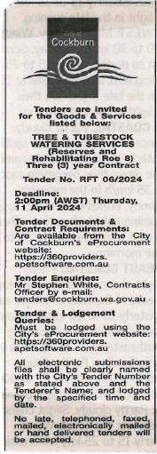 | Director of Planning and Sustainability  Thursday, 12 September 2024
 | Date of Council Meeting:
 | Not Applicable
Name of Successful Tenderer(s): | Raymond N Kerridge & Karen Woodard t/a Tree Watering Services
Amount of Successful Tender(s): (ex GST) | Estimated Value $408,370 Ex GST

