7 February, 2019

Fourth EV charge station installed in the City of Cockburn

The City of Cockburn has a new fast charge Electric Vehicle (EV) charging station for use by the general public, following a generous donation from a local ratepayer.
The 80 amp DC Fast Charger, valued at about $44,000, was financed by Cockburn ratepayer and resident Jon Edwards with the City covering the $18,000 cost of installation at a specially marked parking bay on Junction Boulevard in Cockburn Central.
Mr Edwards, a retired mechanical engineer passionate about promoting electric vehicles, hoped the donation would improve EV charging facilities accessibility for residents and visitors, and foster increased adoption of electric-powered vehicles among the mainstream population.
The station can recharge EVs in a shorter time than lesser powered chargers and its central location is close to Kwinana Freeway, Gateway Shopping City and the new higher density residential areas of Cockburn Central and Success.
The installation, carried out by specialist electrical consultants Gemtek, is the fourth EV charger made available by the City for public use.
The others are at the Youth Centre carpark, Wentworth Parade, Success and at the City’s Administration, Library and Seniors Centre carpark off Coleville Crescent in Spearwood.
City of Cockburn Manager Infrastructure Services Doug Vickery said the new charger was a great facility for local residents and visitors and helped further advance sustainability practices in the City.

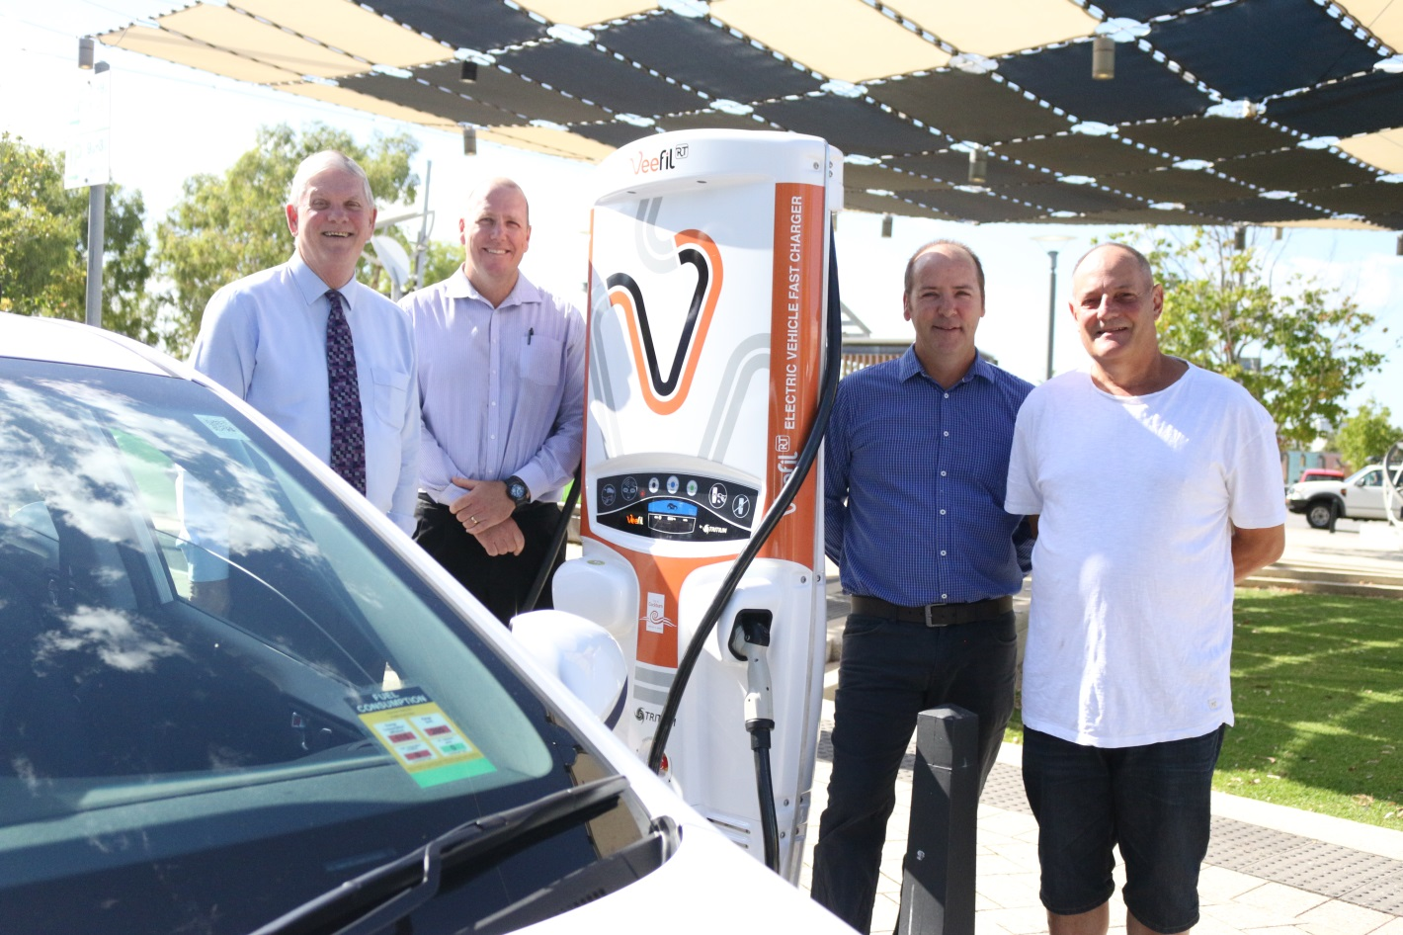

l-r: City of Cockburn Mayor Logan Howlett, City of Cockburn Facilities & Plant Manager Ben Roser, Gemtek Managing Director Edward Kestel and donor and local resident Jon Edwards.

For more information contact:
Media and Communications Officer
City of Cockburn
T: 08 9411 3551
E: media@cockburn.wa.gov.au

