Tender Title: |  | Turf Renovation Service
Request ID: |  | 78982
Tender Description: |  | The City of Cockburn (the Principal) is seeking a suitably qualified and experienced Contractor to conduct scheduled turf renovation services on the Principal’s Sporting Reserves.  Turf renovation works will include:  • Verti-Mowing  • Scarifying  • Low Mowing  • Green Waste Removal  • Coring (hollow and solid tyne)  • Topdressing (sand, compost, blend)  • Fraise Mowing  • Surface Planning  • Over Seeding.  The tender consists of two distinct zones. Tenderers may submit for either one zone or both zones:  Zone A – West: Zone A will consist of all renovation works within the Western division of suburbs.  Zone B – East: Zone B will consist of all renovation works within the Eastern division of suburbs.
Advert Approval: |  | Decision to Advertise: Director Infrastructure Services  Decision Date: Tuesday, 13 January 2026
Closing Date and Time: |  | 2:00PM (AWST) Tuesday, 3 February 2026
Opening Date and Time: |  | 2:00PM (AWST) Tuesday, 3 February 2026
 | Tenderer’s Name:
1 | ENVIRONMENTAL INDUSTRIES PTY LTD
2 | GECKO CONTRACTING TURF & LANDSCAPE MAINTENANCE t/a Gecko Contracting Turf & Landscape Maintenance (Gecko Contracting Turf & Landscape Maintenance)
3 | GREEN OPTIONS t/a GREEN OPTIONS PTY LIMITED
4 | STATEWIDE TURF PTY LTD t/a STATE WIDE TURF SERVICES

Advertisement
Method 1: City of Cockburn website | Method 2: City of Cockburn Libraries Public Noticeboards
Method 3:  The Western Australian, Saturday, 17 January 2026 | Tender Awarded by:
Copy of Statewide Notice:  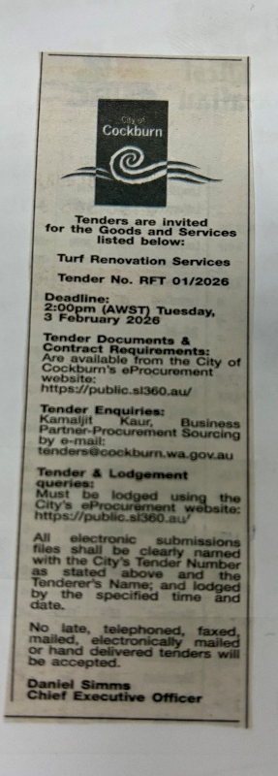 | OCM  Director Infrastructure Services  Tuesday, 10 March 2026
 | Date of Council Meeting:
Tuesday, 10 March 2026
2026/MINUTE NO 0031
Item No. 14.3.2
Name of Successful Tenderer(s): | Zone A: Environmental Industries Pty Ltd Zone B: Gecko Contracting Turf & Landscape Maintenance
Amount of Successful Tender(s): (ex GST) | Zone A: Environmental Industries Pty Ltd - $750,000.00  Zone B: Gecko Contracting Turf & Landscape Maintenance - $750,000.00

