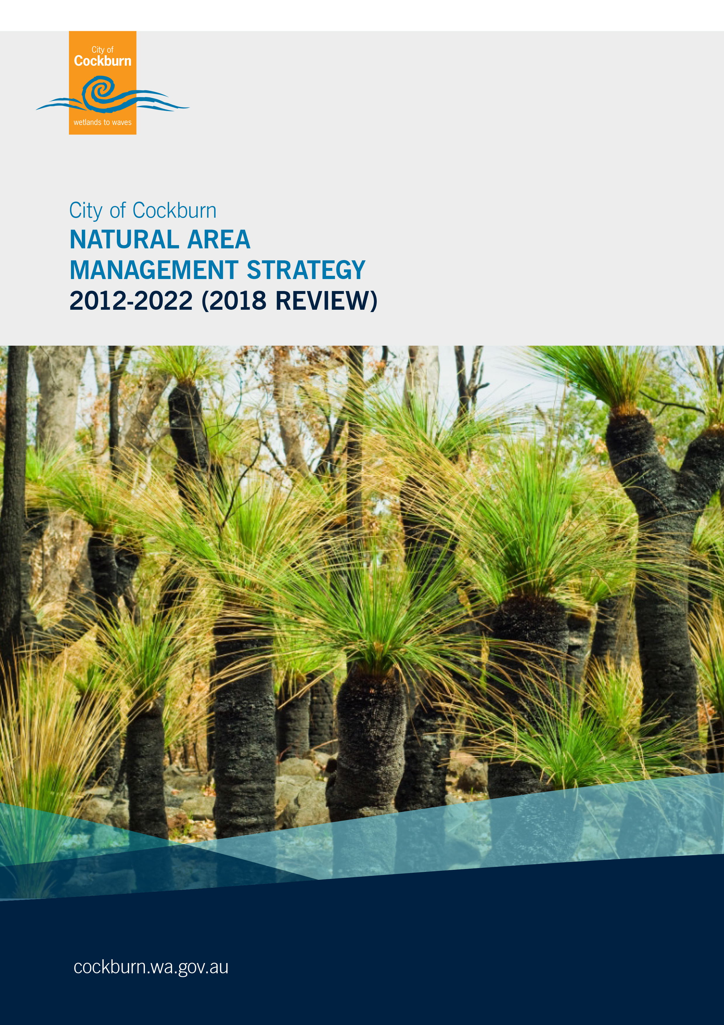

Document Information
Document Title: | Natural Area Management Strategy 2012 – 2022 (2018 Review)
Prepared by: | Chris Beaton, City of Cockburn
Doc. Status: | 2018 Review

Document Control
Version History: | Description: | Date: | Authorised By:
1.0 | First Draft | 06/04/2012 | Chris Beaton
2.0 | Second Draft | 04/01/2012 | Chris Beaton
3.0 | Third Draft | 02/05/2012 | Chris Beaton
4.0 | Final Draft | 11/05/2012 | Chris Beaton
4.1 | Graphic design and final formatting | 06/06/2012 | Chris Beaton
4.2 | Appendices included | 25/06/2012 | Chris Beaton
4.3 | Revised costings and maps | 17/07/2012 | Chris Beaton
4.4 | Review – 2018 | 21/05/2018 | Chris Beaton
4.5 | Revision – SMT & Executive Comments | 31/7/2018 | Chris Beaton
4.6 | 2018 Review – Final | 21/9/2018 | Anton Lees

Table of Contents
Executive Summary 4
1. Strategy Vision 5
2. Strategic Alignment 5
3. Natural Areas 7
4. Natural Areas in the City of Cockburn 8
5. Natural Area Management Objectives 11
5.1. Prioritising Reserves 11
5.2. Environmental Weeds 16
5.3. Feral Animals 18
5.4. Illegal Access 21
5.5. Illegal dumping 22
5.6. Fire Management 23
5.7. Diseases Affecting Bushland 25
5.8. Stormwater Drainage 26
5.9. Climate Change 28
5.10. Wetland Management 29
5.11. Degraded Natural Areas 30
5.12. Ecological Corridors and Linkages 32
6. Achievements 37
7. Summary of Objectives, KPIs and Actions 40
8. Community Consultation 44
9. Operational Funding Requirements 45
10. Measuring Achievement 47
11. Glossary of terms 48
Appendix A - Actively Managed Reserve Classification 49
Appendix B - Bushland Maintenance and Revegetation Costs 51
Appendix C - Keighery 1994 Vegetation Condition Scale 53
References 54

Executive Summary
The City of Cockburn manages 92 bushland reserves, spanning 1,189 hectares. Since 2012, 98 hectares of bushland across eight reserves have been added to the City’s responsibility. While the majority of the City’s natural vegetation reserves are actively managed, a number of the smaller reserves of poor quality bushland are not, due to insufficient resources. Each year the City’s actively managed portfolio increases and in future years additional bushland reserves will be vested to the City as development continues.
As well as bushland reserves, the City contains and manages a number of ecological linkages, which provide important movement passages for fauna and habitat for flora, in developed areas. As the City becomes increasingly urbanised, protecting and enhancing these linkages will be a vital part of maintaining healthy ecosystems in Cockburn.
The City manages natural areas through a system of prioritisation and allocates appropriate resources to each reserve. Each of the City’s reserves is assessed for vegetation condition every four years, and these assessments allow areas to be categorised into low, medium and high priority reserves according to their condition. Reduced bushland condition has negative impacts on native fauna and flora, suburban amenity, carbon sequestration and community expectations.
The City of Cockburn’s Natural Area Management Strategy (NAMS) outlines the City’s approach to managing its vested natural areas, and builds its capacity to maintain them for the conservation of biodiversity. The ultimate goal is for all of the City’s natural areas to have a vegetation condition rating of good or better based on the Keighery 1994 definition of vegetation condition.
The main threats to the City’s natural areas are environmental weeds, feral animals, illegal access, illegal rubbish dumping, increased fire frequency, diseases such as dieback, untreated storm water and the impacts of climate change.
This document is a five year review of the strategy which contained 12 objectives aligned to 7 KPI’s with 55 actions to improve bushland condition. The review established a consolidated list of 32 actions and also updated the number of bushland reserves, the vegetation condition of these reserves and other key areas of management. A progress summary against each KPI has been included.

Strategy Vision
The ultimate vision or goal of this Strategy is for all of the City’s natural areas to have a vegetation condition rating of good or better based on the Keighery 1994 definition of vegetation condition.

Strategic Alignment
The City recognises the importance of its natural areas through a number of existing Council documents and strategies.

Figure 1: Strategic alignment
City of Cockburn Strategic Community Plan 2016 - 2026
The Strategic Community Plan contains strategic objectives closely aligned with the NAMS:

Community, Lifestyle and Security
- Providing safe, attractive, healthy programs and infrastructure for a diverse range of activity and people.
- Provide safe places and activities for residents and visitors to relax and socialise.
Economic, Social and Environmental Responsibility
- Sustainably manage our environment by protecting, managing and enhancing our unique natural resources and minimising risks to human health.
- Further develop adaptation actions including planning, infrastructure and ecological management to reduce adverse outcomes arising from climate change.
City of Cockburn Sustainability Strategy 2017 - 2022
The principles of the Sustainability Strategy that relate directly to natural area management are to:
- Conserve biological diversity and ecological integrity
- Act cautiously when there is a risk of serious or irreversible impacts on the environment or the community, and
- Recognise dimensions beyond our borders while concentrating on issues we can influence.

Long Term Financial Plan 2016 - 2026
The Long Term Financial Plan includes funding for reserve maintenance goals, objectives and revegetation projects as outlined in this Strategy.

Public Open Space Strategy 2014- 2024
Many areas of public open space contain pockets of bushland. The Public Open Space Strategy outlines the approach to managing these small parcels within broader turfed areas.

Urban Forest Plan 2018 - 2028
The Urban Forest Plan provides a holistic approach to improving canopy cover throughout the City of Cockburn. The Plan is guided by six strategic objectives and targets, accompanied by 27 actions which map a clear pathway to achieving the City’s aspirations for a thriving urban forest.

Reserve Management Plans/Master Plans
The Natural Area Management Strategy provides an overarching framework for natural areas but individual reserve management plans are necessary in some instances to provide a more detailed approach to management in areas where there are unique factors specific to that particular reserve.

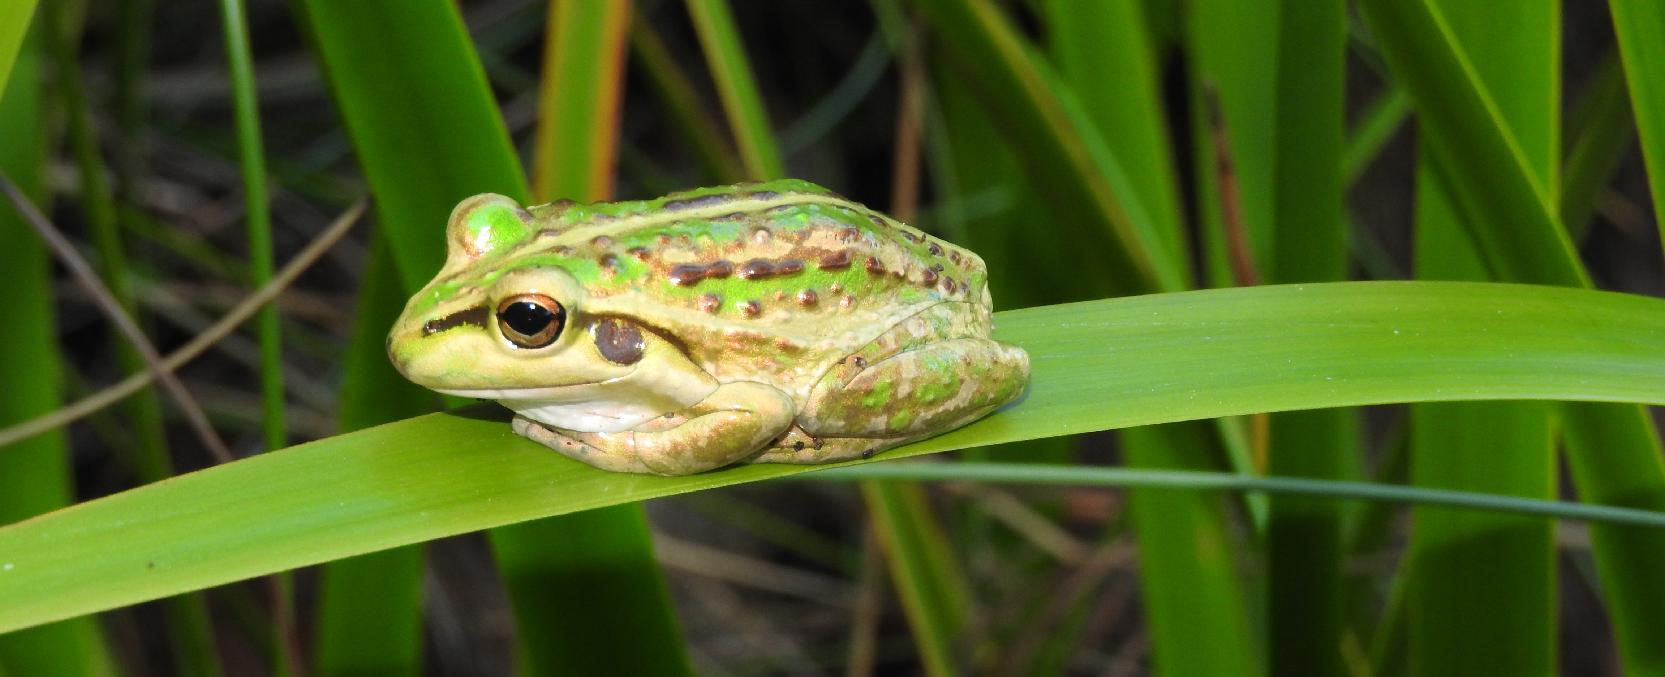

Image 1: Motorbike Frog (Photo credit: Amy Krupa)

Natural Areas
A natural area is a term used to describe places that have native species or communities in a relatively natural state and contain biodiversity. They can include native vegetation, vegetated or open water bodies (lakes, swamps, wetlands) or waterways (rivers, streams, creeks), springs, rocky outcrops, bare ground (sand or mud), caves, coastal dunes or cliffs. Natural areas exclude cleared parkland areas, isolated trees in cleared settings, ovals and turf areas.
Natural areas retain and protect biodiversity, provide a sense of place and create a ‘green’ living environment for local residents. They offer recreational opportunities such as bushwalking and bird watching and are a valuable educational resource for schools, TAFEs and universities. Natural areas in the urban environment provide health benefits including improved air and water quality, help cities avoid extremes in temperatures and are linked to lower rates of chronic disease. There are an enormous range of potential health and wellbeing benefits from contact with nature including crime reduction, psychological wellbeing, reduced stress, boosted immunity, enhanced productivity, improved mental health, reduced blood pressure, heart rate and cholesterol and spiritual development.
Natural areas ensure the long term survival of diverse ecological communities. Research suggests that at least 30% of a region’s ecological community needs to be retained to maintain species diversity. The Australian Government has recognised the need to retain this percentage of each vegetation community and has set objectives and targets to achieve this. Four of the six vegetation complexes in the City are below the 30% threshold (see Table 1 below). Representatives of these complexes must be retained to ensure their long term survival.
Vegetation Complex | Pre-European extent (ha) | 2010 Remnant vegetation extent (ha) | 2016 Remnant vegetation extent (ha) | % of Pre-European remaining Swan Coastal Plain | % Proportion within Cockburn
Bassendean Complex - Central and South | 6,810 | 2,217.37 | 1,839 | 32.37 | 7.78
Cottesloe Complex-Central And South | 4,991 | 1,035.17 | 973 | 21.39 | 11.02
Herdsman Complex | 1,231 | 514.56 | 508 | 41.67 | 12.73
Karrakatta Complex-Central And South | 1,390 | 171.01 | 154 | 12.30 | 2.62
Quindalup Complex | 1,021 | 87.44 | 729 | 63.48 | 1.87
Southern River Complex | 313 | 112.85 | 108 | 36.07 | 0.53

Table 1: Remnant Vegetation Extent by Vegetation Complexes within the City of Cockburn

Natural Areas in the City of Cockburn
In 2012 the City was responsible for 82 reserves containing bushland comprising 1,091 hectares, ranging in quality from degraded through to excellent. In 2018 there were 1,189 hectares of reserves with bushland in 92 reserves which included coastal, wetland and upland areas, ranging in size from small areas surrounded by parkland of approximately 3,500 square metres to larger reserves of 256 hectares. Of the 92 current reserves, 17 are afforded additional protection through the Bush Forever program. Many of the City’s reserves are located within three regional parks – Beeliar, Jandakot and Woodman Point.
Most of the reserves that contain large areas of vegetation are under active management. There are some smaller reserves of poor quality bushland which are not actively managed due to limited resources. However, all bushland areas are important as they provide movement passages for fauna, and it is hoped that the City will eventually manage these smaller pockets as resources become available. The City will also continue to assume responsibility for additional natural areas in the future as a result of planners securing additional Parks and Recreation reserves via the structure planning process which are then ceded through new subdivisions. These will be primarily in the southern parts of the City. Some of the criteria for selecting natural areas for retention are listed on section 5.1.
Reserve Summary | 2012 | 2018
Total area of reserves containing bushland (Ha) | 1,091 | 1,189
Total area of actively managed reserves | 986 | 1,073
Total area of bushland in conservation reserves (Ha) | 904 | 724*
Area of bushland in actively managed conservation reserves (Ha) | 896 | 660*
% Bushland in actively managed conservation reserves | 91 | 65
% Bushland in non actively managed conservation reserves | 9 | 25
Number of actively managed reserves | 48 | 67
Number of non actively managed | 34 | 25

Table 2: Reserve Summary
*Discrepancies (reductions) in terms of areas of bushland in the above table are due to more accurate vegetation condition mapping being undertaken since 2012. In 2012 the condition rating of reserves included areas of parkland, firebreaks and revegetation. This has been changed and now only bushland within reserves is rated.
Management actions identified in the 2012 Strategy will continue to be used to enhance the condition of existing bushland with the ultimate long term goal of managing the overall condition of the City’s natural areas to a minimum vegetation condition rating of ‘good’ or better based on the Keighery 1994 definition of vegetation condition (see Appendix C). Each reserve is mapped for bushland condition every four years. Comparisons with previous mapping allow the City to monitor its maintenance performance and progress toward enhancing its natural areas. Bushland condition maps are available for viewing on the City’s Geographical Information System (GIS) - Intramaps.
The City’s biodiversity is part of the South West Botanical Province of Western Australia, which is now recognised as one of the world’s top 25 biodiversity hotspots. This is not only because of the huge diversity of plants, animals and habitat types that are highly endemic but because of the loss of these areas due to clearing and urban development.
The City is home to one internationally recognised Ramsar Wetland – Thomson’s Lake. Ramsar is an intergovernmental treaty dedicated to the conservation and 'wise use' of wetlands. Some of the other wetlands within the Beeliar Regional Park are also listed in the Directory of Important Wetlands in Australia.
The City contains important coastal vegetation, consisting of numerous limestone outcrops and significant features such as the Henderson Cliffs.
Flora
There are a variety of flora species, vegetation complexes and groupings in Cockburn’s natural areas. Many of these species are classified as Declared Rare and Priority Flora or EPBC Act 1999 Listed Flora and Threatened Ecological Communities.

In September 2016 the Bassendean Central and South vegetation complex was deemed a Threatened Ecological Community under the Environmental Protection and Biodiversity.
Conservation Act 1999 by the Federal Department of Environment and Energy. Many of the City’s reserves contain this ecological community.
The City has developed a species list for each of its reserves which is continually being updated as additional species are discovered. A herbarium has also been established which is updated as new species are found.
This Strategy and its management actions have been instrumental in conserving and protecting flora within the City’s reserves. The continued improvement in the condition of the City’s natural areas may support an increase of some species into areas where they have become rare.

Fauna
Natural areas provide habitat for a range of local fauna, through a combination of dryland and wetland areas. Reptiles, frogs, birds and mammals are present in each reserve. Wetlands in the City range from fresh to quite saline and offer good seasonal habitat for amphibians such as frogs and turtles. A variety of birds inhabit the various vegetation groupings around wetlands, along the coast and in upland areas. Quendas reside in reserves with areas of dense vegetation throughout the City. Old trees provide nesting hollows for many species of birds and mammals such as possums. Artificial nesting boxes have been installed in trees not yet mature enough to have developed nesting hollows, which provides additional habitat and encourages breeding for local species.

Many trees in areas close to wetlands provide habitat for bats through man-made bat boxes. Bats are known to eat up to 1,000 mosquitos/midge in one night and this helps lessen the impact of these nuisance insects. Reptiles inhabit both wetland and dryland areas and many species of lizards and snakes are quite common.
The City regularly conducts fauna surveys throughout its reserves. Coupled with vegetation condition assessments, these surveys assess the progress the City is making to improve the condition of its natural areas and reveal that a variety of native species are still present within the City’s natural areas. The use of motion sensitive cameras in some reserves has revealed interesting information such as Black Gloved Wallabies visiting Denis De Young Reserve.
Some fauna species found in the City’s natural areas are considered significant or rare under the Western Australian Wildlife Conservation Act 1950 or EPBC Act 1999 Conservation Codes. Others are listed by the Department of Biodiversity, Conservation and Attractions as Priority Fauna.
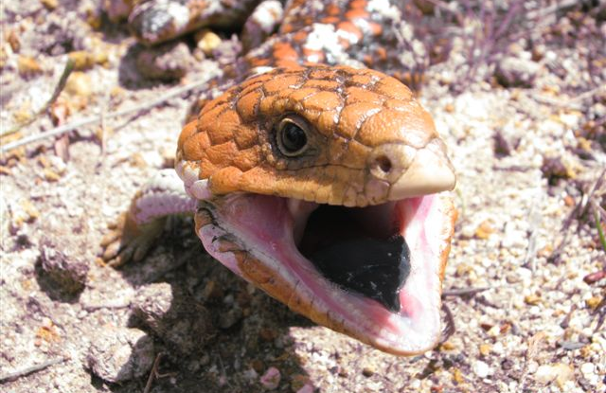

Image 2: Bobtail Lizard, Tiliqua rugosa

Natural Area Management Objectives
This Strategy outlines the City’s approach to sustainably managing its natural areas, through dealing with threats and enhancing its unique natural resources. Its aims are supported by individual objectives which are outlined below.

Prioritising Reserves
Objective 1: To identify reserves of higher value to ensure that finances and resources are allocated in a manner that provides the best outcomes for both the community and the natural area.

The City must prioritise bushland reserves for maintenance and ongoing management. Financial and resource constraints mean that it is not currently possible to manage and improve the condition of all its natural areas, so there needs to be a focus on the reserves that will give the best return on expenditure.
Some of the City’s natural areas are so small that it is not cost effective to manage them intensively and the process of prioritisation determines the amount of funding spent on these reserves. The City of Cockburn prioritises its natural areas based on the Perth Biodiversity Project Local Government Biodiversity Planning Guidelines 2004:

- Vegetation condition
- Reserve size
- Shape
- Perimeter to area ratio
- Connectivity
- Visibility/Community involvement

- Vegetation Condition
Vegetation condition is a measure of an area’s similarity to its state prior to the effects of disturbance from European settlement in Australia. The scale used to assess the vegetation condition of natural areas in Cockburn is the Keighery 1994 method, outlined in Appendix C. The various factors assessed using the condition scales are:

- Plant community structure and composition
- Disturbance factors such as logging, grazing, partial clearing, inappropriate fire regimes, soil disturbance, predation by feral animals, impacts from surrounding land uses
- Weed invasion, and
- Vegetation health such as disease pests, threatening processes such a salinisation, lowering of water tables, climate change, fragmentation.
The City maps vegetation condition on a four year rotating basis. Each vegetation condition survey is accompanied by a natural area assessment which provides information such as fauna observations, type of disturbance, status of management and photos.

Fauna surveys are completed in some reserves at the same time as vegetation condition mapping. Flora and fauna surveys compliment one another, with each providing an indication of how effective management actions are at improving vegetation condition and habitat, particularly when compared with previous years. In April 2011, the City completed a full round of vegetation condition mapping and this has been used as the baseline to assess progress and funding allocations. Table 3 compares vegetation condition between 2012 and 2017.
Bushland Vegetation Condition | Hectares  2012 | Hectares  2017 |  | Percentage of Bushland  2012 | Percentage of Bushland  2018
Pristine | 0 |  | 0 | 0 |  | 0
Excellent | 59 |  | 106 | 7 |  | 16
Very Good | 317 |  | 169 | 35 |  | 26
Good | 225 |  | 202 | 25 |  | 31
Degraded | 113 |  | 140 | 13 |  | 21
Completely Degraded | 182 |  | 43 | 20 |  | 6
Bushland Total | 896* |  | 660* | 100 |  | 100
Revegetation | Included above |  | 36 | Included above |  | 3
Other | Included above |  | 377 | Included above |  | 35
Total Area (Actively Managed) | 896 |  | 1073 | - |  | -

Table 3: Vegetation Condition Comparison 2012-2018

- Size of Reserve
Viability is a measure of how well an ecological community can sustain and support the organisms that occur naturally within that community in the long term. Size is important in determining the long term viability of a natural area.

The bigger the area, the greater its capacity to retain biodiversity, maintain ecological function and resist disturbance factors and threatening processes. The minimum size for an area’s viability varies greatly between different ecological communities and depends on the presence of threats and how well these can be controlled.

Minimum size also depends on the requirements of different species. Remnant areas as small as four hectares are important for retaining intact examples of reptile diversity and areas of one hectare can retain viable populations of many reptiles species if fire frequency and feral animal predation are controlled.

Management costs are much lower for larger and more viable areas. Small areas of remnant vegetation often require intensive management and can be costly, though they provide some habitat value and are worthy as ecological linkages providing connectivity between other larger areas.
- Reserve Shape
Shape influences the impact that threats may have on the edges of a natural area, and their effects often extend into natural areas. The degree that edge effects extend into natural areas varies greatly and depends on the types of threats and how well they can be controlled. These include weed invasion, grazing and trampling, increased sun and wind exposure, pollutants, drift or runoff, air pollution, noise, artificial light at night, rubbish accumulation and dumping, exposure to feral animals and pests and diseases from surrounding land uses. In the metropolitan area of the Swan Coastal Plain edge effects typically extend at least 25 metres into natural areas.

Compact areas such as circles, squares and squat rectangles are the most viable, as their core areas are the largest for their given size. Long thin shapes have the lowest viability as most of their area is impacted by edge effects (see Table 4).
Research indicates that native vegetation acting as a link between larger viable natural areas needs to be at least 25–50 metres wide for use by many bird species. Birds are also more likely to use patches of native vegetation if they are within 500-1,000 metres of viable natural areas.
Shape | Viability
Circle, square or squat rectangle | Highest
Oval, squat oblong or symmetrical triangle | High
Irregular shape with few indentations | Medium
Irregular shape with many indentations | Medium to low
Long shape with large proportion of area greater than 50m wide | Lower
Long thin shape with large proportion of area less than 50m wide | Very Low

Table 4. Natural Area Shape Viability

- Perimeter to area ratio
Perimeter to area ratio can be a useful indicator of viability and is determined by size and shape, by dividing the length of the perimeter by the area. The higher the score the lower the viability because the greater the perimeter the more likely the site is to be impacted by outside influences. This is more commonly known as edge effects.
- Connectivity
The viability of any natural area depends on its proximity to other natural areas and the quality of an ecological linkage between them. These factors influence the movement of individual living organisms and the flow of genetic material between natural areas. This determines the long term survival of species, their genetic variation, their ability to adapt to changes in the environment and the maintenance of ecosystem processes. The viability of a given natural area will increase:
- The closer it is to other protected natural areas
- The greater the number of protected natural areas within close proximity to it, and
- The better the condition of surrounding natural areas.

- Visibility/Community Involvement
Prominent reserves are valued more highly by the community and have higher participation rates. Often there are higher expectations for management and maintenance costs are generally higher than less prominent reserves. Greater community involvement provides benefits as applications for funding from alternative sources such as grants are more likely to be successful. Consideration is given to proximity to residential areas, public perception and amenity and whether or not a reserve has an active community group that is involved in its maintenance.

Management Categories
The City’s 92 natural areas are prioritised using the six criteria detailed above. Each of the criteria are given a rating out of five and totaled. The reserves are then prioritised into three management categories high, medium and low.
Table 5 compares ratings between 2012 and 2018. The differences are due to the change in the way reserves have been assessed for vegetation condition and re-evaluated based on updated information.
Score | Priority Rating | Hectares 2012 | Hectares 2018
1 to 10 | Low | 7.42 | 1.05
11 to 20 | Med | 169.51 | 221.69
Above 20 | High | 719.41 | 473.02
Total |  | 896 | 696

Table 5: Management Categories
High priority bushland reserves have the highest ecological viability and/or community involvement. Medium priority bushland reserves have lower ecological viability and/or community involvement than high priority reserves. Low priority bushland reserves have the lowest ecological viability and little or no community involvement. Generally, resources should first be allocated to
high priority reserves, followed by medium. Minimal resources should be directed towards low priority reserves until the higher priority reserves are in good or better condition.
Table 6 provides a summary of the reserve categories and considerations while Appendix A lists the reserves and their priority classification.

Management Category | Considerations
High Priority | Very high viability, Bush Forever Site, low community involvement
High Priority | High viability, Bush Forever Site, high community involvement
High Priority | High viability rating, Bush Forever Site, Low community involvement
Medium Priority | Medium viability, medium-low community involvement
Medium Priority | Low viability, medium-high community involvement
Medium Priority | Medium viability, low community involvement
Medium Priority | Low viability, high community involvement, Bush Forever Site, part of Regional Park
Medium Priority | Low viability, very high community involvement
Low Priority | Medium viability, low community involvement
Low Priority | Medium viability, low-medium community involvement
Low Priority | Low viability, medium to low community involvement

Table 6: Management Category Summary
In 2012, there were three Bushland Maintenance Teams made up of two full time employees, who were responsible for groundworks in the City’s natural areas. This has since been consolidated into two teams of three, as recommended in the 2012 Strategy: Each team is responsible for particular reserves and undertakes on-ground works within a set number of hours. Maintenance hours are allocated based on reserve priority. The City also engages contractors for maintenance because the number of reserves is beyond the capacity of the current staff allocation for bushland maintenance. Contractors are currently responsible for maintaining 25 reserves. All actively managed reserves are regularly maintained and higher priority reserves are allocated the most hours.

Environmental Weeds
Objective 2: To control environmental weeds within the City’s managed natural areas.

The Australia Biodiversity Conservation Strategy 2010-2020 states that “weeds are among the most serious threats to Australia’s natural environment and primary production. They displace native species; contribute significantly to land degradation”.
Environmental weeds can increase the frequency and intensity of fire in bushland areas, which in turn results in more weeds becoming established. This is called the fire-weed cycle and ultimately leads to a loss of biodiversity and an increase in the fire hazard of a bushland area.
Many of the City’s natural areas are infested with weeds, which degrades their quality and affects the overall viability of the area.
The City’s Weed Management Plan was developed to address weed control. It has been recently updated to coincide with the review of this document. One of the recommendations of the Plan is to undertake regular weed mapping throughout all of the City’s natural areas. Weed mapping identifies the types of weeds in given reserves and enables on ground programs to be developed. The first round of weed mapping for the City’s natural areas was completed in April 2010.
As part of the Weed Management Plan, a Priority Weed List was developed. Priority weeds are those considered to be highly invasive and which pose the most serious threat to native vegetation. Weeds are listed in order of threat, which indicates the order they should be targeted for control. The Priority Weed List is reviewed every five years in line with the reviews of this Strategy. The list was most recently reviewed in 2018.
The City measures the effectiveness and overall performance of each reserve’s management program through weed mapping and vegetation condition mapping. Weed mapping is undertaken every four years in each reserve and allows programs to be modified if they are ineffective. Mapping provides a good indicator of the current status of the City’s natural areas and enables management goals and targets to be set. The City has recently begun undertaking fauna surveys in selected reserves which provides an indication of how effective management actions are in improving habitat for native species.
Perennial Veldt Grass (PVG) is having the greatest impact on natural areas in the City. It is well established in many reserves, is the most widely spread and abundant environmental weed and is also considered a major fire hazard. There are many factors to consider when targeting PVG for control. Without a concerted revegetation program in degraded areas, other significant environmental weeds such as Geraldton Carnation weed, Gladiolus species and Wild Oats may replace the PVG and many of these are more difficult to control.
The City has begun to use fire to assist in weed control as areas identified as high fire risk are often areas with a high level of weed invasion. Controlled burns are used to reduce fuel loads from weeds such as PVG in conservation zones, and intensive weed control is then undertaken for two years to prevent weeds returning. This reduces long term fire risk and improves vegetation condition. Fire provides a perfect opportunity for increased weed invasion as without intensive weed control after a burn, the fuel load can become just as high within two to three years because of the return of invasive weeds. Funding must be available for a two year intensive weed control program after controlled burns.
Where practical the Bradley Method of Bush Regeneration is practiced (see section 5.11 for more details).

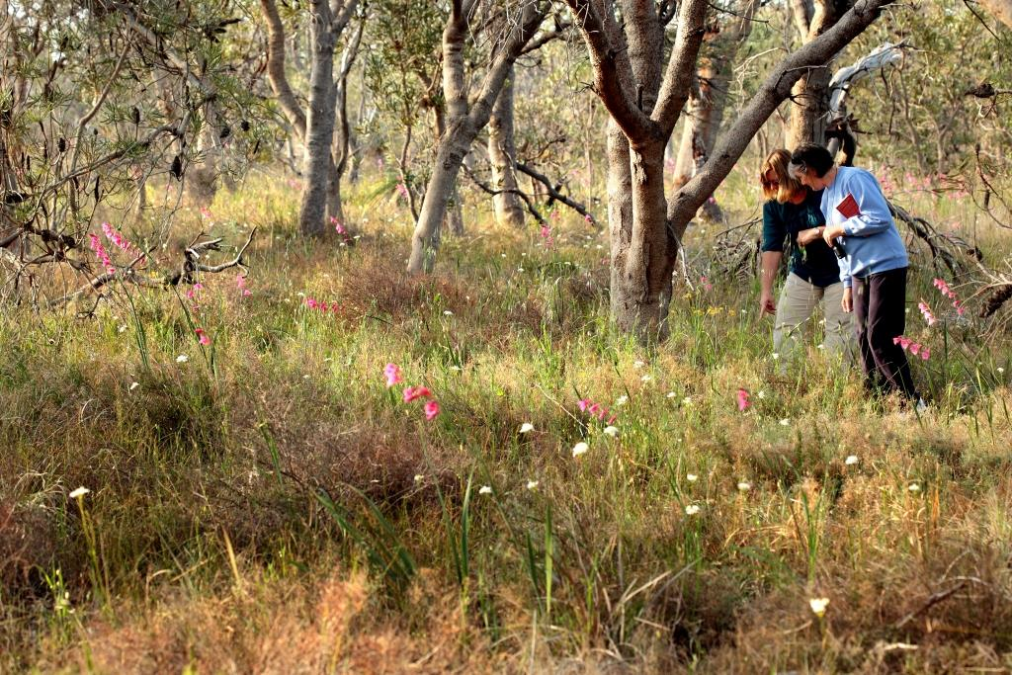

Image 3: Weed Identification at Denis de Young Reserve

Feral Animals
Objective 3: To control and, where possible, eradicate feral animals and minimise the impact of roaming cats within City managed natural areas.

A feral animal is defined as an introduced or domestic animal living in the wild. Roaming cats are domesticated cats that owners allow to roam outside their property boundary. Animals that cause the greatest impact on City’s natural areas are rabbits, foxes, cats, bees and a number of birds such as the Eastern Rosella that are not endemic to Western Australia. Horses cause damage in reserves by spreading disease such as dieback, weeds via droppings, trampling vegetation, erosion and causing potential conflicts with other park users. The City does not permit horses in actively managed conservation areas.
Feral animals compete with native species for food and breeding sites. They prey on native animals and destroy native vegetation, particularly young seedlings. Roaming cats hunt in natural areas catching and killing native animals including insects, reptiles and frogs. Many reserves are fragmented and surrounded by residential, commercial or industrial areas and domesticated and feral animals move from these areas into local reserves to hunt.
Feral animal control
The City uses an integrated pest control program to manage this problem through fencing, baiting, trapping, virus release, fumigation, nest removal and hive destruction. Specialist contractors implement the programs, depending on tasks required. These include the release of Rabbit Haemorrhaging Disease Virus (RHDV) K5 for rabbit control, specific gun licenses to humanely destroy animals and site risk assessments undertaken before implementing control programs. The City does not control feral animals on private property but encourages rural landowners to do so via the Landowner Biodiversity Conservation Grant Program. The City does not condone cruelty to any animals and any trapped animals are humanely destroyed if required. No feral animal control programs occur where there is risk to pets, people or native wildlife.

Cats
Cats are caught in standard box traps that are set at dusk and removed or closed at dawn, which prevents ravens and other fauna being captured. Feral cats are euthanised and domestic cats are returned to their owners by Ranger Services if they can be identified, otherwise they are taken to a refuge. Under current legislation, cats do not need to be confined to their owner’s properties and owners are issued with a cat control notice only. There is scope for this to be addressed in local laws through fines, as it will help to reduce the number of cats entering reserves. City staff are working on developing this as well as an intensive cat owner education program.

The City received funding in early 2018 to track both cats and foxes using radio collars, in conjunction with other local governments in the region. This program will highlight where domesticated cats roam and the information will be used to develop an education program for cat owners. The focus will be on ensuring cat’s safety. Fox tracking will provide additional information about how these animals move across the urban environment, which will be used to develop more effective control programs.
Most of the City’s high priority reserves have annual control programs. These include:
- Bibra Lake
- Yangebup Lake
- Denis De Young
- Little Rush Lake
- Coogee Beach
- Manning Lake, and
- Redemptora Reserve.

Smaller reserves have programs instigated as required.

Rabbits
A number of reserves have rabbit proof fencing. As at October 2017, Cocos and Denis De Young Reserves have had rabbit proof fencing installed. An intensive program of rabbit control has been undertaken in these reserves. Vegetation condition mapping indicates that fencing has been successful in reducing the impact of rabbits within these reserves.

Rabbit proof fencing needs to be carefully considered. In the event of fire, fencing can prevent native animals from escaping. To compensate, concrete pipes have been buried in some reserves to provide refuge for fauna during fire events. Barrier fences can reduce migration to and from areas and impact on genetic diversity. They can also impact on the makeup of resident populations by preventing the dispersal of offspring.
Nesting boxes for birds and bats are installed in trees within reserves to compensate for the hollows that have been taken over by pest species including feral bees.
Collaborative animal control
The City works with neighbouring Councils and other government agencies such as the Department of Biodiversity, Conservation and Attractions and Water Corporation to control feral animals. Coordinating controls and aligning times ensures that better results are achieved, which reduces the likelihood of feral animals taking up residence in areas where animals have been removed. The City also invests in programs that help improve its understanding of feral animals, which improves control measures. Table 7 illustrates how a typical program of feral animal control would be structured.

Reserve | Treatment type  Spring | Treatment Type  Spring/Summer | Treatment Type  Summer
Manning Lake | CV, FW, FT, CT | FT, CT | PB, FT, CT
Denis De Young | MV, FW, FT, CT | FT ,CT | PB, FT, CT
Coogee Beach | CV, FW, FT, CT | FT, CT | PB, FT, CT
Bibra Lake | MV, FW, FT, CT | FT, CT | PB, FT, CT
Yangebup Lake | CV, FW, FT, CT | FT, CT | PB, FT, CT
CV- Calici Virus (or RHDV), MV- Mixamotosis, FW - Fumigation of Warrens, FT - Fox Trapping, CT - Feral Cat Trapping, PB - Pindone Baiting

Table 7: Typical feral animal control program

The City undertakes a regular survey to determine community perceptions in the area of feral animal control. Figure 1 is an excerpt from the most recent community survey in June 2017, which indicates that community satisfaction in this service area is good.
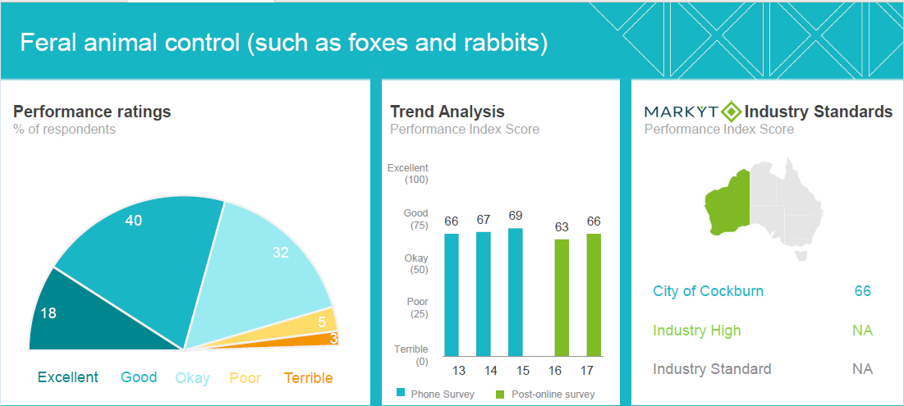

Figure 1: Community Satisfaction Survey Feral Animal Control

Illegal Access
Objective 4: To minimise the impacts to natural areas caused by unauthorised and uncontrolled access.

Bushland reserves are a valuable community asset and controlled pedestrian access is encouraged. However unauthorised access by off road vehicles, motor bikes and horses can contribute to environmental degradation. Impacts include vegetation loss by trampling and browsing, erosion, introduction of weeds (horses via feed and droppings) potential conflicts with other visitors and impacts on visitor experience. Anecdotal evidence suggests that reserves with uncontrolled access are also more prone to arson and graffiti.
Most of the City’s bushland reserves have fencing to minimise uncontrolled and illegal access. Reserves surrounded by passive parkland are generally not fenced as this detracts from their amenity.
A number of different types of fences, gates and entry points are used to control access. The type of fence installed depends on their location and their objective. Consideration is given to access for authorised vehicles, wheelchairs, prams and gophers and as well as for firefighting purposes. Where practical, chicanes are installed at pedestrian access points to restrict motorbike and horse access while gates are installed to allow authorised vehicle access. Bollards are also used in some locations.
Although most of the City’s reserves are fenced, illegal access still occurs. Fences are regularly cut, gates knocked over and motorbikes and horses enter reserves via pedestrian access points. The City repairs damage to fences within two working days of being notified.

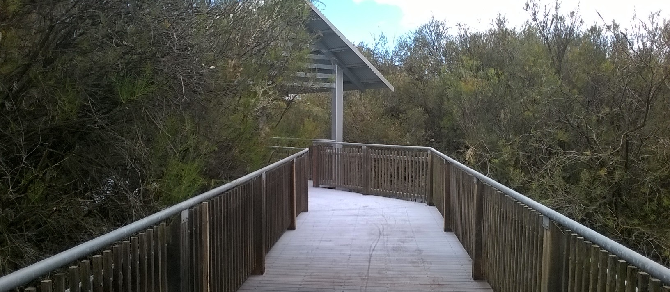

Image 4 : Secure access and viewing for the community at Eco Park

Illegal dumping
Objective 5: To prevent illegal rubbish dumping in natural areas.

Illegal dumping refers to the dumping of rubbish and garden waste in public areas. The environmental impacts of illegal dumping are significant and include introduced weeds, contamination, vermin, reduced aesthetic value and amenity as well as increased bushfire risk. Water quality within wetlands can also be affected.
Illegal dumping can also pose serious health risks. Areas used for illegal dumping may be accessible to people who are vulnerable to the physical and chemical hazards posed by waste, particularly children.
Most reserves are fenced which helps to prevent illegal dumping. Where dumping still occurs the current strategy is to clean up any rubbish as soon as practical and dispose of it appropriately. Rubbish removal costs impact on the funding available for other maintenance and enhancement activities in City reserves. Perpetrators are identified where possible and fines are imposed.
In areas where illegal dumping regularly occurs, a community education and engagement program has been developed. Community groups are also encouraged to be involved in clean up programs such as Keep Australia Beautiful. The City uses surveillance cameras to help identify illegal dumping and will prosecute offenders. The City will continue to develop and implement education programs that assist in reducing the amount of waste being dumped by raising awareness of the issues associated with dumping.
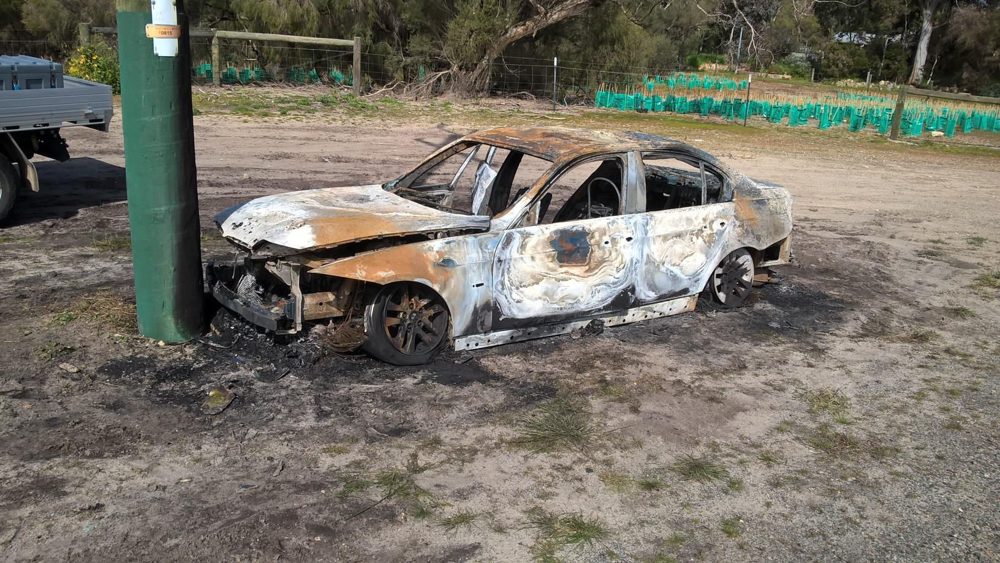
Image 5: Illegal dumping at Buckingham Reserve

Fire Management
Objective 6: To protect the biodiversity values of the City of Cockburn’s bushland reserves and limit the risk to people and property by reducing the frequency and intensity of unplanned fires.

Unplanned fires are a major cause of degradation of bushland areas. Many fires are deliberately lit. Frequent fires lead to the degradation of bushland by creating an environment ideally suited to weeds, particularly grasses because of a lack of canopy cover and additional nutrients post-fire.
Frequent fires also impact on plant diversity by destroying slower growing species before they can produce seed. This can lead to the loss of species and changes to vegetation communities. The control of environmental weeds, particularly PVG, is an effective way to reduce the fuel load of bushland areas. Reducing fuel loads minimises both the likelihood and intensity of fire.
Prescribed burning can also be an effective management tool. Undertaking slow burns in the cooler months can reduce fuel load within natural areas, but it is important that these burns are at intervals of between eight and 16 years. It is also important that when prescribed burns are undertaken, there are available resources for weed control for at least two years after the burn. Without follow-up weed control, weeds can quickly reestablish in a natural area and any benefit in fuel load reduction is soon lost, sometimes within one to two years.
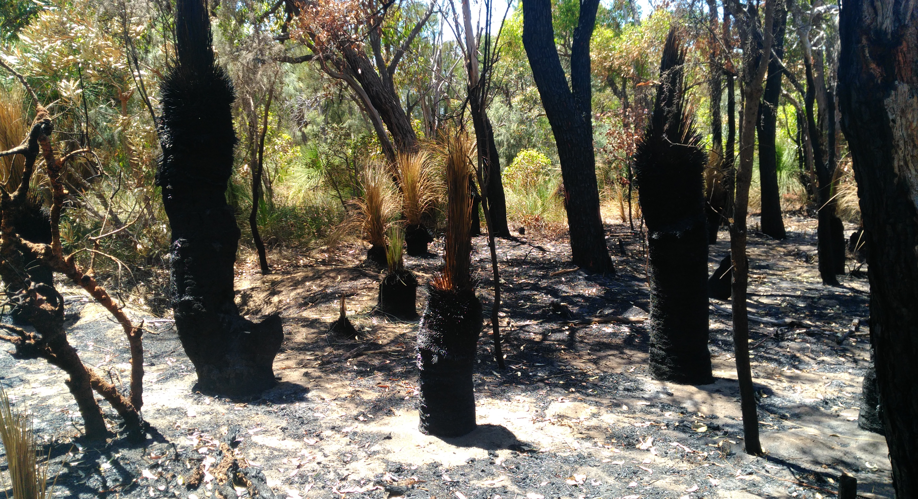
Image 6: Post-fire inspection at Jamy Reserve
Research has indicated that it is important to have a number of sites with varying fire histories to provide a range of habitats. This mix should include areas that are burnt more frequently at eight year intervals, up to areas that have not been subjected to burns in 30 years.
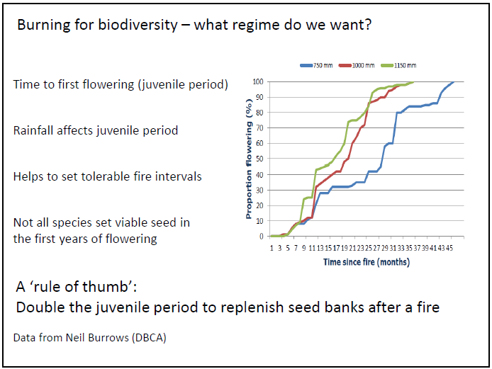

Figure 2: Biodiversity Burning Regimes

Firebreaks are an important consideration for fire management in bushland reserves. By law, reserves greater than two hectares require three metre wide firebreaks around their perimeter and in larger reserves, additional strategic firebreaks are also considered. The City has been placing crushed limestone on selected firebreaks to reduce maintenance costs, provide ease of access for firefighting and community use and reduce the spread of disease such as dieback.
Controlling illegal vehicle access into reserves can also reduce unplanned fires in natural areas. Weed control is undertaken on verges directly abutting reserves to reduce fuel loads and the likelihood of roadside fires spreading into reserves.
Fire response plans are prepared for all City reserves. Plans use current aerial photos to show designated firebreaks, past fire sites, access points, vegetation types, water points and constraints within the reserve. Plans are updated every three years. Fire response plans are issued to the Department of Fire and Emergency Services (DFES).

Diseases Affecting Bushland
Objective 7: To reduce the impact of plant disease in natural areas.

A number of diseases can impact on bushland quality, including Dieback and Armillaria root rot. The main disease affecting bushland areas is Dieback Phytophthora cinnamomic, although other strains of the disease are becoming more prevalent. Dieback has been identified in a number of bushland reserves, including Denis De Young, Little Rush Lake, Yangebup Lake, Holdsworth, Berrigan, Bosworth and Gil Chalwell.
Dieback can have catastrophic consequences for the biota of ecosystems, causing a decline in biodiversity and irreversible damage to plant communities. This reduces habitat and food supplies for native fauna and once Dieback is established in an area it is extremely difficult to eradicate.
Dieback prevention and identification
When entering reserves and undertaking works, staff and contractors are expected to follow correct hygiene procedures. Where Dieback is suspected, phytophthora dieback surveys are done by specialty consultants and other factors (fire, insects, flood, drought, nutrient deficiencies or toxicities and other plant diseases) are first discounted. If Dieback is positively identified in a reserve, the area is mapped for future reference. Dieback areas are highlighted on Fire Response Plans, reserves are re-mapped and follow up treatments occur every three years.

Dieback treatment
Phosphite is used to treat Dieback in selected areas, through either spray or by injecting the stems of susceptible plants. A combination of both treatments can also be employed. Where large areas have been infected, aerial helicopter treatment can be undertaken. This method has been used at Denis De Young Reserve.

Crushed limestone is placed on firebreaks in reserves to reduce the spread of Dieback and other diseases. Limestone makes an ideal material in constructing firebreaks as its high pH suppresses Phytophthora Dieback. Where possible, Dieback resistant plants are used to revegetate Dieback affected areas.

Stormwater Drainage
Objective 8: To enhance wetland water quality and reduce erosion in conservation areas.

The Beeliar Regional Park contains many of the City’s wetlands. Some of the reserves in the East Ward also contain wetlands, including Bosworth, Emma Treeby, Mather and Denis de Young. Until recently, many wetlands were filled and development was allowed to occur very close to water bodies without adequate buffers. In the latter case stormwater was generally discharged directly into wetlands and as a result many suffered from water quality issues including excess nutrients, hydrocarbon and heavy metal contamination.
Today wetlands are valued and planning controls exist to prevent the direct discharge of stormwater into them. The Western Australian Planning Commissions Better Urban Water Management 2008 document and the Department of Water and Environmental Regulations Guidelines for Water Sensitive Urban Design have been developed to enhance water quality and use on the Swan Coastal Plain and help protect wetlands.
If stormwater is discharged near wetlands, it is generally done so in infiltration basins or vegetated swales, sometimes called nutrient stripping basins. These retain water for short periods and allow larger particles to settle and nutrients to be filtered or utilised by vegetation. Water within these basins is filtered as it percolates through the soil entering the groundwater which then recharges the wetlands.
In the City, basins and swales are generally required to contain one in five year storm events. In events greater than a one in five, stormwater is allowed to overflow directly into a wetland buffer and ultimately into a wetland. The theory behind this is that most of the contaminants have already been washed into infiltration basins in the early downpour and the quality of the water flowing into the wetland is reasonably good. Erosion control measures are included in the basin design to prevent erosion in the event of an overflow in bigger storm events.
Gross pollutant traps are installed adjacent to wetland areas where development occurs, to capture larger material such as leaves and litter before they enter swales and basins.
Poor water quality can lead to problems associated with nuisance midge and mosquitoes. Seasonal midge swarms close to lakes and wetlands adversely impact the quality of life of nearby residents. The City receives numerous complaints from residents who live close to wetlands. Larger wetlands are generally treated with a larvaecide or pesticide when midge numbers become excessive and monitoring indicates ongoing problems. The City has prepared and implements an integrated Midge Control Strategy to limit the impact of nuisance midge.

In 2015 a solar powered nutrient stripping basin was constructed on the edge of Yangebup Lake, which was used to take water from the lake into a specially designed basin that was heavily vegetated with native plants. The plants used the nutrients and also supplied much needed habitat for local wildlife. The trial was a success and the basin is still functioning. There are plans to further enhance the design and to construct other similar basins.

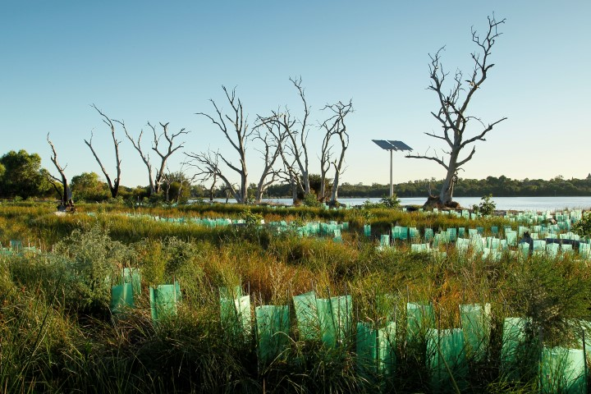
Image 7: Yangebup Lake Nutrient Stripping basin 2016

Climate Change
Objective 9: To build the resilience of natural areas to allow them to adapt to climate change.

Australia’s Biodiversity Conservation Strategy 2010-2030 indicates that natural environments need to be supported to retain their biodiversity values and critical ecological functions in the face of growing pressure, including those from climate change. Maintaining reserves and developing ecological linkages is the most effective and immediate strategy to build resilience in a changing climate and parks and reserves play a key role in buffering natural systems against climate change. Maintaining a comprehensive, adequate and representative reserve system is the best way to secure the habitats of vulnerable species.
Reduced rainfall, increased storm intensity, sea level rise and temperature change all have the potential to impact on natural areas. The most challenging aspect of climate change for natural areas is reduced rainfall, which can dramatically alter vegetation communities. Increasingly, wetlands are retaining less water for shorter periods and if rainfall continues to decrease, plants that depend on periodic inundation may suffer water stress which may impact on species diversity. Lower rainfall could eventually lead to a change in vegetation communities. Upland vegetation will progressively move into areas that were once the domain of wetland species. Although there is no certainty that rainfall will continue to reduce in the longer term, the current trend indicates that this will be the case.
Reduced rainfall may increase the likelihood of bushfire. Frequent fires also impact on plant diversity by destroying slower growing species before they can produce seed. This can lead to the loss of species and changes to vegetation communities.
Vegetation, ecological communities and natural areas are generally very resilient. If allowed to take their own course there will be a natural succession with plants that survive in dryer areas replacing wetland dependent species. The City’s management approach to natural areas in the face of climate change is to allow nature to take the lead, to allow natural succession. In order for this to occur the City needs to make natural systems as resilient as possible to maintain ecological function. This involves reducing other threats that natural areas face so that ecosystems can adapt to climate change. In areas where it is evident that rainfall is decreasing over time, different species are planted. However, this approach needs to be considered carefully as rainfall has been slightly above average in 2016 and 2017 and inundation may still occur. Establishing and enhancing ecological corridors also promotes resilience by allowing species to migrate to and from natural areas.

Wetland Management
Objective 10: To enhance and rehabilitate natural wetland areas while increasing their resilience to withstand climate change impacts.

Many of the reserves managed for conservation also contain wetlands, and wetland dependent vegetation is managed in a similar manner to dry land vegetation. The procedures used for rehabilitation are also similar. Rehabilitation strategies also reflect changes to vegetation communities as a result of climate change.
As part of the Integrated Midge Control Program, wetland water quality is monitored in many of the larger wetland systems where there have been water quality issues in the past. In smaller wetlands water quality is sampled on an as needs basis.
Measures used to address poor water quality include:
- Revegetating riparian areas
- Removing invasive species such as Typha orientalis and replacing with less invasive native species
- Installing gross pollutant traps and nutrient stripping basins, and
- Converting drains into living streams.

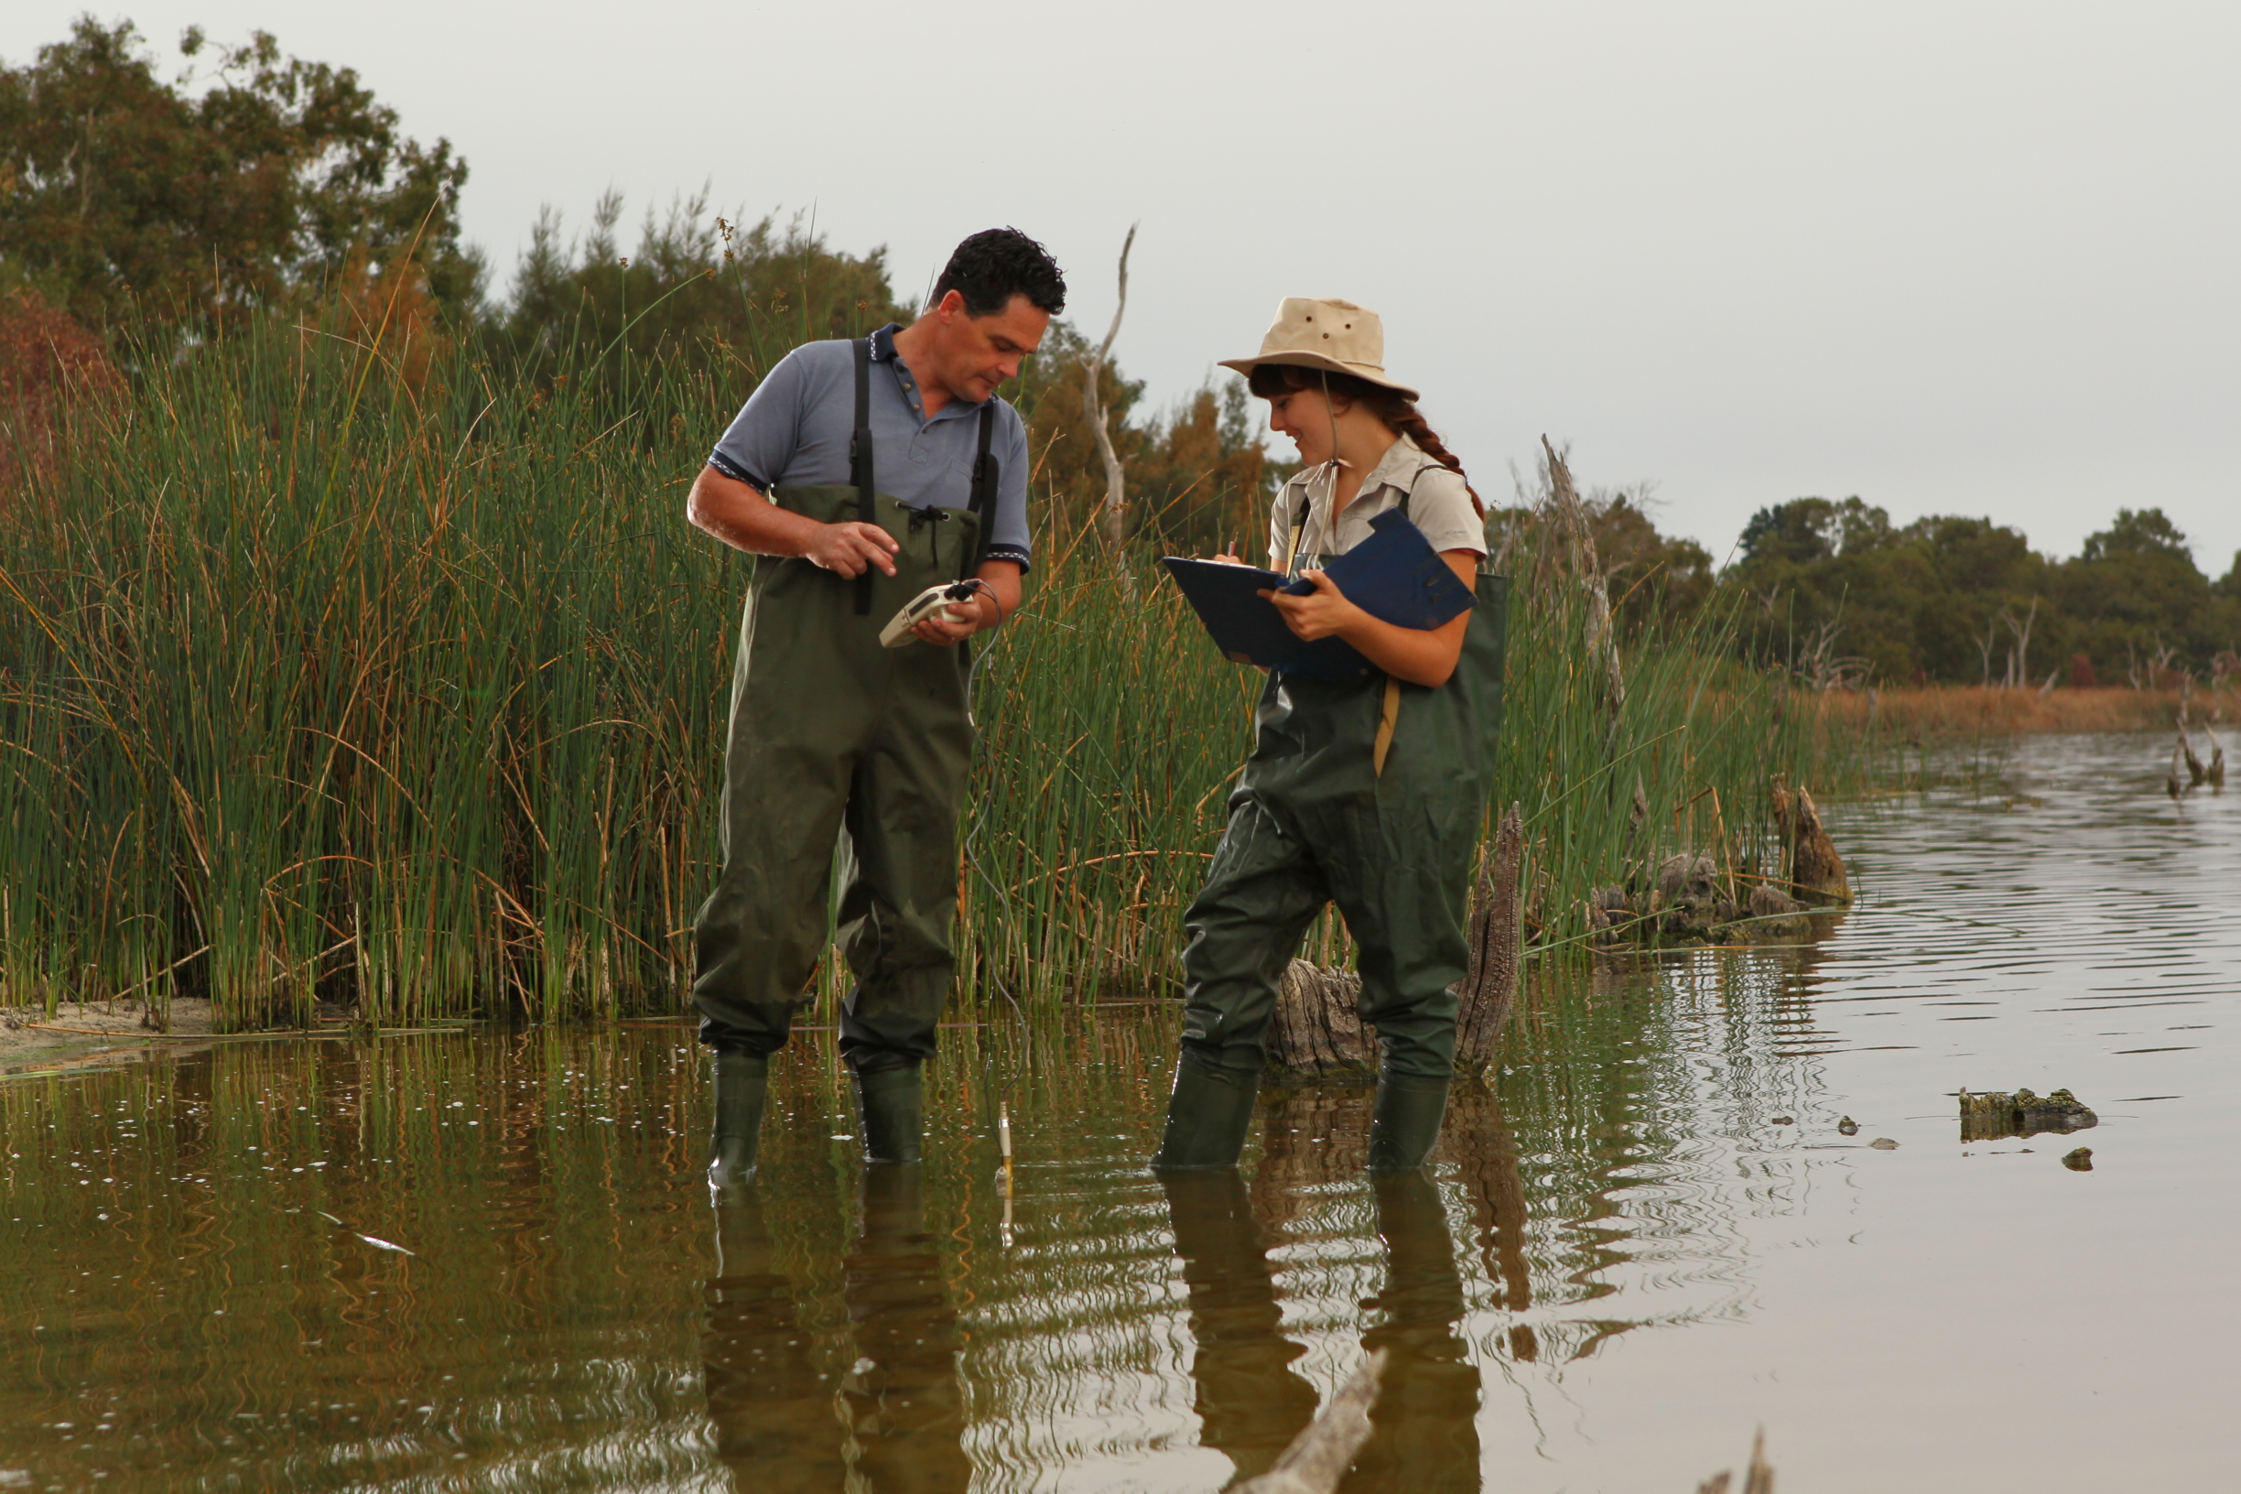
Image 8: Midge monitoring at Yangebup Lake

Degraded Natural Areas
Objective 11: To enhance and rehabilitate degraded natural areas.

The City manages a number of reserves that have been impacted by past land use practices. Many of these are either degraded or completely degraded on the vegetation condition scale. Enhancing the condition of these areas has a number of benefits:
- Improves the habitat values of an area
- Reduces longer term management inputs
- Increases other values such as amenity and passive recreational use, and
- Assists in reducing the risk of fire by reducing the prevalence of weeds.
The City uses a number of approaches to enhance the condition of reserves:
Rehabilitation
This involves direct or indirect actions to reinstate a level of ecosystem functionality where ecological restoration is not sought, but rather renewed to enable ecosystem goods and services to be provided.

Natural regeneration
This involves germination, birth or other recruitment of biota including plants, animals and microbiota, whether arising from colonisation or in situ processes. A natural regeneration approach to restoration relies on increases without direct planting or seeding, after removal of causal factors alone, as distinct from assisted natural regeneration approach that depends on active intervention.

Assisted regeneration
This is a particular approach to restoration that focuses on actively harnessing any natural regeneration capacity of biota remaining on site or nearby as distinct from reintroducing the biota to the site or leaving a site to regenerate naturally. The major differences between methods of regeneration are the means of weed removal, germinating existing native plant propagules and whether or not revegetation will be undertaken.

Revegetation
Revegetation is planting or direct seeding of native species in areas that have been cleared or highly modified. The City utilises the basic principles of the Bradley method of regeneration. However this may be used in conjunction with revegetation of larger areas where weeds have been controlled or removed by chemical means. The Bradley method of Bush regeneration works on three general principles, which are to:
- Work outwards from good bush areas towards areas of weed
- Make minimal disturbance to the environment, and
- Let native plant regeneration dictate rate of weed removal.

Other important points include:
- Ensuring that any work on large weed infestations includes follow-up work, as removing parent plants may create light and space for hundreds of new weeds
- Ensuring three years or more of control, and
- Aiming for control, not eradication and tipping the balance in favour of the local native plants.

Bushland enhancement is a slow process which requires ongoing resources. Only local native species are used when rehabilitating and revegetating reserves in the City. Where possible, local plants are grown from seed that is sourced locally.
The City has an annual natural area management program with a strong emphasis on coordinated actions that assist natural bushland regeneration. The aim is to rehabilitate a minimum of two and a half hectares per annum. Resourcing and funding is based on this target.
The long-term approach for natural area enhancement is to integrate all regeneration and restoration works with ongoing weed control. Detailed site assessments are undertaken by staff experienced in natural area management before regeneration and restoration works. Planting plans are prepared for each site before works commence. Consideration is also given to bushfire risk minimisation when planning and undertaking regeneration and restoration works.
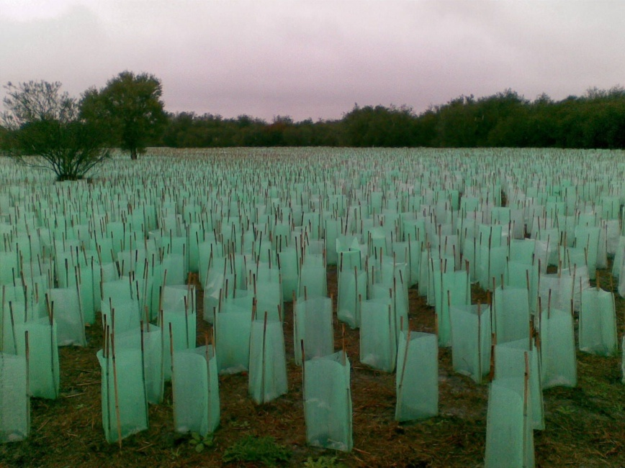
Image 9: Bibra Lake Reserve Revegetation

Ecological Corridors and Linkages
Objective 12: To maintain genetic diversity and genetic viability across natural areas.
Ecological corridors are contiguous natural or revegetated areas that directly connect larger areas, allowing organisms to move over time between these larger areas. Ecological linkages are non-contiguous natural areas that connect larger natural areas by forming stepping stones that also allow organisms to move over time between these areas. Both corridors and linkages will be referred to as linkages herein.
Ecological linkages are integral to the health of natural areas because they provide habitat as development increases in the City as well as important and safe movement passages for fauna. These linkages help to preserve and protect biodiversity and complement the ecological value of natural areas in the City.
A number of small isolated pockets of vegetation are increasingly at risk of decline due to modification, loss and fragmentation of the City’s natural bushland and wetlands. The species in these areas are at risk because there is limited potential to maintain their genetic diversity and their resilience because of their isolation. These pockets are at further risk due to climate change, because smaller populations with limited diversity will have difficulty adapting to changing environmental conditions and increased competition from weeds. However, the decline of these isolated areas can be improved by developing a network of linkages that will connect them and promote the movement and exchange of genetic material between these remnants.
WALGA’s Perth Biodiversity Project has identified a network of possible future ecological linkages across the metropolitan area. Within the City these regional linkages are primarily north south and associated with regional parks including Beeliar, Woodman Point and Jandakot Regional Parks. Although dissected by roads, Beeliar and Woodman Point provide good connectivity through the western edge and centre of the City while Jandakot provides connectivity in the east in conjunction with rural properties and other reserves.
Although quite narrow, the Baldivis Tramway Trail was identified in the Strategic Plan for Perth Greenways as Greenways Link 78. It abuts portions of the Beeliar Regional Park through Kogalup and Thomson’s Lakes and Harry Waring Marsupial Reserve and extends into and through Kwinana and Rockingham to Baldivis.
Currently there is limited connectivity between natural areas in the east and west of the City. Due to development, there is little scope to develop connected east west corridors. The best opportunities are currently offered by revegetating road reserves including medians and railway corridors and by encouraging the protection of vegetation in rural properties. Many of the east west roads pass through rural areas and dissect regional parks.

Possible roads that could be revegetated include:
- Roe Highway Road Reserve (Stages eight and nine)
- Beeliar Drive/Armadale Roads
- Russell/Gibbs Roads
- Wattleup and Rowley Road

The current WA Government stopped the Roe Highway extension and part of the Roe 8 alignment that was previously cleared is currently being revegetated. The local community supports the formal establishment of an ecological corridor and other community infrastructure along the entire Roe 8 and 9 road reserves, which would link Bibra Lake to Manning Park and Clontarf Hill in Fremantle. The Cockburn Community Wildlife Corridor Group was formed by residents to help promote the concept. The City remains opposed to any extension of the Roe Highway for a number of reasons, one of which is because construction will adversely impact on the ecological linkage currently provided by the road reserve.
Great opportunity exists to connect the western portion of the Beeliar Regional Park with the eastern portion of the Park via Landcorp Latitude 32 Industrial development area. No land has been set aside for the exclusive establishment of linkages but ecological links have been identified along road reserves and easements in the Latitude 32 Biodiversity Strategy.
Rail corridors
Railway corridors represent important potential ecological linkages. At some locations, rail corridors are adjacent to remnant vegetation. Rail reserves make a major contribution to ecological connectivity and provide key habitat for many species in some landscapes. The revegetation of some or all of the rail reserves has the potential to link both large and isolated bushland areas throughout the City.

Transmission lines and oil pipelines
There are a number of power transmission line easements that cross the City. Although there are limitations for vegetation in terms of height restrictions, they have great potential to act as ecological linkages. Many of these easements also pass through reserves, rural areas and traverse other land already identified as possible ecological links including rail corridors.

Carparks have been constructed on the easement adjacent to the Aubin Grove Rail Station and Cockburn ARC. If designed and landscaped appropriately, carparks can still allow easements to function as ecological corridors.
The BP oil pipeline has an easement that runs north south through the City. The easement is only 20 metres wide and although not adjacent to any larger conservation areas, it does link to some smaller reserves and other road reserves, public open space and vacant lots. In many areas the pipeline offers a good opportunity to create connections to other identified linkages such as the Roe 8 and 9 Highway road reserve and Stock Road. The opportunity to plant large trees is limited but the planting of smaller shrubs and vegetation is permitted.

Rural linkages
Much of the eastern region of Cockburn is zoned resource and contains predominantly private rural landholdings of approximately two hectares. The resource zoning provides protection for the Jandakot Groundwater Mound. Many of the lots still contain native vegetation. There are other smaller rural and rural living zones across the City. Generally these are considered transition areas and act as buffers between industry and higher density urban zones.

Both vegetated and pasture lots in the rural, rural living and resource zones currently provide ecological connectivity between conservation reserves and other remnant vegetation. Should rezoning occur in these areas it will be important to seek planning outcomes that retain ecological linkages where possible.
The City’s Landowner Biodiversity Conservation Grant Program currently provides financial support and natural resource management training to landowners living in the rural, rural living and resource zones of the City who wish to conserve and enhance natural bushland and wetland areas on their property.
Residential Linkages
Residential areas in the urban environment offer some ecological linkage potential. Vegetated gardens and verges with local species will attract native fauna, help maintain genetic diversity and provide a series of ecological stepping stones across the City, particularly for birds and insects. Gardens and verges are particularly valuable where they are close to remnant native vegetation in conservation reserves, road reserves and easements.

The City has developed a number of initiatives to encourage local residents to plant local species in gardens and verges. These include:
- A Residential Plant Subsidy Scheme. Residents can purchase discounted local native plants for their gardens
- Local Plant Guide Brochures. These brochures list endemic species and nurseries that sell local plant species
- Bird Bath Rebate Program. This program offers subsidies to residents to install bird baths in their gardens
- Verge Policy. Supports residential landowners to replace lawn with native plants
- Waterwise Verge Grants. Provides funding to residents to vegetate their verges with native plants.

Other initiatives
The City is aware that there may be other opportunities that have been overlooked and supports studies that investigate the potential for urban gardens to promote ecological connectivity.

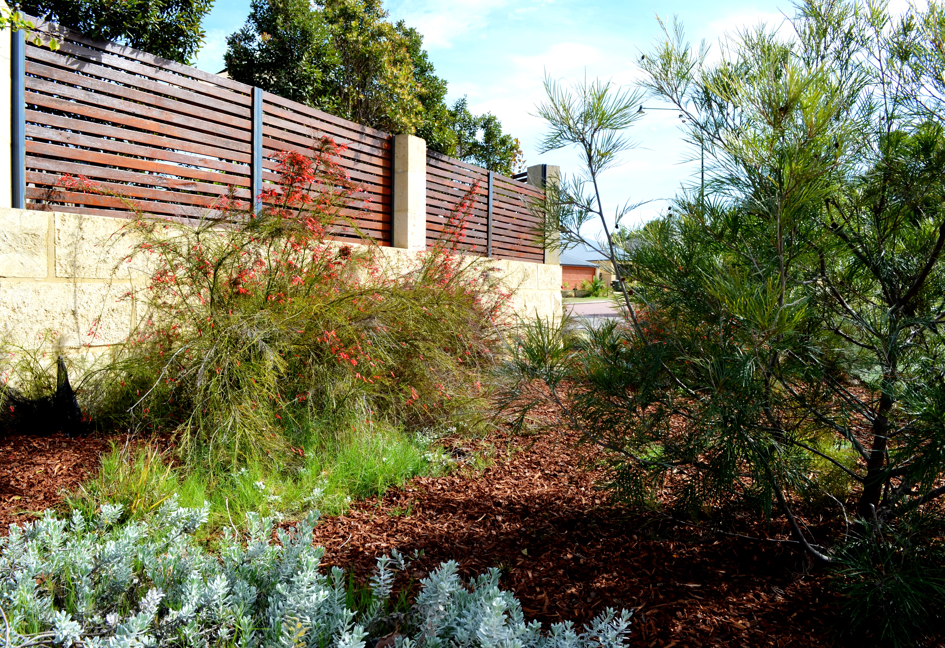

Image 10: Residential Verge, Beeliar

Future development
Where practical the City encourages developers to consider ecological linkages when submitting local structure plans. Through early integration in the planning process, good outcomes can be achieved as evident in the Meve Development in Beeliar and the Vevente development in Hammond Park.

Fauna Crossings
Fauna crossings allow animals to cross constructed barriers such as roads safely. They can vary in design and be large to cater for animals such as kangaroos or for smaller creatures such as frogs. Examples may include underpass tunnels and culverts and overpasses including structures such as rope bridges.

The City has installed a number of fauna underpasses to connect areas that would otherwise have been separated. Underpasses exist on North Lake Road to connect Bibra Lake and South Lake and Beeliar Drive in Yangebup. The drain at the eastern end of Osprey Drive in Yangebup will be modified to allow wildlife to cross this busy road. Figure 3 shows all of the opportunities for ecological linkages and their proximity and connection to existing conservation areas.

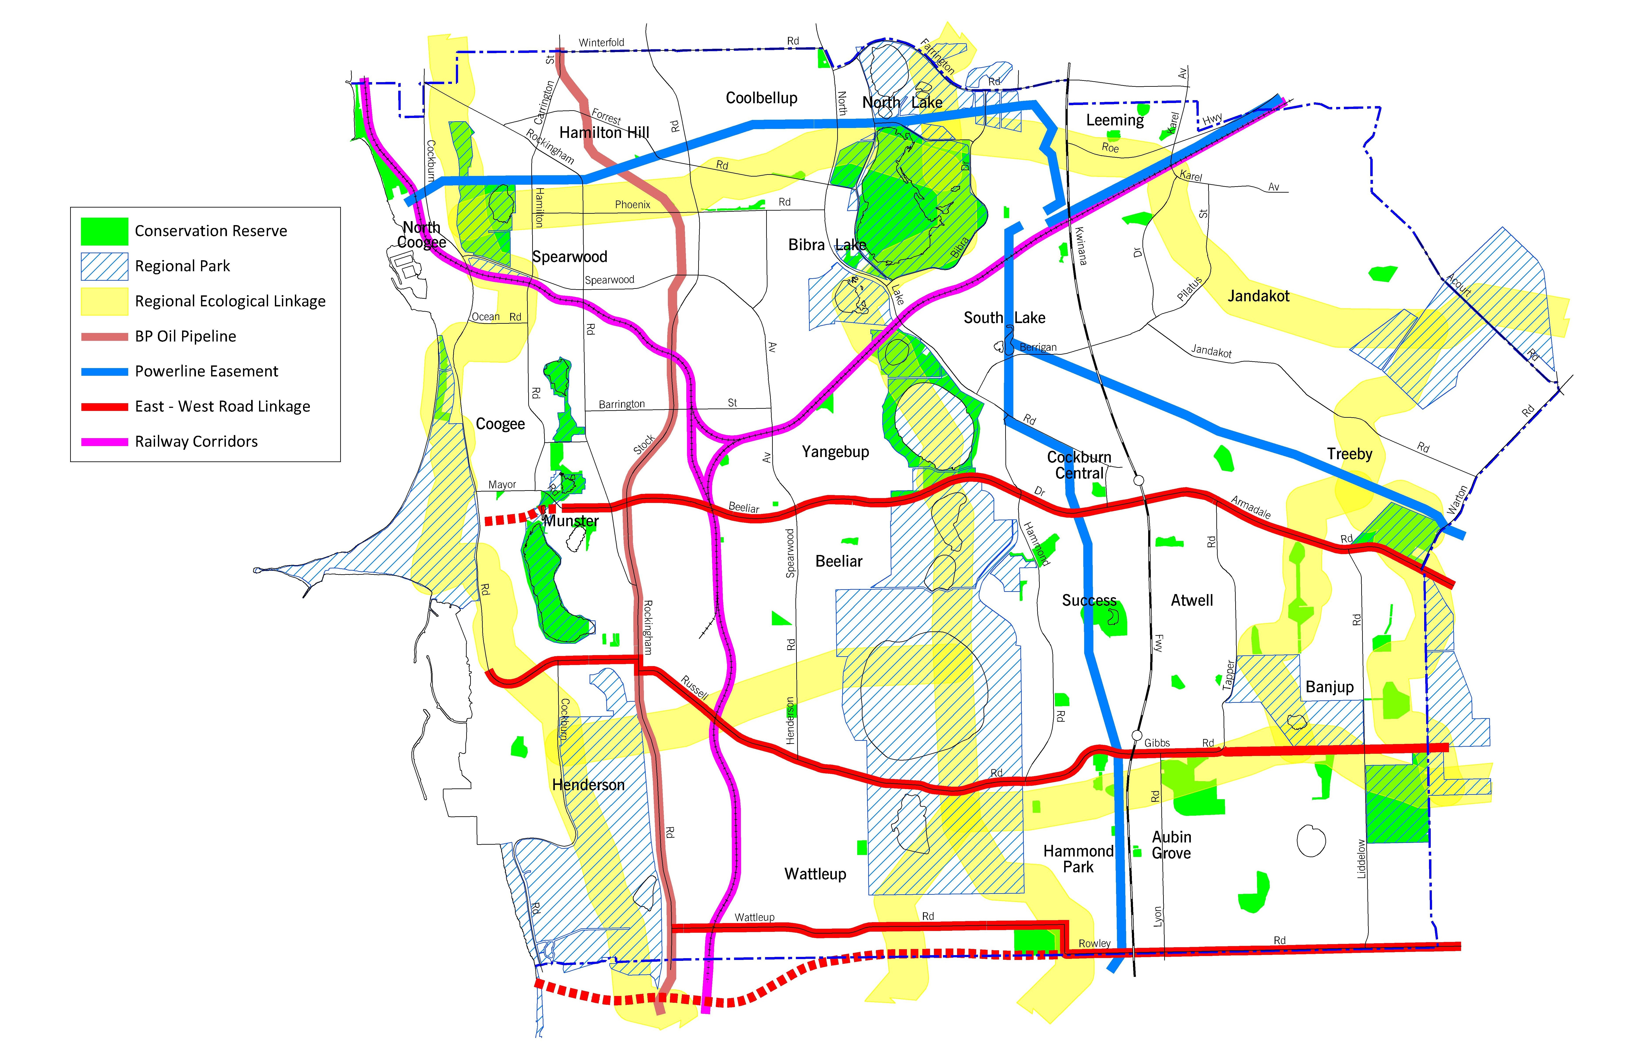
Figure 3: Suggested and Existing Ecological Corridors

Achievements
Progress against key performance indicators
- Increase percentage of good quality vegetation (hectares)
Table 8 summarises bushland condition ratings in managed reserves in 2012 and 2018. It is difficult to make precise comparisons between 2012 and 2018 in terms of overall vegetation condition because the assessment methods have changed over the five year study period. Current mapping focuses only on existing bushland and does not include paths, firebreaks and revegetation.

Bushland Vegetation Condition | Hectares  2012 | Hectares  2018 |  | Percentage of Bushland  2012 | Percentage of Bushland  2018
Pristine | 0 |  | 0 | 0 |  | 0
Excellent | 59 |  | 106 | 7 |  | 16
Very Good | 317 |  | 169 | 35 |  | 26
Good | 225 |  | 202 | 25 |  | 31
Degraded | 113 |  | 140 | 13 |  | 21
Completely degraded | 182 |  | 43 | 20 |  | 6
Bushland total | 896* |  | 660* | 100 |  | 100
Revegetation | Included above |  | 36 | Included above |  | 3
Other | Included above |  | 377 | Included above |  | 35
Total Area (actively managed) | 896 |  | 1,073 | - |  | -

Table 8: Bushland condition comparison between 2012 and 2017

Comparisons between two individual reserves, Denis De Young and Bibra Lake, provides a better indication of the improvement in vegetation condition. The way in which these reserves were assessed for vegetation condition has not changed greatly as each has limited firebreaks and parkland areas. Table 9 shows a distinct improvement in vegetation condition in these two areas.

Reserve | Area (Ha) | Year | Pristine | Excellent | Very Good | Good | Degraded | Completely Degraded | Total  %
Denis De Young Reserve | 83 | 2018 | 0 | 24.79 | 55.9 | 18.23 | 0 | 1.08 | 100
Denis De Young Reserve | 83 | 2012 | 0 | 0.87 | 86.96 | 1.83 | 0 | 10.34 | 100
Bibra Lake Reserve | 263* | 2018 | 0 | 6.16 | 19.15 | 39.59 | 26.91 | 8.19 | 100
Bibra Lake Reserve | 257* | 2013 | 0 | 0 | 24.96 | 25.84 | 12.82 | 36.38 | 100

Table 9: Bushland Condition Comparison in Denis De Young Reserve and Bibra Lake for 2012 and 2018 * Variations are due to more accurate mapping techniques

- Reduce the number of high priority weeds within reserves
Improving overall vegetation condition across all reserves results in less priority weeds within reserves.

- Reduce the number of reports of feral animals the noted presence of feral animals within reserves
The number of reports of feral animals within the City and reserves has increased. This is likely due to an increase in awareness of the impact of feral animals on the environment through extensive media reporting of feral animals such as cats, foxes, wild dogs and cane toads. The increase in the number of reports helps to identify problem areas that can be targeted for additional control.
- Decrease the amount of rubbish being removed from reserves
Rubbish removal costs are allocated against each reserve and changes in costs measure progress towards this KPI. Even with consideration given to cost increases and wage growth, the cost to remove rubbish from within reserves and on verges has increased. This is reflected across the metropolitan area with the Department of Water and Environmental Regulation stepping up programs to address illegal dumping. Table 10 shows annual increases.

Table 10: Rubbish removal costs per year

Rubbish removal costs per year | 2013-14 | 2014-15 | 2015-16 | 2016-17
Staff Costs ($) | 60,213 | 91,818 | 132,755 | 149,562
Contractor Costs ($) | 13,741 | 29,273 | 26,158 | 41,150
Total | 73,954 | 121,091 | 158,913 | 190,712
- Ensure best practice fire management in all reserves
All reserves have regulation firebreaks which include limestone breaks where deemed necessary. Fire Response Plans have been developed for all reserves and updated regularly to ensure compliance to the relevant Acts. Fuel load reduction are undertaken accordingly, including prescribed burning, in a number of reserves which have identified as high fire risk sites.
- Reduce the number of hectares of bushland containing dieback
In 2012, 67 hectares of bushland were contaminated by Dieback. Recent mapping indicates the figure is slightly over 100 hectares, with a further 38 hectares suspected to be infected by Armillaria, a fungus that attacks the roots of plants.
- Annually increase funding per hectares (above the CPI) for reserve management
The difference between actual required funding in 2012 was $1,828 per hectare or a 55% shortfall. In 2018 the difference is $1,605 per hectare or a 36% shortfall. There has been a slight overall increase in funding allocated for bushland maintenance which is having a positive effect on bushland condition.

Summary of Objectives, KPIs and Actions
Objective 1: Prioritising Reserves
To identify reserves of higher value to ensure that finances and resources are allocated in a manner that provides the best outcomes for both the community and the natural area
KPI | Action
Increase percentage of good quality vegetation (hectares).  Annually increase funding per hectares (above the CPI) for reserve management | 1.1 |  | Continue to prioritise reserves based on vegetation condition, size, shape, perimeter to area ratio, connectivity, visibility and community involvement.
 | 1.2 |  | Reassess reserve prioritisation every eight years.
 | 1.3 |  | Map priority weeds and vegetation condition in all bushland reserves on a rotational basis every four years.
 | 1.4 |  | Support the objectives of the City’s Bushland Conservation Policy.
Objective 2: Environmental Weeds
To control environmental weeds within the City’s managed natural areas
KPI | Action
Reduce the number of high priority weeds within reserves | 2.1 |  | Continue to review and implement the Weed Management Plan.
Reduce the number of high priority weeds within reserves | 2.2 |  | Develop revegetation programs following weed control programs where required.
Reduce the number of high priority weeds within reserves | 2.3 |  | Assist and encourage volunteers such as community “friends of” groups, Conservation Volunteers Australia and educational institutions to participate in bushland management activities in natural areas managed by the City.
Reduce the number of high priority weeds within reserves | 2.4 |  | Ensure verges adjoining reserves are free from weeds.
Objective 3: Feral Animals And Roaming Cats
To control and, where possible, eradicate feral animals and minimise the impact of roaming cats within City managed natural areas
KPI | Action
Reduce the number of reports of feral animals the noted presence of feral animals within reserves | 3.1 |  | Continue to implement feral animal control programs.
 | 3.2 |  | Work with other local governments and government agencies to develop and implement a regional feral animal control program.
Objective 4: Minimise Illegal Access
To minimise the impacts to natural areas caused by unauthorised and uncontrolled access
KPI |  | Action
Increase percentage of good quality vegetation (hectares) |  | 4.1 |  | Maintain appropriate fences around conservation reserves to prevent and control unauthorised access.
 |  | 4.2 |  | Undertake fence repairs within two working days of notification of damage.
Objective 5: Illegal Dumping
To prevent illegal rubbish dumping in natural areas
KPI |  | Action
Decreased amount of rubbish removed from reserves |  | 5.1 |  | Remove rubbish from conservation reserves as early as practical.
 |  | 5.2 |  | Continue to develop community education programs that raise awareness of the issues associated with dumping rubbish.
Objective 6: Fire Management
To protect the biodiversity values of the City of Cockburn’s bushland reserves and limit the risk to people and property by reducing the frequency and intensity of unplanned fires
KPI |  | Action
Ensure best practice fire management in all reserves |  | 6.1 |  | Ensure all reserves have firebreaks that comply with the Bush Fires Act 1954.
 |  | 6.2 |  | Install limestone firebreaks or use herbicides where practical rather than grading to keep firebreaks free from vegetation and loose sand.
 |  | 6.3 |  | Prepare Bush Fire Response Plans for all conservation reserves and review every three years.
 |  | 6.4 |  | Assess the suitability and appropriateness of prescribed burning to reduce high fuel loads and control weeds.

Objective 7: Diseases Management
Objective: To reduce the impact of plant disease in natural areas
KPI | Action
Reduce the number of hectares of bushland containing dieback | 7.1 | Ensure staff and contractors practice appropriate Dieback hygiene procedures when working in reserves.
Reduce the number of hectares of bushland containing dieback | 7.2 | Undertake Dieback assessment and mapping in reserves containing Dieback and in those suspected to contain the disease.
Reduce the number of hectares of bushland containing dieback | 7.3 | Instigate Dieback control methods where practical such as phosphite treatment, limestone on firebreaks and revegetation using Dieback tolerant endemic species.
Reduce the number of hectares of bushland containing dieback | 7.4 | Support the Dieback Working Group.
Objective 8: Stormwater Management
To enhance wetland water quality and reduce erosion in conservation areas
KPI | Action
Increase percentage of good quality vegetation (hectares). | 8.1 | Ensure best practice Water Sensitive Urban Design is implemented throughout the planning process.
Increase percentage of good quality vegetation (hectares). | 8.2 | Retrofit best practice Water Sensitive Urban Design measures into areas where water quality is being adversely affected by outdated practices.
Objective 9: Climate Change
To build the resilience of natural areas to allow them to adapt to climate change
KPI | Action
Ensure best practice fire management in all reserves | 9.1 | Be prepared to alter management practices to adapt to a changing climate.
Objective 10: Wetland Management
To enhance and rehabilitate natural wetland areas while increasing their resilience to withstand climate change impacts.
KPI | Action
Increase percentage of good quality vegetation (hectares) | 10.1 | Undertake regular wetland water quality and vegetation monitoring of wetland areas.

Objective 11: Rehabilitate Degraded Natural Areas
To enhance and rehabilitate degraded natural areas.
KPI | Action
Increase percentage of good quality vegetation (hectares) | 11.1 | Identify sites and prepare planting plans before undertaking revegetation works.
Increase percentage of good quality vegetation (hectares) | 11.2 | Provide adequate resources for the ongoing maintenance of natural areas.
Objective 12 :Ecological Corridors and Linkages
To maintain genetic diversity and genetic viability across natural areas.
KPI | Action
Increase percentage of good quality vegetation (hectares) | 12.1 | Continue to offer incentives, training and information to landowners to encourage natural area management and the use of local species on private property.
Increase percentage of good quality vegetation (hectares) | 12.2 | Develop a network of ecological corridors and linkages.
Increase percentage of good quality vegetation (hectares) | 12.3 | Continue to support tertiary studies that investigate potential locations, designs and the effectiveness of ecological corridors.
Increase percentage of good quality vegetation (hectares) | 12.4 | Where roads are being constructed, upgraded or widened through natural areas ensure that consideration is given to the construction of wildlife crossings.

Table 11: Summary of Objectives, KPIs and Actions

Community Consultation
As this document is a review of an earlier Strategy, extensive community consultation was not warranted. The original Strategy has been available on the City’s website since 2012 and there have not been any public submissions received in relation to its content or the manner in which the City’s conservation reserves are currently being managed.
The annual Community Perceptions Survey measures community satisfaction over a number of service areas in the City. The following figure illustrates the level of community satisfaction with conservation and environmental management and clearly shows an upward trend in performance in this area with June 2017 having the highest performance rating. The City is on par with the industry high.
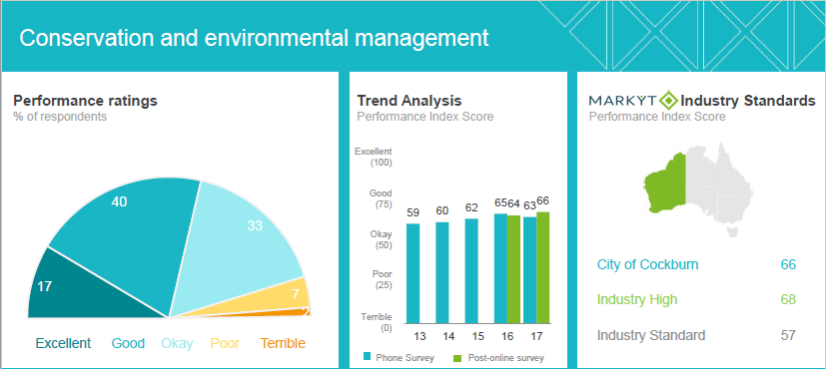

Figure 4. Community Satisfaction 2017 Survey Conservation and Environmental Management.

Operational Funding Requirements
Operational Costs
The costs to maintain, enhance and revegetate bushland will vary depending on condition and vegetation type. Degraded areas cost more to rehabilitate and maintain than areas in good or better condition. The estimated cost to maintain and enhance good quality bushland is approximately $4,367 per hectare per year (see Appendix B). Based on this estimate it would cost the City $3,039,430 per annum to maintain and enhance the 696 hectares of bushland presently managed.
In the 2017/18 financial year, $1,991,099 was allocated toward bushland maintenance. This equates to $2,860 per managed hectare (696 hectares) which is lower than $4,367 required to maintain and improve bushland condition. However since 2012 the budget has increased by $663,343 which includes funding for the maintenance of new reserves.
The difference between actual and required funding per hectare in 2012 was $1,828 which equates to a 55% shortfall. In 2017/18 the difference per hectare is $1,605 which equates to 36% shortfall. This increase in overall funding has had a positive effect on bushland condition and continued investment will provide further enhanced benefits.

Yearly Cost to Maintain 1 hectare of Good Quality Bushland
2012-13 | 2013-14 | 2014-15 | 2015-16 | 2016-17 | 2017-18
$3,310 | $3,568 | $3,913 | $3,945 | $3,983 | $4,367

Table 12. Comparison of Yearly Bushland Maintenance Costs

Current Staffing 2018
There are nine and half full time equivalent employees within the Environment Service Unit who deliver natural area management. This is the same FTE count as 2012.
Position | FTE Allocation
Environment Manager | 0.5
Environmental Natural Resource Officer | 1
Environmental Supervisor | 1
Environmental Officer | 1
Bushland Maintenance Officers | 6
Total | 9.5

Table 13: Current Environmental Service Unit Staffing Levels

Since 2012 the number of actively managed reserves has risen from 48 to 67. Internal staff resources have been unable to meet demand which has meant that additional reserves have been allocated to contractors. Contractors now maintain 21 reserves with bushland maintenance teams managing the other 46. In the 2018-19 financial year, it is expected that a further three natural area reserves will be ceded to the City requiring active management. Additional resources or funding to engage contractors will need to be made available
Sources of funding and assistance
The majority of funding for maintenance, enhancement and revegetation of the City’s natural areas comes from municipal funds. Other sources of funding include grants from State and Federal government funding programs and sponsorship and funding from developers as consideration for offset programs.

There are options for the City to be involved in government employment programs such as Green Corps, Work for the Dole and Repay WA, a Department of Corrective Services initiative. These initiatives are designed to give people within the community better long term employment prospects through access to training and work experience. The costs to local government are minimal and mainly associated with the purchase of equipment, while the benefits to both the participants and local government authority can be substantial. The City also uses the resources of Conservation Volunteers Australia however this additional assistance has a cost implication and volunteer numbers can vary in numbers from day to day.
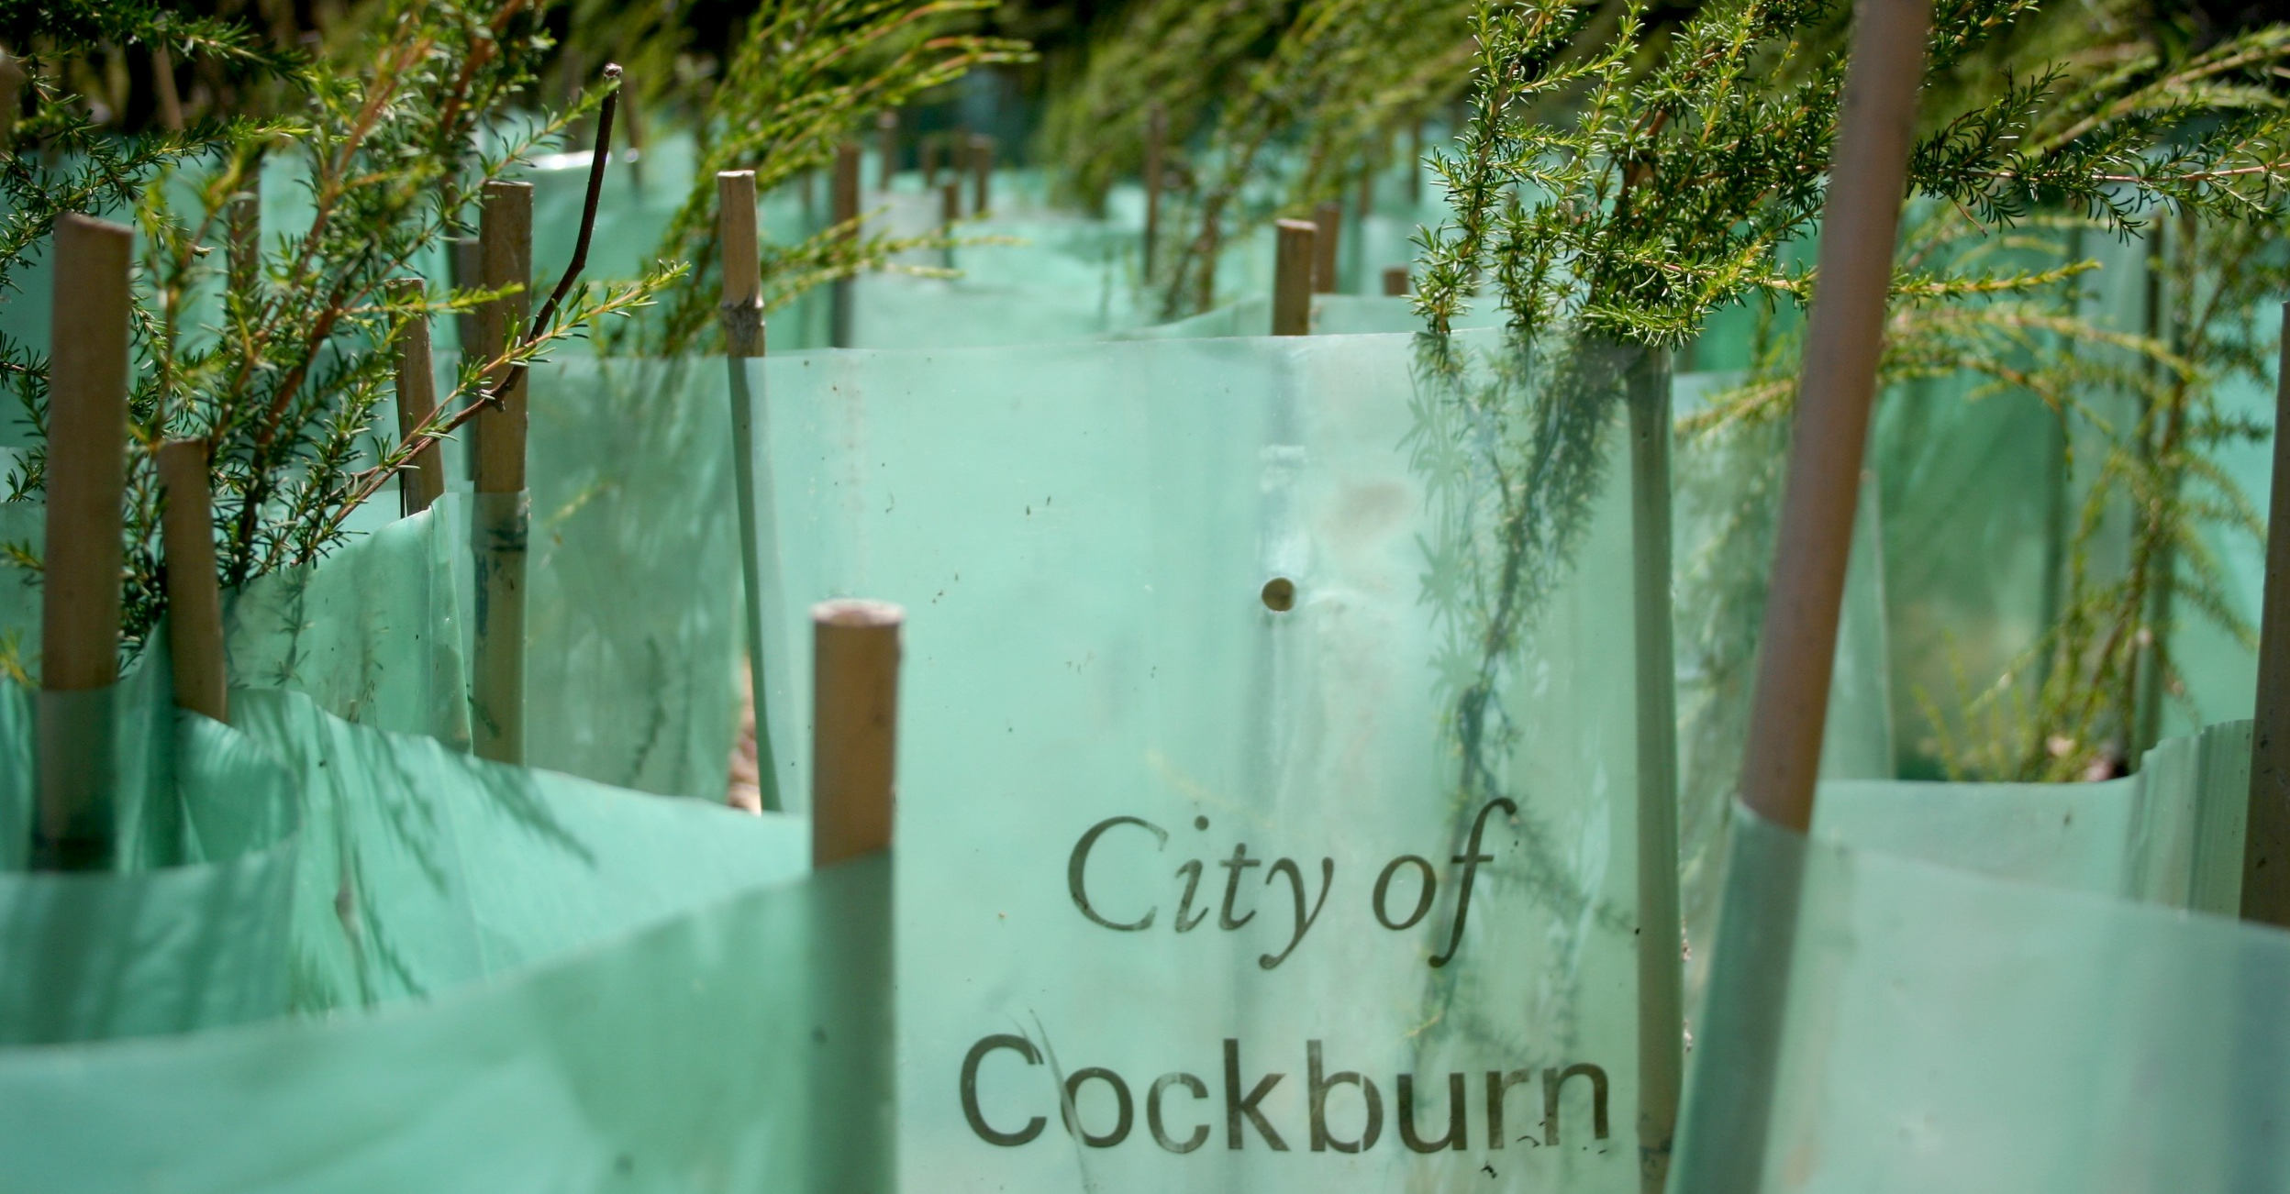
Image 11: Revegetation, City of Cockburn

Measuring Achievement
This Strategy is supported by a long term vision which encourages planning, investment and evaluation over time. The original Strategy had a 10 year time frame with a full review of all actions and progress to be completed after five years. This document is the five year review. Comparisons between individual reserves between 2012 and 2017 indicate that management actions are working.
Long term evaluation of maintenance and enhancement activities is generally undertaken using the four yearly rotating weed and vegetation condition mapping. This gives a clear indication as to whether a particular reserve is deteriorating or improving and provides an historical record of management progress.
Direct comparisons between mapping from year to year clearly show where weeds have increased or where vegetation condition has changed. Vegetation condition mapping allows the various condition ratings to be shown as a percentage and provides an easy method of assessing maintenance and enhancement activities across the entire City. The City has recently begun to undertake fauna surveys in a select number of reserves in the same year as vegetation condition mapping. This provides another way to assess overall condition. An increase in fauna will point to improved habitat and thus improved reserve condition. When assessing vegetation condition, consideration is given to other factors that might be impacting vegetation such as reduced rainfall, longer heatwaves and disease.
Review Timeline
This strategy will be reviewed at the conclusion of its 10 year plan by the Environmental Service Unit. The next review is due in 2022.
Reporting format
The Key Performance Indicators associated with this strategy are reported upon in the annual State of Sustainability Report.

Glossary of terms
Armillaria - Armillaria root rot is a fungal root rot caused by several different members of the genus Armillaria.
Biodiversity - the degree of variation of life forms within a given ecosystem, biome or an entire planet.
Ecological function- means the natural processes, products or services that living and non-living environments provide or perform within or between species, ecosystems and landscapes. These may include biological, physical and socio-economic interactions.
Ecological linkage – a series of contiguous or non-contiguous patches of vegetation which by virtue of their proximity to one another allow flora and fauna to use them as stepping stones of habitat to move across the landscape.
Flora - the plant life occurring in a particular region, generally the naturally occurring or indigenous plant life
Fauna - all of the animal life of any particular region.
Herbarium – a systematically arranged collection of dried plants
Sustainable - how biological systems remain diverse and productive over time
Rehabilitation - direct or indirect actions with the aim of reinstating a level of ecosystem functionality where ecological restoration is not sought, but rather renewed with ongoing provision of ecosystem goods and services. (McDonald et al 2016)
Natural Regeneration - defined as germination, birth or other recruitment of biota including plants, animals and microbiota, whether arising from colonisation or in situ processes. A natural regeneration approach to restoration relies on increases in individuals, without direct planting or seeding, after removal of causal factors alone, as distinct from assisted natural regeneration approach that depends on active intervention. (Prach & Hobbs 2008, Clewell & Mc Donald 2009).
Assisted Regeneration - defined as a particular approach to restoration that focuses on actively harnessing any natural regeneration capacity of biota remaining on site or nearby as distinct from reintroducing the biotoa to the site or leaving a site to regenerate naturally. (Clewell & McDonald 2009)

Appendix A - Actively Managed Reserve Classification
 | Reserve Name | Priority | Area of Bushland (Ha) Oct 2017 | Total Area (Ha)  Oct 2017
1 | Baler Reserve | Med | 3.28 | 4.08
2 | Banbar Reserve | Low | 0.24 | 0.95
3 | Bandicoot Reserve | Med | 4.20 | 4.20
4 | Banksia Eucalypt Woodland (North ) | High | 26.87 | 27.72
5 | Banksia Eucalypt Woodland (South) | High | 12.95 | 13.25
6 | Barfield Reserve | Med | 1.11 | 1.12
7 | Beeliar Bushland | Med | 1.32 | 1.32
8 | Bibra Lake Reserve | High | 150.08 | 263.20
9 | Binjar Reserve | Med | 4.08 | 8.25
10 | Bloodwood Park | Med | 1.45 | 4.16
11 | Boorn Park | Med | 0.00 | 3.27
12 | Bosworth Reserve | Med | 5.81 | 6.54
13 | Brandwood Reserve | Med | 2.05 | 3.21
14 | Buckingham Reserve | Med | 7.76 | 8.40
15 | Bushland Park | Med | 0.64 | 0.92
16 | C. Y. O’Connor Reserve | Med | 15.18 | 16.50
17 | Christmas Tree Reserve | Med | 1.77 | 3.10
18 | Classon Reserve | Med | 2.13 | 2.82
19 | Cocos Park | High | 1.77 | 2.04
20 | Coogee Beach Reserve | High | 9.19 | 13.13
21 | Coojong Reserve | Med | 0.86 | 1.06
22 | Denis De Young Reserve | High | 74.59 | 83.90
23 | Djidi Djidi Reserve | Med | 0.00 | 1.62
24 | Doherty Reserve | Med | 1.83 | 2.42
25 | Eco Park | Med | 1.05 | 1.96
26 | Emma Treeby Reserve | High | 5.81 | 7.00
27 | Fancote Reserve | Med | 2.26 | 2.26
28 | Frankland Park | Med | 23.89 | 24.30
29 | Freshwater Reserve | Med | 3.16 | 4.39
30 | Gaebler Reserve | Med | 0.15 | 0.15
31 | Gil Chalwell Reserve | Med | 12.15 | 12.53
32 | Heatherlea Reserve | Med | 1.12 | 1.69

 | Reserve Name | Priority | Area of Bushland (Ha) Oct 2017 | Total Area (Ha)  Oct 2017
33 | Holdsworth Reserve | Med | 1.89 | 2.20
34 | Ingrilli Reserve | Low | 0.53 | 0.53
35 | Jamy Park | Med | 1.46 | 1.56
36 | Jubilee Park | Med | 0.00 | 6.59
37 | Katsura Gardens | Med | 0.30 | 0.35
38 | Kraemer Reserve | Med | 4.61 | 5.37
39 | Kurrajong Reserve | Med | 0.66 | 2.18
40 | Lake Coogee Reserve | High | 12.78 | 75.20
41 | L’Aquilla Reserve | Med | 0.41 | 0.43
42 | Levi Reserve | Med | 2.86 | 3.05
43 | Little Rush Lake | High | 38.01 | 42.44
44 | Lukin Swamp | Med | 5.07 | 5.19
45 | Macrozamia Park | Med | 0.16 | 0.31
46 | Manning Reserve | High | 56.34 | 85.10
47 | Market Garden Swamp 1 | High | 12.34 | 22.50
48 | Market Garden Swamp 2 | High | 10.78 | 18.80
49 | Marshwood Park | Med | 0.91 | 1.15
50 | Mather Reserve | Med | 2.53 | 3.05
51 | McGrath Reserve | Low | 0.28 | 0.28
52 | McNeil Field | Med | 0.41 | 0.45
53 | Mohan Reserve | Med | 0.27 | 0.43
54 | Monticola Gardens | Med | 0.72 | 0.98
55 | Nola Waters Reserve | Med | 0.67 | 0.79
56 | Redemptora Reserve | Med | 3.67 | 3.94
57 | Roper Reserve | Med | 1.23 | 1.36
58 | Rose Shanks Reserve | High | 41.54 | 47.93
59 | Sherbrooke Reserve | Med | 2.40 | 2.40
60 | Skaife Reserve | Med | 2.00 | 2.00
61 | Success Reserve | Med | 16.00 | 27.47
62 | Triandra Reserve | Med | 10.00 | 10.70
63 | Twin Bartram Swamps | High | 0.00 | 20.21
64 | Ulinda Park | Med | 0.51 | 1.14
65 | Verde Reserve | Med | 4.91 | 5.24
66 | Warthwyke Reserve | Low | 1.87 | 2.48
67 | Yangebup Lake | Med | 47.48 | 141.89
Total |  |  | 660* | 1073

* Does not include 36 hectares of revegetation

Appendix B - Bushland Maintenance and Revegetation Costs
Estimated Bushland Maintenance Costs per Hec 2017
Jarrah/Banksia Woodland in Good Condition
 | Hours | Numbers/description | Cost ($)
Staff | 10 | 2 | 2,600
Contractor |  | Grass Weed Control | 800
Chemical Costs (Glyphosate) 2% solution |  | General | 50
Chemical Costs (Metsulphuron and Pulse) 1% Solution |  | Bulbs
Woody Weed |  | Cut & Paste | 4
Weed Mapping |  |  | 15
Dieback Mapping |  | Every 5 years | 33
Rubbish Collection |  | Collect and remove | 585
Fence Repair |  | Annual | 150
Feral Control |  | Annual | 57
Total Cost |  |  | 4,367

Revegetation Costs per Hecatare (Jarrah/Banksia Woodland)
Task | Year 1 | Year 2 | Year 3 | Year 4 | Year 5
Weed control - grass | $800 | $600 | $500 | $300 | $300
Weed control - broad-leaved/bulbous | $1,000 | $1,100 | $500 | $300 | $300
Woody weed removal | $2,000 | $2,200 | $1,000 | $500 | $200
Revegetation tubestock (plant costs) | $20,000 | $6,000 | $1,000 | -- | --
Revegetation - greenstock planting | $27,500 | $15,000 | $3,000 | -- | --
Greenstock maintenance + watering | $39,000 | $19,500 | $3,900 | -- | --
Total | $90,300 | $44,400 | $8,900 | $1,100 | $800

Operational | $ | Revegetation | $
Herbicide | 22,115 | Plants & Sedges | 78,800
Mulch | 18,000 | Fertiliser | 3,640
Limestone for tracks | 0 | Tree Stakes | 7,700
Habitat boxes | 34,00 | Tree Guards | 7,200
Contract Rubbish removal | 28,250 | Contract Planting | 114,000
Contract Fence & Gate Repairs | 53,000 | Watering Greenstock | 67,700
Contract Grass Weed Control | 107,550 | Greenstock Maintenance | 25,600
Contract General Weed Control | 94,200
Firebreak Prevention | 31,500
Firebreak Weed Control | 23,500
Contract Hand Weeding | 63,500
Pruning | 42,200
Dieback Control | 23,500
Contract Reserve Patrols
Earthworks (Boulders, Access) | 12,500
Path Maintenance | 13,950
Feral Animal Control | 44,500
On Ground Staff Labour Costs 95% | 1,409,434 | On Ground Staff Labour Costs 5% | 74,180
Total | 1,991,099 |  | 378,820

Appendix C - Keighery 1994 Vegetation Condition Scale

References

Environmental Protection Authority (2003). Guidance Statement No.10: Guidance for the Assessment of Environmental Factors – Level of assessment for proposals affecting natural areas within the System 6 region and the Swan Coastal Plain portion of the System 1 region. Perth, Western Australia.
Howitz, P. (2017). How urban bushland improves our health and why planners need to listen. Article Published in “The Conversation” May 2017.
Deakin University, 2002
National Objectives and Targets for Biodiversity Conservation 2001-2005.
Bush Forever is a State Government initiative that aims to protect regionally significant bushland into the future.
Myers, N., Mittermermeier, C.G., de Fonseca, G.A.B. & Kent, J. (2000). Biodiversity Hotspots for conservation priorities. Nature 403 pp 853-858.
Perth Biodiversity Project (2004). Local Government Biodiversity Planning Guidelines for the Perth Metropolitan Region. Western Australian Local Government Association.
Keighery, B.J. (1994). Bushland plant survey. A guide to plant community survey for the community Wildflower Society of WA (Inc), Nedlands, Western Australia.
Perth Biodiversity Project (2004). Local Government Biodiversity Planning Guidelines for the Perth Metropolitan Region. Western Australian Local Government Association.
How, R. & Dell, J. (2000) Ground vertebrate fauna of Perth’s vegetation remnants: impact of 170 years of urbanisation. Pacific Conservation Biology 6: 198-217.
Clarke, pers. comm. July 2003 Perth Biodiversity Project
Barret, G. (2000). Birds on farms: ecological management for agricultural sustainability. Supplement to Wingspan. 10 (4); Fruedenberger 1999
Freudenberger, D. (1999) Guidelines for enhancing grassy woodlands for the vegetation investment project. A report commissioned by Greening Australia, ACT and SE NSW, Inc CSIRO Wildlife and Ecology, Canberra
Department of Environment, Heritage, Water and the Arts, 2009
Barret, G, Burrows, N and McCaw (2017) Fire and Banksia Wood Lands. Presentation to South West Group Management Forum October 2017.
Barret, G, Burrows, N and McCaw (2017) Fire and Banksia Wood Lands. Presentation to South West Group Management Forum October 2017.
Department of Sustainability Environment, Water, Population and Communities . (2010). Australia Biodiversity Conservation Strategy 2010-2030.
McDonald T, Gann G.D, Jonson J, and Dixon K.W, (2016) International standards for the practice of ecological restoration – including principles and key concepts. Society for Ecological Restoration, Washington, D.C.
Prach K, and Hobbs R.J. (2008). Spontaineous succession versus technical reclamation in the restoration of disturbed sites. Resoration Ecology 16:363-366; Clewell, A and McDonald, T (2009). Relevance of natural recovery to ecological restoration. Ecological Restoration 27:122 -124
Clewell, A and McDonald, T (2009). Relevance of natural recovery to ecological restoration. Ecological Restoration 27:122 -124
Commonwealth of Australia (2001). Australian Native Vegetation Assessment 2001. National Land and Water Resources Audit, Canberra, Australia.
Bradley J (1997). Bringing Back the Bush – The Bradley Method of Bush Regeneration. Lansdowne Publishing Pty Ltd, The Rocks, NSW, Australia
Perth Biodiversity Project (2004). Local Government Biodiversity Planning Guidelines for the Perth Metropolitan Region. Western Australian Local Government Association.
Victorian Environmental Assessment Council (2011), Remnant Native Vegetation Investigation, Final Report Other References Australian Weeds Strategy – A national strategy for weed management in Australia Natural Resource Management Ministerial Council. Commonwealth of Australia 2007 Brown, K and Paczkowska, G (2005). Managing weeds in bushland: The perennial tussock forming grass weeds. Urban Nature, Department of Conservation and Land Management. Conservation Commission of Western Australia (2006). Beeliar Regional Park Management Plan. Environment Australia (2001). A Directory of Important Wetlands in Australia, Third Edition. Environment Australia, Canberra. Fire and Emergency Services Authority (2000). Fire Management Planning for Urban Bushland: A Guide for Landowners, Fire Officers and Bushland ‘Friends’ Groups. Government of Western Australia (2017). 2016 South West Vegetation Complex Statistics. Current as of December 2016. WA Department of Parks & Wildlife, Perth. Government of Western Australia (2000). Bush Forever – Keeping the bush in the city. Vol 1: Policies, principles and processors, Western Australian Planning Commission, Perth. Hawksbury–Nepean Catchment Management Trust 2000. Guidelines for assessing and Monitoring Sclerophyll Bushland Health. Windsor, NSW, Australia Kaesehagen, D. (unpub 2001). Notes for participants undertaking the introduction to Bush Regeneration Course run by APACE, North Fremantle, Perth. Western Australia Landcorp, (unknown date), Latitude 32 Structure Plan - Creating The Structure Plan. Perth Biodiversity Project 2010, Environmental Planning Tool. http://pbp.agric.wa.gov.au/module/enviro SWPSG (2001). A Weed Plan for Western Australia. Department of Agriculture, Western Australia. Alan Tingay and Associates. (1998). A Strategic Plan for Perth’s Greenways

